TRANSPORT AND TELECOMMUNICATION INSTITUTE


ENGINEERING FACULTY

Lab 1

Course: Database design concepts

Theme: Conceptual data modelling

Student: Artjoms Voroncovs
St. code: 83663
Group: 4301BNA

Riga
2025
Contents
Introduction 3
Case summary 3
Business Rules 3
Description of the Conceptual data model 3
Conceptual data model against user queries 3
Conclusion 3

Introduction
In this project is required to analyze business case, understand and define business rules, entities and relationships between those entities. Based on identified relationships and entities it is required to create EDR diagram which visually will demonstrate connections and type of connections between entities. It is important to validate that all queries which are provided in the task is possible to execute and therefore retrieve all necessary information.

Case summary
Project Management Consultancy operates multiple offices in multiple countries, each office employs staff to do project work. Each employee holds a position. Employees can hold any position.

Consultancy working with multiple clients from different locations, clients can submit project requests. Single client can submit multiple projects, but each project is assigned only to single client. When a project request is submitted, between 1 to 5 staff members are assigned to work on it, and single staff member can be assigned to multiple projects at the same time.

Business Rules
Staff rules
- Each staff member holds some position (e.g., Project Manager, Business Analyst); Multiple staff members can hold same position
- Staff members have First Name, Last Name, and Contact Number.
- Staff member assigned to specific office
- Each staff member should have unique identifier
Office rules
- There are multiple offices
- Office can be in multiple locations, and therefore address fields should be available
- Each office should have unique identifier
- Each office employs staff to do project work
Clent rules
- Client can submit multiple project requests
- Field registration_date should be available to identify how many new clients were registered per month
- Each client should have a unique identifier
Project rules
- Project can be submitted only by one client
- To project can be assigned from 1 to 5 staff members
- Project should have end_date and project_cost fields to identify how many projects were completed within one month and their total cost
- Each project should have a unique identifier

Description of the Conceptual data model
List of entities:
- Office
- Staff
- Client
- Project
- Position
- Country
- Education

Relationships:
Office:Staff 1:M
Position:Staff 1:M
Country:Staff 1:M

Education:Staff 1:M
Staff Project Assignment:Staff 1:1
Staff Project Assignment:Project 1:1
Client:Project 1:M

ERD for the conceptual model
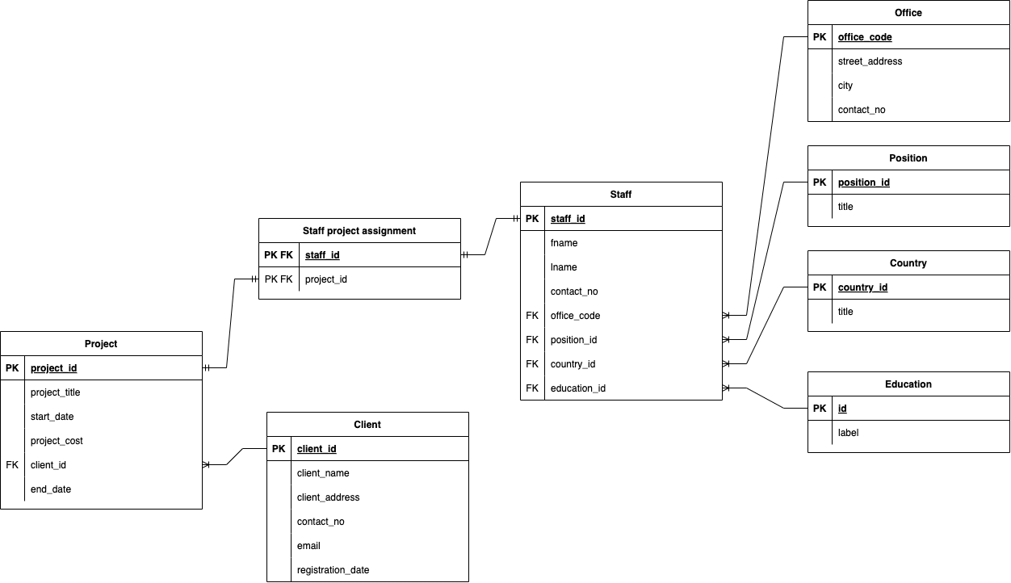

Attributes, primary keys, foreign keys and composite keys
- Office (office_code – PK, street_address, city, contact_no)
- Staff (staff_id – PK, fname, lname, contact_no, office_code – FK, position_id, country_id – FK, education_id – FK)
- Client (client_id – PK, client_name, client_address, contact_no, email, registration_date)
- Project (project_id – PK, project_title, start_date, project_cost, client_id – FK, end_date)
- Position (position_id – PK, title)
- Country (country_id – PK, title)
- Education (education_id – PK, title)
- Staff project assignment (staff_id – FK , project_id – FK)
Office
Entity | Attribute | Description | Data Type & Length | Nullable | Possible Values | Constraints & Formats
Office | office_code | Unique identifier for the office | INT | NO | Unique | PRIMARY KEY, AUTO_INCREMENT
Office | street_address | Office address | VARCHAR(255) | NO | 5th avenue | NOT NULL
Office | city | City where the office is located | VARCHAR(100) | NO | New York | NOT NULL
Office | contact_no | Office contact number | VARCHAR(20) | NO | Valid phone number | NOT NULL, FORMAT: "+[Country Code]-[Number]"

Education
Entity | Attribute | Description | Data Type & Length | Nullable | Possible Values | Constraints & Formats
Education | education_id | Unique identifier for education | INT | NO | Unique | PRIMARY KEY, AUTO_INCREMENT
Education | title | Education level | VARCHAR(100) | NO | Bachelor | NOT NULL

Position
Entity | Attribute | Description | Data Type & Length | Nullable | Possible Values | Constraints & Formats
Position | position_id | Unique identifier for position | INT | NO | Unique | PRIMARY KEY, AUTO_INCREMENT
Position | title | Position title | VARCHAR(100) | NO | CEO | NOT NULL

Staff project assignment
Entity | Attribute | Description | Data Type & Length | Nullable | Possible Values | Constraints & Formats
Staff Project Assignment | staff_id | Assigned staff member | INT | NO | References Staff(staff_id) | FOREIGN KEY, NOT NULL
Staff Project Assignment | project_id | Assigned project | INT | NO | References Project(project_id) | FOREIGN KEY, NOT NULL
Staff Project Assignment | PRIMARY KEY | Composite key for assignment | (staff_id, project_id) | NO | Unique combination | COMPOSITE PRIMARY KEY
Staff Project Assignment | Staff Limit Constraint | Prevents assigning more than 5 staff to a project | Trigger-Based Validation | NO | 1 to 5 staff per project | Enforced using BEFORE INSERT trigger: If project_id already has 5 staff, prevent insert
Project
Entity | Attribute | Description | Data Type & Length | Nullable | Possible Values | Constraints & Formats
Project | project_id | Unique identifier for project | INT | NO | Unique | PRIMARY KEY, AUTO_INCREMENT
Project | project_title | Title of the project | VARCHAR(255) | NO | Walmart | NOT NULL
Project | start_date | Project start date | DATE | NO | YYYY-MM-DD | NOT NULL
Project | project_cost | Estimated project cost | DECIMAL(10,2) | NO | Positive values | NOT NULL, CHECK (project_cost > 0)
Project | client_id | Client associated with project | INT | NO | References Client(client_id) | FOREIGN KEY, NOT NULL
Project | end_date | Project completion date | DATE | YES | YYYY-MM-DD | NULLABLE

Client
Entity | Attribute | Description | Data Type & Length | Nullable | Possible Values | Constraints & Formats
Client | client_id | Unique identifier for client | INT | NO | Unique | PRIMARY KEY, AUTO_INCREMENT
Client | client_name | Client’s name | VARCHAR(255) | NO | Walmart | NOT NULL
Client | client_address | Client’s address | VARCHAR(255) | NO | Silicon valley john-street/9 | NOT NULL
Client | contact_no | Client’s contact number | VARCHAR(20) | NO | Valid phone number | NOT NULL, FORMAT: "+[Country Code]-[Number]"
Client | email | Client’s email | VARCHAR(255) | NO | Unique, valid email | NOT NULL, UNIQUE, FORMAT: "user@domain.com"
Client | registration_date | Date of client registration | DATE | NO | YYYY-MM-DD | NOT NULL

Staff
Entity | Attribute | Description | Data Type & Length | Nullable | Possible Values | Constraints & Formats
Staff | staff_id | Unique identifier for staff | INT | NO | Unique | PRIMARY KEY, AUTO_INCREMENT
Staff | fname | Staff first name | VARCHAR(100) | NO | John | NOT NULL
Staff | lname | Staff last name | VARCHAR(100) | NO | Smith | NOT NULL
Staff | contact_no | Staff contact number | VARCHAR(20) | NO | Valid phone number | NOT NULL, FORMAT: "+[Country Code]-[Number]"
Staff | office_code | Office assigned to staff | INT | NO | References Office(office_code) | FOREIGN KEY, NOT NULL
Staff | position_id | Staff position | INT | NO | References Position(position_id) | FOREIGN KEY, NOT NULL
Staff | country_id | Country of staff | INT | NO | References Country(country_id) | FOREIGN KEY, NOT NULL
Staff | education_id | Staff education level | INT | NO | References Education(education_id) | FOREIGN KEY, NOT NULL

Conceptual data model against user queries
- How many projects are completed per month, and what is their total cost?
  - Possible by selection of projects which are in given timeframe using start_date and end_date fields, then sum of values located in project_cost fields.
- How many new clients are registered per month?
  - Possible by selection of clients which are in given timeframe using client’s registration_date field, then obtaining count of records in result
- How many staff members are employed in each country?
  - Possible by selection number of references from each country’s country_id PK field to staff member FK field country_id
- What is the educational level of staff members (Bachelors, Masters, PhDs, etc.)?
  - Possible by selection number of references from each education’s education_id PK field to staff member FK field education_id

Conclusion
With this project I learned how to correctly understand business requirements, extract entities, business rules and specific constrains from given business case. In scope of that laboratory work also was created entity relationship diagram which visually represents all relationships between entities and makes overall database structure clearer.

