TRANSPORT AND TELECOMMUNICATION INSTITUTE


ENGINEERING FACULTY

Lab 2

Course: Database design concepts

Theme: Developing a logical data model for the Business Case

Student: Artjoms Voroncovs
St. code: 83663
Group: 4301BNA

Riga
2025
Contents
Introduction 3
Description of corrections and changes made in the Conceptual data model 3
Introduction to changes made in the conceptual data model 3
1. The summary does not contain some problems and issues encountered in the Business case. 3
2. Business Rules are scattered and they can't be useful for defining the elements of the Conceptual data Model. 4
3. What is the entity Project Assignment? Where does it come from? 4
4. The conceptual data model does not contain FKs. It just reflects formalized aspects of the Business case. 4
5. Too many micro entities. Is this efficient? 4
Transformation of the Conceptual data model into a Logical data model. 4
Description of the Conceptual data model 4
Transformation to Logical data model 5
ERD for the Logical data model 15
Conclusion 15

Introduction
In this laboratory project it is required to correct errors and omissions occurring in the first laboratory project. Then it is necessary to transform the Conceptual data model from the first laboratory project into a Logical data model it will involve definition of logical structure, normalization activities, constrains definition and naming convention introduction. After creation of logical data model, it is required to create ERD for the Logical data model and produce a written report.

Description of corrections and changes made in the Conceptual data model

Introduction to changes made in the conceptual data model
According to comments made on first laboratory work several corrections were made in order to improve conceptual data model on which second laboratory work relies.

The summary does not contain some problems and issues encountered in the Business case.
Summary was enhanced, in business case were included missing problems:

A leading project management consultancy operates multiple offices in multiple countries, each office employs staff to do project work. Each employee holds a specific position (Project Managers, Business Analysts, Product owners, Admin Assistant, etc). Employees can hold any position. The same position can be given to several staff members
Consultancy working with multiple clients from different locations, clients can submit project requests. Single client can submit multiple project requests, but each project is assigned only to single client. When a project request is submitted, between 1 to 5 staff members are assigned to work on it. Single staff member can be assigned to multiple projects at the same time.
Each Office is described by: Office Code, Street address, City, Contact No, email
Staff is represented: Staff Id, Fname, Lname, Contact No
Clients are described by Client Id, Client name, Client Address, Contact No, email
Projects are described by Project Id, Project Title, Start date, Project Cost.

Also management needs to monitor the following information:
1. How many projects are completed per month and their total cost?
2. How many new clients are registered per month?
3. How many staff members are employed in each country?
4. What is the educational level of staff members (Bachelors, Masters, PhDs, etc.)?

Business Rules are scattered and they can't be useful for defining the elements of the Conceptual data Model.
Business rules definitions were improved and now defined as such:

Staff rules
- Each staff member holds some position (e.g., Project Manager, Business Analyst); Multiple staff members can hold same position
- Staff members have First Name, Last Name, and Contact Number.
- Staff member assigned to specific office
- Each staff member should have unique identifier
Office rules
- One office must maintain records of Street address, City, Contact Number, email.
- Each office should have unique identifier
- Each office employs staff to do project work
Clent rules
- Client can submit multiple project requests
- Client must ne tracked with: Client Id, Client Name, Client Address, Contact Number, and Email.
Project rules
- Project can be submitted only by one client
- To project can be assigned from 1 to 5 staff members
- Project must be tracked with the following attributes: Project ID, Project Title, Start Date, Project Cost
- One project request must be associated with one client

What is the entity Project Assignment? Where does it come from?
Entity Project Assignment is bridge entity which is more appropriate for logical data model, therefore in scope of conceptual data model improvement it was removed.

The conceptual data model does not contain FKs. It just reflects formalized aspects of the Business case.
According to this comment, FK’s were removed from conceptual data model

Too many micro entities. Is this efficient?
Micro entities such as position, country and education are more appropriate for actual implementation and logical data model, therefore in scope of improvement of conceptual data model they were removed.

Transformation of the Conceptual data model into a Logical data model.

Description of the Conceptual data model
List of Entities:
- Office
- Staff
- Client
- Project
Relationships:
- One Office employs many Staff
- One Client can submit many Projects
- One Project is submitted by one Client
- One Project involves 1 to 5 Staff
- One Staff can be involved in many Projects
EDR for the Conceptual data model
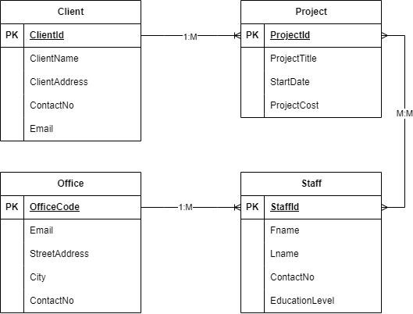

Transformation to Logical data model
In scope of transformation were introduced new tables such as position, country, education and staff project assignment.

Why was the position table introduced?
If many staff share the same position, and we want to avoid typos like “BA”, “Business Analyst”, “Business analyst”, we can normalize it.
In scope of 3NF normalization was introduced position table

Why was the education table introduced?
If many staff share the same education level, and we want to avoid typos like “Masters”, “masters”, “MSc”, we can normalize it.
In scope of 3NF normalization was introduced education table

Why was the country table introduced?
If many staff share the same education level, and we want to avoid typos like “USA”, “United states of America”, “ASV”, we can normalize it.
In scope of 3NF normalization was introduced country table

Why staff project assignment table was introduced?
This table was introduced jn scope of 2NF normalization and it resolves a many-to-many relationship between Staff and Project. Without normalization - we'd need a repeat group of staff per project or projects per staff. This violates 1NF Normalization Step.
New staff project assignment table becomes a bridge table with a composite primary key.

List of tables
- Office
- Staff
- Client
- Project
- Position
- Country
- Education
- Staff project assignment
Relationships
- Office:Staff 1:M
- Position:Staff 1:M
- Country:Staff 1:M
- Education:Staff 1:M
- Staff Project Assignment:Staff 1:1
- Staff Project Assignment:Project 1:1
- Client:Project 1:M
Attributes, primary keys, foreign keys and composite keys
- Office (office_code – PK, street_address, city, contact_no)
- Staff (staff_id – PK, fname, lname, contact_no, office_code – FK, position_id, country_id – FK, education_id – FK)
- Client (client_id – PK, client_name, client_address, contact_no, email, registration_date)
- Project (project_id – PK, project_title, start_date, project_cost, client_id – FK, end_date)
- Position (position_id – PK, title)
- Country (country_id – PK, title)
- Education (education_id – PK, title)
- Staff project assignment (staff_id – FK , project_id – FK)

Tables description
Office
Entity | Attribute | Description | Data Type & Length | Nullable | Possible Values | Constraints & Formats
Office | office_code | Unique identifier for the office | INT | NO | Unique | PRIMARY KEY, AUTO_INCREMENT
Office | street_address | Office address | VARCHAR(255) | NO | 5th avenue | NOT NULL
Office | city | City where the office is located | VARCHAR(100) | NO | New York | NOT NULL
Office | contact_no | Office contact number | VARCHAR(20) | NO | Valid phone number | NOT NULL, FORMAT: "+[Country Code]-[Number]"

Education
Entity | Attribute | Description | Data Type & Length | Nullable | Possible Values | Constraints & Formats
Education | education_id | Unique identifier for education | INT | NO | Unique | PRIMARY KEY, AUTO_INCREMENT
Education | title | Education level | VARCHAR(100) | NO | Bachelor | NOT NULL

Country
Entity | Attribute | Description | Data Type & Length | Nullable | Possible Values | Constraints & Formats
Education | country_id | Unique identifier for country | INT | NO | Unique | PRIMARY KEY, AUTO_INCREMENT
Education | title | Country title | VARCHAR(100) | NO | Latvia | NOT NULL

Position
Entity | Attribute | Description | Data Type & Length | Nullable | Possible Values | Constraints & Formats
Position | position_id | Unique identifier for position | INT | NO | Unique | PRIMARY KEY, AUTO_INCREMENT
Position | title | Position title | VARCHAR(100) | NO | CEO | NOT NULL

Staff project assignment
Entity | Attribute | Description | Data Type & Length | Nullable | Possible Values | Constraints & Formats
Staff Project Assignment | staff_id | Assigned staff member | INT | NO | References Staff(staff_id) | FOREIGN KEY, NOT NULL
Staff Project Assignment | project_id | Assigned project | INT | NO | References Project(project_id) | FOREIGN KEY, NOT NULL
Staff Project Assignment | PRIMARY KEY | Composite key for assignment | (staff_id, project_id) | NO | Unique combination | COMPOSITE PRIMARY KEY
Staff Project Assignment | Staff Limit Constraint | Prevents assigning more than 5 staff to a project | Trigger-Based Validation | NO | 1 to 5 staff per project | Enforced using BEFORE INSERT trigger: If project_id already has 5 staff, prevent insert

Project
Entity | Attribute | Description | Data Type & Length | Nullable | Possible Values | Constraints & Formats
Project | project_id | Unique identifier for project | INT | NO | Unique | PRIMARY KEY, AUTO_INCREMENT
Project | project_title | Title of the project | VARCHAR(255) | NO | Walmart | NOT NULL
Project | start_date | Project start date | DATE | NO | YYYY-MM-DD | NOT NULL
Project | project_cost | Estimated project cost | DECIMAL(10,2) | NO | Positive values | NOT NULL, CHECK (project_cost > 0)
Project | client_id | Client associated with project | INT | NO | References Client(client_id) | FOREIGN KEY, NOT NULL
Project | end_date | Project completion date | DATE | YES | YYYY-MM-DD | NULLABLE

Client
Entity | Attribute | Description | Data Type & Length | Nullable | Possible Values | Constraints & Formats
Client | client_id | Unique identifier for client | INT | NO | Unique | PRIMARY KEY, AUTO_INCREMENT
Client | client_name | Client’s name | VARCHAR(255) | NO | Walmart | NOT NULL
Client | client_address | Client’s address | VARCHAR(255) | NO | Silicon valley john-street/9 | NOT NULL
Client | contact_no | Client’s contact number | VARCHAR(20) | NO | Valid phone number | NOT NULL, FORMAT: "+[Country Code]-[Number]"
Client | email | Client’s email | VARCHAR(255) | NO | Unique, valid email | NOT NULL, UNIQUE, FORMAT: "user@domain.com"
Client | registration_date | Date of client registration | DATE | NO | YYYY-MM-DD | NOT NULL

Staff
Entity | Attribute | Description | Data Type & Length | Nullable | Possible Values | Constraints & Formats
Staff | staff_id | Unique identifier for staff | INT | NO | Unique | PRIMARY KEY, AUTO_INCREMENT
Staff | fname | Staff first name | VARCHAR(100) | NO | John | NOT NULL
Staff | lname | Staff last name | VARCHAR(100) | NO | Smith | NOT NULL
Staff | contact_no | Staff contact number | VARCHAR(20) | NO | Valid phone number | NOT NULL, FORMAT: "+[Country Code]-[Number]"
Staff | office_code | Office assigned to staff | INT | NO | References Office(office_code) | FOREIGN KEY, NOT NULL
Staff | position_id | Staff position | INT | NO | References Position(position_id) | FOREIGN KEY, NOT NULL
Staff | country_id | Country of staff | INT | NO | References Country(country_id) | FOREIGN KEY, NOT NULL
Staff | education_id | Staff education level | INT | NO | References Education(education_id) | FOREIGN KEY, NOT NULL

Logical data model against user queries
- How many projects are completed per month, and what is their total cost?
  - Possible by selection of projects which are in given timeframe using start_date and end_date fields, then sum of values located in project_cost fields.
- How many new clients are registered per month?
  - Possible by selection of clients which are in given timeframe using client’s registration_date field, then obtaining count of records in result
- How many staff members are employed in each country?
  - Possible by selection number of references from each country’s country_id PK field to staff member FK field country_id
- What is the educational level of staff members (Bachelors, Masters, PhDs, etc.)?
  - Possible by selection number of references from each education’s education_id PK field to staff member FK field education_id

ERD for the Logical data model

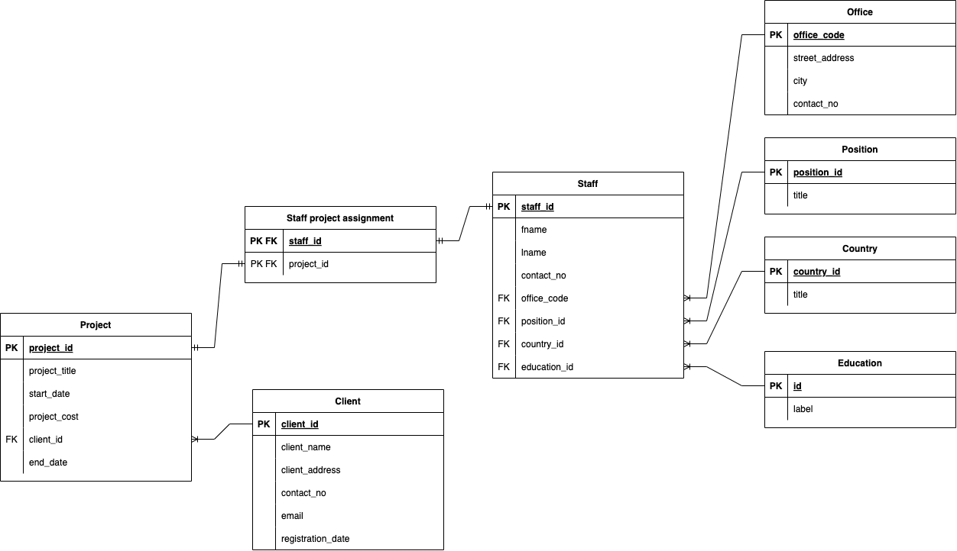

Conclusion
With this project I learned how to correctly understand business requirements, extract entities, business rules and specific constraints from given business cases. I fully understood the difference between conceptual data model and functional data model. I conducted a decent rework of my first laboratory work to improve and align it with this (second) laboratory work. As a designer of functional data model, I applied normalization methods in order to improve my functional data model and make it more robust and convenient in implementation and exploitation. In scope of current assignment also was created an entity relationship diagram which visually represents all relationships between entities and makes overall database structure clearer.

