

Database processing Course Project
Business Requirements and Analysis (BRD)

Student’s name: Artjoms
Student’s surname: Voroncovs
St. code: st83663

RIGA

TABLE OF CONTENTS

1. Scenario Overview 3
Service Description 3
Key Business Stakeholders 3
Purpose of the Monthly Report 3
2. Business Questions 4
2.1 Revenue & Subscription Base 4
2.2 Engagement / Usage 4
2.3 Churn & Customer Movement 5
2.4 Data Quality / Reliability 5
3. KPI & Metric Definitions 7
3.1 Revenue KPIs 7
3.2 Engagement KPIs 7
3.3 Churn & Retention KPIs 8
3.4 Data Quality KPIs 9
4. Assumptions & Constraints 9

1. Scenario Overview

Video streaming platform Name: StreamNova - a subscription-based video streaming platform.

Pic 1.0 StreamNova platform logo

1.1 Service Description
Stream Nova is service which provides online access to movies, series and other exclusive original content created by various partners. Service revenue based on monthly subscription model using several plans such as Basic, Standard and premium. Each plan offering different video quality (resolution, bit rate etc), number of concurrent users, and access to paid content. Stream Nova is available on different types of devices such as web, mobile and smart TV.
The platform operates on global scale and mainly relies on subscription revenue. User engagement is a main indicator of customer satisfaction and product quality.

Pic 1.1 StreamNova mobile app mock-up
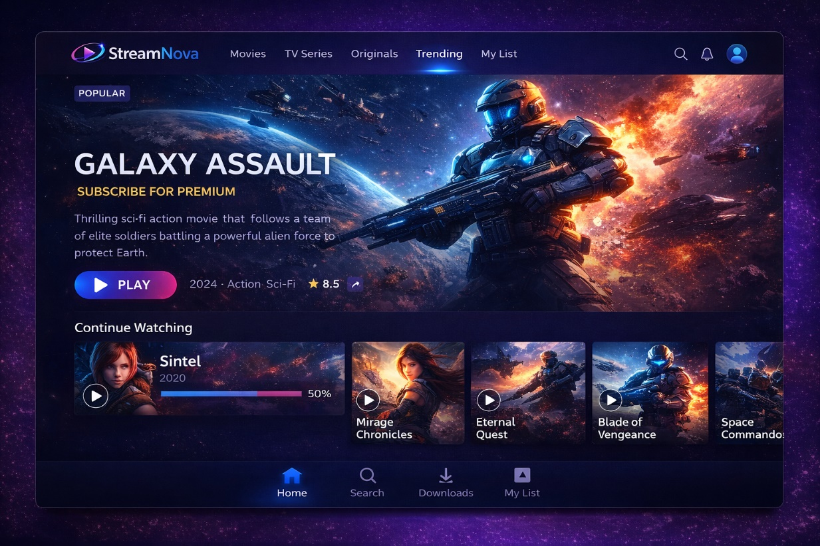
Pic 1.2 StreamNova desktop mock-up

1.2 Key Business Stakeholders
CFO / Finance Team - checks revenue, discounts, refunds, and in general financial performance of a company.
Head of Product - monitors content engagement parameter and develops roadmap guide for strategic decisions.
Marketing Manager - analyzes amount of trials, conversion parameter, online content promotions, and unsubscribe trends.
Customer Success / Retention Team - tracks unsubscribe metric, engagement downgrades, and platform inactive users.
Data / Analytics Team - ensures data quality, customer satisfaction and reliability for strategic decision-making.

1.3 Purpose of the Monthly Report
The Monthly Performance & Engagement Report helps management:
- Understand revenue trends and the health of the subscription base.
- Measure how actively subscribers are using the service.
- Detect unsubscribe risks, plan changes, and trial subscription conversions.
- Identify potential data quality / content issues that could distort KPIs.

The report is designed to be run directly in Oracle using PL/SQL and DBMS_OUTPUT.

2. Business Questions

2.1 Revenue & Subscription Base

Q1. What is the total net revenue for the selected revenue report month?
Description: Measures of how much total money was earned after applied discounts in the report month.
Stakeholders / Business users: CFO, Finance Team
Report priority: Must have

Q2. How does net revenue compare to the previous month?
Description: Demonstrates month-over-month revenue growth or decline.
Stakeholders / Business users: CFO, Management
Report priority: Must have

Q3. How many active subscribers do we have per subscription plan?
Description: Describes the amount of the active customer base divided by subscription plan type.
Stakeholders / Business users: Product, Marketing
Report priority: Must have

Q4. What share of total revenue does each plan generate?
Description: Shows which plans contribute most to overall revenue.
Stakeholders / Business users: CFO, Product
Report priority: Nice to have

2.2 Engagement / Usage

Q5. What is the average count of active sessions per active user in the selected month?
Description: Indicates how often active users use the platform.
Stakeholders: Product, Customer Success
Report priority: Must have

Q6. What is the total average watch time per platform user during the month?
Description: Indicates average depth of user engagement, not just frequency.
Stakeholders: Product
Report priority: Must have

Q7. Which video content categories are the most watched?
Description: Helps understand type of content preferences and guide strategic decisions related to new content licensing.
Stakeholders: Product, Content Team
Report priority: Nice to have

2.3 Churn and Customer Movement

Q8. How many subscribers decided to cancel subscription during selected month?
Description: Counts users whose subscriptions ended or were cancelled.
Stakeholders: Customer Success, Marketing
Priority: Must have

Q9. How many platform users upgraded or downgraded their plan?
Description: Tracks movement between subscription plans, needed to understand how to change pricing and rate content value.
Stakeholders: Product, Marketing
Priority: Nice to have

2.4 Data Quality / Reliability

Q10. Are there payments with missing or zero money amounts?
Description: Detects suspicious or incomplete transaction payment records.
Stakeholders: Finance, Data Team
Priority: Must have

Q11. Are there active users/subscribers without recorded usage in the selected month?
Description: Identifies possible data tracking issues or disengaged users.
Stakeholders: Product, Data Team
Priority: Must have

3. KPI and Metric Definitions

3.1 Revenue KPIs

KPI 1: Application Monthly Net Revenue
Meaning: Total revenue after all discounts for the report month.
Formula: SUM(payment_amount) - SUM(discount_amount) for payments in month
Grain: Per month
Dependencies: PAYMENT.amount, PAYMENT.discount_amount, PAYMENT.payment_date

KPI 2: Month over Month platform Revenue Change in percents
Meaning: Growth or decline compared to previous month.
Formula: (CurrentMonthRevenue - PreviousMonthRevenue) / PreviousMonthRevenue * 100
Grain: Per month
Dependencies: PAYMENT.amount, PAYMENT.discount_amount, PAYMENT.payment_date

KPI 3: Revenue by subscription plan
Meaning: Net revenue generated by data from each subscription plan.
Formula: Net revenue grouped by plan_id
Grain: Per month, per plan
Dependencies: PAYMENT, SUBSCRIPTION.plan_id

3.2 Engagement KPIs

KPI 4: Active Users
Meaning: Number of application users with an active subscription during the month.
Formula: COUNT(DISTINCT user_id) with active subscription
Grain: Per month
Dependencies: SUBSCRIPTION.start_date, SUBSCRIPTION.end_date

KPI 5: Average viewing sessions per user
Meaning: Average number of viewing sessions per active user in the application.
Formula: COUNT(session_id) / COUNT(DISTINCT user_id)
Grain: Per month
Dependencies: USAGE_SESSION.session_id, user_id

KPI 6: Average Watch Time per User (minutes)
Meaning: Average total minutes watched per active user.
Formula: SUM(watch_minutes) / COUNT(DISTINCT user_id)
Grain: Per month
Dependencies: USAGE_SESSION.watch_minutes

3.3 Churn and Retention KPIs

KPI 7: Churned Subscribers
Meaning: Number of subscriptions cancelled in the report month.
Formula: COUNT(subscriptions with status = 'CANCELLED' and end_date in month)
Grain: Per month
Dependencies: SUBSCRIPTION.status, SUBSCRIPTION.end_date

KPI 8: Churn Rate in percentage
Meaning: Percentage of active users who decided to unsubscribe during the month.
Formula: ChurnedSubscribers / ActiveSubscribers * 100
Grain: Per month
Dependencies: SUBSCRIPTION

3.4 Data Quality KPIs

KPI 9: Invalid Payments Count
Meaning: Number of payment records with missing or non-positive amounts.
Formula: COUNT(payments where amount <= 0 or amount IS NULL)
Grain: Per month
Dependencies: PAYMENT.amount

KPI 10: Active Users with No Usage
Meaning: Active subscribers without any recorded sessions in the month.
Formula: ActiveUsers minus UsersWithUsage
Grain: Per month
Dependencies: SUBSCRIPTION, USAGE_SESSION

4. Assumptions and Constraints

- One active service subscription per user at a time.
- Revenue is updated at payment date.
- User engagement is measured only via recorded active user viewing sessions.
- The report scope is single selected month.
- Data volume is small enough to be processed via PL/SQL with DBMS_OUTPUT for demonstrational purposes.

