Conv. AI Project Proposals – Winter 2026

In this course, you will develop a real-world Conversational AI project. These projects enable you to specialize in a specific area and gain expertise that complements our core lectures and lab assignments.

For the Winter 2026 term, projects are organized into five categories:
- Speech & Audio Tokens
- Efficient & Tiny LLMs
- Alternatives to Autoregressive Modeling
- Trustworthy Conversational AI
- Model Adaptation, Distillation, and Combination

This document lists the proposed projects. For details on project expectations, general guidelines, and the applicable policies, please refer to the Project Guidelines document. We strongly encourage you to read them carefully.

Important Note on Computing: Access to a GPU is required for the project. Please ensure you have sufficient computing credits (refer to the "Computing" section in the project guidelines for details).

P1: Neural Speaker Diarization with Lightweight Architectures
Speaker diarization is the task of determining who is speaking and when in an audio recording with multiple speakers (e.g., a meeting, a podcast, a TV show, etc). Given a speech signal, a diarization system outputs time-stamped speaker labels, as illustrated below:

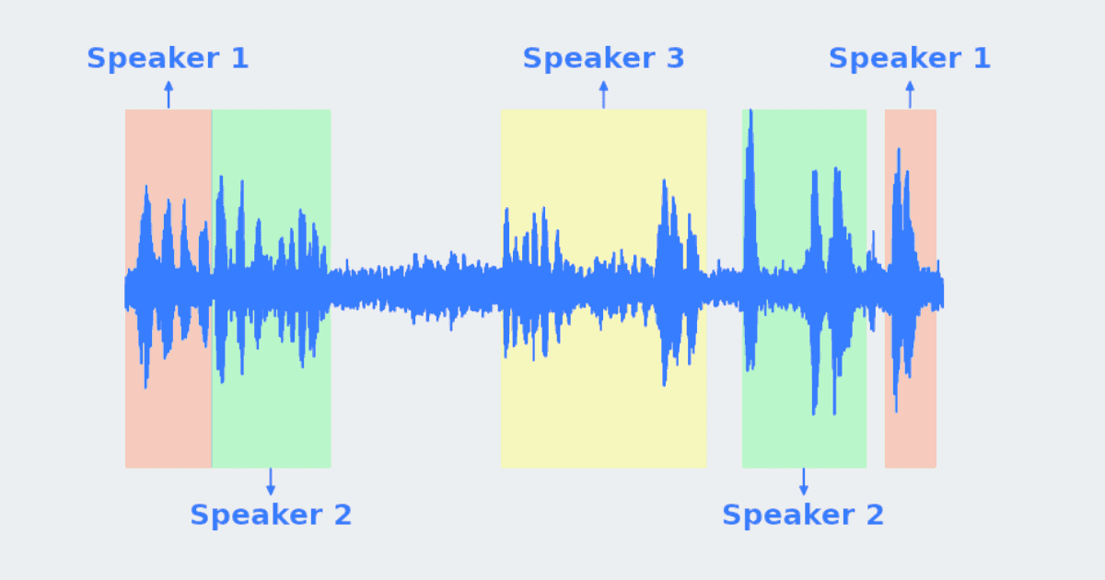

For example, the expected output of a diarization system could be:

0.00 – 5.00 s Speaker 1
5.00 – 12.00 s Speaker 2
12.00 – 16.00 s No speech
16.00 – 31.00 s Speaker 3
etc

In real scenarios, multiple speakers may speak at the same time. A strong diarization system should therefore be able to also detect overlapping speech.

Project Objective
The goal of this project is to design, implement, and evaluate a neural speaker diarization system that is:
- As accurate as possible
- Computationally efficient
- Based on modern deep learning techniques

You are expected to compare at least two models (a baseline and a more advanced one) and provide a clear experimental analysis.

Proposed Project Plan

Literature Review: Conduct a deep and focused literature review on speaker diarization. Try to identify the main diarization models, how the models are trained and which evaluation metrics are standard for this task.

Data Generation: For this project, you may generate your own dataset. You can create simulated speech recordings (e.g., ~30 seconds long), include multiple speakers (with occasional speaker overlap) and add non-speech segments (silence, background noise, or sound events). Ensure that the generated data is realistic enough to meaningfully evaluate a diarization system. You must also generate automatically ground-truth annotations indicating which speaker(s) are active at each time interval.

Baseline Model: Implement a first simple baseline diarization system and evaluate it properly. The baseline should be reasonable and well-implemented. You are expected to tune hyperparameters using validation data. You may rely on pretrained speaker embedding models (e.g., ECAPA-TDNN) if appropriate.

Advanced Model: Implement at least one more advanced diarization model. This model should improve upon the simple baseline in some way (efficiency, diarization performance, overlap handling, etc.). Clearly explain what makes it more advanced. Compare its performance against the baseline using appropriate metrics.

Evaluation and Analysis: Use standard diarization metrics. Analyze typical errors (e.g., confusion between speakers, missed overlaps). Discuss the strengths and limitations of your approach.

P2: Speech Separation Using Discrete Audio Tokens
Speech separation is the task of isolating individual speaker signals from a single audio recording that contains multiple overlapping speakers (the so-called cocktail party problem). Given a mixture of speech signals, a speech separation system outputs one audio signal per speaker, each corresponding to a single talker, as shown in the figure below.

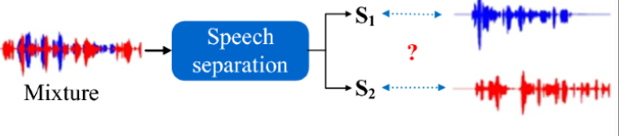

For example, given a two-speaker mixture, the expected output of a speech separation system is:
- Input: single-channel mixture audio
- Output 1: reconstructed speech signal of Speaker 1
- Output 2: reconstructed speech signal of Speaker 2

In recent years, discrete audio tokens have emerged as an alternative representation to continuous spectrograms. Instead of operating directly on time–frequency features (e.g, spectrogram, FBANKs), models can process sequences of learned audio tokens (e.g., produced by neural audio codecs). This project explores whether and how speech separation can be performed in the discrete token domain.

Project Objective
The goal of this project is to design, implement, and evaluate a neural speech separation system that operates on discrete audio tokens, rather than traditional acoustic features. The system should be:
- As accurate as possible in separating speakers
- Computationally efficient
- Based on modern deep learning techniques and discrete representations

You are expected to compare at least two models (a baseline and a more advanced one) and provide a clear experimental analysis. Ideally, the model should be able to properly manage mixtures with a variable number of speakers (e.g, 2 speakers or 3 speakers).

Proposed Project Plan

Literature Review: Conduct a focused literature review on speech separation and audio tokenization. Try to understand standard neural approaches to speech separation. Read about Token-based audio representations (e.g., neural codecs). Familiarize yourself with the standard evaluation metrics for speech separation (e.g., SI-SDR, SDR, etc).

Data Generation: For this project, you may generate your own speech mixtures. Create multi-speaker mixtures by combining clean speech signals from different speakers. Include both non-overlapping and overlapping speech segments. Optionally add background noise to increase realism. You will then convert the audio signals into discrete audio tokens using a pretrained tokenizer. The ground-truth clean signals for each speaker must be preserved to enable proper training and evaluation.

Baseline Model: Implement a first simple baseline model that performs speech separation in the token domain. The baseline can be a simple sequence-to-sequence model operating on audio tokens. For instance, the model can take as input the sequence of tokens corresponding to the mixtures and return the tokens for speakers one after the other (e.g, first the sequence of tokens for speaker 1, then a special symbol to separate the speakers, and then the tokens for speaker 2). The model should be well-implemented and properly evaluated. You are expected to tune hyperparameters using validation data.

Advanced Model: Implement at least one more advanced token-based speech separation model. The advanced model should improve upon the baseline in some way (e.g., efficiency, separation quality). Clearly explain what makes the model more advanced. Compare its performance against the baseline using appropriate metrics. As an alternative, you can also feed the baseline system with many different tokenizers and analyze which one is the best for the task of speech separation.

Evaluation and Analysis: Evaluate the quality of the separated speech using standard speech separation metrics. Report objective metrics (e.g., SI-SDR improvements, token error rates) and subjective metrics (e.g, MOS), if relevant. Analyze typical failure cases (e.g., strong overlap, similar speakers). Discuss the strengths and limitations of token-based separation compared to traditional approaches.

P.3 Diffusion-Based Text Generation (at Small Scale)
Most modern text generation systems are based on autoregressive Transformer models, which generate text token by token in a left-to-right fashion. While that turned out to be highly effective, this paradigm is not the only possible approach to sequence generation. In other domains, such as image, speech, and audio generation, diffusion models have shown remarkable performance by generating data through an iterative denoising process rather than autoregressive decoding.

Diffusion models generate samples by progressively refining a noisy signal into a final clean output. Instead of predicting the next token, they learn to reverse a noise corruption process, iteratively improving the quality of the generated sample. This non-autoregressive generation process offers potential advantages, such as parallel generation.

Despite their success in other modalities, diffusion-based approaches have so far shown limited effectiveness in text generation, mainly due to the discrete nature of text and the difficulty of defining suitable diffusion processes over token sequences. Nevertheless, recent work suggests that diffusion models may be potentially viable.

Project Objective
The goal of this project is to design, implement, and evaluate diffusion-based models for text generation, and to compare their behavior and performance with standard autoregressive Transformer models. The focus of the project is not on achieving state-of-the-art performance, but on understanding the strengths and limitations of diffusion models for text, analyzing their training dynamics and generation behavior, and comparing them fairly to autoregressive baselines at a small scale.

Proposed Project Plan

Literature Review: Conduct a focused literature review on diffusion models for sequence and text generation. In particular, try to understand the general principles of diffusion and denoising-based generative models, have insights into existing approaches to diffusion over discrete sequences or text representations, and figure out the challenges and limitations of diffusion-based text generation.

Data and Representation: Select a suitable text dataset for small-scale experimentation. Possible choices include a subset of Wikipedia or book corpora. You may operate at the character, byte, or token level. Dataset size should be chosen to keep training computationally manageable.

Baseline Model (Autoregressive): Implement a standard autoregressive text generation baseline. Train and evaluate the model using standard text generation metrics. Tune hyperparameters using validation data.

Diffusion-Based Model: Implement one or more diffusion-based models for text generation. Define an appropriate forward noise process and a reverse denoising model. Clearly explain architectural and modeling choices. Ensure that training and inference are computationally feasible.

Evaluation and Analysis: Compare diffusion-based models and autoregressive models using quantitative metrics (e.g., perplexity, negative log-likelihood, or other suitable measures). Do a qualitative analysis of the generated text, training stability, generation speed, and other relevant aspects you might find relevant. Optionally, you may explore scaling behavior, such as how performance changes with model size or dataset size for diffusion-based versus autoregressive models.

P.4 Tiny Recursive Model (TMR)
A recent work has proposed a new architecture for language modeling called the Tiny Recursive Model (TMR). Unlike standard Large Language Models (LLMs), which rely on large autoregressive Transformers with hundreds of millions or billions of parameters, TMR has shown that competitive performance on certain reasoning and language tasks can be achieved using a much smaller and faster model.
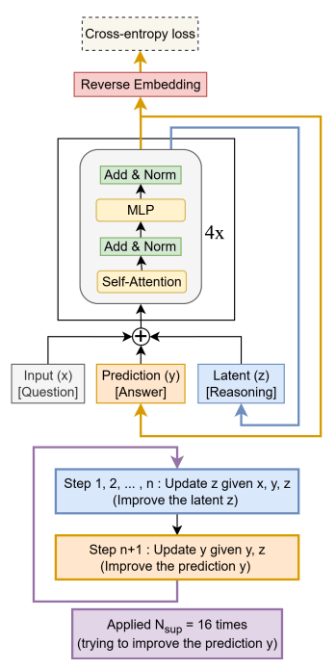
The core idea behind TMR is to generate text through an iterative refinement process. Instead of predicting the output strictly left-to-right in a single pass, the model repeatedly revises and improves an initial prediction over multiple steps. This recursive mechanism allows the model to progressively refine its output, enabling reasoning-like behavior despite a very small parameter budget. The resulting architecture is significantly more efficient than standard LLMs, while still achieving strong performance on selected tasks.

Project Objective
The goal of this project is to replicate, analyze, and extend the Tiny Recursive Model (TMR). In particular, you are expected to:
- Reproduce the main findings reported in the original paper
- Evaluate whether these findings generalize to datasets or tasks not considered by the authors
- Explore potential modifications or improvements to the proposed approach
The emphasis of the project is on understanding the modeling paradigm, validating experimental claims, and critically analyzing strengths and limitations.

Proposed Project Plan

Literature Review: Read all the Tiny Recursive Model reference paper, familiarize yourself with the model itself, and the relevant literature.

Model Implementation and Replication: Implement the TMR architecture as described in the paper. Carefully follow the architectural and training details reported by the authors. Reproduce the experimental setup as closely as possible. Validate your implementation by replicating key results (e.g., performance on reasoning or language modeling benchmarks).
Evaluation on New Data or Tasks: Test the TMR model on datasets or tasks not used in the original paper. Examples include alternative reasoning datasets, different text domains, or simplified language modeling tasks. Analyze whether the performance trends reported in the paper still hold. Compare results with a small autoregressive Transformer baseline of comparable size.

Extensions and Improvements (Optional but Encouraged): Propose and evaluate one or more extensions to the original method. Clearly justify your proposed modifications and evaluate their impact.

Evaluation and Analysis: Provide an extensive experimental analysis, including quantitative performance comparisons, training efficiency, and inference speed. Qualitative analysis of model outputs. Discussion of failure cases and limitations.

P5: Merging Fine-Tuned Language Models
Modern language models are often fine-tuned separately for different tasks or domains, resulting in multiple specialized models that each perform well on a narrow set of problems. An emerging line of research, known as model merging, aims to combine such independently fine-tuned models into a single model that can perform well across multiple tasks, without retraining from scratch and without access to the original training data.
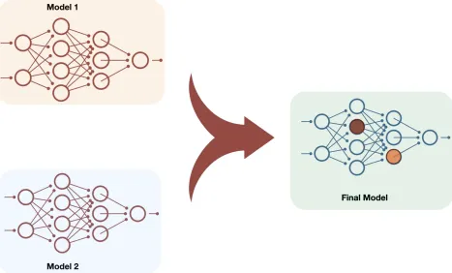

Model merging typically operates directly in parameter space, combining the weights of multiple models that share the same base architecture. Recent studies have shown that surprisingly simple techniques, such as weight averaging or task arithmetic, can yield promising multi-task performance. Given the large number of publicly available fine-tuned models, model merging has the potential to become a practical alternative to costly multi-task training.

Project Objective
The goal of this project is to experiment with and analyze model merging techniques for language models. You are expected to fine-tune a shared base language model on multiple tasks, merge the resulting task-specific models using different merging strategies, and evaluate the merged models and compare them with standard multi-task fine-tuning.
The main focus should be on understanding when and why model merging works, as well as its limitations.

Proposed Project Plan

Literature Review: Conduct a focused literature review on model merging and related techniques. In particular, try to understand parameter-space merging methods (e.g., weight averaging, task vectors, Breadcrumbs), conditions under which merging is effective, and Known failure modes.

Task-Specific Fine-Tuning: Select a small set of tasks and fine-tune a shared base language model separately on each task. Example tasks include question answering, summarization, classification, or dialogue-style generation. Fine-tuning should be computationally lightweight (e.g., using small models or parameter-efficient methods such as LoRA). Each fine-tuned model should perform reasonably well on its respective task, but bad on the others.

Model Merging: Experiment with different model merging strategies described in the literature.

Evaluation and Comparison: Evaluate the merged models on all tasks and compare them against the individual task-specific models and a single model fine-tuned jointly on all tasks (multi-task baseline). Analyze performance trade-offs, task interference, and generalization.

P6: Federated Fine-Tuning of Small Language Models

In many real-world applications, training data cannot be centralized due to privacy, legal, or ethical constraints. This is particularly true in sensitive domains such as healthcare, where data must remain on local devices or institutional servers. Federated learning is a training paradigm that enables multiple clients to collaboratively train a shared model without exchanging raw data.

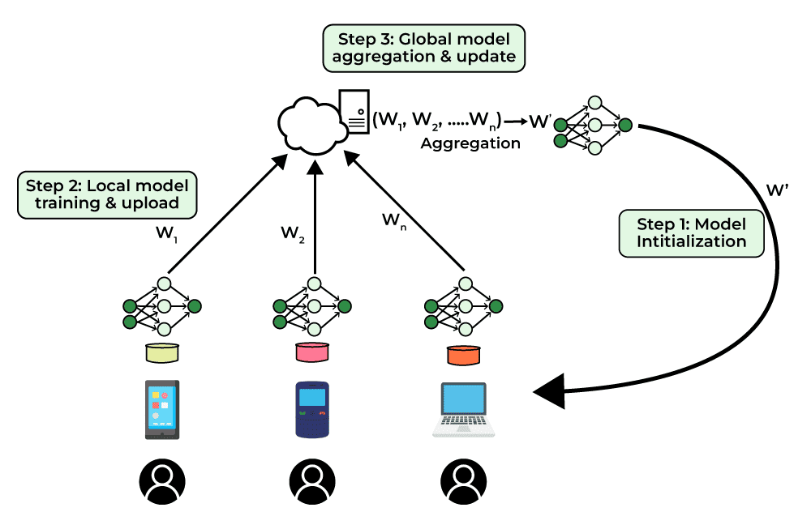

In the context of language models, federated learning allows a model to be fine-tuned on distributed, private text datasets, while only sharing model updates with a central server. This project explores how small language models can be adapted in a federated setting and investigates the trade-offs between performance, level of privacy, and communication efficiency.

Project Objective
The goal of this project is to design, implement, and evaluate a federated fine-tuning framework for small language models, under the constraint that training data cannot be shared across clients.
You are expected to simulate a federated learning scenario with multiple data-owning clients, fine-tune a shared language model using non-shared datasets, and analyze the implemented methods in terms of performance and communication efficiency. The focus is on federated adaptation, not large-scale pretraining.

Proposed Project Plan

Literature Review: Conduct a focused literature review on federated learning for neural networks and language models. In particular, aim to understand the core principles of federated learning and the challenges specific to federated NLP and LLMs.

Federated Learning Setup: Design a simulated federated environment with multiple clients. Each client holds a private dataset that cannot be shared. Data distributions across clients should be non-identical (non-IID). Example client datasets may represent different institutions or domains (e.g., medical notes, clinical reports, conversational data, or scientific text). All clients share the same base language model architecture.

Model and Fine-Tuning Strategy: Select a small language model suitable for federated training. The model should be small enough to train efficiently on a single GPU. You are encouraged to use parameter-efficient fine-tuning methods (e.g., LoRA or adapters) to reduce communication and computation costs. Clients fine-tune the model locally for a small number of steps before sending updates to a central server.

Federated Optimization: Implement one or more federated optimization strategies. Make sure only model updates (or adaptation parameters) or other relevant information communicate However, raw data must never be shared.

Evaluation and Comparison: Evaluate the federated model and compare it with a centrally fine-tuned model trained on the combination of all client datasets (upper bound) and the individually fine-tuned client models (lower bound). Analyze the overall task performance and the communication efficiency.

P7: Hallucination Detection Using Internal Representations
Large Language Models (LLMs) are capable of producing fluent text, but they may also generate hallucinations, i.e., statements that are factually incorrect but written with misleading confidence. Detecting hallucinations is a critical challenge for deploying trustworthy conversational AI systems. Most existing hallucination detection methods rely on the generated text or on external verification tools. In contrast, this project explores whether internal representations of LLMs, such as hidden states, attention patterns, or token-level confidence, could be useful signals for detecting LLM hallucinations.

Project Objective
The goal of this project is to design, implement, and evaluate a hallucination detector that uses the internal representations of an LLM.

You are expected to:
- Generate or collect a dataset containing hallucinated and non-hallucinated model outputs
- Extract internal representations from an open-source LLM
- Train a lightweight classifier to detect hallucinations
- Analyze which internal signals are most informative

The focus is on interpretability, i.e., on detecting which internal representation is more informative to detect possible hallucinations.

Proposed Project Plan

Literature Review: Conduct a focused literature review on hallucination in language models. Try to understand types of hallucinations and familiarize yourself with existing hallucination detection approaches. Review prior work using hidden states or confidence-based signals.

Choose a Base Language Model: Select an open-source LLM that allows easy access to internal representations. The chosen model should be small enough to run on a single GPU (e.g, small variants of popular open-source LLMs)

Hallucination Dataset Construction: You will construct a dataset of model outputs labeled as hallucinated or non-hallucinated. A possible strategy includes using Question Answering with Ground Truth, i.e, use QA datasets with clear factual answers and label outputs as hallucinated when they deviate from the reference answer. You can also provide questions that cannot be answered given the available information, or generate Synthetic Hallucinations by modifying correct outputs by introducing factual errors. Large and diverse datasets are ideal for this project.

Feature Extraction from Internal Representations: Extract internal signals from the LLM during generation, such as hidden states from one or more layers, attention patterns, token-level probabilities, etc

Hallucination Detector: Train a lightweight classifier (e.g., MLP or shallow Transformer) to predict hallucinations. The inputs may include internal representations alone or combined with textual features. You should do an ablation study to detect a configuration that provides the best performance.

Evaluation and Analysis: Evaluate your hallucination detector using standard classification metrics (e.g., Accuracy, precision, recall, ROC-AUC). Analyze which layers or signals are most relevant. Study failure cases and limitations. Compare your internal-representation-based detectors with text-only baselines.

P8: Distillation of Large Language Models into Tiny Models
LLMs achieve strong performance across a wide range of tasks, but their computational cost often makes them impractical for real-time or resource-constrained applications. Knowledge distillation is a technique that transfers knowledge from a large, high-performing teacher model into a smaller, more efficient student model, enabling significant reductions in inference time, memory usage, and energy consumption.

In the context of language models, an ideal distillation should preserve much of the teacher’s capabilities while enabling models to run on edge devices, mobile platforms, or low-latency systems. This project explores how different distillation strategies influence distillation performance, efficiency, and generalization when distilling LLMs into tiny models.

Project Objective
The goal of this project is to implement and compare knowledge distillation methods for language models, where a small student model learns to approximate the behavior of a larger teacher model. You are expected to distill a pretrained LLM into a significantly smaller model, compare the performance between teacher and student on standard benchmarks, and measure efficiency improvements in terms of speed, memory, and compute. You should experiment with multiple distillation strategies and student architectures and compare their performance.

Proposed Project Plan

Literature Review: Conduct a focused literature review on model distillation for language models. You should familiarize yourself with classical knowledge distillation techniques, sequence-level and token-level distillation for NLP, and the recent approaches for distillation and LLM compression.

Teacher–Student Model Selection: Select a teacher model and one or more student models. The teacher model (larger) could be a small-to-medium open-source LLM (e.g., ~1B–7B parameters). The Student models (tiny) could be a small Transformer-based language model or (better) A parameter-efficient architecture such as Mamba or other state-space models or Lightweight Transformer variants. Students should be at least 5×–20× smaller than the teacher.

Distillation Dataset Construction: Construct a dataset for distillation by sampling teacher outputs. A possible approach could be to prompt the teacher with diverse text inputs and record the generated outputs using prompt datasets available online. You can also use existing text corpora and replace ground truth with teacher predictions.

Distillation Techniques: Implement and compare multiple distillation strategies, such as simple methods based on liquid distillation to more sophisticated methods based on internal layer distillation. Students should train using the teacher as a fixed reference model.

Evaluation and Comparison: Evaluate teacher and student models on standard benchmarks (e.g., WikiText, GSM8K, etc) using appropriate metrics such as Language modeling perplexity, Question answering accuracy, etc. Beyond performance, measure efficiency metrics, including such as inference time (e.g, tokens per second) and memory.

P.9 Generative AI Detector (Speech + Text)
Modern Generative AI has made it increasingly difficult to distinguish between human-generated and machine-generated content. For instance, LLMS can produce very fluent text, and modern Text-to-Speech (TTS) systems can generate speech that is almost indistinguishable from real human voices. This raises important concerns related to misuses of AI, such as deep fakes, scams, etc.

The goal of this project is to design and evaluate detectors capable of identifying AI-generated content, focusing on both text and speech modalities.

Text-Based Generative AI Detection: For text, students will collect or construct a dataset containing a mix of human-written text and LLM-generated text. Human-written text can be sourced from open datasets such as Wikipedia, news articles, or academic essays, while synthetic text can be generated using open-source LLMs (e.g., LLaMA, Mistral, Gemma, Phi) with varying decoding strategies (temperature, nucleus sampling, etc.). You will then train a classifier to distinguish between human and machine-generated text.

Speech-Based Generative AI Detection: For speech, the task is to distinguish human speech recordings from synthetically generated speech produced by modern TTS systems. Human speech data can be obtained from open speech corpora (e.g., LibriSpeech, Common Voice), while synthetic speech can be generated using open-source TTS models (e.g., VITS, FastSpeech2, YourTTS, Bark). Make sure you collect different synthetic voices. The text uttered by real and synthetic speakers must be the same. Make sure real and fake speakers are different in the training, validation, and test parts of your dataset. Special attention can be given to generalization, testing whether a detector trained on certain TTS systems can detect speech generated by unseen models. After collecting the dataset, you are asked to train a classifier.

Evaluation and Analysis: Evaluation should be conducted using standard classification metrics such as accuracy, precision, recall, F1-score, and ROC-AUC. Students should consider different models and perform ablations of relevant hyperparameters. The students are welcome to focus on interpretability too, e.g., try to understand what the speech patterns or the specific words that the detector considers more important to make a real/fake prediction.

P.10 Context Compression (Text and/or Speech)
Tool-calling agents have become a popular strategy for developing conversational AI systems which can interact with external computer systems, to access real-time information, or execute actions in the real world. These agents accumulate extensive context through multi-turn interactions with the user, intermediate reasoning steps, tool inputs and outputs, and retrieved or edited documents. Inevitably, the agents accumulate more information than can be contained in their context window, and the context must somehow be compressed.

Transformer-based LLMs rely on KV caching to avoid recomputing attention for previously processed tokens. Standard KV cache implementations require exact prefix matching and if any token in the prompt changes, all subsequent cached tokens are invalidated and must be recomputed. This constraint arises from the causal nature of auto-regressive text generation.

A simple way to compress the context involves summarization using an LLM, or dropping messages according to some heuristic. However, these approaches discard the entire KV cache, wasting the valuable representation the model has already built of the conversation. This waste seems unnecessary; transformers are already function approximators which have proven to be robust to many types of noise, so perhaps they do not require perfectly accurate KV values.

Project Objective
This project proposes to investigate whether we can compress the KV cache itself–approximating key-value representations while leveraging their existing structure–rather than restarting from scratch, while maintaining both inference efficiency and task performance. The goal is to determine whether KV cache compression can serve as a better alternative to text-based summarization for managing long contexts. You are expected to implement and evaluate KV cache compression techniques on long-context tasks, compare performance against baselines that use LLM summarization or message dropping, and analyze the trade-offs between compression ratio and quality. You should experiment with multiple compression strategies and measure both task-specific performance metrics and efficiency gains.

Proposed Project Plan

Literature Review: Conduct a focused literature review on KV cache-compression and management for LLMs. You should familiarize yourself with eviction-based methods, token merging techniques that combine similar representations, and hybrid strategies. Additionally, familiarize yourself with approaches to long-context management and summarization in conversational systems.

Reproduction of an Existing Method: Select one published KV cache compression technique and carefully reproduce its results. Follow implementation details reported by the authors as closely as possible, and validate your implementation by replicating the paper’s key findings. Additionally evaluate the method on other standard benchmarks tasks or datasets.

Dataset Selection: Select a long-context dataset suitable for evaluation. This could be conversational datasets with multi-turn dialogue, long document question-answering tasks, or a synthetic task you propose. The key requirement is that the task requires more context than fits in the model’s context window (to simplify the project, this can be artificially constrained) and therefore requires some compression.

Baseline Implementation: Implement additional baselines that compress by discarding the cache, such as LLM-based summarization, heuristic message dropping, or sliding window approaches.

Novel Compression Techniques: Design and implement your own KV cache compression approach. This could involve adapting existing methods to new domains, combining multiple techniques, or developing a novel strategy based on your own insights. Clearly justify your design choices and explain how your approach differs from existing work.

Evaluation and Analysis: Evaluate each method on task-specific quality metrics like response relevance, information retention, and task completion, as well as memory reduction and inference speed. Analyze the compression-quality trade-off. Conduct qualitative analysis of specific examples where compression succeeds or fails. Discuss the limitations and failure modes of your approach.

