LABWORK #10: Working with Embedded Documents and Arrays in MongoDB
NAME: Julia Janielle M. Arañador INSTRUCTOR: Dr. John Alexis Rubio
SECTION: BSIT 2-10 DATE: MAY 18, 2025 GRADE:

Use NoSQL and MongoDB Shell to complete the following activity.
- Create a collection named faculty_profiles. If the collection already exists, reset it first before inserting the required records. The collection will store faculty profile information using embedded documents and arrays.

db.createCollection("faculty_profiles")
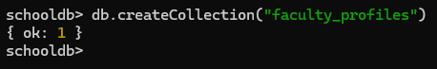

- Insert at least 8 faculty profile documents into the faculty_profiles collection. Each document must include the following fields:
  - faculty_id
  - full_name
  - department ("Information Technology", "Engineering", "Business Administration", "Public Administration"
  - employment_status ("Full-Time", "Part-Time", "Probationary", "Contractual")
  - academic_rank ("Instructor", "Assistant Professor", "Associate Professor", "Professor", "Lecturer")
  - years_of_service
  - contact
  - specializations
  - subjects_handled
  - committee_assignments
The contact field must be an embedded document. Inside contact, include another embedded document named address.
Example structure:
{
faculty_id: "FAC001",
full_name: "Dr. Maria Santos",
department: "Information Technology",
employment_status: "Full-Time",
academic_rank: "Associate Professor",
years_of_service: 8,
contact: {
email: "maria.santos@school.edu",
phone: "09170000001",
address: {
city: "Caloocan",
province: "Metro Manila",
zip_code: "1400"
}
},
specializations: ["Database Systems", "Web Development", "Information Management"],
subjects_handled: ["IM102", "DBMS201", "WEBDEV101"],
committee_assignments: ["Curriculum Committee", "Research Committee"]
}

db.faculty_profiles.insertMany([
{
faculty_id: "FAC001",
full_name: "Dr. Maria Santos",
department: "Information Technology",
employment_status: "Full-Time",
academic_rank: "Associate Professor",
years_of_service: 8,
contact: {
email: "maria.santos@school.edu",
phone: "09170000001",
address: {
city: "Caloocan",
province: "Metro Manila",
zip_code: "1400"
}
},
specializations: ["Database Systems", "Web Development", "Information Management"],
subjects_handled: ["IM102", "DBMS201", "WEBDEV101"],
committee_assignments: ["Curriculum Committee", "Research Committee"]
},
{
faculty_id: "FAC002",
full_name: "Mr. Phineas Flynn",
department: "Engineering",
employment_status: "Part-Time",
academic_rank: "Lecturer",
years_of_service: 3,
contact: {
email: "phineasflynn@school.edu",
phone: "09290000008",
address: {
city: "Malabon",
province: "Metro Manila",
zip_code: "1407"
}
},
specializations: ["Infrastructure planning", "Design", "Construction"],
subjects_handled: ["Engineering Core", "Principles"],
committee_assignments: ["Infrastructure Committee", "Youth & Sports Committee"]
},
{
faculty_id: "FAC003",
full_name: "Mr. Ferb Fletcher",
department: "Engineering",
employment_status: "Part-Time",
academic_rank: "Assistant Professor",
years_of_service: 2,
contact: {
email: "ferbfletcher@school.edu",
phone: "09890000005",
address: {
city: "Valenzuela",
province: "Metro Manila",
zip_code: "1442"
}
},
specializations: ["Infrastructure planning", "Design", "Construction"],
subjects_handled: ["Principles", "Statistics", "Thermodynamics"],
committee_assignments: ["Agriculture Committee", "Peace & Order Committee"]
},
{
faculty_id: "FAC004",
full_name: "Mrs. Candice Johnson",
department: "Business Administration",
employment_status: "Contractual",
academic_rank: "Instructor",
years_of_service: 6,
contact: {
email: "Candicejohnson@school.edu",
phone: "09180000009",
address: {
city: "Quezon",
province: "Metro Manila",
zip_code: "1487"
}
},
specializations: ["Finance", "Marketing", "Human Resources", "Operations", "Data Analytics"],
subjects_handled: ["Business Core", "Finance", "Communication"],
committee_assignments: ["Women & Family Committee", "Tourism Committee"]
},
{
faculty_id: "FAC005",
full_name: "Mr. Jeremy Johnson",
department: "Public Administration",
employment_status: "Full-Time",
academic_rank: "Professor",
years_of_service: 10,
contact: {
email: "jeremyjohnson@school.edu",
phone: "09810000006",
address: {
city: "Quezon",
province: "Metro Manila",
zip_code: "1487"
}
},
specializations: ["Human Behavior", "Politics", "Public Policy Analysis", "Government Accounting"],
subjects_handled: ["Management", "Law", "Social Science"],
committee_assignments: ["Women & Family Committee", "Environmental Protection Committee"]
},
{
faculty_id: "FAC006",
full_name: "Mr. Heinz Doofenshmirtz",
department: "Engineering",
employment_status: "Probationary",
academic_rank: "Instructor",
years_of_service: 15,
contact: {
email: "heinzdoofenshmirtz@school.edu",
phone: "09120000003",
address: {
city: "San Fernando",
province: "Central Luzon",
zip_code: "1165"
}
},
specializations: ["Infrastructure planning", "Design", "Construction"],
subjects_handled: ["Engineering Core", "Thermodynamics"],
committee_assignments: ["Peace & Order Committee"]
},
{
faculty_id: "FAC007",
full_name: "Maj. Francis Monogram",
department: "Public Administration",
employment_status: "Contractual",
academic_rank: "Associate Professor",
years_of_service: 17,
contact: {
email: "francismonogram@school.edu",
phone: "09340000005",
address: {
city: "Balanga",
province: "Central Luzon",
zip_code: "1156"
}
},
specializations: ["Human Behavior", "Politics", "Public Policy Analysis", "Government Accounting"],
subjects_handled: ["Management", "Foundation", "Corruption"],
committee_assignments: ["Women & Family Committee", "Agriculture Committee", "Health Committee"]
},
{
faculty_id: "FAC008",
full_name: "Ms. Vanessa Doofenshmirtz",
department: "Business Administration",
employment_status: "Part-Time",
academic_rank: "Lecturer",
years_of_service: 1,
contact: {
email: "vanessadoofenshmirtz@school.edu",
phone: "09670000008",
address: {
city: "San Fernando",
province: "Central Luzon",
zip_code: "1165"
}
},
specializations: ["Finance", "Marketing", "Data Analytics"],
subjects_handled: ["Finance", "Communication"],
committee_assignments: ["Youth & Sports Committee"]
},
{
faculty_id: "FAC009",
full_name: "Dr. Lawrence Fletcher",
department: "Information Technology",
employment_status: "Full-Time",
academic_rank: "Professor",
years_of_service: 12,
contact: {
email: "lawrencefletcher@school.edu",
phone: "09890000001",
address: {
city: "Batangas",
province: "CALABARZON",
zip_code: "1894"
}
},
specializations: ["Database Systems", "Artificial Intelligence", "Information Management"],
subjects_handled: ["IM102", "DBMS201", "Network Administration"],
committee_assignments: ["Health Committee", "Peace & Order Committee", "Infrastructure Committee", "Research Committee"]
},
{
faculty_id: "FAC010",
full_name: "Ms. Isabella Garcia-Shapiro",
department: "Public Administration",
employment_status: "Part-Time",
academic_rank: "Assistant Professor",
years_of_service: 5,
contact: {
email: "isabellagarcia@school.edu",
phone: "09230000006",
address: {
city: "Isabela",
province: "Cagayan Valley",
zip_code: "1407"
}
},
specializations: ["Human Behavior", "Government Accounting"],
subjects_handled: ["Management", "Law"],
committee_assignments: ["Tourism Committee", "Women & Family Committee"]
}
])
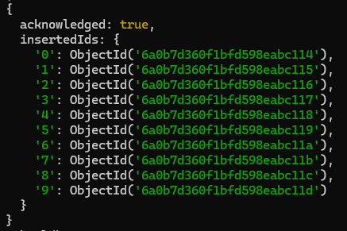

- Insert at least 2 additional faculty profile documents that demonstrate MongoDB’s flexible document structure. One document must include an additional field named: professional_license
Another document must include an additional field named: research_center_affiliation

db.faculty_profiles.insertMany([
{
faculty_id: "FAC011",
full_name: "Mr. Baljeet Tjinder",
department: "Business Administration",
employment_status: "Part-Time",
academic_rank: "Instructor",
years_of_service: 3,
contact: {
email: "baljeettjinder@school.edu",
phone: "09250000003",
address: {
city: "Ifugao",
province: "CAR",
zip_code: "5682"
}
},
specializations: ["Finance", "Operations", "Data Analytics"],
subjects_handled: ["GenEd", "Business Core", "Finance"],
committee_assignments: ["Environmental Protection Committee", "Research Committee"],
professional_license: "prc"
},
{
faculty_id: "FAC012",
full_name: "Mr. Buford Van Stomm",
department: "Information Technology",
employment_status: "Probationary",
academic_rank: "Lecturer",
years_of_service: 1,
contact: {
email: "bufordvanstomm@school.edu",
phone: "09920000009",
address: {
city: "Sorsogon",
province: "Bicol",
zip_code: "3684"
}
},
specializations: ["Information Management", "Cybersecurity"],
subjects_handled: ["Web Development", "Multimedia Systems"],
committee_assignments: ["Peace & Order Committee"],
research_center_affiliation: "Visiting Scholar"
}
])
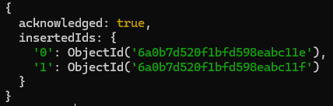

- Retrieve and display all documents from the faculty_profiles collection.

db.faculty_profiles.find({})
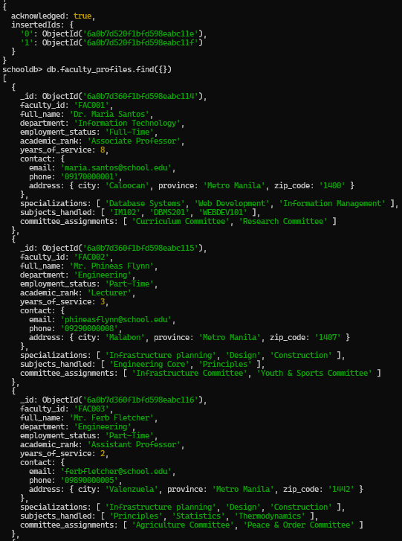
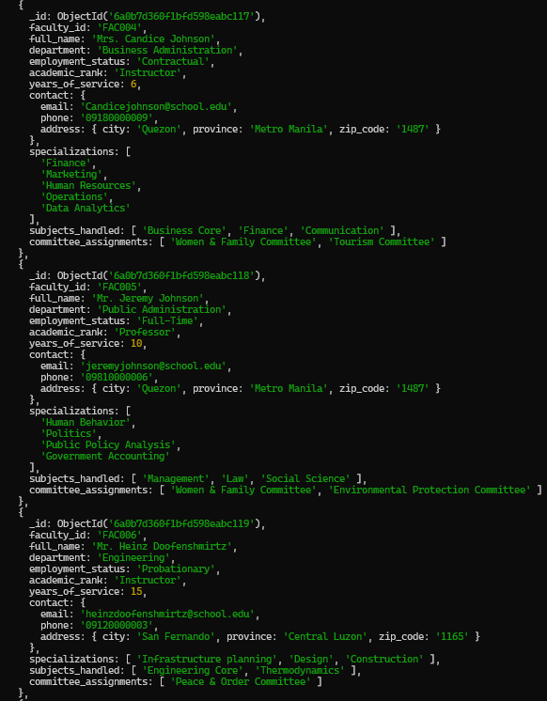
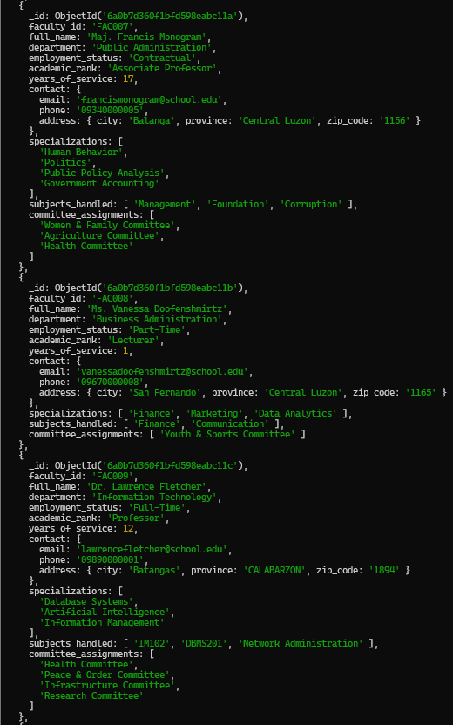
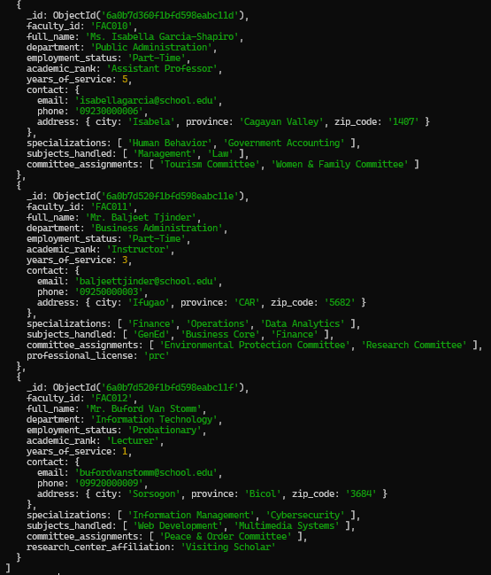

- Retrieve all faculty records but display only the following fields:
  - faculty_id
  - full_name
  - department
  - academic_rank
The _id field should not be displayed.

db.faculty_profiles.find({}, {_id: 0, faculty_id: 1, full_name: 1, department: 1, academic_rank: 1})
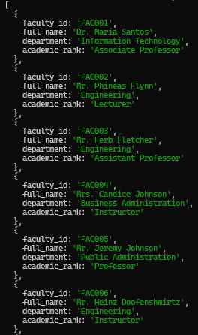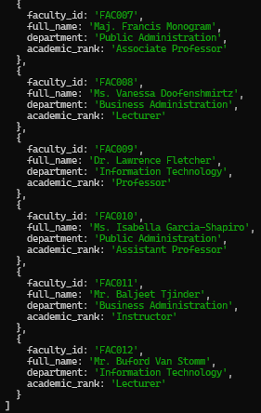

- Display all faculty members where the department field is equal to "Information Technology". Display only:
  - faculty_id
  - full_name
  - department

db.faculty_profiles.find({department: "Information Technology"}, {_id: 0, faculty_id: 1, full_name: 1, department: 1 })
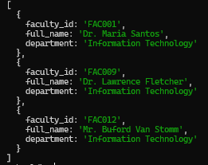

- Display all faculty members where the employment_status field is equal to "Full-Time". Display only:
  - faculty_id
  - full_name
  - employment_status
db.faculty_profiles.find({employment_status: "Full-Time"}, {_id: 0, faculty_id: 1, full_name: 1, employment_status: 1 })
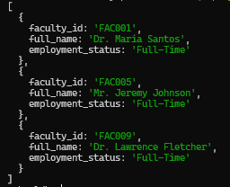
- Display all faculty members where the employment_status field is not equal to "Full-Time". Use a MongoDB comparison selector. Display only:
  - faculty_id
  - full_name
  - employment_status

db.faculty_profiles.find({employment_status: {$nin: ["Full-Time"]}}, {_id: 0, faculty_id: 1, full_name: 1, employment_status: 1 })
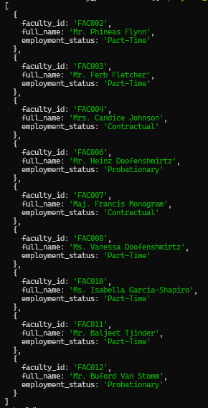
- Retrieve faculty members whose years_of_service is greater than or equal to 5. Use the $gte selector. Display only:
  - faculty_id
  - full_name
  - years_of_service

db.faculty_profiles.find({years_of_service: {$gte: 5}}, {_id: 0, faculty_id: 1, full_name: 1, years_of_service: 1 })
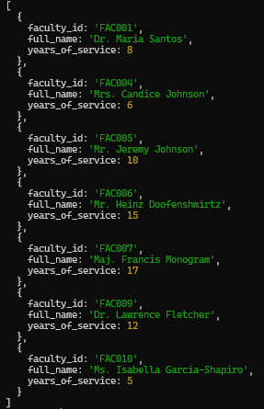

- Retrieve faculty members whose years_of_service is within the range of 3 to 10, inclusive. Use $gte and $lte. Display only:
  - faculty_id
  - full_name
  - years_of_service

db.faculty_profiles.find({years_of_service: {$gte: 3, $lte: 10}}, {_id: 0, faculty_id: 1, full_name: 1, years_of_service: 1 })
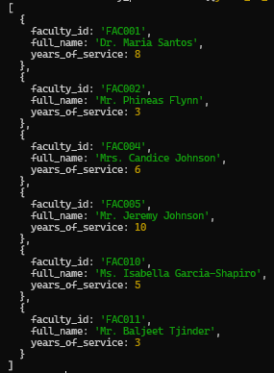

- Retrieve faculty members that belong to either "Information Technology" or "Computer Science". Use the $in operator and display only:
  - faculty_id
  - full_name
  - department

db.faculty_profiles.find({department: {$in: ["Information Technology", "Computer Science"]}}, {_id: 0, faculty_id: 1, full_name: 1, department: 1 })
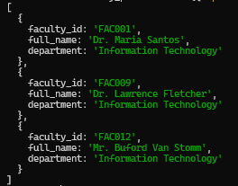

- Display all faculty members that satisfy both conditions:
  - department is "Information Technology"
  - employment_status is "Full-Time"
Use the explicit $and operator and display only:
  - faculty_id
  - full_name
  - department
  - employment_status

db.faculty_profiles.find({$and: [{department: "Information Technology"}, {employment_status: "Full-Time"}]}, {_id: 0, faculty_id: 1, full_name: 1, department: 1, employment_status: 1})
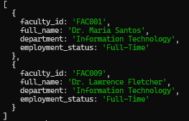

- Display all faculty members that satisfy at least one of the following conditions:
  - academic_rank is "Professor"
  - years_of_service is greater than or equal to 10
Use the $or operator and display only:
  - faculty_id
  - full_name
  - academic_rank
  - years_of_service

db.faculty_profiles.find({$or: [{academic_rank: "Professor"}, {years_of_service: {$gte: 10}}]}, {_id: 0, faculty_id: 1, full_name: 1, academic_rank: 1, years_of_service: 1})
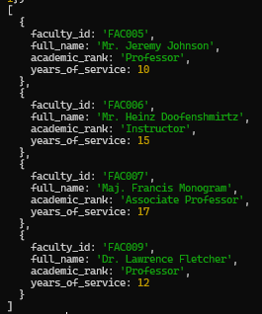

- Retrieve all faculty members whose embedded field contact.address.city is equal to "Caloocan". Use dot notation and display only:
  - faculty_id
  - full_name
  - contact.address.city

db.faculty_profiles.find({"contact.address.city": "Caloocan"}, {_id: 0, faculty_id: 1, full_name: 1, "contact.address.city": 1})
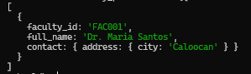

- Retrieve all faculty members whose embedded field contact.address.province is equal to "Metro Manila". Use dot notation and display only:
  - faculty_id
  - full_name
  - contact.address.province

db.faculty_profiles.find({"contact.address.province": "Metro Manila"}, {_id: 0, faculty_id: 1, full_name: 1, "contact.address.province": 1})
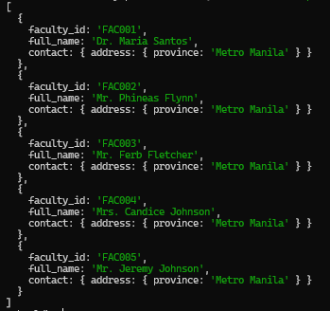
- Retrieve one faculty member using the embedded field contact.email. Use dot notation and display only:
  - faculty_id
  - full_name
  - contact.email

db.faculty_profiles.find({"contact.email": "heinzdoofenshmirtz@school.edu"}, {_id: 0, faculty_id: 1, full_name: 1, "contact.email": 1})
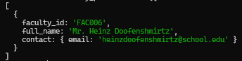

- Display all faculty records but show only the following embedded contact fields:
  - faculty_id
  - full_name
  - contact.email
  - contact.phone
The _id field should not be displayed.

db.faculty_profiles.find({}, {_id: 0, faculty_id: 1, full_name: 1, "contact.email": 1, "contact.phone": 1})
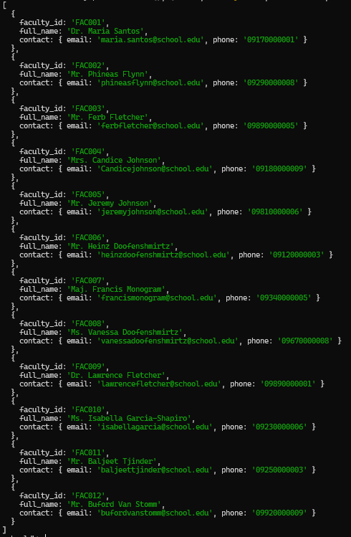

- Retrieve all faculty members whose specializations array contains "Database Systems". Display only:
  - faculty_id
  - full_name
  - specializations

db.faculty_profiles.find({specializations: "Database Systems"}, {_id: 0, faculty_id: 1, full_name: 1, specializations: 1})
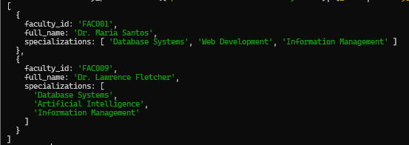

- Retrieve all faculty members whose subjects_handled array contains "IM102". Display only:
  - faculty_id
  - full_name
  - subjects_handled

db.faculty_profiles.find({subjects_handled: "IM102"}, {_id: 0, faculty_id: 1, full_name: 1, subjects_handled: 1})
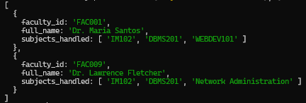
- Retrieve all faculty members whose committee_assignments array contains "Research Committee". Display only:
  - faculty_id
  - full_name
  - committee_assignments

db.faculty_profiles.find({committee_assignments: "Research Committee"}, {_id: 0, faculty_id: 1, full_name: 1, committee_assignments: 1})
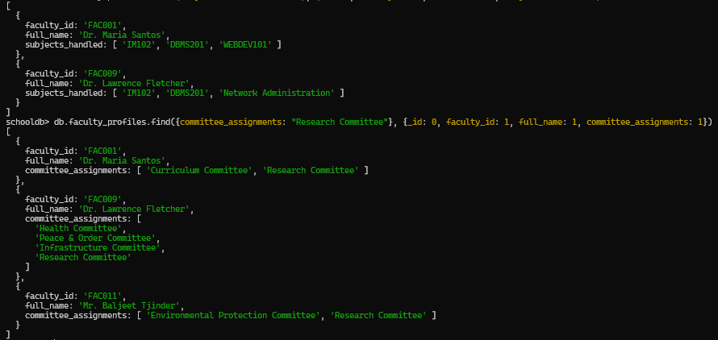

- Retrieve faculty members who have at least one of the following specializations:
  - "Artificial Intelligence"
  - "Cybersecurity"
  - "Data Analytics"
Use $in with an array field and display only:
  - faculty_id
  - full_name
  - specializations

db.faculty_profiles.find({specializations: {$in: ["Artificial Intelligence", "Cybersecurity", "Data Analytics"]}}, {_id: 0, faculty_id: 1, full_name: 1, specializations: 1})
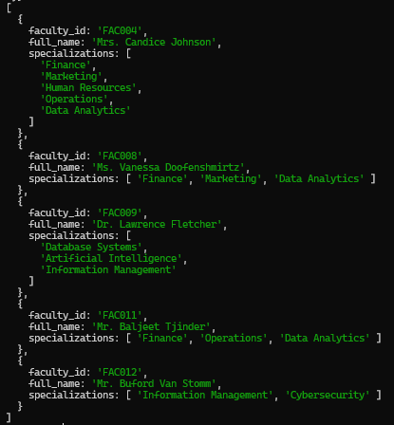

- Retrieve faculty members who have both "Database Systems" and "Information Management" in their specializations array. Use $all and display only:
  - faculty_id
  - full_name
  - specializations

db.faculty_profiles.find({specializations: {$all: ["Database Systems", "Information Management"]}}, {_id: 0, faculty_id: 1, full_name: 1, specializations: 1})
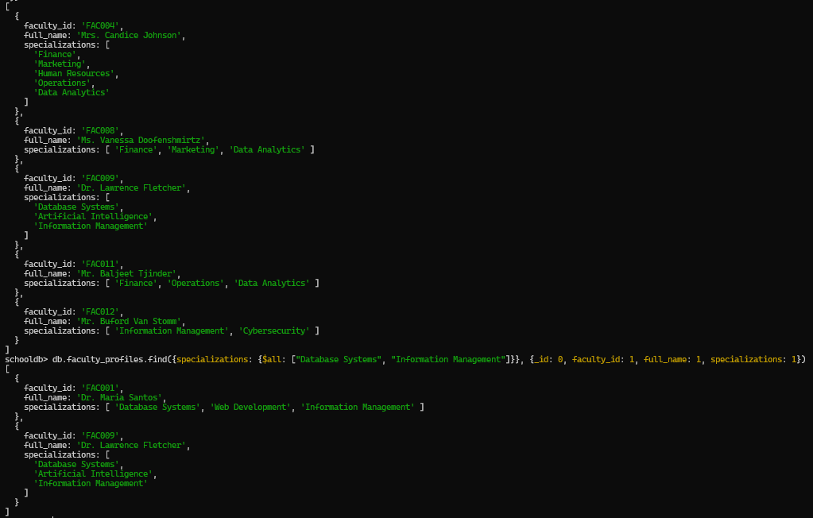

- Retrieve faculty members who handle exactly 3 subjects in the subjects_handled array. Use $size and display only:
  - faculty_id
  - full_name
  - subjects_handled

db.faculty_profiles.find({subjects_handled: {$size: 3}}, {_id: 0, faculty_id: 1, full_name: 1, subjects_handled: 1})
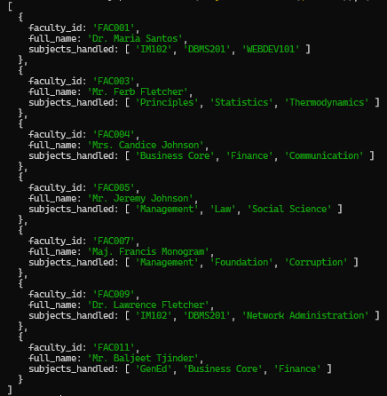

- Add a new embedded field named emergency_phone inside the contact document of one faculty member. Use $set and dot notation.
Example target field:
contact.emergency_phone

db.faculty_profiles.updateOne({full_name: "Mrs. Candice Johnson"}, {$set: {"contact.emergency_phone": "09990000009"}})
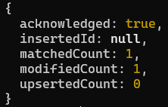

- Update the city of one faculty member inside the embedded field: contact.address.city
Use $set and dot notation.

db.faculty_profiles.updateOne({full_name: "Mr. Ferb Fletcher"}, {$set: {"contact.address.city": "Malabon"}})
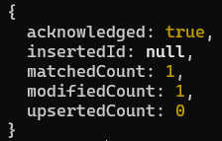

- Add one new specialization to one faculty member’s specializations array using $push.
Example specialization:
"Educational Technology"

db.faculty_profiles.updateOne({faculty_id: "FAC001"}, {$push: {specializations: "Educational Technology"}})
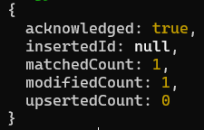

- Add at least two new committee assignments to one faculty member’s committee_assignments array using $push with $each.
Example committee assignments:
["Quality Assurance Committee", "Extension Services Committee"]

db.faculty_profiles.updateOne({faculty_id: "FAC006"}, {$push: { committee_assignments: {$each: ["Quality Assurance Committee", "Extension Services Committee"]}}})
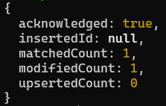

- Remove one subject from a faculty member’s subjects_handled array using $pull.
Example subject to remove:
"WEBDEV101"

db.faculty_profiles.updateOne({faculty_id: "FAC001"}, {$pull: {subjects_handled: "WEBDEV101"}})
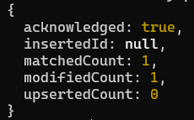

- Create a new collection named faculty_workload. If the collection already exists, reset it first before inserting the required records. This collection will store faculty workload records where the teaching_loads field is an array of embedded documents.

db.createCollection("faculty_workload")

- Insert at least 6 faculty workload documents into the faculty_workload collection. Each document must include the following fields:
  - faculty_id
  - full_name
  - department
  - semester
  - school_year
  - teaching_loads
The teaching_loads field must be an array of embedded documents. Each embedded teaching load document must include:
- subject_code
- subject_title
- section
- units
- schedule
- room
- mode
Example structure:
{
faculty_id: "FAC001",
full_name: "Dr. Maria Santos",
department: "Information Technology",
semester: "1st",
school_year: "2026-2027",
teaching_loads: [
{
subject_code: "IM102",
subject_title: "Intermediate Information Management",
section: "IT2A",
units: 3,
schedule: "MWF 9:00-10:00",
room: "Lab 1",
mode: "Face-to-Face"
},
{
subject_code: "DBMS201",
subject_title: "Database Management Systems",
section: "IT3A",
units: 3,
schedule: "TTh 10:30-12:00",
room: "Lab 2",
mode: "Blended"
}
]
}
db.faculty_workload.insertMany([
{
faculty_id: "FAC001",
full_name: "Dr. Maria Santos",
department: "Information Technology",
semester: "1st",
school_year: "2026-2027",
teaching_loads: [
{
subject_code: "IM102",
subject_title: "Intermediate Information Management",
section: "IT2A",
units: 3,
schedule: "MWF 9:00-10:00",
room: "Lab 1",
mode: "Face-to-Face"
},
{
subject_code: "DBMS201",
subject_title: "Database Management Systems",
section: "IT3A",
units: 3,
schedule: "TTh 10:30-12:00",
room: "Lab 2",
mode: "Blended"
}
]
},
{
faculty_id: "FAC002",
full_name: "Mr. Phineas Flynn",
department: "Engineering",
semester: "1st",
school_year: "2026-2027",
teaching_loads: [
{
subject_code: "EC101",
subject_title: "Engineering Core 101",
section: "Engr2D",
units: 5,
schedule: "MF 10:00-3:00",
room: "Lab 5",
mode: "Face-to-Face"
},
{
subject_code: "PRE1",
subject_title: "Principles of Engineering",
section: "Engr1B",
units: 3,
schedule: "TTHS 7:00-10:00",
room: "CAS 201",
mode: "Online"
}
]
},
{
faculty_id: "FAC003",
full_name: "Mr. Ferb Fletcher",
department: "Engineering",
semester: "2nd",
school_year: "2027-2028",
teaching_loads: [
{
subject_code: "IP2",
subject_title: "Infrastructure Planning",
section: "Engr2C",
units: 5,
schedule: "MWF 9:00-2:00",
room: "Lab 2",
mode: "Face-to-Face"
},
{
subject_code: "ENGRDES",
subject_title: "Engineering Designs",
section: "Engr1A",
units: 3,
schedule: "MF 2:30-5:00",
room: "CEIT 508",
mode: "Blended"
},
{
subject_code: "CONST",
subject_title: "Engineering Construction",
section: "Engr4A",
units: 5,
schedule: "MWF 1:00-6:00",
room: "Lab 2",
mode: "Face-to-Face"
}
]
},
{
faculty_id: "FAC004",
full_name: "Mrs. Candice Johnson",
department: "Business Administration",
semester: "1st",
school_year: "2026-2027",
teaching_loads: [
{
subject_code: "BUSICOR",
subject_title: "Business Core",
section: "BA1A",
units: 3,
schedule: "TTH 9:00-12:00",
room: "CABA 203",
mode: "Blended"
},
{
subject_code: "FIN101",
subject_title: "Business Finance",
section: "BA2C",
units: 3,
schedule: "M 5:00-8:00",
room: "CABA 210",
mode: "Blended"
},
{
subject_code: "BCOMM",
subject_title: "Business Communication",
section: "BA1B",
units: 3,
schedule: "T 10:30-1:30",
room: "CABA 406",
mode: "Online"
}
]
},
{
faculty_id: "FAC005",
full_name: "Mr. Jeremy Johnson",
department: "Public Administration",
semester: "2nd",
school_year: "2027-2028",
teaching_loads: [
{
subject_code: "PUBMAN",
subject_title: "Public Management",
section: "PUBAD1B",
units: 3,
schedule: "WF 9:00-10:00",
room: "CPAG 205",
mode: "Blended"
},
{
subject_code: "LAW3",
subject_title: "Public Law 3",
section: "PUBAD3C",
units: 5,
schedule: "TTHS 8:30-1:30",
room: "CPAG 502",
mode: "Face-to-Face"
},
{
subject_code: "SOCSCI",
subject_title: "Social Sciences",
section: "PUBAD2C",
units: 3,
schedule: "FS 2:00-5:00",
room: "CPAG 306",
mode: "Online"
}
]
},
{
faculty_id: "FAC006",
full_name: "Mr. Heinz Doofenshmirtz",
department: "Engineering",
semester: "1st",
school_year: "2026-2027",
teaching_loads: [
{
subject_code: "ENGRCOR",
subject_title: "Engineering Core",
section: "ENGR1A",
units: 3,
schedule: "MF 9:00-12:00",
room: "CEIT 404",
mode: "Blended"
},
{
subject_code: "TMD",
subject_title: "Thermodynamics",
section: "ENGR4B",
units: 5,
schedule: "MT 7:00-12:00",
room: "Lab 2",
mode: "Face-to-Face"
}
]
},
{
faculty_id: "FAC009",
full_name: "Dr. Lawrence Fletcher",
department: "Information Technology",
semester: "2nd",
school_year: "2027-2028",
teaching_loads: [
{
subject_code: "IM102",
subject_title: "Intermediate Information Management",
section: "IT2J",
units: 5,
schedule: "M 2:30-7:30",
room: "CAS-CL1",
mode: "Face-to-Face"
},
{
subject_code: "NETWORKING",
subject_title: "Network Administration",
section: "IT2J",
units: 5,
schedule: "S 3:30-8:30",
room: "Lab 4",
mode: "Face-to-Face"
}
]
}
])
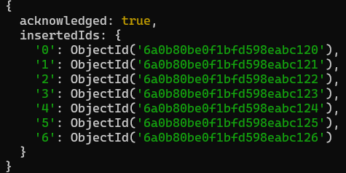

- Retrieve and display all documents from the faculty_workload collection.

db.faculty_workload.find({})
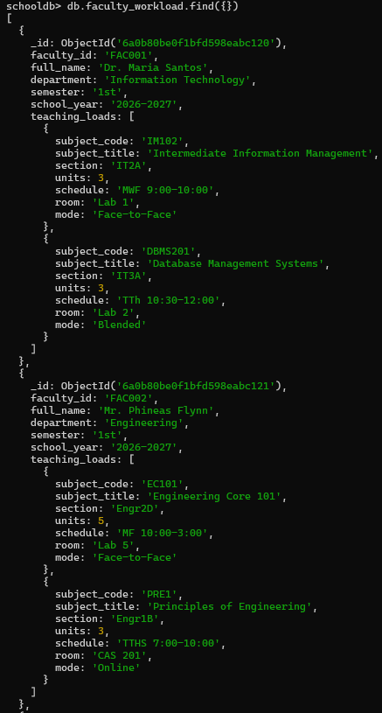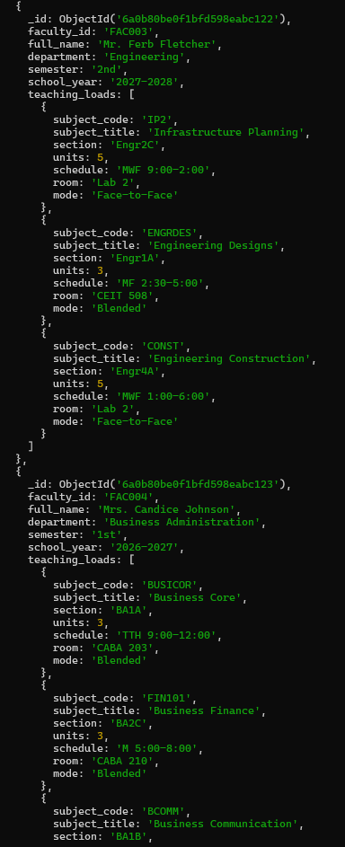
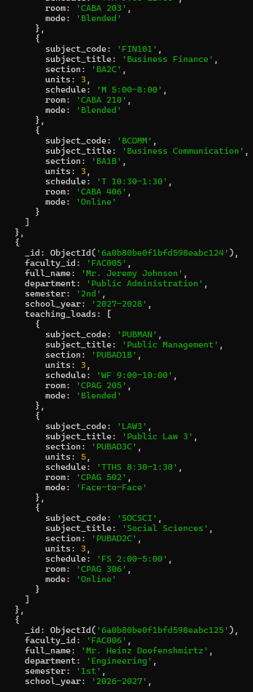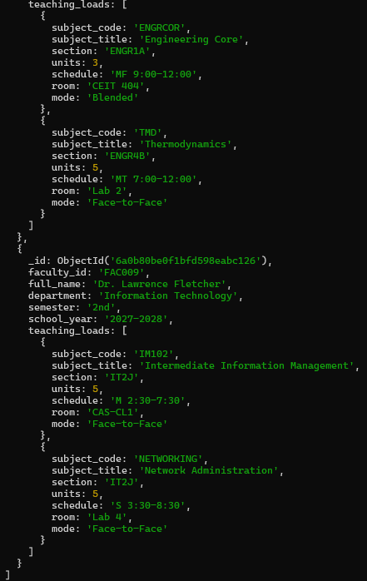

- Retrieve faculty members who have a teaching load for subject code "IM102". Use dot notation and display only:
  - faculty_id
  - full_name
  - teaching_loads.subject_code
  - teaching_loads.section

db.faculty_workload.find({"teaching_loads.subject_code": "IM102"}, {_id: 0, faculty_id: 1, full_name: 1, "teaching_loads.subject_code": 1, "teaching_loads.section": 1})
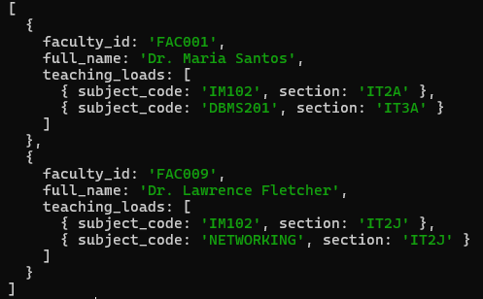

- Retrieve faculty members who have at least one teaching load with mode equal to "Blended". Use dot notation and display only:
  - faculty_id
  - full_name
  - teaching_loads.mode

db.faculty_workload.find({"teaching_loads.mode": "Blended"}, {_id: 0, faculty_id: 1, full_name: 1, "teaching_loads.mode": 1})
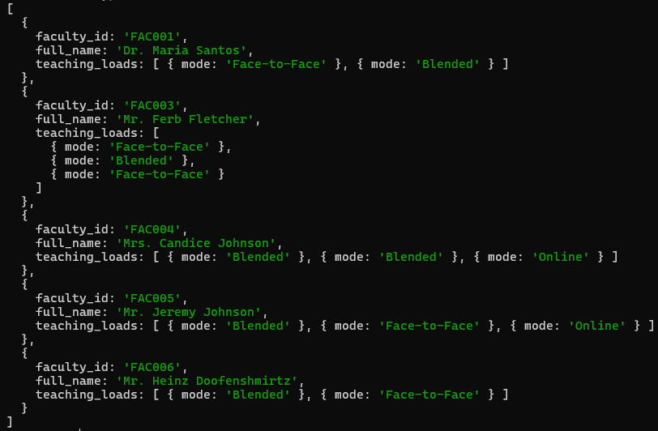

- Retrieve faculty members whose teaching_loads array contains an embedded document where:
  - subject_code is "IM102"
  - section is "IT2A"
Use $elemMatch and display only:
  - faculty_id
  - full_name
  - teaching_loads

db.faculty_workload.find({teaching_loads: {$elemMatch: {subject_code: "IM102", section: "IT2A"}}}, {_id: 0, faculty_id: 1, full_name: 1, teaching_loads: 1})
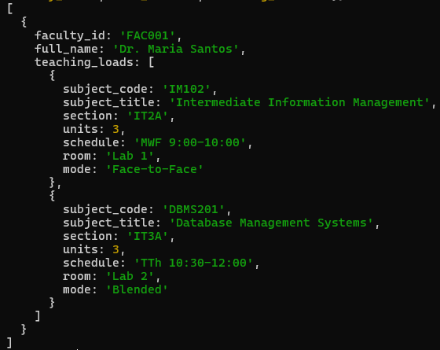

- Retrieve faculty members whose teaching_loads array contains an embedded document where:
  - units is greater than or equal to 3
  - mode is "Face-to-Face"
Use $elemMatch and display only:
  - faculty_id
  - full_name
  - teaching_loads
db.faculty_workload.find({teaching_loads: {$elemMatch: {units: {$gte: 3}, mode: "Face-to-Face"}}}, {_id: 0, faculty_id: 1, full_name: 1, teaching_loads: 1})
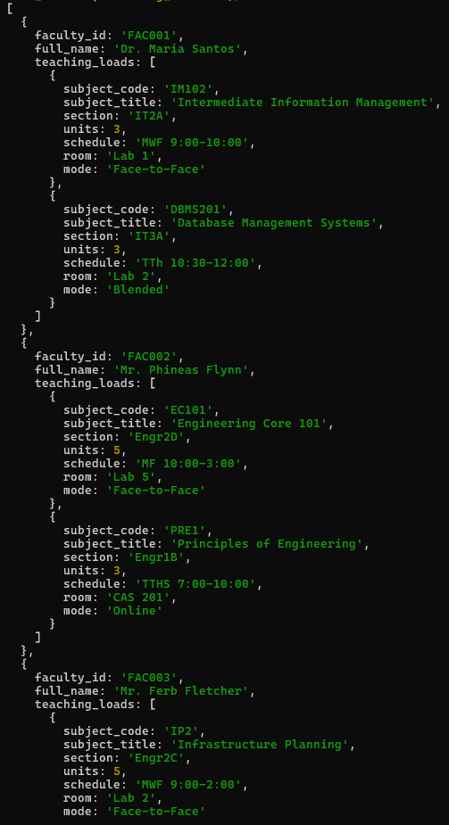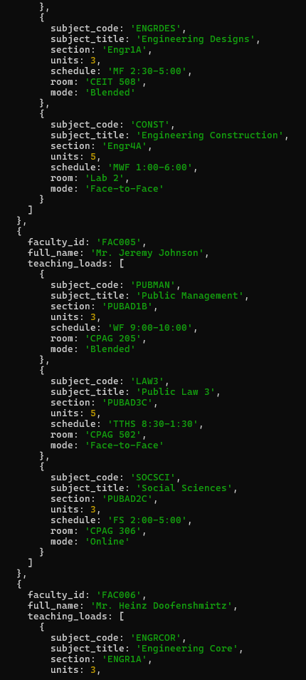
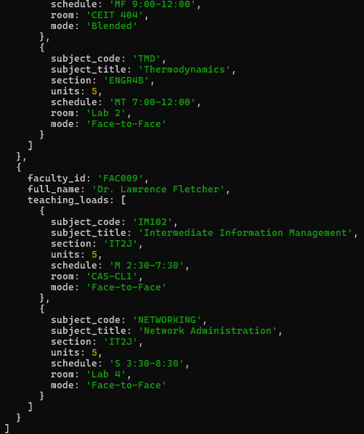

- Update the room of one specific teaching load inside the teaching_loads array using the positional operator $.
Example: update the room of subject "IM102" for faculty "FAC001" from "Lab 1" to "Computer Lab 3".

db.faculty_workload.updateOne({faculty_id: "FAC001", "teaching_loads.subject_code": "IM102"}, {$set: {"teaching_loads.$.room": "Computer Lab 3"}})
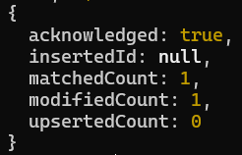
- Update the mode of one specific teaching load inside the teaching_loads array using the positional operator $.
Example: update the mode of subject "DBMS201" for faculty "FAC001" from "Blended" to "Face-to-Face".

db.faculty_workload.updateOne({faculty_id: "FAC001", "teaching_loads.subject_code": "DBMS201"}, {$set: {"teaching_loads.$.mode": "Face-to-Face"}})
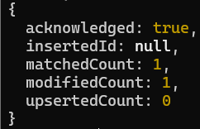

- Add a new teaching load document to one faculty member’s teaching_loads array using $push.
Example embedded document:
{
subject_code: "CAP401",
subject_title: "Capstone Project",
section: "IT4A",
units: 3,
schedule: "Saturday 9:00-12:00",
room: "Research Lab",
mode: "Consultation"
}

db.faculty_workload.updateOne({faculty_id: "FAC001"}, {$push: {teaching_loads: {subject_code: "CAP401", subject_title: "Capstone Project", section: "IT4A", units: 3, schedule: "S 9:00-12:00", room: "Research Lab", mode: "Consultation"}}})
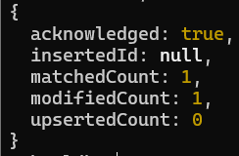

- Remove one teaching load document from a faculty member’s teaching_loads array using $pull.
Example condition:
subject_code: "WEBDEV101"

db.faculty_workload.updateOne({faculty_id: "FAC003"}, {$pull: {teaching_loads: {subject_code: "ENGRDES"}}})
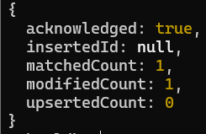

- Display all updated faculty workload records after performing the update, add, and remove operations.

db.faculty_workload.find({}, {_id: 0})
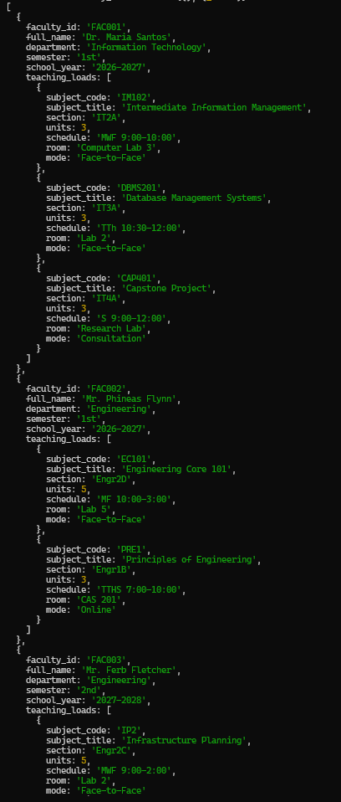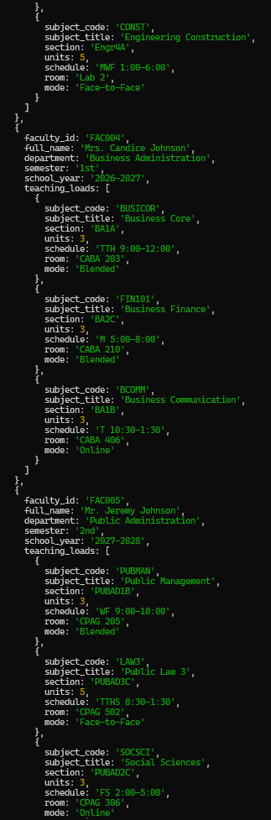
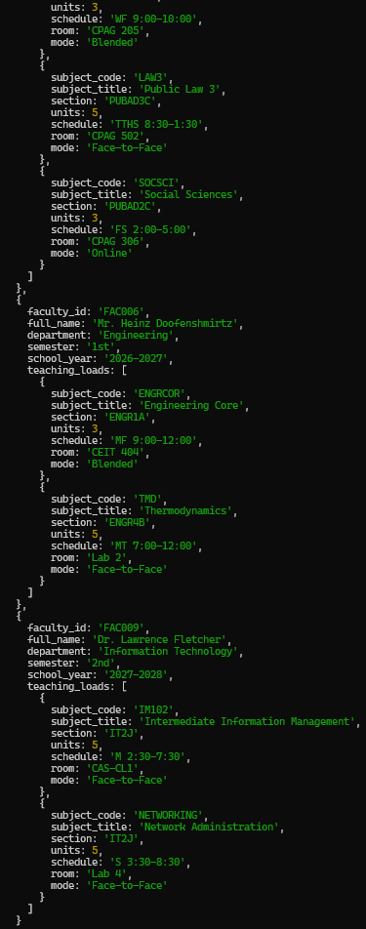
- Create a new collection named faculty_research. If the collection already exists, reset it first before inserting the required records. This collection will store faculty research records where each document includes embedded author details and an array of research outputs.

db.createCollection("faculty_research")

- Insert at least 5 faculty research documents into the faculty_research collection. Each document must include the following fields:
  - faculty_id
  - full_name
  - department
  - research_profile
  - research_outputs
The research_profile field must be an embedded document.
The research_outputs field must be an array of embedded documents.
The research_profile embedded document must include:
- research_area
- orcid
- scopus_id
- active_researcher
Each embedded document inside research_outputs must include:
- research_id
- title
- type
- year
- status
- keywords
The keywords field inside each research output must be an array.
Example structure:
{
faculty_id: "FAC001",
full_name: "Dr. Maria Santos",
department: "Information Technology",
research_profile: {
research_area: "Database Systems",
orcid: "0000-0001-0000-0001",
scopus_id: "57200000001",
active_researcher: true
},
research_outputs: [
{
research_id: "RES001",
title: "Document-Oriented Database Design for Academic Systems",
type: "Journal Article",
year: 2025,
status: "Published",
keywords: ["MongoDB", "NoSQL", "Database Design"]
}
]
}

db.faculty_research.insertMany([
{
faculty_id: "FAC001",
full_name: "Dr. Maria Santos",
department: "Information Technology",
research_profile: {
research_area: "Database Systems",
orcid: "0000-0001-0000-0001",
scopus_id: "57200000001",
active_researcher: true
},
research_outputs: [
{
research_id: "RES001",
title: "Document-Oriented Database Design for Academic Systems",
type: "Journal Article",
year: 2025,
status: "Published",
keywords: ["MongoDB", "NoSQL", "Database Design"]
}
]
},
{
faculty_id: "FAC005",
full_name: "Mr. Jeremy Johnson",
department: "Public Administration",
research_profile: {
research_area: "Local Governance and Public Policy",
orcid: "0000-0007-8901-2345",
scopus_id: "57200000017",
active_researcher: true
},
research_outputs: [
{
research_id: "RES016",
title: "Citizen Participation in Local Governance",
type: "Journal Article",
year: 2025,
status: "Published",
keywords: ["Governance", "Citizen Participation", "Policy"]
}
]
},
{
faculty_id: "FAC006",
full_name: "Mr. Heinz Doofenshmirtz",
department: "Engineering",
research_profile: {
research_area: "Renewable Energy Systems",
orcid: "0000-0003-4567-8901",
scopus_id: "57200000013",
active_researcher: true
},
research_outputs: [
{
research_id: "RES006",
title: "Solar Energy Optimization for Smart Campuses",
type: "Journal Article",
year: 2025,
status: "Published",
keywords: ["Solar Energy", "Optimization", "Smart Campus"]
},
{
research_id: "RES007",
title: "Hybrid Renewable Energy Storage Systems",
type: "Research Project",
year: 2024,
status: "Ongoing",
keywords: ["Energy Storage", "Renewable Energy", "Engineering"]
},
{
research_id: "RES008",
title: "IoT-Based Power Consumption Monitoring",
type: "Prototype Development",
year: 2023,
status: "Completed",
keywords: ["IoT", "Power Monitoring", "Embedded Systems"]
}
]
},
{
faculty_id: "FAC007",
full_name: "Maj. Francis Monogram",
department: "Public Administration",
research_profile: {
research_area: "Disaster Risk Reduction and Management",
orcid: "0000-0008-9012-3456",
scopus_id: "57200000018",
active_researcher: false
},
research_outputs: [
{
research_id: "RES019",
title: "Community Preparedness for Flood Disasters",
type: "Journal Article",
year: 2022,
status: "Published",
keywords: ["Disaster Management", "Flood Preparedness", "Community"]
},
{
research_id: "RES020",
title: "Risk Communication Strategies During Emergencies",
type: "Conference Paper",
year: 2023,
status: "Published",
keywords: ["Risk Communication", "Emergency Response", "Public Safety"]
}
]
},
{
faculty_id: "FAC009",
full_name: "Dr. Lawrence Fletcher",
department: "Information Technology",
research_profile: {
research_area: "Artificial Intelligence and Data Analytics",
orcid: "0000-0001-2345-6789",
scopus_id: "57200000011",
active_researcher: true
},
research_outputs: [
{
research_id: "RES067",
title: "Predictive Analytics for Student Performance Monitoring",
type: "Journal Article",
year: 2025,
status: "Published",
keywords: ["Machine Learning", "Predictive Analytics", "Education"]
},
{
research_id: "RES059",
title: "AI-Powered Chatbot for University Student Services",
type: "Conference Paper",
year: 2024,
status: "Published",
keywords: ["Artificial Intelligence", "Chatbot", "Student Services"]
},
{
research_id: "RES075",
title: "Big Data Framework for Academic Decision Support",
type: "Research Project",
year: 2025,
status: "Ongoing",
keywords: ["Big Data", "Decision Support", "Analytics"]
}
]
},
{
faculty_id: "FAC011",
full_name: "Mr. Baljeet Tjinder",
department: "Business Administration",
research_profile: {
research_area: "Digital Marketing and Consumer Behavior",
orcid: "0000-0005-6789-0123",
scopus_id: "57200000015",
active_researcher: true
},
research_outputs: [
{
research_id: "RES011",
title: "Consumer Trust in Social Media Advertising",
type: "Journal Article",
year: 2025,
status: "Published",
keywords: ["Digital Marketing", "Consumer Behavior", "Social Media"]
},
{
research_id: "RES012",
title: "E-Commerce Adoption Among Small Businesses",
type: "Research Project",
year: 2024,
status: "Completed",
keywords: ["E-Commerce", "SMEs", "Business Technology"]
},
{
research_id: "RES013",
title: "Brand Loyalty in Online Shopping Platforms",
type: "Conference Paper",
year: 2023,
status: "Published",
keywords: ["Brand Loyalty", "Online Shopping", "Marketing"]
}
]
}
])
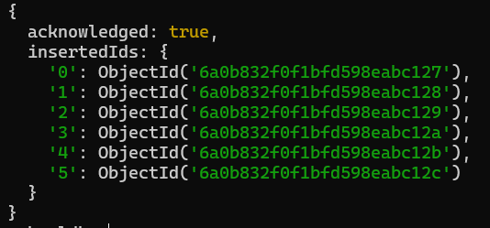

- Retrieve all faculty research records where the embedded field research_profile.research_area is equal to "Database Systems". Use dot notation and display only:
  - faculty_id
  - full_name
  - research_profile.research_area

db.faculty_research.find({"research_profile.research_area": "Database Systems"}, {_id: 0, faculty_id: 1, full_name: 1, "research_profile.research_area": 1})
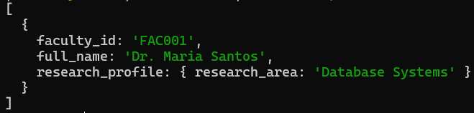

- Retrieve all faculty research records where the embedded field research_profile.active_researcher is equal to true. Display only:
  - faculty_id
  - full_name
  - research_profile.active_researcher

db.faculty_research.find({"research_profile.active_researcher": true}, {_id: 0, faculty_id: 1, full_name: 1, "research_profile.active_researcher": 1})
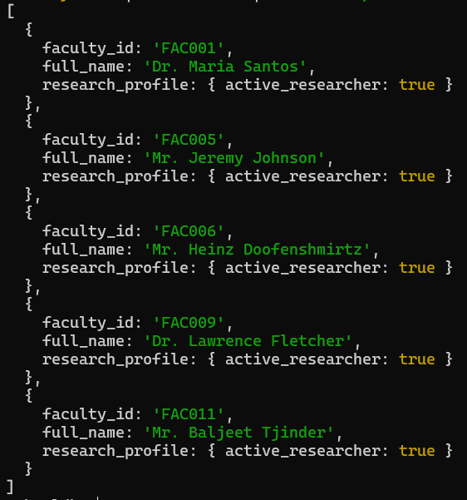

- Retrieve all faculty research records where the research_outputs array contains a research output with status equal to "Published". Use dot notation and display only:
  - faculty_id
  - full_name
  - research_outputs.status

db.faculty_research.find({"research_outputs.status": "Published"}, {_id: 0, faculty_id: 1, full_name: 1, "research_outputs.status": 1})
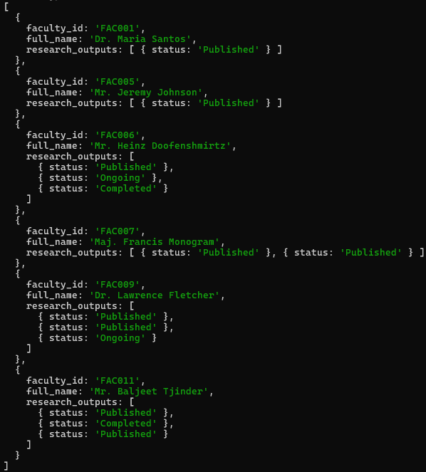
- Retrieve faculty research records where the research_outputs array contains an embedded document where:
  - type is "Conference Paper"
  - year is greater than or equal to 2024
Use $elemMatch.

db.faculty_research.find({research_outputs: {$elemMatch: {type: "Conference Paper", year: {$gte: 2024}}}}, {_id: 0, faculty_id: 1, full_name: 1, research_outputs: 1})
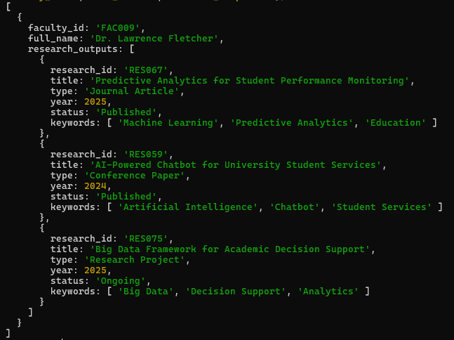

- Retrieve faculty research records where the research_outputs array contains an embedded document where the keywords array includes "MongoDB".

db.faculty_research.find({"research_outputs.keywords": "MongoDB"}, {_id: 0, faculty_id: 1, full_name: 1, research_outputs: 1})
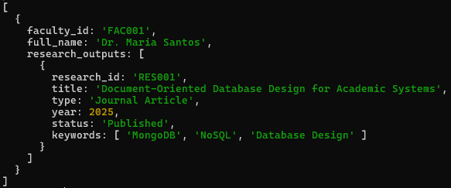

- Add a new research output document to one faculty member’s research_outputs array using $push.
Example embedded document:
{
research_id: "RES010",
title: "Aggregation Pipelines for Institutional Data Reporting",
type: "Conference Paper",
year: 2026,
status: "Presented",
keywords: ["MongoDB", "Aggregation", "Data Reporting"]
}

db.faculty_research.updateOne({faculty_id: "FAC001"}, {$push: {research_outputs: {research_id: "RES010", title: "Aggregation Pipelines for Institutional Data Reporting", type: "Conference Paper", year: 2026, status: "Presented", keywords: ["MongoDB", "Aggregation", "Data Reporting"]}}})
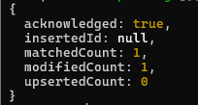

- Update the status of one research output inside the research_outputs array using the positional operator $.
Example: update research output "RES010" from "Presented" to "Published".

db.faculty_research.updateOne({faculty_id: "FAC009", "research_outputs.research_id": "RES075"}, {$set: {"research_outputs.$.status": "Published"}})
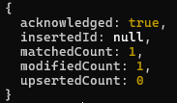

- Remove one research output document from a faculty member’s research_outputs array using $pull.
Example condition:
research_id: "RES003"

db.faculty_research.updateOne({faculty_id: "FAC009"}, {$pull: {research_outputs: {research_id: "RES067"}}})
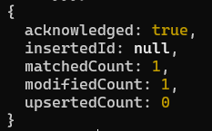

- Display all updated faculty research records after completing the required operations.

db.faculty_research.find({}, {_id: 0})
