**JobAll: “Get your dream job” - Bridging Opportunities for Job Seekers and Providers through an Innovative Online Portal**

A Proposal

Presented to the Faculty of the College of

Computer Studies, University of Cebu – Lapu-lapu and Mandaue

Mandaue City, Cebu

In Partial Fulfillment of the Requirements

For IT-DBSYS32

By

Carpio, Alfred louis

Castillo, Emmanuel

Taneca, Arnel

Valenzona, Ryan Jay

**Hard Harry Nadela**

Teacher

May 2024

**Table of Contents**

1. Introduction 3

2. Entity-Relationship Diagram (ERD) 4

3. Data Dictionary 5

4. User Features 11

5. List of Modules 14

6. User Guide 16

1. Introduction

Welcome to Job All, where dreams find their perfect fit! Job All revolutionizes the online job portal experience by seamlessly connecting job seekers with their ideal career paths and aiding job providers in discovering the right candidates effortlessly. Our platform simplifies the recruitment process for both parties, ensuring a smooth journey towards fulfilling employment opportunities.

For job seekers, Job All offers a user-friendly interface to explore a vast array of job openings tailored to their skills and aspirations. Whether you're a fresh graduate eager to embark on your professional journey or a seasoned professional seeking new challenges, Job All empowers you to discover and apply for positions that resonate with your career goals.

On the employer side, Job All provides job providers with essential tools to streamline the hiring process, from posting listings to managing applications. By eliminating the need for CV submissions, our platform focuses on facilitating direct connections between job seekers and employers, making recruitment efficient and hassle-free.

At Job All, we recognize the profound impact of meaningful employment on individuals and businesses. Our mission is to bridge the gap between talent and opportunity, fostering a thriving ecosystem where dreams are realized and organizations thrive.

Join Job All today and embark on a journey towards your professional aspirations. Whether you're on the hunt for your dream job or seeking to fill crucial positions within your organization, Job All is your ultimate partner in making connections that matter. Prepare to explore boundless possibilities with Job All – Get your dream job!

1. Entity-Relationship Diagram (ERD)

Entity-Relationship Diagram is a tool used to get a comprehensive view of the system used and how the proponents organized the flow.

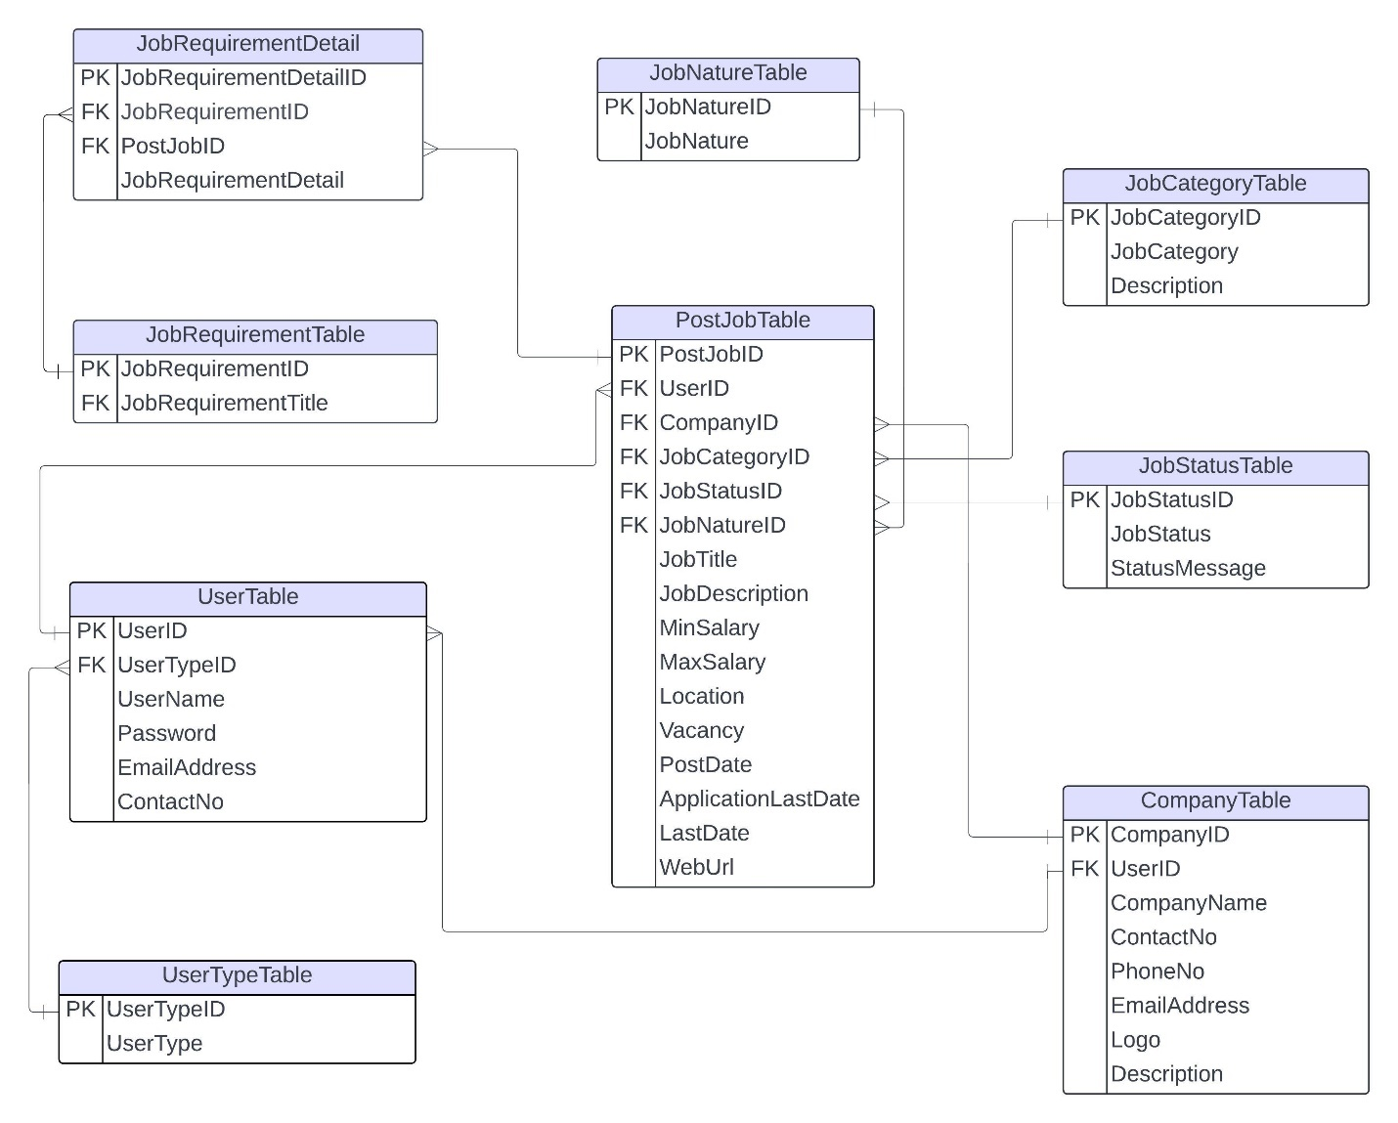

1. Data Dictionary

A data dictionary used to control access to and manipulation of the database. It is a set of information describing the format, contents, and structure of a database and the relationship between its elements.

DATA DICTIONARY OF USER TABLE

|  |  |  |  |  |
| --- | --- | --- | --- | --- |
| **Field Name** | **Constraints** | **Data Type** | **Allow Nulls** | **Description** |
| UserID | PK | int | No | The unique identifier for the user. |
| UserTypeID | FK | int | No | The identifier for the user's role. |
| Username | Not Null | int | No | The username chosen by the user. |
| Password | Not Null | nvarchar | No | The password chosen by the user for authentication |
| EmailAddress | Not Null | nvarchar | No | The email address of the user. |
| ContactNo | Not Null | nvarchar | No | The contact number of the user. |

DATA DICTIONARY OF USER TYPE TABLE

|  |  |  |  |  |
| --- | --- | --- | --- | --- |
| **Field Name** | **Constraints** | **Data Type** | **Allow Nulls** | **Description** |
| UserTypeID | PK | int | No | Serves as the primary key,  Uniquely Identifying each  user within the system. |
| UserType | FK | nvarchar | No | Linked as a foreign key,  Represents the role or  category of each user  within the system. |

DATA DICTIONARY OF COMPANY TABLE

|  |  |  |  |  |
| --- | --- | --- | --- | --- |
| **Field Name** | **Constraints** | **Data Type** | **Allow Nulls** | **Description** |
| CompanyID | PK | int | No | Serves as the primary key,  uniquely identifying each  company within the system. |
| UserID | FK | int | No | Linked as a foreign key,  identifies the user associated  with the company, specifying  their role within the system. |
| CompanyName | Not Null | nvarchar | No | Required field storing the name of the company. |
| ContactNo | Not Null | nvarchar | No | A required field storing the contact number of the company. |
| PhoneNo | Not Null | nvarchar | No | A required field storing the phone number of the company. |
| Logo | Not Null | nvarchar | No | A required field storing the logo of the company.  Top of Form |
| Description | Null | nvarchar | Yes | Allowing null values, stores information about the company's background, products, services, or any other relevant details. |

DATA DICTIONARY OF POSTJOB TABLE

|  |  |  |  |  |
| --- | --- | --- | --- | --- |
| **Field Name** | **Constraints** | **Data Type** | **Allow Nulls** | **Description** |
| PostJobID | PK | int | No | Serves as the primary key,  uniquely identifying each  job posting within the system. |
| UserID | FK | int | No | Linked as a foreign key,  identifies the user associated  with the job posting,  specifying their role within  the system. |
| CompanyID | FK | nvarchar | No | Linked as a foreign key, identifies the company associated with the job posting. |
| JobCategoryID | FK | nvarchar | No | Linked as a foreign key, identifies the category of the job.identification |
| JobStatusID | FK | nvarchar | No | Linked as a foreign key, identifies the status of the job posting. |
| JobNatureID | FK | nvarchar | No | Linked as a foreign key, identifies the nature of the job (e.g., full-time, part-time, contract). |
| JobTitle | Not Null | nvarchar | No | A required field storing the title of the job. |
| JobDescription | Not Null | nvarchar | No | A required field storing the description of the job. |
| MinSalary | Not Null | int | No | A required field storing the minimum salary offered for the job. |
| MaxSalary | Not Null | int | No | A required field storing the maximum salary offered for the job. |
| Location | Not Null | nvarchar | No | A required field storing the location of the job. |
| Vacancy | Not Null | nvarchar | No | A required field storing the number of vacancies available for the job. |
| PostDate | Not Null | date | No | A required field storing the date when the job was posted. |
| ApplicationLastDate | Not Null | date | No | A required field storing the last date for submitting job applications. |
| LastDate | Not Null | date | No | A required field storing the last date associated with the job posting. |
| WebUrl | Not Null | nvarchar | No | A required field storing the website URL associated with the job posting. |

DATA DICTIONARY OF JOB REQUIREMENT DETAIL TABLE

|  |  |  |  |  |
| --- | --- | --- | --- | --- |
| **Field Name** | **Constraints** | **Data Type** | **Allow Nulls** | **Description** |
| JobRequirementDetailID | PK | int | No | Serves as the primary key,  uniquely identifying each  job requirement detail  within the system. |
| JobRequirementID | FK | int | No | Linked as a foreign key,  identifies the specific job  requirement associated  with this detail. |
| PostJobID | FK | int | No | A foreign key, identifies the  post job associated with this requirement detail. |
| JobRequirementDetail | Not Null | nvarchar | No | A required field storing  additional details or  specifications related to  the job requirement.detail |

DATA DICTIONARY OF JOB REQUIREMENT TABLE

|  |  |  |  |  |
| --- | --- | --- | --- | --- |
| **Field Name** | **Constraints** | **Data Type** | **Allow Nulls** | **Description** |
| JobRequirementID | PK | int | No | Serves as the primary key,  uniquely identifying each  job requirement within the  system. |
| JobRequirementTitle | Not null | nvarchar | No | A required field storing the  title representing the  specific job requirement. |

DATA DICTIONARY OF JOB NATURE TABLE

|  |  |  |  |  |
| --- | --- | --- | --- | --- |
| **Field Name** | **Constraints** | **Data Type** | **Allow Nulls** | **Description** |
| JobNatureID | PK | int | No | serves as the primary key,  uniquely identifying each  job nature within the  system. |
| JobNature | Not null | nvarchar | No | a required field storing the  specific nature or type of  job, such as full-time,  part-time, contract, etc. |

DATA DICTIONARY OF JOB CATEGORY TABLE

|  |  |  |  |  |
| --- | --- | --- | --- | --- |
| **Field Name** | **Constraints** | **Data Type** | **Allow Nulls** | **Description** |
| JobCategoryID | PK | int | No | serves as the primary key,  uniquely identifying each  job category within the  system. |
| JobCategory | Not null | nvarchar | No | a required field storing the  specific category or type of  job, such as UI/UX Designing, System Analyst, etc. |
| Description | Null | nvarchar | Yes | Provides additional details or  information about the job  category. This field allows  null values. |

DATA DICTIONARY OF JOB STATUS TABLE

|  |  |  |  |  |
| --- | --- | --- | --- | --- |
| **Field Name** | **Constraints** | **Data Type** | **Allow Nulls** | **Description** |
| JobStatusID | PK | int | No | serves as the primary key,  uniquely identifying each job  status within the system. |
| JobStatus | Not null | nvarchar | No | a required field storing the  status of the job, such as  "Under Review", "Approved",  "Canceled", etc. |
| StatusMessage | Null | nvarchar | Yes | Provides additional information or messages related to the job status.  This field allows null values. |

1. User Features

List all the users and their features

1. **Admin**

**User Management:**

* View and manage all user accounts: Admin can see a list of all registered users and perform actions such as editing or deleting user accounts.
* Edit user information: Admin can modify user details like username, email, password, etc.
* Delete user accounts: Admin can remove user accounts from the platform if necessary.

**Configuration:**

**Job Category**:

* Add, edit, or delete job categories: Admin can create new job categories, modify existing ones, or remove outdated categories.

**Job Nature**:

* Add, edit, or delete job natures: Admin can define job natures such as full-time, part-time, freelance, etc. These can be added, modified, or removed as needed.

**Manage All Job Postings:**

* View and manage all job postings on the platform: Admin can see a list of all job postings and perform actions on them.
* View job details: Admin can see the details of each job posting including the job title, description, requirements, etc.
* Approve pending job postings: Admin can review and approve job postings submitted by users.
* Cancel pending job postings: Admin can reject pending job postings if they don't meet the platform's guidelines or standards.
* Delete job postings: Admin can remove job postings from the platform if necessary.

**Company Management:**

* View all registered companies: Admin can see a list of all companies registered on the platform.
* Edit company information: Admin can modify details of registered companies such as company name, description, contact information, etc.
* View full details of a company: Admin can see comprehensive information about a particular company.
* Delete company: Admin can remove a company from the platform if needed, perhaps due to violation of terms or closure.

1. **Job Provider**

**Post a Job**:

Create and post new job listings to attract potential candidates.

Input job details such as:

* Job title
* Job location
* Minimum salary
* Maximum salary
* Job vacancy
* Job category
* Job nature
* Company website URL
* Application deadlines
* Job description

**View Posted Jobs:**

* Access a list of all job postings created by the job provider.
* Review details of each job listing, including job title, description, and other relevant information.

**Manage Job Requirements**:

* Input specific requirements or qualifications for each job posting.
* Define skills, experience, or other criteria necessary for the job position.
* Delete requirements that are no longer relevant or needed for the job.

1. **Job Seeker**

**Access a list of all approved job postings**:

* Utilize filters such as job category and job nature to refine job search results.
* View job details including title, location, salary range, vacancy, and company information.
* Apply to desired job postings directly through the platform.

1. List of Modules

|  |  |
| --- | --- |
| Proponents | Modules |
| *Alfred Louis Carpio* | ***Homepage Modules*** |
| Registration Process |
| Login Process |
| Forgot password Process |
| ***Admin Module*** |
| View and Manage User Accounts |
| Edit User Information |
| Delete User Accounts |
| Job Category Management |
| Job Nature Management |
| View Job Postings |
| Approve Pending Job Postings |
| Cancel Pending Job Postings |
| Delete Job Postings |
| Edit Company Information |
| View Full Details of a Company |
| Delete Company |
| *Emmanuel Castillo* | ***Job Provider Module*** |
| Create and Post New Job Listings |
| Input Job Details |
| Access List of Posted Jobs |
| Input Specific Requirements for Jobs |
| Define Skills, Experience, etc. |
| Delete Job Requirements |
| View Details of Job Postings |

The table below shows the modules of the system with the proponents and their designated modules to be created by each member.

|  |  |
| --- | --- |
| *Arnel Taneca* | ***Job Seeker Module*** |
| Access Approved Job Postings |
| Utilize Filters for Refining Search |
| View Details of Job Postings |
| Apply to Job Postings |
| *Ryan Jay Valenzona* | ***Job Seeker Module*** |
| Access Approved Job Postings |
| Utilize Filters for Refining Search |
| View Details of Job Postings |
| Apply to Job Postings |

1. User Guide

Creating an Account

Visit our website and click on the "Sign Up" or "Register" button.



If you’re a job seeker, fill in the required information such as user name, password, contact number and email address then click register.

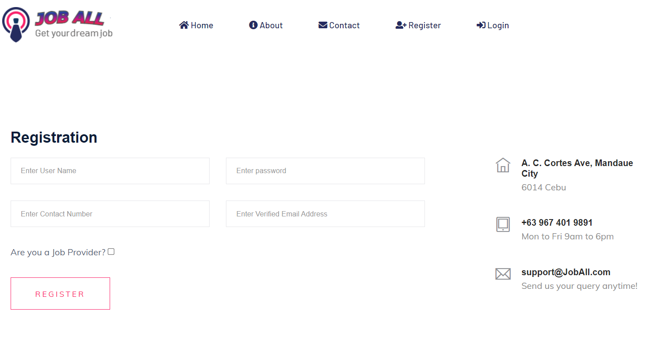

If you’re a job provider, please click the check button and fill in the required information such as user name, password, contact number and email address, company name, company phone number, company email address and company description.

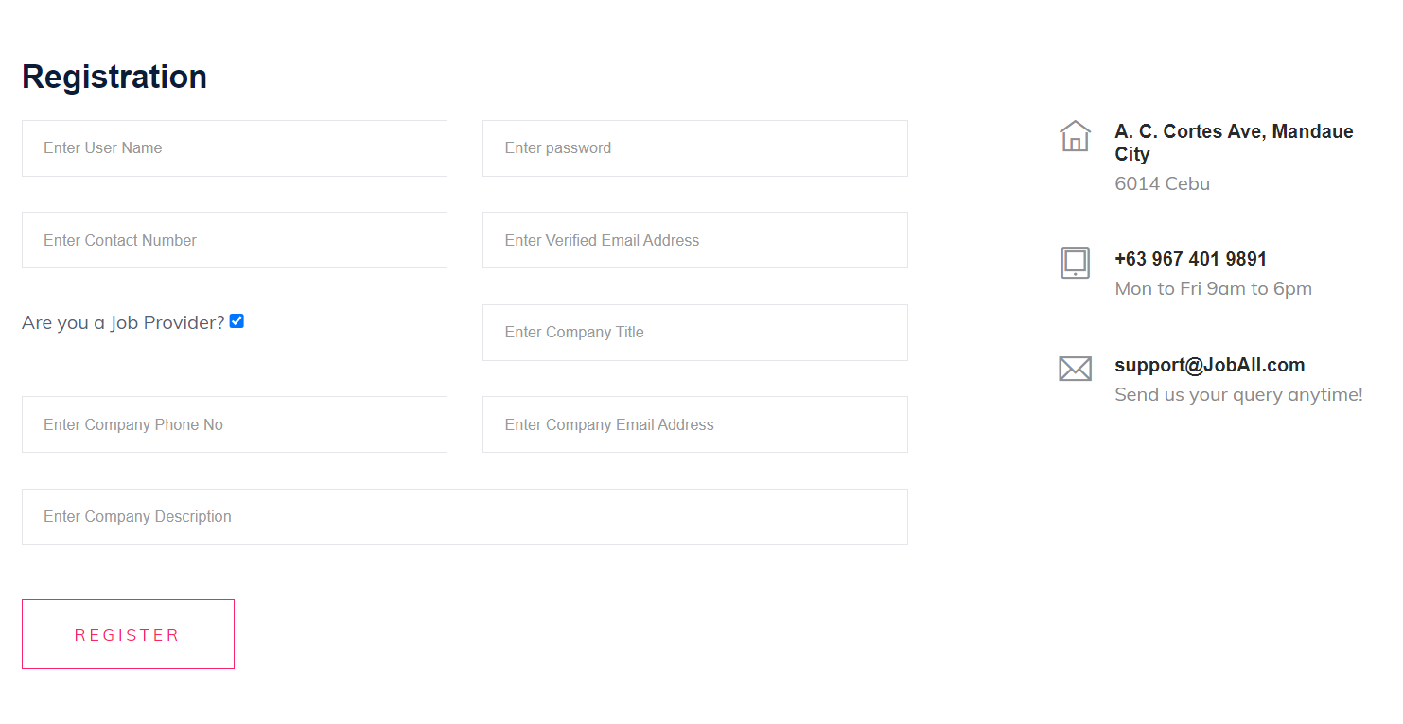

Go to the login page and enter your username and password and click on the "Login" button to access your account.

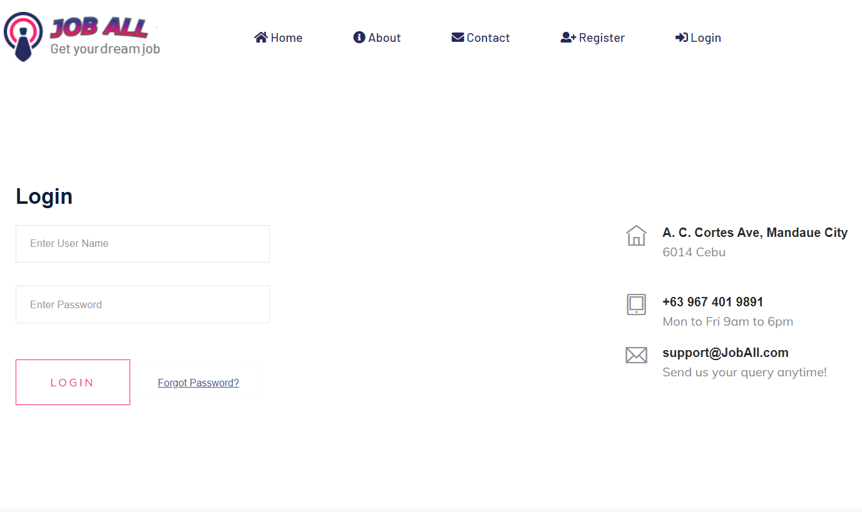

If you've forgotten your password, click on the 'Forgot Password' link and enter your registered email address. It will send you the username and password for your account.

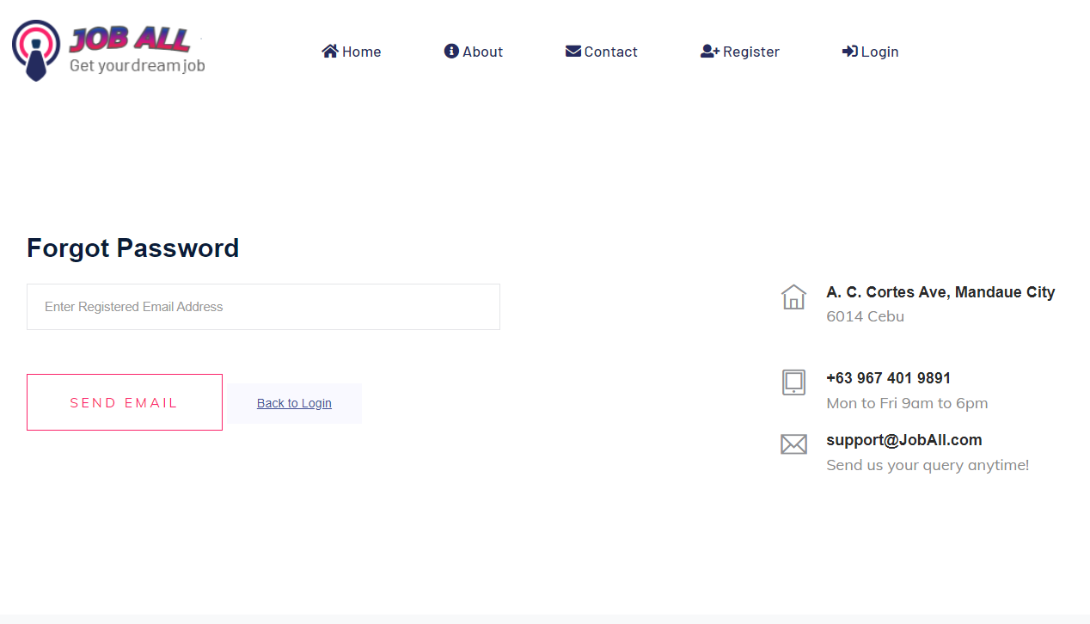

Upon logging in, you will be directed to your dashboard. From the dashboard, you can access various features based on your role (job seeker, job provider, or administrator).

Administrator Dashboard:  


Job Provider Dashboard:



Job Seeker Dashboard:



For Job Seekers

Searching for Jobs

Click on the “Find a Job" tab on the navigation menu.

Use filters such as job category, and job nature to narrow down your search.

Browse through the list of job postings and click on a job title to view details.

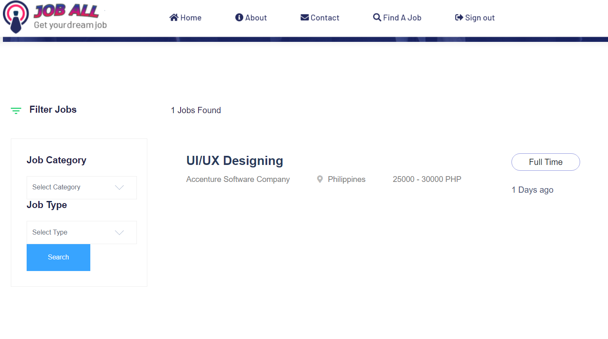

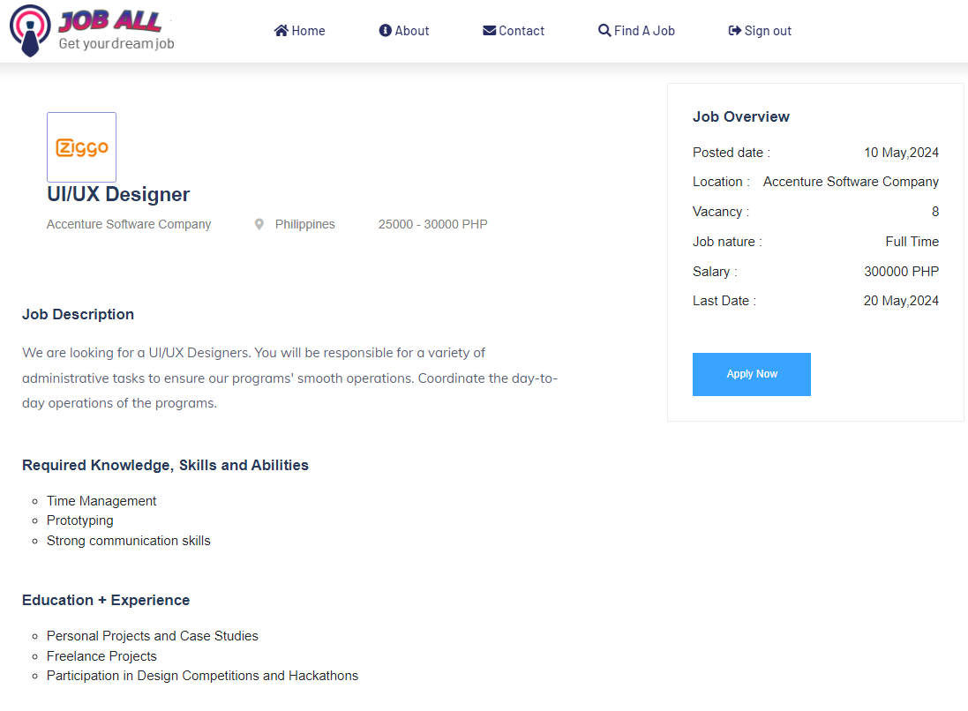

After reviewing a job posting, click on the 'Apply Now' button, and it will direct you to the company site to continue the application.

For Job Providers

Posting Jobs

Click on the "Post Job” tab in the navigation menu.

Fill in the required job details such as Job title, location, salary, and description.

Review the information and click on the "Register" button to post the job and wait for the admin to approve the post.

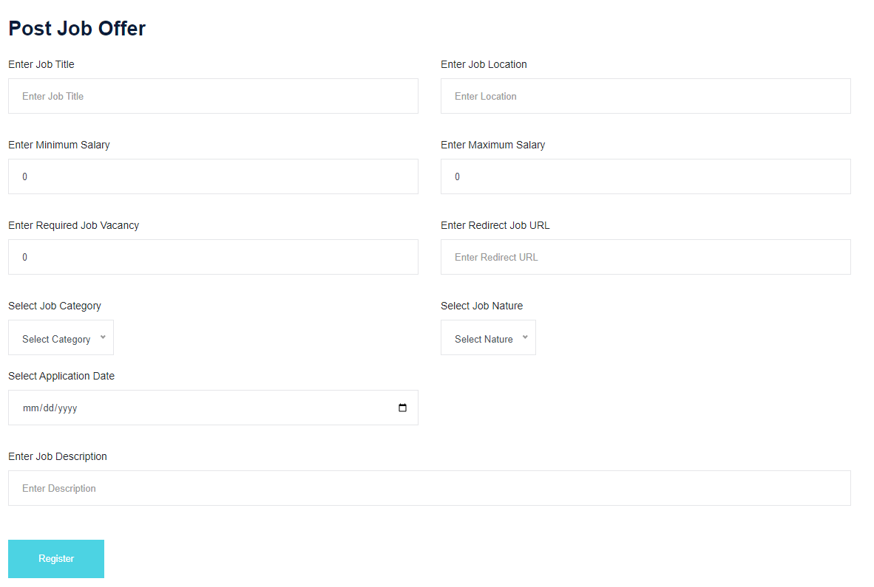

You can also view all job postings by clicking on 'All Posts' in the navigation menu

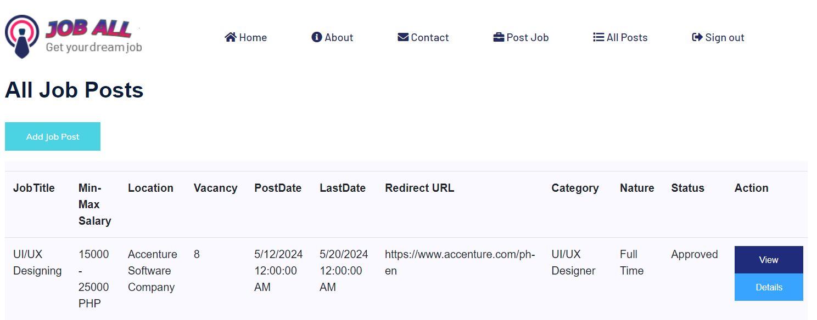

For Administrators

Managing Users

Access the “All Users” section from the admin navigation menu.

Admin can edit, or delete user accounts.

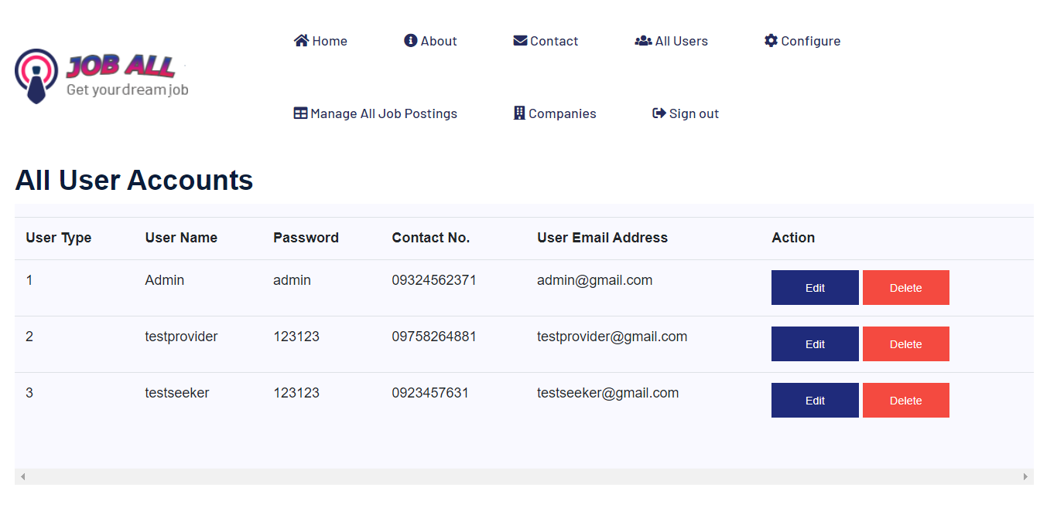

Approving Job Listings

Review pending job listings submitted by job providers.

Approve or cancel job postings based on platform guidelines.

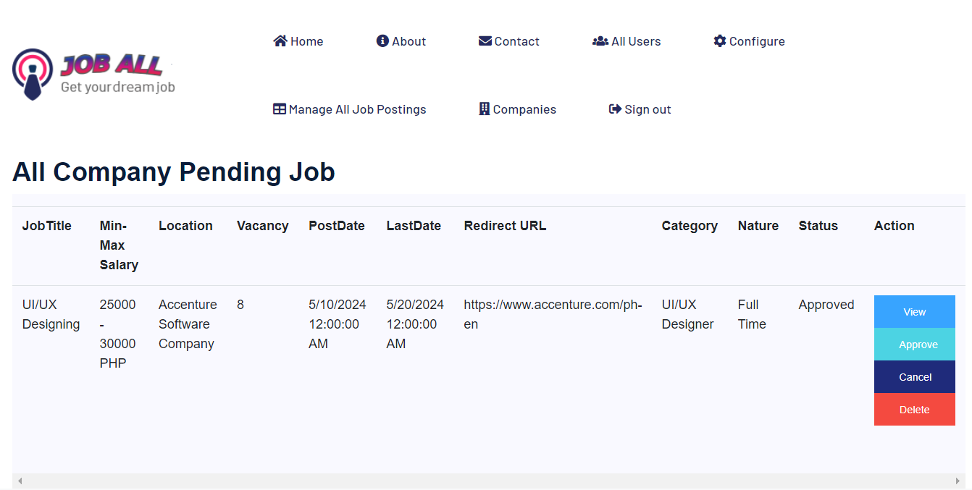

Managing Companies

Access the “Companies” from the admin navigation menu.

View a list of registered companies on the platform.

Admin can edit company information such as company name, description, contact details, etc.

Admin can delete a company from the platform if necessary, such as in cases of violation of terms or closure.

