WEEK 3 TASK – DATA ANALYSIS AND INTERPRETATION
Apparel, Textiles & Fashion Industry

1. Introduction
This report presents an analysis of the cleaned fashion market research data prepared in Week 2. The dataset contains five global fashion brands: Louis Vuitton, Chanel, Nike, Hermès and Zara. The analysis examines market position, observed pricing, product range and target customer segments. Because the dataset contains observed product examples rather than statistical sales or customer survey data, the findings are descriptive and should not be treated as exact measures of market share, product popularity or customer preference.

2. Dataset Overview
Brand | Market Position | Product Range | Observed Price | Target Demographic
Louis Vuitton | Luxury | Leather goods, RTW, shoes, accessories | ₹28,500–₹5,45,000 | Affluent luxury consumers
Chanel | Luxury | RTW, handbags, shoes, couture | Not Available | Luxury fashion consumers
Nike | Sportswear | Footwear, sportswear, lifestyle | ₹2,495–₹19,295 | Athletes & active lifestyle consumers
Hermès | Luxury | RTW, shoes, leather goods | $600–$3,000+ | Affluent luxury consumers
Zara | Fast Fashion | Women, men, kids, shoes, accessories | ₹450–₹8,550 | Trend-conscious mass-market consumers

3. Market Position Analysis
The cleaned dataset contains three market-position groups. Luxury is represented by Louis Vuitton, Chanel and Hermès, while Nike is categorized as sportswear and Zara as fast fashion. Therefore, luxury accounts for 3 of the 5 selected brands (60%), while sportswear and fast fashion each account for 1 brand (20%). This describes the composition of this selected dataset, not the overall global fashion industry.
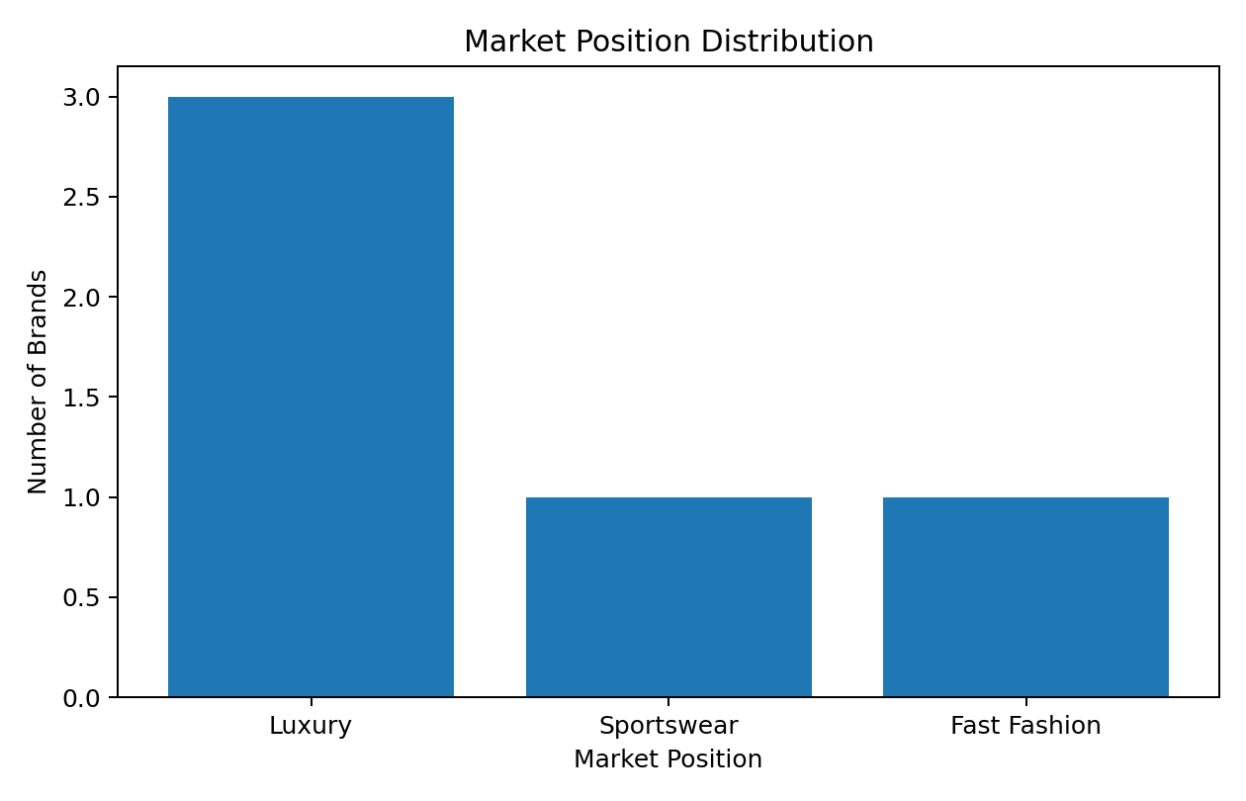

4. Pricing Analysis
Pricing shows clear differences among the observed examples. Louis Vuitton has an observed India range from about ₹28,500 to ₹5,45,000, Nike from about ₹2,495 to ₹19,295, and Zara from about ₹450 to ₹8,550. Chanel does not have a single reliable India-wide average in the cleaned dataset, so its price is recorded as Not Available. Hermès examples are recorded in US dollars ($600–$3,000+), so they should not be directly combined with the INR ranges without currency conversion. The comparable INR examples show that the observed ranges differ substantially across the selected brands.
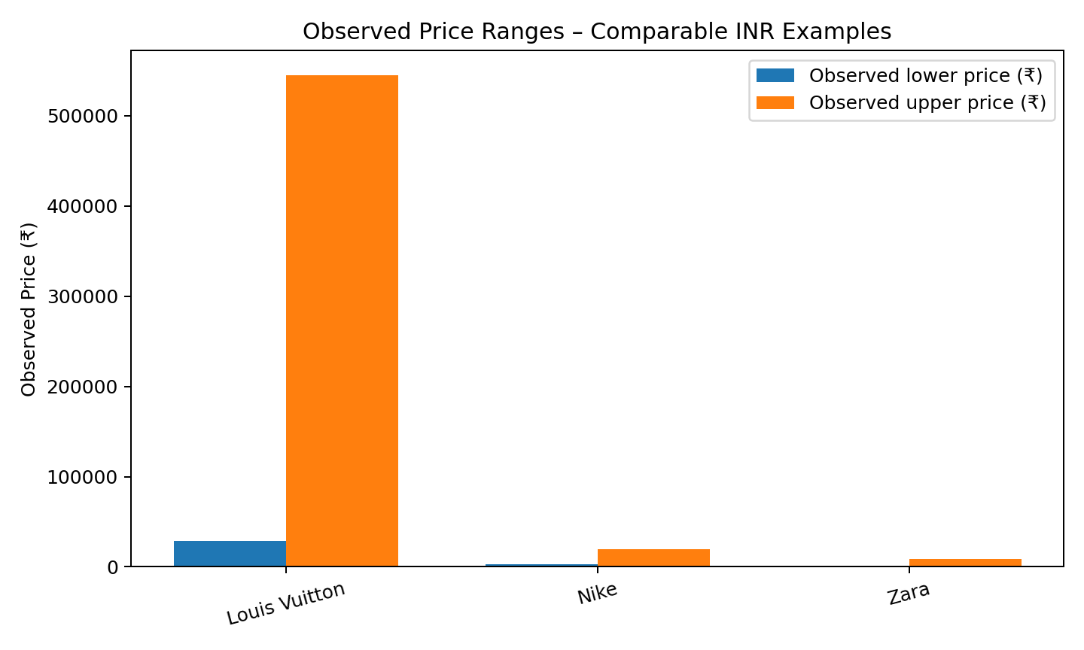
Interpretation: The price data supports a descriptive difference in observed price positioning, with luxury examples generally showing higher observed price points than the selected sportswear and fast-fashion examples. These are observed product examples, not calculated averages.

5. Product Range Analysis
The brands cover different combinations of fashion products. Louis Vuitton focuses on leather goods, ready-to-wear, shoes and accessories. Chanel covers ready-to-wear, handbags, shoes and couture. Nike emphasizes footwear, sportswear and lifestyle products. Hermès includes ready-to-wear, shoes and leather goods. Zara covers women, men, kids, shoes and accessories. The variety indicates different product strategies across luxury, sportswear and fast-fashion positioning.
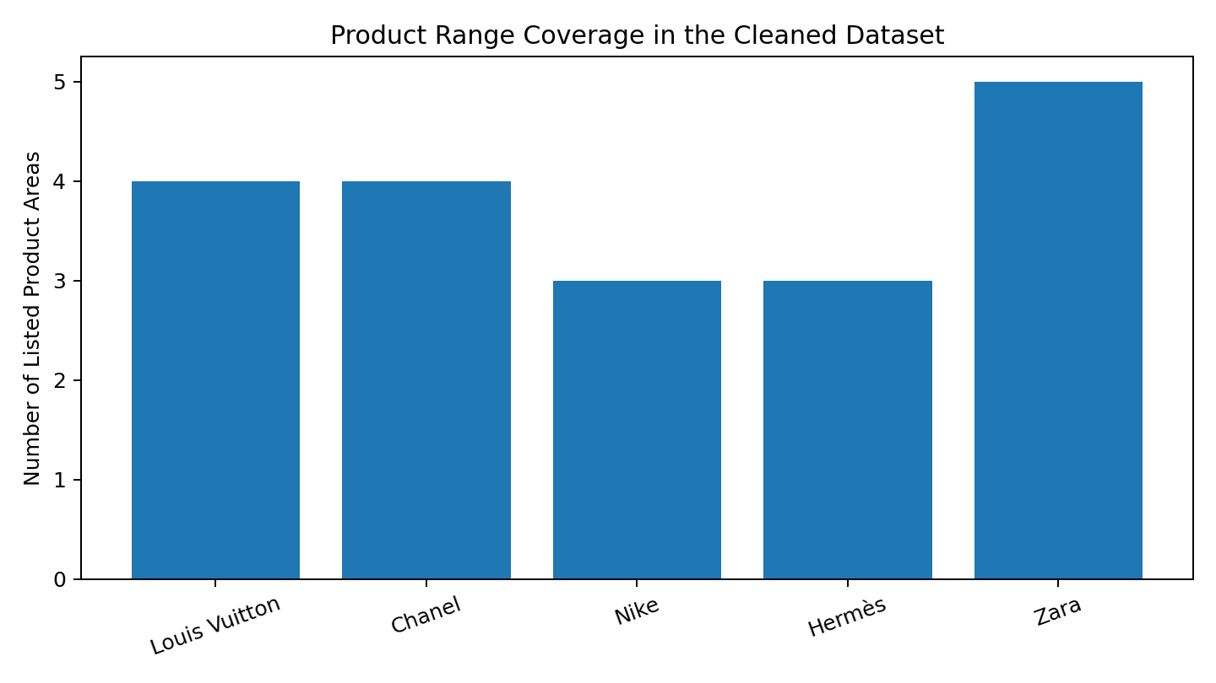
Note: the chart counts the product areas explicitly listed in the cleaned dataset; it is not a measure of total products sold by each brand.

6. Customer Preference and Demographic Analysis
The cleaned dataset identifies customer segments based on brand positioning, product categories and publicly visible collections. Louis Vuitton and Hermès are described as targeting affluent luxury consumers, while Chanel targets luxury fashion consumers. Nike focuses on athletes and active lifestyle consumers. Zara targets a broad, trend-conscious mass-market audience. These are market segments identified during the research and are not exact customer statistics.

7. Key Insights
- The selected dataset contains a strong luxury-brand presence, with three of the five brands categorized as luxury.
- Observed pricing varies considerably across the selected brands, indicating different market-positioning approaches.
- Nike's product range is centered on sportswear, footwear and lifestyle products, distinguishing it from the luxury and fast-fashion brands.
- Zara has broad product coverage across women, men and children and uses an observed lower price structure than the selected luxury examples.
- The customer segments differ according to brand positioning: affluent luxury consumers, luxury fashion consumers, active lifestyle consumers, and trend-conscious mass-market consumers.
- Price and demographic findings are descriptive because the dataset contains observed examples and market-segment descriptions rather than sales volumes or survey responses.

8. Conclusion
The analysis of the cleaned Week 2 dataset shows that the five selected fashion brands use different market positions, product ranges, observed price structures and customer segments. Luxury brands in the dataset are associated with premium positioning, Nike with sports and active lifestyles, and Zara with fast-fashion and broader mass-market coverage. These differences provide a useful basic view of the competitive landscape represented by the selected brands. The analysis also demonstrates the importance of clean and consistent data before drawing business insights.

9. References
- Week 2 – Data Cleaning and Pre-processing dataset
- Week 1 – Market Research and Data Collection report
- FashionUnited – Most Valuable Fashion Brands (2025)
- Official brand websites used in the Week 1 research

