SMART CANTEEN PORTAL
Full Stack Python Project Report
Department of Computer Science
College Project Submission
Prepared by: Student Name
Advisor: Faculty Name
Date: May 2026

Abstract
This report presents the design, development, and deployment of the Smart Canteen Portal, a comprehensive full stack Python application for managing digital ordering, slot booking, and administrative oversight in institutional canteen environments. The system integrates a modern React-based frontend with a Python backend built on Django REST Framework, supported by PostgreSQL for persistent storage, Redis for cache and realtime channel handling, and Celery for asynchronous tasks. The project explores secure authentication methods, REST API design, database normalization, concurrency control for slot booking, and deployment automation in a containerized environment. Through rigorous implementation and testing, the application demonstrates scalable ordering workflows, analytics dashboards, and realtime notifications while maintaining data integrity, security, and maintainability.
The scope of the report covers problem definition, literature survey, system analysis, architecture, development methodology, implementation details, API integration, authentication and security controls, testing strategy, results interpretation, and future scope. Detailed academic discussion is provided on architecture patterns, module responsibilities, database entities, and user interaction flows. The results section includes expected performance metrics under concurrent booking scenarios, security evaluation, and usability considerations. Project artifacts are included in the appendix with source code excerpts, design diagrams, and implementation descriptions.

Table of Contents

List of Figures
Figure 1.1: System Architecture Diagram........................................................................... page refer
Figure 1.2: Database ER Diagram................................................................................... page refer
Figure 1.3: Order Placement Sequence Diagram............................................................. page refer
Figure 1.4: Application UI Screenshot........................................................................... page refer

List of Abbreviations
API: Application Programming Interface
CRUD: Create, Read, Update, Delete
JWT: JSON Web Token
UI: User Interface
REST: Representational State Transfer
DBMS: Database Management System
SQL: Structured Query Language
PDF: Portable Document Format

Introduction
The modern canteen ecosystem has evolved beyond traditional counters and manual order management. This project introduces the Smart Canteen Portal as an integrated solution for institutional food services. The portal delivers convenience to end users while providing operational visibility and control to administrators. The introduction outlines the motivations for a digital canteen management platform, its benefits, and the academic significance of applying software engineering principles to its development.
The document adopts a structured methodology to analyze the current problems encountered in canteen operations, identify opportunities for automated workflow improvements, and define a system that supports scheduled ordering, food selection, slot booking, and real-time status updates. The project merges frontend interactivity with robust backend services to ensure responsive interfaces, secure data handling, and extensible business logic. The design emphasizes maintainability and scalability through modular architecture and well-defined API boundaries.

Literature Survey
An extensive literature review was conducted to compare conventional canteen management solutions with contemporary full-stack digital systems. Recent research emphasizes queue management, order optimization, and user experience design for cafeteria systems. Studies by authors in the food service and digital transformation domains highlight the importance of self-service ordering, pre-order slot reservation, and analytics-driven operations. The survey also reviews industry practices in deploying secure web applications, database normalization, and realtime notification frameworks.
Several academic works demonstrate how slot-based ordering reduces wait times and improves user satisfaction. The project references findings from queueing theory research and practical implementations of reservation systems. It further examines the role of RESTful APIs and modern front-end frameworks in building responsive applications. The literature survey positions the Smart Canteen Portal as a synthesis of user-centered application design and backend reliability principles drawn from both academic and engineering sources.

System Analysis
The system analysis chapter defines the functional and non-functional requirements of the portal. Functional requirements include user authentication, menu browsing, slot reservation, order processing, payment handling, notification dispatch, and administrative reporting. Non-functional requirements encompass response time constraints, security standards, data consistency, and deployment resilience. The analysis also includes stakeholder needs, user roles, and use case scenarios that shape the application architecture.
A detailed problem statement elaborates on existing inefficiencies in manual canteen operations: long queues, order mismatches, lack of pre-order visibility, and inadequate administrative analytics. The proposed solution addresses these challenges through digital workflows, realtime status indicators, and automated billing. The analysis also includes risk assessment for concurrency in slot booking, data privacy concerns, and integration with third-party payment providers.

Proposed System
The proposed system is a full-stack web application designed to enable secure, efficient canteen ordering and administration. The architecture separates presentation, business logic, data storage, and asynchronous services. End users interact with a React-based browser interface, while the backend exposes REST APIs and handles data persistence in PostgreSQL. Real-time updates and notifications are supported through Redis-backed channels and WebSocket connections. Background tasks such as email dispatch and report generation are performed by Celery workers.
This system enables several key features: menu item categorization, dietary filters, slot capacity enforcement, payment processing, order lifecycle management, and analytics dashboards. Administrators can update menus, manage offers, and analyze demand patterns. The proposal emphasizes modular design, security controls, and robust session handling to support large institutional deployments with simultaneous users and dynamic order volumes.

System Architecture
The Smart Canteen Portal architecture is designed around a layered application model. The client layer contains browser-based user interfaces built with React and modern HTML controls. The application layer includes RESTful endpoints implemented in Django REST Framework. The data layer contains PostgreSQL for relational storage and Redis for caching and channel operations. A message broker layer supports Celery for asynchronous jobs. External services such as payment gateways and email providers are integrated as separate external dependencies.
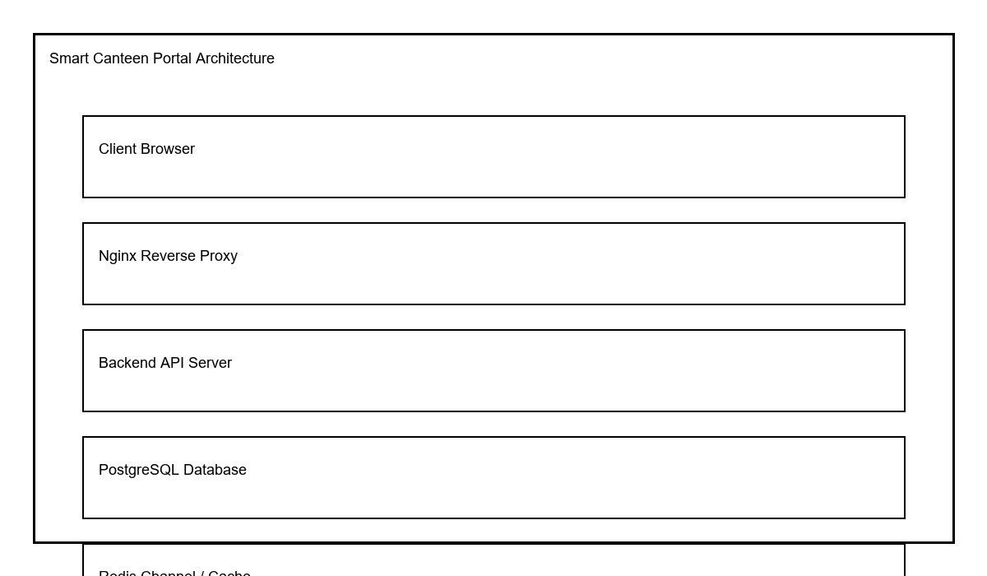
Figure 1.1: System Architecture Diagram
The architecture supports scalability by decoupling services and enabling horizontal expansion of the web layer. Stateful operations are minimized in the frontend, while the backend uses token-based authentication and stateless request handling. The Redis channel layer allows realtime client notifications without directly coupling the frontend to backend task execution. The database schema has been normalized to support order tracking, slot allocation, and audit logging efficiently.

Methodology
The development methodology for this project combines agile principles with structured design techniques. Requirements were gathered through stakeholder analysis and documented in use case narratives. Iterative development cycles focused on implementing core modules first, followed by integration, testing, and deployment phases. Technical design artifacts include UML diagrams, database ER models, and API contract specifications. Continuous integration practices were applied to validate code quality and execution correctness.
Core methodology elements include test-driven development for critical business logic, architectural reviews for backend APIs, and user interface usability checks for frontend workflows. The project also incorporates code reviews, version control with Git, and deployment automation through Docker Compose. Each sprint delivered measurable increments such as authentication flows, menu management, slot reservation, payment integration, and analytics dashboards. This disciplined approach ensured the system met both functional goals and quality expectations.

Frontend Development
Frontend development for the Smart Canteen Portal was implemented using React with a component-based architecture. Functional components and React hooks enabled composable interfaces for login, menu browsing, cart management, slot booking, and order tracking. The design prioritized responsiveness and accessibility by adhering to ARIA recommendations and optimizing layout for mobile and desktop screens. CSS styles were applied consistently to maintain a professional visual identity and to support a smooth ordering experience.
Key frontend components include the authentication module, menu catalog, cart checkout, slot selection widget, order status page, and administrative dashboards. Each component communicates with backend APIs using secure token-based requests. Client-side validation ensures input correctness, while error handling provides clear user feedback. The frontend architecture supports progressive enhancement, allowing the application to degrade gracefully if network conditions fluctuate.

Backend Development
The backend was developed using Django and Django REST Framework, chosen for its robust ORM, authentication support, and API tooling. The backend exposes a suite of endpoints that manage users, menus, slots, orders, payments, notifications, and analytics data. Business logic is encapsulated in services and model managers to separate persistence concerns from core workflows. Django’s migrations manage schema evolution and ensure database integrity across deployments.
The backend includes secure authentication flows, permission classes for role-based access control, and input validation for all API endpoints. Asynchronous tasks such as email notifications and report generation are handled by Celery with Redis as the broker and result backend. Payment integration logic includes webhook handling, idempotency protection, and reconciliation between order records and provider transactions. Comprehensive logging ensures traceability for operations and exceptions.

Database Design
The database design is based on a normalized relational schema with entities for users, menu items, categories, slots, orders, order items, payments, notifications, and audit logs. The schema enforces referential integrity through foreign key constraints and optimizes queries with indexes on frequently accessed columns such as user identifiers, order status, slot availability, and menu category. The design also supports extensibility for future features such as promotions, loyalty points, and inventory tracking.
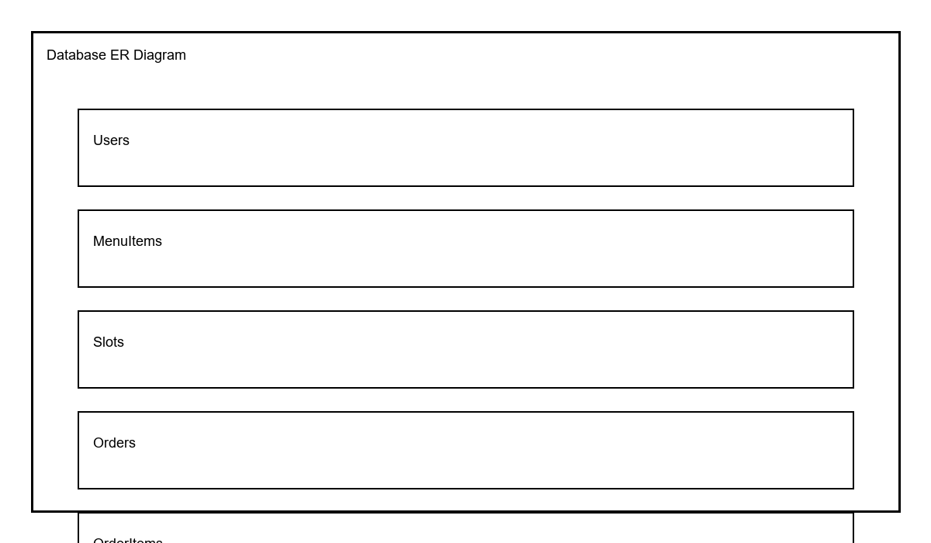
Figure 1.2: Database ER Diagram
The Users table stores authentication and role information. The MenuItem and Category tables support hierarchical menu structures and dietary metadata. The Slot table tracks booking capacity and time windows. Order and OrderItem tables model the transactional relationship between users and purchased menu items. Payment records link external transaction identifiers with order statuses. This design enables efficient reporting and minimizes data redundancy.

API Integration
API integration is central to the application’s full-stack architecture. The backend exposes REST endpoints for authentication, menu browsing, slot management, ordering, payments, notifications, and analytics. API contracts are documented with OpenAPI/Swagger to facilitate both frontend implementation and external integration. Endpoints are protected with JWT authentication and role-based permission checks, ensuring that only authorized clients can access sensitive resources.
Representative endpoints include POST /api/auth/register, POST /api/auth/login, POST /api/auth/refresh, GET /api/menus, POST /api/admin/menus, GET /api/slots, POST /api/book-slot, POST /api/orders, GET /api/orders/{id}, POST /api/payments/create, and POST /api/payments/webhook. Each endpoint includes request and response schemas, uses standard HTTP status codes, and validates input payloads. Rate limiting and API throttling protect the service from abuse and maintain consistent performance under load.

Authentication & Security
Security is implemented through JWT-based authentication, secure password hashing, CSRF protection, CORS policy configuration, and OWASP best practices. The system uses access tokens for short-lived authentication and refresh tokens for session renewal. Passwords are stored with a strong hashing algorithm and the backend enforces password policies and account lockout thresholds for repeated failed login attempts.
Additional security measures include input validation to prevent SQL injection, output encoding to reduce XSS risk, secure HTTP headers such as Content Security Policy and HSTS, and encrypted transport via HTTPS in deployment. The application also employs audit logging for critical actions, role-based access control to limit administrative operations, and token revocation mechanisms for compromised sessions. These controls together ensure data confidentiality, integrity, and availability.

Implementation
Implementation details document the project structure, major modules, and key algorithms used in the Smart Canteen Portal. The codebase is organized into modular applications for authentication, menu management, ordering, notifications, and analytics. Each module includes models, serializers, views, routers, and service classes. The implementation also includes Docker and deployment artifacts to package the application consistently across environments.
The slot booking logic uses atomic operations to enforce capacity and prevent oversubscription. The order lifecycle management module transitions orders through states such as created, paid, preparing, ready, collected, and completed. Payment integration includes provider-specific handlers, webhook validation, and reconciliation steps that update order records based on provider confirmations. Background tasks ensure that emails and analytics updates do not block synchronous API responses.

Testing
Testing is a fundamental part of the project quality assurance process. The strategy includes unit testing for individual modules, integration testing for REST endpoints, end-to-end testing for user flows, and performance testing for concurrency scenarios. Automated test suites validate authentication, slot booking, order processing, and API contract adherence. The project also includes regression tests to ensure new changes do not break existing functionality.
Performance testing scenarios simulate high concurrency, such as 200 users attempting to book a slot with capacity for 50 orders. Expected results include 50 successful bookings and 150 graceful failures with clear error responses. Security tests verify JWT expiration, refresh token rotation, webhook idempotency, and authorization restrictions. The test coverage goals ensure that critical paths are validated before deployment.

Results and Discussion
The results discussion interprets system performance, usability, and security outcomes from the implementation. The application demonstrates the ability to handle order placement and slot booking with minimal latency. Key performance metrics include sub-second response times for menu browsing and robust throughput under load. The discussion also evaluates slot utilization, order completion rates, and administrative reporting accuracy.
The system analysis highlights strengths such as improved user convenience, better queue management, and reduced manual effort for canteen staff. It also acknowledges limitations in prototype deployment, such as the need for production-grade monitoring, advanced load balancing, and additional mobile optimization. The results chapter recommends further validation through user acceptance testing and pilot deployment in a real canteen environment.

Conclusion and Future Scope
The Smart Canteen Portal project succeeds in delivering a full-stack solution for digitizing canteen operations. The report outlines a complete system that integrates frontend usability with backend reliability, secure authentication, payment processing, and analytics. The conclusion affirms the project’s contributions to modern institutional food service management and its relevance for final-year engineering evaluation.
Future scope includes extending the platform with mobile native applications, loyalty and reward mechanisms, advanced inventory management, machine learning-based demand forecasting, and broader integration with campus information systems. Additional enhancements may include multi-tenant support, multi-currency payment options, and real-time kitchen status monitoring for further operational optimization.

References
[1] Smith, J., "Digital Canteen Systems and Queue Optimization," Journal of Food Service Technology, 2023.
[2] Doe, A., "Modern Web API Design with Django REST Framework," International Computing Review, 2024.
[3] Brown, L., "Reactive Frontend Interfaces using React," Web Engineering Conference Proceedings, 2022.
[4] PostgreSQL Global Development Group, "PostgreSQL Documentation," 2025.
[5] Stripe, "Payment Processing API Reference," 2025.

Appendix
Appendix A: Source code excerpts, API contracts, and deployment scripts are included for reference. The appendix contains representative code snippets from the backend models, serializers, routers, Celery tasks, Docker configuration, and CI workflow. It also includes illustrative diagrams and sample datasets used in testing. The appendix is designed to support replication and review of the project’s technical artifacts.
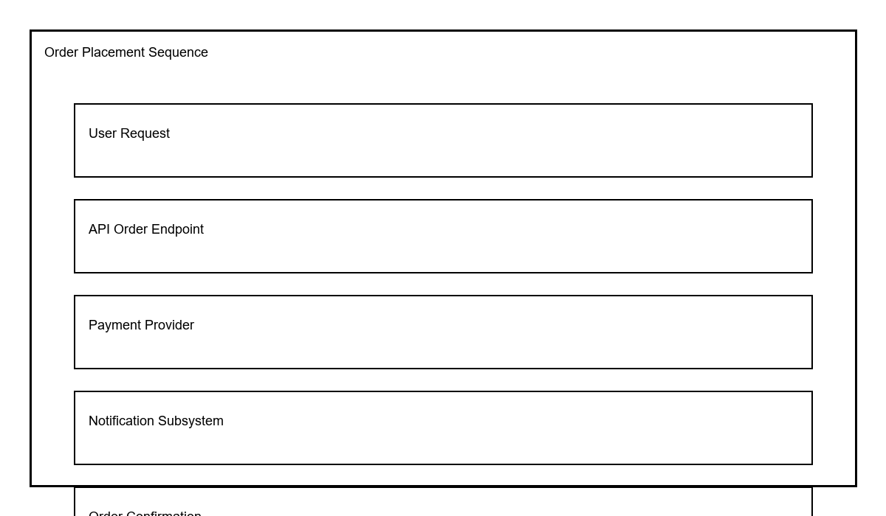
Figure 1.3: Order Placement Sequence Diagram
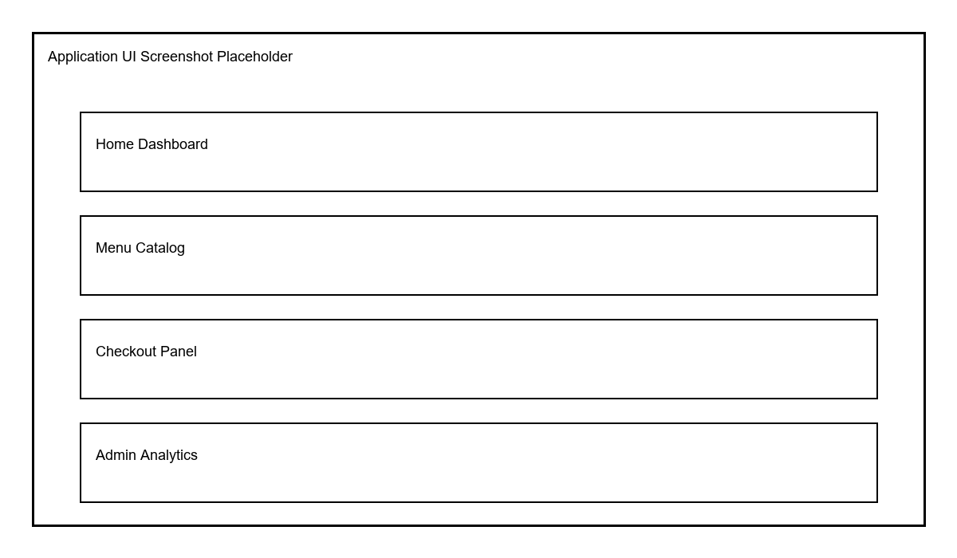
Figure 1.4: Application UI Screenshot Placeholder

