SOP
Legacy pinta pipeline

Overview:
This pipeline is made to process only for Legacy GMRT data. It will take legacy GMRT data as input Which will be as four files per pulsar observation. This program contains those files to give profile archive (.fits) and postscript (.ps) as an output.

Lpinta work flow diagram:
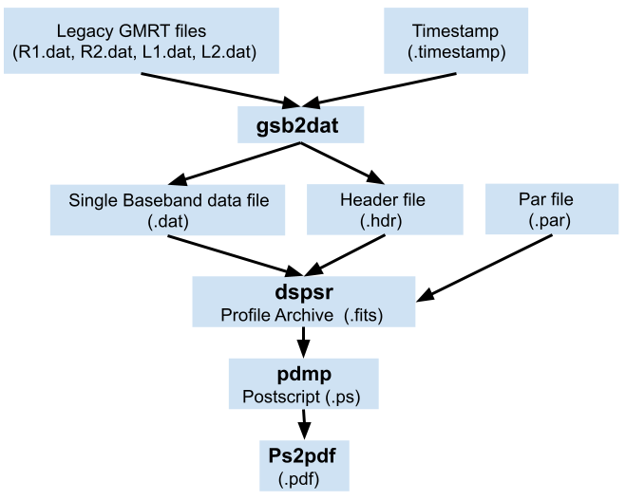

Legacy GMRT observation, For the single pulsar observation the data is written into four separate data files and one timestamp file. In that two of them are right circularly polarized data (R1 and R2) and the other two are left circularly polarized data (L1 and L2).
gsb2dat is the program that takes four data files and timestamp files as an input and combines them then It will give single baseband data and header file for the data as an output.
dspsr performs folding and dedispersion on the data. It takes a single baseband file, header file, and parameter file as an input. After folding it will give the archive profile in fits form.
After dspsr, pdmp and ps2pdf are used to generate postscript and pdf documents.
End of this process we will have three files in the working directory (.fits, .ps, .pdf).

Logging In:
This pipeline was only installed in tapti. Run the following before using Lpinta.

$ newgrp ugmrtpsr
$ umask 0007
$ source /Data/prabu/FORAPANDIAN/Lpinta/Lpinta.bashrc

After the sourcing, Lpinta can run as executable by calling “Lpinta” in the terminal.

Command to run:

Lpinta [-h] [--test] [--nodel] [--pardir PARDIR] <input_dir> <working_dir>

Lpinta description

positional arguments:
input_dir | Input data directory
working_dir | Working directory

optional arguments:
-h, --help | Show this help message and exit
--test | Test on file availability and permissions
--nodel | To keep processed data files
--pardir | Pulsar parameter file directory

“input_dir” and “working_dir” are compulsary to run Lpinta. Input directory and working directory should not be the same. Before processing the data file, Must do the test.
“--test” will do checking the read and group permissions on data files then read and executive permissions on executables to avoid crashes in between the process. Even though not doing a test before the data process it will do the test.
“--nodel” can be used to preserve copied data files in the work directory. By default, all processed data files are removed from the working directory after processing.
“--pardir” can be used to give custom par directory location. The default par directory location is already mentioned inside the code. This code will take the source name to find the par file. So, the source name in the pipeline is case-sensitive.

Pipeline file:
the pipeline file name is case-sensitive. It must be as “Lpipeline.in” . Lpipeline.in file should be in the current directory when you are executing “Lpinta”.
The pipeline file contains 11 parameters for on pulsar data process. 11 parameters should be in one row. Multiple rows can be added to perform multiple pulsar data processes.
“source_name” is pulsar’s J2000 name. Even though, data files contain a ‘B’ name then we should enter the ‘J’ name of the pulsar as the first parameter in the pipeline. The next four parameters are data file names. And 6 the parameter is the timestamp file of the observation data.

Number | Parameters | Comment
1 | source_name | Pulsar name (J2000 name) (string)
2 | RCP_1 | Right circular polarization file 1 (string)
3 | RCP_2 | Right circular polarization file 2 (string)
4 | LCP_1 | Left circular polarization file 1 (string)
5 | LCP_2 | Left circular polarization file 2 (string)
6 | TimeStamp | Timestamp file (string)
7 | Frequency | Observation frequency (float) (MHz)
8 | Nchan | Number of frequency channel (integer)
9 | Int_time | Integration time (integer)
10 | nbins | Number of bins (integer)
11 | fillterbank_chan | Number of filterbank channels (integer)

If the file mentioned in pipeline is not present in Input directory then program will Exit in the intial stage.

