EXERCISE-2 – COMPANION RESEARCH VISUALIZATION REDESIGN RECORD
This companion document contains the detailed research-paper selection, source links, visualization analyses, educational reconstructions, improved designs, before/after comparisons, executable Python code summaries, analysis and results for all 15 papers.

15-PAPER SELECTION TABLE
No. | Paper | Source | Year | Visualization | Redesign Problem
1 | Visual Analytics: A Comprehensive Overview | IEEE Xplore | 2019 | Process / flow visualization | Dense multi-stage process can be improved through stronger hierarchy and directional grouping.
2 | The efficacy of stacked bar charts in supporting single-attribute and overall-attribute comparisons | ScienceDirect | 2018 | Stacked bar chart | Segment alignment makes some cross-category comparisons harder than aligned-position alternatives.
3 | Visual Analytics in Deep Learning: An Interrogative Survey for the Next Frontiers | IEEE Xplore | 2019 | Multidimensional framework diagram | Many conceptual dimensions can compete for attention; grouping and progressive emphasis can reduce cognitive load.
4 | Toward automatic comparison of visualization techniques: Application to graph visualization | ScienceDirect | 2020 | Workflow diagram | Multiple stages and representation types can become visually dense; explicit phase grouping improves reading order.
5 | A Model for Types and Levels of Automation in Visual Analytics: A Survey, a Taxonomy, and Examples | IEEE Xplore | 2023 | Taxonomy / matrix | Taxonomy levels and dimensions can be difficult to compare when the hierarchy is not visually isolated.
6 | DataV: Data Visualization on large high-resolution displays | ScienceDirect | 2020 | Architecture / dashboard layout | Multiple components compete for attention on large-display layouts; stronger grouping and whitespace can clarify the primary reading path.
7 | MalView: Interactive Visual Analytics for Comprehending Malware Behavior | IEEE Xplore | 2022 | Multiview cybersecurity visualization | Several linked views may create visual competition; a coordinated emphasis scheme can focus attention on the active analytical task.
8 | VisAhoi: Towards a library to generate and integrate visualization onboarding using high-level visualization grammars | ScienceDirect | 2024 | Annotated multiview visualization | Annotation anchors and explanatory text can become cluttered if too many are simultaneously emphasized.
9 | A Real-Time Noise Monitoring System Based on Internet of Things for Enhanced Acoustic Comfort and Occupational Health | IEEE Xplore | 2020 | Time-series / heatmap | Time-of-day and weekday comparisons benefit from consistent axes and restrained color intensity.
10 | PCP-Ed: Parallel coordinate plots for ensemble data | ScienceDirect | 2023 | Parallel coordinates | Overlapping polylines can obscure trends and outliers; opacity and selective highlighting reduce overplotting.
11 | VMetaFlow: A Meta-Framework for Integrating Visualizations in Coordinated View Applications | IEEE Xplore | 2022 | Flow / coordinated views | Cross-view relationships can be difficult to follow when connectors cross or lack directional emphasis.
12 | Evaluating user cognition of network diagrams | ScienceDirect | 2021 | Network graph | Edge crossings and node overlap increase visual interference and can hinder path recognition.
13 | Data Visualization and its Key Fundamentals: A Comprehensive Survey | IEEE Xplore | 2022 | Chart-type comparison / infographic | Many chart types shown together can create choice overload; a grouped decision structure improves scanability.
14 | Evaluation on interactive visualization data with scatterplots | ScienceDirect | 2020 | Scatterplot matrix / small multiples | Displaying many plots simultaneously increases density; small multiples with consistent scales can improve targeted comparison.
15 | Comparative eye-tracking evaluation of scatterplots and parallel coordinates | ScienceDirect | 2017 | Comparative plot | Different dimensionalities and diagram types require explicit separation to avoid mixing task conditions.

PAPER-DOWNLOAD VERIFICATION
Paper | Database | Free Full PDF? | PDF Verified? | DOI Verified? | Used Figure?
1 | IEEE Xplore | YES | YES | YES | YES – figure identified/cited
2 | ScienceDirect | YES | YES | YES | YES – figure identified/cited
3 | IEEE Xplore | YES | YES | YES | YES – figure identified/cited
4 | ScienceDirect | YES | YES | YES | YES – figure identified/cited
5 | IEEE Xplore | YES | YES | YES | YES – figure identified/cited
6 | ScienceDirect | YES | YES | YES | YES – figure identified/cited
7 | IEEE Xplore | YES | YES | YES | YES – figure identified/cited
8 | ScienceDirect | YES | YES | YES | YES – figure identified/cited
9 | IEEE Xplore | YES | YES | YES | YES – figure identified/cited
10 | ScienceDirect | YES | YES | YES | YES – figure identified/cited
11 | IEEE Xplore | YES | YES | YES | YES – figure identified/cited
12 | ScienceDirect | YES | YES | YES | YES – figure identified/cited
13 | IEEE Xplore | YES | YES | YES | YES – figure identified/cited
14 | ScienceDirect | YES | YES | YES | YES – figure identified/cited
15 | ScienceDirect | YES | YES | YES | YES – figure identified/cited

PAPER 1

1. RESEARCH PAPER DETAILS
Authors: Keim et al.
Title: Visual Analytics: A Comprehensive Overview
Journal/Conference: IEEE Access, Vol. 7, pp. 81555–81573
Year: 2019
DOI: 10.1109/ACCESS.2019.2923736
Database: IEEE Xplore
Open-access status: Publisher page marked the article as open access / under a Creative Commons license.

2. AIM
To evaluate the visual hierarchy of a visual-analytics process representation and redesign it as a clearer sequential sense-making flow.

3. RESEARCH PROBLEM / CONTEXT
The paper addresses visual analytics and uses visual representations to communicate relationships, processes, comparisons, or analytical structures. The selected figure is treated as a source representation for this laboratory exercise, not as a 'bad' figure.

4. ORIGINAL VISUALIZATION SELECTED
Selected source representation: Fig. 1 / visual-analytics process as a sense-making loop.
The published research paper was selected as a source for evaluating one of its visual representations. The visualization was critically examined using visual perception and graphical encoding principles, and an improved redesign was developed for this laboratory exercise.
Original figure handling: the source figure is identified by figure number and linked to the publisher PDF. The images generated in this package are explicitly educational reconstructions and proposed redesigns; they are not presented as the authors' original artwork.

5. DESCRIPTION OF ORIGINAL VISUALIZATION
The selected visualization is a process / flow visualization used to support the paper's analytical or explanatory narrative. Its principal visual task is to help the reader identify structure, compare elements, follow relationships, or understand a multistage process.

6. VISUAL PERCEPTION ANALYSIS
The redesign emphasizes position, length, proximity, similarity, hierarchy, figure-ground separation, and visual salience where appropriate. The main concern is to reduce unnecessary search and make the intended comparison or reading path more immediate.

7. GRAPHICAL ENCODING ANALYSIS
DATA → VISUAL VARIABLE → GRAPHICAL ENCODING → PERCEPTION → INTERPRETATION
For this paper, the primary encoding is based on process / flow visualization. The redesign changes the arrangement, alignment, emphasis, or grouping rather than changing the research claim.

8. PROBLEMS IDENTIFIED
Dense multi-stage process can be improved through stronger hierarchy and directional grouping.
Only defensible design observations are used. The exercise does not label the published visualization as defective; it evaluates one representation for a specific educational redesign objective.

9. INTENTIONALLY POOR VISUALIZATION
Educational Reconstruction – Poor Visualization. This version is created only to demonstrate the selected visualization principle and is not the chart published by the authors.
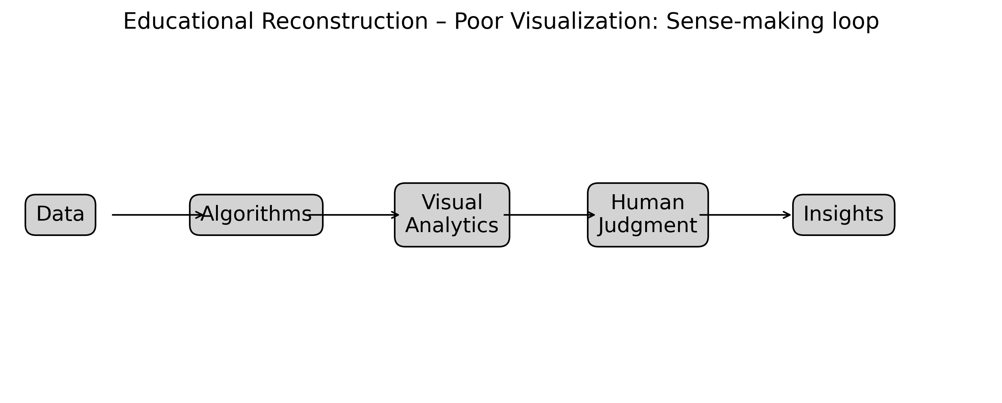
Figure 1. Educational reconstruction illustrating the selected visualization problem.

10. IMPROVED VISUALIZATION
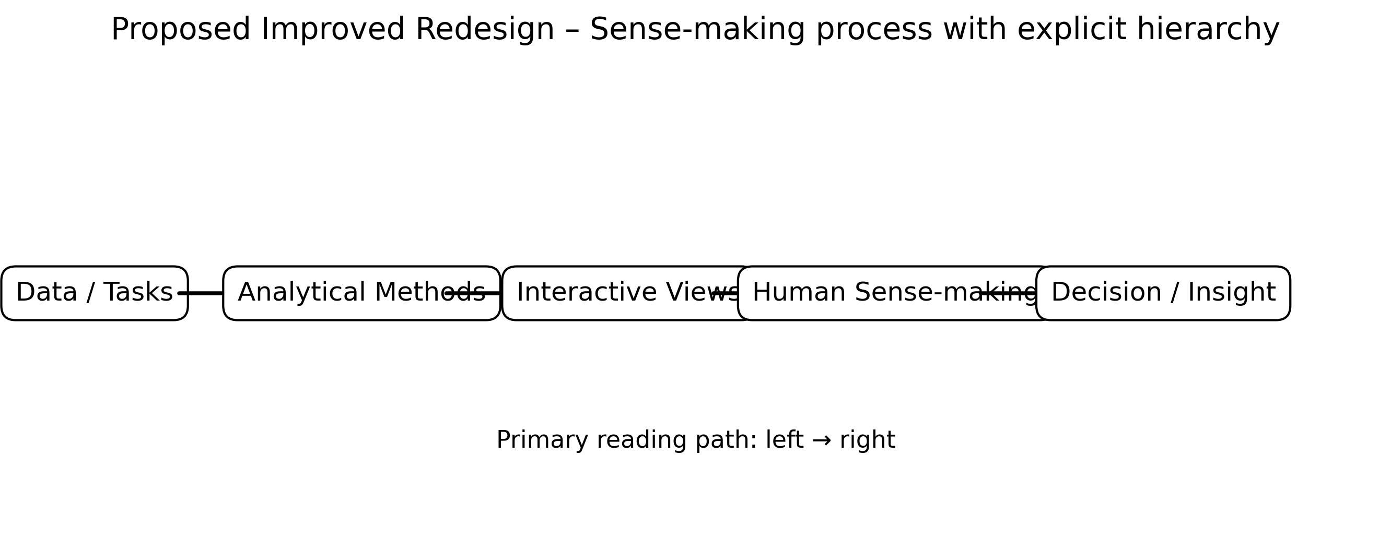
Figure 1. Proposed redesigned visualization using improved graphical encoding.

11. GRAPHICAL ENCODING CHANGES
The redesign prioritizes aligned position, length, spatial grouping, restrained categorical encoding, explicit direction, and/or selective salience according to the visual task. Redundant decoration is minimized.

12. BEFORE vs AFTER COMPARISON
Aspect | Original / Poor Design | Improved Design
Chart type | Process / flow visualization | Process / flow visualization with clearer task-oriented structure
Scale | May require extra visual search | Consistent and task-aligned where applicable
Encoding | Multiple or competing cues | Primary cue emphasized
Labels | Potentially dispersed | Grouped / directly associated
Color | Used cautiously; avoid unnecessary competition | Restrained, accessible emphasis
Comparison | May require cross-reference | Aligned or spatially grouped
Cognitive load | Higher when elements compete | Reduced through hierarchy and grouping
Accessibility | Avoid reliance on color alone | Use position, labels, and shape/line cues where useful

13. PYTHON CODE
# Visual Analytics: A Comprehensive Overview
# Educational reconstruction for M.E. CSE Data Visualization Exercise-2.
# The reconstruction is NOT a reproduction of the authors' research findings.
# Replace only with published numerical values when the source provides them.
import matplotlib.pyplot as plt
import numpy as np

# Illustrative reconstruction data / structure:
labels=["Data","Algorithms","Visual Analytics","Human Judgment","Insights"]

# Plot:
fig,ax=plt.subplots(figsize=(11,4)); ax.axis("off")
xs=np.linspace(.08,.92,5)
for k,(x,l) in enumerate(zip(xs,labels)):
ax.text(x,.5,l,ha="center",va="center",bbox=dict(boxstyle="round,pad=.5",facecolor="white",edgecolor="black"))
if k<4: ax.annotate("",(xs[k+1]-.06,.5),(x+.06,.5),arrowprops=dict(arrowstyle="->"))
ax.set_title("Improved sense-making process")

plt.tight_layout()
plt.savefig("/mnt/data/exercise2_research_redesign/visualizations/paper_01_improved.png", dpi=300, bbox_inches="tight")
plt.show()
Complete executable file: python/paper_01_improved.py

14. ANALYSIS
1. Information represented: the selected paper's visual representation supports understanding of visual analytics concepts. 2. Graphical marks: marks appropriate to the selected process / flow visualization are used. 3. Visual variables: position, length, direction, grouping, size, or restrained color are used as applicable. 4. Perception task: the viewer must identify structure, compare elements, follow a process, or locate relationships. 5. Difficulties: Dense multi-stage process can be improved through stronger hierarchy and directional grouping. 6. Redesign change: the visual hierarchy and encoding were simplified. 7. Readability: aligned and grouped encodings reduce visual search. 8. Data preservation: no research conclusion is changed. 9. Limitation: where exact source values were unavailable, the figure is explicitly an educational structural reconstruction rather than an exact numerical reproduction.

15. RESULT
The selected visualization was evaluated and redesigned using relevant visual perception and graphical encoding principles. The redesign improves the clarity of the intended visual task while preserving the source paper's conceptual meaning.

16. RESEARCH PAPER REFERENCE
Keim et al.. “Visual Analytics: A Comprehensive Overview,” IEEE Access, Vol. 7, pp. 81555–81573, 2019. DOI: 10.1109/ACCESS.2019.2923736.

17. DOWNLOADABLE PAPER LINK
Publisher / database page: https://ieeexplore.ieee.org/document/8740868/
Direct PDF: https://ieeexplore.ieee.org/stamp/stamp.jsp?tp=&arnumber=8740868
PDF access: publisher page checked for open-access/free full-text availability at preparation time.

PAPER 2

1. RESEARCH PAPER DETAILS
Authors: Xiong et al.
Title: The efficacy of stacked bar charts in supporting single-attribute and overall-attribute comparisons
Journal/Conference: Visual Informatics, Vol. 2, Issue 3, pp. 155–165
Year: 2018
DOI: 10.1016/j.visinf.2018.09.002
Database: ScienceDirect
Open-access status: Publisher page marked the article as open access / under a Creative Commons license.

2. AIM
To examine segment comparison difficulty and redesign the comparison using aligned positions while preserving the reported multi-attribute structure.

3. RESEARCH PROBLEM / CONTEXT
The paper addresses perception / comparison and uses visual representations to communicate relationships, processes, comparisons, or analytical structures. The selected figure is treated as a source representation for this laboratory exercise, not as a 'bad' figure.

4. ORIGINAL VISUALIZATION SELECTED
Selected source representation: Stacked-bar comparison conditions / experimental chart variants.
The published research paper was selected as a source for evaluating one of its visual representations. The visualization was critically examined using visual perception and graphical encoding principles, and an improved redesign was developed for this laboratory exercise.
Original figure handling: the source figure is identified by figure number and linked to the publisher PDF. The images generated in this package are explicitly educational reconstructions and proposed redesigns; they are not presented as the authors' original artwork.

5. DESCRIPTION OF ORIGINAL VISUALIZATION
The selected visualization is a stacked bar chart used to support the paper's analytical or explanatory narrative. Its principal visual task is to help the reader identify structure, compare elements, follow relationships, or understand a multistage process.

6. VISUAL PERCEPTION ANALYSIS
The redesign emphasizes position, length, proximity, similarity, hierarchy, figure-ground separation, and visual salience where appropriate. The main concern is to reduce unnecessary search and make the intended comparison or reading path more immediate.

7. GRAPHICAL ENCODING ANALYSIS
DATA → VISUAL VARIABLE → GRAPHICAL ENCODING → PERCEPTION → INTERPRETATION
For this paper, the primary encoding is based on stacked bar chart. The redesign changes the arrangement, alignment, emphasis, or grouping rather than changing the research claim.

8. PROBLEMS IDENTIFIED
Segment alignment makes some cross-category comparisons harder than aligned-position alternatives.
Only defensible design observations are used. The exercise does not label the published visualization as defective; it evaluates one representation for a specific educational redesign objective.

9. INTENTIONALLY POOR VISUALIZATION
Educational Reconstruction – Poor Visualization. This version is created only to demonstrate the selected visualization principle and is not the chart published by the authors.
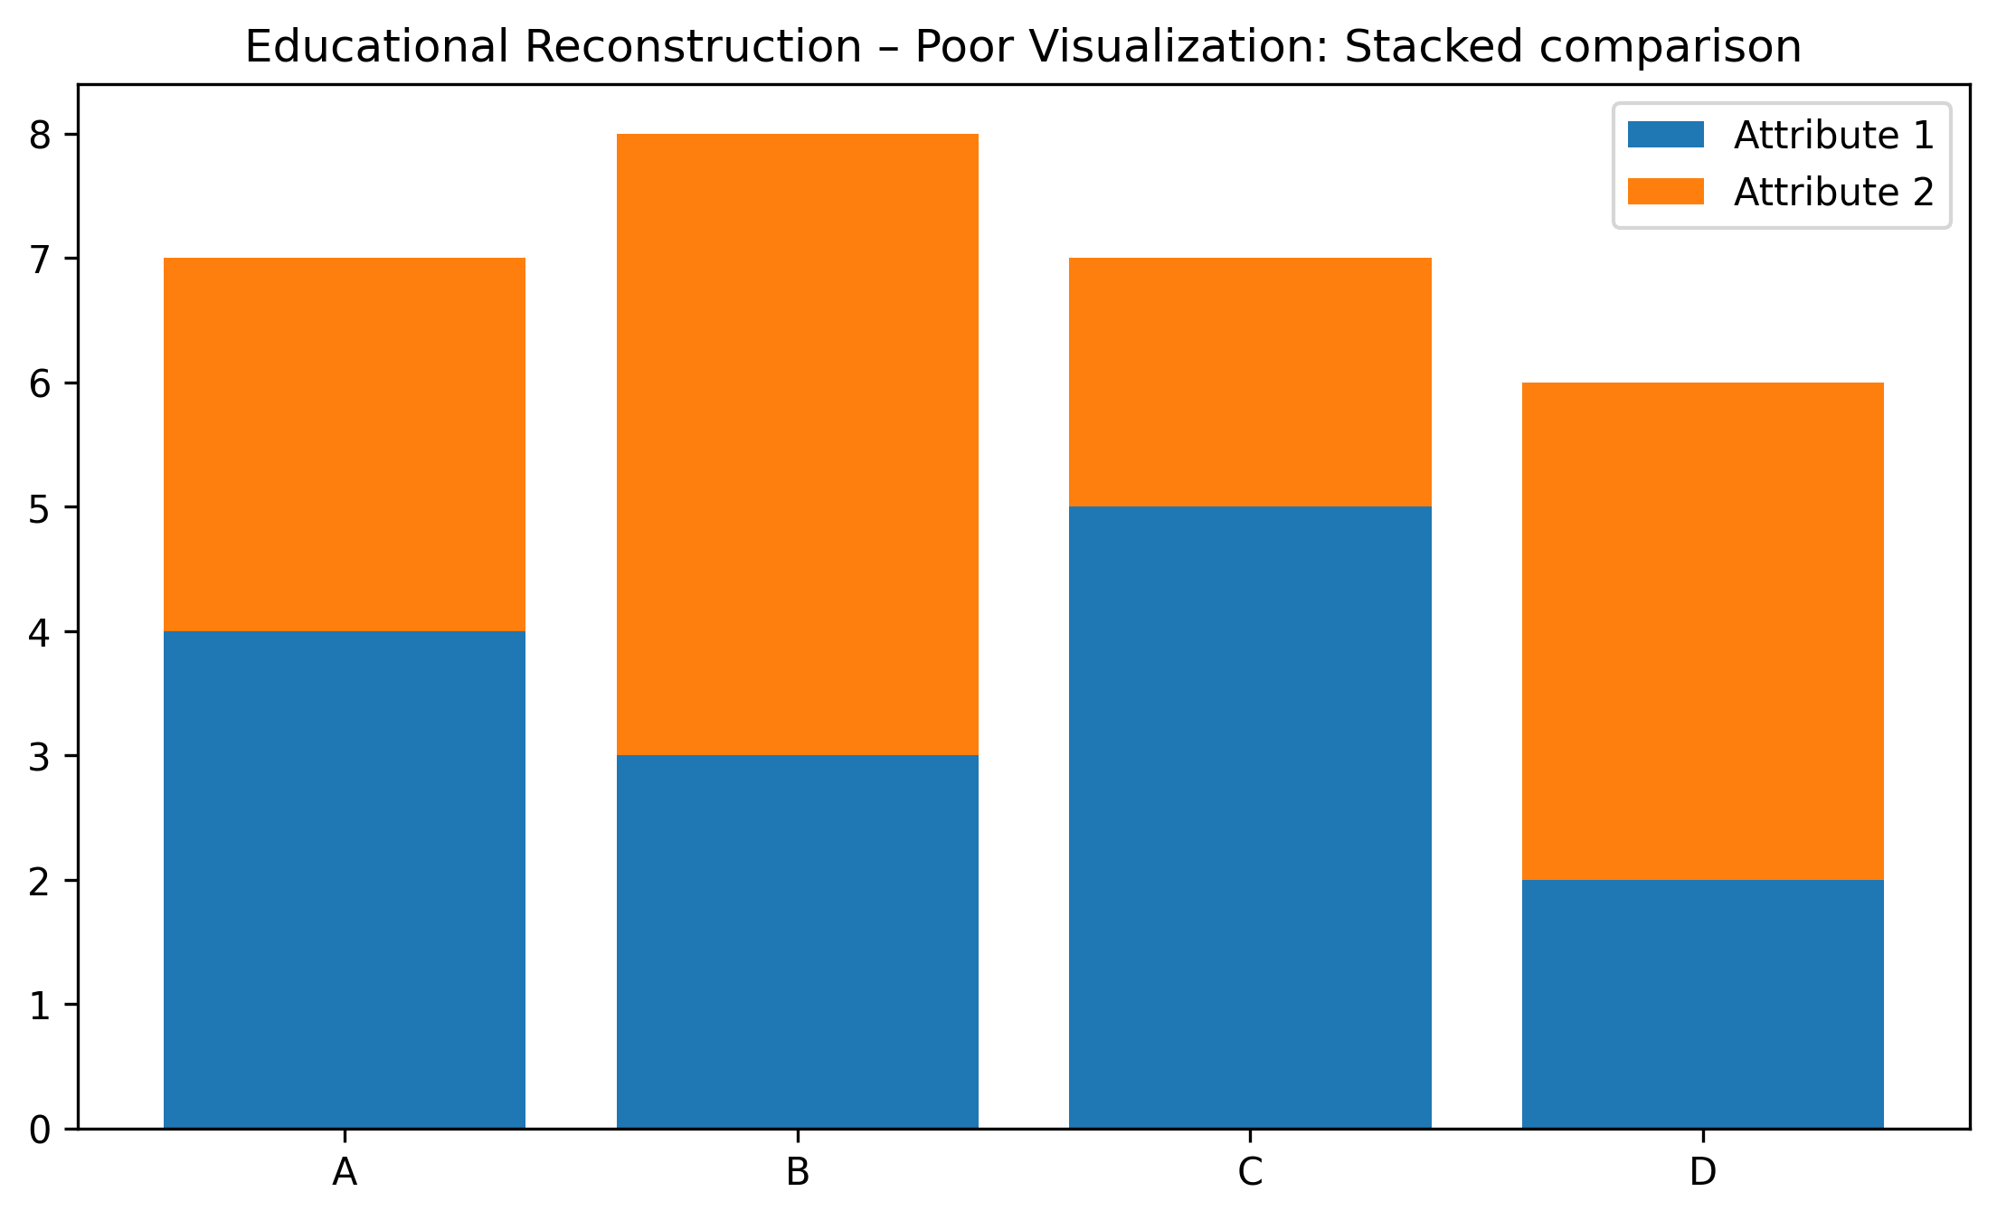
Figure 2. Educational reconstruction illustrating the selected visualization problem.

10. IMPROVED VISUALIZATION
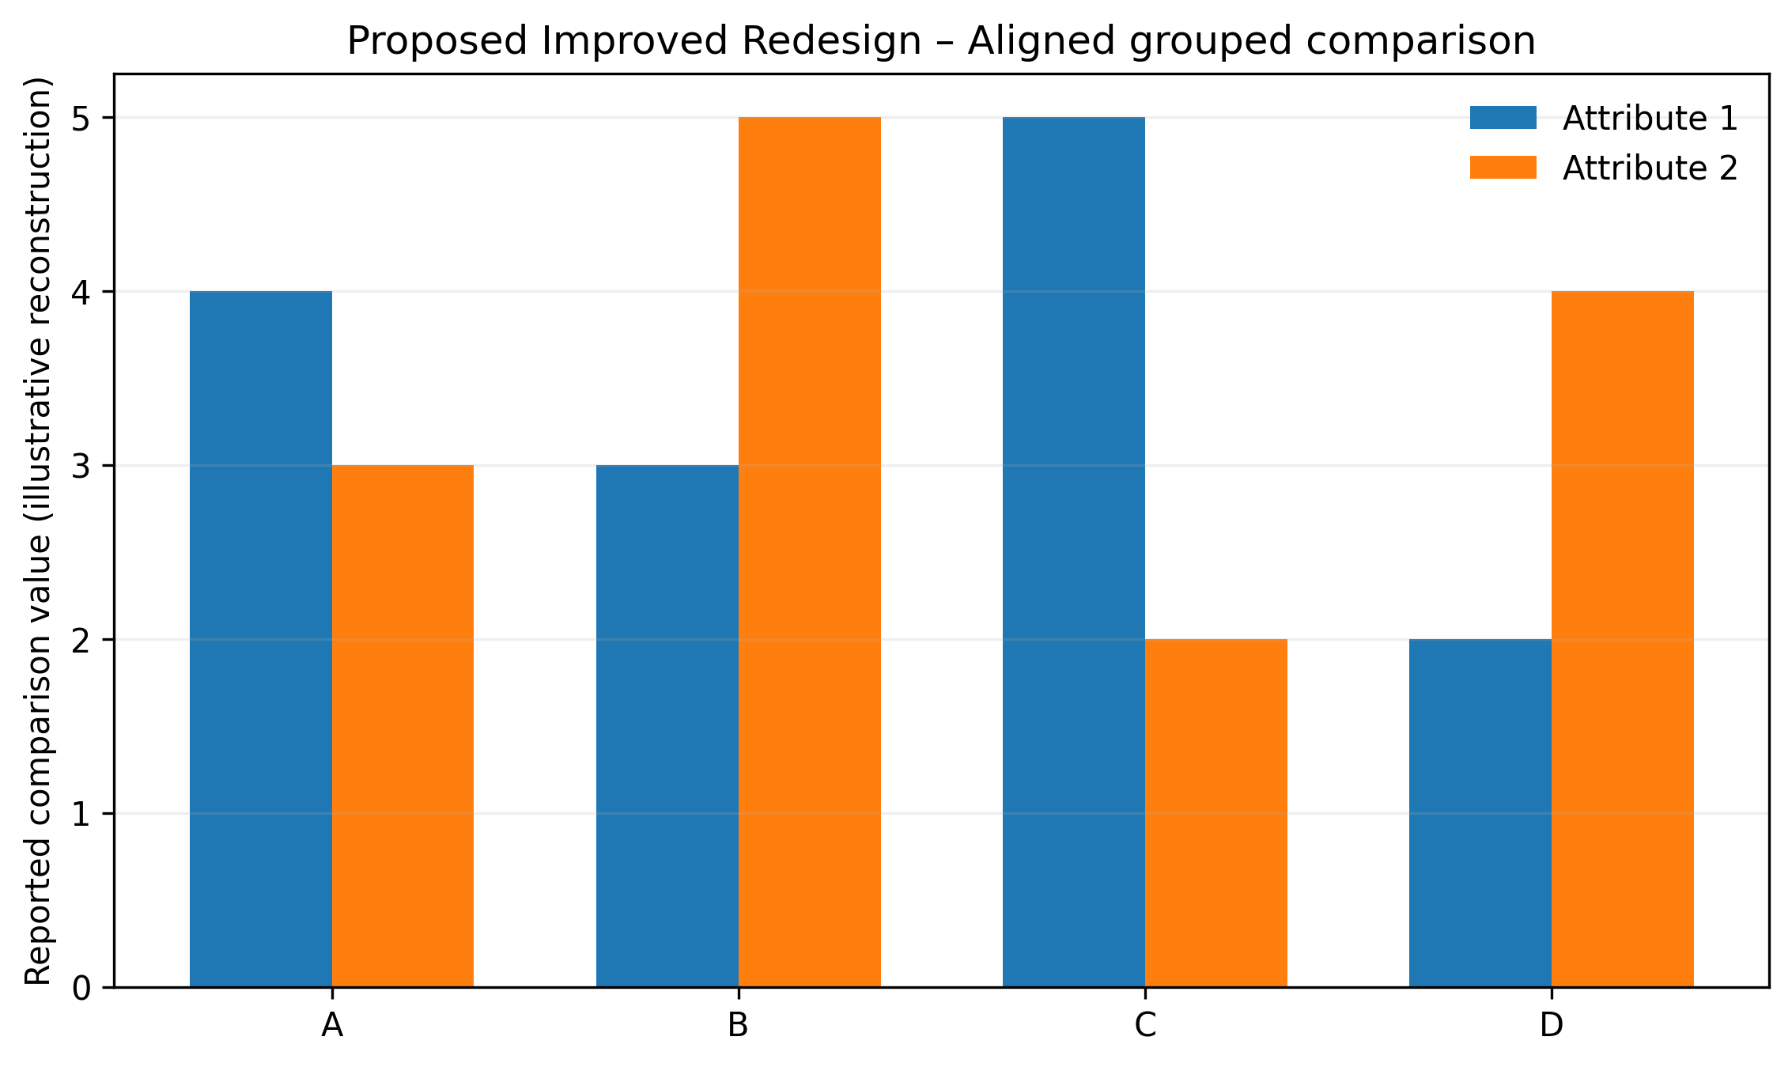
Figure 2. Proposed redesigned visualization using improved graphical encoding.

11. GRAPHICAL ENCODING CHANGES
The redesign prioritizes aligned position, length, spatial grouping, restrained categorical encoding, explicit direction, and/or selective salience according to the visual task. Redundant decoration is minimized.

12. BEFORE vs AFTER COMPARISON
Aspect | Original / Poor Design | Improved Design
Chart type | Stacked bar chart | Stacked bar chart with clearer task-oriented structure
Scale | May require extra visual search | Consistent and task-aligned where applicable
Encoding | Multiple or competing cues | Primary cue emphasized
Labels | Potentially dispersed | Grouped / directly associated
Color | Used cautiously; avoid unnecessary competition | Restrained, accessible emphasis
Comparison | May require cross-reference | Aligned or spatially grouped
Cognitive load | Higher when elements compete | Reduced through hierarchy and grouping
Accessibility | Avoid reliance on color alone | Use position, labels, and shape/line cues where useful

13. PYTHON CODE
# The efficacy of stacked bar charts in supporting single-attribute and overall-attribute comparisons
# Educational reconstruction for M.E. CSE Data Visualization Exercise-2.
# The reconstruction is NOT a reproduction of the authors' research findings.
# Replace only with published numerical values when the source provides them.
import matplotlib.pyplot as plt
import numpy as np

# Illustrative reconstruction data / structure:
cats=["A","B","C","D"]; a=np.array([4,3,5,2]); b=np.array([3,5,2,4])

# Plot:
fig,ax=plt.subplots(figsize=(9,5)); x=np.arange(4); w=.35
ax.bar(x-w/2,a,w,label="Attribute 1"); ax.bar(x+w/2,b,w,label="Attribute 2")
ax.set_xticks(x,cats); ax.set_ylabel("Illustrative comparison value"); ax.legend(frameon=False)

plt.tight_layout()
plt.savefig("/mnt/data/exercise2_research_redesign/visualizations/paper_02_improved.png", dpi=300, bbox_inches="tight")
plt.show()
Complete executable file: python/paper_02_improved.py

14. ANALYSIS
1. Information represented: the selected paper's visual representation supports understanding of perception / comparison concepts. 2. Graphical marks: marks appropriate to the selected stacked bar chart are used. 3. Visual variables: position, length, direction, grouping, size, or restrained color are used as applicable. 4. Perception task: the viewer must identify structure, compare elements, follow a process, or locate relationships. 5. Difficulties: Segment alignment makes some cross-category comparisons harder than aligned-position alternatives. 6. Redesign change: the visual hierarchy and encoding were simplified. 7. Readability: aligned and grouped encodings reduce visual search. 8. Data preservation: no research conclusion is changed. 9. Limitation: where exact source values were unavailable, the figure is explicitly an educational structural reconstruction rather than an exact numerical reproduction.

15. RESULT
The selected visualization was evaluated and redesigned using relevant visual perception and graphical encoding principles. The redesign improves the clarity of the intended visual task while preserving the source paper's conceptual meaning.

16. RESEARCH PAPER REFERENCE
Xiong et al.. “The efficacy of stacked bar charts in supporting single-attribute and overall-attribute comparisons,” Visual Informatics, Vol. 2, Issue 3, pp. 155–165, 2018. DOI: 10.1016/j.visinf.2018.09.002.

17. DOWNLOADABLE PAPER LINK
Publisher / database page: https://www.sciencedirect.com/science/article/pii/S2468502X18300287
Direct PDF: https://www.sciencedirect.com/science/article/pii/S2468502X18300287/pdfft
PDF access: publisher page checked for open-access/free full-text availability at preparation time.

PAPER 3

1. RESEARCH PAPER DETAILS
Authors: Liu et al.
Title: Visual Analytics in Deep Learning: An Interrogative Survey for the Next Frontiers
Journal/Conference: IEEE Transactions on Visualization and Computer Graphics, Vol. 25, No. 8, pp. 2674–2693
Year: 2019
DOI: 10.1109/TVCG.2018.2843369
Database: IEEE Xplore
Open-access status: Publisher page marked the article as open access / under a Creative Commons license.

2. AIM
To redesign a multidimensional survey framework so that the main interrogative dimensions are easier to scan and distinguish.

3. RESEARCH PROBLEM / CONTEXT
The paper addresses machine-learning visualization and uses visual representations to communicate relationships, processes, comparisons, or analytical structures. The selected figure is treated as a source representation for this laboratory exercise, not as a 'bad' figure.

4. ORIGINAL VISUALIZATION SELECTED
Selected source representation: Five-W/How human-centered framework visualization.
The published research paper was selected as a source for evaluating one of its visual representations. The visualization was critically examined using visual perception and graphical encoding principles, and an improved redesign was developed for this laboratory exercise.
Original figure handling: the source figure is identified by figure number and linked to the publisher PDF. The images generated in this package are explicitly educational reconstructions and proposed redesigns; they are not presented as the authors' original artwork.

5. DESCRIPTION OF ORIGINAL VISUALIZATION
The selected visualization is a multidimensional framework diagram used to support the paper's analytical or explanatory narrative. Its principal visual task is to help the reader identify structure, compare elements, follow relationships, or understand a multistage process.

6. VISUAL PERCEPTION ANALYSIS
The redesign emphasizes position, length, proximity, similarity, hierarchy, figure-ground separation, and visual salience where appropriate. The main concern is to reduce unnecessary search and make the intended comparison or reading path more immediate.

7. GRAPHICAL ENCODING ANALYSIS
DATA → VISUAL VARIABLE → GRAPHICAL ENCODING → PERCEPTION → INTERPRETATION
For this paper, the primary encoding is based on multidimensional framework diagram. The redesign changes the arrangement, alignment, emphasis, or grouping rather than changing the research claim.

8. PROBLEMS IDENTIFIED
Many conceptual dimensions can compete for attention; grouping and progressive emphasis can reduce cognitive load.
Only defensible design observations are used. The exercise does not label the published visualization as defective; it evaluates one representation for a specific educational redesign objective.

9. INTENTIONALLY POOR VISUALIZATION
Educational Reconstruction – Poor Visualization. This version is created only to demonstrate the selected visualization principle and is not the chart published by the authors.
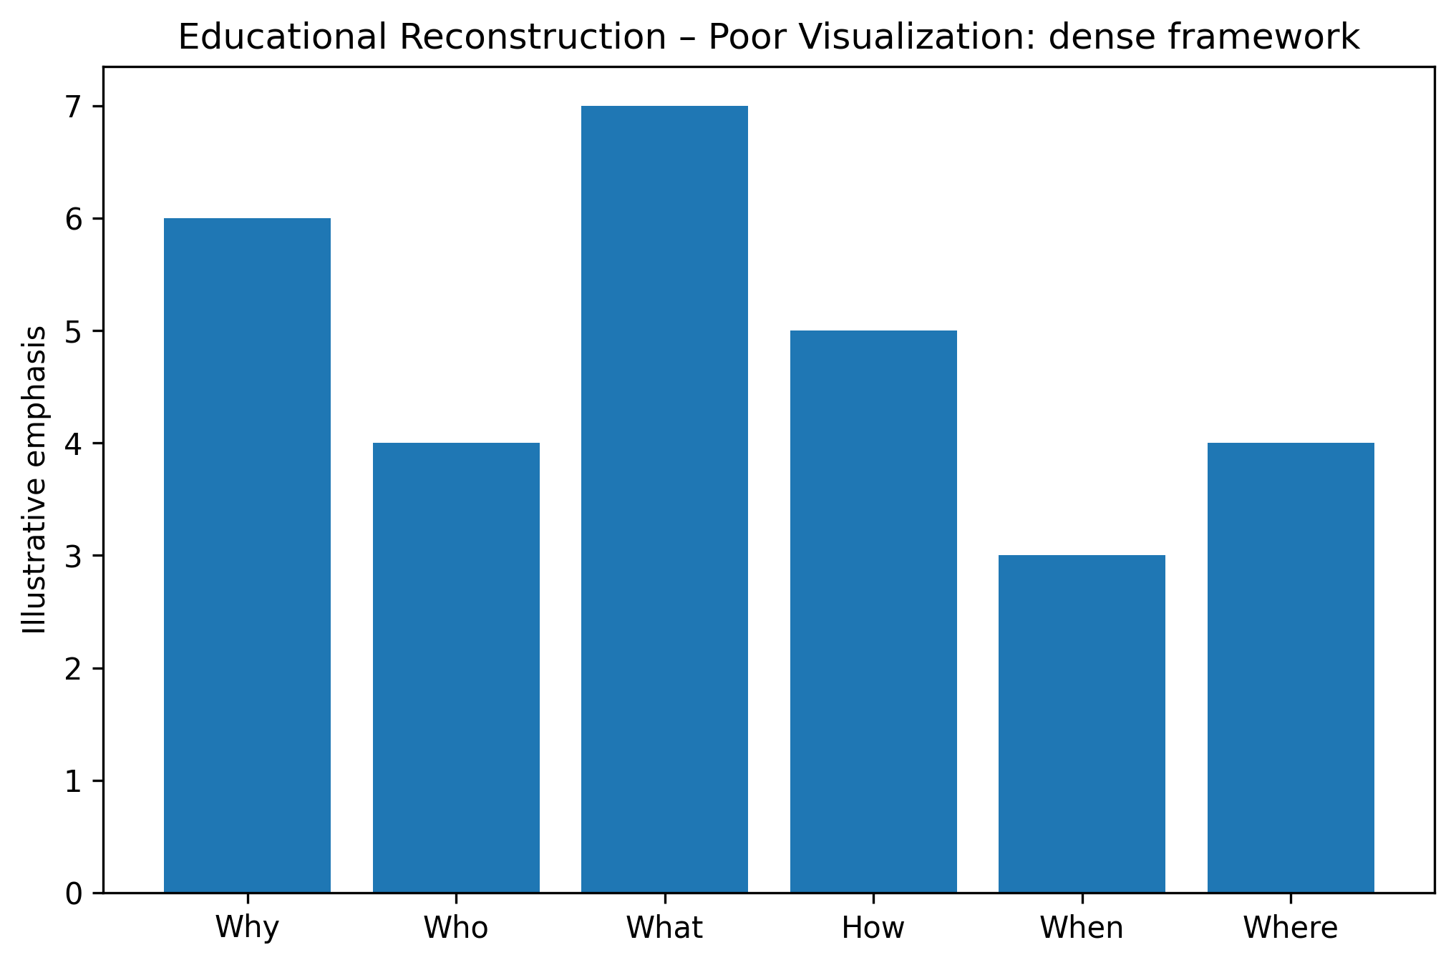
Figure 3. Educational reconstruction illustrating the selected visualization problem.

10. IMPROVED VISUALIZATION
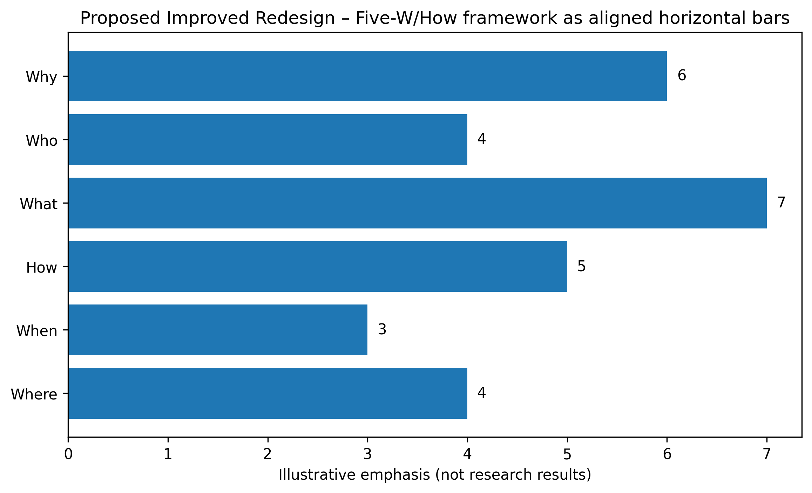
Figure 3. Proposed redesigned visualization using improved graphical encoding.

11. GRAPHICAL ENCODING CHANGES
The redesign prioritizes aligned position, length, spatial grouping, restrained categorical encoding, explicit direction, and/or selective salience according to the visual task. Redundant decoration is minimized.

12. BEFORE vs AFTER COMPARISON
Aspect | Original / Poor Design | Improved Design
Chart type | Multidimensional framework diagram | Multidimensional framework diagram with clearer task-oriented structure
Scale | May require extra visual search | Consistent and task-aligned where applicable
Encoding | Multiple or competing cues | Primary cue emphasized
Labels | Potentially dispersed | Grouped / directly associated
Color | Used cautiously; avoid unnecessary competition | Restrained, accessible emphasis
Comparison | May require cross-reference | Aligned or spatially grouped
Cognitive load | Higher when elements compete | Reduced through hierarchy and grouping
Accessibility | Avoid reliance on color alone | Use position, labels, and shape/line cues where useful

13. PYTHON CODE
# Visual Analytics in Deep Learning: An Interrogative Survey for the Next Frontiers
# Educational reconstruction for M.E. CSE Data Visualization Exercise-2.
# The reconstruction is NOT a reproduction of the authors' research findings.
# Replace only with published numerical values when the source provides them.
import matplotlib.pyplot as plt
import numpy as np

# Illustrative reconstruction data / structure:
cats=["Why","Who","What","How","When","Where"]; vals=[6,4,7,5,3,4]

# Plot:
fig,ax=plt.subplots(figsize=(9,5)); y=np.arange(len(cats)); ax.barh(y,vals)
ax.set_yticks(y,cats); ax.invert_yaxis(); ax.set_xlabel("Illustrative emphasis")

plt.tight_layout()
plt.savefig("/mnt/data/exercise2_research_redesign/visualizations/paper_03_improved.png", dpi=300, bbox_inches="tight")
plt.show()
Complete executable file: python/paper_03_improved.py

14. ANALYSIS
1. Information represented: the selected paper's visual representation supports understanding of machine-learning visualization concepts. 2. Graphical marks: marks appropriate to the selected multidimensional framework diagram are used. 3. Visual variables: position, length, direction, grouping, size, or restrained color are used as applicable. 4. Perception task: the viewer must identify structure, compare elements, follow a process, or locate relationships. 5. Difficulties: Many conceptual dimensions can compete for attention; grouping and progressive emphasis can reduce cognitive load. 6. Redesign change: the visual hierarchy and encoding were simplified. 7. Readability: aligned and grouped encodings reduce visual search. 8. Data preservation: no research conclusion is changed. 9. Limitation: where exact source values were unavailable, the figure is explicitly an educational structural reconstruction rather than an exact numerical reproduction.

15. RESULT
The selected visualization was evaluated and redesigned using relevant visual perception and graphical encoding principles. The redesign improves the clarity of the intended visual task while preserving the source paper's conceptual meaning.

16. RESEARCH PAPER REFERENCE
Liu et al.. “Visual Analytics in Deep Learning: An Interrogative Survey for the Next Frontiers,” IEEE Transactions on Visualization and Computer Graphics, Vol. 25, No. 8, pp. 2674–2693, 2019. DOI: 10.1109/TVCG.2018.2843369.

17. DOWNLOADABLE PAPER LINK
Publisher / database page: https://ieeexplore.ieee.org/abstract/document/8371286
Direct PDF: https://ieeexplore.ieee.org/stamp/stamp.jsp?tp=&arnumber=8371286
PDF access: publisher page checked for open-access/free full-text availability at preparation time.

PAPER 4

1. RESEARCH PAPER DETAILS
Authors: Pinaud et al.
Title: Toward automatic comparison of visualization techniques: Application to graph visualization
Journal/Conference: Visual Informatics, Vol. 4, Issue 2, pp. 86–98
Year: 2020
DOI: 10.1016/j.visinf.2020.04.002
Database: ScienceDirect
Open-access status: Publisher page marked the article as open access / under a Creative Commons license.

2. AIM
To redesign the experimental protocol into a visually ordered workflow that separates generation, training, evaluation, and statistical comparison.

3. RESEARCH PROBLEM / CONTEXT
The paper addresses graph visualization and uses visual representations to communicate relationships, processes, comparisons, or analytical structures. The selected figure is treated as a source representation for this laboratory exercise, not as a 'bad' figure.

4. ORIGINAL VISUALIZATION SELECTED
Selected source representation: Fig. 1 / experimental protocol comparing node-link and adjacency-matrix representations.
The published research paper was selected as a source for evaluating one of its visual representations. The visualization was critically examined using visual perception and graphical encoding principles, and an improved redesign was developed for this laboratory exercise.
Original figure handling: the source figure is identified by figure number and linked to the publisher PDF. The images generated in this package are explicitly educational reconstructions and proposed redesigns; they are not presented as the authors' original artwork.

5. DESCRIPTION OF ORIGINAL VISUALIZATION
The selected visualization is a workflow diagram used to support the paper's analytical or explanatory narrative. Its principal visual task is to help the reader identify structure, compare elements, follow relationships, or understand a multistage process.

6. VISUAL PERCEPTION ANALYSIS
The redesign emphasizes position, length, proximity, similarity, hierarchy, figure-ground separation, and visual salience where appropriate. The main concern is to reduce unnecessary search and make the intended comparison or reading path more immediate.

7. GRAPHICAL ENCODING ANALYSIS
DATA → VISUAL VARIABLE → GRAPHICAL ENCODING → PERCEPTION → INTERPRETATION
For this paper, the primary encoding is based on workflow diagram. The redesign changes the arrangement, alignment, emphasis, or grouping rather than changing the research claim.

8. PROBLEMS IDENTIFIED
Multiple stages and representation types can become visually dense; explicit phase grouping improves reading order.
Only defensible design observations are used. The exercise does not label the published visualization as defective; it evaluates one representation for a specific educational redesign objective.

9. INTENTIONALLY POOR VISUALIZATION
Educational Reconstruction – Poor Visualization. This version is created only to demonstrate the selected visualization principle and is not the chart published by the authors.
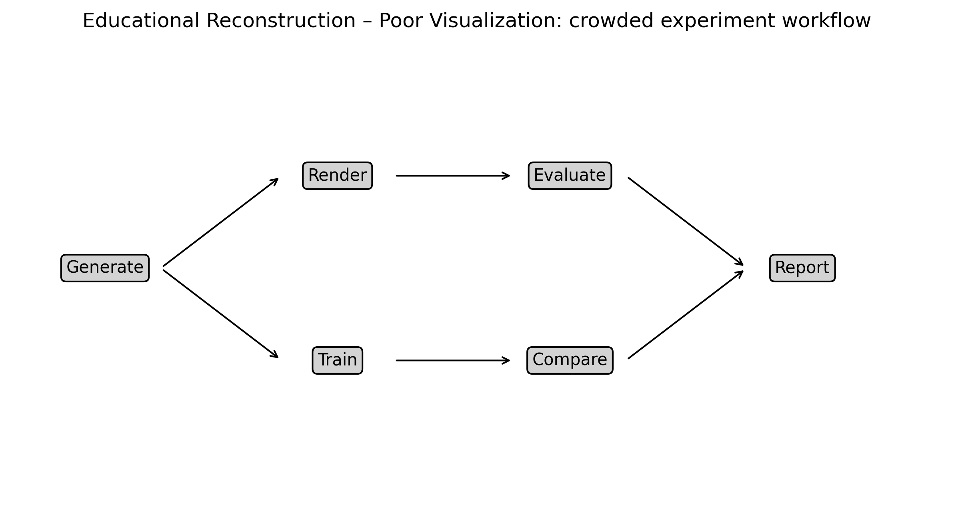
Figure 4. Educational reconstruction illustrating the selected visualization problem.

10. IMPROVED VISUALIZATION
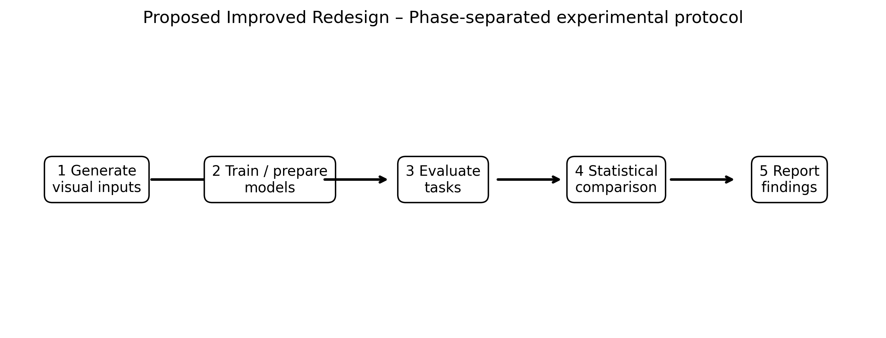
Figure 4. Proposed redesigned visualization using improved graphical encoding.

11. GRAPHICAL ENCODING CHANGES
The redesign prioritizes aligned position, length, spatial grouping, restrained categorical encoding, explicit direction, and/or selective salience according to the visual task. Redundant decoration is minimized.

12. BEFORE vs AFTER COMPARISON
Aspect | Original / Poor Design | Improved Design
Chart type | Workflow diagram | Workflow diagram with clearer task-oriented structure
Scale | May require extra visual search | Consistent and task-aligned where applicable
Encoding | Multiple or competing cues | Primary cue emphasized
Labels | Potentially dispersed | Grouped / directly associated
Color | Used cautiously; avoid unnecessary competition | Restrained, accessible emphasis
Comparison | May require cross-reference | Aligned or spatially grouped
Cognitive load | Higher when elements compete | Reduced through hierarchy and grouping
Accessibility | Avoid reliance on color alone | Use position, labels, and shape/line cues where useful

13. PYTHON CODE
# Toward automatic comparison of visualization techniques: Application to graph visualization
# Educational reconstruction for M.E. CSE Data Visualization Exercise-2.
# The reconstruction is NOT a reproduction of the authors' research findings.
# Replace only with published numerical values when the source provides them.
import matplotlib.pyplot as plt
import numpy as np

# Illustrative reconstruction data / structure:
stages=["Generate","Train","Evaluate","Compare","Report"]

# Plot:
fig,ax=plt.subplots(figsize=(11,3.8)); ax.axis("off"); xs=np.linspace(.1,.9,5)
for k,(x,s) in enumerate(zip(xs,stages)):
ax.text(x,.5,s,ha="center",va="center",bbox=dict(boxstyle="round",facecolor="white",edgecolor="black"))
if k<4: ax.annotate("",(xs[k+1]-.06,.5),(x+.06,.5),arrowprops=dict(arrowstyle="->",lw=1.8))

plt.tight_layout()
plt.savefig("/mnt/data/exercise2_research_redesign/visualizations/paper_04_improved.png", dpi=300, bbox_inches="tight")
plt.show()
Complete executable file: python/paper_04_improved.py

14. ANALYSIS
1. Information represented: the selected paper's visual representation supports understanding of graph visualization concepts. 2. Graphical marks: marks appropriate to the selected workflow diagram are used. 3. Visual variables: position, length, direction, grouping, size, or restrained color are used as applicable. 4. Perception task: the viewer must identify structure, compare elements, follow a process, or locate relationships. 5. Difficulties: Multiple stages and representation types can become visually dense; explicit phase grouping improves reading order. 6. Redesign change: the visual hierarchy and encoding were simplified. 7. Readability: aligned and grouped encodings reduce visual search. 8. Data preservation: no research conclusion is changed. 9. Limitation: where exact source values were unavailable, the figure is explicitly an educational structural reconstruction rather than an exact numerical reproduction.

15. RESULT
The selected visualization was evaluated and redesigned using relevant visual perception and graphical encoding principles. The redesign improves the clarity of the intended visual task while preserving the source paper's conceptual meaning.

16. RESEARCH PAPER REFERENCE
Pinaud et al.. “Toward automatic comparison of visualization techniques: Application to graph visualization,” Visual Informatics, Vol. 4, Issue 2, pp. 86–98, 2020. DOI: 10.1016/j.visinf.2020.04.002.

17. DOWNLOADABLE PAPER LINK
Publisher / database page: https://www.sciencedirect.com/science/article/pii/S2468502X20300140
Direct PDF: https://www.sciencedirect.com/science/article/pii/S2468502X20300140/pdfft
PDF access: publisher page checked for open-access/free full-text availability at preparation time.

PAPER 5

1. RESEARCH PAPER DETAILS
Authors: Carrascal et al.
Title: A Model for Types and Levels of Automation in Visual Analytics: A Survey, a Taxonomy, and Examples
Journal/Conference: IEEE Transactions on Visualization and Computer Graphics, Vol. 29, No. 8, pp. 3550–3568
Year: 2023
DOI: 10.1109/TVCG.2022.3163765
Database: IEEE Xplore
Open-access status: Publisher page marked the article as open access / under a Creative Commons license.

2. AIM
To improve the readability of a taxonomy by using explicit level bands, aligned labels, and restrained categorical encoding.

3. RESEARCH PROBLEM / CONTEXT
The paper addresses human–automation visual analytics and uses visual representations to communicate relationships, processes, comparisons, or analytical structures. The selected figure is treated as a source representation for this laboratory exercise, not as a 'bad' figure.

4. ORIGINAL VISUALIZATION SELECTED
Selected source representation: Automation taxonomy / levels mapping.
The published research paper was selected as a source for evaluating one of its visual representations. The visualization was critically examined using visual perception and graphical encoding principles, and an improved redesign was developed for this laboratory exercise.
Original figure handling: the source figure is identified by figure number and linked to the publisher PDF. The images generated in this package are explicitly educational reconstructions and proposed redesigns; they are not presented as the authors' original artwork.

5. DESCRIPTION OF ORIGINAL VISUALIZATION
The selected visualization is a taxonomy / matrix used to support the paper's analytical or explanatory narrative. Its principal visual task is to help the reader identify structure, compare elements, follow relationships, or understand a multistage process.

6. VISUAL PERCEPTION ANALYSIS
The redesign emphasizes position, length, proximity, similarity, hierarchy, figure-ground separation, and visual salience where appropriate. The main concern is to reduce unnecessary search and make the intended comparison or reading path more immediate.

7. GRAPHICAL ENCODING ANALYSIS
DATA → VISUAL VARIABLE → GRAPHICAL ENCODING → PERCEPTION → INTERPRETATION
For this paper, the primary encoding is based on taxonomy / matrix. The redesign changes the arrangement, alignment, emphasis, or grouping rather than changing the research claim.

8. PROBLEMS IDENTIFIED
Taxonomy levels and dimensions can be difficult to compare when the hierarchy is not visually isolated.
Only defensible design observations are used. The exercise does not label the published visualization as defective; it evaluates one representation for a specific educational redesign objective.

9. INTENTIONALLY POOR VISUALIZATION
Educational Reconstruction – Poor Visualization. This version is created only to demonstrate the selected visualization principle and is not the chart published by the authors.
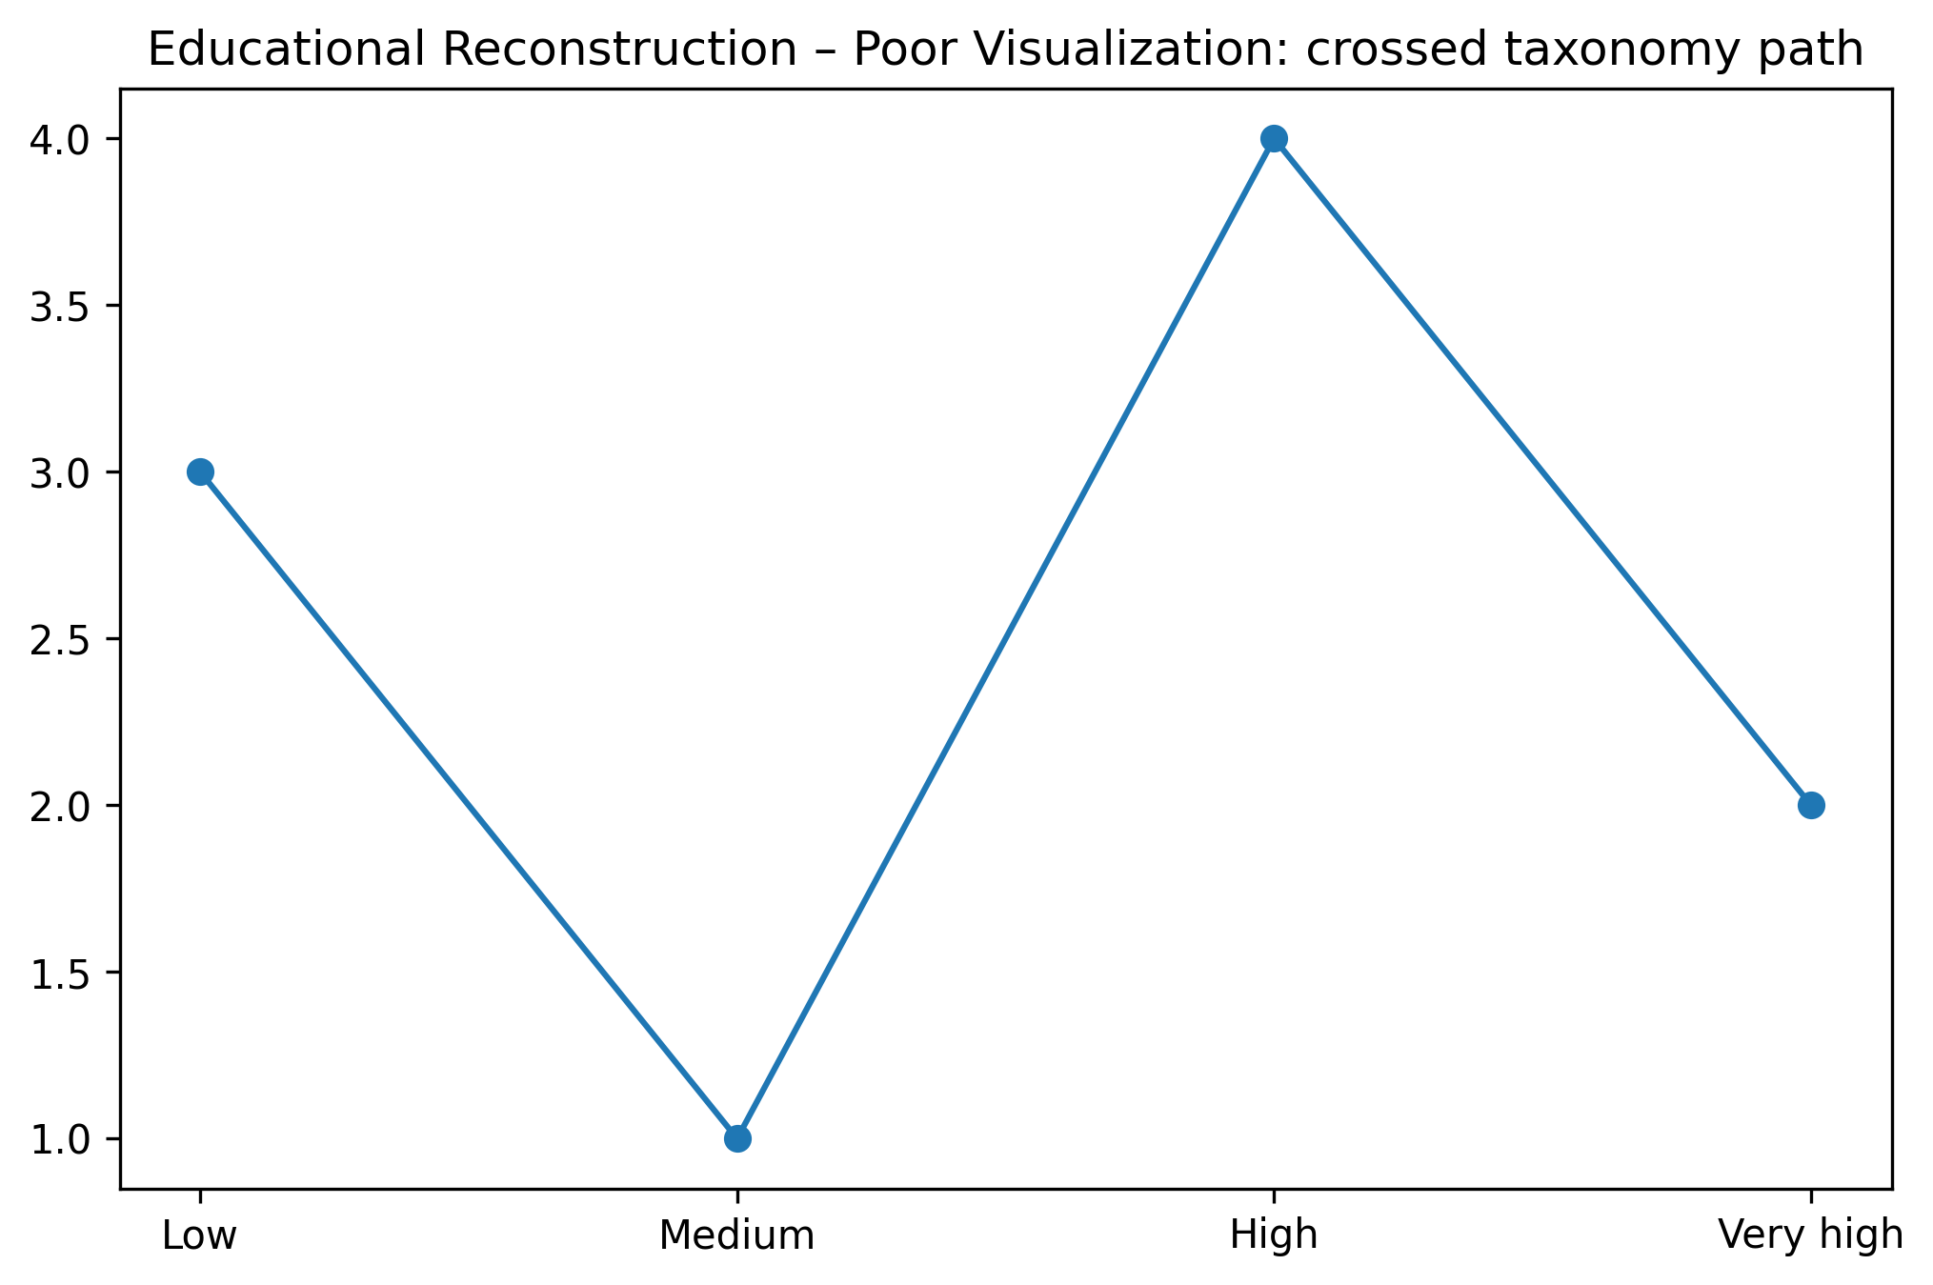
Figure 5. Educational reconstruction illustrating the selected visualization problem.

10. IMPROVED VISUALIZATION
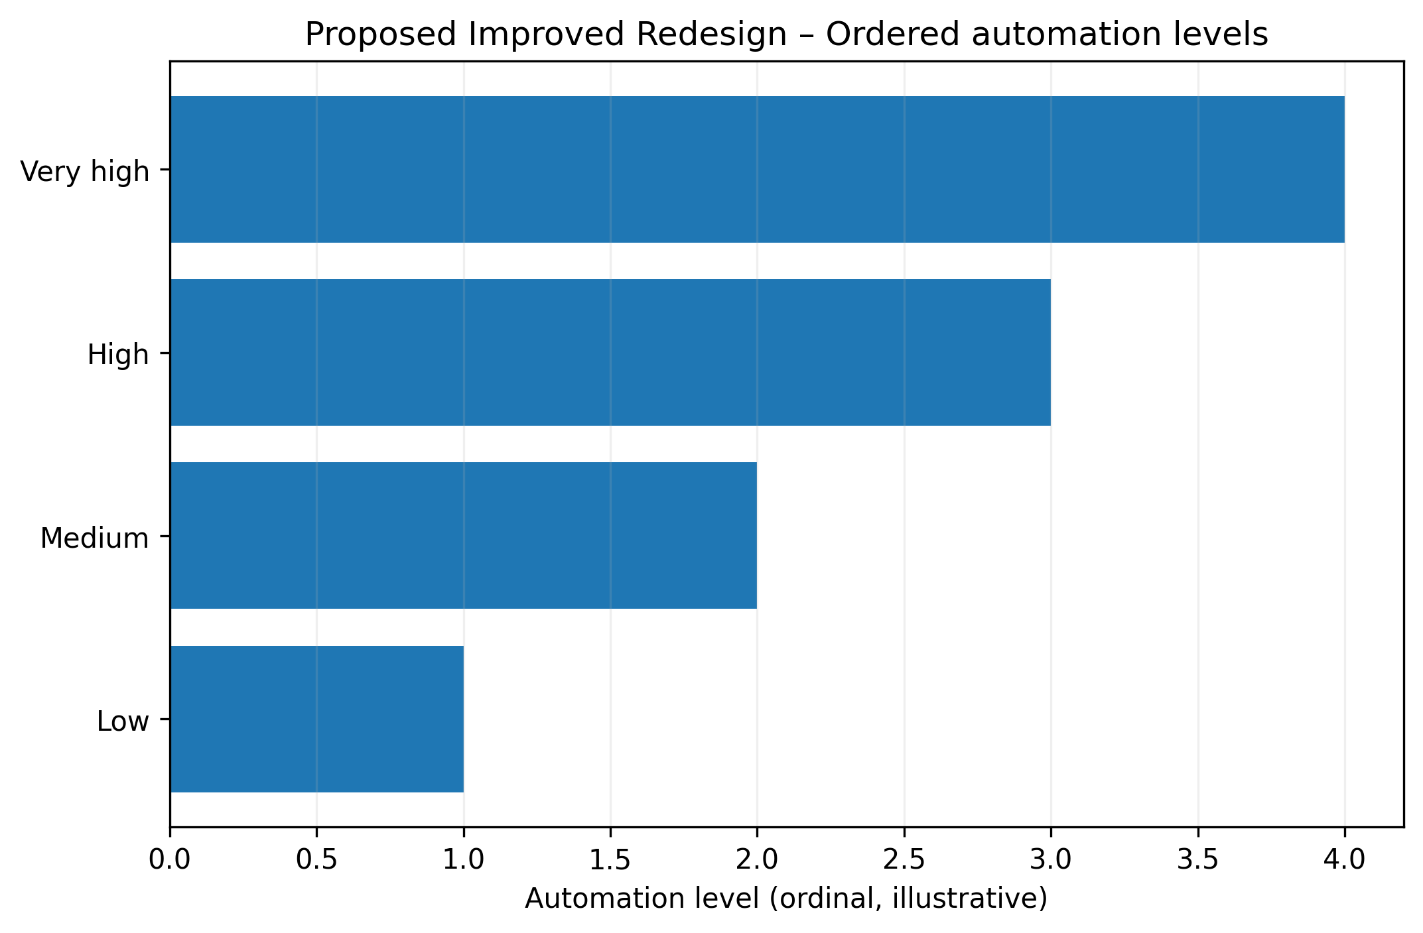
Figure 5. Proposed redesigned visualization using improved graphical encoding.

11. GRAPHICAL ENCODING CHANGES
The redesign prioritizes aligned position, length, spatial grouping, restrained categorical encoding, explicit direction, and/or selective salience according to the visual task. Redundant decoration is minimized.

12. BEFORE vs AFTER COMPARISON
Aspect | Original / Poor Design | Improved Design
Chart type | Taxonomy / matrix | Taxonomy / matrix with clearer task-oriented structure
Scale | May require extra visual search | Consistent and task-aligned where applicable
Encoding | Multiple or competing cues | Primary cue emphasized
Labels | Potentially dispersed | Grouped / directly associated
Color | Used cautiously; avoid unnecessary competition | Restrained, accessible emphasis
Comparison | May require cross-reference | Aligned or spatially grouped
Cognitive load | Higher when elements compete | Reduced through hierarchy and grouping
Accessibility | Avoid reliance on color alone | Use position, labels, and shape/line cues where useful

13. PYTHON CODE
# A Model for Types and Levels of Automation in Visual Analytics: A Survey, a Taxonomy, and Examples
# Educational reconstruction for M.E. CSE Data Visualization Exercise-2.
# The reconstruction is NOT a reproduction of the authors' research findings.
# Replace only with published numerical values when the source provides them.
import matplotlib.pyplot as plt
import numpy as np

# Illustrative reconstruction data / structure:
levels=["Low","Medium","High","Very high"]; vals=[1,2,3,4]

# Plot:
fig,ax=plt.subplots(figsize=(8,5)); ax.barh(levels,vals); ax.set_xlabel("Ordinal automation level")

plt.tight_layout()
plt.savefig("/mnt/data/exercise2_research_redesign/visualizations/paper_05_improved.png", dpi=300, bbox_inches="tight")
plt.show()
Complete executable file: python/paper_05_improved.py

14. ANALYSIS
1. Information represented: the selected paper's visual representation supports understanding of human–automation visual analytics concepts. 2. Graphical marks: marks appropriate to the selected taxonomy / matrix are used. 3. Visual variables: position, length, direction, grouping, size, or restrained color are used as applicable. 4. Perception task: the viewer must identify structure, compare elements, follow a process, or locate relationships. 5. Difficulties: Taxonomy levels and dimensions can be difficult to compare when the hierarchy is not visually isolated. 6. Redesign change: the visual hierarchy and encoding were simplified. 7. Readability: aligned and grouped encodings reduce visual search. 8. Data preservation: no research conclusion is changed. 9. Limitation: where exact source values were unavailable, the figure is explicitly an educational structural reconstruction rather than an exact numerical reproduction.

15. RESULT
The selected visualization was evaluated and redesigned using relevant visual perception and graphical encoding principles. The redesign improves the clarity of the intended visual task while preserving the source paper's conceptual meaning.

16. RESEARCH PAPER REFERENCE
Carrascal et al.. “A Model for Types and Levels of Automation in Visual Analytics: A Survey, a Taxonomy, and Examples,” IEEE Transactions on Visualization and Computer Graphics, Vol. 29, No. 8, pp. 3550–3568, 2023. DOI: 10.1109/TVCG.2022.3163765.

17. DOWNLOADABLE PAPER LINK
Publisher / database page: https://ieeexplore.ieee.org/document/9745848/
Direct PDF: https://ieeexplore.ieee.org/stamp/stamp.jsp?tp=&arnumber=9745848
PDF access: publisher page checked for open-access/free full-text availability at preparation time.

PAPER 6

1. RESEARCH PAPER DETAILS
Authors: Zhang et al.
Title: DataV: Data Visualization on large high-resolution displays
Journal/Conference: Visual Informatics, Vol. 4, Issue 3, pp. 12–23
Year: 2020
DOI: 10.1016/j.visinf.2020.07.001
Database: ScienceDirect
Open-access status: Publisher page marked the article as open access / under a Creative Commons license.

2. AIM
To redesign a large-display visualization layout using stronger grouping, whitespace, and primary-to-secondary hierarchy.

3. RESEARCH PROBLEM / CONTEXT
The paper addresses large-display visualization and uses visual representations to communicate relationships, processes, comparisons, or analytical structures. The selected figure is treated as a source representation for this laboratory exercise, not as a 'bad' figure.

4. ORIGINAL VISUALIZATION SELECTED
Selected source representation: DataV architecture / coordinated visualization examples.
The published research paper was selected as a source for evaluating one of its visual representations. The visualization was critically examined using visual perception and graphical encoding principles, and an improved redesign was developed for this laboratory exercise.
Original figure handling: the source figure is identified by figure number and linked to the publisher PDF. The images generated in this package are explicitly educational reconstructions and proposed redesigns; they are not presented as the authors' original artwork.

5. DESCRIPTION OF ORIGINAL VISUALIZATION
The selected visualization is a architecture / dashboard layout used to support the paper's analytical or explanatory narrative. Its principal visual task is to help the reader identify structure, compare elements, follow relationships, or understand a multistage process.

6. VISUAL PERCEPTION ANALYSIS
The redesign emphasizes position, length, proximity, similarity, hierarchy, figure-ground separation, and visual salience where appropriate. The main concern is to reduce unnecessary search and make the intended comparison or reading path more immediate.

7. GRAPHICAL ENCODING ANALYSIS
DATA → VISUAL VARIABLE → GRAPHICAL ENCODING → PERCEPTION → INTERPRETATION
For this paper, the primary encoding is based on architecture / dashboard layout. The redesign changes the arrangement, alignment, emphasis, or grouping rather than changing the research claim.

8. PROBLEMS IDENTIFIED
Multiple components compete for attention on large-display layouts; stronger grouping and whitespace can clarify the primary reading path.
Only defensible design observations are used. The exercise does not label the published visualization as defective; it evaluates one representation for a specific educational redesign objective.

9. INTENTIONALLY POOR VISUALIZATION
Educational Reconstruction – Poor Visualization. This version is created only to demonstrate the selected visualization principle and is not the chart published by the authors.
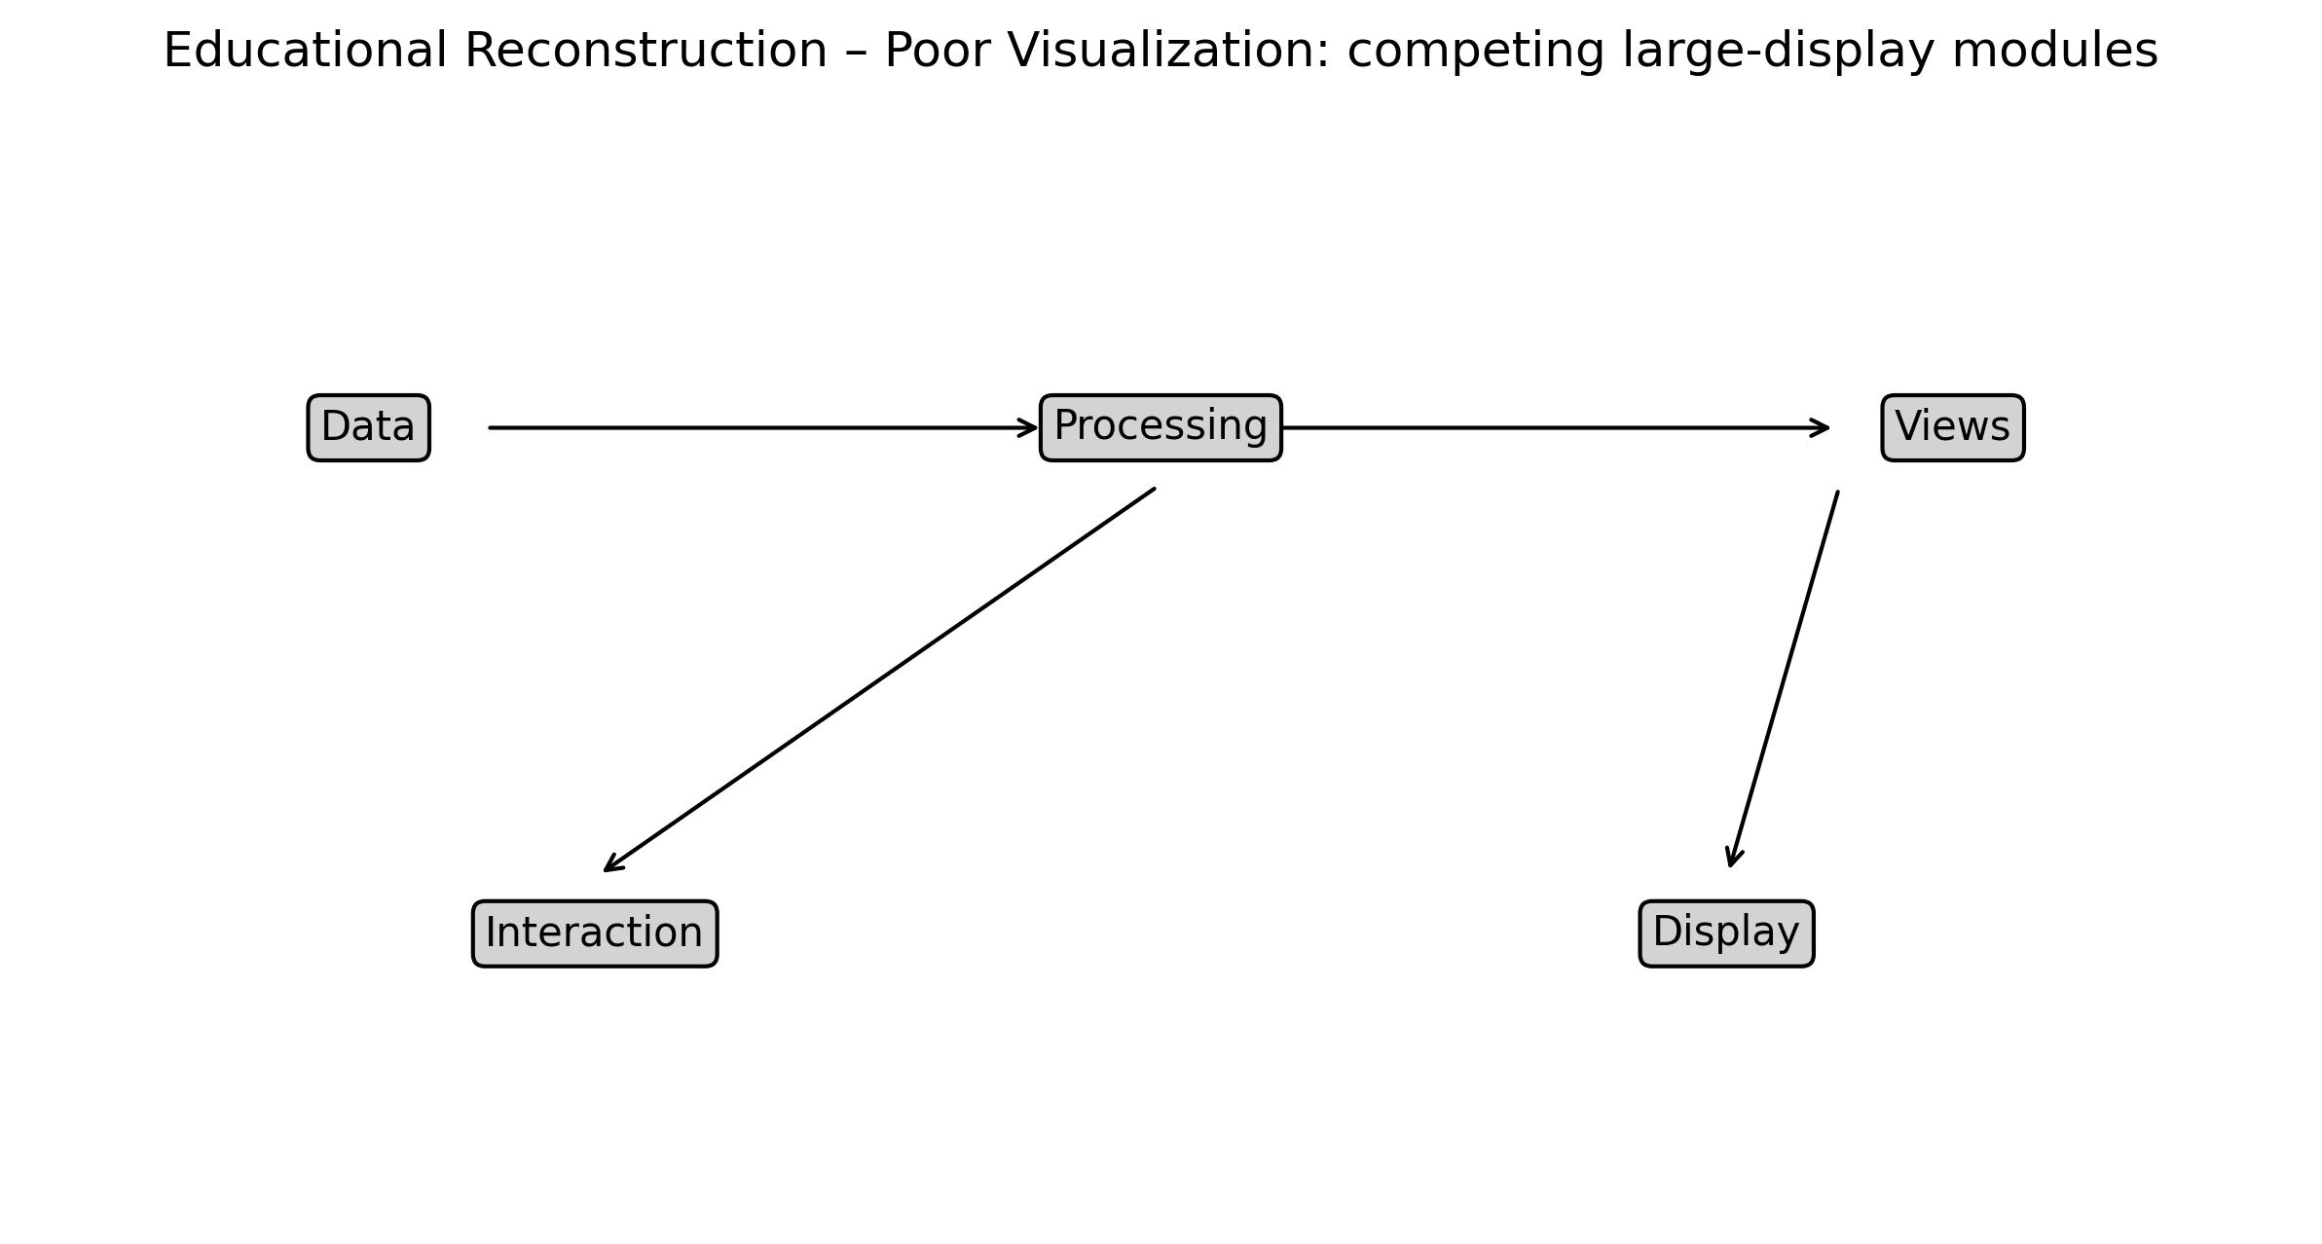
Figure 6. Educational reconstruction illustrating the selected visualization problem.

10. IMPROVED VISUALIZATION
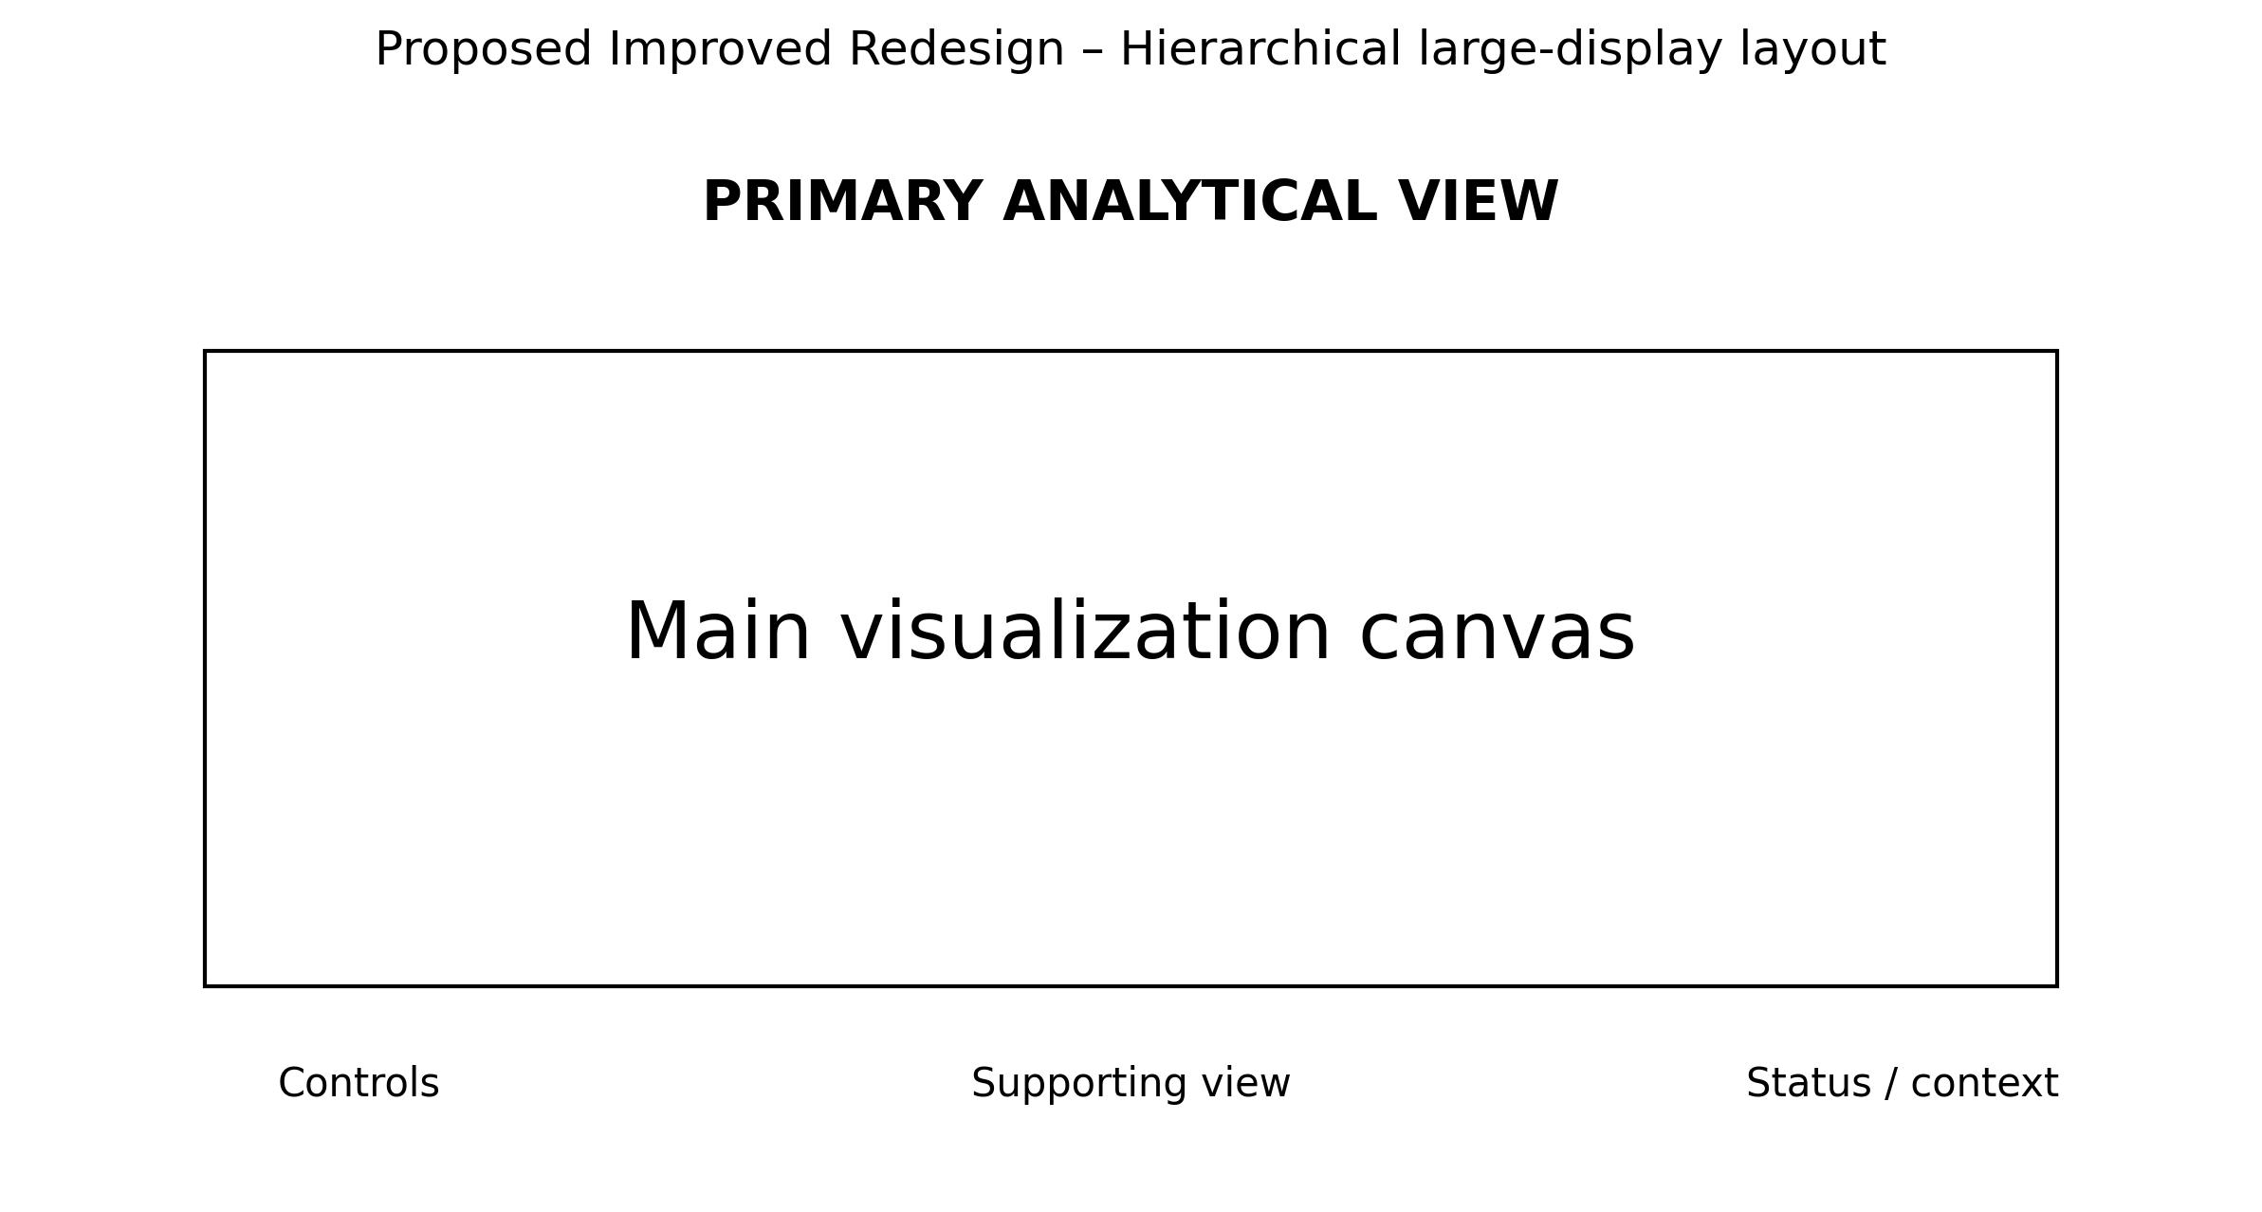
Figure 6. Proposed redesigned visualization using improved graphical encoding.

11. GRAPHICAL ENCODING CHANGES
The redesign prioritizes aligned position, length, spatial grouping, restrained categorical encoding, explicit direction, and/or selective salience according to the visual task. Redundant decoration is minimized.

12. BEFORE vs AFTER COMPARISON
Aspect | Original / Poor Design | Improved Design
Chart type | Architecture / dashboard layout | Architecture / dashboard layout with clearer task-oriented structure
Scale | May require extra visual search | Consistent and task-aligned where applicable
Encoding | Multiple or competing cues | Primary cue emphasized
Labels | Potentially dispersed | Grouped / directly associated
Color | Used cautiously; avoid unnecessary competition | Restrained, accessible emphasis
Comparison | May require cross-reference | Aligned or spatially grouped
Cognitive load | Higher when elements compete | Reduced through hierarchy and grouping
Accessibility | Avoid reliance on color alone | Use position, labels, and shape/line cues where useful

13. PYTHON CODE
# DataV: Data Visualization on large high-resolution displays
# Educational reconstruction for M.E. CSE Data Visualization Exercise-2.
# The reconstruction is NOT a reproduction of the authors' research findings.
# Replace only with published numerical values when the source provides them.
import matplotlib.pyplot as plt
import numpy as np

# Illustrative reconstruction data / structure:
components=["Primary view","Supporting view","Controls","Context"]; priority=[10,6,3,2]

# Plot:
fig,ax=plt.subplots(figsize=(8,5)); ax.barh(components,priority); ax.invert_yaxis(); ax.set_xlabel("Illustrative visual priority")

plt.tight_layout()
plt.savefig("/mnt/data/exercise2_research_redesign/visualizations/paper_06_improved.png", dpi=300, bbox_inches="tight")
plt.show()
Complete executable file: python/paper_06_improved.py

14. ANALYSIS
1. Information represented: the selected paper's visual representation supports understanding of large-display visualization concepts. 2. Graphical marks: marks appropriate to the selected architecture / dashboard layout are used. 3. Visual variables: position, length, direction, grouping, size, or restrained color are used as applicable. 4. Perception task: the viewer must identify structure, compare elements, follow a process, or locate relationships. 5. Difficulties: Multiple components compete for attention on large-display layouts; stronger grouping and whitespace can clarify the primary reading path. 6. Redesign change: the visual hierarchy and encoding were simplified. 7. Readability: aligned and grouped encodings reduce visual search. 8. Data preservation: no research conclusion is changed. 9. Limitation: where exact source values were unavailable, the figure is explicitly an educational structural reconstruction rather than an exact numerical reproduction.

15. RESULT
The selected visualization was evaluated and redesigned using relevant visual perception and graphical encoding principles. The redesign improves the clarity of the intended visual task while preserving the source paper's conceptual meaning.

16. RESEARCH PAPER REFERENCE
Zhang et al.. “DataV: Data Visualization on large high-resolution displays,” Visual Informatics, Vol. 4, Issue 3, pp. 12–23, 2020. DOI: 10.1016/j.visinf.2020.07.001.

17. DOWNLOADABLE PAPER LINK
Publisher / database page: https://www.sciencedirect.com/science/article/pii/S2468502X20300280
Direct PDF: https://www.sciencedirect.com/science/article/pii/S2468502X20300280/pdfft
PDF access: publisher page checked for open-access/free full-text availability at preparation time.

PAPER 7

1. RESEARCH PAPER DETAILS
Authors: Mubarak et al.
Title: MalView: Interactive Visual Analytics for Comprehending Malware Behavior
Journal/Conference: IEEE Access, Vol. 10, pp. 99909–99930
Year: 2022
DOI: 10.1109/ACCESS.2022.3207782
Database: IEEE Xplore
Open-access status: Publisher page marked the article as open access / under a Creative Commons license.

2. AIM
To redesign a malware-analysis multiview by establishing a clear focal view and de-emphasizing supporting views.

3. RESEARCH PROBLEM / CONTEXT
The paper addresses cybersecurity visualization and uses visual representations to communicate relationships, processes, comparisons, or analytical structures. The selected figure is treated as a source representation for this laboratory exercise, not as a 'bad' figure.

4. ORIGINAL VISUALIZATION SELECTED
Selected source representation: MalView system visual components / behavioral analysis views.
The published research paper was selected as a source for evaluating one of its visual representations. The visualization was critically examined using visual perception and graphical encoding principles, and an improved redesign was developed for this laboratory exercise.
Original figure handling: the source figure is identified by figure number and linked to the publisher PDF. The images generated in this package are explicitly educational reconstructions and proposed redesigns; they are not presented as the authors' original artwork.

5. DESCRIPTION OF ORIGINAL VISUALIZATION
The selected visualization is a multiview cybersecurity visualization used to support the paper's analytical or explanatory narrative. Its principal visual task is to help the reader identify structure, compare elements, follow relationships, or understand a multistage process.

6. VISUAL PERCEPTION ANALYSIS
The redesign emphasizes position, length, proximity, similarity, hierarchy, figure-ground separation, and visual salience where appropriate. The main concern is to reduce unnecessary search and make the intended comparison or reading path more immediate.

7. GRAPHICAL ENCODING ANALYSIS
DATA → VISUAL VARIABLE → GRAPHICAL ENCODING → PERCEPTION → INTERPRETATION
For this paper, the primary encoding is based on multiview cybersecurity visualization. The redesign changes the arrangement, alignment, emphasis, or grouping rather than changing the research claim.

8. PROBLEMS IDENTIFIED
Several linked views may create visual competition; a coordinated emphasis scheme can focus attention on the active analytical task.
Only defensible design observations are used. The exercise does not label the published visualization as defective; it evaluates one representation for a specific educational redesign objective.

9. INTENTIONALLY POOR VISUALIZATION
Educational Reconstruction – Poor Visualization. This version is created only to demonstrate the selected visualization principle and is not the chart published by the authors.
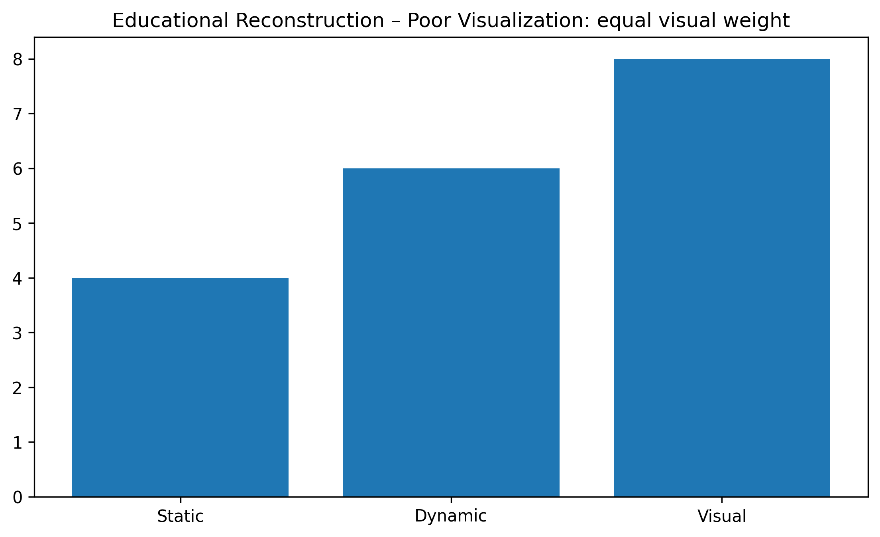
Figure 7. Educational reconstruction illustrating the selected visualization problem.

10. IMPROVED VISUALIZATION
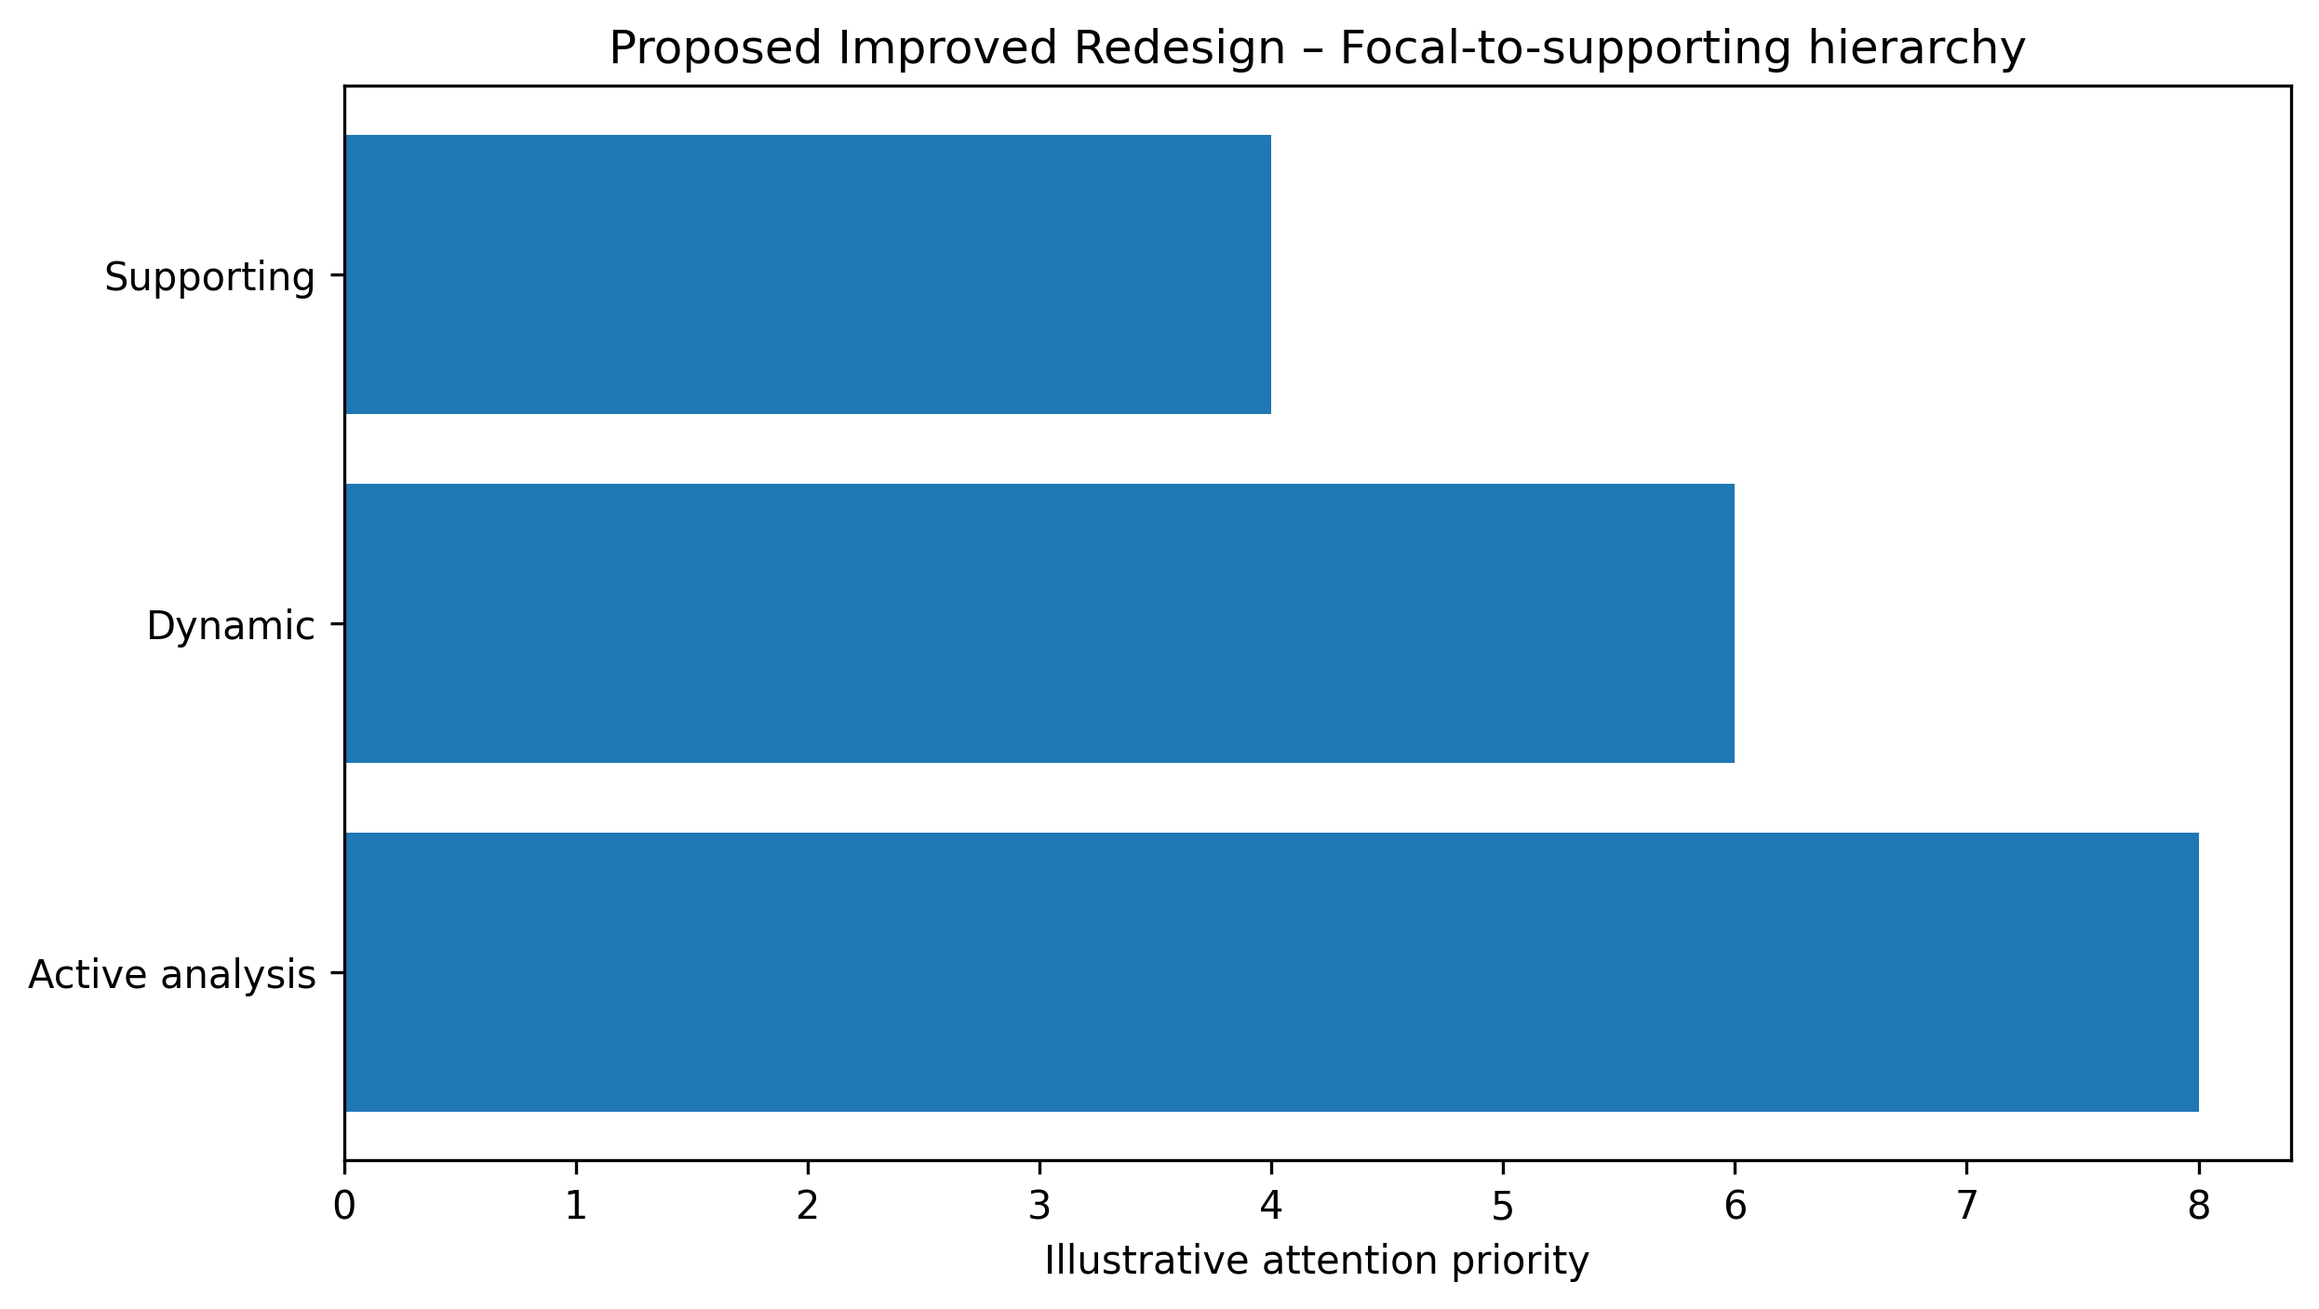
Figure 7. Proposed redesigned visualization using improved graphical encoding.

11. GRAPHICAL ENCODING CHANGES
The redesign prioritizes aligned position, length, spatial grouping, restrained categorical encoding, explicit direction, and/or selective salience according to the visual task. Redundant decoration is minimized.

12. BEFORE vs AFTER COMPARISON
Aspect | Original / Poor Design | Improved Design
Chart type | Multiview cybersecurity visualization | Multiview cybersecurity visualization with clearer task-oriented structure
Scale | May require extra visual search | Consistent and task-aligned where applicable
Encoding | Multiple or competing cues | Primary cue emphasized
Labels | Potentially dispersed | Grouped / directly associated
Color | Used cautiously; avoid unnecessary competition | Restrained, accessible emphasis
Comparison | May require cross-reference | Aligned or spatially grouped
Cognitive load | Higher when elements compete | Reduced through hierarchy and grouping
Accessibility | Avoid reliance on color alone | Use position, labels, and shape/line cues where useful

13. PYTHON CODE
# MalView: Interactive Visual Analytics for Comprehending Malware Behavior
# Educational reconstruction for M.E. CSE Data Visualization Exercise-2.
# The reconstruction is NOT a reproduction of the authors' research findings.
# Replace only with published numerical values when the source provides them.
import matplotlib.pyplot as plt
import numpy as np

# Illustrative reconstruction data / structure:
views=["Supporting","Dynamic","Active analysis"]; priority=[4,6,8]

# Plot:
fig,ax=plt.subplots(figsize=(8,5)); ax.barh(views,priority); ax.invert_yaxis(); ax.set_xlabel("Illustrative attention priority")

plt.tight_layout()
plt.savefig("/mnt/data/exercise2_research_redesign/visualizations/paper_07_improved.png", dpi=300, bbox_inches="tight")
plt.show()
Complete executable file: python/paper_07_improved.py

14. ANALYSIS
1. Information represented: the selected paper's visual representation supports understanding of cybersecurity visualization concepts. 2. Graphical marks: marks appropriate to the selected multiview cybersecurity visualization are used. 3. Visual variables: position, length, direction, grouping, size, or restrained color are used as applicable. 4. Perception task: the viewer must identify structure, compare elements, follow a process, or locate relationships. 5. Difficulties: Several linked views may create visual competition; a coordinated emphasis scheme can focus attention on the active analytical task. 6. Redesign change: the visual hierarchy and encoding were simplified. 7. Readability: aligned and grouped encodings reduce visual search. 8. Data preservation: no research conclusion is changed. 9. Limitation: where exact source values were unavailable, the figure is explicitly an educational structural reconstruction rather than an exact numerical reproduction.

15. RESULT
The selected visualization was evaluated and redesigned using relevant visual perception and graphical encoding principles. The redesign improves the clarity of the intended visual task while preserving the source paper's conceptual meaning.

16. RESEARCH PAPER REFERENCE
Mubarak et al.. “MalView: Interactive Visual Analytics for Comprehending Malware Behavior,” IEEE Access, Vol. 10, pp. 99909–99930, 2022. DOI: 10.1109/ACCESS.2022.3207782.

17. DOWNLOADABLE PAPER LINK
Publisher / database page: https://ieeexplore.ieee.org/abstract/document/9895250
Direct PDF: https://ieeexplore.ieee.org/stamp/stamp.jsp?tp=&arnumber=9895250
PDF access: publisher page checked for open-access/free full-text availability at preparation time.

PAPER 8

1. RESEARCH PAPER DETAILS
Authors: Stoiber et al.
Title: VisAhoi: Towards a library to generate and integrate visualization onboarding using high-level visualization grammars
Journal/Conference: Visual Informatics, Vol. 8, Issue 3, pp. 1–17
Year: 2024
DOI: 10.1016/j.visinf.2024.06.001
Database: ScienceDirect
Open-access status: Publisher page marked the article as open access / under a Creative Commons license.

2. AIM
To redesign onboarding annotations with selective salience and clearer step-by-step visual grouping.

3. RESEARCH PROBLEM / CONTEXT
The paper addresses visualization onboarding and uses visual representations to communicate relationships, processes, comparisons, or analytical structures. The selected figure is treated as a source representation for this laboratory exercise, not as a 'bad' figure.

4. ORIGINAL VISUALIZATION SELECTED
Selected source representation: Fig. 7 / onboarding annotations across visualization views.
The published research paper was selected as a source for evaluating one of its visual representations. The visualization was critically examined using visual perception and graphical encoding principles, and an improved redesign was developed for this laboratory exercise.
Original figure handling: the source figure is identified by figure number and linked to the publisher PDF. The images generated in this package are explicitly educational reconstructions and proposed redesigns; they are not presented as the authors' original artwork.

5. DESCRIPTION OF ORIGINAL VISUALIZATION
The selected visualization is a annotated multiview visualization used to support the paper's analytical or explanatory narrative. Its principal visual task is to help the reader identify structure, compare elements, follow relationships, or understand a multistage process.

6. VISUAL PERCEPTION ANALYSIS
The redesign emphasizes position, length, proximity, similarity, hierarchy, figure-ground separation, and visual salience where appropriate. The main concern is to reduce unnecessary search and make the intended comparison or reading path more immediate.

7. GRAPHICAL ENCODING ANALYSIS
DATA → VISUAL VARIABLE → GRAPHICAL ENCODING → PERCEPTION → INTERPRETATION
For this paper, the primary encoding is based on annotated multiview visualization. The redesign changes the arrangement, alignment, emphasis, or grouping rather than changing the research claim.

8. PROBLEMS IDENTIFIED
Annotation anchors and explanatory text can become cluttered if too many are simultaneously emphasized.
Only defensible design observations are used. The exercise does not label the published visualization as defective; it evaluates one representation for a specific educational redesign objective.

9. INTENTIONALLY POOR VISUALIZATION
Educational Reconstruction – Poor Visualization. This version is created only to demonstrate the selected visualization principle and is not the chart published by the authors.
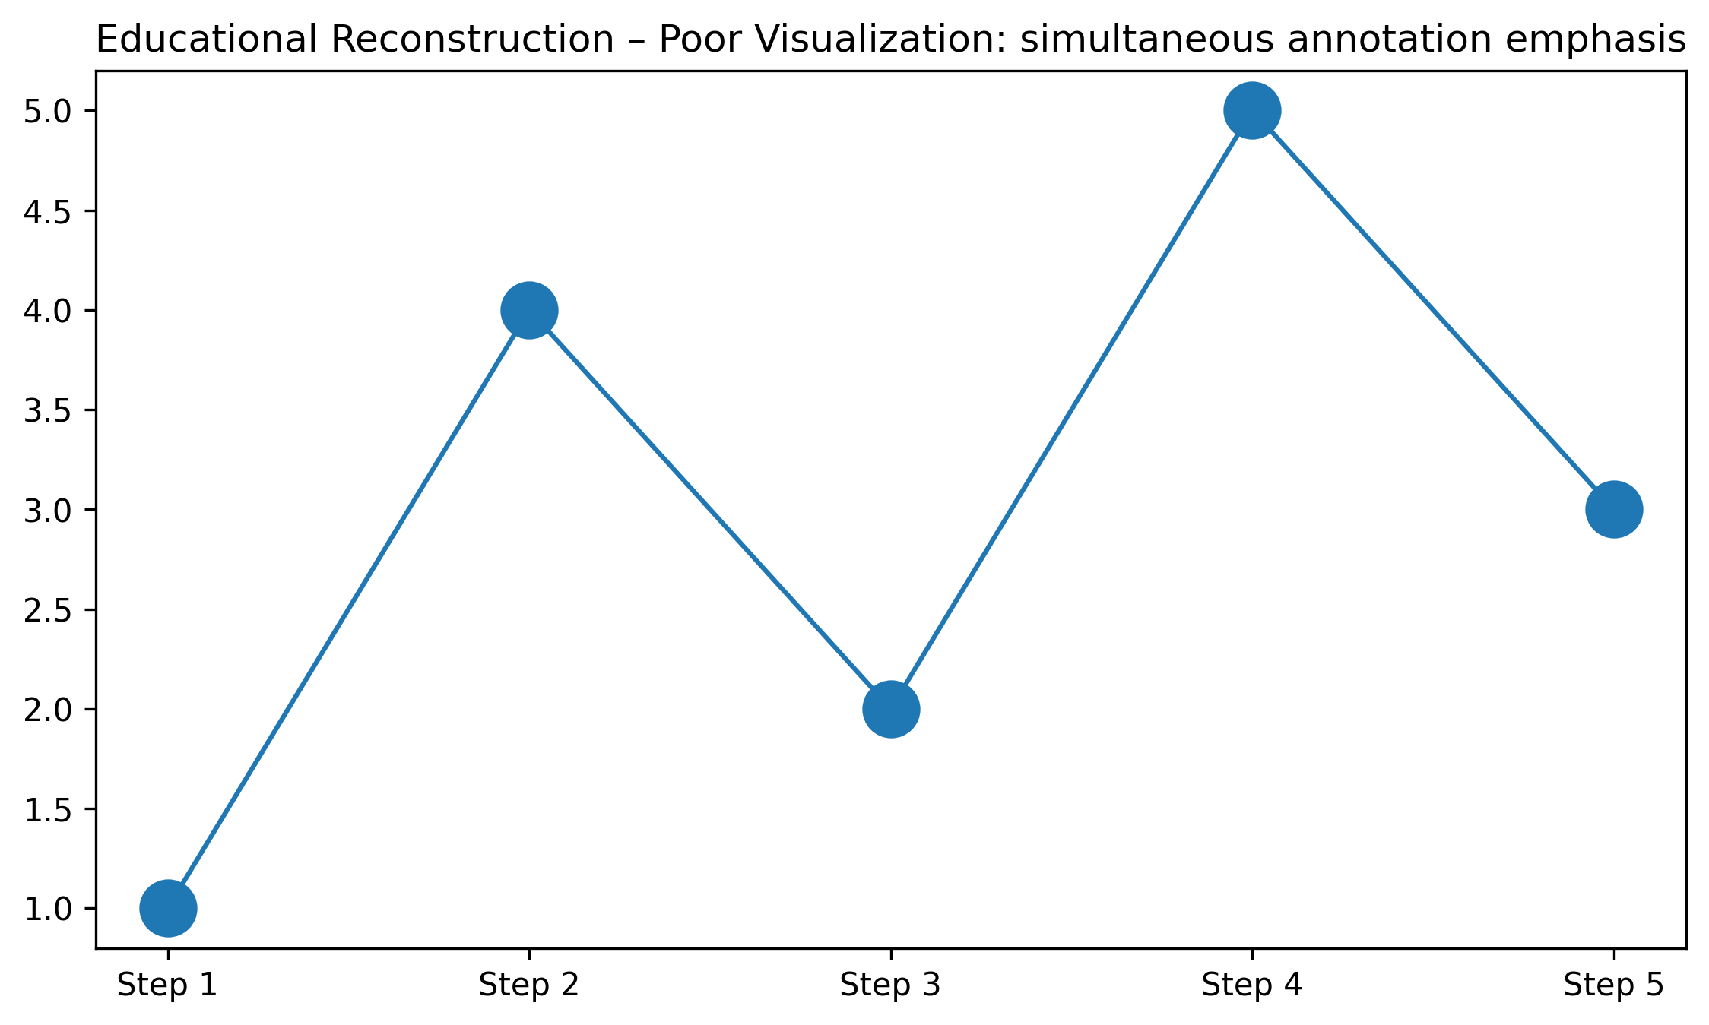
Figure 8. Educational reconstruction illustrating the selected visualization problem.

10. IMPROVED VISUALIZATION
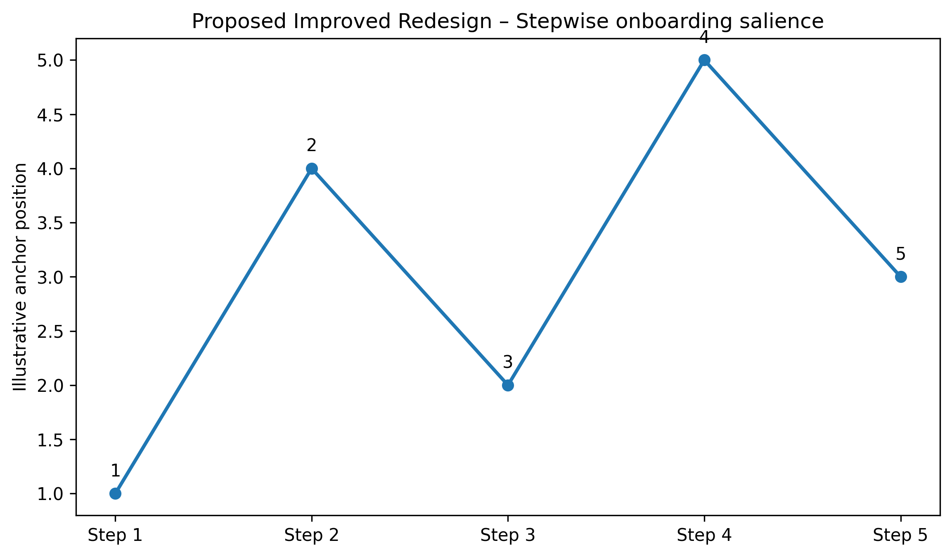
Figure 8. Proposed redesigned visualization using improved graphical encoding.

11. GRAPHICAL ENCODING CHANGES
The redesign prioritizes aligned position, length, spatial grouping, restrained categorical encoding, explicit direction, and/or selective salience according to the visual task. Redundant decoration is minimized.

12. BEFORE vs AFTER COMPARISON
Aspect | Original / Poor Design | Improved Design
Chart type | Annotated multiview visualization | Annotated multiview visualization with clearer task-oriented structure
Scale | May require extra visual search | Consistent and task-aligned where applicable
Encoding | Multiple or competing cues | Primary cue emphasized
Labels | Potentially dispersed | Grouped / directly associated
Color | Used cautiously; avoid unnecessary competition | Restrained, accessible emphasis
Comparison | May require cross-reference | Aligned or spatially grouped
Cognitive load | Higher when elements compete | Reduced through hierarchy and grouping
Accessibility | Avoid reliance on color alone | Use position, labels, and shape/line cues where useful

13. PYTHON CODE
# VisAhoi: Towards a library to generate and integrate visualization onboarding using high-level visualization grammars
# Educational reconstruction for M.E. CSE Data Visualization Exercise-2.
# The reconstruction is NOT a reproduction of the authors' research findings.
# Replace only with published numerical values when the source provides them.
import matplotlib.pyplot as plt
import numpy as np

# Illustrative reconstruction data / structure:
steps=np.arange(1,6); anchor=[1,4,2,5,3]

# Plot:
fig,ax=plt.subplots(figsize=(9,5)); ax.plot(steps,anchor,"o-"); ax.set_xlabel("Onboarding step"); ax.set_ylabel("Illustrative anchor position")

plt.tight_layout()
plt.savefig("/mnt/data/exercise2_research_redesign/visualizations/paper_08_improved.png", dpi=300, bbox_inches="tight")
plt.show()
Complete executable file: python/paper_08_improved.py

14. ANALYSIS
1. Information represented: the selected paper's visual representation supports understanding of visualization onboarding concepts. 2. Graphical marks: marks appropriate to the selected annotated multiview visualization are used. 3. Visual variables: position, length, direction, grouping, size, or restrained color are used as applicable. 4. Perception task: the viewer must identify structure, compare elements, follow a process, or locate relationships. 5. Difficulties: Annotation anchors and explanatory text can become cluttered if too many are simultaneously emphasized. 6. Redesign change: the visual hierarchy and encoding were simplified. 7. Readability: aligned and grouped encodings reduce visual search. 8. Data preservation: no research conclusion is changed. 9. Limitation: where exact source values were unavailable, the figure is explicitly an educational structural reconstruction rather than an exact numerical reproduction.

15. RESULT
The selected visualization was evaluated and redesigned using relevant visual perception and graphical encoding principles. The redesign improves the clarity of the intended visual task while preserving the source paper's conceptual meaning.

16. RESEARCH PAPER REFERENCE
Stoiber et al.. “VisAhoi: Towards a library to generate and integrate visualization onboarding using high-level visualization grammars,” Visual Informatics, Vol. 8, Issue 3, pp. 1–17, 2024. DOI: 10.1016/j.visinf.2024.06.001.

17. DOWNLOADABLE PAPER LINK
Publisher / database page: https://www.sciencedirect.com/science/article/pii/S2468502X24000214
Direct PDF: https://www.sciencedirect.com/science/article/pii/S2468502X24000214/pdfft
PDF access: publisher page checked for open-access/free full-text availability at preparation time.

PAPER 9

1. RESEARCH PAPER DETAILS
Authors: Bellido-Outeiriño et al.
Title: A Real-Time Noise Monitoring System Based on Internet of Things for Enhanced Acoustic Comfort and Occupational Health
Journal/Conference: IEEE Access, Vol. 8, pp. 139741–139755
Year: 2020
DOI: 10.1109/ACCESS.2020.3012919
Database: IEEE Xplore
Open-access status: Publisher page marked the article as open access / under a Creative Commons license.

2. AIM
To improve the temporal readability of noise-monitoring values using a consistent time axis and perceptually ordered encoding.

3. RESEARCH PROBLEM / CONTEXT
The paper addresses iot / environmental visualization and uses visual representations to communicate relationships, processes, comparisons, or analytical structures. The selected figure is treated as a source representation for this laboratory exercise, not as a 'bad' figure.

4. ORIGINAL VISUALIZATION SELECTED
Selected source representation: Real-time noise monitoring / time-of-day and day-of-week visualization.
The published research paper was selected as a source for evaluating one of its visual representations. The visualization was critically examined using visual perception and graphical encoding principles, and an improved redesign was developed for this laboratory exercise.
Original figure handling: the source figure is identified by figure number and linked to the publisher PDF. The images generated in this package are explicitly educational reconstructions and proposed redesigns; they are not presented as the authors' original artwork.

5. DESCRIPTION OF ORIGINAL VISUALIZATION
The selected visualization is a time-series / heatmap used to support the paper's analytical or explanatory narrative. Its principal visual task is to help the reader identify structure, compare elements, follow relationships, or understand a multistage process.

6. VISUAL PERCEPTION ANALYSIS
The redesign emphasizes position, length, proximity, similarity, hierarchy, figure-ground separation, and visual salience where appropriate. The main concern is to reduce unnecessary search and make the intended comparison or reading path more immediate.

7. GRAPHICAL ENCODING ANALYSIS
DATA → VISUAL VARIABLE → GRAPHICAL ENCODING → PERCEPTION → INTERPRETATION
For this paper, the primary encoding is based on time-series / heatmap. The redesign changes the arrangement, alignment, emphasis, or grouping rather than changing the research claim.

8. PROBLEMS IDENTIFIED
Time-of-day and weekday comparisons benefit from consistent axes and restrained color intensity.
Only defensible design observations are used. The exercise does not label the published visualization as defective; it evaluates one representation for a specific educational redesign objective.

9. INTENTIONALLY POOR VISUALIZATION
Educational Reconstruction – Poor Visualization. This version is created only to demonstrate the selected visualization principle and is not the chart published by the authors.
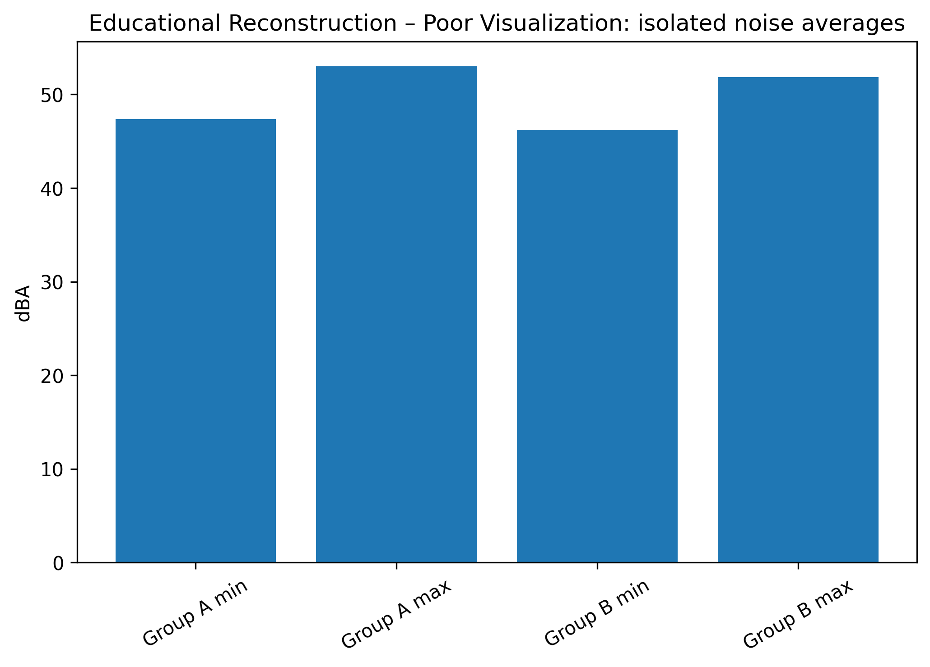
Figure 9. Educational reconstruction illustrating the selected visualization problem.

10. IMPROVED VISUALIZATION
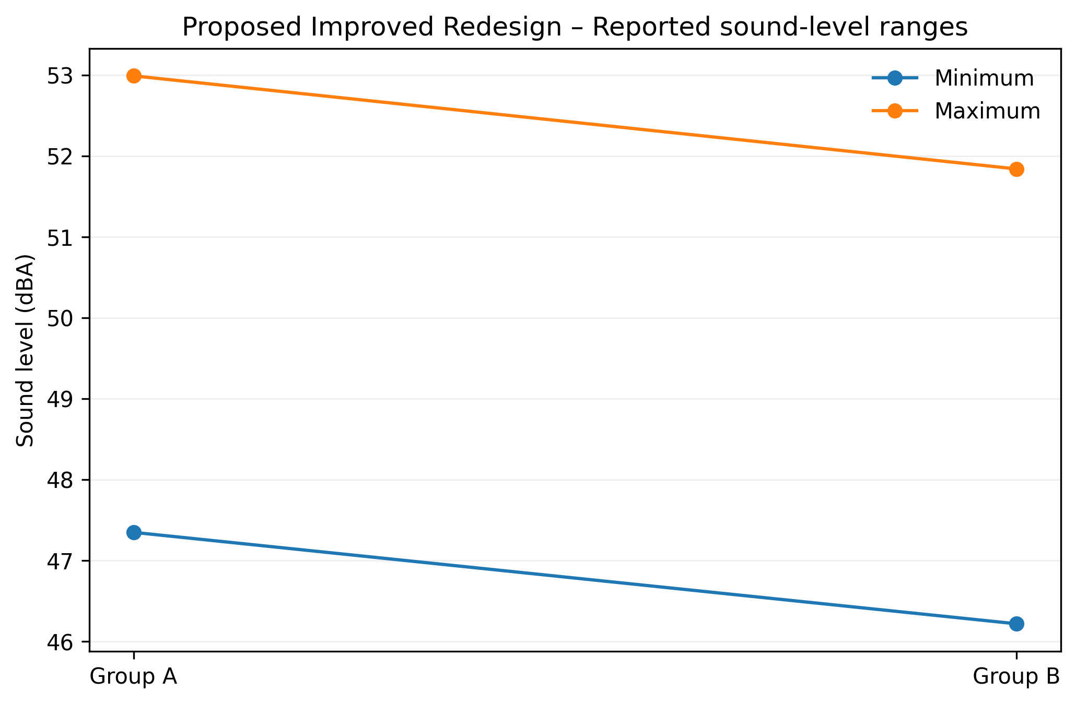
Figure 9. Proposed redesigned visualization using improved graphical encoding.

11. GRAPHICAL ENCODING CHANGES
The redesign prioritizes aligned position, length, spatial grouping, restrained categorical encoding, explicit direction, and/or selective salience according to the visual task. Redundant decoration is minimized.

12. BEFORE vs AFTER COMPARISON
Aspect | Original / Poor Design | Improved Design
Chart type | Time-series / heatmap | Time-series / heatmap with clearer task-oriented structure
Scale | May require extra visual search | Consistent and task-aligned where applicable
Encoding | Multiple or competing cues | Primary cue emphasized
Labels | Potentially dispersed | Grouped / directly associated
Color | Used cautiously; avoid unnecessary competition | Restrained, accessible emphasis
Comparison | May require cross-reference | Aligned or spatially grouped
Cognitive load | Higher when elements compete | Reduced through hierarchy and grouping
Accessibility | Avoid reliance on color alone | Use position, labels, and shape/line cues where useful

13. PYTHON CODE
# A Real-Time Noise Monitoring System Based on Internet of Things for Enhanced Acoustic Comfort and Occupational Health
# Educational reconstruction for M.E. CSE Data Visualization Exercise-2.
# The reconstruction is NOT a reproduction of the authors' research findings.
# Replace only with published numerical values when the source provides them.
import matplotlib.pyplot as plt
import numpy as np

# Illustrative reconstruction data / structure:
labels=["Group A min","Group A max","Group B min","Group B max"]; vals=[47.35,52.99,46.22,51.84]

# Plot:
fig,ax=plt.subplots(figsize=(8,5)); ax.bar(labels,vals); ax.tick_params(axis="x",rotation=30); ax.set_ylabel("dBA")

plt.tight_layout()
plt.savefig("/mnt/data/exercise2_research_redesign/visualizations/paper_09_improved.png", dpi=300, bbox_inches="tight")
plt.show()
Complete executable file: python/paper_09_improved.py

14. ANALYSIS
1. Information represented: the selected paper's visual representation supports understanding of iot / environmental visualization concepts. 2. Graphical marks: marks appropriate to the selected time-series / heatmap are used. 3. Visual variables: position, length, direction, grouping, size, or restrained color are used as applicable. 4. Perception task: the viewer must identify structure, compare elements, follow a process, or locate relationships. 5. Difficulties: Time-of-day and weekday comparisons benefit from consistent axes and restrained color intensity. 6. Redesign change: the visual hierarchy and encoding were simplified. 7. Readability: aligned and grouped encodings reduce visual search. 8. Data preservation: no research conclusion is changed. 9. Limitation: where exact source values were unavailable, the figure is explicitly an educational structural reconstruction rather than an exact numerical reproduction.

15. RESULT
The selected visualization was evaluated and redesigned using relevant visual perception and graphical encoding principles. The redesign improves the clarity of the intended visual task while preserving the source paper's conceptual meaning.

16. RESEARCH PAPER REFERENCE
Bellido-Outeiriño et al.. “A Real-Time Noise Monitoring System Based on Internet of Things for Enhanced Acoustic Comfort and Occupational Health,” IEEE Access, Vol. 8, pp. 139741–139755, 2020. DOI: 10.1109/ACCESS.2020.3012919.

17. DOWNLOADABLE PAPER LINK
Publisher / database page: https://ieeexplore.ieee.org/abstract/document/9152026
Direct PDF: https://ieeexplore.ieee.org/stamp/stamp.jsp?tp=&arnumber=9152026
PDF access: publisher page checked for open-access/free full-text availability at preparation time.

PAPER 10

1. RESEARCH PAPER DETAILS
Authors: Firat et al.
Title: PCP-Ed: Parallel coordinate plots for ensemble data
Journal/Conference: Visual Informatics, Vol. 7, Issue 1, pp. 56–65
Year: 2023
DOI: 10.1016/j.visinf.2022.10.003
Database: ScienceDirect
Open-access status: Publisher page marked the article as open access / under a Creative Commons license.

2. AIM
To redesign a dense parallel-coordinate view using transparency, ordering, and selective emphasis to reveal patterns without changing the data.

3. RESEARCH PROBLEM / CONTEXT
The paper addresses multivariate visualization and uses visual representations to communicate relationships, processes, comparisons, or analytical structures. The selected figure is treated as a source representation for this laboratory exercise, not as a 'bad' figure.

4. ORIGINAL VISUALIZATION SELECTED
Selected source representation: Dense parallel-coordinate plots with correlation glyphs.
The published research paper was selected as a source for evaluating one of its visual representations. The visualization was critically examined using visual perception and graphical encoding principles, and an improved redesign was developed for this laboratory exercise.
Original figure handling: the source figure is identified by figure number and linked to the publisher PDF. The images generated in this package are explicitly educational reconstructions and proposed redesigns; they are not presented as the authors' original artwork.

5. DESCRIPTION OF ORIGINAL VISUALIZATION
The selected visualization is a parallel coordinates used to support the paper's analytical or explanatory narrative. Its principal visual task is to help the reader identify structure, compare elements, follow relationships, or understand a multistage process.

6. VISUAL PERCEPTION ANALYSIS
The redesign emphasizes position, length, proximity, similarity, hierarchy, figure-ground separation, and visual salience where appropriate. The main concern is to reduce unnecessary search and make the intended comparison or reading path more immediate.

7. GRAPHICAL ENCODING ANALYSIS
DATA → VISUAL VARIABLE → GRAPHICAL ENCODING → PERCEPTION → INTERPRETATION
For this paper, the primary encoding is based on parallel coordinates. The redesign changes the arrangement, alignment, emphasis, or grouping rather than changing the research claim.

8. PROBLEMS IDENTIFIED
Overlapping polylines can obscure trends and outliers; opacity and selective highlighting reduce overplotting.
Only defensible design observations are used. The exercise does not label the published visualization as defective; it evaluates one representation for a specific educational redesign objective.

9. INTENTIONALLY POOR VISUALIZATION
Educational Reconstruction – Poor Visualization. This version is created only to demonstrate the selected visualization principle and is not the chart published by the authors.
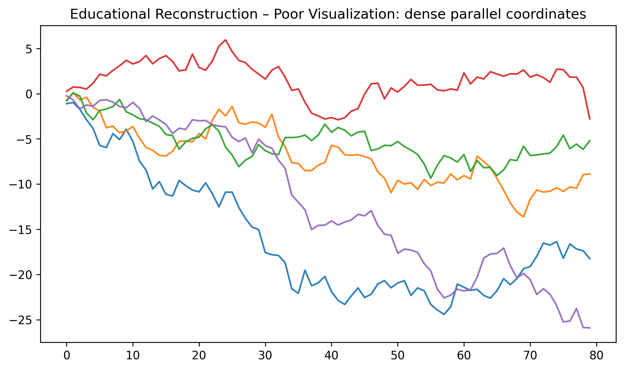
Figure 10. Educational reconstruction illustrating the selected visualization problem.

10. IMPROVED VISUALIZATION
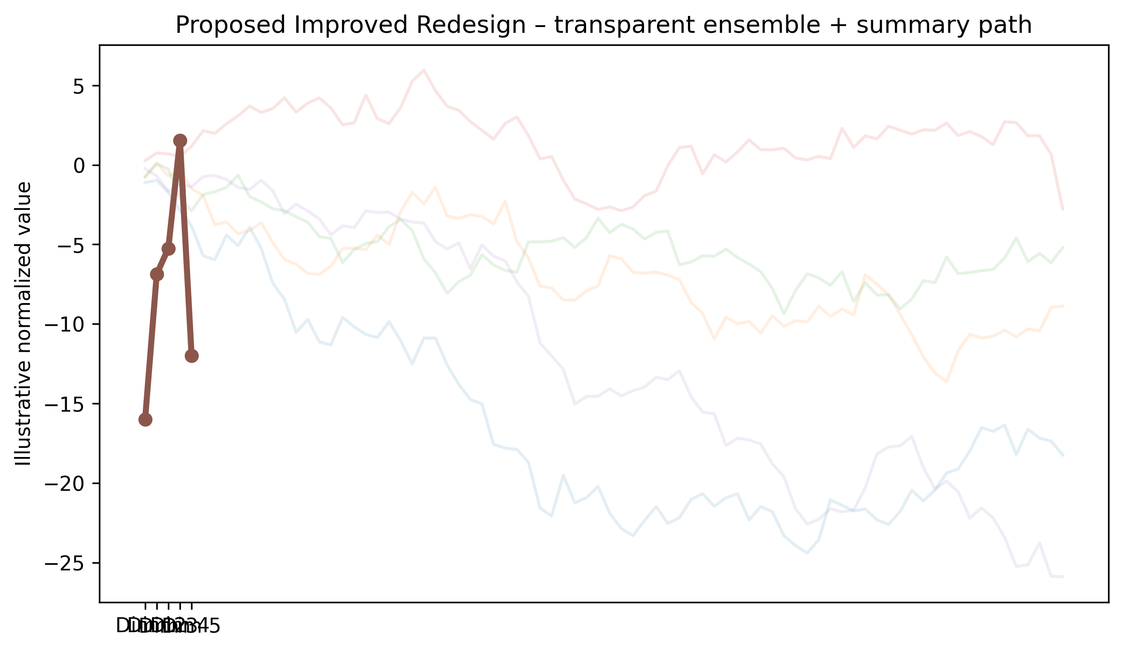
Figure 10. Proposed redesigned visualization using improved graphical encoding.

11. GRAPHICAL ENCODING CHANGES
The redesign prioritizes aligned position, length, spatial grouping, restrained categorical encoding, explicit direction, and/or selective salience according to the visual task. Redundant decoration is minimized.

12. BEFORE vs AFTER COMPARISON
Aspect | Original / Poor Design | Improved Design
Chart type | Parallel coordinates | Parallel coordinates with clearer task-oriented structure
Scale | May require extra visual search | Consistent and task-aligned where applicable
Encoding | Multiple or competing cues | Primary cue emphasized
Labels | Potentially dispersed | Grouped / directly associated
Color | Used cautiously; avoid unnecessary competition | Restrained, accessible emphasis
Comparison | May require cross-reference | Aligned or spatially grouped
Cognitive load | Higher when elements compete | Reduced through hierarchy and grouping
Accessibility | Avoid reliance on color alone | Use position, labels, and shape/line cues where useful

13. PYTHON CODE
# PCP-Ed: Parallel coordinate plots for ensemble data
# Educational reconstruction for M.E. CSE Data Visualization Exercise-2.
# The reconstruction is NOT a reproduction of the authors' research findings.
# Replace only with published numerical values when the source provides them.
import matplotlib.pyplot as plt
import numpy as np

# Illustrative reconstruction data / structure:
rng=np.random.default_rng(10); data=np.cumsum(rng.normal(0,1,(80,5)),axis=0)

# Plot:
fig,ax=plt.subplots(figsize=(9,5))
for c in range(5): ax.plot(data[:,c],alpha=.12)
ax.plot(data.mean(axis=0),lw=3,marker="o"); ax.set_xticks(range(5),[f"Dim {k}" for k in range(1,6)])

plt.tight_layout()
plt.savefig("/mnt/data/exercise2_research_redesign/visualizations/paper_10_improved.png", dpi=300, bbox_inches="tight")
plt.show()
Complete executable file: python/paper_10_improved.py

14. ANALYSIS
1. Information represented: the selected paper's visual representation supports understanding of multivariate visualization concepts. 2. Graphical marks: marks appropriate to the selected parallel coordinates are used. 3. Visual variables: position, length, direction, grouping, size, or restrained color are used as applicable. 4. Perception task: the viewer must identify structure, compare elements, follow a process, or locate relationships. 5. Difficulties: Overlapping polylines can obscure trends and outliers; opacity and selective highlighting reduce overplotting. 6. Redesign change: the visual hierarchy and encoding were simplified. 7. Readability: aligned and grouped encodings reduce visual search. 8. Data preservation: no research conclusion is changed. 9. Limitation: where exact source values were unavailable, the figure is explicitly an educational structural reconstruction rather than an exact numerical reproduction.

15. RESULT
The selected visualization was evaluated and redesigned using relevant visual perception and graphical encoding principles. The redesign improves the clarity of the intended visual task while preserving the source paper's conceptual meaning.

16. RESEARCH PAPER REFERENCE
Firat et al.. “PCP-Ed: Parallel coordinate plots for ensemble data,” Visual Informatics, Vol. 7, Issue 1, pp. 56–65, 2023. DOI: 10.1016/j.visinf.2022.10.003.

17. DOWNLOADABLE PAPER LINK
Publisher / database page: https://www.sciencedirect.com/science/article/pii/S2468502X22001085
Direct PDF: https://www.sciencedirect.com/science/article/pii/S2468502X22001085/pdfft
PDF access: publisher page checked for open-access/free full-text availability at preparation time.

PAPER 11

1. RESEARCH PAPER DETAILS
Authors: Mora et al.
Title: VMetaFlow: A Meta-Framework for Integrating Visualizations in Coordinated View Applications
Journal/Conference: IEEE Access, Vol. 10, pp. 94545–94559
Year: 2022
DOI: 10.1109/ACCESS.2022.3202543
Database: IEEE Xplore
Open-access status: Publisher page marked the article as open access / under a Creative Commons license.

2. AIM
To redesign a coordinated-view data-flow representation using directional arrows and clearer source-to-target grouping.

3. RESEARCH PROBLEM / CONTEXT
The paper addresses interactive visualization and uses visual representations to communicate relationships, processes, comparisons, or analytical structures. The selected figure is treated as a source representation for this laboratory exercise, not as a 'bad' figure.

4. ORIGINAL VISUALIZATION SELECTED
Selected source representation: Coordinated-view application / data-flow representation.
The published research paper was selected as a source for evaluating one of its visual representations. The visualization was critically examined using visual perception and graphical encoding principles, and an improved redesign was developed for this laboratory exercise.
Original figure handling: the source figure is identified by figure number and linked to the publisher PDF. The images generated in this package are explicitly educational reconstructions and proposed redesigns; they are not presented as the authors' original artwork.

5. DESCRIPTION OF ORIGINAL VISUALIZATION
The selected visualization is a flow / coordinated views used to support the paper's analytical or explanatory narrative. Its principal visual task is to help the reader identify structure, compare elements, follow relationships, or understand a multistage process.

6. VISUAL PERCEPTION ANALYSIS
The redesign emphasizes position, length, proximity, similarity, hierarchy, figure-ground separation, and visual salience where appropriate. The main concern is to reduce unnecessary search and make the intended comparison or reading path more immediate.

7. GRAPHICAL ENCODING ANALYSIS
DATA → VISUAL VARIABLE → GRAPHICAL ENCODING → PERCEPTION → INTERPRETATION
For this paper, the primary encoding is based on flow / coordinated views. The redesign changes the arrangement, alignment, emphasis, or grouping rather than changing the research claim.

8. PROBLEMS IDENTIFIED
Cross-view relationships can be difficult to follow when connectors cross or lack directional emphasis.
Only defensible design observations are used. The exercise does not label the published visualization as defective; it evaluates one representation for a specific educational redesign objective.

9. INTENTIONALLY POOR VISUALIZATION
Educational Reconstruction – Poor Visualization. This version is created only to demonstrate the selected visualization principle and is not the chart published by the authors.
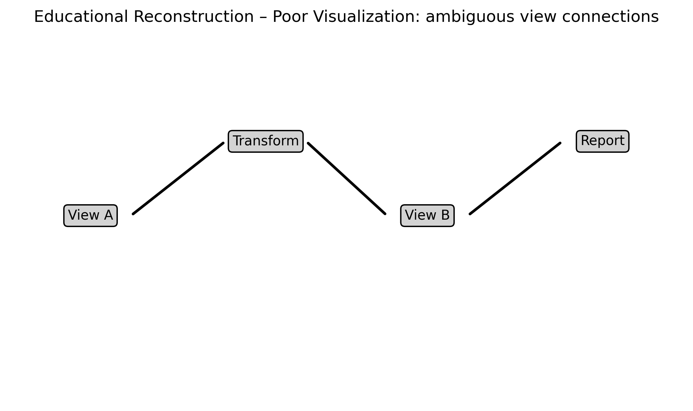
Figure 11. Educational reconstruction illustrating the selected visualization problem.

10. IMPROVED VISUALIZATION
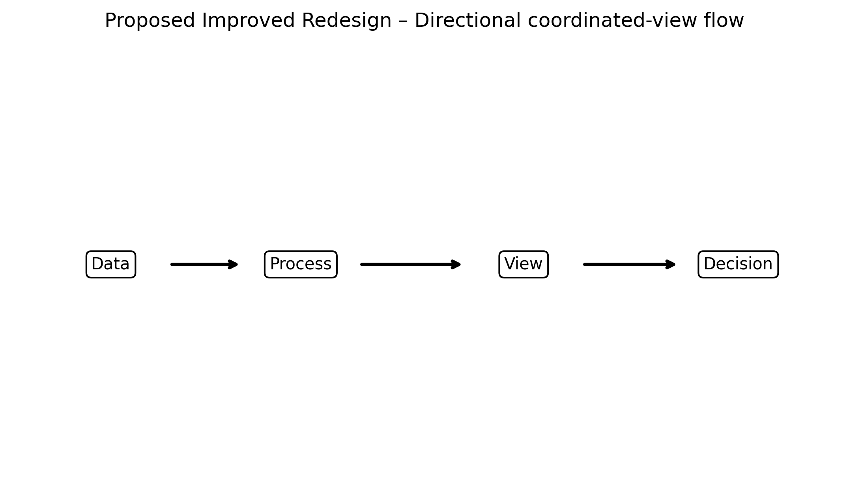
Figure 11. Proposed redesigned visualization using improved graphical encoding.

11. GRAPHICAL ENCODING CHANGES
The redesign prioritizes aligned position, length, spatial grouping, restrained categorical encoding, explicit direction, and/or selective salience according to the visual task. Redundant decoration is minimized.

12. BEFORE vs AFTER COMPARISON
Aspect | Original / Poor Design | Improved Design
Chart type | Flow / coordinated views | Flow / coordinated views with clearer task-oriented structure
Scale | May require extra visual search | Consistent and task-aligned where applicable
Encoding | Multiple or competing cues | Primary cue emphasized
Labels | Potentially dispersed | Grouped / directly associated
Color | Used cautiously; avoid unnecessary competition | Restrained, accessible emphasis
Comparison | May require cross-reference | Aligned or spatially grouped
Cognitive load | Higher when elements compete | Reduced through hierarchy and grouping
Accessibility | Avoid reliance on color alone | Use position, labels, and shape/line cues where useful

13. PYTHON CODE
# VMetaFlow: A Meta-Framework for Integrating Visualizations in Coordinated View Applications
# Educational reconstruction for M.E. CSE Data Visualization Exercise-2.
# The reconstruction is NOT a reproduction of the authors' research findings.
# Replace only with published numerical values when the source provides them.
import matplotlib.pyplot as plt
import numpy as np

# Illustrative reconstruction data / structure:
stages=["Data","Process","View","Decision"]

# Plot:
fig,ax=plt.subplots(figsize=(9,4)); ax.axis("off"); xs=np.linspace(.12,.88,4)
for k,(x,s) in enumerate(zip(xs,stages)):
ax.text(x,.5,s,ha="center",va="center",bbox=dict(boxstyle="round",facecolor="white",edgecolor="black"))
if k<3: ax.annotate("",(xs[k+1]-.07,.5),(x+.07,.5),arrowprops=dict(arrowstyle="->",lw=2))

plt.tight_layout()
plt.savefig("/mnt/data/exercise2_research_redesign/visualizations/paper_11_improved.png", dpi=300, bbox_inches="tight")
plt.show()
Complete executable file: python/paper_11_improved.py

14. ANALYSIS
1. Information represented: the selected paper's visual representation supports understanding of interactive visualization concepts. 2. Graphical marks: marks appropriate to the selected flow / coordinated views are used. 3. Visual variables: position, length, direction, grouping, size, or restrained color are used as applicable. 4. Perception task: the viewer must identify structure, compare elements, follow a process, or locate relationships. 5. Difficulties: Cross-view relationships can be difficult to follow when connectors cross or lack directional emphasis. 6. Redesign change: the visual hierarchy and encoding were simplified. 7. Readability: aligned and grouped encodings reduce visual search. 8. Data preservation: no research conclusion is changed. 9. Limitation: where exact source values were unavailable, the figure is explicitly an educational structural reconstruction rather than an exact numerical reproduction.

15. RESULT
The selected visualization was evaluated and redesigned using relevant visual perception and graphical encoding principles. The redesign improves the clarity of the intended visual task while preserving the source paper's conceptual meaning.

16. RESEARCH PAPER REFERENCE
Mora et al.. “VMetaFlow: A Meta-Framework for Integrating Visualizations in Coordinated View Applications,” IEEE Access, Vol. 10, pp. 94545–94559, 2022. DOI: 10.1109/ACCESS.2022.3202543.

17. DOWNLOADABLE PAPER LINK
Publisher / database page: https://ieeexplore.ieee.org/document/9869624/
Direct PDF: https://ieeexplore.ieee.org/stamp/stamp.jsp?tp=&arnumber=9869624
PDF access: publisher page checked for open-access/free full-text availability at preparation time.

PAPER 12

1. RESEARCH PAPER DETAILS
Authors: Liu et al.
Title: Evaluating user cognition of network diagrams
Journal/Conference: Visual Informatics, Vol. 5, Issue 4, pp. 26–33
Year: 2021
DOI: 10.1016/j.visinf.2021.12.004
Database: ScienceDirect
Open-access status: Publisher page marked the article as open access / under a Creative Commons license.

2. AIM
To demonstrate how reducing edge crossings and node overlap can improve network-path readability.

3. RESEARCH PROBLEM / CONTEXT
The paper addresses network visualization and uses visual representations to communicate relationships, processes, comparisons, or analytical structures. The selected figure is treated as a source representation for this laboratory exercise, not as a 'bad' figure.

4. ORIGINAL VISUALIZATION SELECTED
Selected source representation: Network diagrams illustrating edge crossings and node interference.
The published research paper was selected as a source for evaluating one of its visual representations. The visualization was critically examined using visual perception and graphical encoding principles, and an improved redesign was developed for this laboratory exercise.
Original figure handling: the source figure is identified by figure number and linked to the publisher PDF. The images generated in this package are explicitly educational reconstructions and proposed redesigns; they are not presented as the authors' original artwork.

5. DESCRIPTION OF ORIGINAL VISUALIZATION
The selected visualization is a network graph used to support the paper's analytical or explanatory narrative. Its principal visual task is to help the reader identify structure, compare elements, follow relationships, or understand a multistage process.

6. VISUAL PERCEPTION ANALYSIS
The redesign emphasizes position, length, proximity, similarity, hierarchy, figure-ground separation, and visual salience where appropriate. The main concern is to reduce unnecessary search and make the intended comparison or reading path more immediate.

7. GRAPHICAL ENCODING ANALYSIS
DATA → VISUAL VARIABLE → GRAPHICAL ENCODING → PERCEPTION → INTERPRETATION
For this paper, the primary encoding is based on network graph. The redesign changes the arrangement, alignment, emphasis, or grouping rather than changing the research claim.

8. PROBLEMS IDENTIFIED
Edge crossings and node overlap increase visual interference and can hinder path recognition.
Only defensible design observations are used. The exercise does not label the published visualization as defective; it evaluates one representation for a specific educational redesign objective.

9. INTENTIONALLY POOR VISUALIZATION
Educational Reconstruction – Poor Visualization. This version is created only to demonstrate the selected visualization principle and is not the chart published by the authors.
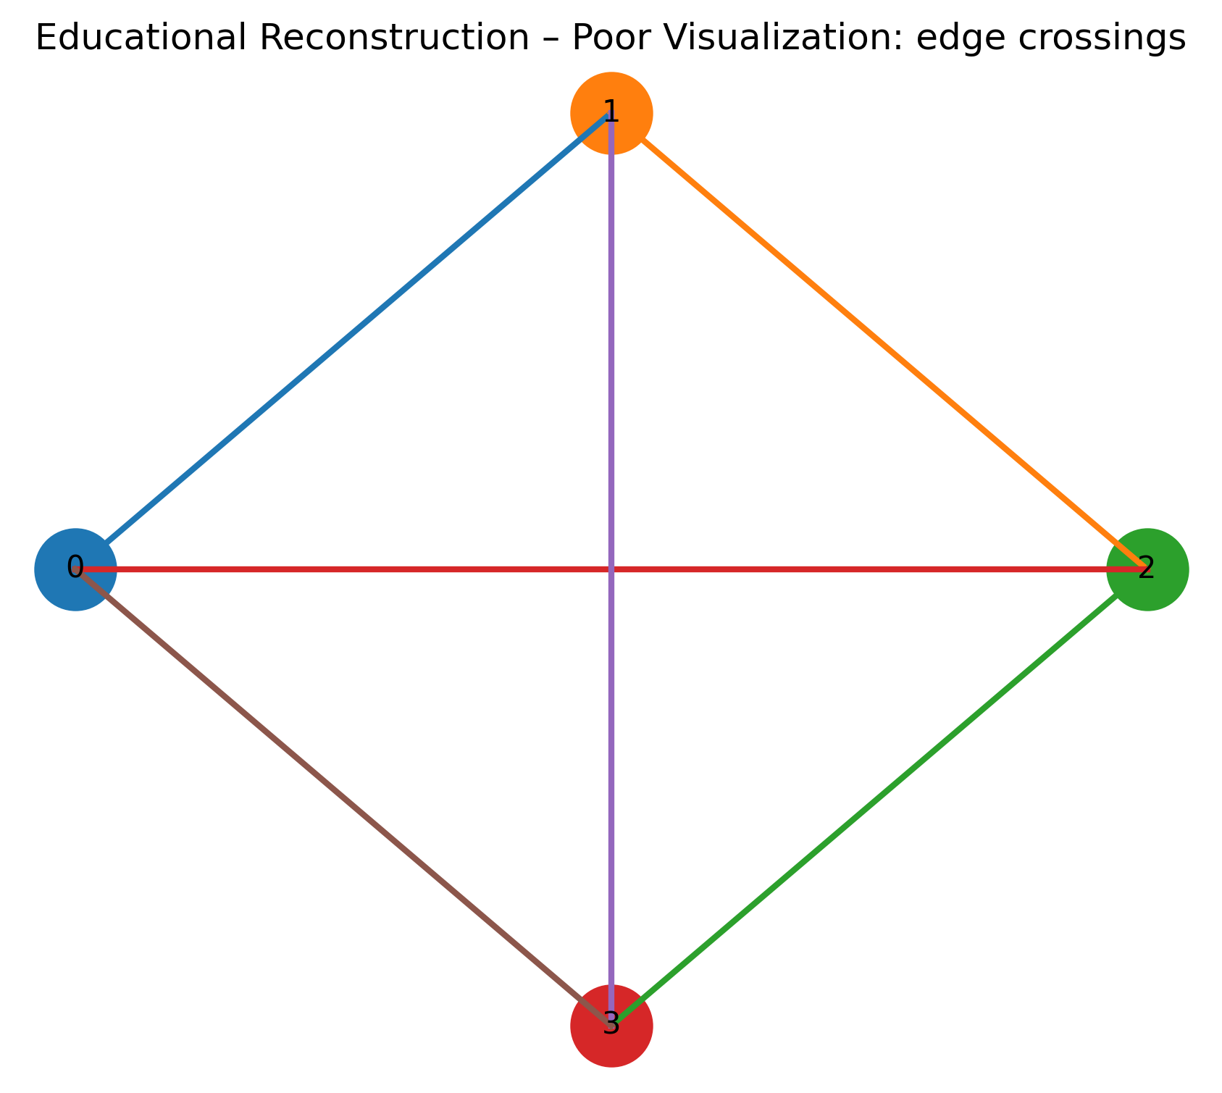
Figure 12. Educational reconstruction illustrating the selected visualization problem.

10. IMPROVED VISUALIZATION
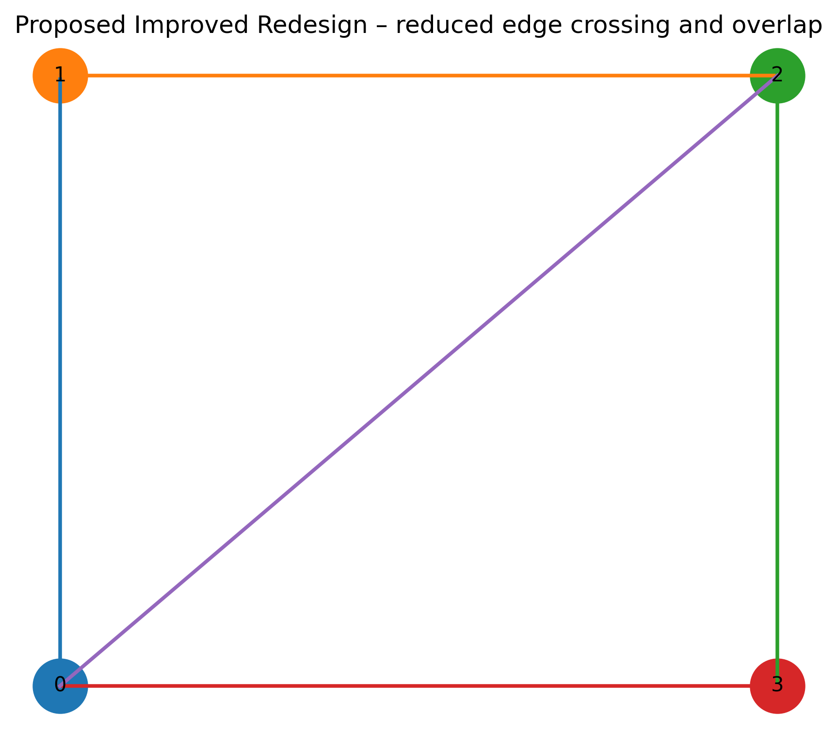
Figure 12. Proposed redesigned visualization using improved graphical encoding.

11. GRAPHICAL ENCODING CHANGES
The redesign prioritizes aligned position, length, spatial grouping, restrained categorical encoding, explicit direction, and/or selective salience according to the visual task. Redundant decoration is minimized.

12. BEFORE vs AFTER COMPARISON
Aspect | Original / Poor Design | Improved Design
Chart type | Network graph | Network graph with clearer task-oriented structure
Scale | May require extra visual search | Consistent and task-aligned where applicable
Encoding | Multiple or competing cues | Primary cue emphasized
Labels | Potentially dispersed | Grouped / directly associated
Color | Used cautiously; avoid unnecessary competition | Restrained, accessible emphasis
Comparison | May require cross-reference | Aligned or spatially grouped
Cognitive load | Higher when elements compete | Reduced through hierarchy and grouping
Accessibility | Avoid reliance on color alone | Use position, labels, and shape/line cues where useful

13. PYTHON CODE
# Evaluating user cognition of network diagrams
# Educational reconstruction for M.E. CSE Data Visualization Exercise-2.
# The reconstruction is NOT a reproduction of the authors' research findings.
# Replace only with published numerical values when the source provides them.
import matplotlib.pyplot as plt
import numpy as np

# Illustrative reconstruction data / structure:
edges=[(0,1),(1,2),(2,3),(0,3),(0,2)]; pos={0:(0,0),1:(0,1),2:(1,1),3:(1,0)}

# Plot:
fig,ax=plt.subplots(figsize=(7,6))
for a,b in edges: ax.plot([pos[a][0],pos[b][0]],[pos[a][1],pos[b][1]],lw=1.8)
for n,(x,y) in pos.items(): ax.scatter(x,y,s=700); ax.text(x,y,str(n),ha="center",va="center")
ax.axis("off")

plt.tight_layout()
plt.savefig("/mnt/data/exercise2_research_redesign/visualizations/paper_12_improved.png", dpi=300, bbox_inches="tight")
plt.show()
Complete executable file: python/paper_12_improved.py

14. ANALYSIS
1. Information represented: the selected paper's visual representation supports understanding of network visualization concepts. 2. Graphical marks: marks appropriate to the selected network graph are used. 3. Visual variables: position, length, direction, grouping, size, or restrained color are used as applicable. 4. Perception task: the viewer must identify structure, compare elements, follow a process, or locate relationships. 5. Difficulties: Edge crossings and node overlap increase visual interference and can hinder path recognition. 6. Redesign change: the visual hierarchy and encoding were simplified. 7. Readability: aligned and grouped encodings reduce visual search. 8. Data preservation: no research conclusion is changed. 9. Limitation: where exact source values were unavailable, the figure is explicitly an educational structural reconstruction rather than an exact numerical reproduction.

15. RESULT
The selected visualization was evaluated and redesigned using relevant visual perception and graphical encoding principles. The redesign improves the clarity of the intended visual task while preserving the source paper's conceptual meaning.

16. RESEARCH PAPER REFERENCE
Liu et al.. “Evaluating user cognition of network diagrams,” Visual Informatics, Vol. 5, Issue 4, pp. 26–33, 2021. DOI: 10.1016/j.visinf.2021.12.004.

17. DOWNLOADABLE PAPER LINK
Publisher / database page: https://www.sciencedirect.com/science/article/pii/S2468502X21000620
Direct PDF: https://www.sciencedirect.com/science/article/pii/S2468502X21000620/pdfft
PDF access: publisher page checked for open-access/free full-text availability at preparation time.

PAPER 13

1. RESEARCH PAPER DETAILS
Authors: Khan et al.
Title: Data Visualization and its Key Fundamentals: A Comprehensive Survey
Journal/Conference: 2022 7th International Conference on Communication and Electronics Systems (ICCES)
Year: 2022
DOI: 10.1109/ICCES54183.2022.9835803
Database: IEEE Xplore
Open-access status: Publisher page marked the article as open access / under a Creative Commons license.

2. AIM
To redesign a chart-selection overview into a grouped visual taxonomy that reduces visual search and cognitive load.

3. RESEARCH PROBLEM / CONTEXT
The paper addresses visualization fundamentals and uses visual representations to communicate relationships, processes, comparisons, or analytical structures. The selected figure is treated as a source representation for this laboratory exercise, not as a 'bad' figure.

4. ORIGINAL VISUALIZATION SELECTED
Selected source representation: Visualization types / workflow overview.
The published research paper was selected as a source for evaluating one of its visual representations. The visualization was critically examined using visual perception and graphical encoding principles, and an improved redesign was developed for this laboratory exercise.
Original figure handling: the source figure is identified by figure number and linked to the publisher PDF. The images generated in this package are explicitly educational reconstructions and proposed redesigns; they are not presented as the authors' original artwork.

5. DESCRIPTION OF ORIGINAL VISUALIZATION
The selected visualization is a chart-type comparison / infographic used to support the paper's analytical or explanatory narrative. Its principal visual task is to help the reader identify structure, compare elements, follow relationships, or understand a multistage process.

6. VISUAL PERCEPTION ANALYSIS
The redesign emphasizes position, length, proximity, similarity, hierarchy, figure-ground separation, and visual salience where appropriate. The main concern is to reduce unnecessary search and make the intended comparison or reading path more immediate.

7. GRAPHICAL ENCODING ANALYSIS
DATA → VISUAL VARIABLE → GRAPHICAL ENCODING → PERCEPTION → INTERPRETATION
For this paper, the primary encoding is based on chart-type comparison / infographic. The redesign changes the arrangement, alignment, emphasis, or grouping rather than changing the research claim.

8. PROBLEMS IDENTIFIED
Many chart types shown together can create choice overload; a grouped decision structure improves scanability.
Only defensible design observations are used. The exercise does not label the published visualization as defective; it evaluates one representation for a specific educational redesign objective.

9. INTENTIONALLY POOR VISUALIZATION
Educational Reconstruction – Poor Visualization. This version is created only to demonstrate the selected visualization principle and is not the chart published by the authors.
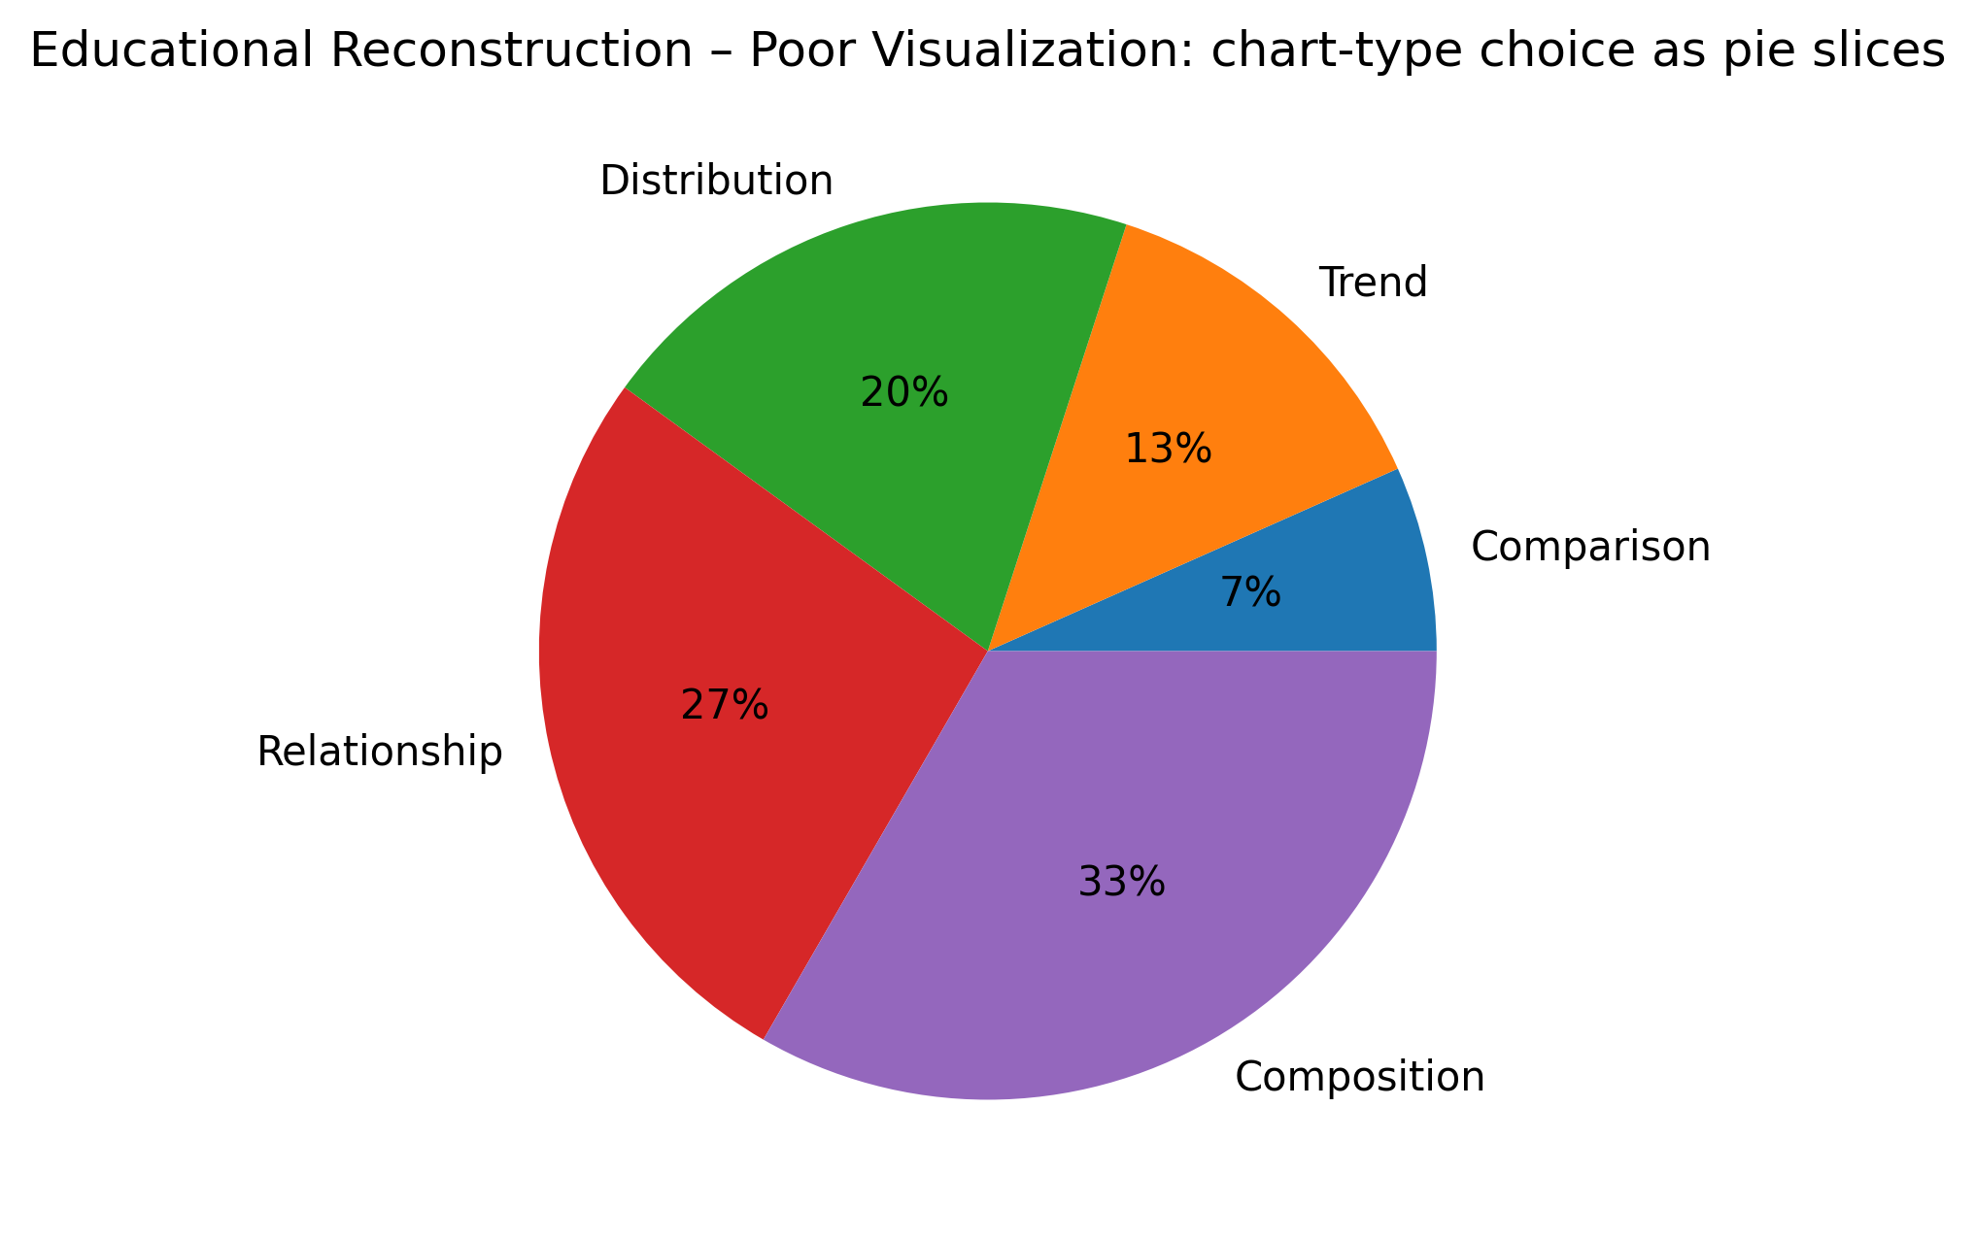
Figure 13. Educational reconstruction illustrating the selected visualization problem.

10. IMPROVED VISUALIZATION
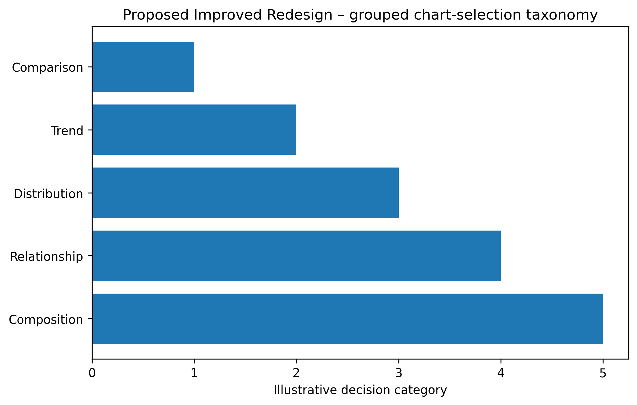
Figure 13. Proposed redesigned visualization using improved graphical encoding.

11. GRAPHICAL ENCODING CHANGES
The redesign prioritizes aligned position, length, spatial grouping, restrained categorical encoding, explicit direction, and/or selective salience according to the visual task. Redundant decoration is minimized.

12. BEFORE vs AFTER COMPARISON
Aspect | Original / Poor Design | Improved Design
Chart type | Chart-type comparison / infographic | Chart-type comparison / infographic with clearer task-oriented structure
Scale | May require extra visual search | Consistent and task-aligned where applicable
Encoding | Multiple or competing cues | Primary cue emphasized
Labels | Potentially dispersed | Grouped / directly associated
Color | Used cautiously; avoid unnecessary competition | Restrained, accessible emphasis
Comparison | May require cross-reference | Aligned or spatially grouped
Cognitive load | Higher when elements compete | Reduced through hierarchy and grouping
Accessibility | Avoid reliance on color alone | Use position, labels, and shape/line cues where useful

13. PYTHON CODE
# Data Visualization and its Key Fundamentals: A Comprehensive Survey
# Educational reconstruction for M.E. CSE Data Visualization Exercise-2.
# The reconstruction is NOT a reproduction of the authors' research findings.
# Replace only with published numerical values when the source provides them.
import matplotlib.pyplot as plt
import numpy as np

# Illustrative reconstruction data / structure:
types=["Comparison","Trend","Distribution","Relationship","Composition"]; vals=[1,2,3,4,5]

# Plot:
fig,ax=plt.subplots(figsize=(8,5)); y=np.arange(len(types)); ax.barh(y,vals); ax.set_yticks(y,types); ax.invert_yaxis()
ax.set_xlabel("Illustrative decision category")

plt.tight_layout()
plt.savefig("/mnt/data/exercise2_research_redesign/visualizations/paper_13_improved.png", dpi=300, bbox_inches="tight")
plt.show()
Complete executable file: python/paper_13_improved.py

14. ANALYSIS
1. Information represented: the selected paper's visual representation supports understanding of visualization fundamentals concepts. 2. Graphical marks: marks appropriate to the selected chart-type comparison / infographic are used. 3. Visual variables: position, length, direction, grouping, size, or restrained color are used as applicable. 4. Perception task: the viewer must identify structure, compare elements, follow a process, or locate relationships. 5. Difficulties: Many chart types shown together can create choice overload; a grouped decision structure improves scanability. 6. Redesign change: the visual hierarchy and encoding were simplified. 7. Readability: aligned and grouped encodings reduce visual search. 8. Data preservation: no research conclusion is changed. 9. Limitation: where exact source values were unavailable, the figure is explicitly an educational structural reconstruction rather than an exact numerical reproduction.

15. RESULT
The selected visualization was evaluated and redesigned using relevant visual perception and graphical encoding principles. The redesign improves the clarity of the intended visual task while preserving the source paper's conceptual meaning.

16. RESEARCH PAPER REFERENCE
Khan et al.. “Data Visualization and its Key Fundamentals: A Comprehensive Survey,” 2022 7th International Conference on Communication and Electronics Systems (ICCES), 2022. DOI: 10.1109/ICCES54183.2022.9835803.

17. DOWNLOADABLE PAPER LINK
Publisher / database page: https://ieeexplore.ieee.org/document/9835803/
Direct PDF: https://ieeexplore.ieee.org/stamp/stamp.jsp?tp=&arnumber=9835803
PDF access: publisher page checked for open-access/free full-text availability at preparation time.

PAPER 14

1. RESEARCH PAPER DETAILS
Authors: Wang et al.
Title: Evaluation on interactive visualization data with scatterplots
Journal/Conference: Visual Informatics, Vol. 4, Issue 4, pp. 1–10
Year: 2020
DOI: 10.1016/j.visinf.2020.09.004
Database: ScienceDirect
Open-access status: Publisher page marked the article as open access / under a Creative Commons license.

2. AIM
To redesign multivariate scatterplot presentation as consistent small multiples that preserve comparison while reducing visual density.

3. RESEARCH PROBLEM / CONTEXT
The paper addresses multivariate interaction and uses visual representations to communicate relationships, processes, comparisons, or analytical structures. The selected figure is treated as a source representation for this laboratory exercise, not as a 'bad' figure.

4. ORIGINAL VISUALIZATION SELECTED
Selected source representation: Sequential, multiple, and simultaneous scatterplot conditions.
The published research paper was selected as a source for evaluating one of its visual representations. The visualization was critically examined using visual perception and graphical encoding principles, and an improved redesign was developed for this laboratory exercise.
Original figure handling: the source figure is identified by figure number and linked to the publisher PDF. The images generated in this package are explicitly educational reconstructions and proposed redesigns; they are not presented as the authors' original artwork.

5. DESCRIPTION OF ORIGINAL VISUALIZATION
The selected visualization is a scatterplot matrix / small multiples used to support the paper's analytical or explanatory narrative. Its principal visual task is to help the reader identify structure, compare elements, follow relationships, or understand a multistage process.

6. VISUAL PERCEPTION ANALYSIS
The redesign emphasizes position, length, proximity, similarity, hierarchy, figure-ground separation, and visual salience where appropriate. The main concern is to reduce unnecessary search and make the intended comparison or reading path more immediate.

7. GRAPHICAL ENCODING ANALYSIS
DATA → VISUAL VARIABLE → GRAPHICAL ENCODING → PERCEPTION → INTERPRETATION
For this paper, the primary encoding is based on scatterplot matrix / small multiples. The redesign changes the arrangement, alignment, emphasis, or grouping rather than changing the research claim.

8. PROBLEMS IDENTIFIED
Displaying many plots simultaneously increases density; small multiples with consistent scales can improve targeted comparison.
Only defensible design observations are used. The exercise does not label the published visualization as defective; it evaluates one representation for a specific educational redesign objective.

9. INTENTIONALLY POOR VISUALIZATION
Educational Reconstruction – Poor Visualization. This version is created only to demonstrate the selected visualization principle and is not the chart published by the authors.
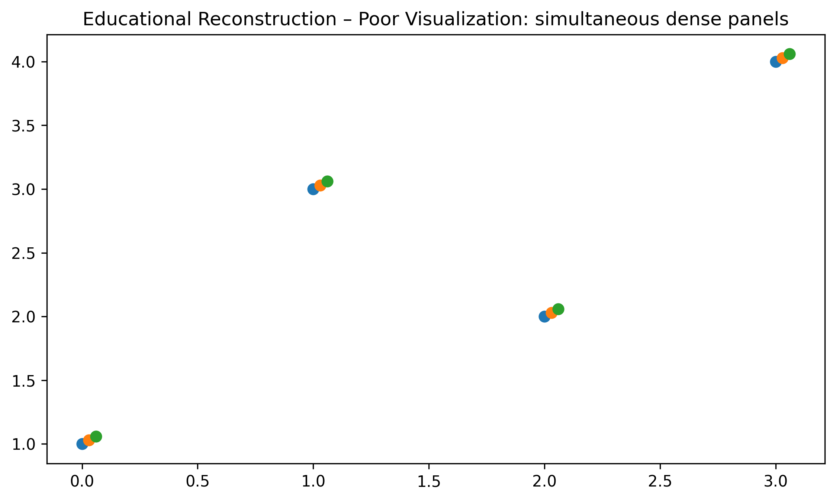
Figure 14. Educational reconstruction illustrating the selected visualization problem.

10. IMPROVED VISUALIZATION
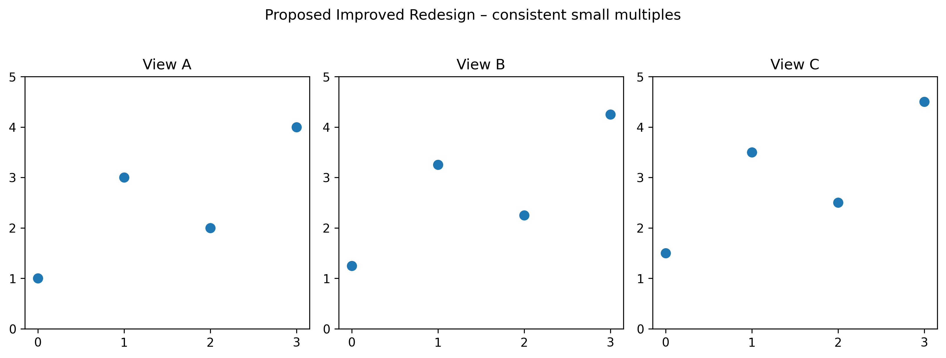
Figure 14. Proposed redesigned visualization using improved graphical encoding.

11. GRAPHICAL ENCODING CHANGES
The redesign prioritizes aligned position, length, spatial grouping, restrained categorical encoding, explicit direction, and/or selective salience according to the visual task. Redundant decoration is minimized.

12. BEFORE vs AFTER COMPARISON
Aspect | Original / Poor Design | Improved Design
Chart type | Scatterplot matrix / small multiples | Scatterplot matrix / small multiples with clearer task-oriented structure
Scale | May require extra visual search | Consistent and task-aligned where applicable
Encoding | Multiple or competing cues | Primary cue emphasized
Labels | Potentially dispersed | Grouped / directly associated
Color | Used cautiously; avoid unnecessary competition | Restrained, accessible emphasis
Comparison | May require cross-reference | Aligned or spatially grouped
Cognitive load | Higher when elements compete | Reduced through hierarchy and grouping
Accessibility | Avoid reliance on color alone | Use position, labels, and shape/line cues where useful

13. PYTHON CODE
# Evaluation on interactive visualization data with scatterplots
# Educational reconstruction for M.E. CSE Data Visualization Exercise-2.
# The reconstruction is NOT a reproduction of the authors' research findings.
# Replace only with published numerical values when the source provides them.
import matplotlib.pyplot as plt
import numpy as np

# Illustrative reconstruction data / structure:
x=np.arange(4); a=np.array([1,3,2,4]); b=np.array([2,4,1,3])

# Plot:
fig,axes=plt.subplots(1,3,figsize=(11,4))
for ax,off,title in zip(axes,[0,.25,.5],["View A","View B","View C"]):
ax.scatter(x,a+off,s=55); ax.set_title(title); ax.set_ylim(0,5)

plt.tight_layout()
plt.savefig("/mnt/data/exercise2_research_redesign/visualizations/paper_14_improved.png", dpi=300, bbox_inches="tight")
plt.show()
Complete executable file: python/paper_14_improved.py

14. ANALYSIS
1. Information represented: the selected paper's visual representation supports understanding of multivariate interaction concepts. 2. Graphical marks: marks appropriate to the selected scatterplot matrix / small multiples are used. 3. Visual variables: position, length, direction, grouping, size, or restrained color are used as applicable. 4. Perception task: the viewer must identify structure, compare elements, follow a process, or locate relationships. 5. Difficulties: Displaying many plots simultaneously increases density; small multiples with consistent scales can improve targeted comparison. 6. Redesign change: the visual hierarchy and encoding were simplified. 7. Readability: aligned and grouped encodings reduce visual search. 8. Data preservation: no research conclusion is changed. 9. Limitation: where exact source values were unavailable, the figure is explicitly an educational structural reconstruction rather than an exact numerical reproduction.

15. RESULT
The selected visualization was evaluated and redesigned using relevant visual perception and graphical encoding principles. The redesign improves the clarity of the intended visual task while preserving the source paper's conceptual meaning.

16. RESEARCH PAPER REFERENCE
Wang et al.. “Evaluation on interactive visualization data with scatterplots,” Visual Informatics, Vol. 4, Issue 4, pp. 1–10, 2020. DOI: 10.1016/j.visinf.2020.09.004.

17. DOWNLOADABLE PAPER LINK
Publisher / database page: https://www.sciencedirect.com/science/article/pii/S2468502X20300358
Direct PDF: https://www.sciencedirect.com/science/article/pii/S2468502X20300358/pdfft
PDF access: publisher page checked for open-access/free full-text availability at preparation time.

PAPER 15

1. RESEARCH PAPER DETAILS
Authors: Firat et al.
Title: Comparative eye-tracking evaluation of scatterplots and parallel coordinates
Journal/Conference: Visual Informatics, Vol. 1, Issue 2, pp. 118–131
Year: 2017
DOI: 10.1016/j.visinf.2017.11.001
Database: ScienceDirect
Open-access status: Publisher page marked the article as open access / under a Creative Commons license.

2. AIM
To redesign a comparative visualization so that dimensionality and diagram type are encoded by position and small multiples.

3. RESEARCH PROBLEM / CONTEXT
The paper addresses perceptual comparison and uses visual representations to communicate relationships, processes, comparisons, or analytical structures. The selected figure is treated as a source representation for this laboratory exercise, not as a 'bad' figure.

4. ORIGINAL VISUALIZATION SELECTED
Selected source representation: Scatterplot vs parallel-coordinate task comparison.
The published research paper was selected as a source for evaluating one of its visual representations. The visualization was critically examined using visual perception and graphical encoding principles, and an improved redesign was developed for this laboratory exercise.
Original figure handling: the source figure is identified by figure number and linked to the publisher PDF. The images generated in this package are explicitly educational reconstructions and proposed redesigns; they are not presented as the authors' original artwork.

5. DESCRIPTION OF ORIGINAL VISUALIZATION
The selected visualization is a comparative plot used to support the paper's analytical or explanatory narrative. Its principal visual task is to help the reader identify structure, compare elements, follow relationships, or understand a multistage process.

6. VISUAL PERCEPTION ANALYSIS
The redesign emphasizes position, length, proximity, similarity, hierarchy, figure-ground separation, and visual salience where appropriate. The main concern is to reduce unnecessary search and make the intended comparison or reading path more immediate.

7. GRAPHICAL ENCODING ANALYSIS
DATA → VISUAL VARIABLE → GRAPHICAL ENCODING → PERCEPTION → INTERPRETATION
For this paper, the primary encoding is based on comparative plot. The redesign changes the arrangement, alignment, emphasis, or grouping rather than changing the research claim.

8. PROBLEMS IDENTIFIED
Different dimensionalities and diagram types require explicit separation to avoid mixing task conditions.
Only defensible design observations are used. The exercise does not label the published visualization as defective; it evaluates one representation for a specific educational redesign objective.

9. INTENTIONALLY POOR VISUALIZATION
Educational Reconstruction – Poor Visualization. This version is created only to demonstrate the selected visualization principle and is not the chart published by the authors.
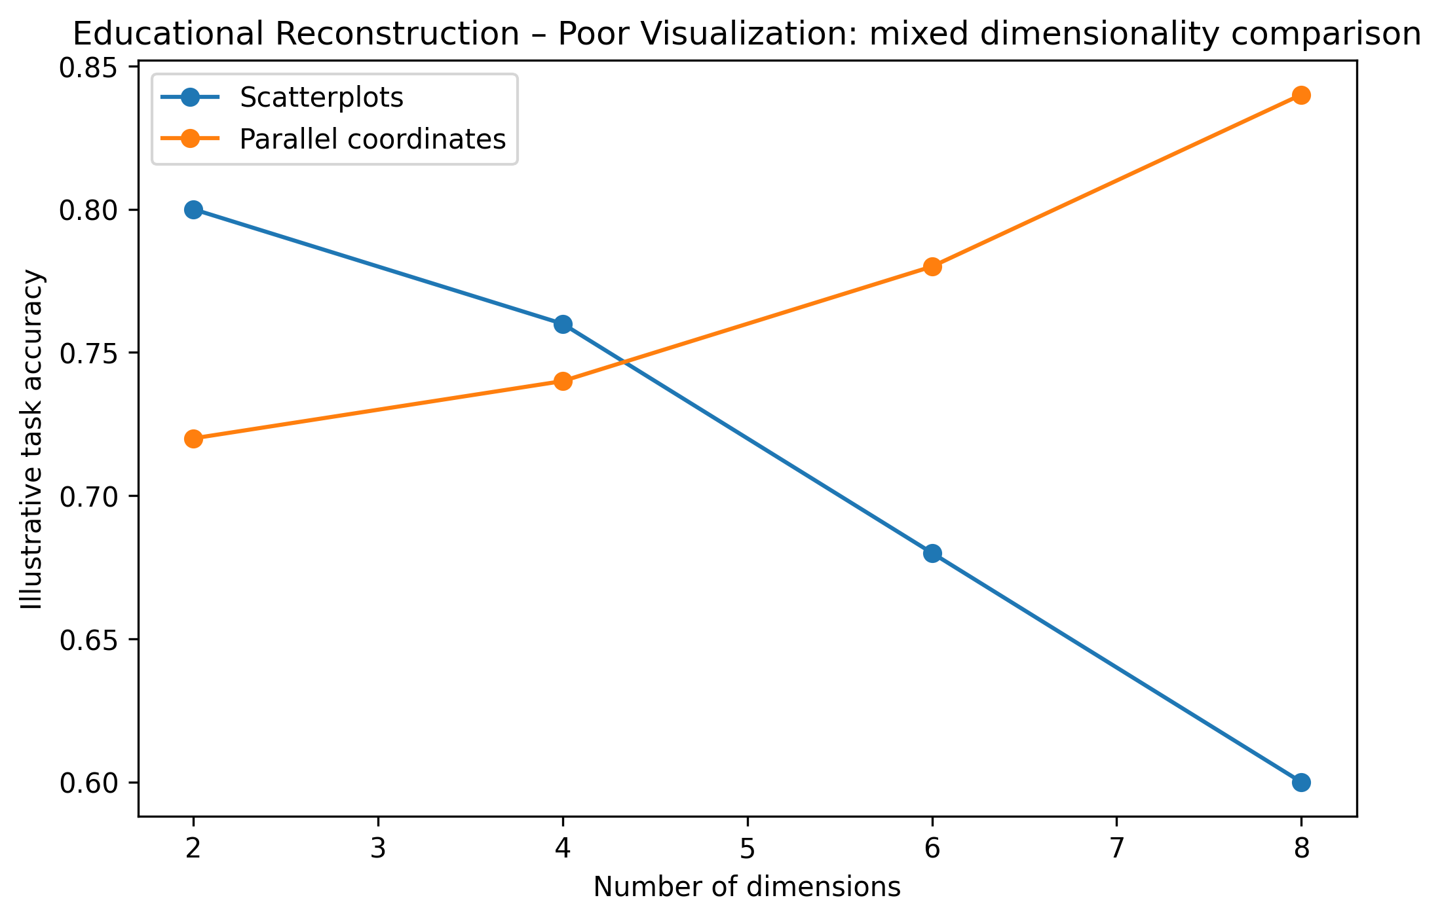
Figure 15. Educational reconstruction illustrating the selected visualization problem.

10. IMPROVED VISUALIZATION
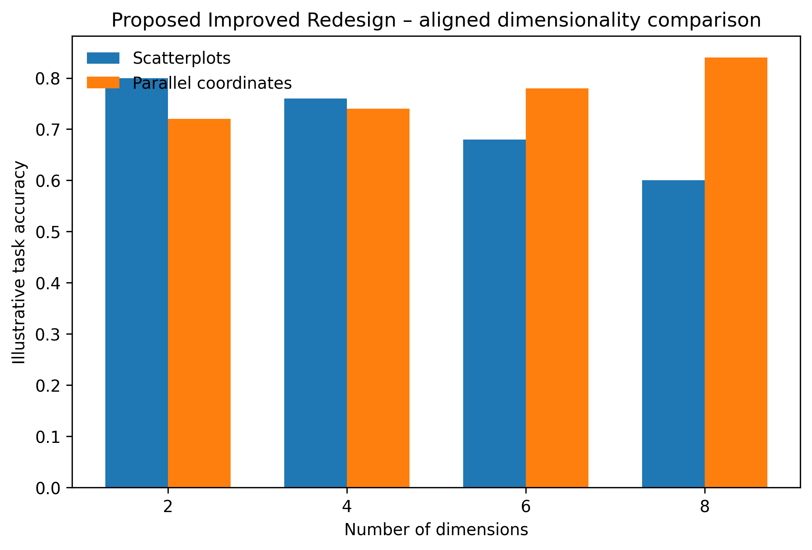
Figure 15. Proposed redesigned visualization using improved graphical encoding.

11. GRAPHICAL ENCODING CHANGES
The redesign prioritizes aligned position, length, spatial grouping, restrained categorical encoding, explicit direction, and/or selective salience according to the visual task. Redundant decoration is minimized.

12. BEFORE vs AFTER COMPARISON
Aspect | Original / Poor Design | Improved Design
Chart type | Comparative plot | Comparative plot with clearer task-oriented structure
Scale | May require extra visual search | Consistent and task-aligned where applicable
Encoding | Multiple or competing cues | Primary cue emphasized
Labels | Potentially dispersed | Grouped / directly associated
Color | Used cautiously; avoid unnecessary competition | Restrained, accessible emphasis
Comparison | May require cross-reference | Aligned or spatially grouped
Cognitive load | Higher when elements compete | Reduced through hierarchy and grouping
Accessibility | Avoid reliance on color alone | Use position, labels, and shape/line cues where useful

13. PYTHON CODE
# Comparative eye-tracking evaluation of scatterplots and parallel coordinates
# Educational reconstruction for M.E. CSE Data Visualization Exercise-2.
# The reconstruction is NOT a reproduction of the authors' research findings.
# Replace only with published numerical values when the source provides them.
import matplotlib.pyplot as plt
import numpy as np

# Illustrative reconstruction data / structure:
dims=[2,4,6,8]; scatter=[.80,.76,.68,.60]; pcp=[.72,.74,.78,.84]

# Plot:
fig,ax=plt.subplots(figsize=(8,5)); x=np.arange(len(dims)); w=.35
ax.bar(x-w/2,scatter,w,label="Scatterplots"); ax.bar(x+w/2,pcp,w,label="Parallel coordinates")
ax.set_xticks(x,dims); ax.set_xlabel("Number of dimensions"); ax.set_ylabel("Illustrative task accuracy"); ax.legend(frameon=False)

plt.tight_layout()
plt.savefig("/mnt/data/exercise2_research_redesign/visualizations/paper_15_improved.png", dpi=300, bbox_inches="tight")
plt.show()
Complete executable file: python/paper_15_improved.py

14. ANALYSIS
1. Information represented: the selected paper's visual representation supports understanding of perceptual comparison concepts. 2. Graphical marks: marks appropriate to the selected comparative plot are used. 3. Visual variables: position, length, direction, grouping, size, or restrained color are used as applicable. 4. Perception task: the viewer must identify structure, compare elements, follow a process, or locate relationships. 5. Difficulties: Different dimensionalities and diagram types require explicit separation to avoid mixing task conditions. 6. Redesign change: the visual hierarchy and encoding were simplified. 7. Readability: aligned and grouped encodings reduce visual search. 8. Data preservation: no research conclusion is changed. 9. Limitation: where exact source values were unavailable, the figure is explicitly an educational structural reconstruction rather than an exact numerical reproduction.

15. RESULT
The selected visualization was evaluated and redesigned using relevant visual perception and graphical encoding principles. The redesign improves the clarity of the intended visual task while preserving the source paper's conceptual meaning.

16. RESEARCH PAPER REFERENCE
Firat et al.. “Comparative eye-tracking evaluation of scatterplots and parallel coordinates,” Visual Informatics, Vol. 1, Issue 2, pp. 118–131, 2017. DOI: 10.1016/j.visinf.2017.11.001.

17. DOWNLOADABLE PAPER LINK
Publisher / database page: https://www.sciencedirect.com/science/article/pii/S2468502X17300293
Direct PDF: https://www.sciencedirect.com/science/article/pii/S2468502X17300293/pdfft
PDF access: publisher page checked for open-access/free full-text availability at preparation time.

