EXERCISE-2
APPLICATION OF VISUAL PERCEPTION AND GRAPHICAL ENCODING PRINCIPLES FOR EVALUATION AND REDESIGN OF DATA VISUALIZATIONS

AIM:
To evaluate poorly designed data visualizations using visual perception and graphical encoding principles, and redesign them into clear, accurate, and effective visualizations using Python Matplotlib.

PROCEDURE:
- Import the required Python library (matplotlib.pyplot) and numpy where necessary.
- Create sample datasets such as customer revenue, monthly sales, website traffic, marketing channels, and category distributions.
- Generate intentionally poor visualizations by introducing common design mistakes such as:
  - Truncated Y-axis
  - Missing axis labels
  - Crowded legends
  - Excessive colors and annotations
  - Poor pie chart color choices
- Apply graphical encoding principles to redesign each visualization by:
  - Starting bar chart Y-axes from zero.
  - Adding meaningful titles and axis labels.
  - Using appropriate colors with good contrast.
  - Displaying only essential data labels.
  - Reducing visual clutter.
  - Highlighting important information while de-emphasizing less important elements.
- Display both poor and corrected versions side by side for comparison.
- Analyze how the redesigned charts improve readability, accuracy, and user understanding.
CODE:
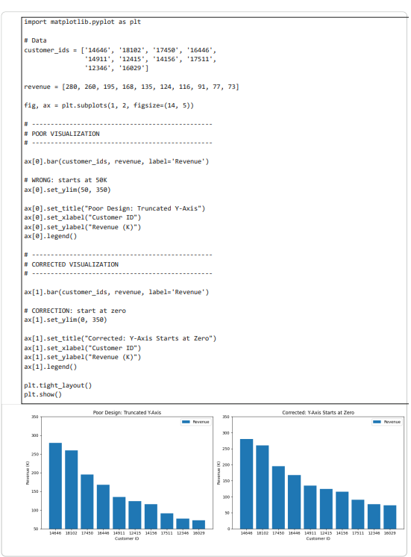
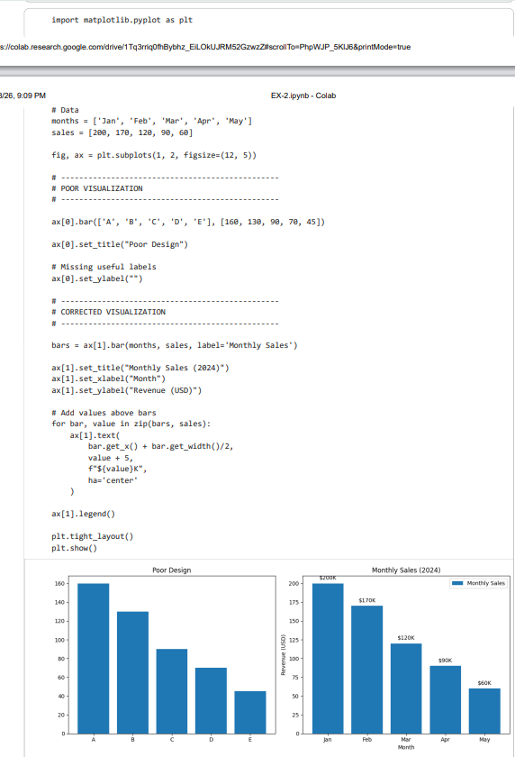

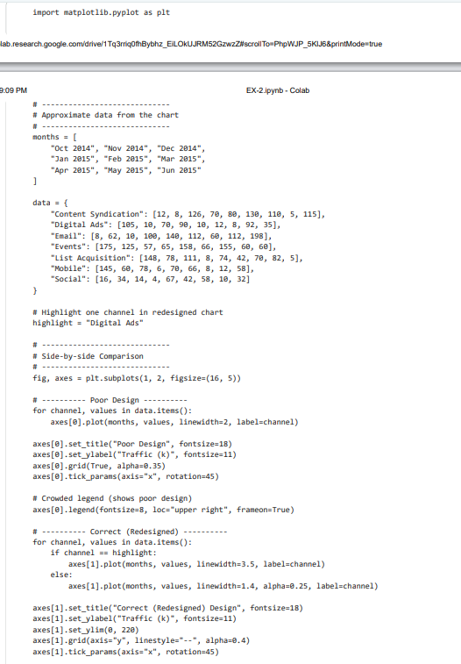
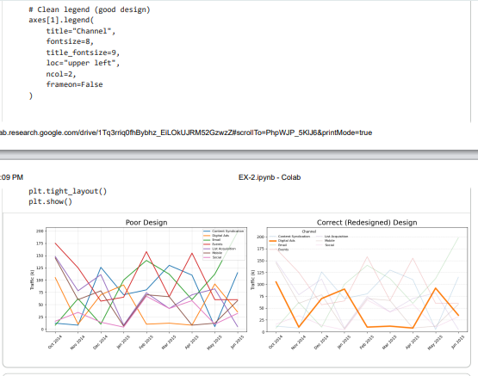
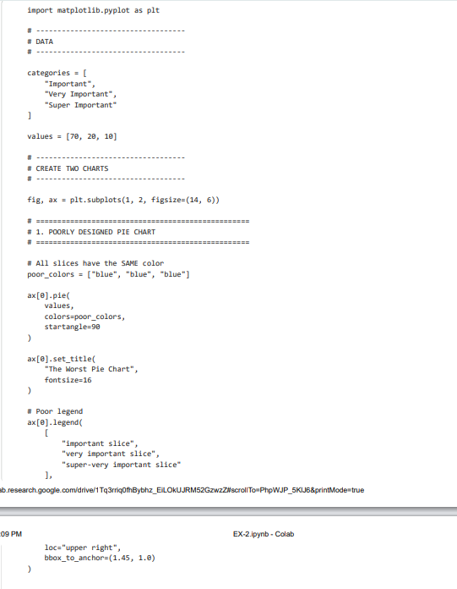

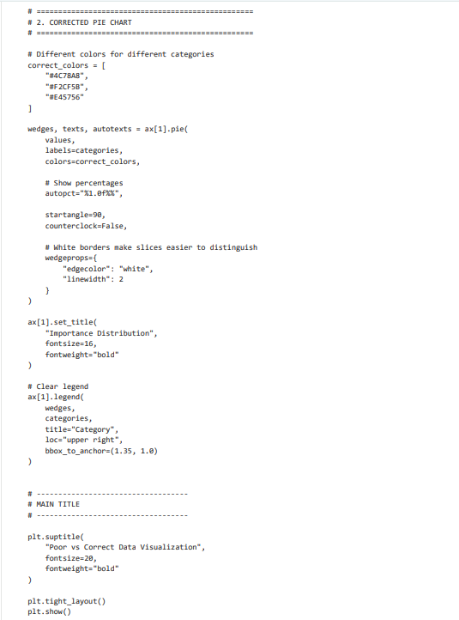
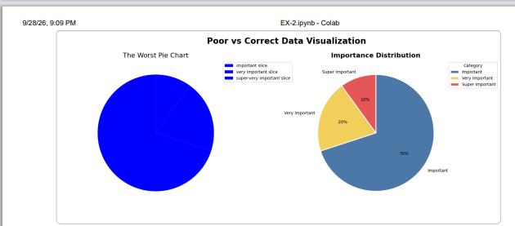
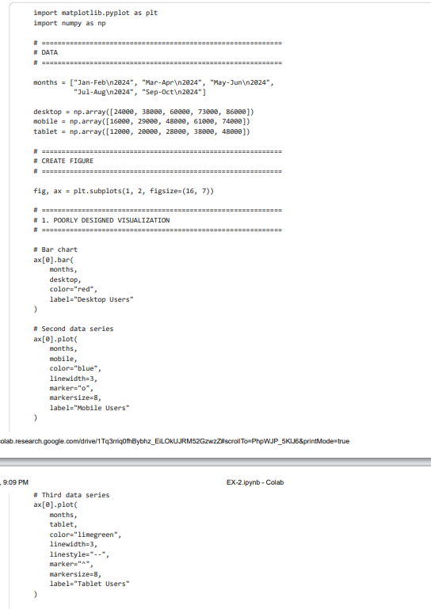
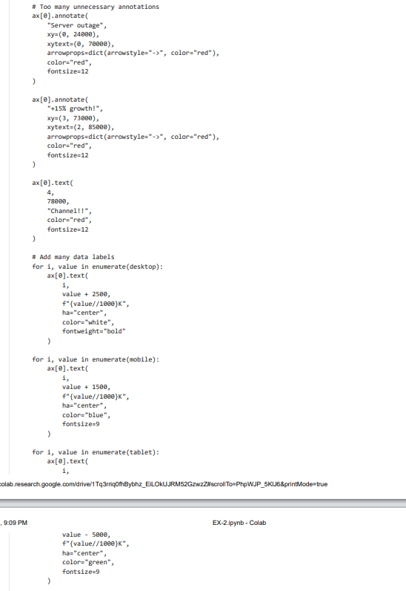
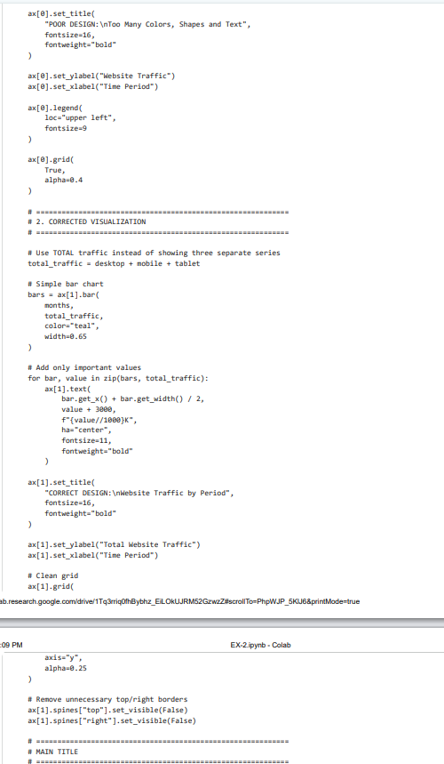
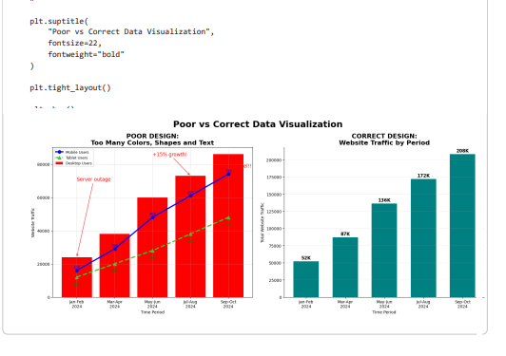

RESULT:
The poor visualizations were successfully evaluated and redesigned by applying visual perception and graphical encoding principles. The corrected charts improved accuracy, readability, visual hierarchy, and user comprehension by using proper scales, meaningful labels, effective color encoding, reduced clutter, and appropriate emphasis on important information.

PERFORMANCE (25)
VIVA (10)
RECORD (15)
TOTAL (50)

