EXERCISE-2
APPLICATION OF VISUAL PERCEPTION AND GRAPHICAL ENCODING PRINCIPLES FOR EVALUATION AND REDESIGN OF DATA VISUALIZATIONS
Student Name: [Enter Your Name] Register No.: [Enter Register Number]
AIM:
To evaluate a published research visualization using visual perception and graphical encoding principles, and redesign the comprehension-score chart so that the magnitude of differences is not exaggerated and uncertainty is visible.
RESEARCH PAPER SELECTED:
Research paper used: Abukmail E, Bakhit M, Jones M, Del Mar C, Hoffmann T. Effect of different visual presentations on the public’s comprehension of prognostic information using acute and chronic condition scenarios: two online randomised controlled trials. BMJ Open. 2023;13:e067624. DOI: 10.1136/bmjopen-2022-067624. CC BY 4.0.
Important academic note: the source paper is not labelled as a 'bad paper'. For this exercise, one published visualization/data display is used as the source, and a deliberately poor version is constructed so that visual-perception problems can be evaluated and then corrected. The numerical values are taken from the published paper.
VISUALIZATION 1: Mean Comprehension Score – Bar Chart Redesign
Published Trial A values: Text only 3.71 (SD 1.63), Bar graph 3.79 (SD 1.54), Pictograph 4.25 (SD 1.40), Line graph 3.81 (SD 1.53).
PROCEDURE:
- Select the published Trial A comprehension-score data from the research paper.
- Recreate an intentionally poor bar chart using a truncated numerical axis.
- Identify how the truncated baseline changes the perceived difference between groups.
- Redesign the chart with a zero-based score scale, clear labels, and standard-deviation error bars.
- Compare the poor and corrected versions and explain the perceptual improvement.
POOR VISUALIZATION – PROBLEMS IDENTIFIED:
- The vertical scale begins near the observed values instead of showing the full 0–6 score range.
- The small numerical differences can appear visually larger than they actually are.
- Uncertainty information is omitted.
- The chart uses extra visual emphasis that is not required for a simple group comparison.
CORRECTED VISUALIZATION – GRAPHICAL ENCODING CHANGES:
- Use a full 0–6 score scale because the paper defines comprehension as a 0–6 outcome.
- Add standard-deviation error bars so variability is visible.
- Use a horizontal bar layout to make group labels easier to read.
- Place the numerical value beside each bar instead of forcing the reader to estimate it.
- Use a restrained grid only on the quantitative axis.
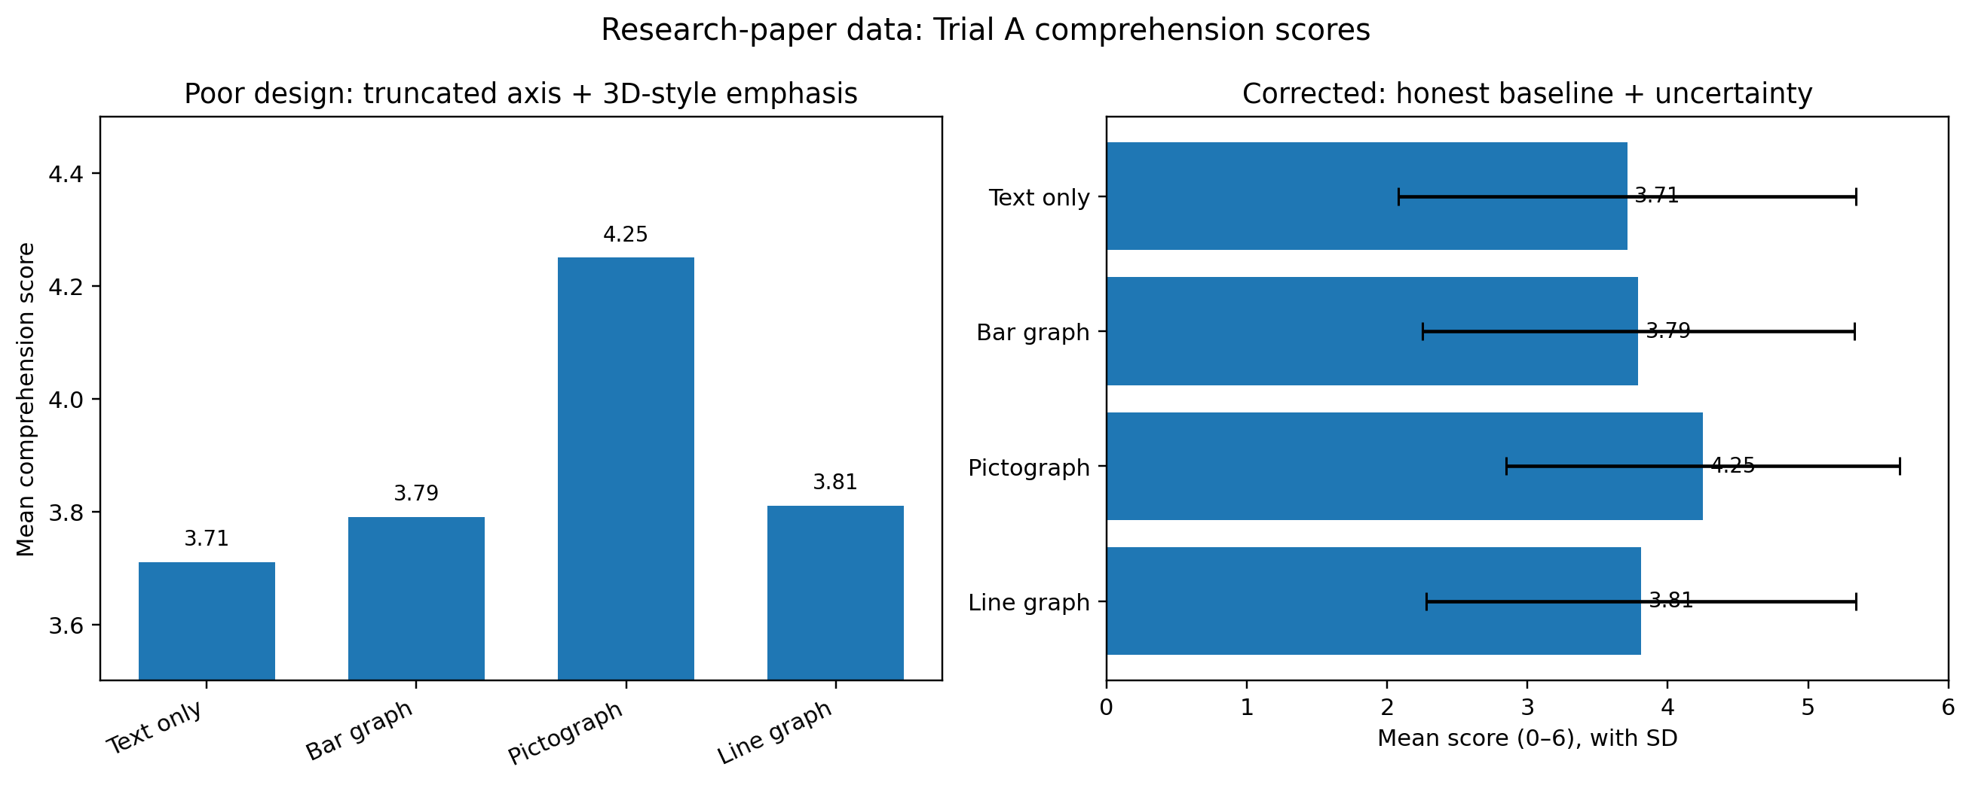
Figure: Intentionally poor visualization compared with the corrected redesign.
CODE:
import matplotlib.pyplot as plt
import numpy as np
groups = ["Text only", "Bar graph", "Pictograph", "Line graph"]
mean = [3.71, 3.79, 4.25, 3.81]
sd = [1.63, 1.54, 1.40, 1.53]
fig, ax = plt.subplots(figsize=(8, 5))
y = np.arange(len(groups))
ax.barh(y, mean, xerr=sd, capsize=4)
ax.set_yticks(y, groups)
ax.invert_yaxis()
ax.set_xlim(0, 6)
ax.set_xlabel("Mean comprehension score (0–6)")
ax.set_title("Trial A: Mean comprehension score")
ax.grid(axis="x", alpha=0.25)
for i, value in enumerate(mean):
ax.text(value + 0.05, i, f"{value:.2f}", va="center")
plt.tight_layout()
plt.show()
ANALYSIS:
The source values are close to one another except for the pictograph group. A truncated axis can visually magnify those differences. The corrected chart preserves the same values but makes the scale honest and adds SD values, allowing the reader to distinguish the central estimate from its variability.
RESULT:
The research-paper visualization was successfully evaluated and redesigned using visual perception and graphical encoding principles. The redesigned chart removes misleading or unnecessary visual effects, establishes an appropriate scale, improves labels and hierarchy, and makes the intended comparison easier to read without changing the underlying published data.
SOURCE / PAPER LINK:
Official paper page: https://bmjopen.bmj.com/content/13/6/e067624
Open-access PDF: https://pure.bond.edu.au/ws/files/214042719/e067624.full.pdf

