EXERCISE-2
APPLICATION OF VISUAL PERCEPTION AND GRAPHICAL ENCODING PRINCIPLES FOR EVALUATION AND REDESIGN OF DATA VISUALIZATIONS
Student Name: [Enter Your Name] Register No.: [Enter Register Number]
AIM:
To evaluate a research-paper visualization of treatment decision intentions and redesign it so that the before-versus-after comparison is visually direct, less cluttered, and easier to interpret.
RESEARCH PAPER SELECTED:
Research paper used: Abukmail E, Bakhit M, Jones M, Del Mar C, Hoffmann T. Effect of different visual presentations on the public’s comprehension of prognostic information using acute and chronic condition scenarios: two online randomised controlled trials. BMJ Open. 2023;13:e067624. DOI: 10.1136/bmjopen-2022-067624. CC BY 4.0.
Important academic note: the source paper is not labelled as a 'bad paper'. For this exercise, one published visualization/data display is used as the source, and a deliberately poor version is constructed so that visual-perception problems can be evaluated and then corrected. The numerical values are taken from the published paper.
VISUALIZATION 2: Decision Intention – Before/After Comparison Redesign
Trial A main-category percentages: before = 66.0%, 64.6%, 62.7%, 68.1%; after = 72.8%, 64.6%, 79.1%, 73.6% for Text only, Bar graph, Pictograph and Line graph respectively.
PROCEDURE:
- Extract Trial A decision-intention percentages from Table 2 of the paper.
- Construct a deliberately crowded stacked visualization containing several categories and before/after encodings.
- Identify problems caused by too many visual encodings and a large legend.
- Redesign the visualization as a focused grouped bar chart for the main decision category.
- Explain how the corrected encoding improves comparison without changing the source values.
POOR VISUALIZATION – PROBLEMS IDENTIFIED:
- Multiple categories and time states are encoded at the same time.
- The legend becomes large and forces the reader to repeatedly decode colors.
- The main comparison is not immediately visible.
- The viewer must estimate segment sizes before comparing the groups.
CORRECTED VISUALIZATION – GRAPHICAL ENCODING CHANGES:
- Use grouped bars for the before/after comparison.
- Keep the y-axis fixed from 0 to 100% because the data are percentages.
- Use direct value labels for the main category.
- Use a short, descriptive title and an explicit y-axis label.
- Move secondary categories to a separate table or figure when they are not the main message.
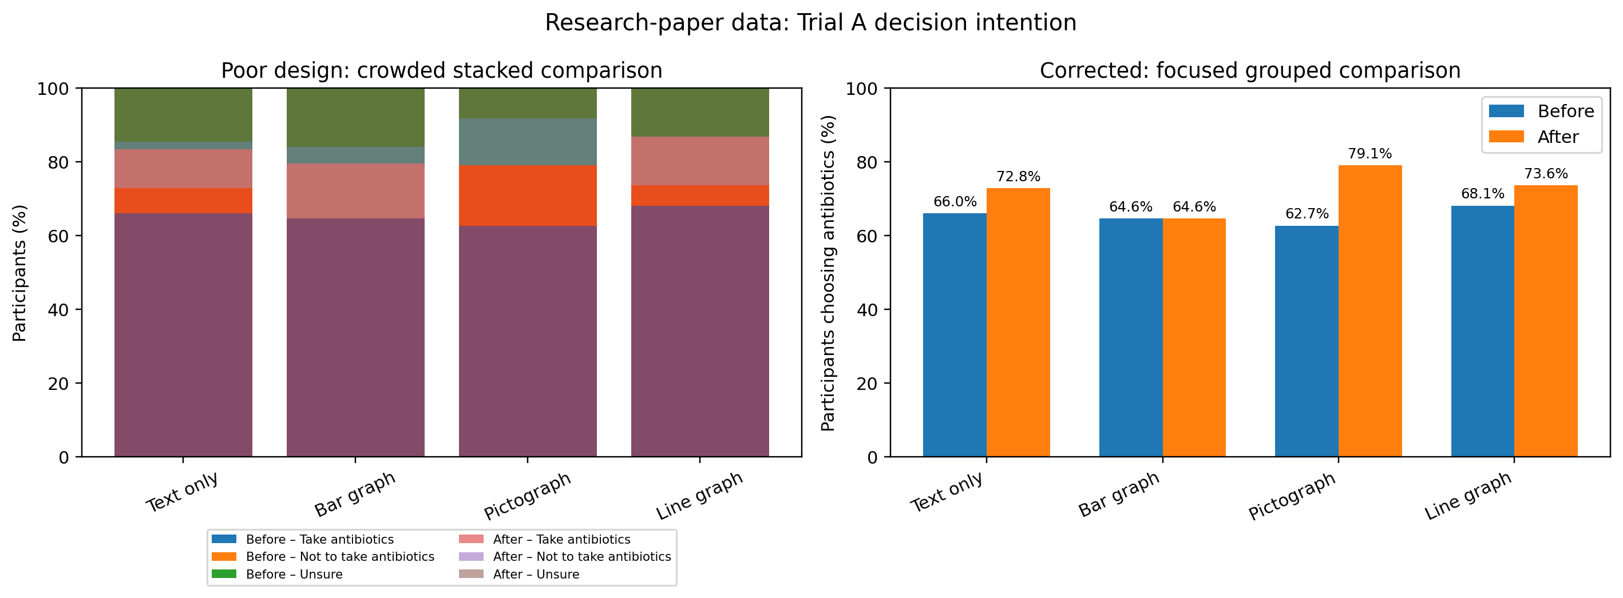
Figure: Intentionally poor visualization compared with the corrected redesign.
CODE:
import matplotlib.pyplot as plt
import numpy as np
groups = ["Text only", "Bar graph", "Pictograph", "Line graph"]
before = [66.0, 64.6, 62.7, 68.1]
after = [72.8, 64.6, 79.1, 73.6]
x = np.arange(len(groups))
width = 0.36
fig, ax = plt.subplots(figsize=(9, 5))
ax.bar(x - width/2, before, width, label="Before")
ax.bar(x + width/2, after, width, label="After")
ax.set_xticks(x, groups, rotation=25, ha="right")
ax.set_ylim(0, 100)
ax.set_ylabel("Participants choosing antibiotics (%)")
ax.set_title("Trial A: Decision intention before vs after")
ax.legend()
for i, value in enumerate(before):
ax.text(i - width/2, value + 2, f"{value:.1f}%", ha="center")
for i, value in enumerate(after):
ax.text(i + width/2, value + 2, f"{value:.1f}%", ha="center")
plt.tight_layout()
plt.show()
ANALYSIS:
The corrected version focuses on the percentage choosing antibiotics, which is explicitly discussed in the paper. This reduces cognitive load while retaining the before/after comparison across the four intervention groups. The paper itself reports that statistical testing did not provide sufficient evidence of a difference between intervention groups for change in decision intention, so the visualization should not visually imply a causal or statistically significant effect.
RESULT:
The research-paper visualization was successfully evaluated and redesigned using visual perception and graphical encoding principles. The redesigned chart removes misleading or unnecessary visual effects, establishes an appropriate scale, improves labels and hierarchy, and makes the intended comparison easier to read without changing the underlying published data.
SOURCE / PAPER LINK:
Official paper page: https://bmjopen.bmj.com/content/13/6/e067624
Open-access PDF: https://pure.bond.edu.au/ws/files/214042719/e067624.full.pdf

