EXERCISE-2
APPLICATION OF VISUAL PERCEPTION AND GRAPHICAL ENCODING PRINCIPLES FOR EVALUATION AND REDESIGN OF DATA VISUALIZATIONS
Student Name: [Enter Your Name] Register No.: [Enter Register Number]
AIM:
To evaluate a published research-paper preference visualization and redesign it from a visually decorative part-to-whole display into a precise categorical comparison.
RESEARCH PAPER SELECTED:
Research paper used: Abukmail E, Bakhit M, Jones M, Del Mar C, Hoffmann T. Effect of different visual presentations on the public’s comprehension of prognostic information using acute and chronic condition scenarios: two online randomised controlled trials. BMJ Open. 2023;13:e067624. DOI: 10.1136/bmjopen-2022-067624. CC BY 4.0.
Important academic note: the source paper is not labelled as a 'bad paper'. For this exercise, one published visualization/data display is used as the source, and a deliberately poor version is constructed so that visual-perception problems can be evaluated and then corrected. The numerical values are taken from the published paper.
VISUALIZATION 3: Visual Presentation Preference – Pie-to-Bar Redesign
Trial A first-choice counts: Text only 124, Bar graph 137, Pictograph 58, Line graph 98; total n=417.
PROCEDURE:
- Use the Trial A overall first-choice counts reported in the research paper.
- Construct a deliberately decorative pie chart with many labels and visual effects.
- Identify problems related to angle comparison, label crowding, and unnecessary decoration.
- Redesign the same values as a horizontal bar chart with one common numerical scale.
- Add direct percentage labels and explain why the corrected encoding supports faster comparison.
POOR VISUALIZATION – PROBLEMS IDENTIFIED:
- Pie-slice angles are harder to compare precisely than aligned bar lengths.
- Several labels compete for attention around the circle.
- Decorative effects add visual complexity without adding information.
- The exact ranking is less immediately readable.
CORRECTED VISUALIZATION – GRAPHICAL ENCODING CHANGES:
- Use a horizontal bar chart because the task is categorical comparison.
- Sort categories so the relative sizes can be compared quickly.
- Use one common quantitative axis.
- Place percentages directly beside bars.
- Remove shadows, exploded slices, and unnecessary decoration.
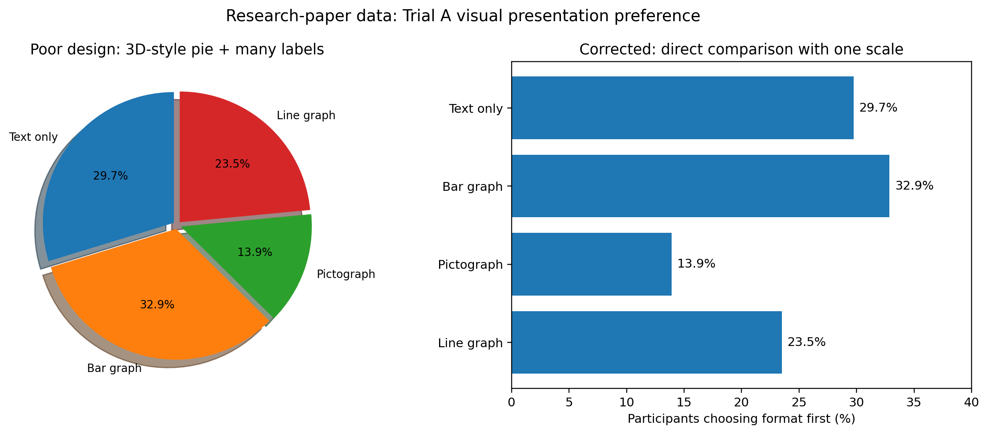
Figure: Intentionally poor visualization compared with the corrected redesign.
CODE:
import matplotlib.pyplot as plt
labels = ["Text only", "Bar graph", "Pictograph", "Line graph"]
counts = [124, 137, 58, 98]
total = sum(counts)
percent = [c / total * 100 for c in counts]
fig, ax = plt.subplots(figsize=(8, 5))
ax.barh(labels[::-1], percent[::-1])
ax.set_xlim(0, 40)
ax.set_xlabel("Participants choosing format first (%)")
ax.set_title("Trial A: Visual presentation preference")
for y, value in enumerate(percent[::-1]):
ax.text(value + 0.5, y, f"{value:.1f}%", va="center")
plt.tight_layout()
plt.show()
ANALYSIS:
The paper reports 137 participants choosing the bar graph first, 124 choosing text-only, 58 choosing pictograph, and the remaining 98 choosing line graph in Trial A. The corrected horizontal bar chart makes these differences easier to compare than pie-slice angles. This is a redesign for readability, not a change to the study's findings.
RESULT:
The research-paper visualization was successfully evaluated and redesigned using visual perception and graphical encoding principles. The redesigned chart removes misleading or unnecessary visual effects, establishes an appropriate scale, improves labels and hierarchy, and makes the intended comparison easier to read without changing the underlying published data.
SOURCE / PAPER LINK:
Official paper page: https://bmjopen.bmj.com/content/13/6/e067624
Open-access PDF: https://pure.bond.edu.au/ws/files/214042719/e067624.full.pdf

