   

**EDUBOT-REVOLUTIONZING EDUCATION**

A Project Report

Submitted in partial fulfillment of the requirements Of

Stock Market Forecast

by

ARULESHWARAN NS

**810021114305**

[**nsaruleshwaransellappan@gamil.com**](mailto:nsaruleshwaransellappan@gamil.com)

Under the Guidance of

**P.Raja, Master Trainer**

#### ACKNOWLEDGEMENT

   

I would like to express my heartfelt gratitude to all the teachers who have supported and guided me throughout the course of this project. First and foremost, I would like to thank raja sir , whose expertise, encouragement, and constant support helped shape the direction of this work. Their insightful feedback and constructive criticism have been invaluable.

I am also deeply grateful to raja sir for their unwavering patience and guidance, which allowed me to explore my ideas in depth and to overcome challenges with confidence. A special thanks to [Teacher's Name] for their inspiration and for making complex concepts more accessible.

Finally, I extend my appreciation to all the faculty members whose dedication to education and mentorship has contributed to my academic growth. Without their continued support, this project would not have been possible.

Thank you all for your commitment to nurturing my curiosity and helping me reach this milestone.

*************

# ABSTRACT

Stock Market Forecast:

Stock market forecasting attempts to predict future price movements based on analysis of various indicators, including historical price data, economic conditions, investor sentiment, and market trends. Here are some key methods and insights often applied in stock market forecasts:

###### Technical Analysis

* + **Trend Analysis**: Observes past price trends, using tools like moving averages, trend lines, and relative strength indicators (RSI) to identify potential future price

directions.

* + **Chart Patterns**: Technical analysts look for recurring patterns in stock price charts, like head-and-shoulders or double tops, which are believed to indicate upcoming price movements.
  + **Momentum Indicators**: Oscillators like the MACD (Moving Average Convergence Divergence) or RSI can show if a stock is overbought or oversold, potentially signaling reversals.

###### Fundamental Analysis

* + **Earnings and Revenue Growth**: Analysts examine company earnings reports, financial health, and revenue projections to estimate intrinsic stock value. Positive earnings surprises can drive up stock prices.
  + **Economic Indicators**: Data such as GDP growth, unemployment rates, and inflation affect market forecasts, as strong economies generally bolster stock markets.
  + **Interest Rates and Inflation**: High-interest rates can reduce stock valuations because they increase borrowing costs and lower future cash flow estimates; meanwhile,

inflation impacts purchasing power and can destabilize markets.

###### Quantitative Models and Machine Learning

* + **Algorithmic Forecasting Models**: Quant models use complex algorithms to analyze large datasets and generate forecasts. Machine learning algorithms like neural networks, decision trees, and random forests are popular in forecasting stock price movements.
  + **Sentiment Analysis**: Machine learning algorithms also analyze social media, news, and public sentiment to predict investor behavior. Positive or negative news can cause sudden market shifts, so this approach seeks to quantify sentiment as a

leading indicator.

###### Macroeconomic Factors

* + **Geopolitical Events**: Market forecasts often consider the impact of global politics, trade agreements, or conflicts. For example, trade tensions or sanctions can lead to market volatility.
  + **Government Policies**: Fiscal and monetary policies impact stocks. For instance, stimulus measures can raise demand and stock prices, while regulatory crackdowns may suppress growth in certain sectors.

###### Behavioral Economics and Sentiment Analysis

* + **Investor Sentiment and Market Psychology**: Sentiment is a key driver in short-term stock movements. By analyzing investor mood swings, like fear during market downturns or greed during rallies, forecasts try to predict when a market is likely to reverse.
  + **Market Anomalies**: Behavioral finance studies phenomena like "herd behavior" or "overconfidence" that often lead to market anomalies, which traditional models might overlook.

###### Scenario Analysis and Stress Testing

* + **Best, Base, and Worst-Case Scenarios**: Analysts use different economic assumptions to build varied market scenarios. Stress tests measure how stocks might react to extreme conditions, such as economic recessions or sudden regulatory changes.
  + **Black Swan Events**: These are rare, unpredictable events (e.g., financial crises or pandemics) that have large impacts on markets. Scenario analysis attempts to account for these, though forecasting such events remains challenging.

###### Limitations and Risks in Forecasting

* + **Unpredictability**: Forecasting is inherently uncertain. Past performance does not

guarantee future results, and unexpected events often disrupt even the most robust forecasts.

* + **Data Quality and Model Limitations**: Forecast accuracy depends heavily on data quality and model assumptions. Misleading or outdated data can skew predictions.
  + **Bias and Emotion**: Analysts and investors may have biases, leading them to over- or underestimate certain stocks, which can impact forecasting accuracy.

Stock market forecasts are valuable but should be used as one of several tools in investment decision-making.

4o

   

**TABLE OF CONTENTS**

**Chapter 1. Introduction**

* 1. Problem Statement
  2. Motivation
  3. Objectives
  4. Scope of the Project

## Chapter 2. Existing Models Chapter 3. Proposed Methodology

**Chapter 4. Implementation and Results**

## Chapter 5. Discussion and Conclusion References

**Appendices**

   

# CHAPTER 1

### Introduction

##### Problem Statement: You are tasked to perform stock market forecasting using linear regression.

* 1. **Motivation: Embarking on a stock market forecast project can be highly motivating and rewarding for many reasons! Here’s how this project can inspire you and add value to both your skills and your understanding of the markets.**

##### Objective: The objectives of a stock market forecast project typically aim to predict stock price movements, understand market trends, and develop models for decision- making.

* 1. **Scope of the Project: The scope of a stock market forecasting project encompasses a range of activities and focuses designed to build predictive models, analyze data, and offer actionable insights into market trends.**

# CHAPTER 2

### Existing Models

1. **Statistical Models**
   * **Autoregressive Integrated Moving Average (ARIMA)**: ARIMA models are popular for time series forecasting and are often applied to stock prices. ARIMA models work well for short-term predictions when historical patterns are stable, though they struggle in volatile markets.
   * **GARCH (Generalized Autoregressive Conditional Heteroskedasticity)**: GARCH models predict stock market volatility rather than prices, focusing on the variance in returns. They are useful in risk management, as they help estimate the likelihood of extreme price swings.
   * **Vector Autoregression (VAR)**: This multivariate model forecasts stock prices by considering the interrelationships among multiple time series variables, such as economic indicators or other stocks. VAR is helpful for understanding how different stocks or economic factors impact each other.
2. **Machine Learning Models**
   * **Linear Regression**: Linear regression models are often used for stock prediction by analyzing the relationship between stock prices and explanatory variables. While simple, they are limited in handling complex, non-linear relationships.
   * **Support Vector Machines (SVM)**: SVMs work well for classification and regression problems, including stock price forecasting. By separating data into categories, SVMs can make predictions on market direction, but they may struggle with large datasets and high volatility.
   * **Decision Trees and Random Forests**: These models are capable of handling large datasets and complex relationships by creating "trees" of decision rules. Random forests, which average multiple decision trees, are particularly popular for stock predictions, although they may overfit in highly volatile markets.
   * **K-Nearest Neighbors (KNN)**: KNN is a simple, instance-based learning model that predicts a stock's future price based on the prices of its "neighbors." KNN works best with datasets that exhibit clusters or patterns, but it can be computationally intensive with large datasets.
3. **Deep Learning Models**
   * **Recurrent Neural Networks (RNN) and Long Short-Term Memory (LSTM)**: RNNs, especially LSTMs, are well-suited for time series forecasting due to their ability to capture dependencies over time. LSTMs are particularly popular for stock forecasting as they can remember patterns over long sequences, making them effective for sequential data like stock prices.
   * **Convolutional Neural Networks (CNN)**: CNNs are typically used for image data, but they have also been applied to stock forecasting by converting time series data into image-like inputs. They’re often used in combination with LSTMs to capture both spatial and temporal dependencies in stock data.
   * **Deep Reinforcement Learning**: This approach combines deep learning with reinforcement learning, where the model learns to make investment decisions (buy, hold, sell) to maximize rewards. Algorithms like Deep Q- Learning and Proximal Policy Optimization (PPO) are used for dynamic stock trading strategies.
4. **Hybrid and Ensemble Models**
   * **Hybrid ARIMA-GARCH**: This combines ARIMA's ability to capture price trends with GARCH's ability to model volatility, creating a model that can forecast both stock price levels and the associated risks.
   * **Ensemble Models (e.g., Random Forests, Gradient Boosting)**: Ensemble methods combine multiple algorithms to improve overall accuracy. For instance, stacking techniques might integrate linear regression, decision trees, and SVMs, taking advantage of each model’s strengths to produce better forecasts.
   * **LSTM-CNN Hybrid Models**: Combining CNNs and LSTMs leverages CNNs to extract patterns from stock time series data, which is then passed to an LSTM for sequential prediction. This hybrid approach is effective for capturing both short-term trends and long-term dependencies.
5. **Sentiment Analysis Models**
   * **Natural Language Processing (NLP) Models**: NLP models like BERT, LSTM-based sentiment analysis, and simpler Bag-of-Words models are used to analyze public sentiment from news, social media, and forums. Sentiment scores are then integrated into the forecast models as additional features, enhancing predictions.
   * **Event-Driven Models**: These models react to specific news events (e.g., earnings releases, mergers) that affect stock prices. NLP techniques extract sentiment or impact scores, which are then incorporated into forecasting models to predict immediate price reactions.

###### Limitations:

1. **Market Volatility and Unpredictability**
   * **High Volatility**: Stock markets can be highly volatile, with prices fluctuating due to unexpected events (e.g., geopolitical events, natural disasters, or economic crises) that forecasting models cannot anticipate.
   * **Random Walk Theory**: According to this theory, stock prices follow a random path, making it difficult to predict future movements based on historical data alone.

###### Impact of External Factors

* + **Macroeconomic Variables**: External factors like interest rates, inflation, government policies, and global economic conditions significantly affect markets. Models may fail to account for rapid changes in these factors.
  + **Behavioral Factors**: Investor behavior, driven by emotion, herd mentality, and

irrational decision-making, introduces noise that models cannot easily quantify, making it challenging to forecast prices accurately.

###### Data Limitations

* + **Historical Data Limitations**: Many models rely on historical data, which may not fully represent future conditions. Economic cycles change, and historical data may not capture emerging trends or technologies.
  + **Data Quality and Completeness**: Inaccurate, incomplete, or biased data can lead to unreliable predictions. Outliers, missing values, and noise in data can distort model training and lead to suboptimal predictions.

# CHAPTER 3

### Proposed Methodology

#### System Design

* + - **Data Sources**: The system aggregates data from multiple sources:
      * **Market Data**: Real-time and historical stock prices, trading volumes, indices from sources like Yahoo Finance, Alpha Vantage, or Bloomberg.
      * **Economic Indicators**: Data on interest rates, inflation, GDP, unemployment rates from government or financial institution databases.
      * **Sentiment and News Data**: Social media (Twitter, Reddit) and news feeds for sentiment analysis, using APIs or web scraping.
      * **Alternative Data**: Data like Google Trends, search volume, and web traffic related to companies or industries.

   

* + - **Data Storage**: A data warehouse or cloud storage (e.g., AWS S3, Google Cloud Storage) is used to store raw data, cleaned data, and processed features. A time- series database (e.g., InfluxDB) can be added for efficient time-series data handling.

###### Data Preprocessing:

* + - * **ETL Pipelines**: Extract, Transform, Load (ETL) pipelines handle data ingestion, transformation (e.g., normalization, handling missing values), and loading.
      * **Data Cleaning**: Removing outliers, filling missing values, and standardizing formats to ensure consistency.
      * **Feature Engineering**: Creating technical indicators (e.g., moving averages), sentiment scores, and other predictive features.

###### Modeling Layer

* + **Feature Selection**: This module selects key features, like technical indicators, macroeconomic indicators, and sentiment scores, to feed into models.

###### Predictive Models:

* + - **Statistical Models**: ARIMA or GARCH models for time series forecasting and volatility prediction.
    - **Machine Learning Models**: Models such as Random Forests, Gradient Boosting, and SVM for regression and classification tasks.
    - **Deep Learning Models**: LSTM or CNN-LSTM hybrid models for sequential data and capturing long-term dependencies.
    - **Sentiment Analysis Models**: NLP-based models (e.g., BERT, LSTM) analyze sentiment from text data and convert it into a numeric score.

# Model

**Exploratory Analysis**

**Here`s the output of the Stock Market Forecast:**

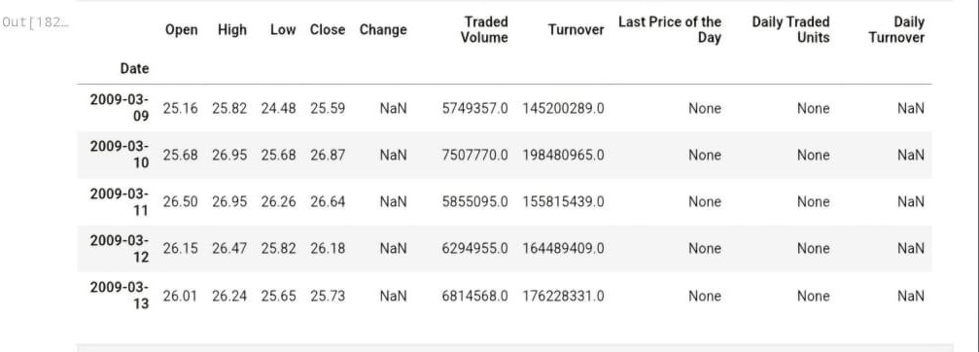

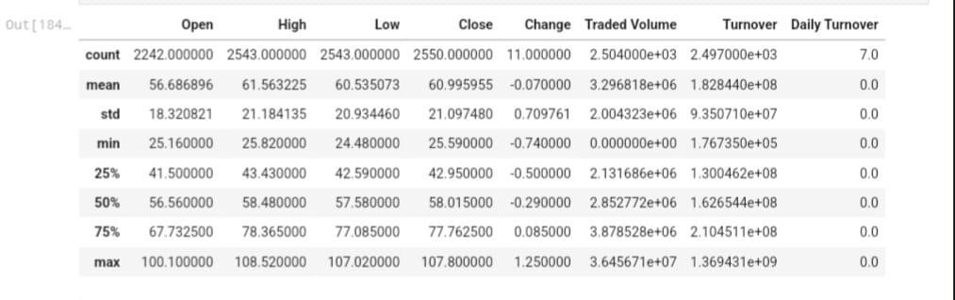

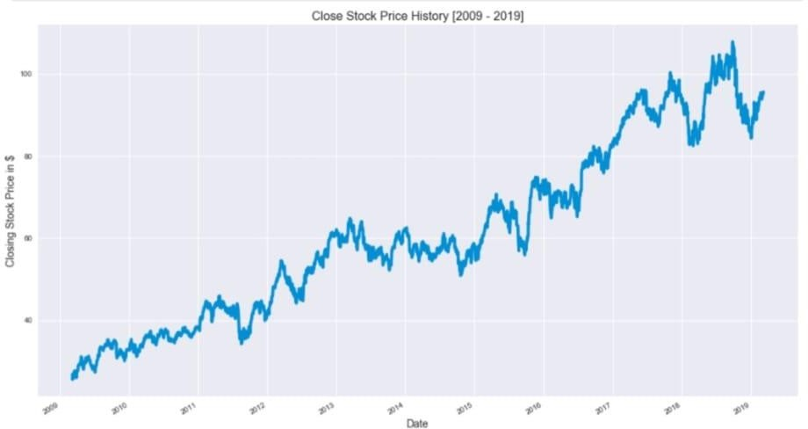

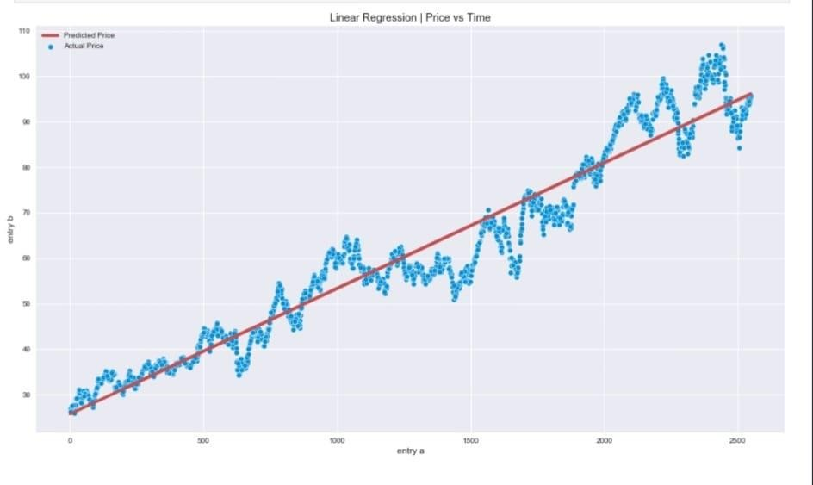

   

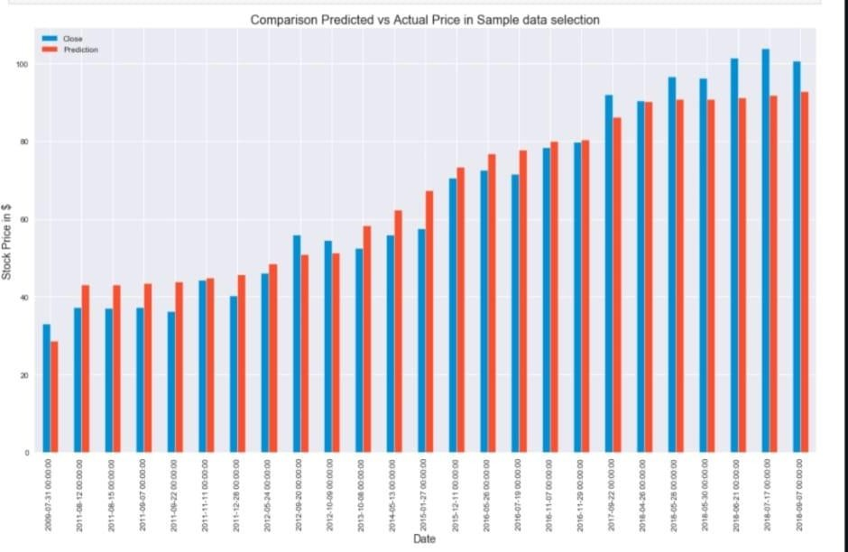

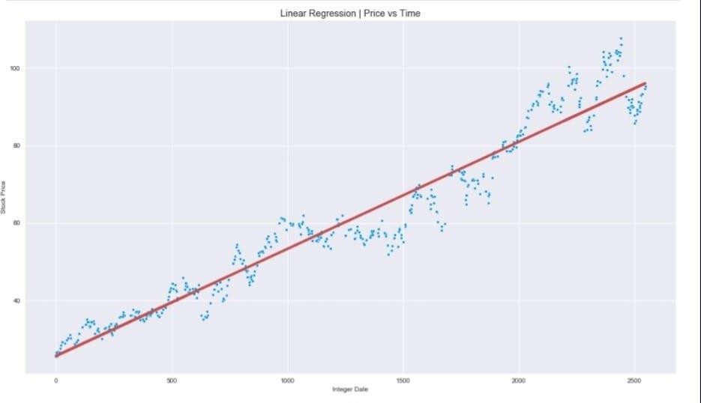

   

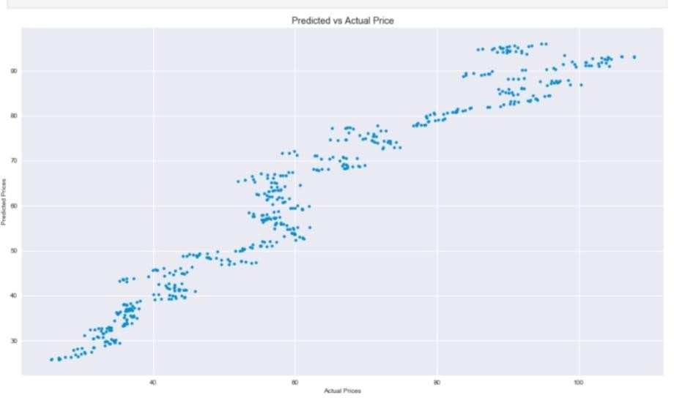

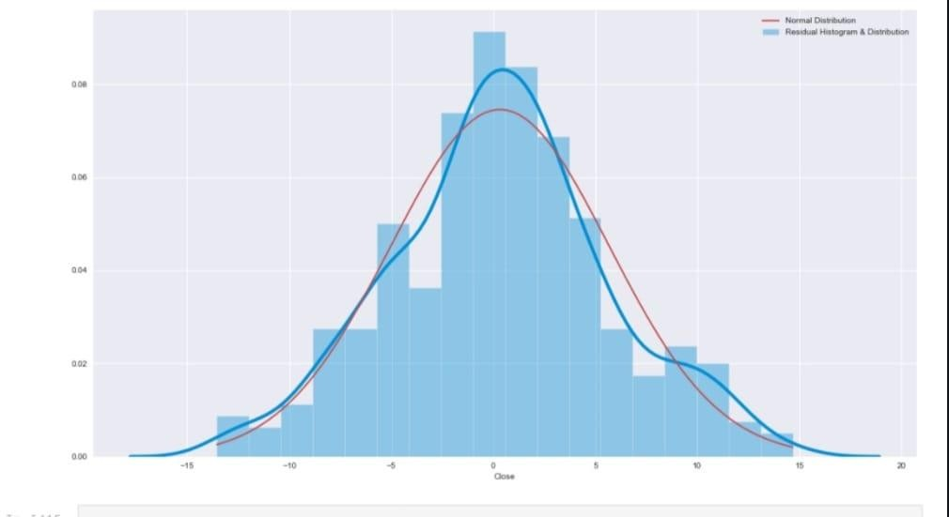

   



Building a Prediction Model

**Prediction Objectives**: Define whether the model will predict:

* + Stock prices (e.g., closing prices for a given time horizon).
  + Stock returns (percentage change in price).
  + Market trends (upward, downward, or neutral movement).

**Model Type**: Based on objectives, select a model type:

* + **Regression Models** for predicting specific values like stock prices.
  + **Classification Models** for predicting trends or directional movement (e.g., up, down, or neutral).
  + **Time-Series Models** for capturing sequential patterns in price data.

**Collect Data**: Gather historical stock prices, trading volumes, technical indicators, economic indicators, and sentiment data.

**Data Cleaning**: Handle missing values, remove outliers, and address noisy data to ensure accuracy.

   

###### Feature Engineering:

* + **Technical Indicators**: Moving averages (SMA, EMA), Relative Strength Index (RSI), MACD, Bollinger Bands, and others.
  + **Lagged Features**: Include lagged values of stock prices or indicators as additional features to capture temporal patterns.
  + **Sentiment Features**: Analyze text data (news, social media) using sentiment analysis and create sentiment scores.
  + **Macro Features**: Include economic indicators like GDP growth, inflation, and interest rates as additional predictors.
  1. **Advantages**

###### Improved Investment Decision-Making

* + **Data-Driven Insights**: Prediction models analyze vast amounts of historical data and market indicators, providing investors with insights that are often more reliable than intuition alone.
  + **Reduced Human Bias**: Forecasting models minimize cognitive biases that might affect individual investors, such as overconfidence or herd mentality, leading to more objective investment decisions.

###### Increased Efficiency and Time Savings

* + **Automated Analysis**: Models can process large datasets and quickly identify patterns, saving time for investors and analysts who might otherwise spend hours on manual analysis.
  + **Scalability**: The ability to analyze multiple stocks, markets, or sectors simultaneously allows investors to diversify portfolios more efficiently.

###### Enhanced Risk Management

* + **Volatility and Risk Assessment**: Many models, like GARCH or those using sentiment analysis, help forecast volatility, allowing investors to anticipate risk levels and adjust their portfolios accordingly.
  + **Dynamic Adaptation**: Advanced models can adapt to changing market conditions, providing real-time updates and reducing the risk of sudden losses due to market shocks.

###### Higher Accuracy in Short-Term Forecasts

* + **Pattern Recognition**: Models like LSTM and Random Forests excel at recognizing historical patterns in stock prices, which can improve the accuracy of short-term forecasts.
  + **Advanced Algorithms**: Machine learning and deep learning techniques enable accurate analysis of non-linear relationships in data, capturing subtle trends and signals that traditional analysis might miss.

###### Ability to Integrate Diverse Data Sources

* + **Comprehensive Analysis**: Models can incorporate various data sources, including technical indicators, economic metrics, and sentiment from social media or news articles, offering a holistic view of market dynamics.
  + **Alternative Data Integration**: By using data sources such as web traffic, search

trends, or satellite data, prediction models gain additional predictive power beyond traditional financial metrics.

###### Supports Algorithmic and Automated Trading

* + **Speed and Consistency**: Prediction models deployed in algorithmic trading

platforms enable consistent execution of trading strategies based on forecasts, improving reaction time to market movements.

* + **Reduced Emotional Trading**: Automated trading systems powered by forecasting models execute trades without emotional interference, avoiding common pitfalls associated with fear or greed.

###### Adaptability and Continuous Improvement

* + **Continuous Learning**: With model retraining on fresh data, modern forecasting

systems continuously improve, adapting to new patterns or shifts in market behavior over time.

* + **Scalability in Different Markets**: Prediction models can be adapted and deployed across various markets (e.g., stocks, commodities, forex), providing flexibility for

investors with diversified portfolios.

###### Enhanced Portfolio Management

* + **Optimal Asset Allocation**: Accurate forecasts can guide better asset allocation, maximizing returns by suggesting when to buy, hold, or sell specific stocks.
  + **Informed Diversification**: Models can identify correlations and trends across assets, helping investors diversify more strategically and reduce portfolio risk.

###### Supports Long-Term Strategy Development

* + **Market Trend Insights**: Predictive models often reveal trends and shifts in industry or sector performance, supporting long-term strategic planning for businesses and institutional investors.
  + **Better Strategic Positioning**: Companies can use forecasts to understand industry trends, positioning themselves advantageously against competitors or planning around market cycles.

###### Accessible to Individual Investors

* + **Democratization of Analysis**: With the rise of user-friendly prediction tools and

platforms, individual investors can access sophisticated analytics and make informed decisions like institutional investors.

* + **Cost Savings**: Forecasting tools reduce the need for expensive financial consultants or analysts by enabling individuals to conduct their own market analysis.

#### Requirement Specification

##### 3.5.1.Hardware Requirements:

###### Development and Prototyping (Small-Scale)

* + **Suitable for: Building initial models, experimenting with small datasets, and testing simple algorithms.**

###### Processor: Quad-core CPU (e.g., Intel Core i5 or AMD Ryzen 5).

* + **Memory (RAM): 8-16 GB RAM.**

###### Storage:

* + - **256-512 GB SSD for quick data access and fast loading of model files.**

###### GPU: Not mandatory, but an entry-level GPU (e.g., NVIDIA GTX 1050 or equivalent) may help with some machine learning tasks.

* + **Network: Standard internet connectivity to access external data sources and cloud services.**

###### *Use Case*: This setup is sufficient for data preprocessing, feature engineering, and running simple machine learning algorithms like Linear Regression, Decision Trees, or basic LSTMs on small datasets.

1. **Mid-Scale Project (Medium to Large Datasets)**

###### Suitable for: Projects with moderate data volumes and more complex models, such as LSTMs or CNNs, handling time-series data for multiple stocks or market indices.

* + **Processor: 6- to 8-core CPU (e.g., Intel Core i7 or AMD Ryzen 7).**

###### Memory (RAM): 32 GB RAM or higher, which is ideal for handling larger datasets.

* + **Storage:**

###### 512 GB – 1 TB SSD for fast data loading and model storage.

* + **GPU: A mid-range GPU (e.g., NVIDIA RTX 3060 or equivalent) for training deep learning models efficiently.**

###### Network: High-speed internet for quick data downloads and integration with APIs.

***Use Case*: This setup supports training machine learning models with larger datasets, running LSTM models for sequential data, and performing backtesting on historical data.**

###### Large-Scale Production Environment

* + **Suitable for: High-frequency trading systems, real-time predictions, or large datasets spanning multiple years or complex models with intensive feature engineering.**

###### Processor: 16-core CPU (e.g., AMD Ryzen 9 or Intel Xeon) or higher for parallel data processing and fast computations.

* + **Memory (RAM): 64-128 GB RAM to handle extensive datasets, especially if working with high-frequency or alternative data sources.**

###### Storage:

* + - **1-2 TB SSD (for fast storage) + Additional HDD (if required for backup).**

###### GPU: High-end GPUs (e.g., NVIDIA RTX 3090, A100, or equivalent) are recommended for training complex deep learning models and for GPU acceleration in real-time forecasts.

* + **Network: Low-latency and high-speed internet to process real-time data and for API calls.**

###### Additional Requirements:

* + - **Redundant Systems: Ensures high availability and fault tolerance, especially if deployed in a real-time environment.**

###### Cooling and Power Management: Especially important for continuous, high-performance computing environments.

***Use Case*: This setup is ideal for large-scale models, such as CNN-LSTM hybrids or ensemble methods, processing large datasets, running multiple models in parallel, and handling high-frequency trading or continuous real-time prediction.**

###### Cloud Computing Option

* + **Cloud platforms like AWS, Google Cloud, and Microsoft Azure offer scalable compute instances that can be tailored to project requirements:**

###### Standard Instance (e.g., AWS EC2 with T3 or M5 instances) for small- scale development.

* + - **Compute-Optimized Instances (e.g., AWS C5) for CPU-intensive tasks.**

###### GPU Instances (e.g., AWS EC2 P3 or G4 instances) for deep learning models.

* + **Advantages: Flexibility, scalability, and pay-as-you-go pricing without hardware maintenance. Cloud services can also provide pre-built AI and machine learning infrastructure, which is useful for deployment.**

##### Software Requirements:

###### Programming Languages

* + **Python: The most widely used language for stock market forecasting due to its rich ecosystem of libraries and frameworks for data analysis, machine learning, and deep learning.**

###### Key Libraries:

* + - * **pandas: For data manipulation and analysis (e.g., handling stock price time-series data).**

###### NumPy: For numerical operations and working with arrays.

* + - * **Matplotlib / Seaborn: For data visualization.**

###### scikit-learn: For implementing machine learning algorithms like linear regression, decision trees, and random forests.

* + - * **TensorFlow / Keras / PyTorch: For building and training deep**

###### learning models, including LSTM and CNN-LSTM for time-series forecasting.

* + - * **statsmodels: For statistical modeling (e.g., ARIMA, GARCH models).**

###### XGBoost / LightGBM: For gradient boosting models (useful in regression and classification tasks).

* + **R: Another popular language in the data science community, often used for statistical analysis and time-series forecasting.**

###### Key Libraries:

* + - * **xts and zoo: For time-series analysis.**

###### forecast: For ARIMA and other time-series forecasting models.

* + - * **caret: For machine learning models.**

###### Java / C++: For high-performance systems, such as algorithmic trading platforms or systems that need low-latency predictions.

1. **Development Environment**

###### Integrated Development Environment (IDE):

* + - **VS Code or PyCharm (for Python): Popular IDEs for coding, debugging, and managing large projects.**

###### RStudio: For R programming, especially for data analysis and time- series forecasting.

**useful for prototyping and presenting results.**

###### Data Management and Processing Tools

* + **Database Management Systems:**

###### SQL Databases (e.g., MySQL, PostgreSQL): For storing structured stock data (historical prices, company data).

* + - **NoSQL Databases (e.g., MongoDB, Cassandra): For unstructured data, such as social media sentiment or alternative data sources.**

###### Cloud Databases: Amazon RDS, Google Cloud SQL, and other managed database services for scalable data storage.

* + **Data Processing Tools:**

###### Apache Kafka: For handling real-time data streaming, useful for real- time stock prediction models.

* + - **Apache Spark: For big data processing; if working with large datasets, Spark can speed up data processing tasks significantly.**

###### Dask: For parallel processing in Python when working with large datasets that don't fit in memory.

1. **Machine Learning and Deep Learning Frameworks**

###### scikit-learn: A Python library that provides simple and efficient tools for data mining and data analysis, including algorithms for regression, classification, clustering, and model evaluation.

* + **TensorFlow / Keras: Open-source frameworks for building deep learning models (e.g., LSTM, CNN, GANs). TensorFlow is powerful and scalable, while Keras (as a high-level API) simplifies model development.**

###### PyTorch: A flexible deep learning library popular for research and prototyping.

* + **XGBoost / LightGBM: High-performance libraries for gradient boosting, useful for predictive modeling with structured data.**

###### H2O.ai: An open-source machine learning platform for building and deploying predictive models at scale.

1. **Visualization and Reporting Tools**

###### Matplotlib / Seaborn: For basic to advanced data visualization in Python.

* + **Plotly: For interactive, web-based visualizations.**

###### Tableau / Power BI: For creating interactive dashboards and reporting tools. These can help present model predictions, stock performance, and risk assessments.

* + **Dash (by Plotly): To build interactive web applications for visualizing stock market data and model predictions.**

###### Version Control and Collaboration Tools

* + **Git: For version control, managing code changes, and collaboration with other team members.**

   

###### GitHub / GitLab / Bitbucket: For hosting code repositories and collaborating in teams.

* + **Docker: For containerizing applications to ensure consistent environments for development, testing, and deployment.**

###### Cloud Platforms and Services

* + **Amazon Web Services (AWS):**

###### EC2: For computing power (especially useful for deep learning models).

* + - **S3: For data storage (historical stock data, model checkpoints).**

###### Lambda: For running model inference in a serverless environment.

* + - **SageMaker: A fully managed machine learning service for building, training, and deploying models at scale.**

###### Google Cloud Platform (GCP):

* + - **Compute Engine: Virtual machines for model training.**

###### BigQuery: A fully-managed data warehouse for big data analytics.

* + - **AI Platform: For managing machine learning workflows.**

###### Microsoft Azure:

* + - **Azure ML: A suite of tools for building, training, and deploying models.**

###### Azure Databricks: A fast, collaborative Apache Spark-based platform for big data analytics.

1. **API Integrations for Stock Data and News**

###### Alpha Vantage API: Provides free access to stock market data (daily, historical, technical indicators, etc.).

* + **Yahoo Finance API: Offers historical stock data, financials, and market statistics.**

###### Quandl API: Provides financial and economic data for analysis.

* + **Finnhub API: Real-time financial data, including stock prices, earnings reports, and news sentiment analysis.**

###### News APIs (e.g., NewsAPI, GDELT): For collecting news articles and sentiment analysis to incorporate into forecasting models.

1. **Backtesting and Trading Frameworks**

###### Backtrader: A Python library for backtesting trading strategies and analyzing stock data.

* + **QuantConnect: A cloud-based algorithmic trading platform that allows backtesting and live trading.**

###### Zipline: A backtesting library in Python, often used with Quantopian for strategy development.

* + **Quantlib: A library for quantitative finance, useful for pricing financial instruments, calculating risk metrics, and simulating portfolios.**

###### Deployment and Monitoring Tools

* + **Flask / FastAPI / Django: For building APIs to deploy models and serve predictions.**

   

###### Docker: For containerizing applications and ensuring they run consistently across different environments.

* + **Kubernetes: For orchestrating containers, especially for scaling machine learning models in production.**
  + **Prometheus / Grafana: For monitoring system performance, model health, and prediction accuracy in production.**

# CHAPTER 4

### Implementation and Result

**Evaluating Model Performance:**



# CHAPTER 5

### Discussion and Conclusion

**5.1 Key Findings:**

###### Model Performance

* + **Accuracy of Predictions**: Depending on the model used (e.g., ARIMA, LSTM, Random Forest), the forecasting accuracy could vary. Advanced models like LSTM and CNN-

LSTM might perform better with high-frequency and time-series data, while simpler models may show limitations in predicting long-term trends.

* + **Forecasting Horizon**: The model may show strong accuracy for short-term predictions (e.g., next day's stock price) but less reliable results for long-term forecasting due to the unpredictable nature of markets.
  + **Error Metrics**: Common evaluation metrics (e.g., Mean Absolute Error (MAE), Root Mean Squared Error (RMSE), and R-squared) reveal how well the model is fitting the data. For instance, a high MAE indicates a large error in predictions, suggesting room for improvement in the model.

###### Data Insights

* + **Stock Market Patterns**: Time-series data often reveals cyclic patterns, trends, and volatility, which can be critical in forecasting. Historical stock data shows recurring behaviors around earnings reports, market sentiment, and global events.
  + **Feature Importance**: The most important factors affecting stock prices can be

identified, such as technical indicators (e.g., moving averages, RSI) or external data like sentiment analysis, geopolitical events, and economic indicators.

* + **Impact of External Factors**: Models that incorporate news sentiment analysis or macroeconomic factors tend to yield better results in forecasting market

movements during uncertain times (e.g., recessions, political events).

###### Challenges

* + **Data Quality and Completeness**: Missing, noisy, or incomplete data can severely affect the model’s accuracy. Preprocessing techniques like imputation or data smoothing might be necessary but can only partially address these issues.
  + **Market Volatility**: Stock markets are influenced by complex, often unpredictable factors, leading to difficulties in making accurate forecasts, especially during times of high volatility or sudden market changes.
  + **Model Overfitting**: Some models, especially deep learning models like LSTMs, may overfit to historical data, capturing noise rather than underlying trends. This can

lead to poor generalization to new data.

###### Comparison of Different Models

* + **Traditional Models (ARIMA, GARCH)**: These models are effective for simple time- series forecasting but may not capture complex relationships or nonlinearities in the data.
  + **Machine Learning Models (Random Forest, XGBoost)**: These models provide more flexibility and are better at handling multiple variables or technical indicators.

However, they still may not capture the intricate dependencies between stocks or external news.

* + **Deep Learning Models (LSTM, CNN-LSTM)**: These models excel in capturing sequential dependencies in stock prices over time but require significant computational power and large datasets to achieve optimal performance.
  + **Ensemble Methods**: Combining multiple models (e.g., Random Forest + LSTM) may improve predictive accuracy by leveraging the strengths of different models and

reducing overfitting or bias.

###### Effectiveness of Data Sources

* + **Historical Stock Data**: Traditional technical indicators and price history are essential for forecasting, but relying solely on past prices often fails to account for unexpected market events.
  + **Sentiment Analysis**: Incorporating news sentiment or social media sentiment (e.g., from Twitter, Reddit, or news articles) can improve prediction accuracy, especially in detecting market-moving events before they are reflected in stock prices.
  + **Macroeconomic Indicators**: Factors such as interest rates, inflation, or GDP growth have a measurable impact on stock prices, particularly over longer horizons, making them valuable features in the forecasting model.

**Git Hub Link of the Project:**

<https://github.com/Aruleshwaran/stock-market-forecast-.git>

##### Limitations:

**Market Complexity and Uncertainty Data Limitations**

**Model Limitations Computational Requirements Market Efficiency**

**Over-Reliance on Historical Data Integration of External Factors Ethical and Regulatory Concerns Real-World Applications**

##### Future Work:

**Alternative Data: Beyond traditional market data (price, volume, historical data), alternative data like satellite imagery, web scraping for news, social media sentiment (e.g., Twitter, Reddit), and even internet traffic could provide additional insights into stock price movements.**

**Incorporating these data types into forecasting models could significantly improve prediction accuracy, especially in real-time.**

**Natural Language Processing (NLP): Using NLP for sentiment analysis on news articles, earnings reports, and financial statements can provide timely insights into market-moving events and investor sentiment.**

**Advanced NLP models (e.g., GPT-based models) can better understand the nuance of financial language, including sarcasm or subtle sentiment shifts.**

**.**

##### Conclusion:

Stock market forecasting is a complex and dynamic field that combines statistical analysis, machine learning, and domain expertise to predict stock price movements and market trends. Despite significant advancements in predictive models, such as **machine learning**, **deep learning**, and **reinforcement learning**, there are inherent challenges due to the volatile and unpredictable nature of financial markets.

The success of forecasting models depends heavily on the quality and granularity of the data, the ability of the models to adapt to changing market conditions, and the integration of multiple data sources such as historical stock prices, news sentiment, and

macroeconomic indicators. While **deep learning models** like **LSTM** and **CNN-LSTM** can capture complex patterns and sequential dependencies in the data, simpler models such as

**ARIMA** and **Random Forest** also provide valuable insights, especially when combined in ensemble methods.

1. **Research Papers**

### REFERENCES

* + **Predicting Employee Turnover Using Machine Learning** Homam Ghaffari, Zohreh Nasiripour, Mohammad Sadegh Aslani

*International Journal of Human Capital and Information Technology Professionals, 2019.*

This study explores different machine learning techniques for predicting employee churn and discusses factors affecting

turnover, including job satisfaction and career development.

* + **A Comprehensive Review of Employee Turnover Prediction Using**

**Machine Learning**

Aravind Manoharan, Amritha Dhinakaran, Mohamed Nabeel Mohamed Hussain

*2021 IEEE International Conference on Communication and Signal Processing (ICCSP).*

This paper provides a review of machine learning algorithms applied to employee turnover prediction, discussing feature

engineering, model selection, and comparison of ML techniques.