Experiment 8
Objective
Implement Logistic regression for binary class and multiclass classification in python (no inbuilt function should be used) to find optimized parameters using Gradient descent for any application and Plot Gradient Descent curve.
Theory
- Binary logistic regression uses the sigmoid activation with binary cross-entropy loss; multiclass logistic regression uses the softmax activation with categorical cross-entropy loss - both optimized by gradient descent from scratch with numpy only.
- The application uses synthetic 2D clustered data: classes 0 and 1 for the binary model, classes 0, 1 and 2 for the multiclass model, both standardized before training.
- Gradients dW = (1/m)X'(A - Y) and db = (1/m)sum(A - Y) update the weights and bias over 500 epochs at learning rate 0.1.
- Two gradient descent cost curves are plotted and saved: binary log-loss (0.693 to 0.031, 99.5% accuracy) and multiclass cross-entropy (1.099 to 0.063, 99.3% accuracy).
Code
import numpy as np
import matplotlib.pyplot as plt
# ==========================================
# 1. Binary Logistic Regression
# ==========================================
class BinaryLogisticRegression:
def __init__(self, learning_rate=0.05, epochs=1000):
self.lr = learning_rate
self.epochs = epochs
self.cost_history = []
def sigmoid(self, z):
# Clip z to prevent overflow in exp
z = np.clip(z, -250, 250)
return 1 / (1 + np.exp(-z))
def fit(self, X, y):
m, n = X.shape
self.W = np.zeros((n, 1))
self.b = 0
# Ensure y is a column vector
y = y.reshape(-1, 1)
for i in range(self.epochs):
# 1. Linear combination & Activation
Z = np.dot(X, self.W) + self.b
A = self.sigmoid(Z)
# 2. Cost Calculation (Binary Cross-Entropy)
# Add small epsilon to prevent log(0)
epsilon = 1e-15
cost = -(1/m) * np.sum(y * np.log(A + epsilon) + (1 - y) * np.log(1 - A + epsilon))
self.cost_history.append(cost)
# 3. Gradients
dW = (1/m) * np.dot(X.T, (A - y))
db = (1/m) * np.sum(A - y)
# 4. Update parameters
self.W -= self.lr * dW
self.b -= self.lr * db
def predict(self, X):
Z = np.dot(X, self.W) + self.b
return (self.sigmoid(Z) >= 0.5).astype(int)
# ==========================================
# 2. Multiclass Logistic Regression (Softmax)
# ==========================================
class MulticlassLogisticRegression:
def __init__(self, learning_rate=0.05, epochs=1000):
self.lr = learning_rate
self.epochs = epochs
self.cost_history = []
def softmax(self, z):
# Shift z for numerical stability
exp_z = np.exp(z - np.max(z, axis=1, keepdims=True))
return exp_z / np.sum(exp_z, axis=1, keepdims=True)
def to_one_hot(self, y, num_classes):
one_hot = np.zeros((len(y), num_classes))
one_hot[np.arange(len(y)), y] = 1
return one_hot
def fit(self, X, y):
m, n = X.shape
num_classes = len(np.unique(y))
y_oh = self.to_one_hot(y, num_classes)
# W shape: (n_features, n_classes), b shape: (1, n_classes)
self.W = np.zeros((n, num_classes))
self.b = np.zeros((1, num_classes))
for i in range(self.epochs):
# 1. Linear combination & Softmax Activation
Z = np.dot(X, self.W) + self.b
A = self.softmax(Z)
# 2. Cost Calculation (Categorical Cross-Entropy)
epsilon = 1e-15
cost = -(1/m) * np.sum(y_oh * np.log(A + epsilon))
self.cost_history.append(cost)
# 3. Gradients
dW = (1/m) * np.dot(X.T, (A - y_oh))
db = (1/m) * np.sum(A - y_oh, axis=0, keepdims=True)
# 4. Update parameters
self.W -= self.lr * dW
self.b -= self.lr * db
def predict(self, X):
Z = np.dot(X, self.W) + self.b
A = self.softmax(Z)
return np.argmax(A, axis=1)
# ==========================================
# 3. Application / Execution
# ==========================================
np.random.seed(42)
# Generate Synthetic Data: 3 Distinct Clusters
# Class 0: centered at (2,2), Class 1: (6,6), Class 2: (2,8)
X_0 = np.random.randn(100, 2) + np.array([2, 2])
X_1 = np.random.randn(100, 2) + np.array([6, 6])
X_2 = np.random.randn(100, 2) + np.array([2, 8])
# Binary Dataset (Classes 0 and 1 only)
X_bin = np.vstack([X_0, X_1])
y_bin = np.hstack([np.zeros(100), np.ones(100)]).astype(int)
# Multiclass Dataset (Classes 0, 1, and 2)
X_multi = np.vstack([X_0, X_1, X_2])
y_multi = np.hstack([np.zeros(100), np.ones(100), np.full(100, 2)]).astype(int)
# Standardizing the Binary Dataset
X_bin_mean = np.mean(X_bin, axis=0)
X_bin_std = np.std(X_bin, axis=0)
X_bin_scaled = (X_bin - X_bin_mean) / X_bin_std
# Standardizing the Multiclass Dataset
X_multi_mean = np.mean(X_multi, axis=0)
X_multi_std = np.std(X_multi, axis=0)
X_multi_scaled = (X_multi - X_multi_mean) / X_multi_std
# Then pass the scaled data to the fit functions:
# Train Binary Model
binary_model = BinaryLogisticRegression(learning_rate=0.1, epochs=500)
#binary_model.fit(X_bin, y_bin)
binary_model.fit(X_bin_scaled, y_bin)
# Train Multiclass Model
multi_model = MulticlassLogisticRegression(learning_rate=0.1, epochs=500)
#multi_model.fit(X_multi, y_multi)
multi_model.fit(X_multi_scaled, y_multi)
# ==========================================
# 4. Plotting the Gradient Descent Curves
# ==========================================
plt.figure(figsize=(14, 5))
# Plot 1: Binary LR Cost Curve
plt.subplot(1, 2, 1)
plt.plot(range(binary_model.epochs), binary_model.cost_history, color='blue', linewidth=2)
plt.title('Binary Logistic Regression\nGradient Descent Optimization')
plt.xlabel('Iterations (Epochs)')
plt.ylabel('Cost (Log Loss)')
plt.grid(True, linestyle='--', alpha=0.6)
# Plot 2: Multiclass LR Cost Curve
plt.subplot(1, 2, 2)
plt.plot(range(multi_model.epochs), multi_model.cost_history, color='red', linewidth=2)
plt.title('Multiclass Logistic Regression (Softmax)\nGradient Descent Optimization')
plt.xlabel('Iterations (Epochs)')
plt.ylabel('Cost (Categorical Cross-Entropy)')
plt.grid(True, linestyle='--', alpha=0.6)
plt.tight_layout()
import os
out_path = os.path.join(os.path.dirname(os.path.abspath(__file__)),
"logistic_regression.png")
plt.savefig(out_path, dpi=150)
print(f"Plot saved to {out_path}")
plt.show()
Output

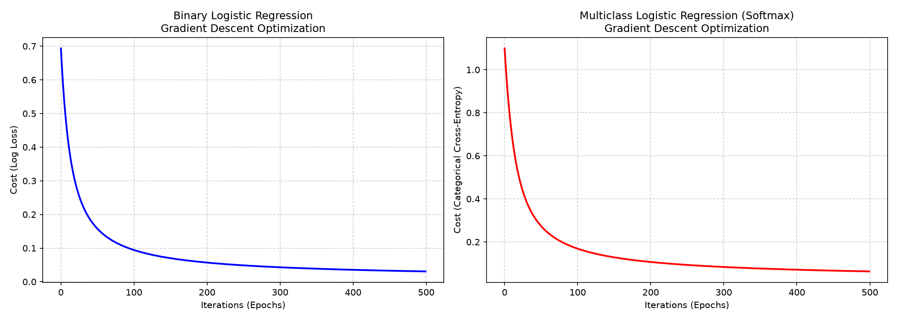
Output: binary and multiclass gradient descent cost curves

