Experiment 9
Objective
Implement regularization for any application show plots of 1) decision boundary and 2) performance before and after applying regularization.
Theory
- Logistic regression with L2 regularization is built from scratch: cost = binary cross-entropy + (lambda/2m) times the squared weight norm, with the gradient gaining a (lambda/m)W penalty term (bias unpenalized).
- The application uses concentric circles (inner blob vs outer ring with label noise) expanded to degree-8 polynomial features, where the unregularized model memorizes noise.
- Without regularization the model reaches 100% train vs 90% test accuracy (10% gap, weight norm 57, wiggly boundary); with L2 (lambda = 0.5) the gap halves to 4.8% with weight norm 12 and a smooth boundary.
- Two plots are produced and saved: decision boundaries before vs after regularization and grouped train/test accuracy bars showing performance before vs after.
Code
import numpy as np
import matplotlib.pyplot as plt
# ==========================================
# 1. Application dataset (from scratch)
# Concentric circles: inner blob = class 0, outer ring = class 1.
# Small training set + high-degree polynomial features => overfits
# without regularization.
# ==========================================
np.random.seed(11)
def make_circles(n_inner=25, n_ring=25, noise=0.6, flip=0.05):
r_inner = np.abs(np.random.randn(n_inner)) * 0.9
t_inner = np.random.rand(n_inner) * 2 * np.pi
X0 = np.c_[r_inner * np.cos(t_inner), r_inner * np.sin(t_inner)]
r_ring = 2.5 + np.random.randn(n_ring) * noise
t_ring = np.random.rand(n_ring) * 2 * np.pi
X1 = np.c_[r_ring * np.cos(t_ring), r_ring * np.sin(t_ring)]
X = np.vstack([X0, X1])
y = np.hstack([np.zeros(n_inner), np.ones(n_ring)]).astype(int)
noisy = np.random.rand(len(y)) < flip # label noise: forces memorization
y[noisy] = 1 - y[noisy]
return X, y
X_train, y_train = make_circles()
X_test, y_test = make_circles(n_inner=60, n_ring=60)
# Polynomial feature expansion (degree 8, no inbuilt function)
DEGREE = 8
def poly_features(X):
x1, x2 = X[:, 0], X[:, 1]
cols = [np.ones(len(X))]
for d in range(1, DEGREE + 1):
for k in range(d + 1):
cols.append((x1 ** (d - k)) * (x2 ** k))
return np.column_stack(cols)
Phi_train = poly_features(X_train)
Phi_test = poly_features(X_test)
# Standardize using training statistics (skip bias column)
mu = Phi_train[:, 1:].mean(axis=0)
sd = Phi_train[:, 1:].std(axis=0) + 1e-12
Phi_train[:, 1:] = (Phi_train[:, 1:] - mu) / sd
Phi_test[:, 1:] = (Phi_test[:, 1:] - mu) / sd
# ==========================================
# 2. Logistic Regression with L2 (from scratch)
# Cost = BCE + (lambd/2m) * ||W||^2 ; gradient gets + (lambd/m)*W
# ==========================================
class LogisticL2:
def __init__(self, learning_rate=0.5, epochs=3000, lambd=0.0):
self.lr = learning_rate
self.epochs = epochs
self.lambd = lambd
self.cost_history = []
def sigmoid(self, z):
z = np.clip(z, -250, 250)
return 1 / (1 + np.exp(-z))
def fit(self, X, y):
m, n = X.shape
y = y.reshape(-1, 1)
self.W = np.zeros((n, 1))
self.b = 0.0
for _ in range(self.epochs):
A = self.sigmoid(X @ self.W + self.b)
eps = 1e-15
bce = -(1 / m) * np.sum(y * np.log(A + eps) + (1 - y) * np.log(1 - A + eps))
reg = (self.lambd / (2 * m)) * np.sum(self.W[1:] ** 2) # don't penalize bias
self.cost_history.append(bce + reg)
dW = (1 / m) * (X.T @ (A - y))
dW[1:] += (self.lambd / m) * self.W[1:]
db = (1 / m) * np.sum(A - y)
self.W -= self.lr * dW
self.b -= self.lr * db
return self
def predict(self, X):
return (self.sigmoid(X @ self.W + self.b) >= 0.5).astype(int).ravel()
def accuracy(self, X, y):
return float(np.mean(self.predict(X) == y) * 100)
# ==========================================
# 3. Train before (lambd=0) vs after (lambd>0) regularization
# ==========================================
model_plain = LogisticL2(lambd=0.0).fit(Phi_train, y_train)
model_reg = LogisticL2(lambd=0.5).fit(Phi_train, y_train)
acc = {
"plain_train": model_plain.accuracy(Phi_train, y_train),
"plain_test": model_plain.accuracy(Phi_test, y_test),
"reg_train": model_reg.accuracy(Phi_train, y_train),
"reg_test": model_reg.accuracy(Phi_test, y_test),
}
w_plain = float(np.abs(model_plain.W[1:]).sum())
w_reg = float(np.abs(model_reg.W[1:]).sum())
print(f"Without regularization : train={acc['plain_train']:.1f}% test={acc['plain_test']:.1f}% |W|={w_plain:.0f}")
print(f"With L2 (lambd=0.5) : train={acc['reg_train']:.1f}% test={acc['reg_test']:.1f}% |W|={w_reg:.0f}")
print(f"Overfitting gap : {acc['plain_train']-acc['plain_test']:.1f}% -> "
f"{acc['reg_train']-acc['reg_test']:.1f}%")
# ==========================================
# 4. Plots: decision boundaries + performance before/after
# ==========================================
def boundary_grid(model, h=0.05):
x_min, x_max = -4, 4
y_min, y_max = -4, 4
xx, yy = np.meshgrid(np.arange(x_min, x_max, h), np.arange(y_min, y_max, h))
Phi = poly_features(np.c_[xx.ravel(), yy.ravel()])
Phi[:, 1:] = (Phi[:, 1:] - mu) / sd
return xx, yy, model.predict(Phi).reshape(xx.shape)
plt.figure(figsize=(18, 5))
plt.subplot(1, 3, 1)
xx, yy, Z = boundary_grid(model_plain)
plt.contourf(xx, yy, Z, alpha=0.3, cmap="coolwarm")
plt.scatter(X_train[:, 0], X_train[:, 1], c=y_train, cmap="coolwarm", edgecolors="k")
plt.title(f"Decision Boundary WITHOUT Regularization\ntrain={acc['plain_train']:.1f}% test={acc['plain_test']:.1f}%")
plt.xlabel("x1")
plt.ylabel("x2")
plt.subplot(1, 3, 2)
xx, yy, Z = boundary_grid(model_reg)
plt.contourf(xx, yy, Z, alpha=0.3, cmap="coolwarm")
plt.scatter(X_train[:, 0], X_train[:, 1], c=y_train, cmap="coolwarm", edgecolors="k")
plt.title(f"Decision Boundary WITH L2 Regularization\ntrain={acc['reg_train']:.1f}% test={acc['reg_test']:.1f}%")
plt.xlabel("x1")
plt.ylabel("x2")
plt.subplot(1, 3, 3)
labels = ["Without\nRegularization", "With L2\nRegularization"]
x = np.arange(len(labels))
w = 0.35
plt.bar(x - w / 2, [acc["plain_train"], acc["reg_train"]], w, label="Train accuracy")
plt.bar(x + w / 2, [acc["plain_test"], acc["reg_test"]], w, label="Test accuracy")
plt.xticks(x, labels)
plt.ylabel("Accuracy (%)")
plt.ylim(0, 105)
plt.title("Performance Before vs After Regularization")
plt.legend()
plt.grid(True, axis="y", linestyle="--", alpha=0.6)
plt.tight_layout()
import os
out_path = os.path.join(os.path.dirname(os.path.abspath(__file__)),
"regularization.png")
plt.savefig(out_path, dpi=150)
print(f"Plot saved to {out_path}")
plt.show()
Output

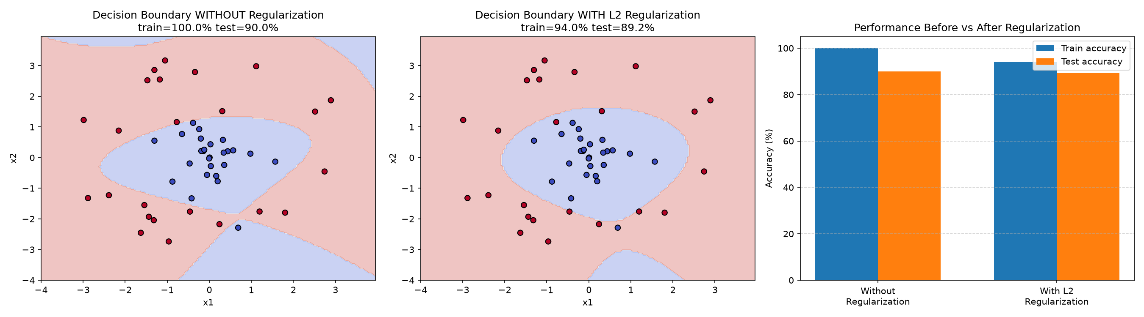
Output: decision boundaries and performance before vs after regularization

