Django Billing System
A full-featured billing and invoice generation system built using Django.
This project supports product billing, tax calculation, cash denomination handling, invoice generation, and email delivery.
Features
- Product management (Admin panel)
- Dynamic billing with multiple products
- Tax calculation per item
- Net price and rounded billing
- Cash paid via denominations
- Automatic balance calculation
- Optimal balance denomination breakdown
- Invoice generation page
- Email invoice sending via SMTP
- Purchase history tracking

Project Structure
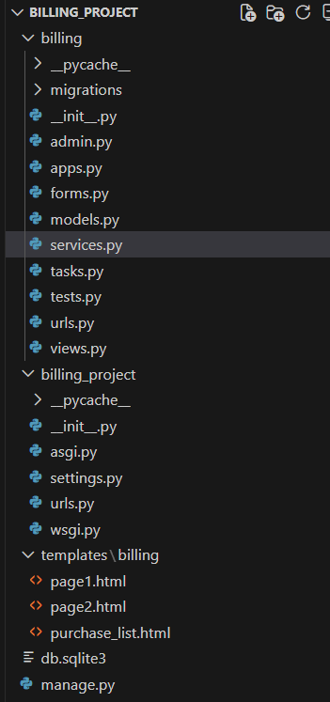
1.Create virtual environment
python -m venv venv
venv\Scripts\activate
2.Install dependencies
pip install Django
3. Run migrations
python manage.py makemigrations
python manage.py migrate
4. Create superuser
python manage.py createsuperuser
Username : Aruljothi
Password :
Confirm Password :
5. Run server
python manage.py runserver
Billing Logic
- Tax Calculation (services.py)

- Rounded Net Price (services.py)

- Denomination Algorithm

Greedy approach is used:

System returns optimal balance using available notes.

Denomination Output – page1

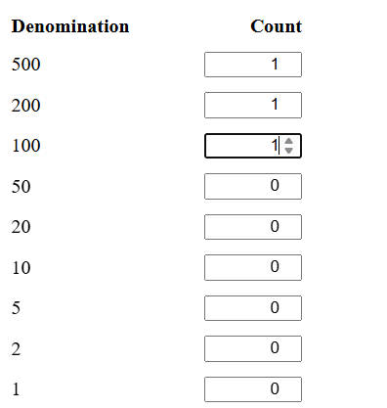

- Email Configuration (settings.py)

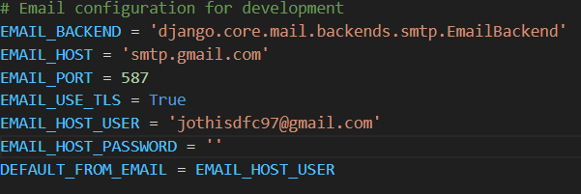

EMAIL_HOST_PASSWORD – Requires Gmail App Password.

Final Output :
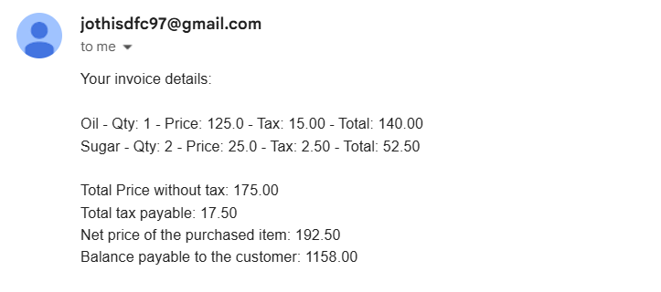
- Billing Page

- Enter customer email
- Add multiple products
- Enter denominations
- Auto calculate paid amount

The output is:
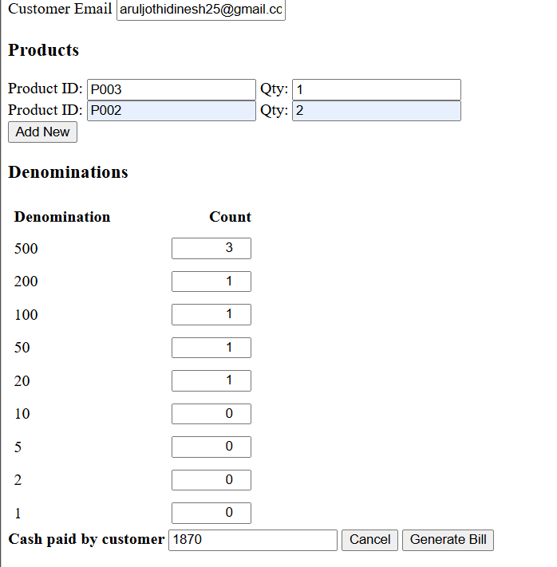

6.Invoice Page
Displays:
- Product ID
- Unit price
- Purchase price
- Tax %
- Tax amount
- Total per item
- Total tax payable
- Rounded net price
- Balance payable
- Balance denominations
