**CHAPTER 1**

**INTRODUCTION**

**1.1 INTRODUCTION**

The project “Hospital And Service Provided” system is designed to gather all the information about the hospitals, their specialization, and the government medicals schemes they provide. The user can get to the web site and view all the hospitals and schemes provided them and what they specialize in, the hospital rating, address, contact info. This will make the user to access, view and compare all the hospitals which will help them in deciding which hospital to visit. This will give them a clarity, without visiting or searching in individual websites or onsite and saves a lot of time for the user and gives the knowledge about the schemes provided by the government.

**1.2 PROJECT SCOPE**

This project is to develop a web application that can be help people to

search the hospitals in their locality and know the scheme and specialization of that hospital

The scope for this web application,

1. This web application targets on all the user who are using multimedia devices.

2. This web app requires internet in order to search for the details of the hospital.

3. GPS is required to get the current location of the user for giving the route.

4. It satisfies the user requirement.

5. It is easy to understand by the user and the operator.

6. It has good user interface.

7. Provides the various searching and filtering facilities based on various factors such as hospital, scheme, and specialization.

**1.3 JUSTIFICATION OF STUDY**

We implement this system for better user experience. This system is very

easy to access. Also for establish real time data sharing, using modern

and updated technology. This system will compatible with user device such as pc, laptop, tab & smart phone. So user can easily access the system anytime anywhere. This system is very simple & user friendly so, any user can use this system easily.

**1.4 OBJECTIVE**

The main objective of the project on HASP system is to

1. Manage the details of the hospital, specialization, contact, location and government schemes.

2. The purpose of the project is to build a web application program to reduce the manual work for searching the hospitals and its details.

3. It tracks the information about hospitals and the schemes provided by them.

4. The user can enter the website and check the details.

5. Users can search and filter for the hospitals and the schemes they need.

**1.5 TERMINOLOGIES**

**GPS -** Global Positioning System

**SQL -** Structured Query Language

**HTML -** Hyper Text Markup Language

**CSS -** Cascading Style Sheet

**JS -** Java Script

**PHP -** Personal Home Page

**DB**  **-** Data Base

**HASP -** Hospital and Service Provided

**CHAPTER 2**

**SYSTEM REQUIREMENTS**

**2.1 REQUIREMENT SPECIFICATIONS**

After analyzing the data collected, we formulated a number of requirements namely user requirement, system hardware software attribute. These were grouped as user, and systems requirements.

**2.2 USER REQUIREMENT**

During data collection, the we investigated and found out how the current system operates, not only that but also tried out which problems are faced and how best they can be settled. The users described some of the basic requirements of the system this includes search and filter for the hospital and the schemes.

**2.3 HARDWARE AND SOFTWARE REQUIREMENTS**

This section describes the hardware components and software requirements needed for effective and efficient running of the system.

|  |  |  |
| --- | --- | --- |
| **Sl.No** | **Hardware** | **Minimum System Requirement** |
| 01 | Processor | 2.4 GHz Processor speed |
| 02 | Memory | 2 GB RAM |
| 03 | Disk Space | 100 GB |

**TABLE 2.1.Hardware requirements**

|  |  |  |
| --- | --- | --- |
| **Sl.No** | **Software** | **Minimum System Requirement** |
| 01 | Operating System | Windows Server 2008,Windows7 |
| 02 | Database Management System | Microsoft SQL Server 2014 |
| 03 | Runtime Environment | Android studio |

**TABLE 2.2 Software requirements**

**2.4 EXISTING WORK**

The current system has a details of the hospitals and what they are specialized in. They don’t show the details of the government schemes available and the give the review or the contact info. They just show the name and address. These kind of system doesn’t help the users in getting all the information they need to in single handedly. And updating the data is also a tedious process. Showing only the name and location makes the user difficult to find the details and make the right decision.

**2.5 PROPOSED WORK**

This is a application that overcomes the issue of managing the details and lack of details.

1. The task sometimes becomes very tedious for the users to find the right hospital with all the needs they were searching for.

2. Hence this project offers an effective solution where HASP users can find the hospital, location, schemes and specialization available.

3. This system also the developer to update the data andedit it real quicly.

**2.6 MODULES**

**2.6.1 SEARCH MODULE**

After entering the website the user can search the hospitals with any one of the attributes like hospital name, specialization, scheme. Then it will direct the user to a page where it displays the hospital details and their schemes.

**2.6.2 IMPORT MODULE**

To insert a new hospital, the admin should enter the details in excel and save it in .csv format and can import to the data base which makes easier to enter a new data.

**2.6.3 OUR WEBPAGE MODULE**

The following page is the HASP webpage where the information about hospitals, address, specialization, and schemes will be organized and displayed by “HASP”.

**2.7 ADVANTAGES**

1 Time saving.

2. Track lots of hospital details.

3. Explore hospital near you and their contact info easily.

4. Get Details like website link, contact no, email address, and Address of Nearest Hospital around you.

5. Find a Specialist Nearby and compare them in a single site.

6. Get to know the medical schemes available and effectively reduce the cost of the bill in the hospital.

**2.8 SOFTWARE SPECIFICATION**

**2.8.1 HTML**

**HTML** or **Hypertext Markup Language** is the standard [markup language](http://en.wikipedia.org/wiki/Markup_language" \o "Markup language) used to create [web pages](http://en.wikipedia.org/wiki/Web_page" \o "Web page).

HTML is written in the form of [HTML elements](http://en.wikipedia.org/wiki/HTML_element" \o "HTML element) consisting of tags enclosed in [angle brackets](http://en.wikipedia.org/wiki/Angle_brackets" \o "Angle brackets) (like <html>). HTML tags most commonly come in pairs like <h1> and </h1>, although some tags represent empty elements and so are unpaired, for example <img>. The first tag in a pair is the start tag, and the second tag is the end tag (they are also called opening tags and closing tags). Though not always necessary, it is best practice to append a slash to tags which are not paired with a closing tag.

The purpose of a [web browser](http://en.wikipedia.org/wiki/Web_browser" \o "Web browser) is to read HTML documents and compose them into visible or audible web pages. The browser does not display the HTML tags, but uses the tags to interpret the content of the page. HTML describes the structure of a website [semantically](http://en.wikipedia.org/wiki/Semantic" \o "Semantic) along with cues for presentation, making it a [markup language](http://en.wikipedia.org/wiki/Markup_language" \o "Markup language) rather than a [programming language](http://en.wikipedia.org/wiki/Programming_language" \o "Programming language).

HTML elements form the building blocks of all [websites](http://en.wikipedia.org/wiki/Website" \o "Website). HTML allows [images and objects](http://en.wikipedia.org/wiki/Img_(HTML_element)" \o "Img (HTML element)) to be embedded and can be used to create [interactive forms](http://en.wikipedia.org/wiki/Fieldset" \o "Fieldset). It provides a means to create [structured documents](http://en.wikipedia.org/wiki/Structured_document" \o "Structured document) by denoting structural [semantics](http://en.wikipedia.org/wiki/Semantic" \o "Semantic) for text such as headings, paragraphs, lists, [links](http://en.wikipedia.org/wiki/Hyperlink" \o "Hyperlink), quotes and other items. It can embed [scripts](http://en.wikipedia.org/wiki/Scripting_language" \o "Scripting language) written in languages such as [JavaScript](http://en.wikipedia.org/wiki/JavaScript" \o "JavaScript) which affect the behavior of HTML web pages.

**2.8.2 CASCADING STYLE SHEETS** (**CSS**)

It is a [style sheet language](http://en.wikipedia.org/wiki/Style_sheet_language" \o "Style sheet language) used for describing the [look and formatting](http://en.wikipedia.org/wiki/Presentation_semantics" \o "Presentation semantics) of a document written in a [markup language](http://en.wikipedia.org/wiki/Markup_language" \o "Markup language). While most often used to style [web pages](http://en.wikipedia.org/wiki/Web_page" \o "Web page) and [interfaces](http://en.wikipedia.org/wiki/Interface_(computing)" \o "Interface (computing)) written in [HTML](http://en.wikipedia.org/wiki/HTML" \o "HTML) and [XHTML](http://en.wikipedia.org/wiki/XHTML" \o "XHTML), the language can be applied to any kind of [XML](http://en.wikipedia.org/wiki/XML" \o "XML) document, including [plain XML](http://en.wikipedia.org/wiki/Plain_Old_XML" \o "Plain Old XML), [SVG](http://en.wikipedia.org/wiki/Scalable_Vector_Graphics" \o "Scalable Vector Graphics) and [XUL](http://en.wikipedia.org/wiki/XUL" \o "XUL). CSS is a cornerstone specification of [the web](http://en.wikipedia.org/wiki/The_web" \o "The web) and almost all web pages use CSS style sheets to describe their presentation.

CSS is designed primarily to enable the separation of document content from document presentation, including elements such as the [layout](http://en.wikipedia.org/wiki/Page_layout" \o "Page layout), [colors](http://en.wikipedia.org/wiki/Color" \o "Color), and [fonts](http://en.wikipedia.org/wiki/Typeface" \o "Typeface). This separation can improve content [accessibility](http://en.wikipedia.org/wiki/Accessibility" \o "Accessibility), provide more flexibility and control in the specification of presentation characteristics, enable multiple pages to share formatting, and reduce complexity and repetition in the structural content .

CSS can also allow the same markup page to be presented in different styles for different rendering methods, such as on-screen, in print, by voice (when read out by a speech-based browser or [screen reader](http://en.wikipedia.org/wiki/Screen_reader" \o "Screen reader)) and on [Braille-based](http://en.wikipedia.org/wiki/Braille_display" \o "Braille display), tactile devices. It can also be used to allow the web page to display differently depending on the screen size or device on which it is being viewed. While the author of a document typically links that document to a CSS file, readers can use a different style sheet, perhaps one on their own computer, to override the one the author has specified. However if the author or the reader did not link the document to a specific style sheet the default style of the browser will be applied.

**2.8.3 MySQL**

MySQL is developed, distributed, and supported by Oracle Corporation. MySQL is a database system used on the web it runs on a server. MySQL is ideal for both small and large applications. It is very fast, reliable, and easy to use. It supports standard SQL. MySQL can be compiled on a number of platforms.

The data in MySQL is stored in tables. A table is a collection of related data, and it consists of columns and rows. Databases are useful when storing information categorically.

**2.8.4 FEATURES OF MySQL**

**Internals and portability**

* Written in C and C++.
* Tested with a broad range of different compilers.
* Works on many different platforms.
* Tested with Purify (a commercial memory leakage detector) as well as with Val grind, a GPL tool.
* Uses multi-layered server design with independent modules.

#### Security:

* A privilege and password system that is very flexible and secure, and that enables host-based verification.
* Password security by encryption of all password traffic when you connect to a server.

#### Scalability and Limits

* Support for large databases. We use MySQL Server with databases that contain 50 million records. We also know of users who use MySQL Server with 200,000 tables and about 5,000,000,000 rows.

#### 2.8.5 CONNECTIVITY

Clients can connect to MySQL Server using several protocols:

* Clients can connect using TCP/IP sockets on any platform.
* On Windows systems in the NT family (NT, 2000, XP, 2003, or Vista), clients can connect using named pipes if the server is started with the [--enable-named-pipe](https://dev.mysql.com/doc/refman/5.0/en/server-options.html" \l "option_mysqld_enable-named-pipe) option. In MySQL 4.1 and higher, Windows servers also support shared-memory connections if started with the [--shared-memory](https://dev.mysql.com/doc/refman/5.0/en/server-options.html" \l "option_mysqld_shared-memory) option. Clients can connect through shared memory by using the --protocol=memory option.
* On UNIX systems, clients can connect using Unix domain socket files.

#### 2.8.6 LOCALIZATION:

* The server can provide error messages to clients in many languages.
* All data is saved in the chosen character set.

**2.8.7 CLIENTS AND TOOLS**:

* MySQL includes several client and utility programs. These include both command-line programs such as **[mysqldump](https://dev.mysql.com/doc/refman/5.0/en/mysqldump.html" \o "4.5.4 mysqldump — A Database Backup Program)** and **[mysqladmin](https://dev.mysql.com/doc/refman/5.0/en/mysqladmin.html" \o "4.5.2 mysqladmin — Client for Administering a MySQL Server)**, and graphical programs such as [MySQL Workbench](http://dev.mysql.com/doc/refman/5.1/en/workbench.html" \t "_top).
* MySQL Server has built-in support for SQL statements to check, optimize, and repair tables. These statements are available from the command line through the **[mysqlcheck](https://dev.mysql.com/doc/refman/5.0/en/mysqlcheck.html" \o "4.5.3 mysqlcheck — A Table Maintenance Program)** client. MySQL also includes **[myisamchk](https://dev.mysql.com/doc/refman/5.0/en/myisamchk.html" \o "4.6.3 myisamchk — MyISAM Table-Maintenance Utility)**, a very fast command-line utility for performing these operations on **MyISAM** tables.
* MySQL programs can be invoked with the --help or -? option to obtain online assistance.

**2.8.8 WHY TO USE MySQL**

* Leading open source RDBMS
* Ease of use – No frills
* Fast
* Robust
* Security
* Multiple OS support
* Free
* Technical support
* Support large database– up to 50 million rows, file size limit up to 8 Million TB

**2.8.9 JAVASCRIPT**

JavaScript is the scripting language of the Web. All modern HTML pages are using JavaScript. A scripting language is a lightweight programming language.JavaScript code can be inserted into any HTML page, and it can be executed by all types of web browsers. JavaScript is easy to learn.

**2.8.10 WHY TO USE JAVASCRIPT**

JavaScript is one of the 3 languages all web developers  must learn:

1. HTML to define the content of web pages
2. CSS to specify the layout of web pages
3. JavaScript to specify the behavior of web pages

Example

x = document.getElementById("demo");  //Find the HTML element with id="demo"  
x.innerHTML = "Hello JavaScript";     //Change the content of the HTML element

**document.getElementById()** is one of the most commonly used HTML DOM methods

## 2.8.11 JAVASCRIPT PROPERTIES

* Properties are the values associated with a JavaScript object.
* A JavaScript object is a collection of unordered properties.
* Properties can usually be changed, added, and deleted, but some are read only.

**PHP**

**2.8.12 WHAT IS PHP?**

* PHP is an acronym for "PHP Hypertext Preprocessor"
* PHP is a widely-used, open source scripting language
* PHP scripts are executed on the server
* PHP costs nothing, it is free to download and use

**2.8.13 WHAT IS PHP FILE?**

* PHP files can contain text, HTML, CSS, JavaScript, and PHP code
* PHP code are executed on the server, and the result is returned to the browser as plain HTML
* PHP files have extension ".php"

**2.8.14 WHAT CAN PHP DO?**

* PHP can generate dynamic page content
* PHP can create, open, read, write, delete, and close files on the server
* PHP can collect form data
* PHP can send and receive cookies
* PHP can add, delete, modify data in your database
* PHP can restrict users to access some pages on your website
* PHP can encrypt data

With PHP you are not limited to output HTML. You can output images, PDF files, and even Flash movies. You can also output any text, such as XHTML and XML.

**2.8.15 WHY PHP?**

* PHP runs on various platforms (Windows, Linux, Unix, Mac OS X, etc.)
* PHP is compatible with almost all servers used today (Apache, IIS, etc.)
* PHP supports a wide range of databases
* PHP is free. Download it from the official PHP resource: [www.php.net](http://www.php.net/" \t "_blank)

**CHAPTER 3**

**IMPLEMENTATION**

**3.1 IMPLEMENTATION**

Implementation is the stage of the project when the theoretical design is turned out into a working system. Thus, it can be considered to be the most critical stage in achieving a successful new system and in giving the user, confidence that the new system will work and be effective.

The implementation stage involves careful planning, investigation of the existing system and its constraints on implementation, designing of methods to achieve changeover and evaluation of changeover methods.

This project is implemented by following the above modules in order. The database about the hospitals is collected and updated in a data base. Then the front end php pages are designed for the users to access the web page easily. Then the front end is connected to the database.

**3.2 SAMPLE CODE**

**HTML & PHP**

**3.2.1 index.php**

This is the front page of the web app, which loads first when user enters the site. It consists of a search box for hospital name, and a dropdown list for specialty and scheme. The hospital name is searched using like query, so it gives all the result that can be relatable.

<!DOCTYPE html>

<html lang="en">

<head>

<title>Hospital search</title>

<!-- Meta tags -->

<meta name="viewport" content="width=device-width, initial-scale=1" />

<meta http-equiv="Content-Type" content="text/html; charset=utf-8" />

<meta name="keywords" content="Doctor Search Form Responsive Widget, Audio and Video players, Login Form Web Template, Flat Pricing Tables, Flat Drop-Downs, Sign-Up Web Templates, Flat Web Templates, Login Sign-up Responsive Web Template, Smartphone Compatible Web Template, Free Web Designs for Nokia, Samsung, LG, Sony Ericsson, Motorola Web Design"

/>

<script>

addEventListener("load", function() { setTimeout(hideURLbar, 0); }, false); function hideURLbar(){ window.scrollTo(0,1); }

</script>

<!-- Meta tags -->

<!-- Calendar -->

<link rel="stylesheet" href="css/jquery-ui.css" />

<!-- //Calendar -->

<!--stylesheets-->

<link href="css/style.css" rel='stylesheet' type='text/css' media="all">

<!--//style sheet end here-->

<link href="//fonts.googleapis.com/css?family=Cuprum:400,700" rel="stylesheet">

</head>

<?php

include('connection.php');

$sql = "SELECT \* FROM hospital";

$result = $conn->query($sql);

if ($result->num\_rows > 0) {

// output data of each row

?>

<body>

<h1 class="header-w3ls">

H A S P

</h1>

<div class="doctor-form">

<h2 class="doctor-list-w3l">Search Here Hospital</h2>

<form action="result.php" method="post">

<div class="main">

<div class="form-left-to-w3l">

<input type="text" name="hname" placeholder="Hospital Name">

<div class="clear"></div>

</div>

<div class="form-right-to-w3l">

<select class="form-control" name="spl">

<option value="">Select Speciality</option>

<?php

while($row = $result->fetch\_assoc()) {

?>

<option value ="<?php echo $row['sepcialization'] ?>"><?php echo $row['sepcialization'] ?></option>

<?php

}

}

?>

</select>

</div>

</div>

<div class="form-right-to-w3l">

<select class="form-control buttom" name="scheme">

<option value="">

Select Scheme

</option>

<option value="chief">Chief Minister Health Insurance</option>

</select>

<div class="clear"></div>

<div class="form-right-to-w3l" style="font-size:18px !important;font-weight:900;color:#000000;">

<input type="radio" name="search" value="hname">Search by Hospital

<input type="radio" name="search" value="spl">Search by Specialization

<input type="radio" name="search" value="scheme">Search by scheme

</div>

</div>

</div>

<div class="clear"></div>

</div>

</div>

<div class="btnn">

<input type="submit" name ="submit" value="Search" style="width:120px;height:45px;background-color:#c2c2c2;"><br>

</div>

</form>

</div>

</div>

<div>

</body>

<!--scripts-->

<script src='js/jquery-2.2.3.min.js'></script>

<!--//scripts-->

<!-- //js -->

<!-- Calendar -->

<script src="js/jquery-ui.js"></script>

<script>

$(function() {

$( "#datepicker,#datepicker1,#datepicker2,#datepicker3" ).datepicker();

});

</script>

<!-- //Calendar -->

</html>

**3.2.2 connection.php**

It is used to establish the connection between the database and the client.

<?php

$servername = "localhost";

$username = "root";

$password = "";

$dbname = "hosdb";

// Create connection

$conn = new mysqli($servername, $username, $password,$dbname);

// Check connection

if ($conn->connect\_error) {

die("Connection failed: " . $conn->connect\_error);

}

?>

**3.2.3 result.php**

In this page it displays the details of the hospital which the user searched for. The details of the search result hospitals are shown in a table format.

<html>

<head>

<title>Hospital Search Results</title>

</head>

<style>

#hospital {

font-family: "Trebuchet MS", Arial, Helvetica, sans-serif;

border-collapse: collapse;

width: 100%;

}

#hospital td, #hospital th {

border: 1px solid #ddd;

padding: 8px;

}

#hospital tr:nth-child(even){background-color: #f2f2f2;}

#hospital tr:hover {background-color: #ddd;}

#hospital th {

padding-top: 12px;

padding-bottom: 12px;

text-align: left;

background-color: #4CAF50;

color: white;

}

#btn {

width:80px;

height:30px;

background:#ddd;

color:#4CAF50;

padding:10px;

font-size:18px;

font-weight:700;

text-align:center;

float:right;

margin-right:10px;

margin-top:10px;

}

</style>

<?php

include('connection.php');

if(isset($\_POST['submit']))

{

$search = $\_POST['search'];

$spec = $\_POST['spl'];

$hname = $\_POST['hname'];

$scheme = $\_POST['scheme'];

if ($search=='hname')

{

$sql1 = "select \* From hospital where hname LIKE '%$hname%'";

}

else if($search=='spl')

{

$sql1 = "select \* From hospital where sepcialization='$spec'";

}

else if ($search =='scheme')

{

$sql1 = "select \* From hospital where schemes Like '%$scheme%'";

}

else

{

$sql1 = "select \* From hospital";

}

$result1 = $conn->query($sql1);

?>

<h1 style="text-align:center;color:#4CAF50">Search Result</h1>

<a href="index.php" id="btn">Back</a>

<table id="hospital">

<tr><th>Name of the Hospital</th><th>Address</th><th>Specialization</th><th>Schemes</th></tr>

<?php

if ($result1->num\_rows > 0) {

// output data of each row

while($row = $result1->fetch\_assoc()) {

echo "<tr><td>".$row['hname']."</td><td>".$row['haddress']."</td><td>".$row['sepcialization']."</td><td>".$row['schemes']."</td></tr>";

}

}

}

?>

</table>

**3.2.4 import.php**

This code is to insert a new data set in the data base of the hospitals.

<?php

error\_reporting(0);

include("connection.php");

if(isset($\_POST['import']))

{

$month = $\_POST['month'];

$fileName = $\_FILES["file"]["tmp\_name"];

if ($\_FILES["file"]["size"] > 0) {

$file = fopen($fileName, "r");

while (($column = fgetcsv($file, 10000, ",")) !== FALSE) {

//Department subject qtype question

//CREATE TABLE attendance ( id INT(6) UNSIGNED PRIMARY KEY, name VARCHAR(30) NOT NULL, depart VARCHAR(30) NOT NULL, workingdays

//int(50), attendDays int(3),absDays int(3),earlyDays int(3),lateDays int(3),overtime int(3),allowance float(10),charges float(10),netpay float(10),salmonth date, import\_date TIMESTAMP )

echo $sqlInsert = "INSERT into hospital (id,hname,sepcialization,haddress,schemes)

values ('','" . $column[1] . "','" . $column[2] . "','" . $column[3] . "','" . $column[4] ."')";

$result = mysqli\_query($db\_connect, $sqlInsert);

if (! empty($result)) {

$type = "success";

$message = "CSV Data Imported into the Database";

} else {

$type = "error";

$message = "Problem in Importing CSV Data";

}

}

}

}

?>

<!DOCTYPE html>

<html>

<head>

<script src="jquery-3.2.1.min.js"></script>

<style>

body {

font-family: Arial;

width: 800px;

}

.outer-scontainer {

background: #F0F0F0;

border: #e0dfdf 1px solid;

padding: 20px;

border-radius: 2px;

}

.input-row {

margin-top: 0px;

margin-bottom: 20px;

}

.btn-submit {

background: #333;

border: #1d1d1d 1px solid;

color: #f0f0f0;

font-size: 0.9em;

width: 100px;

border-radius: 2px;

cursor: pointer;

}

.outer-scontainer table {

border-collapse: collapse;

width: 100%;

}

.outer-scontainer th {

border: 1px solid #dddddd;

padding: 8px;

text-align: left;

}

.outer-scontainer td {

border: 1px solid #dddddd;

padding: 8px;

text-align: left;

}

#response {

padding: 10px;

margin-bottom: 10px;

border-radius: 2px;

display:none;

}

.success {

background: #c7efd9;

border: #bbe2cd 1px solid;

}

.error {

background: #fbcfcf;

border: #f3c6c7 1px solid;

}

div#response.display-block {

display: block;

}

</style>

<script type="text/javascript">

$(document).ready(function() {

$("#frmCSVImport").on("submit", function () {

$("#response").attr("class", "");

$("#response").html("");

var fileType = ".csv";

var regex = new RegExp("([a-zA-Z0-9\s\_\\.\-:])+(" + fileType + ")$");

if (!regex.test($("#file").val().toLowerCase())) {

$("#response").addClass("error");

$("#response").addClass("display-block");

$("#response").html("Invalid File. Upload : <b>" + fileType + "</b> Files.");

return false;

}

return true;

});

});

</script>

</head>

<body>

<?php

?>

<a href="index.php" style="color:red;font-weight:700;padding:5px;">Back to home</a>

<li class="nav-item"><a href="../dashboard/view-details.php"><span class="nav-icon"><i class="fa fa-user"></i></span>View Report</a></li>

<h2>Import Attendance Data in .csv format from Finger Print Device</h2>

<div id="response" class="<?php if(!empty($type)) { echo $type . " display-block"; } ?>"><?php if(!empty($message)) { echo $message; } ?></div>

<div class="outer-scontainer">

<div class="row">

<form class="form-horizontal" action="" method="post"

name="frmCSVImport" id="frmCSVImport" enctype="multipart/form-data">

<div class="input-row">

<select name="month">

<option value="Jan">January</option>

<option value="Feb">February</option>

<option value="Mar">March</option>

<option value="Apr">April</option>

<option value="May">May</option>

<option value="June">June</option>

<option value="July">July</option>

<option value="Aug">August</option>

<option value="Sep">September</option>

<option value="Oct">October</option>

<option value="Nov">November</option>

<option value="Dec">December</option>

</select>

</div>

<div class="input-row">

<label class="col-md-4 control-label">Choose CSV

File</label> <input type="file" name="file"

id="file" accept=".csv">

<button type="submit" id="submit" name="import"

class="btn-submit">Import</button>

<br />

</div>

</form>

</div>

</body>

</html>

</div>

</div>

</section>

<script type="text/javascript" src="../js/global.js"></script>

</body>

</html>

**3.2.5 style.css**

This code is to configure margin size, background, font size and all the designing and decoration part of the web page.

html,body,div,span,applet,object,iframe,h1,h2,h3,h4,h5,h6,p,blockquote,pre,a,abbr,acronym,address,big,cite,code,del,dfn,em,img,ins,kbd,q,s,samp,small,strike,strong,sub,sup,tt,var,b,u,i,dl,dt,dd,ol,navul,navli,fieldset,form,label,legend,table,caption,tbody,tfoot,thead,tr,th,td,article,aside,canvas,details,embed,figure,figcaption,footer,header,hgroup,menu,nav,output,ruby,section,summary,time,mark,audio,video{margin:0;padding:0;border:0;font-size:100%;font:inherit;vertical-align:baseline;}

article, aside, details, figcaption, figure,footer, header, hgroup, menu, nav, section {display: block;}

ol,ul{list-style:none;margin:0px;padding:0px;}

blockquote,q{quotes:none;}

blockquote:before,blockquote:after,q:before,q:after{content:'';content:none;}

table{border-collapse:collapse;border-spacing:0;}

a{text-decoration:none;}

.txt-rt{text-align:right;}

.txt-lt{text-align:left;}

.txt-center{text-align:center;}

.float-rt{float:right;}

.float-lt{float:left;}

.clear{clear:both;}

.pos-relative{position:relative;}

.pos-absolute{position:absolute;}

.vertical-base{ vertical-align:baseline;}

.vertical-top{ vertical-align:top;}

nav.vertical ul li{ display:block;}

nav.horizontal ul li{ display: inline-block;}

img{max-width:100%;}

html,body{

padding:0;

margin:0;

background:#fff;

font-family: 'Cuprum', sans-serif;

}

body a{

transition:0.5s all;

-webkit-transition:0.5s all;

-moz-transition:0.5s all;

-o-transition:0.5s all;

-ms-transition:0.5s all;

text-decoration:none;

}

body a:hover {

text-decoration: none;

}

body a:focus, a:hover {

text-decoration: none;

}

select,input[type="email"],input[type="text"],input[type=password],

input[type="button"],input[type="submit"],textarea{

font-family: 'Cuprum', sans-serif;

transition:0.5s all;

-webkit-transition:0.5s all;

-moz-transition:0.5s all;

-o-transition:0.5s all;

-ms-transition:0.5s all;

letter-spacing: 1px;

}

h1,h2,h3,h4,h5,h6{

margin:0;

padding:0;

font-family: 'Cuprum', sans-serif;

letter-spacing:1px;

}

p{

margin:0;

padding:0;

letter-spacing:1px;

font-family: 'Cuprum', sans-serif;

letter-spacing: 1px;

}

ul{

margin:0;

padding:0;

letter-spacing: 1px;

}

/\*-- //Reset-Code --\*/

body {

background: url(../images/b1.jpg);

background-repeat: no-repeat;

background-position: center;

background-size: cover;

-webkit-background-size: cover;

-moz-background-size: cover;

-o-background-size: cover;

min-height: 100vh;

}

h1.header-w3ls {

text-align: center;

text-transform: uppercase;

color:#fff;

padding: 42px 0px 50px;

letter-spacing: 8px;

text-shadow: 2px 3px rgba(0, 0, 0, 0.42);

}

.doctor-form{

border:none;

margin: 0em auto;

padding: 53px 46px 60px;

background:#ffffff47;

box-sizing: border-box;

}

h2.doctor-list-w3l{

color: #000;

letter-spacing: 2px;

text-align: center;

padding-bottom: 34px;

}

.main {

display: -webkit-flex;

display: flex;

-webkit-justify-content: space-between;

justify-content: space-between;

}

.form-right-to-w3l, .form-left-to-w3l {

flex-basis:48%;

-webkit-flex-basis: 48%;

}

select.form-control,.form-left-to-w3l input[type="text"],.input#datepicker1{

width: 100%;

color: #fff;

outline: none;

font-size: 15px;

padding: .8em 1em;

border: 1px solid #fff;

margin: 0px 0px 30px;

display: inline-block;

background: none;

letter-spacing: 2px;

transition: all 0.5s ease-in-out;

-webkit-transition: all 0.5s ease-in-out;

-moz-transition: all 0.5s ease-in-out;

-o-transition: all 0.5s ease-in-out;

-ms-transition: all 0.5s ease-in-out;

box-sizing: border-box;

}

select.form-control {

outline: none;

height: 43px;

transition: all 0.5s ease-in-out;

-webkit-transition: all 0.5s ease-in-out;

-moz-transition: all 0.5s ease-in-out;

-o-transition: all 0.5s ease-in-out;

-ms-transition: all 0.5s ease-in-out;

}

option {

background: #000;

}

::-webkit-input-placeholder { /\* Chrome/Opera/Safari \*/

color: #fff;

}

::-moz-placeholder { /\* Firefox 19+ \*/

color: #fff;

}

:-ms-input-placeholder { /\* IE 10+ \*/

color: #fff;

}

:-moz-placeholder { /\* Firefox 18- \*/

color: #fff;

}

label.rating {

font-size: 17px;

font-weight: 500;

color: #fff;

text-align: justify;

letter-spacing: 2px;

text-transform: capitalize;

margin-bottom: 10px;

position:relative;

}

.grid-outs1 ul li,.grid-outs2 ul li{

color: #fff;

display: block;

position: relative;

height: 25px;

}

ul li input[type=radio]{

position: absolute;

visibility: hidden;

}

ul li label{

display: block;

position: relative;

font-weight: 300;

text-transform: capitalize;

padding: 12px 0px 0px 46px;

margin: 10px auto;

height: 30px;

z-index: 3;

cursor: pointer;

-webkit-transition: all 0.25s linear;

}

ul li:hover label{

color: #FFFFFF;

}

ul li .check{

display: block;

position: absolute;

border: 2px solid #fff;

border-radius: 100%;

height: 12px;

width: 12px;

top: 13px;

left: 20px;

z-index: 2;

transition: border .25s linear;

-webkit-transition: border .25s linear;

}

ul li:hover .check {

border: 2px solid #FFFFFF;

}

ul li .check::before {

display: block;

position: absolute;

content: '';

border-radius: 100%;

height: 8px;

width: 8px;

top: 2px;

left: 2px;

margin: auto;

transition: background 0.25s linear;

-webkit-transition: background 0.25s linear;

}

input[type=radio]:checked ~ .check {

border: 2px solid #000;

}

input[type=radio]:checked ~ .check::before{

background: #000;

}

input[type=radio]:checked ~ label{

color: #000;

}

/\*-- /radio button --\*/

.btnn{

margin-top: 32px;

text-align: center;

}

button[type=submit] {

width: 30%;

background: #33ccccd4;

outline: none;

color: #fff;

font-size: 17px;

font-weight: 400;

border:none;

padding: 11px 11px;

letter-spacing: 1px;

text-transform: uppercase;

cursor: pointer;

transition: 0.5s all;

-webkit-transition: 0.5s all;

-o-transition: 0.5s all;

-moz-transition: 0.5s all;

-ms-transition: 0.5s all;

}

button:hover {

color: #000;

background: #fff;

}

.copy p {

margin: 0em;

text-align: center;

font-size: 17px;

color: white;

letter-spacing: 3px;

}

.copy p a {

color: #fff;

text-decoration: none;

}

.copy p a:hover {

color: #fff;

}

/\*--responsive--\*/

@media(max-width:1920px){

.doctor-form {

width: 43%;

}

.copy {

padding: 42px 0px;

}

ul li label {

font-size: 16px;

}

h1.header-w3ls {

font-size: 61px;

}

h2.doctor-list-w3l {

font-size: 40px;

}

}

@media(max-width:1680px){

h1.header-w3ls {

font-size: 58px;

}

h2.doctor-list-w3l {

font-size: 38px;

}

.copy {

padding: 35px 0px;

}

.doctor-form {

width: 42%;

}

ul li label {

font-size: 15px;

}

}

@media(max-width:1600px){

.doctor-form{

width: 38%;

}

h1.header-w3ls {

font-size: 57px;

}

h2.doctor-list-w3l {

font-size: 37px;

}

.copy {

padding: 30px 0px;

}

}

@media(max-width:1440px){

.Doctor-form {

width: 46%;

}

h1.header-w3ls {

font-size: 53px;

}

.doctor-form {

width: 45%;

padding: 45px 46px 56px;

}

select.form-control, .form-left-to-w3l input[type="text"], .input#datepicker1 {

margin: 0px 0px 26px;

}

}

@media(max-width:1366px){

.doctor-form {

width: 50%;

}

h1.header-w3ls {

padding: 37px 0px 41px;

}

}

@media(max-width:1280px){

copy p {

font-size: 16px;

}

button[type=submit] {

font-size: 17px;

}

h2.doctor-list-w3l {

padding-bottom: 26px;

}

h1.header-w3ls {

letter-spacing: 6px;

}

}

@media(max-width:1080px){

.doctor-form {

width: 57%;

}

select.form-control, .form-left-to-w3l input[type="text"], .input#datepicker1 {

padding: .7em .8em;

letter-spacing: 1px

}

.grid-outs1 ul li, .grid-outs2 ul li {

height: 23px;

}

.btnn {

margin-top: 30px;

}

}

@media(max-width:1050px){

.doctor-form {

width: 60%;

}

label.rating {

font-size: 16px;

}

h2.doctor-list-w3l {

font-size: 33px;

}

}

@media(max-width:1024px){

h1.header-w3ls {

padding: 32px 0px 35px;

font-size: 49px;

}

.doctor-form {

width: 63%;

padding: 39px 46px 50px;

}

h2.doctor-list-w3l {

font-size: 31px;

padding-bottom: 21px;

}

button[type=submit] {

font-size: 15px;

}

}

@media(max-width:991px){

select.form-control {

height: 39px;

}

.copy p {

font-size: 16px;

letter-spacing: 3px;

}

ul li label {

font-size: 14px;

}

select.form-control, .form-left-to-w3l input[type="text"], .input#datepicker1 {

padding: .7em .7em;

}

h1.header-w3ls {

padding: 34px 0px 29px;

font-size: 46px;

}

}

@media(max-width:900px){

.doctor-form {

width: 68%;

padding: 33px 40px 46px;

}

select.form-control, .form-left-to-w3l input[type="text"], .input#datepicker1 {

margin: 0px 0px 22px;

}

}

@media(max-width:800px){

.doctor-form {

width: 76%;

}

}

@media(max-width:768px){

.doctor-form {

width: 80%;

}

h1.header-w3ls {

letter-spacing: 4px;

font-size: 44px;

}

select.form-control, .form-left-to-w3l input[type="text"],

.input#datepicker1 {

font-size: 14px;

}

.copy p {

font-size: 15px;

letter-spacing: 2px;

}

}

@media(max-width:767px){

.doctor-form {

padding: 30px 32px 42px;

}

}

@media(max-width:736px){

label.rating {

letter-spacing: 1px;

}

.grid-outs1 ul li, .grid-outs2 ul li {

height: 21px;

}

}

@media(max-width:667px){

.doctor-form {

width: 86%;

}

ul li label {

padding: 6px 0px 0px 44px;

}

ul li .check {

height: 11px;

width: 11px;

top: 6px;

left: 16px;

}

ul li .check::before {

height: 6px;

width: 6px;

top: 3px;

}

}

@media(max-width:640px){

.doctor-form {

padding: 30px 25px 37px;

}

h1.header-w3ls {

letter-spacing: 3px;

font-size: 42px;

}

.copy p {

font-size: 14px;

}

}

@media(max-width:600px){

h2.doctor-list-w3l {

letter-spacing: 1px;

}

.doctor-form {

width: 91%;

}

button[type=submit] {

font-size: 14px;

}

}

@media(max-width:568px){

h1.header-w3ls {

letter-spacing: 2px;

font-size: 39px;

}

.main {

-webkit-flex-direction: column;

flex-direction: column;

}

.gap-top{padding-top:24px;}

button[type=submit] {

padding: 10px 11px;

}

}

@media(max-width:480px){

h2.doctor-list-w3l {

padding-bottom: 16px;

}

label.rating {

font-size: 15px;

}

.copy p {

letter-spacing: 1px;

padding: 0px 15px;

line-height: 25px;

}

.copy {

padding: 24px 0px;

}

}

@media(max-width:440px){

h1.header-w3ls {

letter-spacing: 1px;

font-size: 35px;

}

h2.doctor-list-w3l {

font-size: 29px;

}

}

@media(max-width:414px){

.doctor-form {

padding: 25px 22px 32px;

}

h1.header-w3ls {

padding: 34px 0px 24px;

}

button[type=submit] {

width: 35%;

}

}

@media(max-width:384px){

select.form-control, .form-left-to-w3l input[type="text"], .input#datepicker1 {

margin: 0px 0px 18px;

}

.btnn {

margin-top: 25px;

}

}

@media(max-width:375px){

h1.header-w3ls {

font-size: 33px;

}

h2.doctor-list-w3l {

font-size: 28px;

}

select.form-control, .form-left-to-w3l input[type="text"], .input#datepicker1 {

padding: .6em .7em;

}

select.form-control {

height: 34px;

}

button[type=submit] {

width: 40%;

}

@media(max-width:320px){

h1.header-w3ls {

font-size: 29px;

}

h2.doctor-list-w3l {

font-size: 25px;

}

.copy {

padding: 18px 0px;

}

}

**CHAPTER 4**

**SYSTEM ANALYSIS**

|  |  |  |  |  |  |  |  |  |  |  |  |  |  |  |  |  |  |  |  |  |  |  |  |  |  |  |  |  |  |  |  |  |  |  |  |  |  |  |  |  |  |  |  |  |  |  |  |  |  |  |  |  |  |  |  |  |  |  |  |  |  |  |  |  |  |  |  |  |  |  |  |  |  |  |  |  |  |  |  |  |  |  |  |  |
| --- | --- | --- | --- | --- | --- | --- | --- | --- | --- | --- | --- | --- | --- | --- | --- | --- | --- | --- | --- | --- | --- | --- | --- | --- | --- | --- | --- | --- | --- | --- | --- | --- | --- | --- | --- | --- | --- | --- | --- | --- | --- | --- | --- | --- | --- | --- | --- | --- | --- | --- | --- | --- | --- | --- | --- | --- | --- | --- | --- | --- | --- | --- | --- | --- | --- | --- | --- | --- | --- | --- | --- | --- | --- | --- | --- | --- | --- | --- | --- | --- | --- | --- | --- | --- |
| |  |  |  |  | | --- | --- | --- | --- | | [ARAVIND EYE HOSPITAL](http://www.cmchistn.com/specPopup.php?module=s&id=24) | OPTHALMOLOGY | AVINASHI ROAD CIVIL AERODRAME,COIMBATORE | Chief Minister's Comprehensive Health Insurance Scheme | | [COIMBATORE BONE & JOINT FOUNDATION (P) LTD](http://www.cmchistn.com/specPopup.php?module=s&id=25) | ORTHOPEDICS (INCLUDING POLYTRAUMA) | 1091, METTUPALAYAM ROAD, NORTH COIMBATORE BUS STOP, COIMBATORE | Chief Minister's Comprehensive Health Insurance Scheme | | [LOTUS EYE CARE](http://www.cmchistn.com/specPopup.php?module=s&id=26) | OPTHALMOLOGY | AVINASHI ROAD, CIVIL AERODROME POST, COIMBATORE | Chief Minister's Comprehensive Health Insurance Scheme | | [REX ORTHO HOSPITAL](http://www.cmchistn.com/specPopup.php?module=s&id=27) | SPINE REPLACEMENT | 43, R.R. LAY-OUT, POOMARKET BUS STOP, NEXT TO SHANMUGA THEATRE, METTUPALAYAM ROAD, COIMBATORE | Chief Minister's Comprehensive Health Insurance Scheme | | [SANKARA EYE HOSPITAL](http://www.cmchistn.com/specPopup.php?module=s&id=28) | OPTHALMOLOGY | SATHY ROAD, SIVANANDAPURAM, COIMBATORE | Chief Minister's Comprehensive Health Insurance Scheme | | [SINDHIA ORTHO CLINIC](http://www.cmchistn.com/specPopup.php?module=s&id=29) | ORTHOPEDICS (INCLUDING POLYTRAUMA) | #54, BHARATHI ST, LIG COLONY, MAHALINGAPURAM,POLLACHI, COIMBATORE | Chief Minister's Comprehensive Health Insurance Scheme | | [EYE FOUNDATION LTD](http://www.cmchistn.com/specPopup.php?module=s&id=30) | OPTHALMOLOGY | 582 A, DB ROAD, RS PURAM, COIMBATORE - 641002 | Chief Minister's Comprehensive Health Insurance Scheme | | [VIKRAM ENT HOSPITAL AND RESEARCH INSTITUTE](http://www.cmchistn.com/specPopup.php?module=s&id=31) | COCHLEAR IMPLANT SURGERY | 69, WEST VENKATASAMY ROAD, RS PURAM, COIMBATORE | Chief Minister's Comprehensive Health Insurance Scheme | | [ARATHANA HOSPITAL](http://www.cmchistn.com/specPopup.php?module=s&id=189) | ORTHOPEDICS (INCLUDING POLYTRAUMA) | NO : 136, APPAR STREET, VENKATESA COLONY, POLLACHI, COIMBATORE- 642001 | Chief Minister's Comprehensive Health Insurance Scheme | | [SATHYAM KIDNEY CARE CENTRE](http://www.cmchistn.com/specPopup.php?module=s&id=1232) | NEPHROLOGY,GENTIO URINARY SURGERY | NO 5/621 A, THADAGAM ROAD,NEAR KNG PUDUR PIRIVU, COIMBATORE | Chief Minister's Comprehensive Health Insurance Scheme | | [GEM HOSPITAL & RESEARCH CENTRE (P) LTD](http://www.cmchistn.com/specPopup.php?module=s&id=199) | MEDICAL ONCOLOGY, BARIATRIC SURGERY, SURGICAL GASTROENTEROLOGY, TRANSPLANTATION | 45 PANKAJA MILL ROAD RAMANATHAPURAM COIMBATORE | Chief Minister's Comprehensive Health Insurance Scheme | | [KONGUNAD KIDNEY CENTRE, TATABAD,COIMBATORE TN.](http://www.cmchistn.com/specPopup.php?module=s&id=1083) | GENITOURINARY SURGERY,NEPHROLOGY | 206, 207, 11TH STREET, TATABAD | Chief Minister's Comprehensive Health Insurance Scheme | | [SHREE VETRIVEL HOSPITAL](http://www.cmchistn.com/specPopup.php?module=s&id=1071) | ORTHO REPLACEMENT | 5/435 OPPOSITE TO CTC DEPOT,KOVAI MAIN ROAD,METTUPALAYAM-641301 | Chief Minister's Comprehensive Health Insurance Scheme | | [MCV MEMORIAL ENT TRUST HOSPITAL](http://www.cmchistn.com/specPopup.php?module=s&id=1072) | ENT | 115,PALAKAD ROAD, | Chief Minister's Comprehensive Health Insurance Scheme | | [DR. MUTHUS HOSPITAL](http://www.cmchistn.com/specPopup.php?module=s&id=509) | ORTHOPEDICS (INCLUDING POLYTRAUMA),SPINE REPLACEMENT | 331/1-TRICHY ROAD, SINGANALLUR, COIMBATORE - 641005 | Chief Minister's Comprehensive Health Insurance Scheme | | [NEHRU UROLOGY CENTRE](http://www.cmchistn.com/specPopup.php?module=s&id=822) | GENITOURINARY SURGERY | 58/1, 3RD CROSS WEST, BHARATHY COLONY, PEELAMEDU, COIMBATORE - 641004 | Chief Minister's Comprehensive Health Insurance Scheme | | [PONNAMMAL DURAISAMY EYE HOSPITAL](http://www.cmchistn.com/specPopup.php?module=s&id=1173) | OPTHALMOLOGY | 90 VIVEKANANDA ROAD ,RAMNAGAR,COIMBATORE 641009 | Chief Minister's Comprehensive Health Insurance Scheme | | [MADURAI EYE CENTRE](http://www.cmchistn.com/specPopup.php?module=s&id=1174) | OPTHALMOLOGY | 137, PERIASAMY ROAD EAST, R S PURAM | Chief Minister's Comprehensive Health Insurance Scheme | | [SATHYAN EYE CARE HOSPITAL & COIMBATORE GLAUCOMA](http://www.cmchistn.com/specPopup.php?module=s&id=862) | OPTHALMOLOGY | NO. 77, OM SAKTHI NAGAR, OFF. TRICHY ROAD, SOWRIPALAYAM PIRIVU, RAMANATHAPURAM, COIMBATORE - 641045 | Chief Minister's Comprehensive Health Insurance Scheme | | [A R ORTHO HOSPITAL, POLLACHI](http://www.cmchistn.com/specPopup.php?module=s&id=781) | ORTHOPEDICS (INCLUDING POLYTRAUMA) | NEW SCHEME RD, MAHALINGAPURAM, POLLACHI, COIMBATORE - 642001 | Chief Minister's Comprehensive Health Insurance Scheme | | [ONE CARE MEDICAL CENTRE](http://www.cmchistn.com/specPopup.php?module=s&id=938) | ORTHOPEDICS (INCLUDING POLYTRAUMA),SPINE REPLACEMENT | NO 61, NSR ROAD, OPP TO VIJAYA BANK, SAIBAB COLONY, COIMBATORE-641011 | Chief Minister's Comprehensive Health Insurance Scheme | |

**TABLE 4.1 DATA BASE TABLE**

**CHAPTER 5**

**CONCLUSION AND FUTURE ENHANCEMENT**

**5.1 CONCLUSION**

In this study, a basic and up-to-date medical category application is designed to help the user to determine the nearest hospital with a specific specialization field and the schemes. The hospital names along with their address, reviews and web link will be provided. This application is greatly useful in emergency cases as well as for the people who are not aware of the government schemes. The future scope of this application is to develop and determine the availability of the specialist doctor in the hospital, this development will also give an opportunity to book online appointment which facilitates the patients by saving the time.

**5.2 FUTURE ENHANCEMENTS**

Currently, this application shows the hospitals and schemes available in a hospital. This web application can be enhanced to provide real-time information about the percent of reductions in the specific hospital for a scheme. This application will be designed and tested within the Coimbatore city and possibly not work outside the city for now. Furthermore, this application can be upgraded to cover more cities and all major hospitals of Tamil Nadu. This web application will later be designed for android, iOS, windows OS and other popular mobile operating systems. A questionnaire survey will be helpful in determining the benefits and usability of this application among general users.

**CHAPTER 6**

**SAMPLE SCREENSHOTS**

**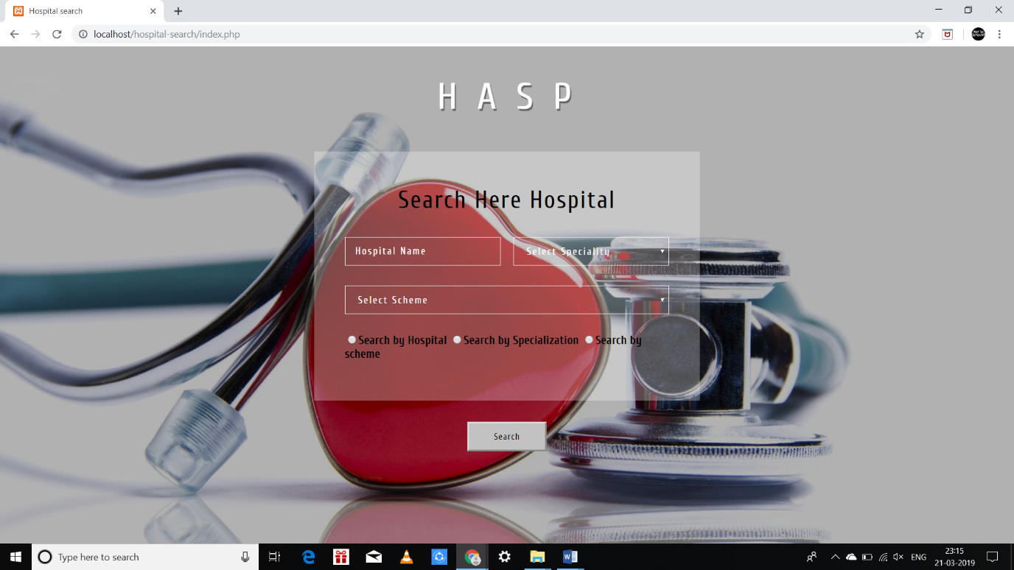**

**6.1 Home page**

**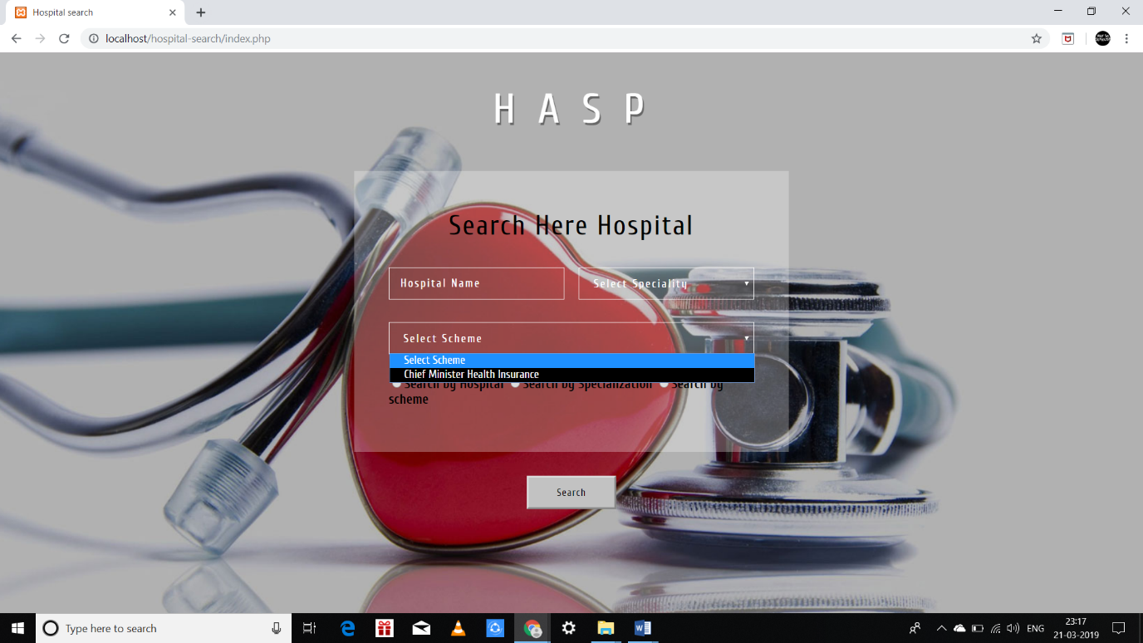**

**6.2 Search by hospital**

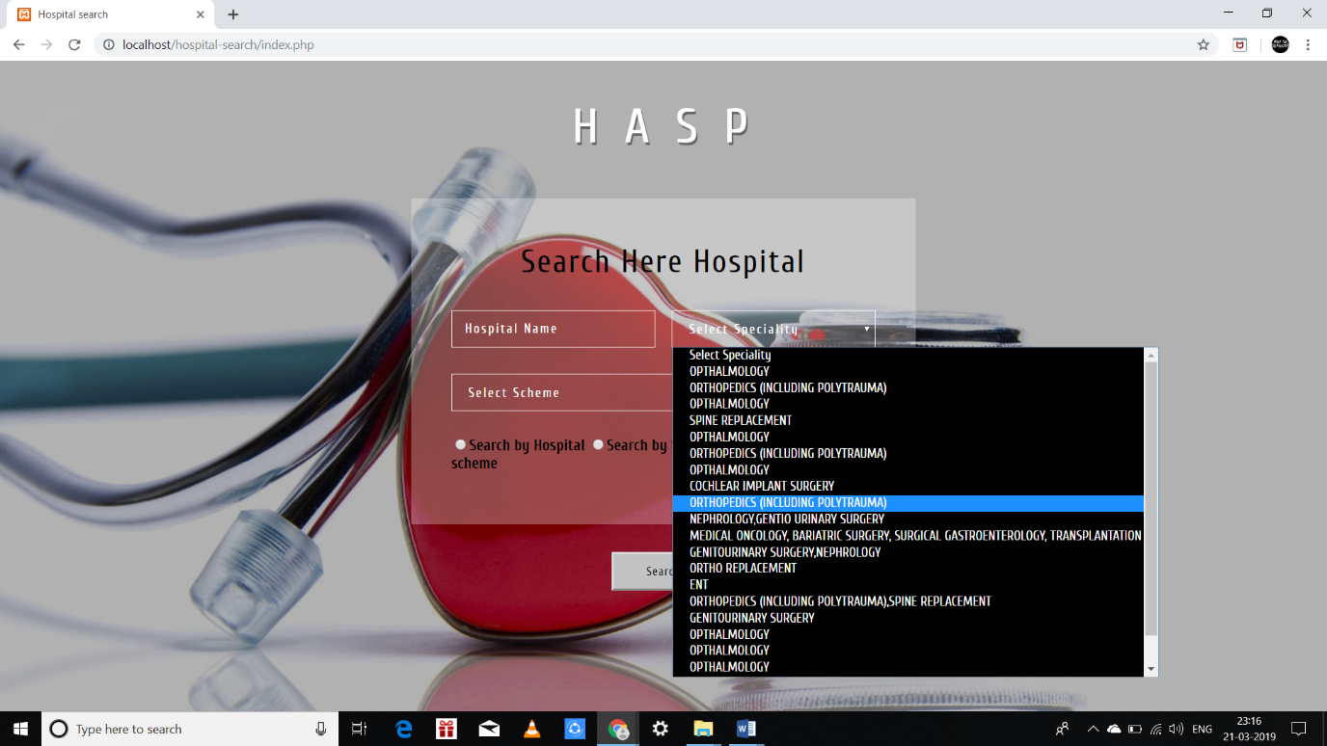

**6.3 Search by specialization**

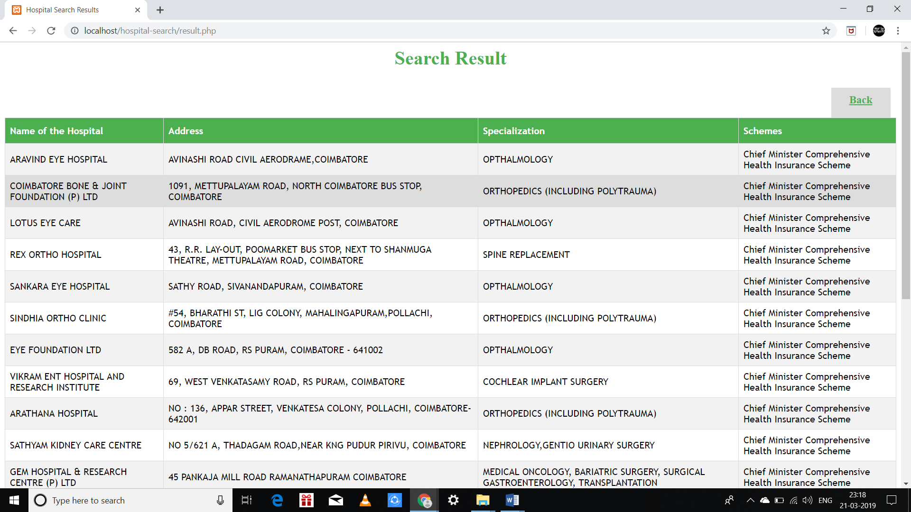

**6.4 Result for search**

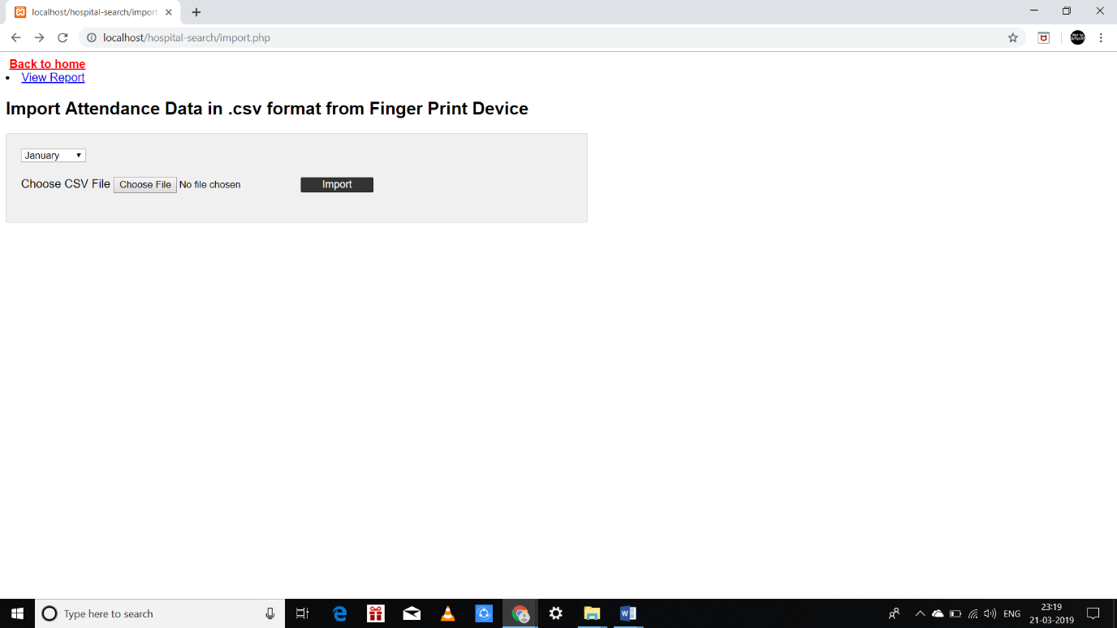

**6.5 Adding additional data**

**CHAPTER 6**

**REFERENCES**

1. Bartlett, Kynn. Sams Teach Yourself Cascading Style Sheets in 24 Hours, Second Edition, Sams, 2006.
2. Felke-Morris. Basics of Web Design: HTML5 & CSS3, 2nd Edition, Addison-Wesley, 2013.
3. Heilmann, Christian. Beginning JavaScript with DOM Scripting and Ajax: From Novice to Professional, Apress, 2006.
4. Nixon, Robin. Learning PHP, MySQL, JavaScript, and CSS: A Step-by-Step Guide to Creating Dynamic Websites, O'Reilly, 2012.
5. Crowe, Sam. Webwise: A Simplified Management Guide for the Development of a Successful Web Site, Publishers' Group West, 1999.
6. CSS3 Selectors module (@ <http://www.w3.org/TR/selectors/>); CSS3 Colors module (@ <http://www.w3.org/TR/css3-color/>).
7. Mozilla's (MDN) JavaScript Project @ <https://developer.mozilla.org/en-US/docs/Web/JavaScript>.
8. PHP Language Reference @ <http://php.net/manual/en/langref.php>.
9. MySQL Mother Site @ [www.mysql.com](http://www.mysql.com/).