# AZ-900 (Microsoft Azure Fundamentals)

**Azure** – Microsoft’s Cloud Computing Platform.

**Cloud computing** – Delivery of computing services over the internet by using a pay-as-you-go pricing model. (e.g., Instead of maintaining CPUs and storage in your datacentre, you rent them for the time that you need them)

**Cloud** **computing advantages** –

**1.**Reliability(High Availability, SLA),

**2.**Scalability(Vertical/Up-Down; Horizontal/Out-In),

**3.**Elasticity(Stretch/Shrink🡪Dynamic/Auto),

**4.**Agility(Time to Market),

**5.**Geo-Distribution(Global Presence),

**6.**Disaster Recovery(Business Continuity).

Cloud computing’s **Service Model** – 3 Models 🡪

1.IaaS(**I**nfrastructure **a**s **a** **S**ervice),

2.PaaS (**P**latform), *[****Serverless*** *Computing]*

3.SaaS(**S**oftware) 🡪e.g., Office 365.

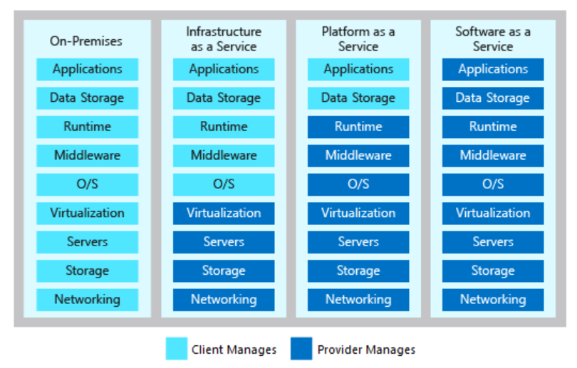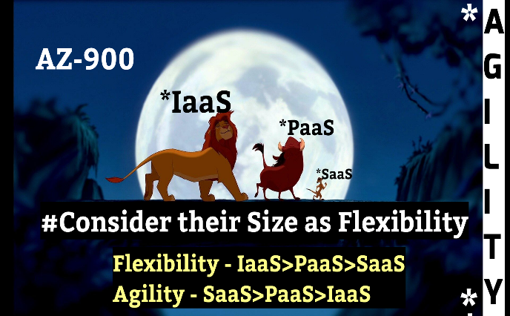

High Initial Cost(Capital Expenditure/CapEx)=High Administration=Great Flexibility 🡪 IaaS>PaaS>SaaS.

No/Low Capex=Low Operational Expenditure/OpEx =No/Less Administration=Low Flexibility 🡪 SaaS>PaaS>IaaS.

**Deployment Model** – 3 Models 🡪

**1.**Public,

**2.**Private,

**3.**Hybrid.

**Azure Portal** 🡪 Web-based(GUI), unified console that provides an alternative to command-line tools to build, manage, configure, monitor, secure Azure Services.

**Azure Marketplace** 🡪 connect users with Microsoft partners, independent software vendors, and startups that are offering their solutions and services, which are optimized to run on Azure.

**Azure Overview🡪** [MS link](https://www.microsoft.com/en-us/videoplayer/embed/RE2yuas?pid=RE2yuas-ax-89-id-oneplayer&postJsllMsg=true&autoplay=false&mute=false&loop=false&market=en-us&playFullScreen=false)

**Azure Services🡪**

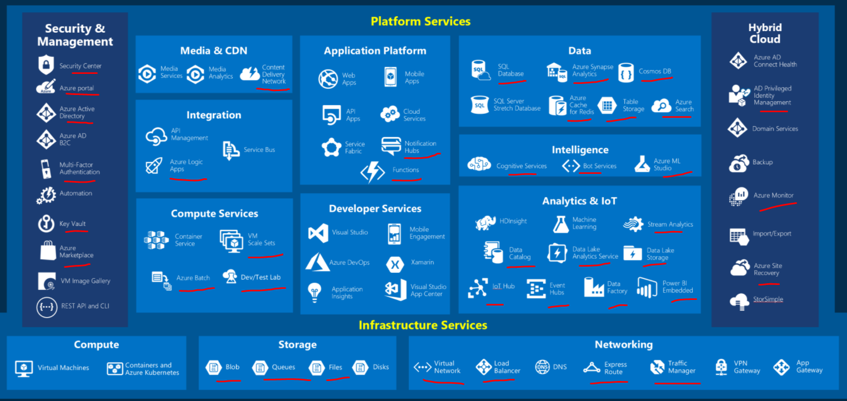

**Azure Security Center** - a *unified infrastructure security management system* that strengthens the security posture of our data centers and provides advanced threat protection across our hybrid workloads in the cloud. [link](https://twitter.com/arulmouzhi/status/1282213904991391745/photo/1)

**Azure Active Directory (Azure AD)** - Microsoft's enterprise cloud-based *identity and access management (IAM) solution*.

**Azure Key Vault** - a *secure secrets store, providing management for secrets, keys, and certificates*, all backed by Hardware Security Modules.

**Multi-factor authentication (MFA)-** *something they know, something they are/own*.

**Content delivery network/content distribution network** - a geographically *distributed network* of proxy servers and their data centers. Reduce load times, save bandwidth, and speed responsiveness.

**Azure Logic Apps** - *Serverless* - Cloud service that helps you *schedule, automate, and orchestrate tasks, business processes, and workflows* when you need to integrate apps, data, systems, and services across enterprises or organizations.

**Azure virtual machine scale sets** - let you create and *manage a group of load balanced VMs*.

**Azure DevTest Labs** - *Self-service cost control*, Quick custom templates, Works with our CI/CD tools, Simplify cost management, *Quickly set up environments*. Provides developers and testers a self-service sandbox environment to quickly create Dev/Test environments while *minimizing waste and controlling costs*.

**Azure Notification Hubs** - an easy-to-use and *scaled-out push engine that enables you to send notifications to any platform*.

**Azure Functions** - a *serverless* solution that allows you to *write less code, maintain less infrastructure, and save on costs*.

**Azure Blob storage** - Microsoft's *object storage solution* for the cloud. Blob storage is optimized for *storing massive amounts of unstructured data*.

**Azure Files** - fully managed file shares in the cloud that are accessible via ***Server Message Block (SMB)*** protocol or Network File System (NFS) protocol. Azure file shares can be mounted concurrently by cloud or on-premises deployments.

**Azure Queue storage** - a service for *storing large numbers of* ***messages*** that can be accessed from anywhere in the world via authenticated calls.

**Azure Virtual Network (VNet)** - a representation of our own network in the cloud.

**Azure load balancer** - Layer-4 (TCP, UDP) - provides high availability by distributing incoming traffic among healthy VMs.

**Azure Traffic Manager** - a *DNS-based traffic load balancer*. This service allows you to distribute traffic to your public facing applications across the global Azure regions.

**Azure ExpressRoute** - *create private connections* between Azure datacenters and infrastructure that's on our premises.

**Azure Privileged Identity Management (PIM)** - service in Azure AD that enables you to manage, control, and monitor access to important resources.

* + Provide ***just-in-time*** privileged access to Azure AD and Azure resources.
  + Assign ***time-bound*** access to resources using start and end dates.

**Azure Monitor** - collects monitoring telemetry from a variety of on-premises and Azure sources. [link](https://twitter.com/i/status/1297865145838796800)

**Azure Site Recovery (ASR)** - *DRaaS* offered by Azure for use in cloud and hybrid cloud architectures.

**Azure Cosmos DB** - fully managed *NoSQL DB*. [link](https://twitter.com/i/status/1287807055999295489)

**Azure Table storage** - service that stores non-relational structured data (aka structured NoSQL data) in the cloud, providing a ***key/attribute store*** with a schema less design.

**Azure SQL DB** - intelligent, scalable, *relational DB* service.

**Azure Synapse Analytics** (formerly ***Azure SQL Data Warehouse***) - ***limitless analytics service*** that brings together data integration, enterprise data warehousing and big data analytics. [Synapse Compute + Cost if we forgot to PAUSE](https://twitter.com/i/status/1298306285947912192)

**Azure Data Lake Analytics** - an ***on-demand analytics job service*** that simplifies big data.

**Azure HDInsight** - a fully managed, ***open-source analytics*** service for enterprises.

[link](https://twitter.com/arulmouzhi/status/1282882092464869377/photo/1)

**Azure Cache for Redis** - fully managed, ***in-memory cache*** that enables high-performance and scalable architectures.

**Azure Search** - *providing indexing and querying capabilities for data* uploaded to Microsoft servers.

**Azure ML Studio** - provides MLOps capabilities for the different users in machine learning projects.

**Azure Cognitive Services** [***Language, Speech, Vision, Decision***] - brings AI *without requiring machine-learning* expertise. [link](https://twitter.com/arulmouzhi/status/1299041070227980290/photo/1)-1 , [link](https://twitter.com/arulmouzhi/status/1299420681348800514/photo/1)-2

**Azure Bot Service** - provides an integrated environment that is purpose-*built for bot development*. [link](https://twitter.com/arulmouzhi/status/1299786644904583170/photo/1)

**Azure Data Catalog** - enterprise-wide metadata catalog - fully-managed service - register, enrich, discover, understand, and consume data sources.

**Azure Data Lake** - a platform for organizations to store/park - and process and analyze - *vast volumes of data in any format*.

**Azure Stream Analytics** - a ***real-time analytics*** and complex event-processing engine that is designed to analyze and process high volumes of fast streaming data from multiple sources simultaneously.

**Azure IoT Hub** - a fully managed service that enables reliable and secure ***bidirectional*** communications between millions of ***IoT devices*** and a solution back end.

**Azure Event Hubs** - a fully managed***, real-time data ingestion service*** that is simple, trusted, and scalable.

**Azure Data Factory** - *cloud-based ETL and data integration service that allows you to create data-driven workflows for orchestrating data movement and transforming data at scale.*

**Power BI Embedded** - Microsoft Azure service that lets developers quickly embed visuals, reports, and dashboards into an application.

**Azure Account 🡪 Subscription 🡪 Resource Groups 🡪 Resources.**

* *Azure account* 🡺 ***global unique entity*** that gets you access to Azure services and our Azure subscriptions.
* *Subscription* 🡺 Billing boundary, Access control boundary. Azure subscription - a ***logical unit of Azure services that links to an Azure account for tracking and billing purposes***.
* *Resource group* 🡺 A ***container that holds related resources for an Azure solution***. *Resource groups can't be nested*.
* *Resource* 🡺 A manageable item that's available through Azure. 1 Resource can only be available under 1 Resource Group at a point of time, can’t be nested under more than 1 Resource Group.

In an ***IaaS*** environment, the ***cloud provider***(~~not cloud tenant~~) is responsible for any hardware maintenance.

**Concepts/Cloud Terms:**

* High availability
* Scalability
* Elasticity
* Agility
* Geo-distribution
* Disaster recovery
* Capital expenses vs. operating expenses

**Azure Function Vs Azure Logic Apps:**

[link](https://twitter.com/arulmouzhi/status/1283277694621245445/photo/1)

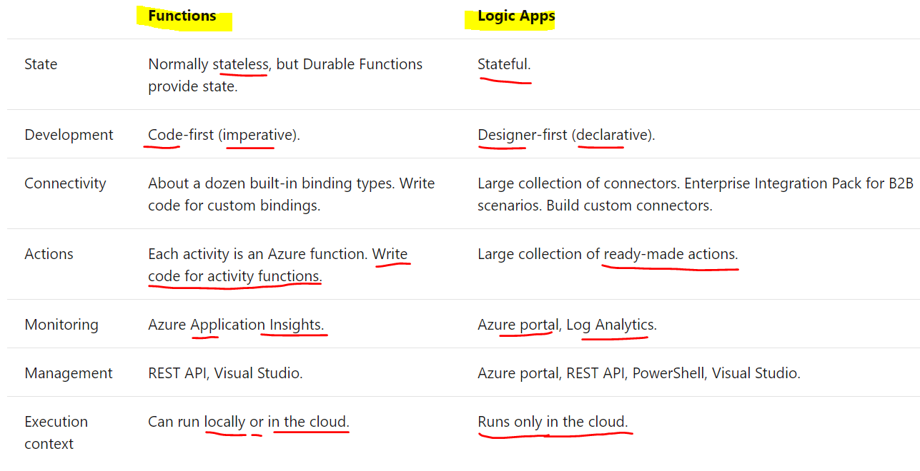

**Azure Resource Lock Vs RBAC(Role Based Access Control)** – [link](https://twitter.com/i/status/1294363208669466625)-1, [link](https://twitter.com/arulmouzhi/status/1281981659059896320)-2, [Own Article](https://quantumtechcrew.com/azure-resource-lock-simple-2-steps/)

**Azure Service Health** - [link](https://twitter.com/arulmouzhi/status/1282528652349943809/photo/1) - provides a personalized view of the health of the Azure services, regions, and resources.

**Azure Elastic pool** - [link](https://twitter.com/i/status/1298640535045828608)

**Azure Data Migration Service -** [link](https://twitter.com/arulmouzhi/status/1331345223239102465/photo/1)

**Main Know-how-1:**

* **Azure Cosmos DB** supports SQL, MongoDB, Cassandra, Tables, and Gremlin APIs.
* Azure Database for **MySQL** is the logical choice for existing **LAMP** stack applications.
* **Azure Synapse Analytics** is the logical choice for **analyzing large volumes of data**.
* **Virtual machine scale sets** let you deploy and manage a set of identical virtual machines.
* **Azure Functions** is used when you need to perform work in response to an event (often via a REST request), timer, or message from another Azure service, and when that work can be completed quickly, within seconds or less.
* **Windows Virtual Desktop** enables your team members to run Windows in the cloud, with access to the required applications for your company's needs.
* You must create an Azure Storage account before you can use any Azure Storage features.
* **Azure Blob Storage** is your best option for storing disaster recovery files and archives.
* **ExpressRoute** does provide private connectivity, **but it isn't encrypted**.
* **FTP over SSL can't be used** to create a secure communication tunnel. [Point-to-site VPN, Site-to-site and Azure ExpressRoute - to create a secure communication tunnel]
* Virtual network peering (**VNet Peering**) can be used to link virtual networks.
* Azure **ExpressRoute** 🡺 Any-to-any connection, Point-to-point Ethernet connection, CloudExchange colocation. [A ***site-to-site VPN isn't an ExpressRoute model***.]

**Azure Resource Manager(ARM)** - **deployment and management service** for Azure.

**Azure regions** - A region is a **geographical area** on the planet. Special Azure regions - e.g., US Gov, China.

**Availability zones** - physically separate datacenters within an Azure region. Each availability zone is made up of one or more datacenters equipped with **independent power, cooling, and networking**. An availability zone is set up to be an **isolation boundary**.

**Zonal services** - pin the resource to a specific zone (e.g., ***VMs, managed disks, IP addresses***).

**Zone-redundant services** - platform replicates automatically across zones (e.g., zone-redundant storage, ***SQL DB***).

Azure **region pairs** vs ***Minimum of three zones within a single region***.

Each Azure region is always paired with another region within the same geography (such as US, Europe, or Asia) **at least 300 miles away**.

**App Service** - an HTTP-based service that enables you to build and host many types of web-based solutions without managing infrastructure.

**Management groups** - to manage governance across multiple Azure subscriptions.

**Blob access tiers** - 3 - Hot, Cool, Archive. Archive to hot/cool --> **Blob-Rehydration**.

***Layer 2 - Data Link Layer*** - provides node-to-node communication between two nodes on the same network. ***Layer 3 - Network Layer***

**Azure Repos** - a ***centralized source-code repository*** where software development, DevOps engineering, and documentation professionals can publish their code for review and collaboration.

**Azure Boards** - an ***agile project management suite*** that includes Kanban boards, reporting, and tracking ideas and work from high-level epics to work items and issues.

**Azure Pipelines** - a ***CI/CD pipeline automation tool***.

**Azure Artifacts** - a ***repository for hosting artifacts***, such as compiled source code, which can be fed into testing or deployment pipeline steps.

**Azure Test Plans** - an ***automated test tool*** that can be used in a CI/CD pipeline to ensure quality before a software release.

**Azure IoT Central** - builds on top of IoT Hub by adding a dashboard that allows you to ***connect, monitor, and manage our IoT devices***.

**Azure Sphere** - creates an end-to-end, ***highly secure IoT solution*** - has built-in communication and security features for internet-connected devices.

**Azure Security Center** - monitoring service that ***provides visibility of your security posture*** across all of your services, both on Azure and on-premises.

**Secure score** - a measurement of an organization's security posture.

**Azure Sentinel** - ***Microsoft's cloud-based SIEM***(**S**ecurity **I**nformation and **E**vent **M**anagement) system. It ***uses intelligent security analytics and threat analysis***.

**Azure Dedicated Host** - provides ***dedicated physical servers to host your Azure VMs*** for Windows and Linux.

**Azure Firewall** - a managed, cloud-based network security service that helps protect resources in your Azure virtual networks. Azure Firewall is a ***stateful*** firewall. A stateful firewall analyzes the complete context of a network connection, not just an individual packet of network traffic. Azure Firewall features high availability and unrestricted cloud scalability.

**Azure Application Gateway** - also provides a firewall that's called the web application firewall (WAF). WAF provides centralized, inbound protection for your web applications against common exploits and vulnerabilities.

**Azure Front Door** and **Azure Content Delivery Network** - also provide WAF services.

**Application Gateway** - Build secure, scalable, and highly available web front ends in Azure.

**Content Delivery Network(CDN)** - Secure and reliable global content delivery and acceleration.

**Azure Front Door** - Scalable and secure entry point for fast delivery of your global applications.

KINDS of attacks can DDoS Protection help prevent - **3**

* **Volumetric attacks** - to flood the network layer with a substantial amount of seemingly legitimate traffic.
* **Protocol attacks** - render a target inaccessible by exploiting a weakness in the layer 3 and layer 4 protocol stack.
* **Resource-layer (application-layer) attacks (only with web application firewall(WAF))** - target web application packets to disrupt the transmission of data between hosts. ***We need a web application firewall (WAF) to protect against L7 attacks.***

***DDoS Protection Standard protects the WAF from volumetric and protocol attacks.***

**Network Security Group** - enables us to ***filter network traffic to and from Azure resources within an Azure virtual network***. We can think of NSGs like an ***internal firewall***. An NSG can contain multiple inbound and outbound security rules that enable us to filter traffic to and from resources by source and destination IP address, port, and protocol.

**Azure Advisor** - evaluates our Azure resources and makes recommendations to help improve reliability, security, and performance, achieve operational excellence, and reduce costs. Advisor is designed to help you save time on cloud optimization. [link](https://twitter.com/arulmouzhi/status/1283644706786689029/photo/1)

**Scenarios: When? What?**

* Use **Azure portal** to visually understand and manage our cloud environment.
* Use **Azure PowerShell/Azure CLI** for one-off administrative tasks.
* Use **Azure mobile app** to manage Azure on the go.
* Use **Azure DevOps** to manage the application development lifecycle.
* Use **GitHub** to contribute to open-source software.
* Use **ARM templates** to deploy an entire cloud infrastructure.
* Use **Azure DevTest Labs** to manage testing environments.

**Characteristics:**

* **Durable** and **highly available** with redundancy and replication.
* **Secure** through automatic encryption and role-based access control.
* **Scalable** with virtually unlimited storage.
* **Managed**, handling maintenance and any critical problems for you.
* **Accessible** from anywhere in the world over HTTP or HTTPS.

**Defense in Depth (Security) -**

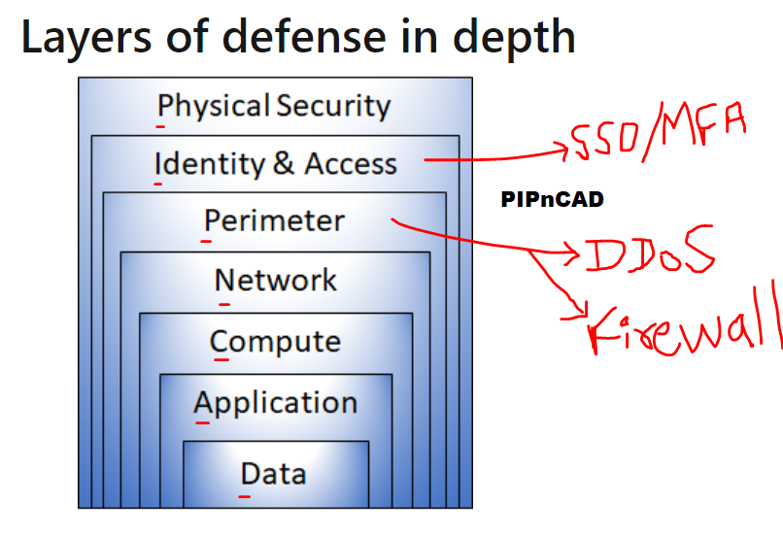

**Main Know-how-2:**

* **Azure Sphere** provides the highest degree of security to ensure the device has not been tampered with.
* **IoT Central** quickly creates a web-based management portal to enable reporting and communication with IoT devices.
* An **IoT hub** communicates to IoT devices by sending and receiving messages.
* **Azure Machine Learning** - to predict future behavior based on previous actions.
* **Azure Bot Service** - creates virtual agent solutions that utilize natural language - to create a human-computer interface that uses natural language to answer customer questions.
* **Azure Cognitive Services** - includes Vision services that can identify the content of an image - to identify the content of product images to automatically create alt tags for images formatted properly.
* **Azure Advisor** can alert you when new recommendations are available.
* **Azure Service Health** provides incident history and RCAs to share with your stakeholders.
* **Azure Monitor** is the platform used by Application Insights.
* **Azure Boards** is an agile project-management tool. It would not be used to automate a CI/CD process. [where Azure Pipelines, GitHub Actions does it]
* **Azure DevTest Labs** is used to manage VMs for testing, including configuration, provisioning, and automatic de-provisioning.
* **Azure Pipelines** is a CI/CD tool for building an automated toolchain. It lacks features to assign tasks for individual developers to work on. However, it can automate other tools to assign tasks to users.
* **Azure Functions** is the correct choice because you can use existing Java code with minimal modification.
* **Azure Logic Apps** makes it easy to create a workflow across well-known services with less effort than writing code and manually orchestrating all the steps yourself.
* **Azure Logic Apps** is best suited for users who are more comfortable in a visual environment that allows them to automate their business processes. Logic Apps is the best option in this scenario.
* **ARM templates** are the best infrastructure-as-code option for quickly and reliably setting up your entire cloud infrastructure declaratively.
* The **Azure portal** is a great place for newcomers to learn about Azure and set up their first resources.
* The **Azure CLI** enables you to use Bash to run one-off tasks on Azure.
* **Azure Security Center** - we can define a list of allowed applications **to ensure that only applications you allow can run**. Azure Security Center can also detect and block malware from being installed on your VMs.
* **Azure Sentinel** - combine security data from all of its monitoring tools into a single report that it can take action on.
* **Azure Key Vault** - enables you to store your secrets in a single, central location. Key Vault also makes it easier to enroll and renew certificates from public certificate authorities (CAs).
* **Azure Dedicated Host**
* - provides dedicated physical servers to host your Azure VMs for Windows and Linux.
* - ensure that certain VM workloads are physically isolated from workloads being run by other Azure customers
* An attacker can bring down your website by sending a large volume of network traffic to your servers. Which Azure service can help - **Azure DDoS Protection**.
* DDoS Protection helps protect your Azure resources from DDoS attacks. A DDoS attack attempts to overwhelm and exhaust an application's resources, making the application slow or unresponsive to legitimate users.
* **Azure Firewall**
* - enables you to limit outbound HTTP/S traffic to a specified list of fully qualified domain names (FQDNs).
* - limit all outbound traffic from VMs to known hosts.
* **Network Security Group(NSG)** - rule enables you to filter traffic to and from resources by source and destination IP address, port, and protocol.
* Create a network security group rule that prevents access from another VM on the same network - most easily implement a deny by default policy so that VMs can't connect to each other.

**TCO (T**otal **C**ost of **O**wnership**) Calculator** - helps you estimate the cost savings of operating your solution on Azure over time, instead of in your on-premises datacenter.

***You don't need an Azure subscription to work with the TCO Calculator.*** Select Download to download or print a copy of the report in ***PDF*** format.

***You don't need an Azure subscription to review service SLAs.***

* **TCO - PDF**
* **ARM - JSON**
* **DASHBOARDS - JSON**
* **Pricing calculator - Excel**

**Types of Azure subscriptions** - Free trial, Pay-as-you-go, Member offers.

**What factors affect cost?** –

* Resource type,
* Usage meters,
* Resource usage,
* Azure subscription types.

Location or Network Traffic(Zones for billing of network traffic) affect cost? Yup.

**Bandwidth** - refers to data moving in and out of Azure datacenters. Some inbound data transfers (data going into Azure datacenters) are free. For outbound data transfers (data leaving Azure datacenters), data transfer pricing is based on zones.

**Pricing calculator** - to estimate the cost of running a basic web application on Azure. It is for information purposes only. The prices are only an estimate, and you won't be charged for any services you select.

**Service-Level Agreement (SLA)** - is a formal agreement between a service company and the customer. For Azure, this agreement defines the performance standards that Microsoft commits to for you, the customer.

* ***Free products typically don't have an SLA.***
* For example, many Azure services provide a free or shared tier that provides more limited functionality.
* Services like ***Azure Advisor are always free***.
* The SLA for Azure Advisor states that because it's free, ***it doesn't have a financially backed SLA.***

**Downtime** - refers to the time duration that the service is unavailable.

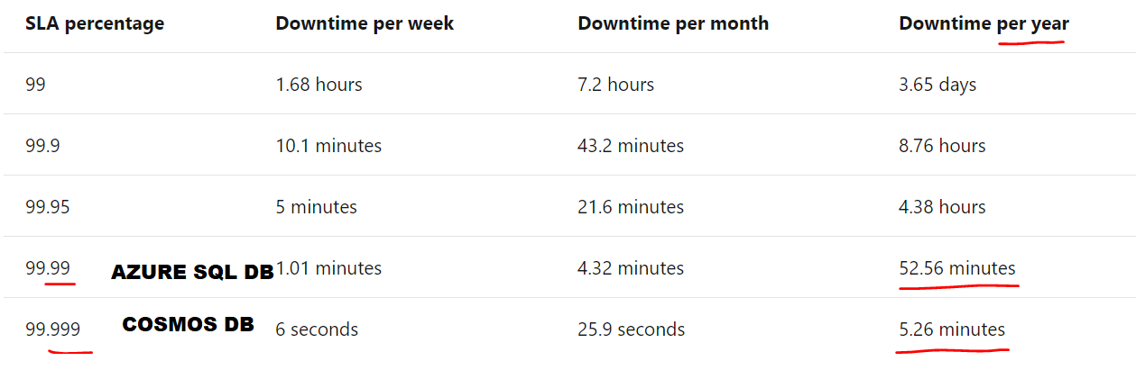

**Composite SLA –**

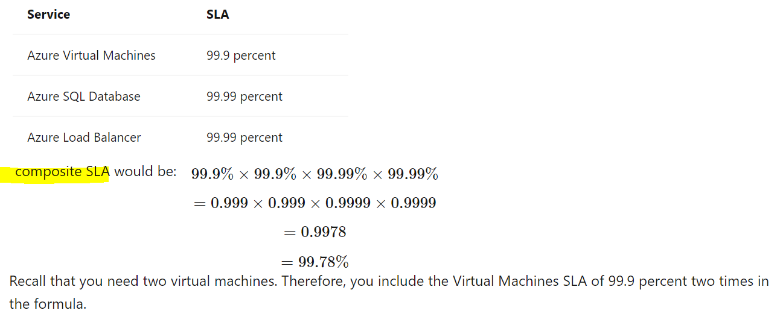

**Service Credit** - Percentage of the fees you paid that are credited back to you according to the claim approval process.

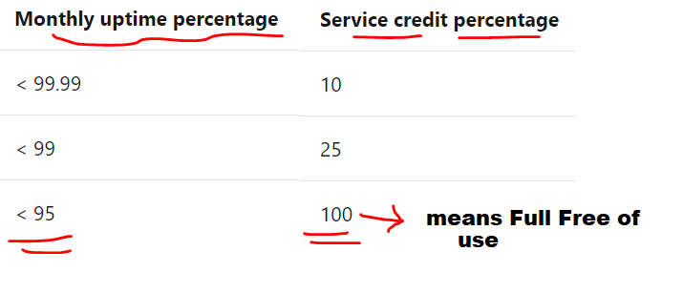

**Manage and minimize total cost on Azure**

* Understand estimated costs before you deploy.
* Use Azure Advisor to monitor your usage.
* Use spending limits to restrict your spending.
* Use Azure Reservations to prepay.
* Choose low-cost locations and regions.
* Research available cost-saving offers.
* Use Azure Cost Management + Billing to control spending.
* Apply tags to identify cost owners.
* Resize underutilized virtual machines.
* Deallocate virtual machines during off hours.
* Delete unused resources.
* Migrate from IaaS to PaaS services.
* Save on licensing costs.
* Choose cost-effective operating systems.
* Use Azure Hybrid Benefit to repurpose software licenses on Azure.

**Service Lifecycle** –

1. Development Phase,
2. Public Preview Phase,
3. General Availability (GA).

**Azure Portal** - [https://**portal.azure.com**/](https://portal.azure.com/)

**Azure Portal (Preview)** - [https://**preview.**portal.azure.com/](https://preview.portal.azure.com/)

**Azure status** - provides a ***global view of the health of Azure services and regions***.

**Azure Service Health** - provides a ***personalized view of the health of the Azure services and regions*** that you're using, directly from the Azure portal.

**Authentication (**Auth**N)** - ***identity of a person or service*** that wants to access a resource

**Authorization (**Auth**Z)** - process of establishing **what level of access** an authenticated person or service has.

**Azure AD** - AuthN.

**Multifactor Authentication** –

* Something the user knows[Password],
* Something the user has[Device AuthN],
* Something the user is[Biometric AuthN]

**Conditional Access** - provides a ***more granular multifactor authentication*** experience for users. To use Conditional Access, ***we need an Azure AD Premium P1 or P2 license.***

We can apply **Azure RBAC** to an individual person or to a group. We manage access permissions on the **Access control (IAM) pane** in the Azure portal.

**Resource Lock** - ***prevents resources from being accidentally deleted or changed***. Levels of locking: CanNotDelete or ReadOnly.

* To modify a locked resource, you must first remove the lock.
* Resource locks apply regardless of RBAC permissions.
* Even if you're an owner of the resource, you must still remove the lock before you can perform the blocked activity.

Combine resource locks with Azure Blueprints.

**Azure Policy** - a service in Azure that enables you to create, assign, and manage policies that control or audit your resources.

**Azure Policy Initiative** - a way of grouping related policies into one set.

* ***e.g.,*** Restrict deployments ***to a specific location*** by using Azure Policy.

**Azure Blueprints (PREVIEW)** - Templates for quick, repeatable creation of fully governed cloud subscriptions. Govern multiple subscriptions by using Azure Blueprints.

**Microsoft Privacy Statement** - explains what personal data Microsoft collects, how Microsoft uses it, and for what purposes.

**Online Services Terms (OST)** - a legal agreement between Microsoft and the customer.

**Data Protection Addendum (DPA)** - defines the data processing and security terms for online services.

**Trust Center** - showcases Microsoft's principles for maintaining data integrity in the cloud and how Microsoft implements and supports security, privacy, compliance, and transparency in all Microsoft cloud products and services.

**Azure Compliance Documentation** - provides you with detailed documentation about legal and regulatory standards and compliance on Azure.

* ***e.g.,*** Payment Card Industry Data Security Standard (***PCI DSS***)

**Azure Government** - a separate instance of the Microsoft Azure service. It addresses the security and compliance needs of US federal agencies, state and local governments, and their solution providers. Azure Government offers physical isolation from non-US government deployments and provides screened US personnel.

**Azure China 21Vianet** - operated by 21Vianet. It's a physically separated instance of cloud services located in China. Azure China 21Vianet is independently operated and transacted by Shanghai Blue Cloud Technology Co., Ltd.

**Main Know-how-3:**

* We can apply ***tags*** to groups of Azure resources ***to organize billing data***.
* When you deallocate virtual machines, the ***associated hard disks and data are still kept*** in Azure. ***But you don't pay for CPU or network consumption, which can help save costs***.
* ***If you exceed your spending limit, active resources are deallocated***. You can then decide whether to increase your limit or provision fewer resources.
* Running the ***Total Cost of Ownership Calculator*** is a great first step because it can provide an accurate comparison of running workloads in the datacenter versus on Azure, certified by an independent research company.
* ***Azure Maps*** will be available at least ***99.9%*** of the time. (SLA)
* Adding a third virtual machine reduces the composite SLA. How can Tailwind Traders offset this reduction? 🡪
* Deploy extra instances of the same virtual machines across the different availability zones in the same Azure region.
* If one availability zone is affected, your virtual machine instance in the other availability zone should be unaffected.
* What approach might the company take in adding the augmented reality (AR) preview service to its architecture? 🡪
* The development team can create a prototype version of the app that includes the AR service that it tests out with select retail employees.
* After the AR service reaches general availability (GA), the team can roll it out to production.
* ***Conditional Access*** enables you to require users to access your applications ***only from approved, or managed, devices***.
* Authenticating through ***multifactor authentication*** can include something the user knows, something the user has, and something the user is.
* ***SSO*** enables a user to remember ***only one ID and one password to access multiple applications.***
* ***Azure RBAC*** enables you to create roles that define access permissions. You might create ***one role that limits access only to virtual machines and a second role that provides administrators*** with access to everything.
* After you enable this policy, that policy is applied when you create new virtual machines or resize existing ones. ***Azure Policy*** also evaluates any current virtual machines in your environment.
* ***Tags*** provide extra information, or metadata, about your resources. The team might create a tag that's named BillingDept whose value would be the name of the billing department. You can use Azure Policy to ensure that the proper tags are assigned when resources are provisioned.
* ***Trust Center*** - a great resource for people in your organization who might play a role in security, privacy, and compliance.
* Where can the legal team access information around how the Microsoft cloud helps them secure sensitive data and comply with applicable laws and regulations? 🡪 ***Trust Centre***.
* ***Azure Compliance Documentation*** - provides reference blueprints, or policy definitions, for common standards that you can apply to your Azure subscription.
* ***Microsoft Privacy Statement*** - provides information that's relevant to specific services, including Cortana.

**Feedback For Azure:**

***What’s Next? 🡪* Multi Cloud**

**Instructor Feedback**

