**What is ActiveMQ?**

It’s a messaging system that implements the JMS interfaces and provides administrative and control features. It is an API that provides the facility to create, send and read messages.

For practicing we will run the ActiveMQ server in local machine.

**Download Link**

<http://activemq.apache.org/download.html>

**How to setup active MQ Server in Mac?**

1. Extract the downloaded tar file
2. Navigate to bin folder in terminal
3. Execute this command **./activemq start**
4. Go to<http://localhost:8161/admin/queues.jsp>

The Active MQ server admin console gets open as follows

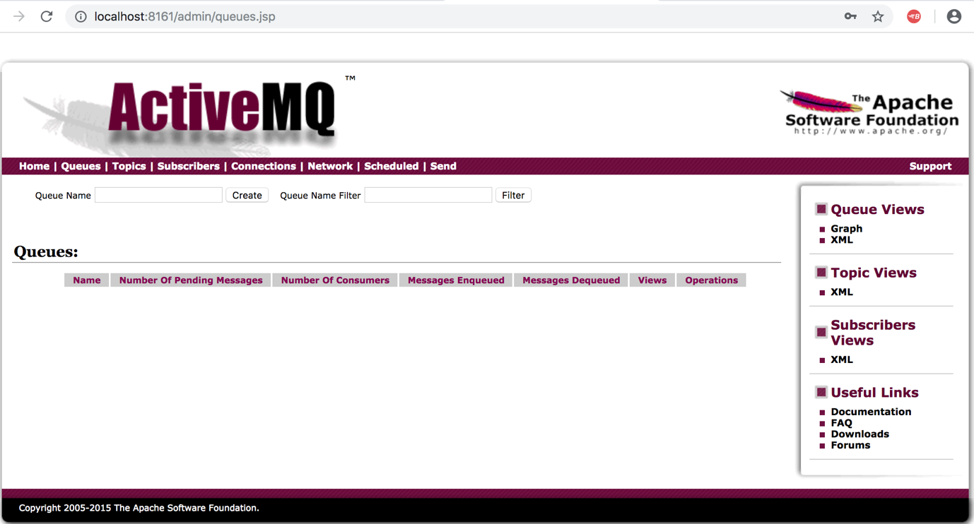

Now the active MQ server is running in your local machine.

We can write java code to create queue and produce/ consume messages in the queue.

Refer the following projects:

1. ActiveMQ with Java Client

<https://github.com/ArulmuruganInfy/ActiveMQ_Java.git>

1. ActiveMQ with Spring

<https://github.com/ArulmuruganInfy/ActiveMQ_SpringBoot.git>

Once you execute this project the queue will be created, and you can track number of messages enqueued / dequeued and number of consumers in the ActiveMQ server Console

