**RabbitMQ:**

**Installation steps:**

**Install through Homebrew**

1. Go to terminal and run the following command

ruby -e "$(curl -fsSL https://raw.githubusercontent.com/Homebrew/install/master/install)" < /dev/null 2> /dev/null

This will install homebrew (Homebrew is a free and open-source software package management system that simplifies the installation of software on Apple's macOS operating system.)

1. Run brew install rabbitmq
2. Now rabbitmq is installed and ready to use.
3. To start the rabbitmq run this command

brew services start rabbitmq

1. Go to <http://localhost:15672>
2. You will see the following rabbitmq admin page

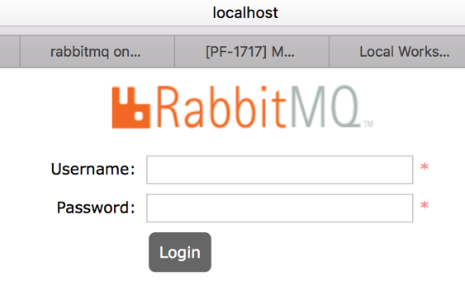

1. Login with

Username: guest

Password: guest

**Sample Rabbit MQ project:**

Producer: used rabbitTemplate

Consumer: used @RabbitListener(queues = "${ queue.name}")

**To execute this project:**

1. Clone the git repository

<https://github.com/ArulmuruganInfy/RabbitMQ_SpringBoot.git>

1. Import maven project in intelliJ
2. Run mvn clean install
3. Run mvn spring-boot:run
4. To post a message into the RabbitMQ Queue

Install post man extenstion in your browser

Hit this API with POST method

<http://localhost:8080/userservice/add>

RequestBody: {"supplierId":"13",

"supplierName":"Apple",

"supplierUrl":"www.apple.com"}

1. In RabbitMQ console you can see the queue size increased
2. Also you will the see the logs in intellij console regarding posting/ listening message from the queue

------ End------------------------