Hadoop Assignment:
1.Create a folder in HDFS by name “dir01” and move input1.txt , input2.txt and input3.txt into
/dir01.
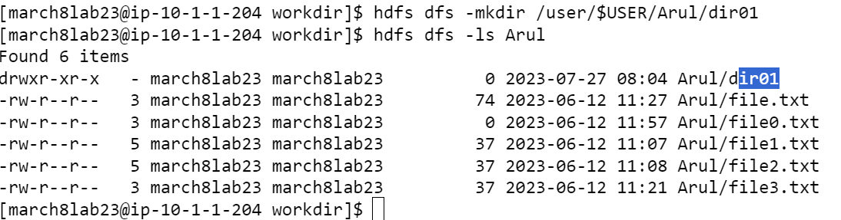

2.List only the file names present in “/dir01”
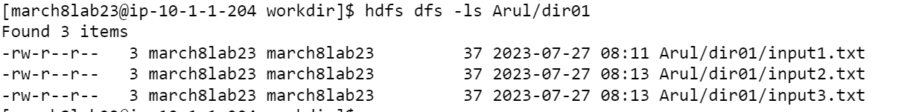
3.Change the replication factor for the content present in directory “/dir01” to 5 and display
the replication factor for the files present in “/dir01”.
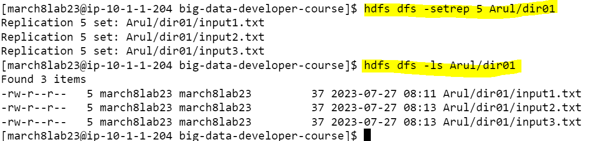

4.Create a folder in HDFS by name “scenario01” and create directory “level01” inside
“scenario01” directory and create another directory “level02” inside directory “level01”.
Once the required directories are created copy input1.txt to scenario01, input2.txt to level01
and input3.txt to level02 and finally recursively print only the file names present in
directory scenario01
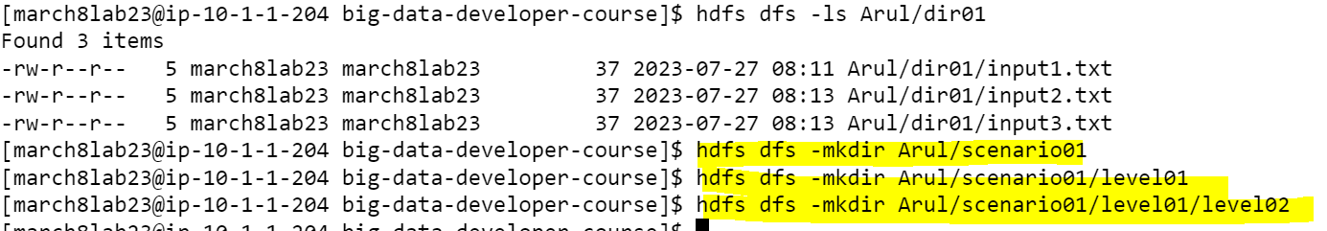
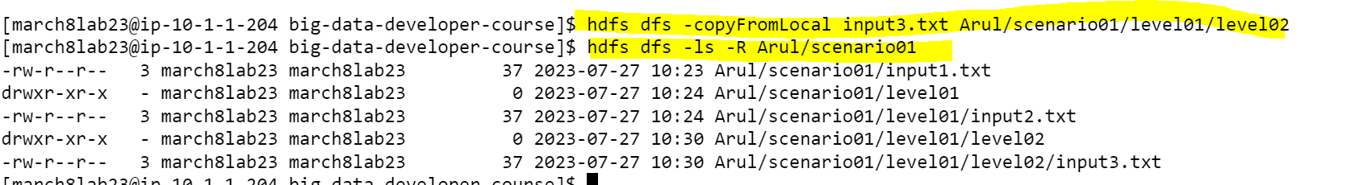

Problem2:

1. Run MapReduce Program and capture the application Id of the job.
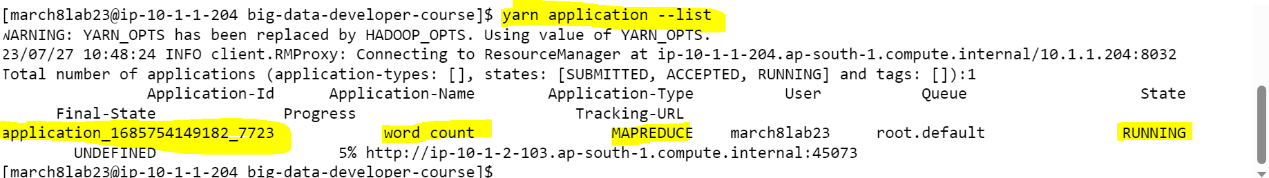

2.Re-run the MapReduce program and kill the application using the yarn command.
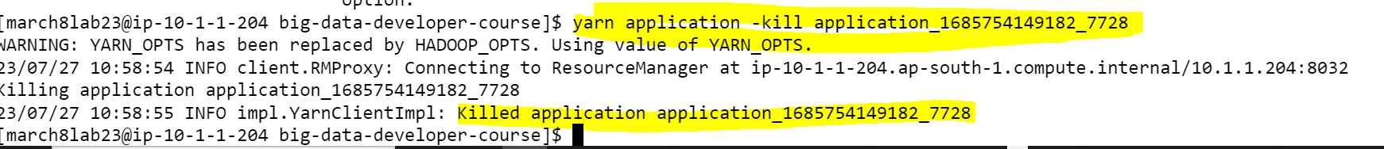

3.List all the applications which are RUNNING state
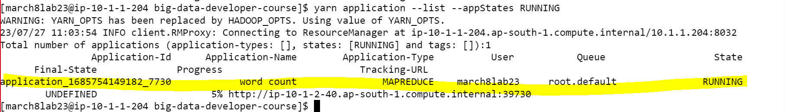

4.View the logs of any of the jobs which are already completed
