1. What are the Boolean data type's two values? How do you go about writing them?

* There are two types of Boolean data types values, True & False.
* If we write 5==3, then output will be shown as False, because it will compare two values whether they are equal, if not equal it will return False, if in case both of the values are equal it will return True.
* Similarly, if we execute 5! =3, then it will return True as we are trying to find whether both of the values are not equal, since it is matching the condition with the input, hence it will return True.

2. What are the three different types of Boolean operators?

* Three Boolean operators are AND, OR, NOT.

3. Make a list of each Boolean operator's truth tables (i.e. every possible combination of Boolean values for the operator and what it evaluate ).

|  |  |  |  |  |
| --- | --- | --- | --- | --- |
| **condition 1** | **condition 2** | **NOT X** | **X AND Y** | **X OR Y** |
| FALSE | FALSE | TRUE | FALSE | FALSE |
| FALSE | TRUE | TRUE | FALSE | TRUE |
| TRUE | FALSE | FALSE | FALSE | TRUE |
| TRUE | TRUE | FALSE | TRUE | TRUE |

4. What are the values of the following expressions?

(5 > 4) and (3 == 5)- Will return False as output, as 5 > 4 is true but 3 does not equal to 5, so as per AND gate True and False is False.

not (5 > 4)- Will return False as output, since the condition is True in NOT operators.

(5 > 4) or (3 == 5)- Will return True as output since in OR gate if one condition is True it will execute the same output.

not ((5 > 4) or (3 == 5))- Will return False as output as one condition is True, but the other condition is False, so in case NOT operator it will return False.

(True and True) and (True == False)- This will return False as only one condition is matching in AND operators so it will return False.

(not False) or (not True)- Will return True in case Not operators as first one is False and second one is True, so it will show output as True.

5. What are the six different types of reference operators?

* Arithmetic operators
* Comparison operators
* Logical operators
* Bitwise operators
* Comparison operators
* Assignment operators

6. How do you tell the difference between the equal to and assignment operators?

* Assignment operators is’ =’ where a value is assigned to a particular variable and equal to operators’ ==’ which compares between two given operands are equal or not.

7. Describe a condition and when you would use one.

* Condition occurs when inside a problem statement in python there are more than one loops execute and may be iterable as well inside the blocks, so if one condition is true it will execute the same block with going further or else it will go to concerned blocks execute, depending on the condition given as an input.

8. Recognize the following three blocks in this code:

spam = 0

if spam == 10: **FIRST BLOCK**

print('eggs')

if spam > 5: **SECOND BLOCK**

print('bacon')

else: **THIRD BLOCK**

print('ham')

print('spam')

print('spam')

This will print output as spam.

9. Create a programme that prints. If 1 is stored in spam, prints Hello; if 2 is stored in spam, prints Howdy; and if 3 is stored in spam, prints Salutations! if there's something else in spam.

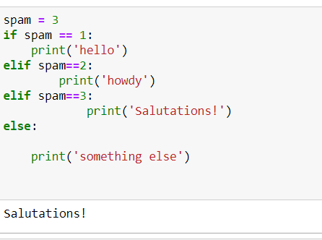

10.If your programme is stuck in an endless loop, what keys can you press?

Ctrl+C.

11. How can you tell the difference between break and continue?

Break statement terminates and end the loop once it is given inside a normal program flow, but continue statement will continue until the loop completes the whole condition satisfies .

12. In a for loop, what is the difference between range(10), range(0, 10), and range(0, 10, 1)?

range (10)- It will show output as range (0,10).

range (0,10)- where the min value is 0 and max is 10.

range (0,10,1)- here starting value is 0, end value is 10 and step is 1, so it will print the output by difference of 1.

13. Using a for loop, write a short programme that prints the numbers 1 to 10 Then, using a while loop, create an identical programme that prints the numbers 1 to 10.

* a=[1,2,3,4,5,6,7,8,9,10]

print(a)

* 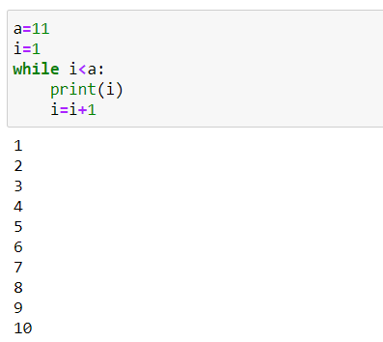

14. If you had a bacon() function within a spam module, how would you call it after importing spam?

* We need to call the function using spam.bacon after (import spam) or ‘from spam import bacon’ and import the particular function(bacon in this case).