EduGenie: Google Gemini Powered Learning Assistant

Project Description
EduGenie is a lightweight AI-powered educational assistant that simplifies learning through generative AI. Designed for students of all academic levels, EduGenie enables users to:
- Ask questions and receive smart, concise answers
- Understand complex concepts through simplified explanations
- Generate quizzes from topics or text
- Receive personalized learning recommendations
- Summarize large educational passages
Built with FastAPI for the backend and a simple HTML+CSS frontend, EduGenie leverages lightweight and cloud-based AI models for local efficiency and cloud power. It works well on devices like the Mac M1, making it accessible to a broad range of learners and developers.
Scenarios
Scenario 1: A student wants to know about oceans and rivers uses EduGenie to ask “Which is the largest ocean?”
Scenario 2: A student wants to know the level of her understanding of “The Pythagoras Theorem” and clicks “Generate Quiz.”
Scenario 3: A learner exploring SQL requests a learning path which is a structured plan with beginner to advanced topics, timelines, and suggestions.

ARCHITECTURAL DIAGRAM


Pre-requisites

Python 3.10+
- Official Documentation: Google AI for Developers
- Installation Guide: Tom's Hardware
- Popular Tutorial: Python Programming Tutorial - Full Course for Beginners
- Installation Steps:
- Download the latest Python 3.10+ installer for your operating system from the official website.
- Run the installer and ensure you check the box that says "Add Python to PATH".
- Follow the installation prompts to complete the setup.
- Verify the installation by opening a terminal or command prompt and typing python --version.

- FastAPI Framework –
- Official Documentation: FastAPI
- User Guide: FastAPI
- Popular Tutorial: FastAPI Crash Course
- HTML & CSS – Basic templating used in /templates and /static

Google Gemini API Key
- Official Documentation: Google AI for Developers
- Setup Guide: GeeksforGeeks
- Popular Tutorial: How to Use Google Gemini API Key
- Setup Steps:
  - Visit the Google AI Studio and sign in with your Google account.
  - Create a new project and enable the Gemini API.
  - Generate an API key and securely store it.

Uvicorn (ASGI Server)
- Official Documentation: PyPI
- Installation Steps:
  - Install Uvicorn using pip: pip install uvicorn

Jinja2 (HTML Templating Engine)
- Official Documentation: Jinja2 Documentation
- Installation Steps:
  - Install Jinja2 using pip: pip install jinja2

Project Workflow
MILESTONE 1: Model Selection and Architecture
Activity 1.1: Select AI Models
Google Gemini (via the google-genai SDK, default model gemini-flash-latest):
- Used for: Q&A, summarization, quiz generation, learning paths and explanation fallback
- Benefits: advanced reasoning, structured JSON output (JSON mode) and fast cloud inference with a free tier
- Reliability: if the model is overloaded (503 “high demand”) or rate limited (429), EduGenie retries with exponential backoff and then falls back to backup models (gemini-flash-latest, gemini-flash-lite-latest)
- Configurable: the model can be changed in .env (GEMINI_MODEL, for example gemini-3.5-flash)
LaMini-Flan-T5-783M (local, optional):
- Used for: concept explanation
- Benefits: instruction-tuned, lightweight and CPU-compatible; EduGenie automatically uses Gemini if it is not installed
Activity 1.2: Folder Architecture
EduGenie/
├── main.py # FastAPI app and API endpoints
├── gemini_client.py # Gemini client (retry + fallback)
├── explanation_module.py # Concept explanation logic
├── qna.py # Question answering
├── quiz_module.py # Quiz generation and JSON validation
├── summary_module.py # Summarization
├── learning_path.py # Learning recommendations
├── templates/index.html # HTML frontend
├── static/style.css # Styling
├── static/script.js # Frontend logic
├── tests/ # Automated tests (pytest) and load test
├── requirements.txt # Python dependencies
└── .env.example # Configuration template (API key, model)

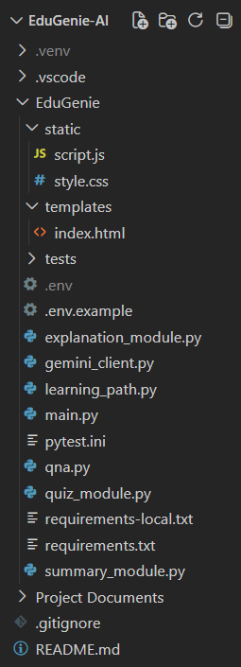
FIG. Showing the Folder Architecture

MILESTONE 2: Core Functionalities Development
Activity 2.1: Module Implementation
Gemini Client
All AI features share one function, generate() in gemini_client.py. It loads the API key from .env, sends the prompt to the configured Gemini model (optionally in JSON mode), retries temporary errors such as 503 “high demand” or 429 rate limits with exponential backoff, tries the backup models when the main model stays busy, and converts SDK errors into clear messages for the user.
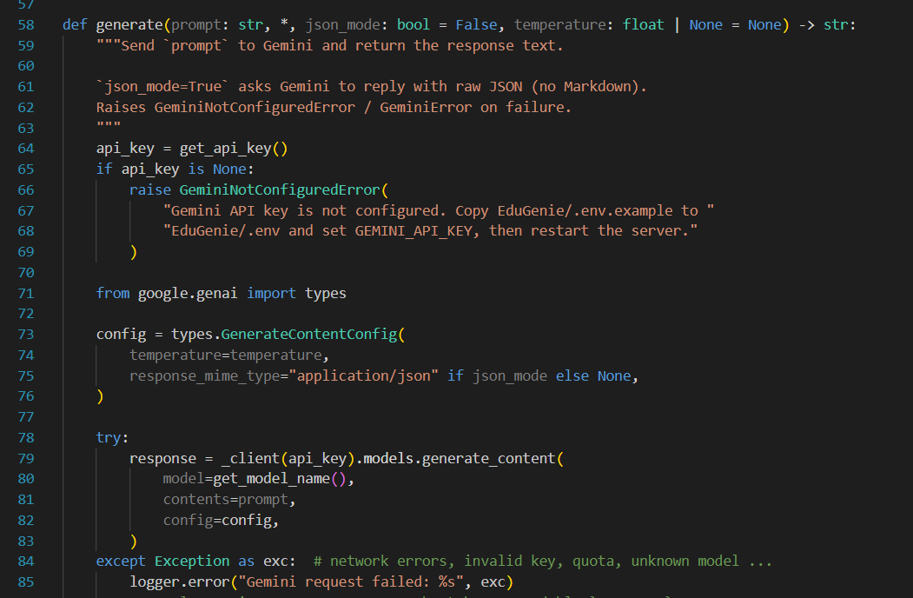
Fig. Gemini client with retry and fallback
Explanation Module
EduGenie uses the LaMini-Flan-T5-783M model, a lightweight yet capable generative model, to explain concepts in a simplified and highly readable way for school students. The model is loaded once and generates a short, clear explanation on the CPU. When the local model is not installed, or if it fails, explain_topic() automatically falls back to Gemini, so the feature always works. This makes EduGenie a reliable study companion for beginners and self-learners.
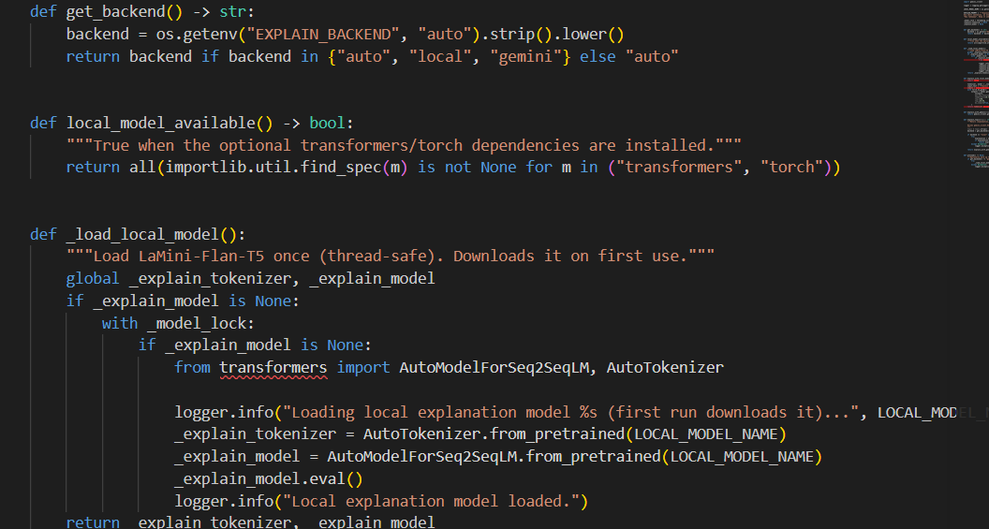
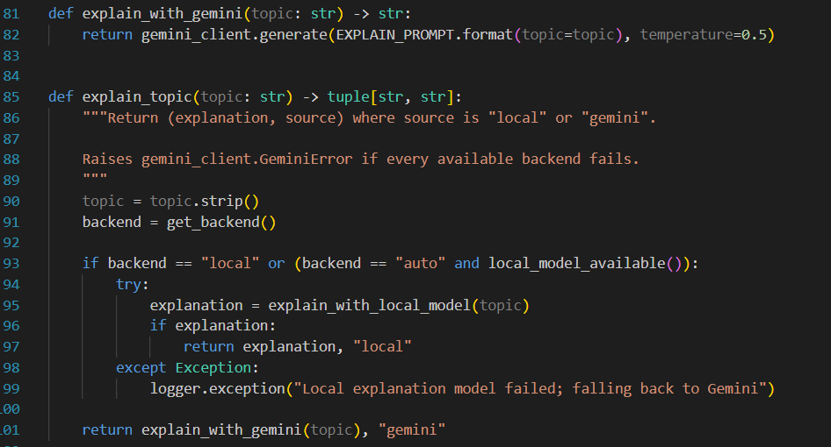
Fig. Explanation module logic
QnA Module
The Q&A module uses Google Gemini to answer a wide range of academic and general-knowledge questions. A focused prompt asks Gemini to answer clearly and concisely in simple language, to give a small example when it helps and not to invent facts.
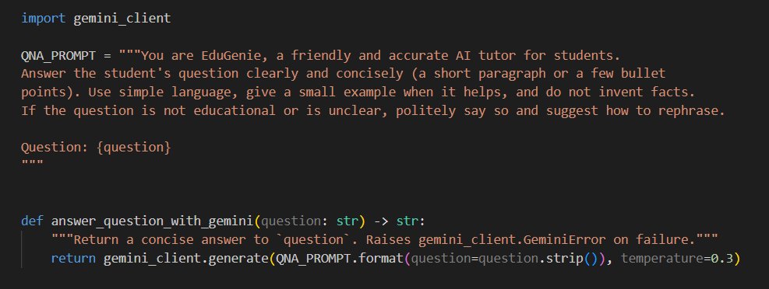
Fig. Q/A Module
Quiz Module
EduGenie generates multiple-choice questions (three by default, up to ten) from a topic or passage, each with four options, the correct answer and a short explanation. Gemini is asked to reply in JSON mode so the output is structured for easy integration.
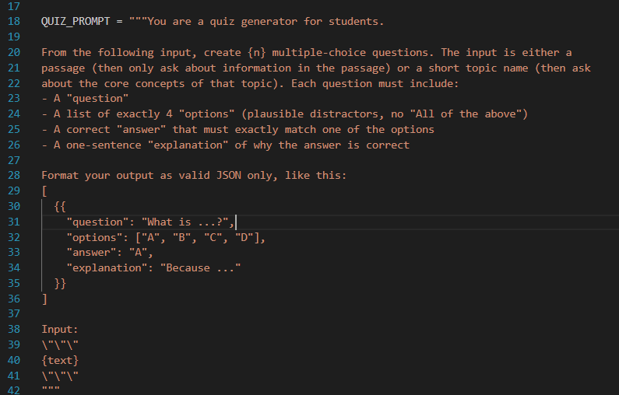
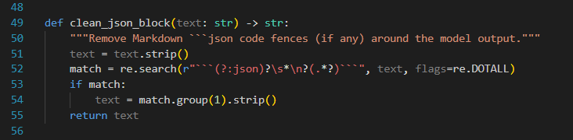
Fig. Quiz Module Logic
The response is cleaned with clean_json_block(), which removes any Markdown code fences, and then validated by parse_quiz(): every question must have exactly four options and an answer that matches one of them (letter answers such as “B” are mapped to the option text). Invalid questions are discarded, and if no valid question remains a clear error message is returned instead of crashing.
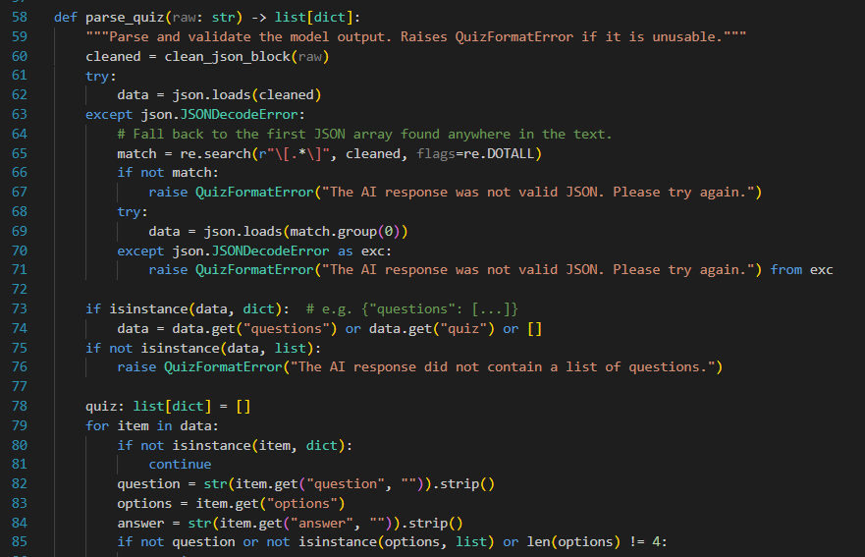
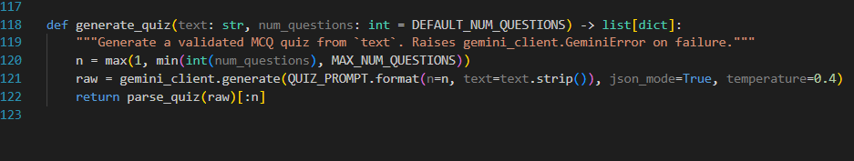
Fig. Quiz validation logic
Summary Module
This feature uses Gemini to summarize long paragraphs into a one-sentence overview followed by key bullet points, which is ideal for quick revision. The prompt keeps the core facts, removes repetition and forbids adding information that is not in the text.
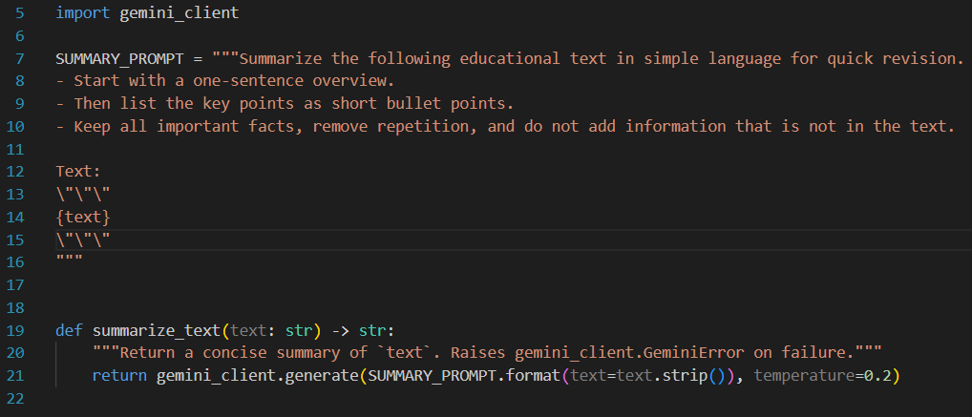
Fig. Summary Module
Learning Path Module
The get_learning_recommendations() function uses Google Gemini to generate a personalized, structured learning path for any topic, adapted to the learner’s level (beginner, intermediate or advanced). It organizes the key topics by difficulty with time estimates, recommends free resources such as documentation, videos and books, suggests practice projects and ends with a week-by-week timeline.
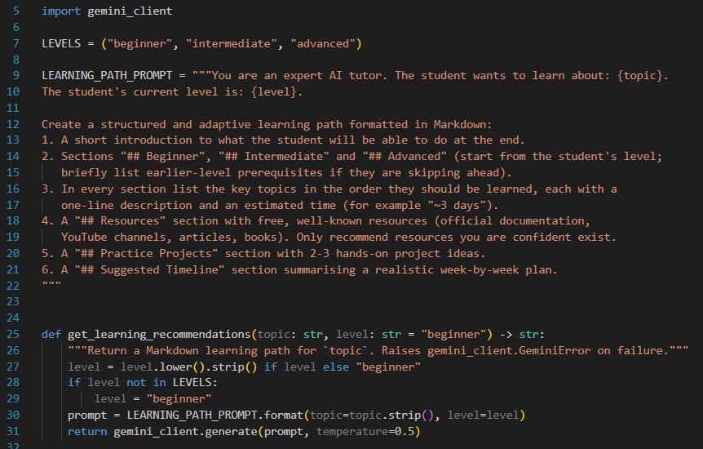
Fig. Learning Path Module
Activity 2.2: Backend API with FastAPI
Defined RESTful endpoints for each module:
- GET /qa – question answering
- POST /explain – concept explanation
- POST /quiz – quiz generation
- POST /summarize – summarization
- GET /learn/recommendations – learning path
- GET /health – configuration status (plus interactive API docs at /docs)
Each endpoint validates the input (empty or too long input returns HTTP 400), calls its module and returns JSON. If Gemini is still busy after the automatic retries the API returns HTTP 503 with a friendly message; other AI errors return HTTP 502.
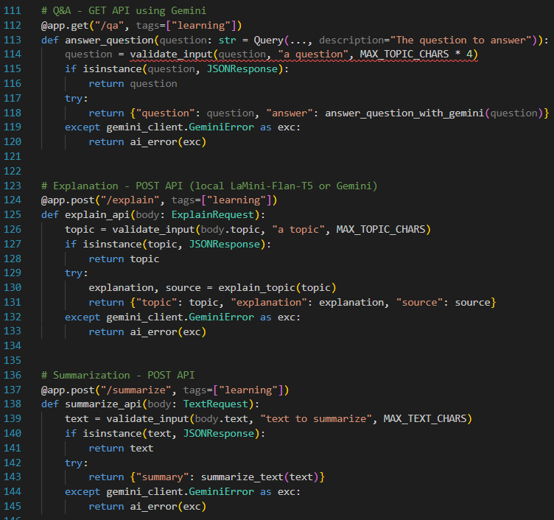
Fig. Endpoints of API
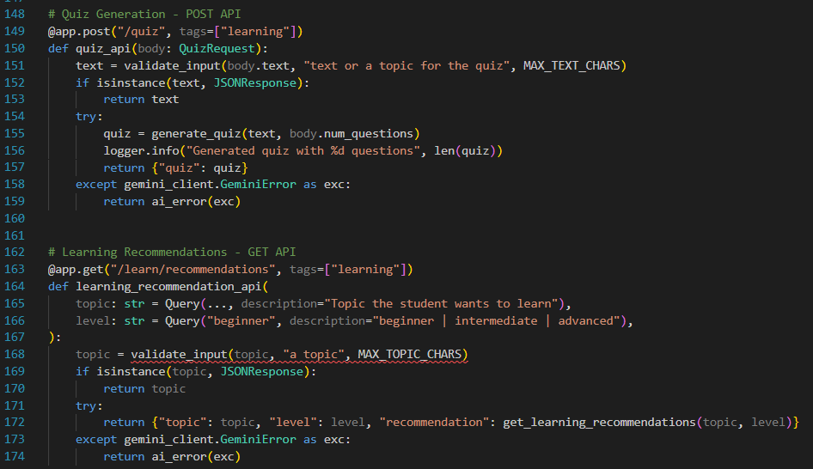
Fig. Endpoints of API
MILESTONE 3: Frontend Development
Activity 3.1: Build Web Interface
HTML Form (index.html):
- Task dropdown (Ask a Question, Explain a Concept, Generate a Quiz, Summarize a Passage, Recommend a Learning Path)
- Text area for user input with a character counter and example suggestions
- Options for the number of quiz questions and the learner’s current level
- Submit and Clear buttons, and a result card with a Copy button
CSS Styling (style.css):
- Responsive design for mobile, tablet and desktop, with automatic dark mode
- Styled buttons, input areas, result container and quiz options (green for correct, red for wrong)
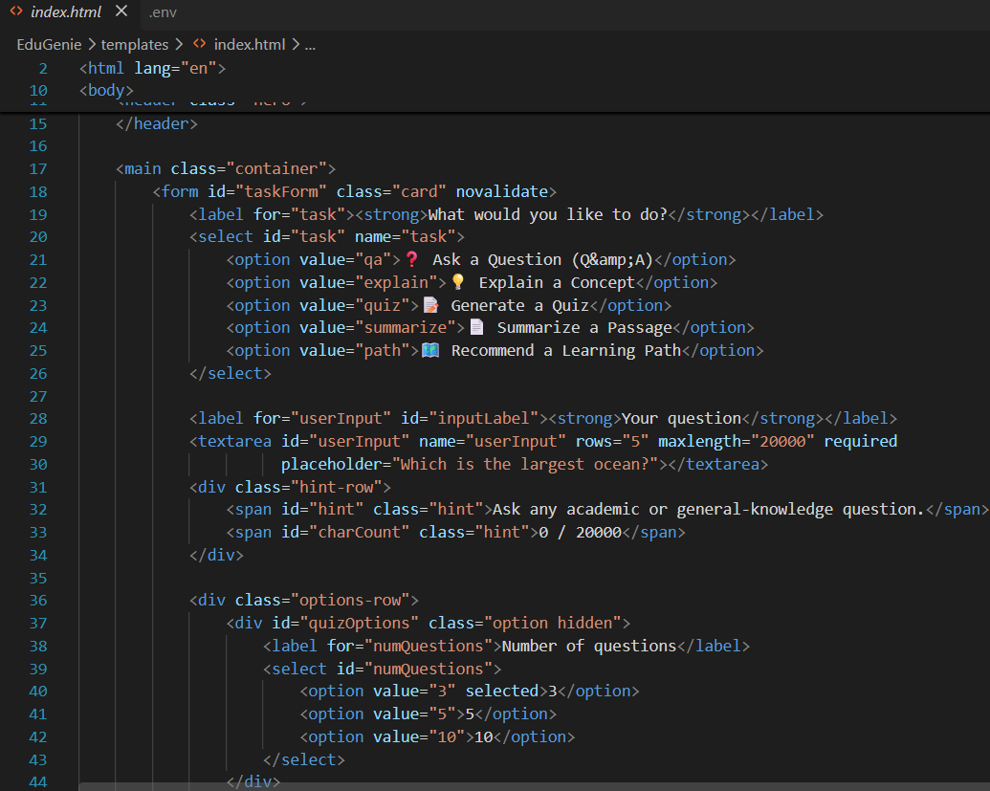
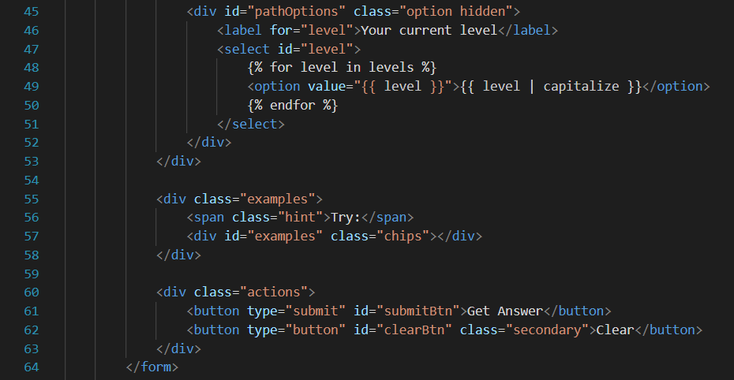
Fig. Showing Frontend Integration
Activity 3.2: Live Integration
- Form submission sends a GET/POST request (fetch API in script.js) to the matching FastAPI endpoint
- A loading indicator is shown while the AI works; if Gemini is busy it shows that EduGenie is retrying automatically
- The result appears below the input box in real time, formatted for easy reading
- Quiz questions are clickable: the answer is checked instantly and a running score is shown
- Errors are shown in a message box with a Try again button when retrying can help
MILESTONE 4: Deployment
Activity 4.1: Run Locally
python -m venv .venv
.venv\Scripts\Activate.ps1 # Windows
source .venv/bin/activate # macOS / Linux
pip install -r EduGenie/requirements.txt
# copy EduGenie/.env.example to EduGenie/.env and set GEMINI_API_KEY
cd EduGenie
uvicorn main:app –reload

- Navigate to: http://127.0.0.1:8000
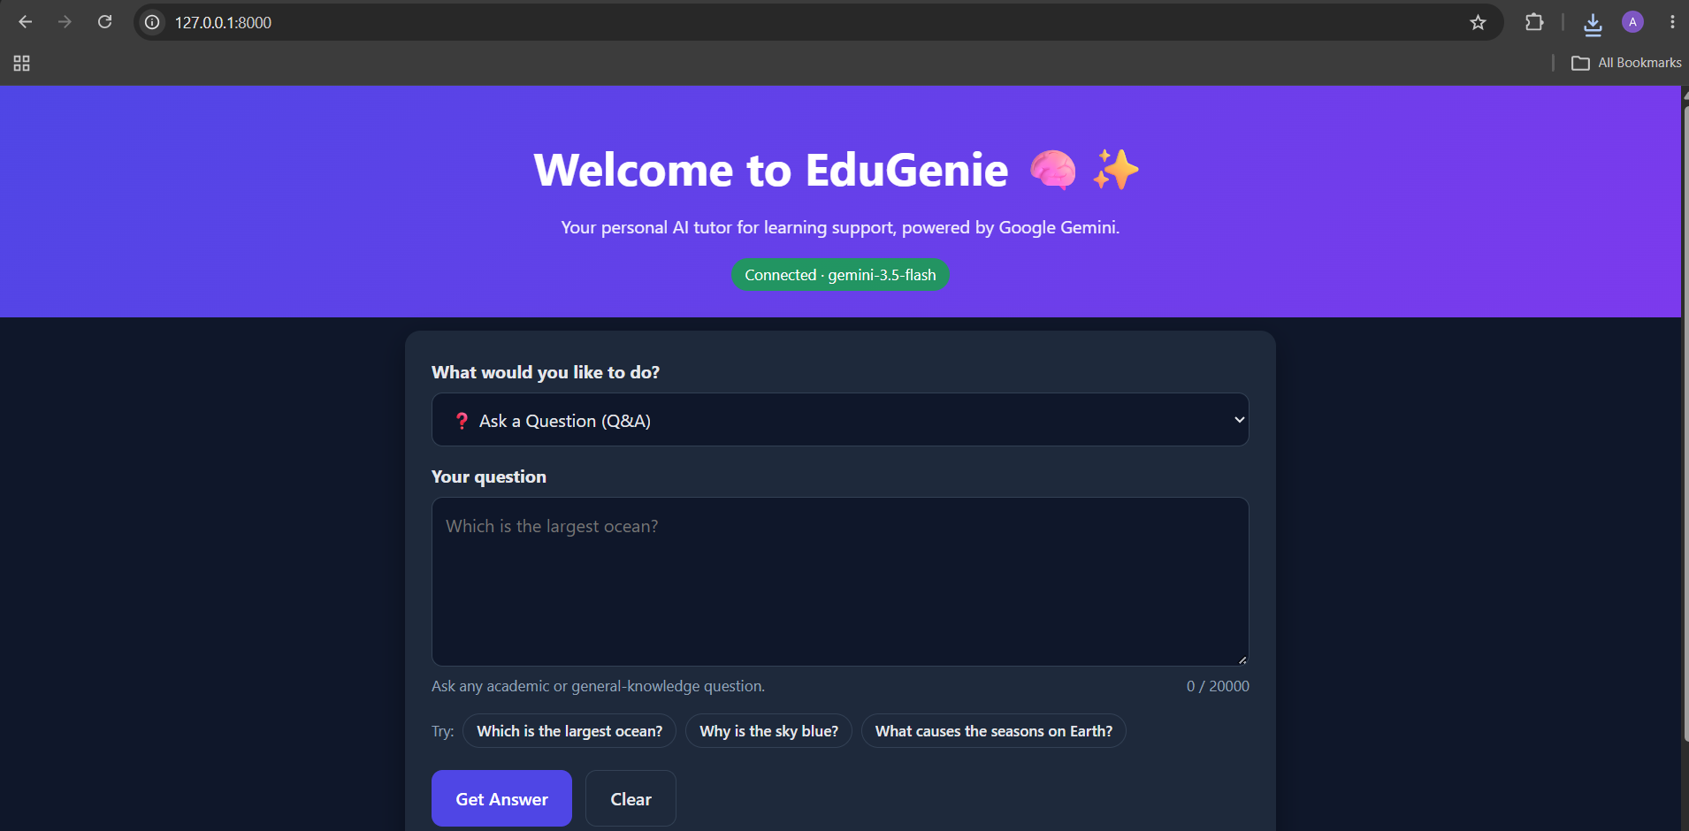
Fig. Showing the Application can be accessed
Activity 4.2: Functional Testing
- Ask a question
- Get an explanation
- Generate a quiz
- Summarize content
- Get a personalized learning plan
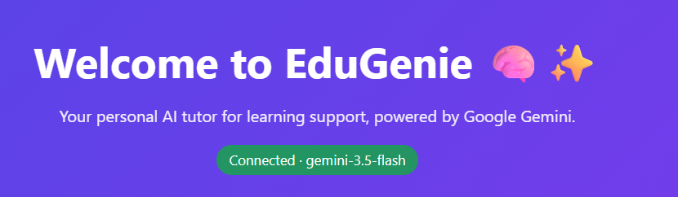
Fig. EDUGENIE
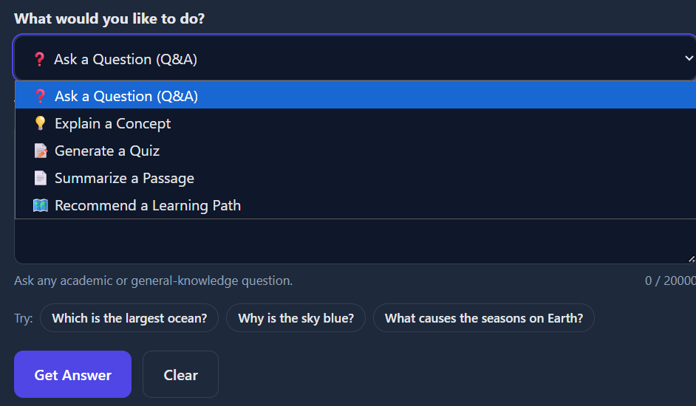
Fig. EDUGENIE
Automated tests: running pytest -v inside the EduGenie folder executes the test suite, which checks every endpoint, input validation, quiz parsing and the retry/fallback behaviour without needing an API key.
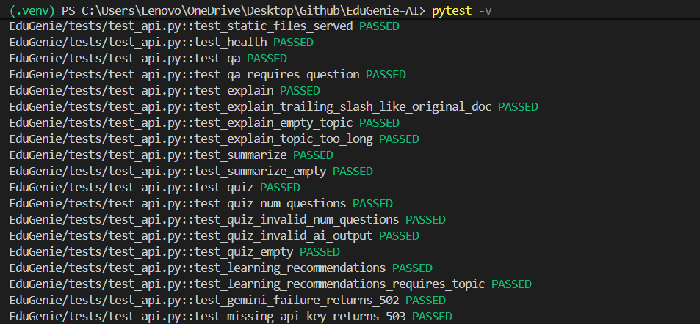
Fig. Automated test results

Exploring EduGenie:
Asking questions:
Select “Ask a Question”, type a question such as “Which is the largest ocean?” and click Get Answer.
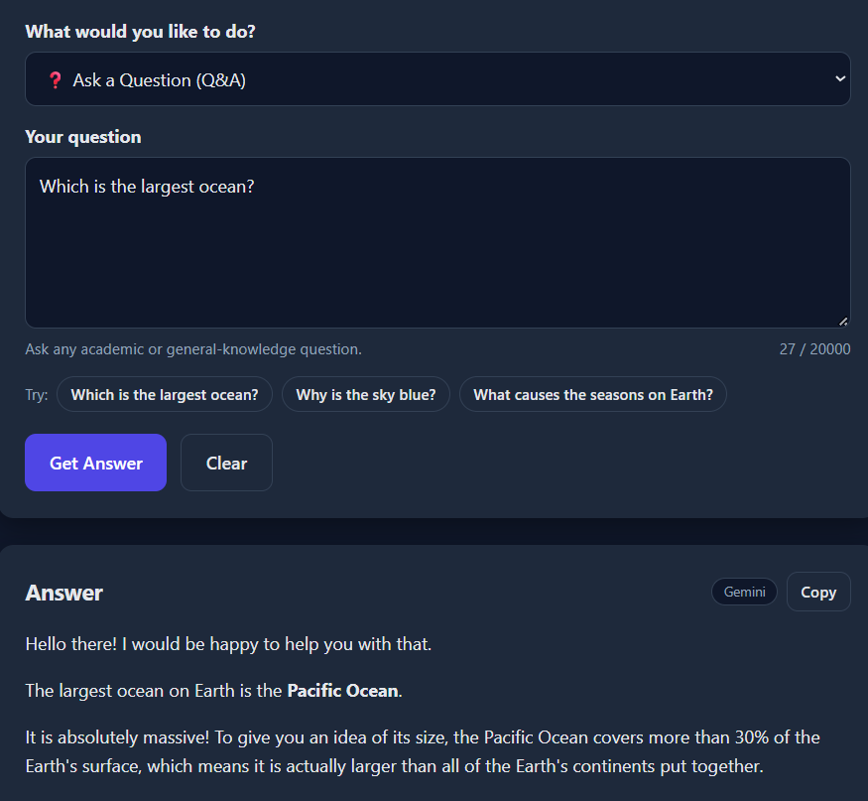

Explanation of any topic:
Select “Explain a Concept” and enter a topic such as Photosynthesis. The badge shows whether the local LaMini-Flan-T5 model or Gemini produced the explanation.
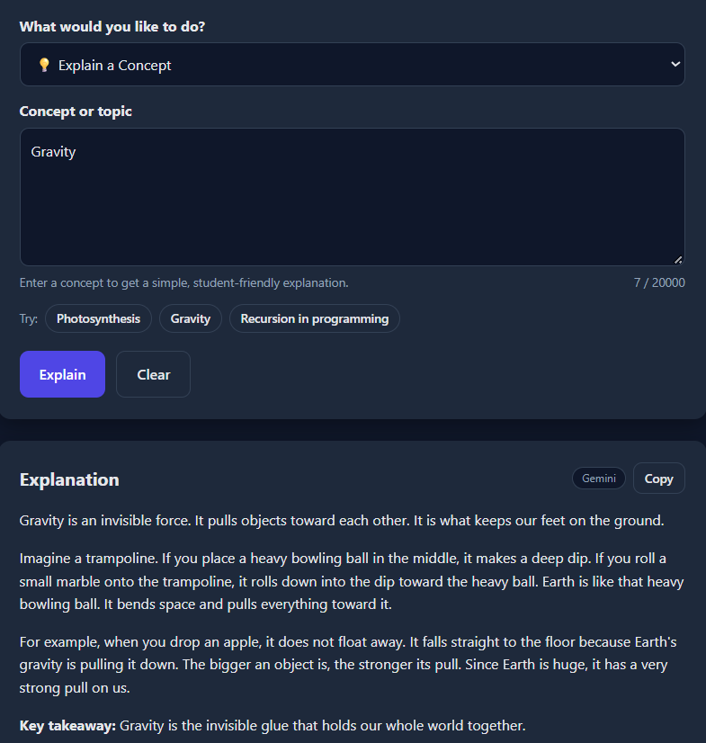

Summarising long paragraphs:
Paste a long passage, select “Summarize a Passage” and click Summarize to get a one-line overview and key bullet points.
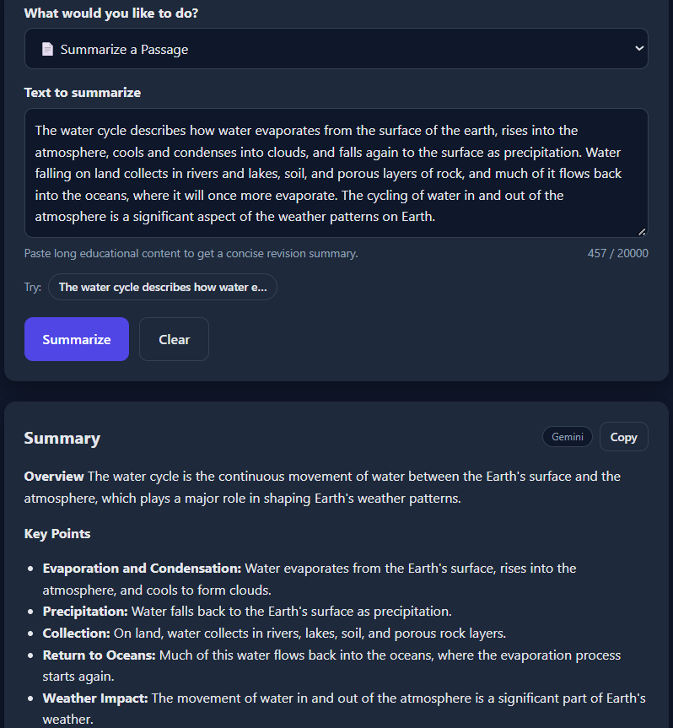
Generating quizzes:
It generates three questions (or 5 or 10) with 4 options each. Clicking an option checks the answer instantly: a correct choice turns green, a wrong choice turns red and the correct answer is highlighted with a short explanation and a running score.
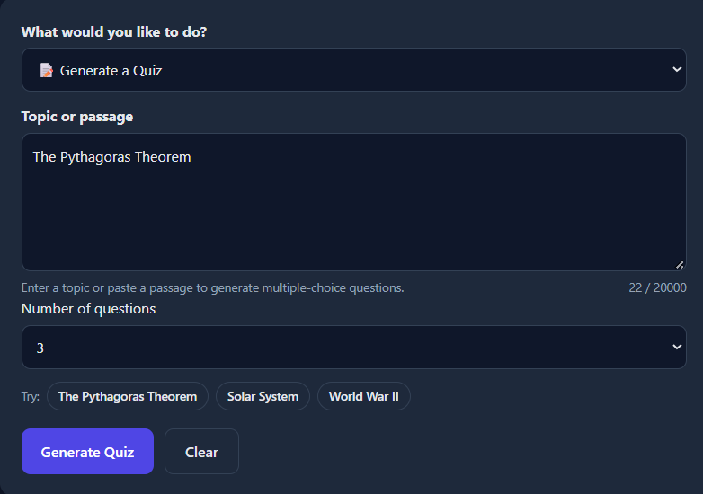
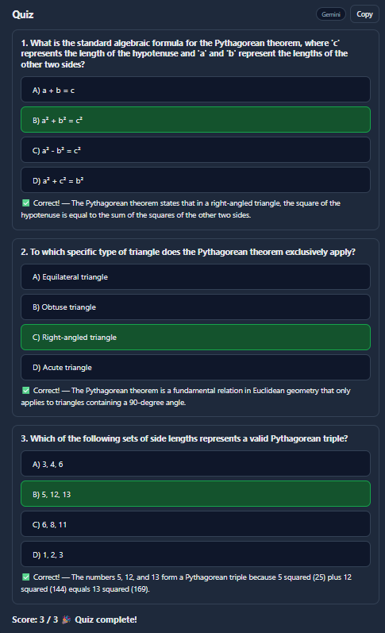

Guiding with learning recommendations from beginners level to advanced level:
Enter a topic such as SQL, choose the current level and click Get Learning Path.
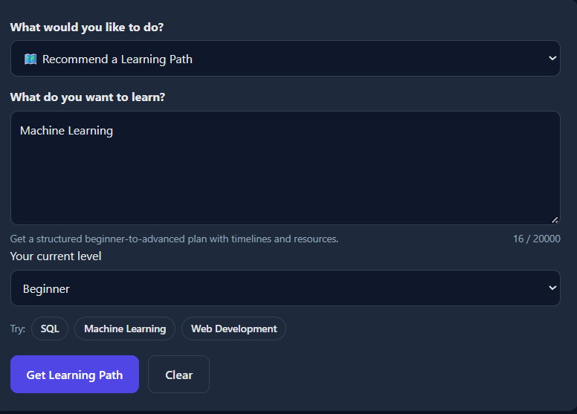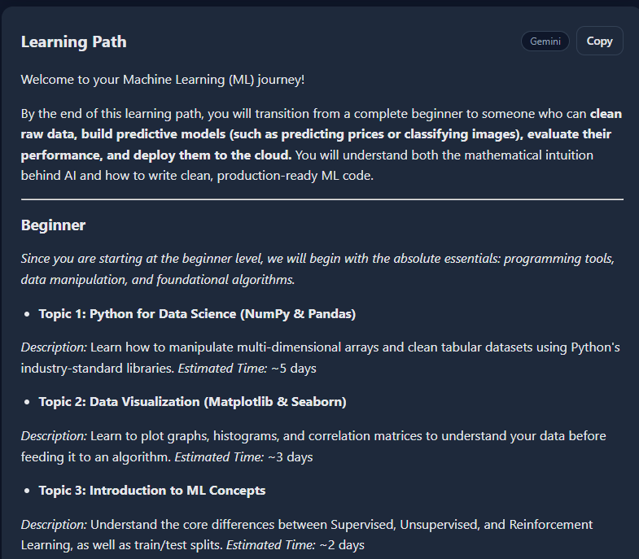
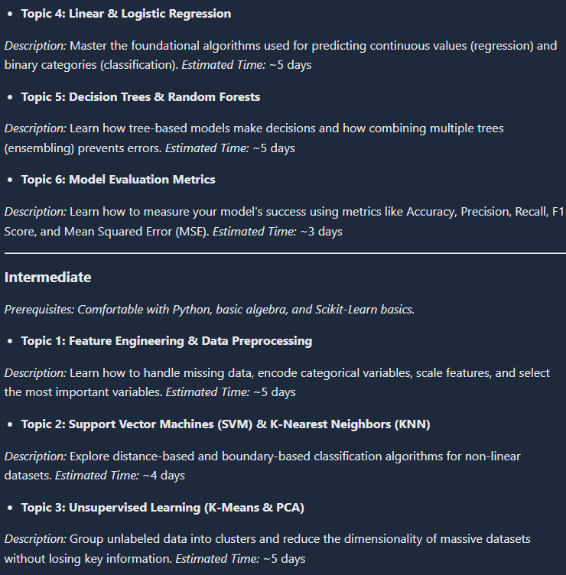
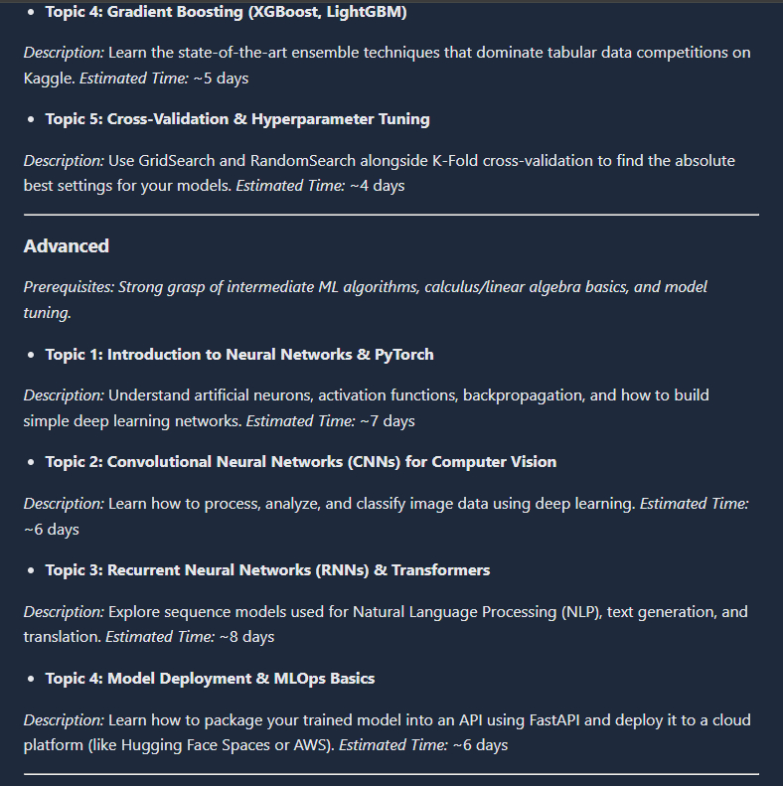
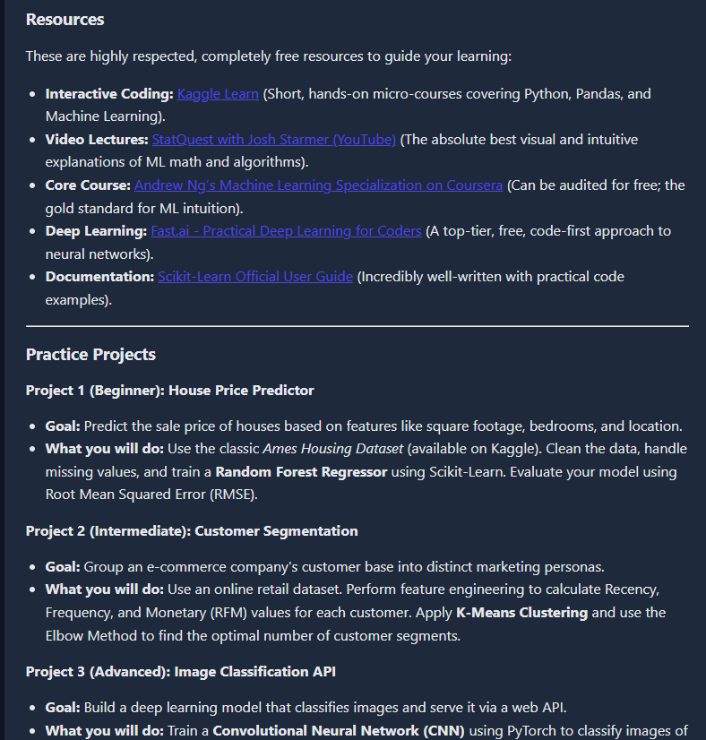
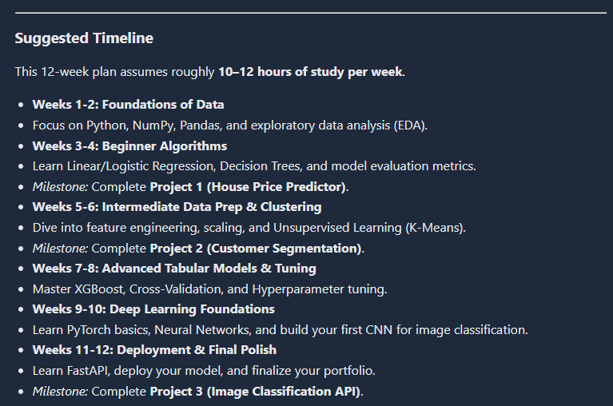
It provides details of resources to learn from, along with stepwise guidance throughout, from the beginner level to the advanced level.
Conclusion:
EduGenie has been developed as an accessible AI-powered learning assistant that brings together cloud-based intelligence from Google Gemini and a simple, low-footprint web interface. It answers questions instantly, explains complex concepts in simple language, generates interactive quizzes with instant feedback, summarizes long passages and builds personalized learning paths from beginner to advanced level. Because the heavy AI processing happens in the cloud, and an optional local model is available for explanations, learners with modest hardware can still access high-quality, personalized learning support.
During development the project reached its key milestones in AI integration, prompt engineering, API design, frontend development and testing. Each feature lives in its own module with a carefully designed prompt, the FastAPI backend validates every request, and an automated test suite verifies all endpoints and error cases. The modular design keeps the code easy to read, extend and maintain.
The project also involved real challenges. AI output had to be reliable, so quizzes use Gemini’s JSON mode together with strict validation of every question. The Gemini API can be temporarily overloaded (“high demand”) or rate limited, so EduGenie retries automatically with exponential backoff, falls back to backup models and otherwise shows a clear message with a Try again button. The API key is kept in a private .env file instead of the source code, and AI responses are safely rendered in the browser. These challenges provided valuable learning in prompt engineering, error handling, cloud API integration and user-centred design.
Looking ahead, EduGenie has strong potential for growth: voice-based interaction for hands-free and accessible learning, multilingual support, a mobile application, user accounts with progress-tracking dashboards, gamification such as badges and learning streaks, integration with learning management systems like Moodle and Google Classroom, and image or PDF input for snapshot-based doubt solving.
In conclusion, EduGenie shows how generative AI can make learning more personal, interactive and inclusive. It is a solid foundation for a smart, scalable and learner-first study companion.

Submitted by:
Arumparithi B
Mentor:
Date:

