Dynamic Priority CPU Scheduling
Implementing MLFQ in xv6
Operating Systems Project Report
A Multilevel Feedback Queue scheduler for the MIT xv6-riscv operating system

Source code: https://github.com/Arumparithi42/xv6-mlfq-scheduler
Based on MIT xv6-riscv: https://github.com/mit-pdos/xv6-riscv

Contents
1. Abstract
2. Introduction
3. Problem statement
4. Objectives
5. Background: scheduling in xv6
6. Background: MLFQ
7. MLFQ design
7.1 Architecture
7.2 Queues without lists
7.3 Configuration
8. Scheduling policy
9. Implementation details
9.1 Process state (kernel/proc.h)
9.2 State changes: proc_setstate()
9.3 Choosing the next process: sched_select()
9.4 The timer tick: sched_tick()
9.5 Interaction with the rest of xv6
9.6 New system calls
9.7 Ctrl-P
10. Modified xv6 files
11. Process statistics
12. Benchmark programs
13. Experimental results
13.1 Experiment 1 – a single CPU-bound job (500 ms of CPU)
13.2 Experiment 2 – three CPU-bound jobs (400 ms each, arriving together)
13.3 Experiment 3 – CPU-bound, I/O-bound and short jobs together
13.4 Experiment 4 – aging and starvation
14. Performance analysis
15. Limitations
16. Future enhancements
17. Conclusion
18. Build, run and test instructions
18.1 Requirements
18.2 Build and boot
18.3 Things to try at the xv6 prompt
18.4 Reproducing the experiments
19. Repository structure
20. References

1. Abstract
xv6 schedules processes round robin: every timer tick, the running process gives up the CPU to the next RUNNABLE process in the process table. That is fair, but it cannot tell interactive work from long-running computation, so short and I/O-bound jobs wait behind CPU-bound ones. This project replaces the policy with a three-level Multilevel Feedback Queue. New processes start at the highest priority. A process that uses its whole time quantum moves down a level. A process that has not run for a long time moves back up (aging). A process of a higher level preempts one of a lower level.
The scheduler is added to xv6 without changing its locking discipline: the process table stays the only data structure and no code holds two process locks at once. Every state change is timestamped with the RISC-V time counter, so CPU time, waiting time and sleeping time add up exactly to the turnaround time. The original round-robin scheduler can be rebuilt from the same tree (make SCHED=RR) with identical instrumentation, which makes the two directly comparable.
Four controlled experiments were run on QEMU with a deterministic instruction-count clock, comparing MLFQ (quanta 4/8/16 ticks) with the original xv6 round-robin scheduler. On a mixed workload, MLFQ served 30 ms jobs in 31 ms instead of 113 ms, cut an I/O-bound job's wakeup latency from 10–20 ms to 0.05 ms and halved its turnaround, while CPU-bound jobs' turnaround grew by under 1 %. On CPU-bound workloads MLFQ needs a tenth of round robin's context switches. Without aging, a demoted job starved for 1.9 s behind a stream of short jobs; with aging, its longest wait stayed close to the configured threshold.

2. Introduction
A CPU scheduler decides which ready process runs next and for how long. Different workloads want different things. Interactive and I/O-bound programs need a quick response every time they wake up. Batch computations need throughput and a guarantee that they eventually finish. Short jobs benefit most from running first. A scheduler cannot know in advance which kind of process it is dealing with.
MLFQ, first described by Corbató et al. for CTSS and used in some form by most general-purpose operating systems, solves this by learning from behaviour. A process's priority changes dynamically according to how it has used the CPU. This project implements MLFQ in xv6-riscv, the teaching operating system used in MIT 6.1810, and measures its effect.

3. Problem statement
The stock xv6 scheduler (scheduler() in kernel/proc.c) loops over the process table and runs every RUNNABLE process in turn; the timer interrupt forces a switch every tick (100 ms in stock xv6). It has no notion of priority, so:
- a short job arriving while long jobs run shares the CPU equally with them and takes several times longer than it needs to;
- an I/O-bound process that wakes up waits for its turn behind every CPU-bound process;
- every process is switched out every tick, even when nothing more urgent is waiting, which costs context switches.

The task is to design and implement a dynamic priority scheduler (MLFQ) that fixes these problems without introducing starvation or breaking xv6's correctness, and to show by measurement what it gains and what it costs.

4. Objectives
- Implement MLFQ with three priority queues (Q0 highest, Q2 lowest) and configurable time quanta (default 4, 8 and 16 ticks).
- Change priorities dynamically: new processes start in Q0; a process that uses its whole quantum is demoted; aging promotes processes that have not run for a long time, which prevents starvation.
- Preempt a running process when its quantum expires or when a higher-priority process becomes RUNNABLE.
- Keep xv6 correct: fork, exit, wait, sleep, wakeup, kill, yield and SMP locking must still work (upstream usertests must pass on 1 and 3 CPUs).
- Measure CPU time, waiting time, sleeping time, response time and turnaround time for every process with a sound, verifiable mechanism, plus queue transitions.
- Provide CPU-bound, I/O-bound and mixed benchmark workloads, and a baseline (the original scheduler) measured in exactly the same way.
- Run controlled experiments, analyse the results and document everything.

5. Background: scheduling in xv6
The parts of xv6-riscv that take part in scheduling:
Component | File | Role
struct proc, enum procstate | kernel/proc.h | Per-process state: UNUSED, USED, SLEEPING, RUNNABLE, RUNNING, ZOMBIE; protected by p->lock.
scheduler() | kernel/proc.c | Per-CPU loop: scan proc[], and for each RUNNABLE process set it RUNNING and swtch() to it.
sched() | kernel/proc.c | Called by a process holding only p->lock after changing its state; switches back to the CPU's scheduler.
yield() | kernel/proc.c | RUNNING → RUNNABLE, then sched().
sleep_prepare(), sleep(), wakeup() | kernel/proc.c | RUNNING → SLEEPING on a channel, and SLEEPING → RUNNABLE.
kfork(), kexit(), kwait(), kkill() | kernel/proc.c | Process creation (→ RUNNABLE), exit (→ ZOMBIE), reaping (→ UNUSED), kill.
clockintr() | kernel/trap.c | Timer interrupt: CPU 0 increments ticks and wakes sleepers on &ticks; every CPU re-arms its timer (stimecmp).
usertrap(), kerneltrap() | kernel/trap.c | On a timer interrupt, call yield(), which preempts the process.
timerinit() | kernel/start.c | Arms the first timer interrupt.

The locking rules that any scheduler must respect:
- p->lock protects p->state (and, here, all scheduling fields).
- scheduler() acquires p->lock before switching to p and the process releases it (in yield(), sleep(), forkret()), and vice versa. sched() panics unless exactly one lock (p->lock) is held and interrupts are off.
- wait_lock must be acquired before any p->lock.

The stock policy is therefore round robin with a one-tick quantum, applied in process-table order.

6. Background: MLFQ
MLFQ keeps several ready queues of decreasing priority and follows rules like these (after Arpaci-Dusseau, OSTEP, ch. 8):
- If A has a higher priority than B, A runs.
- If A and B have the same priority, they run round robin with the queue's time quantum.
- A new job enters the highest-priority queue.
- Once a job has used up its time allotment at a level (however many times it gave up the CPU), it moves down one level.
- Something must stop long-running jobs from starving and let jobs whose behaviour changes move back up: OSTEP uses a periodic priority boost; this project uses aging, which promotes each process individually after it has gone without the CPU for a while.

A job with short CPU bursts (interactive or I/O-bound) never uses up its quantum and so stays at high priority. A CPU-bound job sinks to the lowest level, where long quanta give it throughput with few switches. Without knowing job lengths in advance, MLFQ approximates shortest-job-first for short jobs and round robin for long ones.

7. MLFQ design

7.1 Architecture
timer interrupt (every tick, every CPU)
|
usertrap()/kerneltrap() ----> sched_tick() -- 1 --> yield()
(trap.c) (sched.c) (proc.c)
| charge CPU time, |
| quantum expired? -> demote v
| higher level RUNNABLE? sched() --swtch--> scheduler()
| aging of waiting procs (proc.c)
|
sched_select() <----------+
(sched.c): highest level,
FIFO within level, aging
every state change: proc_setstate(p, new) (sched.c)
fork/userinit -> RUNNABLE, scheduler -> RUNNING, yield -> RUNNABLE,
sleep -> SLEEPING, wakeup/kill -> RUNNABLE, exit -> ZOMBIE
=> time since the last change is added to cpu / wait / sleep time

7.2 Queues without lists
Each process has a level p->priority (0, 1 or 2) and a queue position p->qseq, a number drawn from a global counter whenever the process joins the tail of a queue. Choosing the RUNNABLE process with the smallest (priority, qseq) is exactly "take the head of the highest non-empty FIFO queue". Moving a process to another queue is an assignment to two integers under p->lock. The scan is the same O(NPROC) loop the original scheduler already performs.

7.3 Configuration
All tunables are named constants in kernel/param.h and can be overridden from make:
Constant | Default | make variable | Meaning
TICK_HZ | 100 (10 ms tick) | TICK_HZ= | Timer interrupts per second (stock xv6: 10)
NQUEUE | 3 | – | Number of levels
Q0_QUANTUM, Q1_QUANTUM, Q2_QUANTUM | 4, 8, 16 ticks | QUANTA="q0 q1 q2" | Quantum of each level
AGING_THRESHOLD | 50 ticks | AGING= (0 = off) | Promote after this long without running
SCHED_RR | not set | SCHED=RR | Build the original round-robin scheduler
CPUS | 1 | CPUS= | CPUs given to QEMU (stock xv6: 3)
– | off | ICOUNT=1 | Deterministic QEMU clock (recommended inside a virtual machine, see §15)

Why these values:
- 10 ms tick. Stock xv6's 100 ms tick would make a 4-tick quantum 0.4 s and the aging threshold 5 s, far coarser than real systems (Linux uses 1–4 ms ticks and time slices of a few ms). With 10 ms the quanta are 40/80/160 ms and aging is 0.5 s, and experiments run in seconds instead of minutes. Everything that counts in ticks (for example pause()) just runs ten times faster in wall-clock terms; usertests passes unchanged.
- 4/8/16 ticks. Doubling the quantum at each level is the classic choice. Q0 is short so that interactive jobs are served quickly; Q2 is long so CPU-bound jobs switch rarely. A job must use 12 ticks (120 ms) of CPU before it reaches Q2.
- Aging = 50 ticks. It must be longer than a normal wait among equals, or aging would keep undoing demotion. Three CPU-bound jobs in Q2 each wait 2 × 16 = 32 ticks between turns, so aging does not trigger among them, while a job starved by higher levels is promoted within half a second.
- One CPU by default. With one CPU the schedule is easy to reason about and experiments are reproducible. Everything also works with more CPUs (tested with 3).

8. Scheduling policy
The complete policy, as implemented in kernel/sched.c:
- Levels. There are three levels. Q0 has the highest priority.
- New processes start in Q0 at the tail of the queue.
- Selection. The scheduler runs the RUNNABLE process at the highest non-empty level. Within a level, the process that joined the queue earliest runs first (FIFO, i.e. round robin).
- Quantum. A process may use quantum[level] ticks of CPU time at its level. The quantum is consumed by CPU time only and is not reset when the process sleeps, so sleeping just before the quantum ends does not avoid demotion (OSTEP's revised rule 4).
- Demotion. When the quantum is used up the process is preempted, moves down one level (Q0 → Q1 → Q2; in Q2 it just starts a new quantum) with a fresh quantum, and joins the tail of its new queue.
- Priority preemption. On every tick, if a process of a higher level than the running one is RUNNABLE (for example, an I/O-bound process that has just woken up), the running process is preempted. It keeps its place at the head of its queue and the rest of its quantum.
- Aging. A process that has not run for AGING_THRESHOLD ticks moves up one level (and one more for every further AGING_THRESHOLD ticks), with a fresh quantum, at the tail of the new queue. Aging is checked for every RUNNABLE process on every tick and at every scheduling decision.
  - If the process was RUNNABLE all that time, it is being starved by higher levels, and aging lets it in.
  - If it was SLEEPING (for example, the shell waiting for a key press), it has shown interactive behaviour, and aging undoes an earlier demotion. Without this, long-lived interactive processes slowly use up their quanta over their lifetime (rule 4) and end up in Q2 for good. The first implementation showed exactly this effect: a test driver sank to Q2 and started jobs late.
  - A process that sleeps only briefly, as one gaming rule 4 would, is never promoted.

9. Implementation details

9.1 Process state (kernel/proc.h)
New fields in struct proc, all protected by p->lock:
int priority; // current queue level, 0 = highest
uint64 quantum_used; // timebase cycles of the current quantum used
uint64 qseq; // position in its queue (smaller runs first)
uint64 age_since; // last ran or last promoted, for aging
uint64 state_since; // when the current state was entered
uint64 ctime, first_run, etime; // creation, first run, exit
uint64 cpu_time, wait_time, sleep_time; // time in each state
uint64 level_time[NQUEUE]; // CPU time at each level
uint64 max_wait; // longest RUNNABLE period
int ndispatch, nexpire, npreempt, nsleep, ndemote, npromote;

9.2 State changes: proc_setstate()
Every assignment p->state = RUNNABLE/RUNNING/SLEEPING/ZOMBIE in proc.c (in userinit, kfork, scheduler, yield, sleep, wakeup, kkill, kexit) is replaced by proc_setstate(p, state), called with p->lock held as before. It:
- adds now − p->state_since to the bucket of the old state (cpu_time for RUNNING, which also adds to quantum_used and level_time[priority]; wait_time for RUNNABLE; sleep_time for SLEEPING), where now = r_time();
- sets ctime when a new process first becomes RUNNABLE, and first_run on its first dispatch;
- puts a newly created or woken process at the tail of its queue;
- records age_since when a process stops running, and etime on exit;
- appends an event to the trace buffer if tracing is on.

9.3 Choosing the next process: sched_select()
for (;;) {
best = 0;
for (each p in proc[]) { // one lock at a time, as before
acquire(&p->lock);
if (p->state == RUNNABLE) {
age(p, now);
if (best == 0 || (p->priority, p->qseq) < (best_prio, best_seq))
best = p, ...;
}
release(&p->lock);
}
if (best == 0) return 0; // idle: scheduler() executes wfi
acquire(&best->lock);
if (best->state == RUNNABLE) return best; // returned locked
release(&best->lock); // another CPU took it: rescan
}
scheduler() then runs the process exactly as the original loop did. The only lock held across swtch() is p->lock, so sched()'s checks (one lock held, interrupts off) are unchanged. The re-check after re-acquiring the lock handles the race with another CPU.

9.4 The timer tick: sched_tick()
usertrap() and kerneltrap() used to call yield() on every timer interrupt. They now call yield() only if sched_tick() returns 1:
acquire(&p->lock);
account(p, r_time()); // charge CPU time so far
if (p->quantum_used + TICK/2 >= quantum(p->priority)) {
p->nexpire++;
demote p (or, in Q2, start a new quantum);
p->qseq = tail(); // round robin
release(&p->lock);
return 1;
}
release(&p->lock);
return higher_runnable(p, prio); // also applies aging
higher_runnable() scans the table (one lock at a time, never while holding p->lock), applies aging to RUNNABLE processes, and reports whether any is at a higher level. With SCHED=RR, sched_tick() simply returns 1, which is the original behaviour.

9.5 Interaction with the rest of xv6
Operation | What happens
fork() | allocproc() calls sched_procinit() (level 0, counters zero); kfork() makes the child RUNNABLE via proc_setstate(), which sets ctime and puts it at the tail of Q0.
exit() | kexit() → proc_setstate(ZOMBIE) records the final CPU time and etime. Statistics survive until the parent reaps the zombie.
wait() | kwait() gets an extra argument; waitstat() copies the zombie's statistics to the parent before freeproc().
sleep() / wakeup() | State changes through proc_setstate(). Sleeping does not reset the quantum. A woken process joins the tail of its level's queue and may be promoted by aging if it has not run for long.
kill() | A sleeping victim is made RUNNABLE via proc_setstate().
yield() | Unchanged except for proc_setstate(); called when sched_tick() says so.
SMP | All new fields are under p->lock; the queue counter and CPU count use atomic operations; the trace buffer has its own spinlock, which is only acquired while holding at most one p->lock and never the other way round.

9.6 New system calls
Call | Purpose
int getprocstat(int pid, struct procstat *st) | Live statistics of a process (pid 0 = caller), including time in its current state.
int waitstat(int *status, struct procstat *st) | wait() that also returns the child's final statistics.
int schedinfo(struct schedinfo *si) | Policy, quanta, aging threshold, tick length and CPU count of the running kernel.
int schedtrace(int on, struct schedevent *buf, int max) | Start recording scheduler events (state and level changes, with timestamps), or stop and copy them out.

struct procstat, struct schedinfo and struct schedevent are defined in kernel/pstat.h, which user programs include.

9.7 Ctrl-P
The Ctrl-P process listing (procdump()) now shows each process's level, quantum used, CPU/wait/sleep time (ms), dispatches, demotions and promotions:
1 sleep init Q0 qused=41 cpu=41 wait=41 sleep=2022 disp=25 demote=0 promote=0
2 sleep sh Q0 qused=35 cpu=35 wait=40 sleep=1980 disp=29 demote=0 promote=0
80 run cpubench Q2 qused=71 cpu=349 wait=4 sleep=0 disp=4 demote=2 promote=0

10. Modified xv6 files
Compared with upstream xv6-riscv (commit 9e3161a in this history):
File | Change
kernel/sched.c | New. The MLFQ policy: proc_setstate(), sched_select(), sched_tick(), aging, demotion, statistics, trace buffer, system call back-ends.
kernel/pstat.h | New. struct procstat, struct schedinfo, struct schedevent (shared with user space).
kernel/param.h | Scheduler and timer configuration constants.
kernel/proc.h | Scheduling and statistics fields in struct proc.
kernel/proc.c | State changes go through proc_setstate(); scheduler() uses sched_select() (the original loop is kept under SCHED_RR); kwait() can return statistics; procdump() prints scheduling information; procinit() initialises sched.c.
kernel/trap.c | Yield on a timer interrupt only when sched_tick() says so; timer interval TICK_CYCLES.
kernel/start.c | First timer interrupt uses TICK_CYCLES.
kernel/defs.h | Prototypes for sched.c; kwait() takes a second argument.
kernel/syscall.h, kernel/syscall.c, kernel/sysproc.c | Four new system calls.
user/user.h, user/usys.pl | User-space stubs for the new system calls.
Makefile | sched.o; SCHED, QUANTA, AGING, TICK_HZ options (a stamp file rebuilds the kernel when they change); QEMUEXTRA; CPUS := 1; new user programs; fs.img fixed.

kernel/main.c, kernel/syscall.c's dispatcher, sched(), swtch.S and the rest of the kernel are unchanged.

11. Process statistics
All times are measured with the RISC-V time counter (10 MHz on QEMU's virt machine, 0.1 µs resolution) and reported in microseconds. The counter is read at every state change of a live process, and the time since the previous change is added to the bucket of the state being left.
Metric | Definition
creation time (ctime) | Moment the process first becomes RUNNABLE, i.e. when fork() has finished building it
first run (first_run) | Moment of its first dispatch (RUNNABLE → RUNNING)
completion (etime) | Moment it calls exit() (RUNNING → ZOMBIE)
CPU time | Total time in state RUNNING (user and kernel mode)
waiting time | Total time in state RUNNABLE: ready but not running
sleeping time | Total time in state SLEEPING: blocked (I/O, pause, wait, pipes…)
response time | first_run − ctime
turnaround time | etime − ctime
longest wait | Longest single uninterrupted RUNNABLE period (measures starvation)
CPU time per level | CPU time used while in Q0, Q1, Q2
dispatches | Times the process was given the CPU (context switches to it)
quantum expirations / preemptions / sleeps | Why it left the CPU: used a full quantum / a higher level became RUNNABLE / blocked
demotions / promotions | Level changes down (quantum expiry) and up (aging)

Consistency. Between creation and exit a process is always exactly one of RUNNABLE, RUNNING or SLEEPING, and every transition charges the elapsed time to exactly one bucket, so
turnaround = cpu_time + wait_time + sleep_time (exactly)
cpu_time = level_time[0] + level_time[1] + level_time[2]
schedtest checks both identities for every process it creates (to within 3 µs of rounding). This is also why creation time is taken when the process becomes RUNNABLE rather than in allocproc(): while fork() is still copying memory the child is in state USED, and the parent can even be preempted in between. That time belongs to the parent.
Same mechanism for the baseline. The round-robin build uses the same proc_setstate() accounting, so the metrics mean exactly the same thing under both policies.
Why not tick sampling? Counting a tick for whichever process happens to be running when the timer fires (as the previous version did) misses anything shorter than a tick. It also systematically under-charges processes whose runs end before the tick, such as I/O-bound ones. Timestamps at state changes are exact.

12. Benchmark programs
Workloads are defined by the CPU time they need, not by a number of loop iterations. A CPU-bound job spins in short chunks and asks the kernel (getprocstat) how much CPU time it has used until it reaches its target (burn_ms() in user/bench.h). The same job therefore does the same amount of work whatever the host speed or the competition, just as a job in a textbook scheduling problem has a fixed "service time".
Program | Behaviour | Purpose
cpubench [ms] | Pure computation for ms ms of CPU, or forever | Long-running CPU-bound process; watch it sink with Ctrl-P
cpubench_med | 300 ms of CPU (30 ticks) | Medium job: passes through Q0 and Q1 into Q2 and finishes
cpubench_short | 30 ms of CPU (3 ticks) | Short job: finishes within its Q0 quantum
iobench [n] [us] | n times: us µs of CPU, then block for one tick (default 50 × 500 µs) | I/O-bound process (the tick sleep stands in for a device)
schedtime [-n k] cmd … | Runs k concurrent copies of a command and prints each copy's statistics when it exits (like time) | Interactive demonstrations
schedtest | Automated functional tests | Verification
mlfqexp <exp> [reps] | The controlled experiments | Measurement

Example (on the default MLFQ kernel):
$ schedtime -n 3 cpubench_med
pid 72 cpubench_med: Q2 cpu=302.2 wait=571.5 sleep=0.0 response=0.5 turnaround=873.8 ms dispatch=4 demote=2 promote=0
pid 73 cpubench_med: Q2 cpu=302.8 wait=603.6 sleep=0.0 response=44.0 turnaround=906.4 ms dispatch=4 demote=2 promote=0
pid 74 cpubench_med: Q2 cpu=302.5 wait=635.2 sleep=0.0 response=84.5 turnaround=937.8 ms dispatch=4 demote=2 promote=0
$ schedtime iobench 20
pid 76 iobench: Q0 cpu=15.8 wait=3.2 sleep=190.8 response=0.1 turnaround=210.0 ms dispatch=26 demote=0 promote=0
(CPU is a few ms above 300 because exec() and program start-up also use CPU. The experiments below fork jobs without exec() to avoid this.)

13. Experimental results
All numbers below are measured, in milliseconds. The experiments ran on one emulated CPU (QEMU 8.2.2, -machine virt) with QEMU's deterministic instruction-count clock, which makes runs repeatable: each experiment was run 3 times and the repetitions differed by at most 31 µs. The jobs are forked by a small driver program (mlfqexp) at fixed arrival times; each job is defined by the CPU time it needs. The tables and figures were produced by scripts/analyze.py from the raw logs in results/raw/. "MLFQ" means the default configuration (quanta 4/8/16 ticks, aging threshold 50 ticks); "RR" is the original xv6 round-robin scheduler, built from the same source tree (make SCHED=RR) with the same measurement code.

13.1 Experiment 1 – a single CPU-bound job (500 ms of CPU)
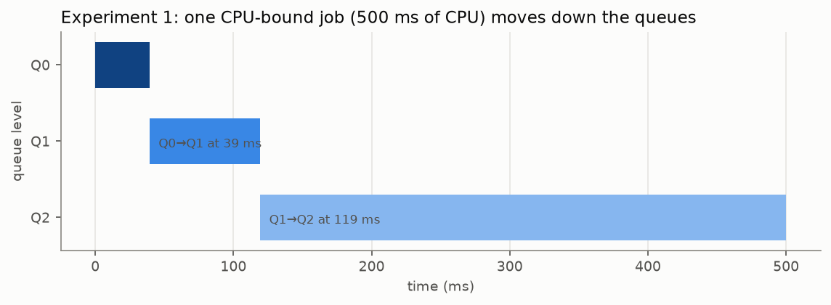
Figure 1: Experiment 1
config | CPU | wait | turnaround | dispatches | demotions | CPU in Q0 | CPU in Q1 | CPU in Q2
MLFQ 4/8/16 | 500.0 | 0.1 | 500.1 | 5 | 2 | 39.2 | 80.1 | 380.7
RR | 500.0 | 0.6 | 500.7 | 51 | 0 | – | – | –

- The job is demoted Q0 → Q1 after 39.2 ms of CPU and Q1 → Q2 after a further 80.1 ms: the configured 40 ms and 80 ms, to within the ±½-tick enforcement precision.
- Alone on the CPU, a process loses nothing under MLFQ (turnaround = CPU time + 0.1 ms). Round robin switches it out and straight back in on every tick (51 dispatches, 0.6 ms of waiting), because it preempts even when nothing else is RUNNABLE. MLFQ only preempts when a quantum expires or a higher level is waiting, so it has 5 dispatches.

13.2 Experiment 2 – three CPU-bound jobs (400 ms each, arriving together)
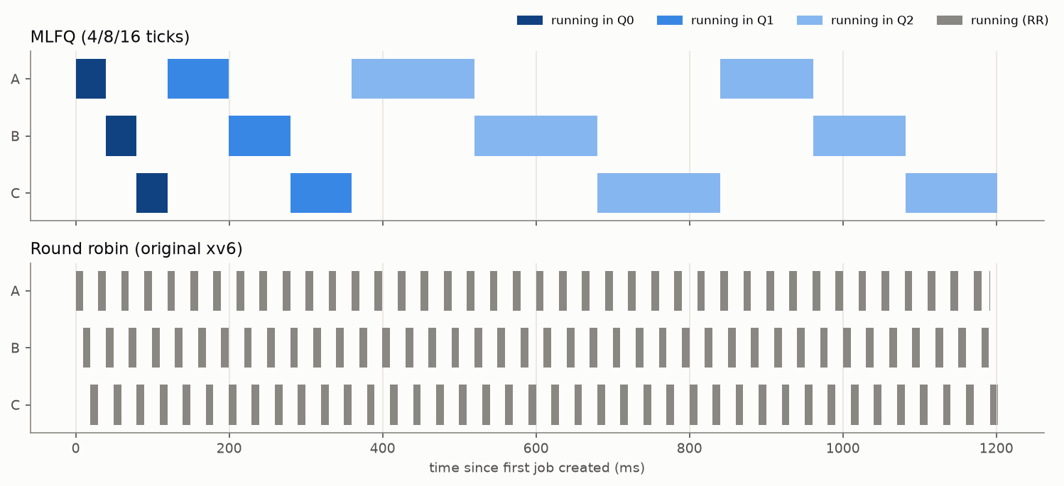
Figure 2: Experiment 2
 | job | response | wait | turnaround | dispatches | longest wait
MLFQ | A | 0.8 | 561.4 | 961.5 | 4 | 320.4
 | B | 38.9 | 681.0 | 1081.1 | 4 | 281.7
 | C | 78.6 | 800.6 | 1200.7 | 4 | 320.4
RR | A | 0.8 | 792.3 | 1192.3 | 41 | 20.0
 | B | 8.9 | 789.7 | 1189.8 | 40 | 20.0
 | C | 18.5 | 801.0 | 1201.0 | 42 | 20.0

 | mean turnaround | completion order | spread of finish times | total dispatches
MLFQ 4/8/16 | 1081.1 | A → B → C | 240.0 | 12
RR | 1194.4 | B → A → C | 11.6 | 123

- All three jobs go Q0 → Q1 → Q2 (2 demotions each). The timeline shows the FIFO order at every level: A, B, C take turns with 40 ms slices in Q0, 80 ms in Q1 and 160 ms in Q2. No promotions happen: each job waits at most 320 ms (2 × 160 ms) between slices, below the 500 ms aging threshold.
- Fairness. All three jobs receive exactly the CPU they need, and none waits more than two Q2 quanta in a row. Round robin is fairer at a fine time scale (it never makes a job wait more than 20 ms), while MLFQ's long Q2 slices make the finish times spread out (240 ms apart vs 12 ms).
- Completion order and turnaround. Because MLFQ's slices are long, the jobs finish in arrival order. For equal jobs this lowers the mean turnaround: 1081 ms vs 1194 ms for RR, whose jobs all finish together at the very end.
- Overhead. MLFQ needs 12 dispatches where RR needs 123.

13.3 Experiment 3 – CPU-bound, I/O-bound and short jobs together
Two long CPU-bound jobs (long1, long2, 1000 ms of CPU each) and an I/O-bound job (io: 100 times 1 ms of CPU followed by a one-tick sleep) start together; two short jobs (short1, short2, 30 ms each) arrive at 300 ms and 700 ms, while the long jobs are running.
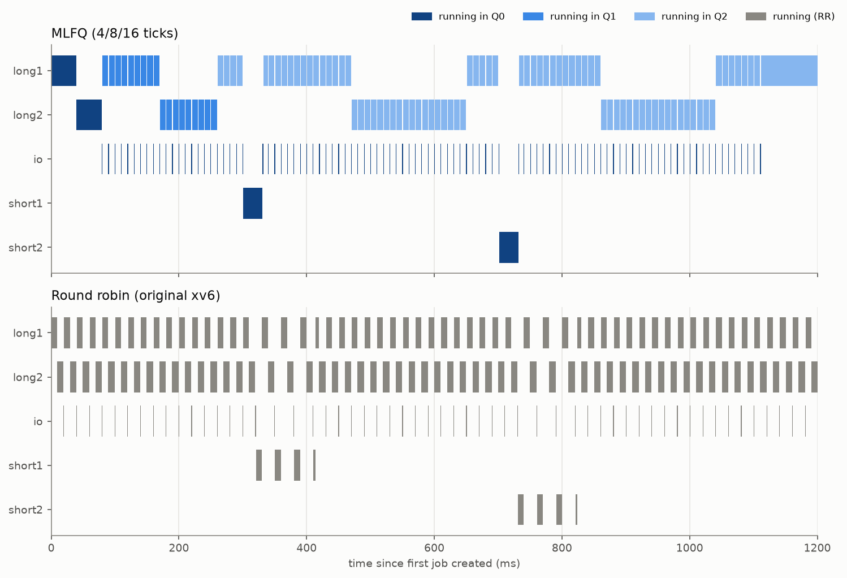
Figure 3: Experiment 3 timeline
 | job | arrival | CPU | response | wait | turnaround | dispatches | final level
MLFQ | long1 | 0.0 | 1000.0 | 0.8 | 1091.0 | 2091.0 | 58 | Q2
 | long2 | 0.4 | 1000.0 | 38.9 | 1167.0 | 2167.0 | 50 | Q2
 | io | 0.7 | 101.5 | 78.6 | 126.8 | 1119.8 | 101 | Q0
 | short1 | 299.9 | 30.0 | 1.0 | 1.0 | 31.1 | 1 | Q0
 | short2 | 700.4 | 30.0 | 1.2 | 1.2 | 31.3 | 1 | Q0
RR | long1 | 0.0 | 1000.0 | 0.8 | 1165.3 | 2165.3 | 111 | –
 | long2 | 0.4 | 1000.0 | 8.9 | 1060.1 | 2060.1 | 100 | –
 | io | 0.7 | 101.5 | 18.5 | 1079.7 | 2080.8 | 102 | –
 | short1 | 301.0 | 30.0 | 19.6 | 82.8 | 112.8 | 4 | –
 | short2 | 711.4 | 30.0 | 19.6 | 82.8 | 112.8 | 4 | –

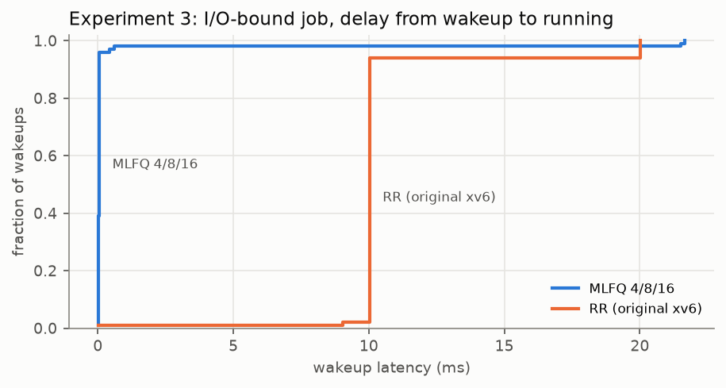
Figure 4: Experiment 3 wakeup latency
I/O job, delay from each of its 100 wakeups until it runs:
 | median | 95th percentile | max
MLFQ | 0.05 | 0.05 | 21.67
RR | 10.02 | 20.03 | 20.03

- Short jobs: under MLFQ they start within 1–1.2 ms of arriving and finish in 31 ms (they need 30 ms). Under RR they share the CPU with three other processes and take 112.8 ms, 3.6 times longer.
- I/O-bound job: it stays in Q0 throughout. Every time it wakes up it preempts whichever long job is running, and it gets the CPU within 0.05 ms in 95 % of wakeups (this 0.05 ms is the emulated cost of the interrupt and context switch). Under RR it waits 10–20 ms after every wakeup (one or two other jobs' ticks), so its total waiting time is 1079.7 ms vs 126.8 ms and its turnaround 2080.8 ms vs 1119.8 ms. Most of MLFQ's 126.8 ms is the start-up wait of 78.6 ms, when the I/O job was third in the Q0 queue behind the two long jobs' first 40 ms quanta; the few long wakeup delays (max 21.7 ms) happen in that phase too, when a long job was still in Q0 and so could not be preempted by the I/O job.
- Long CPU-bound jobs pay very little: their mean turnaround is 2129 ms under MLFQ vs 2113 ms under RR (+0.8 %). The CPU time the short and I/O jobs got earlier is simply time the long jobs would have had to share anyway.
- Context switches: 211 dispatches for MLFQ vs 321 for RR. With MLFQ, almost all are the I/O job's own 100 wakeups and the long jobs' preemptions by them.

13.4 Experiment 4 – aging and starvation
A 300 ms job (long) competes with a stream of 100 ms jobs; two are always running and a new one starts whenever one ends, for 2 s. A stream job finishes after 4 ticks in Q0 and 6 in Q1, so it never reaches Q2 and Q0/Q1 are never empty while the stream lasts.
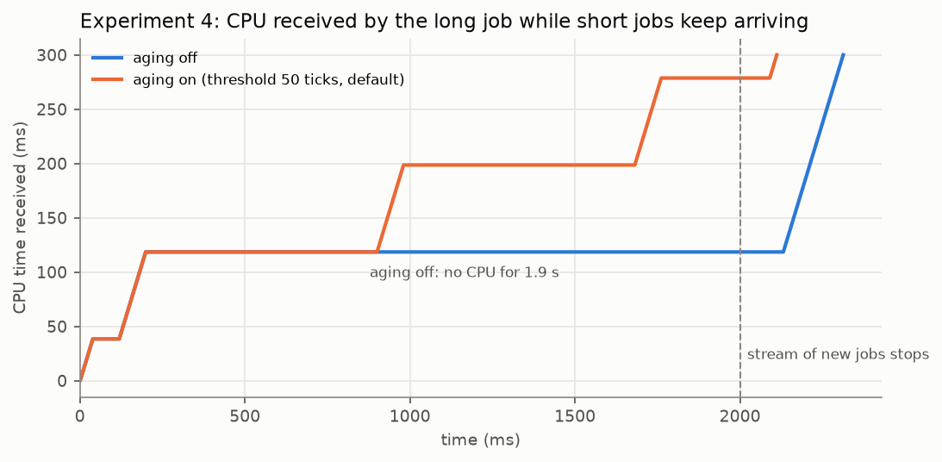
Figure 5: Experiment 4
config | long: turnaround | long: longest wait | promotions | demotions | stream jobs run | stream: mean turnaround
aging off | 2312.8 | 1931.9 | 0 | 2 | 20 | 209.3
aging 50 ticks (default) | 2111.5 | 701.1 | 2 | 4 | 18 | 228.1
RR | 854.3 | 20.1 | – | – | 18 | 227.8

- Without aging, the long job starves. After using its Q0 and Q1 quanta (120 ms) it sits in Q2 and gets no CPU at all for 1.93 s, until the stream stops.
- With aging, the wait is bounded by the threshold. With the default threshold of 50 ticks (500 ms), the long job's longest wait is 701 ms: the threshold plus about 200 ms, the time it then spends waiting in Q1 behind stream jobs that were there first. Each promotion gives it an 80 ms Q1 quantum (the steps in the figure).
- Aging bounds waiting, not turnaround. The long job still gets only about one Q1 quantum per threshold period, so it finishes 2.1 s after starting, versus 0.85 s under round robin, where everyone shares equally. That is MLFQ's deliberate trade-off: short jobs come first. The stream jobs pay a little for aging (228 ms vs 209 ms mean turnaround with the default threshold).

14. Performance analysis
Why MLFQ suits mixed workloads. A scheduler that does not know job lengths can either share the CPU equally (RR), which is fair but slows everything to the pace of the slowest mix, or guess. MLFQ guesses from behaviour: every process is first assumed to be short and interactive (Q0), and the guess is revised downwards only after it has used 40 ms and then 80 ms of CPU. Short jobs therefore finish before the scheduler has "noticed" them (Experiment 3: 31 ms instead of 113 ms), and I/O-bound jobs never use a full quantum, so they keep their high priority indefinitely. The CPU-bound jobs lose almost nothing (+0.8 %), because the CPU they give up is small and would have been shared anyway.
How dynamic priorities work in practice. Priority is a running estimate of how CPU-hungry a process is. Demotion (quantum used up) lowers it; aging (not having run for a while) raises it. Experiment 1 shows the estimate converging (Q2 after 120 ms of CPU). Experiment 3 shows it staying high for the I/O job across 100 sleep/wake cycles. Experiment 4 shows it being raised again for a starved job. Because the quantum is not reset by sleeping, the estimate cannot be fooled by sleeping just before the end of the quantum (schedtest gaming test).
How demotion affects CPU-bound jobs. Demotion puts CPU-bound jobs where they get long slices and few context switches (4 dispatches for 400 ms of CPU in Experiment 2 vs 41 under RR), at the price of lower priority. When there are no interactive jobs, this is a pure gain. When there are, CPU-bound jobs are preempted by them, but their turnaround barely changes (Experiment 3).
How aging prevents starvation. Strict priority can starve Q2 as long as Q0/Q1 are never empty (Experiment 4 without aging: 1.93 s with no CPU). Aging turns "never" into "at most about AGING_THRESHOLD": the measured longest wait (0.70 s with a 0.5 s threshold) tracks the threshold. A small threshold approaches round robin (more promotions, less priority); a large one approaches strict priority. The default of 50 ticks is long enough not to trigger among equal CPU-bound jobs (Experiment 2 had no promotions) but still bounds starvation to well under a second.
How I/O-bound processes behave. They block before using their quantum, so they are never demoted (final level Q0, 0 demotions). Since a woken process of a higher level preempts the running one at the next tick, and xv6's timer wakeups happen in that same tick, they run within about 0.05 ms of waking, compared with 10–20 ms under RR. Their total CPU is small (101.5 ms), so giving them priority costs the others little.
How multiple CPU-bound processes compete. They go through the queues in lock-step, then take turns in Q2 in FIFO order with 160 ms slices. Every job gets the same CPU share over each round, and no job waits more than (n − 1) × Q2 quantum between turns (320 ms for n = 3). Compared with RR, finish times are spread out (by one Q2 quantum each) instead of bunched together, which lowers the mean turnaround.

15. Limitations
- Emulated hardware. All measurements come from QEMU. The deterministic mode charges 1 ns per instruction regardless of instruction type, and has no caches or memory stalls. Absolute overheads (context-switch cost, wakeup latency) are therefore those of the emulated machine, not of real RISC-V hardware. The relative behaviour of the policies is what the experiments establish.
- Enforcement at tick granularity. Quanta are measured exactly, but preemption can only happen at a timer interrupt, so each quantum is enforced to ±½ tick. Likewise, a higher-priority process that wakes up between ticks for any reason other than the timer waits for the next tick. (Timer-driven wakeups, which are the most common kind in xv6, are served in the same interrupt.)
- Host pauses count as CPU time (real-time clock). With the normal QEMU clock, xv6's time follows the host's real time. If QEMU is paused, for example because it runs inside a virtual machine (VirtualBox, especially with Hyper-V enabled) that the host deschedules for tens of milliseconds, the pause is charged to whichever process was running, and timer ticks arrive late. The statistics and the timing tests in schedtest then go wrong (schedtest detects this and prints a warning). Simulating such pauses (freezing QEMU for 150 ms out of every 300 ms) reproduced the failures. With make qemu ICOUNT=1, QEMU's clock counts instructions instead, and all tests passed under the same pauses. Its cost is that QEMU keeps one host CPU busy while xv6 is idle. Real kernels have the same problem inside VMs and account for it as "steal time".
- O(NPROC) scans. The scheduler and the per-tick check scan the whole process table (64 entries), as the original xv6 scheduler does. That is fine for xv6, but a real kernel would use per-level run queues (lists or bitmaps) for O(1) selection.
- Per-tick work on every CPU. With several CPUs, every CPU scans the table on every tick and briefly takes every process lock. That is correct but causes some lock contention; the experiments use one CPU.
- Single global policy. There is no per-CPU affinity or load balancing beyond what the shared process table gives, and no user control (such as nice) over priority.
- pause() wakes every tick. xv6's pause() sleeps on &ticks, so a process in pause(n) wakes up (and briefly runs) on every tick. Such a process "has run" recently, so the SLEEPING part of the aging rule does not apply to it. Blocking in wait(), read() and so on behaves as expected. This is xv6's timer design, not the scheduler's.
- Aging is a heuristic. Promotion depends only on time without the CPU, not on why the process did not run. With more than AGING_THRESHOLD / Q2_QUANTUM + 1 (here 4) CPU-bound jobs competing in Q2, they wait longer than the threshold and start promoting each other. That is harmless (it is still fair), but it adds switches.
- The upstream crash test. ./test-xv6.py crash fails at its last step (dorphan) in this environment. The same failure happens on unmodified upstream xv6 (checked), and dorphan works when run by hand, so it is a harness/QEMU timing issue and not caused by this project.

16. Future enhancements
- Per-level run queues (linked lists plus a bitmap of non-empty levels) for O(1) scheduling, and per-CPU queues for SMP scalability.
- A periodic global priority boost (OSTEP rule 5) as an alternative to per-process aging, compared experimentally.
- A setpriority()/nice system call, so users can pin processes to a level.
- A precise timed-sleep implementation (per-process wakeup time instead of waking every pause() sleeper on every tick).
- Adaptive quanta or a lottery/stride scheduler for proportional sharing, compared against MLFQ on the same benchmarks.
- Measurements on real RISC-V hardware.

17. Conclusion
This project replaced xv6's round-robin policy with a three-level MLFQ scheduler. It has real time slices of 4/8/16 ticks, FIFO order within each level, demotion on quantum expiry, preemption by higher levels, and aging based on the time since a process last ran. The implementation adds one policy file to the kernel and a handful of hooks to proc.c and trap.c, keeps xv6's one-lock-at-a-time discipline, and passes the upstream test suite on one and three CPUs as well as its own 13 scheduler tests.
Exact, timestamp-based accounting and a round-robin baseline built from the same tree made it possible to measure the policy honestly. In controlled, reproducible experiments, MLFQ served short jobs 3.6× faster and I/O-bound jobs about 2× faster than the original scheduler, cut I/O wakeup latency from 10–20 ms to 0.05 ms, and reduced context switches up to tenfold, while CPU-bound jobs' turnaround changed by about 1 %. Without aging, a demoted job starved for the full 1.9 s of a stream of short jobs; with aging, its longest wait stayed close to the configured threshold. Together, these results show dynamic priority scheduling doing what it is designed for: favouring interactive and short work without starving long-running computation.

18. Build, run and test instructions
For a step-by-step live demonstration (including setup on Kali Linux in VirtualBox), see docs/DEMO.md in the repository.

18.1 Requirements
A RISC-V cross compiler and QEMU ≥ 7.2. On Debian/Ubuntu:
sudo apt install build-essential gcc-riscv64-linux-gnu binutils-riscv64-linux-gnu qemu-system-misc
For the experiment scripts: Python 3 and matplotlib (pip install matplotlib).

18.2 Build and boot
make clean
make # kernel and file system image
make qemu # boot MLFQ xv6 on one CPU; exit with Ctrl-A then X
Configurations (the kernel is rebuilt automatically when they change):
make qemu SCHED=RR # original xv6 round-robin scheduler
make qemu QUANTA="2 4 8" # MLFQ quanta of Q0, Q1, Q2 in ticks
make qemu AGING=100 # aging threshold in ticks (0 = off)
make qemu CPUS=3 # three CPUs
make qemu ICOUNT=1 # deterministic clock (use this inside VirtualBox etc.)

18.3 Things to try at the xv6 prompt
$ schedtime cpubench_short # statistics of one short job
$ schedtime -n 3 cpubench_med # three competing CPU-bound jobs
$ schedtime iobench 20 # an I/O-bound job stays in Q0
$ cpubench & # then press Ctrl-P a few times:
# watch it move Q0 -> Q1 -> Q2
$ kill <pid>
$ mlfqexp mixed # one experiment, raw output
$ schedtest # functional tests

18.4 Reproducing the experiments
scripts/run_experiments.py # both clock modes (about 10 minutes)
scripts/run_experiments.py --mode icount --config mlfq rr
scripts/analyze.py # tables and figures

19. Repository structure
kernel/
sched.c MLFQ policy, accounting, statistics, trace (new)
pstat.h statistics structures shared with user space (new)
proc.c proc.h process table, scheduler loop (hooks added)
trap.c start.c timer interrupt -> sched_tick()
param.h scheduler configuration
sysproc.c syscall.[ch] defs.h new system calls
user/
bench.h workload helpers (CPU-time-based burn)
cpubench.c cpubench_med.c cpubench_short.c iobench.c workloads
schedtime.c run a command and print its statistics
schedtest.c functional tests
mlfqexp.c experiment driver
scripts/
xv6qemu.py boot xv6 and drive its console
run_tests.py test matrix
run_experiments.py experiment runs
analyze.py tables and figures
results/
raw/icount/ raw/realtime/ raw console output of every experiment run
jobs_*.csv every job's statistics
summary.md all tables (generated)
tests/ test logs
docs/figures/ figures (generated)
README upstream xv6 README (used by usertests)

20. References
- MIT PDOS, xv6-riscv, https://github.com/mit-pdos/xv6-riscv (the base of this project).
- R. Cox, M. F. Kaashoek, R. Morris, xv6: a simple, Unix-like teaching operating system (RISC-V edition), MIT, https://pdos.csail.mit.edu/6.1810/ — chapter 7, "Scheduling".
- R. H. Arpaci-Dusseau and A. C. Arpaci-Dusseau, Operating Systems: Three Easy Pieces, chapter 8, "Scheduling: The Multi-Level Feedback Queue", https://pages.cs.wisc.edu/~remzi/OSTEP/
- F. J. Corbató, M. Merwin-Daggett, R. C. Daley, "An Experimental Time-Sharing System", AFIPS Spring Joint Computer Conference, 1962.
- A. Silberschatz, P. B. Galvin, G. Gagne, Operating System Concepts, 10th ed., chapter 5, "CPU Scheduling".
- The RISC-V Instruction Set Manual, Volume II: Privileged Architecture (the time CSR and the Sstc extension).
- QEMU documentation, "icount" (deterministic execution), https://www.qemu.org/docs/master/devel/tcg-icount.html

