Evidence-Based Fake News Detection with Calibrated Scoring
Mugilan K S, Nandha Kumar S, Nandhini A, and Kannukkiniyal M^{(✉)}
Department of Computer Science and Engineering, Kongu Engineering College, Perundurai, Erode 638060, Tamil Nadu, India
kannukkiniyal.cse@kongu.edu
{mugilanks.23cse, nandhakumars.23cse, nandhinia.23cse}@kongu.edu
Abstract. Most automated fake news detectors score an article on how it is written: its headline, its tone, whether it names sources. All of these are chosen by the person who writes the article, so a fabricated story in a calm newsroom style can score as well as a genuine report. We built a checking system that looks at evidence outside the author’s control instead. It accepts article links, pasted text, screenshots, which it reads with OCR, and videos, which it reads from their captions, and it refuses input that has no checkable claim. For everything else, it extracts the main claims, searches a news index and counts the independent outlets that report the same event, not the articles it retrieved. Named people and organisations are looked up in an encyclopedia to catch false premises, and the publisher is identified from the web address, not from the name printed on the page. Writing signals such as clickbait, slant, persuasion and transparency become likelihood ratios estimated from labelled articles and are added as log-odds, but they may only count against a story, never for it. The output is a calibrated probability and a verdict with its reason, or an abstention. On 120 held-out ISOT articles the system matched a hand-weighted baseline to within one article (114 against 115 correct) and lowered calibration error on its accusations from 0.267 to 0.152. On six fabrications we wrote to read like ordinary reporting, the baseline rated four as credible and our system rated none.
Keywords: Fake news detection, Evidence-based verification, Independent corroboration, Likelihood ratio, Calibration, Abstention.
1 Introduction
In its Global Risks Report 2026, the World Economic Forum ranked misinformation and disinformation as the second most severe global risk over the next two years, just behind geoeconomic confrontation [2]. Language models now make convincing fakes cheap to produce [3]. Most people meet them as a forwarded message, a screenshot or a link, with no easy way to check where they came from.
Automated detectors are supposed to help with that. Most of them treat the problem as text classification: a model reads the article and labels it fake or real from its wording. Scores on public datasets are high. On the ISOT corpus, accuracies above 99% are common, but an audit by Verma [4] traced much of that to the way the corpus was put together. There is a simpler problem too. A style-based detector rewards features that the writer controls. Anyone fabricating a story can keep the headline calm, quote named officials and avoid loaded words. Chen and Shu [3] found that misinformation rewritten by a language model is harder for both people and detectors to catch than the human-written version with the same meaning.
We saw this in our own project. Our first design added up six checks with hand-picked weights. When we tested it with stories we had invented and written in plain newsroom style, they averaged 7.3 out of 10, and four of the six deceptive items came out as credible. Each check was doing its job. The sum was the problem, because good writing could make up for missing evidence.
This paper describes what we built instead. One rule drives it: anything the author controls may count against a story but never in its favour. Support has to come from outside, from independent outlets reporting the same event, from reference entries on the people named, and from the publisher’s record, which we take from the web address. Each observation contributes a likelihood ratio estimated from labelled articles. The system reports a probability, a verdict and the rule that produced the verdict, and when a check cannot run it says so instead of treating the gap as evidence.
Our base paper is DEFAME [1], a fact-checking system published at ICML 2025 that plans web searches, gathers text and image evidence and writes a justified verdict. We keep its evidence-first approach and add four things a public tool needs: limits on what each kind of evidence may prove, a count of independent sources, a check on who published the page, and defined behaviour when a check fails. We also measured which language-model tasks can run on a local model, and nine of ten can.
Section 2 reviews related work. Section 3 describes the system and the evaluation. Section 4 reports the results, Sect. 5 discusses them, and Sect. 6 concludes.
2 Related Work
Content-based detectors classify the article text. Amri et al. [5] built ExFake, which combines the article with its social context and outside evidence to explain each decision. Its strongest signals, such as who shares a post, only arrive after a story has spread, and an article that has just been forwarded to someone has none. Da San Martino et al. [6] defined a span-level taxonomy of persuasion techniques for SemEval-2020, which we use for one of our writing checks.
Large language models have been tried both as detectors and as helpers. Hu et al. [7] found that GPT-3.5 used directly did worse than a fine-tuned small model, but its written rationales helped the small model when given as extra input. Wang et al. [8] had a language model argue both sides of a claim from collections of raw reports and then pick the better-supported explanation. Both still judge the content or rely on many reports per claim.
Evidence-based fact-checking tests claims against outside sources. Guo et al. [9] describe the whole pipeline, from claim detection through evidence retrieval and verdict prediction to justification, and point out that most systems assumed the evidence was already at hand. AVeriTeC [10] pairs real-world claims with evidence from the open web.
DEFAME [1] is the closest system to ours. It runs in six stages (plan, execute, summarise, develop the fact-check, predict, justify), uses web search, image search, reverse image search and a geolocation tool, and returns supported, refuted, misleading or not enough information. If the evidence is insufficient, it goes back to planning, up to three times. With GPT-4o it reported 70.5% accuracy on AVeriTeC, 59.2% on MOCHEG, 83.9% on the true/false split of VERITE and 69.7% on ClaimReview2024+, at about 13 US cents and four minutes per claim. Its authors note that it does not weigh source credibility and relies on the search engine’s own trustworthiness checks. It also gives a label without a probability.
Source ratings are another way in. Lin et al. [11] found that six professional rating sets for news sites agree closely, and they six professional rating sets into one score for 11,520 news domains. A rating only helps if the outlet is identified correctly. A system that trusts the name printed on a page will give a copycat site the original’s record.
Calibration and abstention come from machine learning more broadly. Minderer et al. [12] found that calibration varies a lot from one model family to another, so a stated confidence has to be measured before it can be read as a probability. Silva Filho et al. [13] surveyed how to measure and repair calibration, including isotonic regression. Hendrickx et al. [14] surveyed models that may decline to answer and how such refusals should be judged. Table 1 groups the cited work.
Table 1. Families of related work and how this paper relates to them.
Family | Studies | Evidence and output | Relation to this work
Content classifiers | [4, 5, 6] | Article text, social context; a label | Writing signals kept, but one-sided
LLM-assisted detection | [7, 8] | Text, rationales, raw reports; label and explanation | Model used only for narrow tasks
Evidence-based fact-checking | [1, 9, 10] | Wikipedia or web evidence; verdict and justification | Base approach; we add independence and identity checks
Source ratings | [11] | Ratings of outlets or domains | Used after the publisher is identified by address
Calibration and abstention | [12, 13, 14] | Probabilities, reject option | Calibrated probability; defined abstention

3 System and Method
3.1 Task
The input is anything a reader might want checked: a link to an article, pasted text, a screenshot or a video link. The output is one of five verdicts (REAL, FAKE, CANNOT VERIFY, NOT A FACTUAL CLAIM or SATIRE), a probability that the story is fabricated, and the grounds for the verdict. Input with nothing checkable in it is refused with a short reason. We work with claims, not whole articles, because one story can mix true and false statements and because claims are what other outlets report. Fig. 1 shows the principle behind the scoring and Fig. 2 the pipeline.
3.2 Reading the Input
A link is read from the publisher’s page. A news API returns only about 200 characters of an article, while the page gives 2,000 to 6,000. Page extraction took several fixes. BBC pages had 76 opening <p> tags and only 37 closing ones, and our first extractor read the site menu as the first paragraph of the story. Extraction is now limited to the article body, and the text is used only if at least half of the headline’s distinctive words appear in it. Screenshots are read with Tesseract OCR and videos through their caption tracks. Text in Tamil, Hindi and Kannada is detected, and its claims are searched in the original language and in English, since a story reported in Tamil is often reported in English as well.
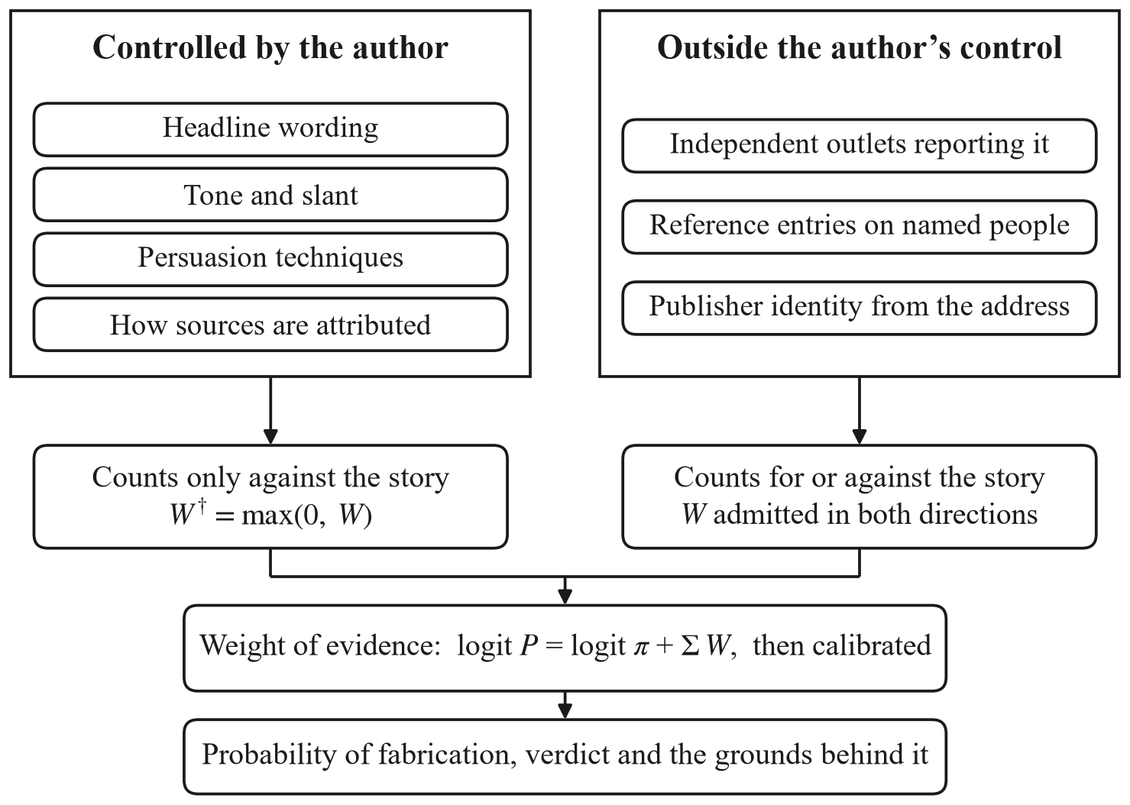
Fig. 1. The scoring principle. Observations the author controls can only count against a story; evidence from outside the author’s control can count either way.
Before anything expensive runs, a rule-based admissibility check decides whether the input says anything a newsroom could confirm or deny. Questions, calls to action and very short fragments are refused. An input passes only if it contains at least one anchor, such as a name, a number or a date. One bug here is worth recording. The check first joined the headline and the body with a plain space, so the exhortation ‘Wake up …’ picked up a phantom proper noun and was given a verdict. The two are now joined with a sentence break.
3.3 Evidence from Outside the Article
Corroboration. A language model pulls up to two checkable claims out of the text, each with three or four search keywords. For each claim the system searches a news index (NewsAPI), leaving out the article’s own outlet, and a second model call reads each result and decides whether it supports the claim, contradicts it or is about something else. The results are then reduced to the sources behind them: outlets with a common owner count once, copies of one wire-agency story count once, and near-duplicate reprints are merged. A relevance gate drops coverage that shares no anchor with the claim. We made the gate stricter after one of our invented test stories, about a chemical leak and written without a single proper noun, was ‘confirmed’ by a real chemical-leak report from Ohio that happened to share four ordinary words with it. A claim that names nothing can no longer be corroborated.
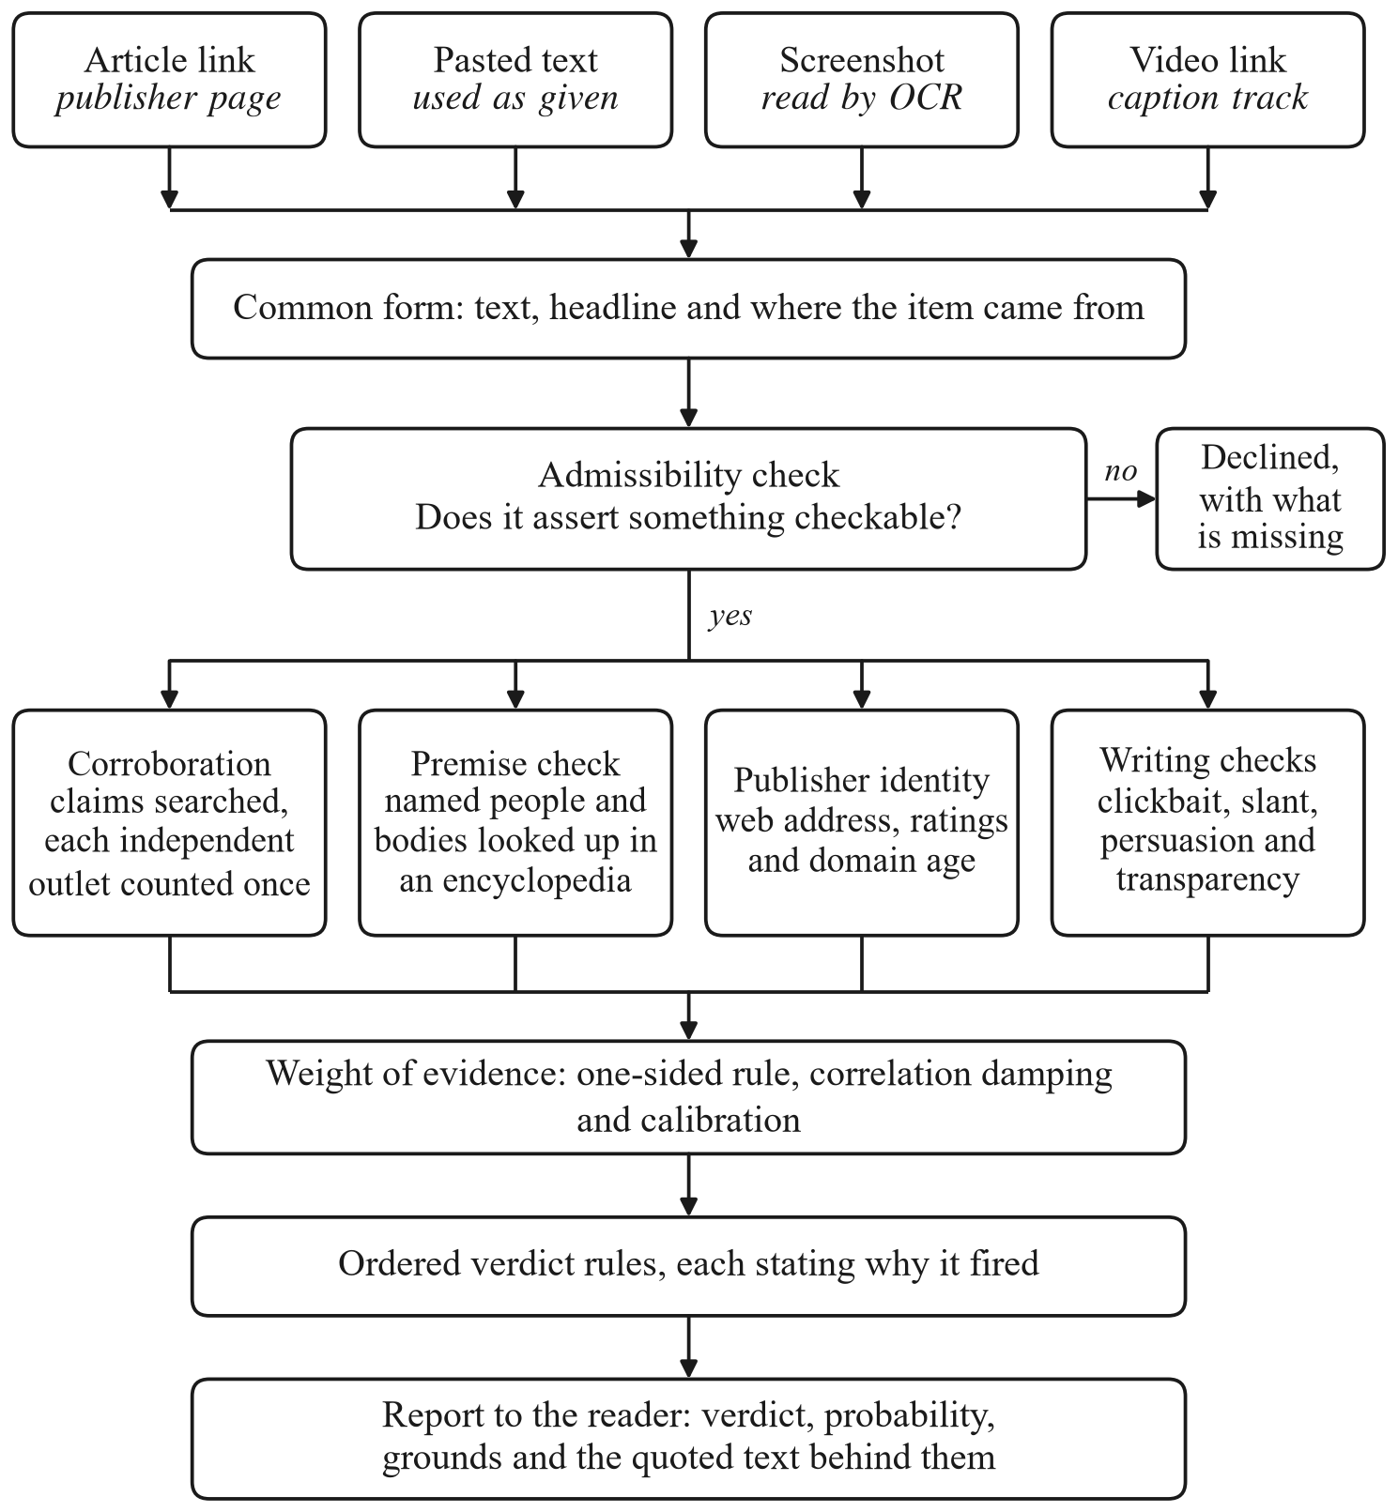
Fig. 2. Processing pipeline, from the reader’s input to the report.
A search can fail for reasons that have nothing to do with the story: a rate limit, a timeout, a reply that cannot be parsed. Our first version treated all of these as ‘no coverage’ and told readers that no other outlet was reporting a wire story that five major outlets were carrying at the time. Each search now records whether it ran. A failed search is reported as unavailable and adds nothing to the probability. The news index also lags behind live publishing: on 28 September 2026 the newest article it returned for any query was 30.5 hours old. A story younger than about a day is therefore reported as too recent to corroborate.
Premise check. A story built on a false premise describes something nobody reports, so a news search finds nothing and cannot say the premise is wrong. The system looks up the people and organisations a story names in Wikipedia and asks a model whether the story conflicts with the entry. A conflict counts only if the model quotes the entry and the quote is found in it, if the entry is about the same person, if the two statements cannot both be true, and if the story makes the claim itself instead of quoting someone else. Each condition came from a real error. One of our genuine test articles quoted a council official called Meera Krishnan and was flagged because the Wikipedia entry under that name is about an actress. An Associated Press video was flagged in one of eight runs because a woman interviewed in it said the Pope’s ancestors came from the region, which the check set against his birthplace in Chicago. The reference work is used only to refute a premise, never to confirm an event.
Publisher identity. The publisher is decided from the web address, not from the name the page gives itself. An outlet’s record applies only on a domain it publishes from or on a platform channel listed as its own. Ratings come first from our list of 90 outlets, which includes Indian publishers missing from the published sets, and otherwise from the ratings of Lin et al. [11] for 11,520 domains. On the 81 outlets in both, the two agree well (Pearson r = 0.848, Spearman ρ = 0.765), and a least-squares fit over those 81 (reliability = 0.38 + 8.95 × score) maps the published 0–1 score onto our 0–10 scale. A page that uses a known outlet’s name from an address the outlet does not use gets no record and is flagged as impersonation. For unrated sites the system reads the domain’s registration date from RDAP. A domain under 90 days old counts as a warning sign, while an old domain earns nothing, because old domains can be bought.
3.4 Writing Checks
Four checks look at how the story is written: clickbait in the headline, slanted or one-sided language, persuasion techniques from the SemEval-2020 taxonomy [6], and transparency, a five-point checklist covering named sources, attributed quotes, links to primary evidence, concrete detail and measured claims. Each check has to quote the words it is reacting to, so its output can be compared with the text. The reader sees all four. How much they may affect the result is set by the scoring rule in Sect. 3.5.
3.5 Scoring
Each observation o is turned into a likelihood ratio and expressed in decibans:
 | $$Λ(o)=\frac{P(o∣fabricated)}{P(o∣genuine)}, W(o)=10 \log_{10}Λ(o)$$ | (1)
The ratios are estimated from labelled articles by putting each observation into bands and counting, with a Jeffreys prior. Each estimate is shrunk to the conservative end of its 95% interval, so a band with only a few articles behind it contributes nothing. The log-odds of fabrication are then a sum:
 | $$logit P(fabricated∣O)=logit π+\sum_{o∈O}{W(o)}$$ | (2)
where π is a prior set by the publisher’s record. We use 0.02 for an outlet with a strong record, 0.06 for an ordinary one, 0.15 for an unrated outlet, 0.25 for a poor record or an impersonating page and 0.35 for a social-media post. These values are our own choice, not measurements, and every report says so.
Observations are split into O_{A}, which the author controls, and O_{I}, which the author does not. For o ∈ O_{A} only the part that counts against the story is kept:
 | $$W^{†}(o)=max\left(0,W(o)\right), o∈O_{A}$$ | (3)
On a corpus of crude fakes, fluent writing really does predict a genuine article, and an unconstrained model learns to reward it. A careful fabricator writes fluently on purpose, so that lesson fails when it matters most. A side effect of Eq. (3) is that a check that tells us nothing, with a ratio of one, adds exactly zero, and so does a band that has never been measured. The report names such checks instead of giving them a made-up weight.
The four writing checks read the same prose and are correlated. Their mean pairwise correlation r̄ was 0.55, and headline quality and slant correlated at 0.93. With k checks and equal correlation, the effective number of independent checks is
 | $$n_{eff}=\frac{k}{1+(k−1) \overline{r}}$$ | (4)
which is 1.52 for our four, so their total weight is multiplied by n_{eff}/k = 0.379 and capped at 8 decibans. Finally, the summed log-odds are calibrated with isotonic regression [13] on held-out data. When we first fitted the map, it quietly put back the weight Eq. (3) had removed, because it was fitted on ISOT, where clean style does go with genuine articles. The clamp is now applied again after calibration, and a regression test checks it.
3.6 Verdict Rules
The probability and the verdict answer different questions. The probability is graded belief. The verdict says what has been established. It comes from an ordered list of rules (Table 2), the first rule that matches decides, and its name is shown to the reader. The two can disagree, and that is deliberate. An uncorroborated story may get a low probability simply because most stories are genuine, but nothing about it has been confirmed, so it stays CANNOT VERIFY.
Table 2. Verdict rules in order of precedence. Input that fails the admissibility check is refused before these rules are reached.
Order | Condition | Verdict shown
1 | The publisher is a known satirical outlet | SATIRE
2 | Two or more independent outlets contradict a claim | FAKE (false)
3 | One independent outlet contradicts a claim | FAKE (probably false)
4 | A reference entry contradicts the story’s premise | FAKE (probably false)
5 | The story is too recent for the news index, or verification could not run | CANNOT VERIFY
6 | No checkable claim is left after extraction | NOT A FACTUAL CLAIM
7 | Two or more independent outlets support the claims | REAL (confirmed)
8 | One independent outlet supports the claims | REAL (probably true)
9 | A high-impact claim is uncorroborated and shows three or more risk signals | FAKE (probably false)
10 | None of the above | CANNOT VERIFY

3.7 Model Routing
Every language-model call goes through one gateway with three providers: a local Llama 3.1 8B model served by Ollama, NVIDIA NIM and Google Gemini. We chose the provider for each task by measurement. A task goes to the local model only if at least 80% of its local replies are valid, at least 80% are correct where the answer is known, and its scores stay within 2 points of the hosted reference on the 0–10 scale. The gateway retries congested providers and moves on when a model is withdrawn. That happened to us once: NVIDIA retired meta/llama-3.1-8b-instruct, the model we had used in Phase I, on 26 August 2026, and every analysis began failing with HTTP 410. If no provider answers, each writing check falls back to word lists and surface patterns, and the report marks it as degraded.
The application is built with MongoDB, Express, React and Node.js. Reports are cached by article address for 14 days, results stream to the reader as each check finishes, and the code has 182 backend and 14 frontend tests that run without network access or API keys.
3.8 Evaluation
We used four test sets and one benchmark of the model providers.
Held-out ISOT articles. After length filtering, ISOT has 21,379 genuine and 21,915 fake articles. We used the 239 articles whose writing checks had all come from the language model and not from the fallback analysers. A hash of the article ID split them into 119 for estimating the ratios and 120 for testing. All of ISOT’s genuine articles come from Reuters, so we hid the source and stripped agency prefixes such as ‘WASHINGTON (Reuters)’, which would otherwise give the label away. Historical articles have no live coverage, so corroboration plays no part here, and this test covers only the writing half of the model. We had planned to use 300 articles but stopped at 239 when both hosted providers went down during the run, one with HTTP 503 errors and the other out of quota. The baseline is our earlier hand-weighted sum applied to the same check outputs. We report accuracy with 95% Wilson intervals, ROC-AUC, the Brier score and the expected calibration error (ECE) over ten bins. We also compute ECE and precision over accusations alone, meaning the predictions that put the probability of fabrication above 0.5.
Adversarial set. ISOT’s fakes are crude, so it cannot show whether good writing still buys trust. We wrote ten items: five fabrications in plain newsroom style with named sources and no clickbait, one high-impact fabrication with manipulation signals, two genuine reports, one satirical piece and one opinion column. Each item was scored under both rules from the same check outputs, using the rule-based analysers so that the run can be repeated without network access.
End-to-end cases. Twelve cases went through the running application on 4 October 2026: pasted text, Tamil text, news links, screenshots and a YouTube video, with every verdict represented.
Lookalike publishers. We checked five lookalikes of the BBC, Reuters and the Associated Press, and ran a made-up income-tax story live on one of them.
Providers. Each of ten model tasks ran three times per provider on a Windows 11 laptop with an NVIDIA RTX 5050 (8 GB). Each run was pinned to one provider, so that a failure could not fall through to another provider and be counted as a success. The hosted models were Nemotron 3 Super 120B on NIM and Gemini 3.1 Flash-Lite.
4 Results
4.1 Held-Out ISOT Articles
Table 3 and Fig. 3 compare the two rules on the 120 test articles. The proposed rule got 114 right (95.0%, 95% interval 89.5–97.7%) and the baseline 115 (95.8%, 90.6–98.2%), so accuracy is the same to within one article. The difference is in calibration on accusations. ECE there fell from 0.267 to 0.152, which is 43% lower, and precision on accusations stayed at 0.967. When the system says a story is probably fabricated, the probability it gives is closer to how often that is true.
Table 3. Held-out comparison of the two scoring rules (120 ISOT articles; lower is better for ECE and Brier).
Rule | Accuracy | ROC-AUC | ECE | ECE (accusing) | Precision (accusing) | Brier
Hand-weighted baseline | 0.958 | 0.978 | 0.237 | 0.267 | 0.968 | 0.101
Proposed, as deployed | 0.950 | 0.951 | 0.246 | 0.152 | 0.967 | 0.117

The proposed rule ranks a little worse (ROC-AUC 0.951 against 0.978), and its overall ECE (0.246 against 0.237) and Brier score (0.117 against 0.101) are slightly higher. Both follow from Eq. (3). On ISOT the only evidence that could clear an article is its style, which the rule will not use, so genuine articles stay near the prior. The 59 test articles in the lowest band were given about 0.41 and turned out to be fabricated 7% of the time. In normal use, corroboration and the publisher’s record do that job, and neither is available on a historical corpus with the sources hidden. Turning the clamp off raised ROC-AUC to 0.983 and ECE on accusations to 0.191. We kept the clamp.
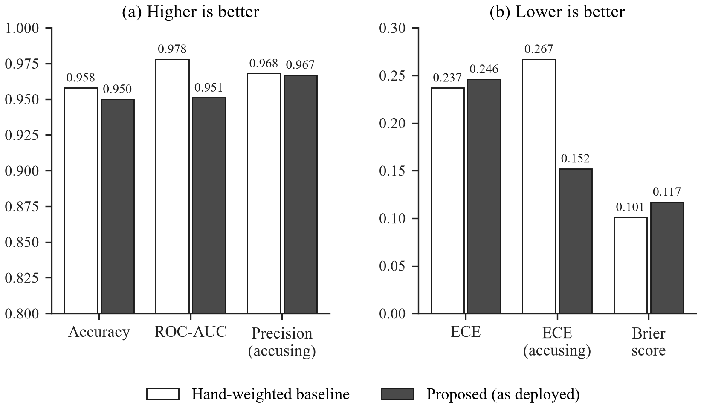
Fig. 3. Held-out metrics for the baseline and the proposed rule: (a) higher is better; (b) lower is better.
4.2 Adversarial Set
The baseline rated four of the six deceptive items as credible. The proposed rule rated none of them as credible, matched the expected verdict on all six and did not condemn either genuine report (Table 4). The fabrications still score well for writing, 7.3 out of 10 on average under the baseline. They just no longer pass on that alone.
Table 4. Adversarial set, scored under both rules from the same outputs of the rule-based analysers. The baseline gives a score, not a verdict.
Measure | Baseline | Proposed
Deceptive items rated credible | 4 of 6 | 0 of 6
Verdicts matching expectation | – | 6 of 6
Genuine reports wrongly condemned | – | 0 of 2
Mean writing score of the fabrications | 7.3 of 10 | –

4.3 End-to-End Cases
Table 5 lists the twelve cases. The four genuine news reports were confirmed by three to five independent outlets each, whether they came in as pasted text, a link, a screenshot or Tamil text. The story calling Rahul Gandhi ‘Prime Minister’ was marked FAKE by the premise check, as text and as a screenshot. Fig. 4 shows what the reader sees, including the line from his Wikipedia entry. The two invented stories came back CANNOT VERIFY, and the three inputs with nothing to check were refused. The Associated Press video, a genuine report whose transcript is mostly an interview in French, came back CANNOT VERIFY because no matching coverage was found on that run. It was not called false. Analyses took 22 to 112 seconds, and refusals were immediate.
The run also hit a real failure. Partway through the first attempt the laptop lost its internet connection, so every news and reference lookup failed. All of the affected cases came back CANNOT VERIFY under the rule ‘verification unavailable’, with the message ‘We could not complete the search, so nothing has been checked’. None was called false. We re-ran those cases when the connection came back, and Table 5 shows the re-run.
4.4 Lookalike Publishers
Table 6 shows the five lookalikes. When the outlet was taken from the name on the page, every one of them inherited the real outlet’s rating. The made-up income-tax story on bbc-breaking-news.xyz, which calls itself BBC News, was then treated as an exclusive from a strong outlet and given a 2% probability of fabrication. With the publisher taken from the address, the same story starts from the poor-record prior, gets 33%, and the reader is told the page is posing as the BBC. The real BBC article in our test set is still confirmed.
Table 5. End-to-end cases run on 4 October 2026.
No. | Input | Expected | Result | Rule that decided it | Time
1 | Pasted text | REAL | REAL | 5 independent outlets | 100 s
2 | News link | REAL | REAL | 3 independent outlets | 33 s
3 | Screenshot | REAL | REAL | 5 independent outlets | 112 s
4 | Tamil text | REAL | REAL | 4 independent outlets | 30 s
5 | YouTube video | REAL or CANNOT VERIFY | CANNOT VERIFY | No coverage found | 55 s
6 | Pasted text | FAKE | FAKE | Premise contradicted | 22 s
7 | Screenshot | FAKE | FAKE | Premise contradicted | 30 s
8 | Pasted text | CANNOT VERIFY | CANNOT VERIFY | No coverage found | 25 s
9 | Pasted text | CANNOT VERIFY | CANNOT VERIFY | No coverage found | 28 s
10 | Pasted text | Refused | Refused | A question | < 1 s
11 | Screenshot | Refused | Refused | A call to action | < 1 s
12 | News link | Refused | Refused | Site blocks reading | < 1 s

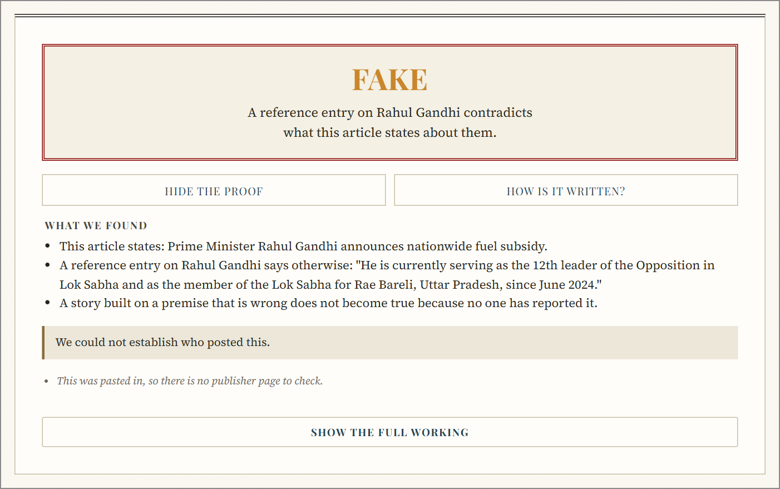
Fig. 4. The report shown for a story built on a false premise (case 6 in Table 5).
Table 6. Lookalike publishers identified by page name and by web address.
Address | By page name | By web address
bbc-breaking-news.xyz, calling itself “BBC News” | BBC News, 9/10 | No rating; impersonation flagged
bbc-world.com | BBC News, 9/10 | No rating
bbc.news-today.com | BBC News, 9/10 | No rating
reuters-updates.info, calling itself “Reuters” | Reuters, 9.5/10 | No rating; impersonation flagged
YouTube channel named “Associated Press”, not AP’s own | AP, 9.5/10 | No rating

4.5 Model Routing and Response Time
Fig. 5 shows the median time per call. The local model was faster on every task, by 1.7 to 15.5 times compared with the faster hosted provider. It was also more reliable at claim extraction, where hosted replies were valid in 67% and 33% of runs and local replies in all of them.
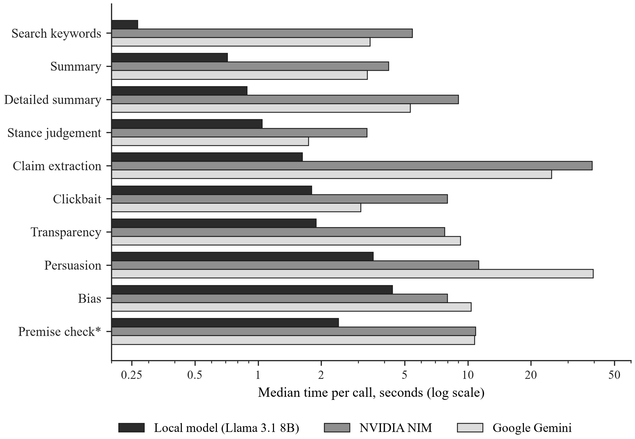
Fig. 5. Median time per call by task and provider (log scale). The premise check (*) is routed to NIM, because the local model missed the known contradiction in all three runs.
The exception was the premise check. Asked whether ‘Prime Minister Rahul Gandhi’ conflicts with his Wikipedia entry, the local model returned clean JSON in 2.4 seconds saying there was no conflict, in all three runs. Both hosted models found the conflict and quoted the sentence that settles it. An earlier version of this benchmark only checked whether replies parsed, and by that measure the local model won this task too, so routing on it would have quietly switched off the premise check. A task with a known answer now has to get it right before it is moved. In the end nine of ten tasks run locally, at no cost per call. In use, the first check reaches the reader 1.47 seconds after an article is opened, and a cached report comes back in 2.7–3.4 milliseconds.
4.6 Comparison with Published Results
Table 7 puts our numbers next to DEFAME’s and next to the ISOT shortcut reported by Verma [4], who found that a classifier given only the subject field of each article, with the text thrown away, reaches F1 = 1.000. The rows use different data, labels and tasks, so this is not a controlled comparison, and we did not run DEFAME on our cases. The table shows where each number comes from, and that a perfect ISOT score is possible without reading a single article.
Table 7. Reported results of related work and of our two rules; data and tasks differ between rows.
Study | Data | Task | Reported result
DEFAME, GPT-4o [1] | AVeriTeC | Real-world claims, web evidence | Acc. 70.5%
DEFAME, GPT-4o [1] | VERITE | Image and text claims, true vs false | Acc. 83.9%
DEFAME, GPT-4o [1] | ClaimReview2024+ | Claims after the model’s cut-off | Acc. 69.7%
Subject field only [4] | ISOT | Fake vs real, no article text | F1 1.000
Our baseline | ISOT, 120 held out | Fake vs real, source hidden | Acc. 95.8%
Our proposed rule | ISOT, 120 held out | Fake vs real, source hidden | Acc. 95.0%, accusing ECE 0.152
Our proposed rule | Adversarial set | Six careful fabrications | 0 of 6 rated credible

5 Discussion
5.1 What the ISOT Score Shows
ISOT accuracy says little on its own. Verma [4] showed how much of it comes from the corpus, and our held-out set is small: the 95% intervals of the two rules overlap almost completely. What our ISOT test does show is that the one-sided rule costs very little accuracy on ordinary data while making accusations better calibrated. The adversarial set is the test that matters for this design, and there the gap between the rules is clear, four credible against none.
5.2 Why the Rule Costs Ranking
The drop of 0.032 in ROC-AUC against the unclamped model is the price of Eq. (3). Without the clamp the model learns from ISOT that tidy writing means a genuine story, which is true of that corpus and false against a careful writer. We would rather give up a little ranking on old data than reward the one thing a fabricator can always supply. On ISOT the largest calibration gap is also on the cautious side, with the lowest band stated at 0.41 and observed at 0.07. Genuine stories are meant to be cleared by corroboration and the publisher’s record, which ISOT cannot test.
5.3 Use in Practice
For a platform or a messaging service, a verdict that comes with its reason, and a willingness to say CANNOT VERIFY, is more useful than a confident score. For newsrooms and other organisations whose name carries weight, such as banks and government departments, reading identity from the address stops copycat sites from borrowing their record. For regulators, every verdict can be traced to a rule, the outlets involved and quoted text, so it can be checked and appealed, and opinion pieces are refused instead of judged. Running nine of ten model tasks locally also removes per-call charges and keeps the article text on the user’s machine for those tasks, which matters for low-budget public deployments in India. In this way the work supports SDG 16, target 16.10, on public access to information.
5.4 Threats to Validity
The likelihood ratios come from 239 articles, so some bands are too thin to estimate and a one-article difference in accuracy means nothing. Each result comes from a single run. The adversarial set is small and we wrote it ourselves, so it shows that the rule behaves as designed, not how often it works in the wild. It was scored with the rule-based analysers, and a full live run is still to be done. The publisher priors and the corroboration ratios are set by hand. Corroboration depends on NewsAPI, whose free plan allows 100 requests a day, runs about a day behind and covers local and regional-language news unevenly. ISOT is mostly US political news from 2016 and 2017, so we have not measured how the system does on current Indian news. Stance is judged from headlines and short descriptions, not full articles. Manipulated images and synthetic video are out of scope.
6 Conclusion
We built a fake news checker that weighs evidence by who controls it. Writing signals can only count against a story, and support has to come from independent outlets, reference entries and a publisher identified by its web address. Every weight is a likelihood ratio estimated from data, and the weights add up to a calibrated probability. On 120 held-out ISOT articles the system matched a hand-weighted baseline’s accuracy to within one article and cut calibration error on its accusations by 43%. It rated none of six carefully written fabrications as credible, against four for the baseline, and gave an acceptable verdict in all twelve end-to-end cases. Next, we will grow the estimation corpus so that the priors can be measured, check thirty live claims by hand, collect ratings for regional Indian outlets, try natural-language inference on full articles, and add image forensics as one more observation.
References
1. Braun, T., Rothermel, M., Rohrbach, M., Rohrbach, A.: DEFAME: dynamic evidence-based fact-checking with multimodal experts. In: Proceedings of the 42nd International Conference on Machine Learning. PMLR, vol. 267 (2025). https://arxiv.org/abs/2412.10510
2. World Economic Forum: Global Risks Report 2026. World Economic Forum, Geneva (2026). https://www.weforum.org/publications/global-risks-report-2026/
3. Chen, C., Shu, K.: Can LLM-generated misinformation be detected? In: Proceedings of the Twelfth International Conference on Learning Representations (ICLR) (2024). https://arxiv.org/abs/2309.13788
4. Verma, Y.: What does 99% accuracy measure? A reproducible audit of shortcut learning in a widely used fake news corpus. arXiv preprint arXiv:2609.25006 (2026). https://arxiv.org/abs/2609.25006
5. Amri, S., Mputu Boleilanga, H.-C., Aïmeur, E.: ExFake: towards an explainable fake news detection based on content and social context information. arXiv preprint arXiv:2311.10784 (2023). https://arxiv.org/abs/2311.10784
6. Da San Martino, G., Barrón-Cedeño, A., Wachsmuth, H., Petrov, R., Nakov, P.: SemEval-2020 Task 11: detection of propaganda techniques in news articles. In: Proceedings of the Fourteenth Workshop on Semantic Evaluation, pp. 1377–1414 (2020). https://doi.org/10.18653/v1/2020.semeval-1.186
7. Hu, B., Sheng, Q., Cao, J., Shi, Y., Li, Y., Wang, D., Qi, P.: Bad actor, good advisor: exploring the role of large language models in fake news detection. In: Proceedings of the AAAI Conference on Artificial Intelligence, vol. 38(20), pp. 22105–22113 (2024). https://doi.org/10.1609/aaai.v38i20.30214
8. Wang, B., Ma, J., Lin, H., Yang, Z., Yang, R., Tian, Y., Chang, Y.: Explainable fake news detection with large language model via defense among competing wisdom. In: Proceedings of the ACM Web Conference 2024, pp. 2452–2463 (2024). https://doi.org/10.1145/3589334.3645471
9. Guo, Z., Schlichtkrull, M., Vlachos, A.: A survey on automated fact-checking. Transactions of the Association for Computational Linguistics 10, 178–206 (2022). https://doi.org/10.1162/tacl_a_00454
10. Schlichtkrull, M., Guo, Z., Vlachos, A.: AVeriTeC: a dataset for real-world claim verification with evidence from the web. In: Advances in Neural Information Processing Systems, vol. 36, Datasets and Benchmarks Track (2023). https://arxiv.org/abs/2305.13117
11. Lin, H., Lasser, J., Lewandowsky, S., Cole, R., Gully, A., Rand, D.G., Pennycook, G.: High level of correspondence across different news domain quality rating sets. PNAS Nexus 2(9), pgad286 (2023). https://doi.org/10.1093/pnasnexus/pgad286
12. Minderer, M., Djolonga, J., Romijnders, R., Hubis, F., Zhai, X., Houlsby, N., Tran, D., Lucic, M.: Revisiting the calibration of modern neural networks. In: Advances in Neural Information Processing Systems, vol. 34 (2021). https://arxiv.org/abs/2106.07998
13. Silva Filho, T., Song, H., Perello-Nieto, M., Santos-Rodriguez, R., Kull, M., Flach, P.: Classifier calibration: a survey on how to assess and improve predicted class probabilities. Machine Learning 112(9), 3211–3260 (2023). https://doi.org/10.1007/s10994-023-06336-7
14. Hendrickx, K., Perini, L., Van der Plas, D., Meert, W., Davis, J.: Machine learning with a reject option: a survey. Machine Learning 113, 3073–3110 (2024). https://arxiv.org/abs/2107.11277

