TEB-103
ETE

Arun Kaarthikeyan R
23321006

1)Materials project id and space group:
Rock Salt (MO):
- NiO: mp-19009, Fm3m
- CoO: mp-22408, F43m
- FeO: mp-1274279, C12/m1
Rutile (MO₂):
- TiO₂: mp-390, I4₁/amd
- RuO₂: mp-825, P4₂/mnm
- IrO₂: mp-2723, P4₂/mnm
Perovskite (ABO₃):
- SrTiO₃: mp-5229, Pm3m
- LaMnO₃: mp-17554, Pnma

2) Quantitative protocol to measure D3-induced error:
To quantify the artificial error introduced by the D3 dispersion correction during lattice expansion, we define it as the deviation of the dispersion energy from a physically smooth baseline.
As we know the D3 induced error is known as ΔE
ΔE​=E min​−E expected,dip​
Where,
- E min= minimum (dip) in the D3 energy curve
- E expected dip= expected smooth value at that point.

Protocol:
- Get the Initial Structure:
Start from the fully relaxed crystal structure (e.g., from Materials Project).

- Apply Uniform Strain:
Generate a series of expanded structures using:
$$a_{i}=a_{0}(1+s_{i})$$where:
- $a_{0}$: original lattice parameter
- $s_{i}$: applied strain
- $a_{i}$: strained lattice parameter

- Compute Dispersion Energies:
For each strained structure:

- Record lattice size: $x_{i}$
- Compute D3 dispersion energy $:E_{dis}(x_{i})$

D3 dispersion energy:
$$E_{disp}^{D3}=-\sum_{i<j}{\left[\frac{C_{6}^{ij}}{R_{ij}^{6}}f_{damp,6}(R_{ij})+\frac{C_{8}^{ij}}{R_{ij}^{8}}f_{damp,8}(R_{ij})\right]}$$
Where:
- $i,j$: atom pairs
- $R_{ij}$: interatomic distance
- $C_{6}^{ij},C_{8}^{ij}$: dispersion coefficients
- $f_{damp}$: damping function (prevents divergence at short range)

- Construct Energy Curve:
Plot:
$$E_{dis}\text{ vs }x$$where:
$E_{dis}$ = Dispersion energy
x = cell length

This curve should ideally be smooth and monotonic.

- Identify Artificial Dip:
Locate:
- $x_{dip}$: position of anomalous dip
- $E_{min}=E_{dis}(x_{dip})$

- Estimate Smooth Baseline:
What should the D3 energy be if there was NO artificial dip? Since you do not know the exact function, you approximate it with a straight line.
Construct a linear baseline using two physically reasonable points:

- Left shoulder: $\left(x_{L} , E_{L}\right)$
- Before the dip
- Curve is smooth and behaving normally.
- Right recovered region: $\left(x_{R} , E_{R}\right)$
- After the dip
- Curve becomes smooth again.

$$E_{\text{expected}}(x)=mx+b$$
$$m=\frac{E_{R}-E_{L}}{x_{R}-x_{L}},b=E_{L}-mx_{L}$$

- Evaluate Expected Energy at Dip:
E expected, dip​ = E expected​(xdip​)

- Compute D3-Induced Error:
ΔE​=Emin​−E expected, dip​

- Interpret the results:
Artificial stabilization → D3 error present
Larger $∣δ_{E}∣$: Stronger unphysical effect
$δ_{E}≈0$: Physically smooth behaviour

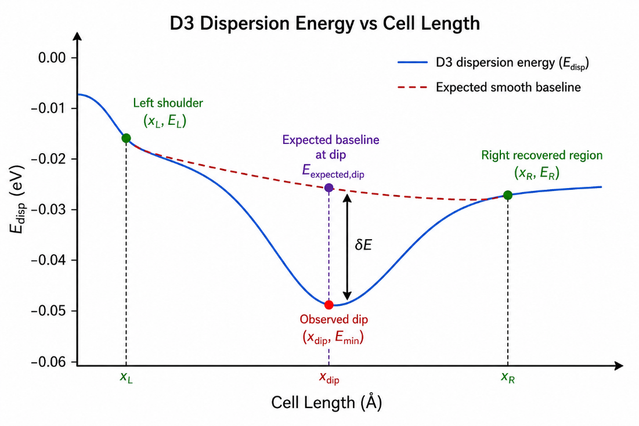
3)D3-Induced Error:
ΔE​=E min​−E expected, dip​
The D3-induced error was calculated from the strained `s-dftd3` dispersion-energy curves using the local peak-dip-recovery baseline method.

Material | Space Group | Dip Cell Length (xdip) | E min (eV) | E expected, dip (eV) | ΔE (eV)
NiO | Fm3m | 3.204500 | -0.031090 | -0.012900 | -0.018230
CoO | F43m | 3.468900 | -0.042810 | -0.019107 | -0.023740
FeO | Fm3m | 2.722090 | -0.091040 | -0.046720 | -0.044320
TiO₂ | I4₁/amd | 5.144195 | -0.033190 | -0.013380 | -0.019820
RuO₂ | P42/mnm | 3.422480 | -0.047050 | -0.038390 | -0.008700
IrO₂ | P42/mnm | 4.289600 | -0.033890 | -0.030380 | -0.003520
SrTiO₃ | Pm3m | 7.174050 | -0.100510 | -0.038770 | -0.061750
LaMnO₃ | Pnma | 8.513580 | -0.222180 | -0.089550 | -0.132650

ΔE order:
$${\text{LaMnO}}_{3}>{\text{SrTiO}}_{3}>\text{FeO}>\text{CoO}>{\text{TiO}}_{2}>\text{NiO}>{\text{RuO}}_{2}>{\text{IrO}}_{2}$$
- LaMnO₃ shows the largest D3-induced error, while IrO₂ shows the smallest, with a clear trend from perovskites to compact rutile structures.

4) Critical Analysis of D3-Induced Error Trends:
The D3-induced error magnitudes follow the trend:
$${\text{LaMnO}}_{3}>{\text{SrTiO}}_{3}>\text{FeO}>\text{CoO}>{\text{TiO}}_{2}>\text{NiO}>{\text{RuO}}_{2}>{\text{IrO}}_{2}$$
Thus, the D3-induced error is governed primarily by structural geometry and coordination changes during expansion, rather than solely by composition or oxidation state. Because D3 is a pairwise, coordination-number-dependent correction, abrupt changes in coordination lead to non-smooth dispersion energy behaviour, resulting in an artificial dip.

Effect of Structure Type:
Perovskites such as LaMnO₃ and SrTiO₃ exhibit the largest errors. These materials contain multiple atomic sublattices and a network of octahedra, resulting in a wide distribution of bond lengths and coordination environments. During expansion, different bonds (A–O, B–O, O–O) stretch at different rates, causing rapid and uneven changes in coordination numbers (CN). Since D3 adjusts dispersion coefficients based on CN, this leads to discontinuities in the energy curve and a large error.
Rutile-type oxides like RuO₂ and IrO₂ show the smallest errors. Their structures are compact and highly regular, with fewer distinct coordination environments. As the lattice expands, the coordination numbers change smoothly and gradually, resulting in a smooth dispersion energy curve and minimal D3-induced error.
Monoxides lie between these extremes. NiO, with its symmetric rocksalt structure, shows stable coordination and a small error. In contrast, FeO has a distorted monoclinic structure, where coordination numbers vary more unevenly under strain, leading to a larger error.

Role of Packing and Ionic Size:
Materials with larger volumes per atom, such as the perovskites, have more open structures. This allows interatomic distances to vary more significantly during expansion, which in turn causes larger fluctuations in coordination numbers. These rapid CN changes amplify the D3 error. However, packing alone does not fully determine the trend, as similar volumes can still produce different errors depending on structural topology.

Oxidation State and Electronic Effects:
Oxidation state does not show a direct correlation with the magnitude of the error. For example, TiO₂, RuO₂, and IrO₂ all contain tetravalent metals but display different error magnitudes. This indicates that coordination behaviour and geometry dominate over oxidation state.
Similarly, although heavier elements are more polarizable and contribute more strongly to dispersion interactions, this does not necessarily lead to larger errors. IrO₂, despite containing a heavy element, shows the smallest error due to its smooth coordination changes and compact structure.

Key Anomalies:
IrO₂ is a key example where high atomic weight does not result in a large error. Its small D3 error arises from its uniform coordination environment and gradual CN variation.
FeO, despite being a simple binary oxide, shows a large error because its distorted structure causes uneven coordination-number changes.
LaMnO₃ exhibits the largest error due to its distorted perovskite structure, large A-site cation, and Jahn–Teller-active Mn³⁺, all of which produce highly non-uniform coordination environments and abrupt CN changes during expansion.
CoO and NiO, despite having the same rocksalt structure, show different errors, highlighting sensitivity to subtle coordination changes. Likewise, TiO₂ and RuO₂ have the same oxidation state but differ due to structural compactness. These cases confirm that coordination evolution, not just composition, controls the D3 error.

Conclusion
Overall, the D3-induced error is fundamentally a coordination-number-driven, geometry-dependent artifact. It is largest in open and distorted structures where coordination numbers change abruptly with strain, and smallest in dense, symmetric structures where coordination evolves smoothly.

