**Stack Buffer Over flow testing and fixing vulnerable code snippets**

**BAD example which is vulnerable towards array out of bound issue.**

Broken and vulnerable code:

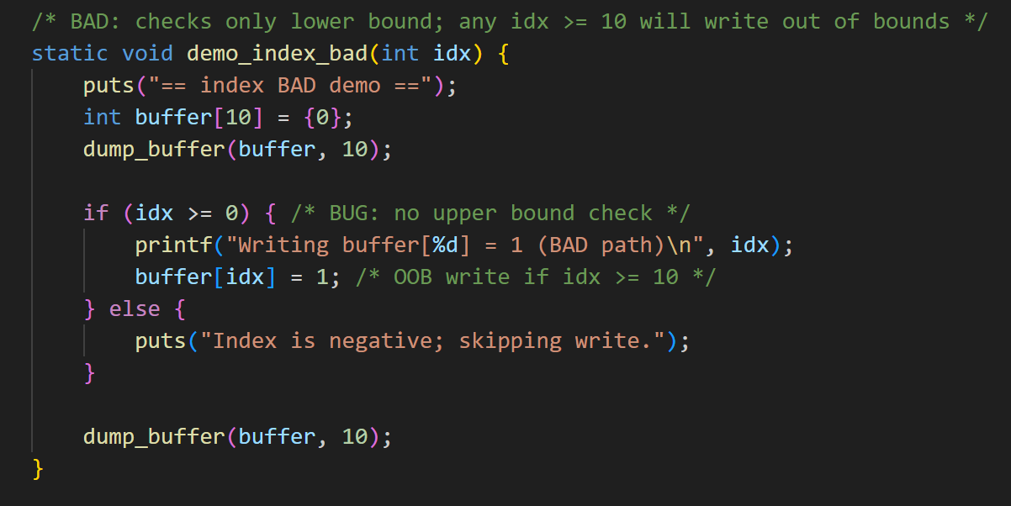

Code Fix done:

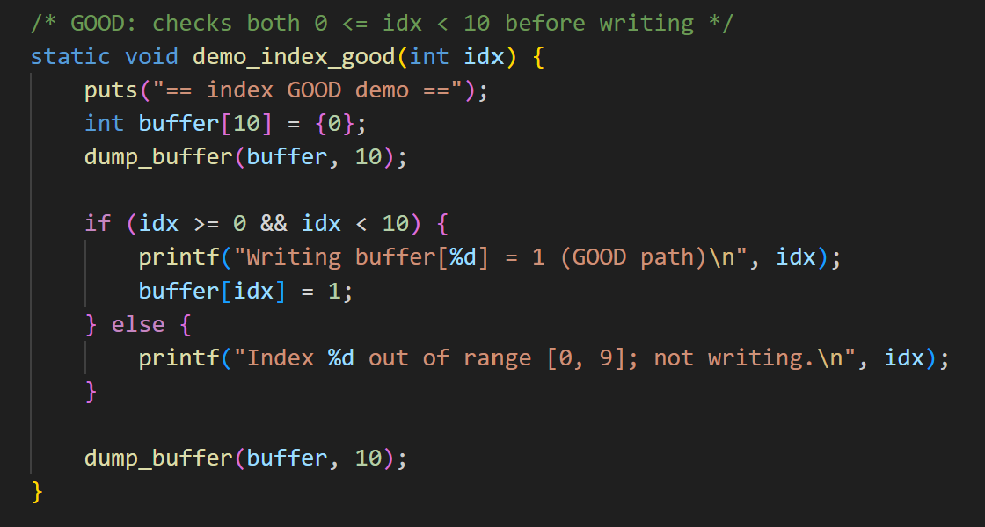

**Implementation Results:**

Output from Bad and Vulnerable code, stack overflow happens and it overwrites the memory.

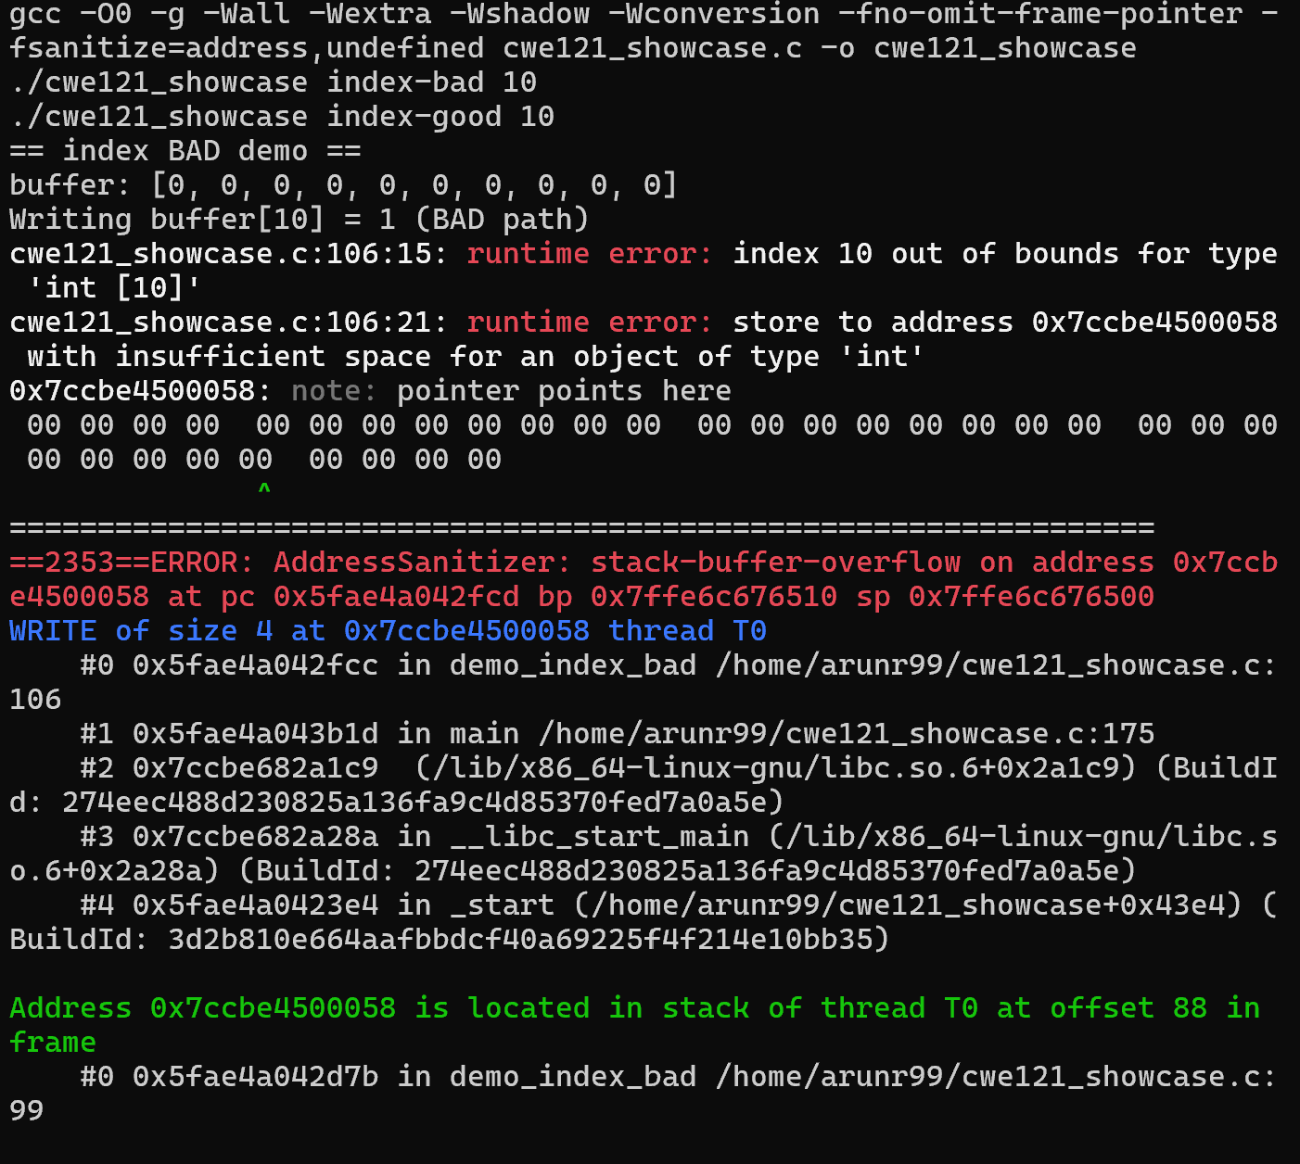

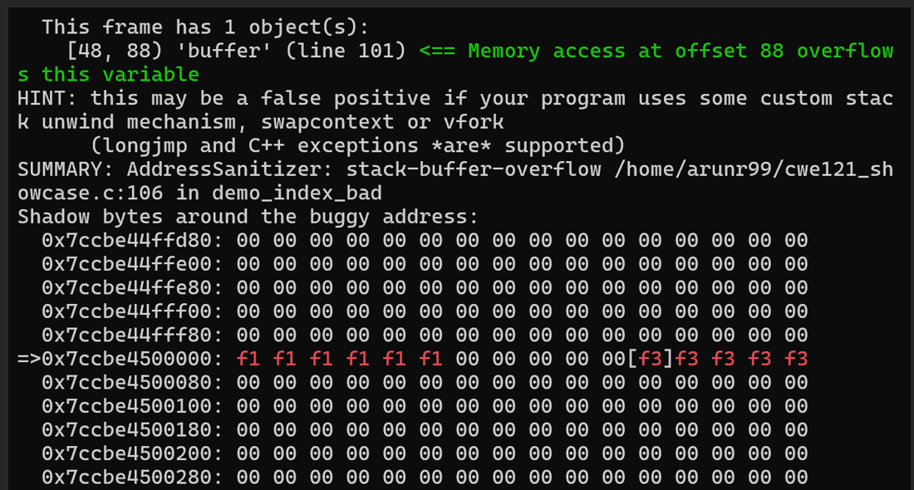

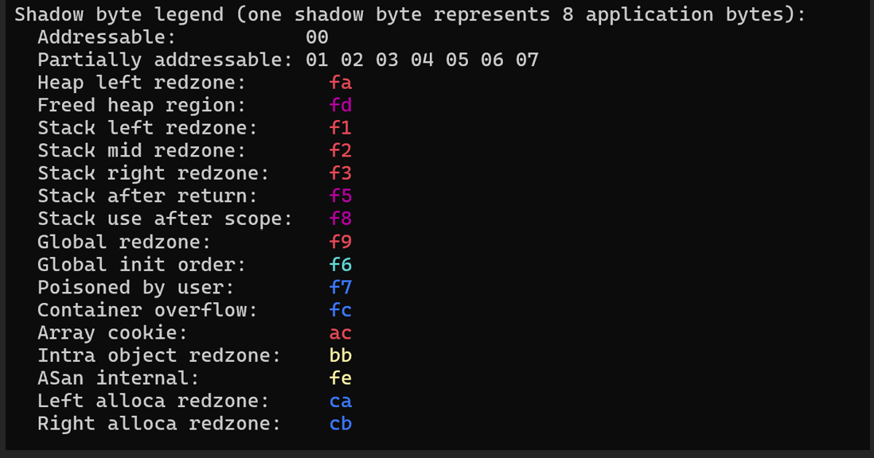

Output from Fixed code, runs successfully without causing an array out of bounds as stack overflow has been fixed here.

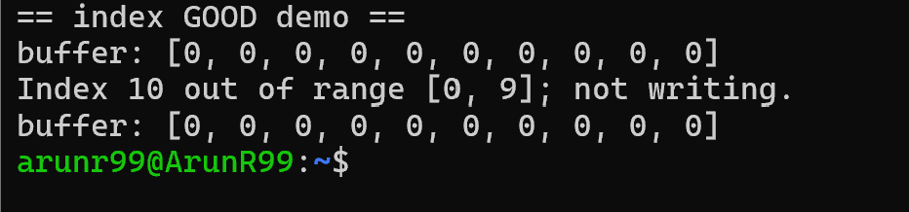

**BAD example which is vulnerable towards a Memory copy issue.**

Broken and vulnerable code:

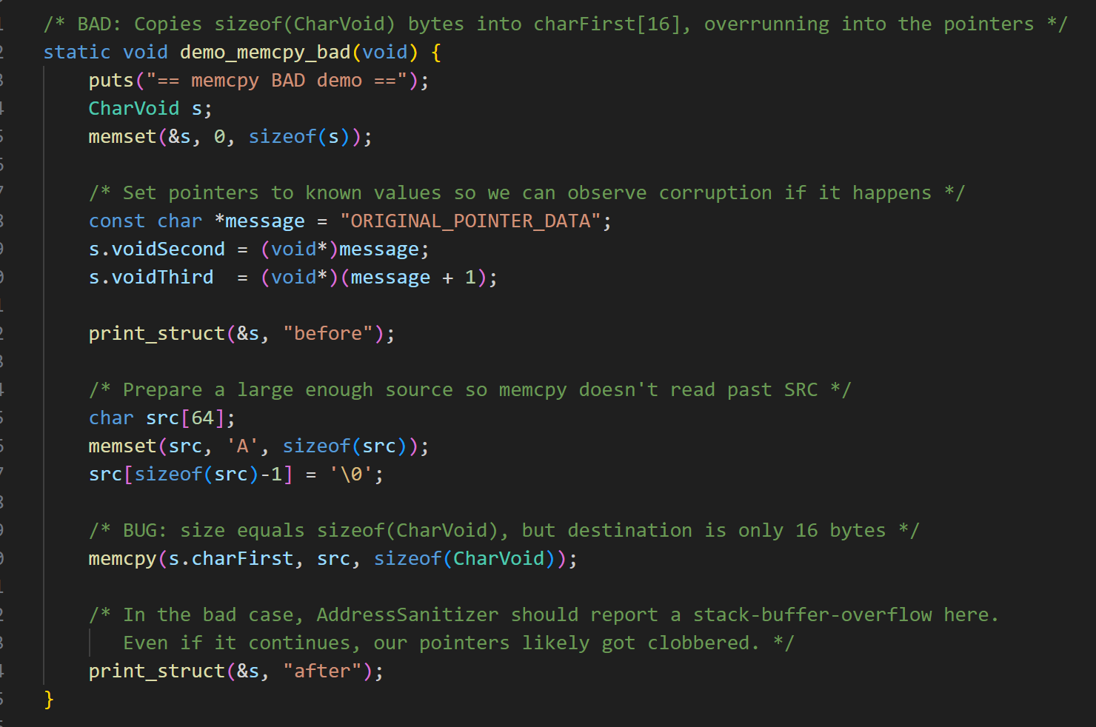

Code Fix done:

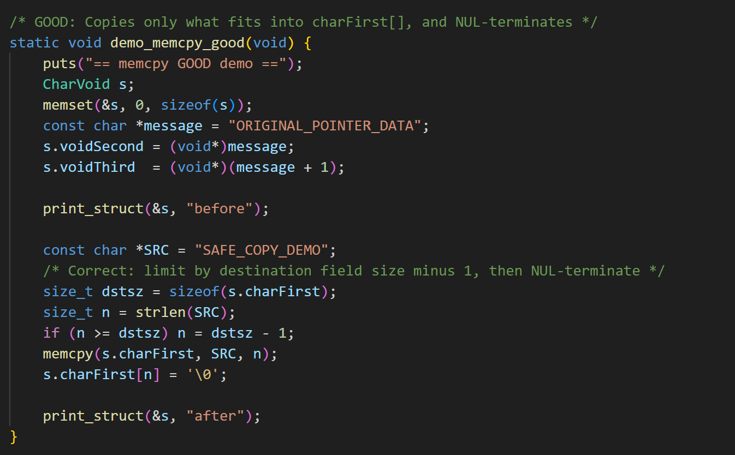

**Implementation Results:**

Output from Bad and Vulnerable code, buffer overflow happens dues to the memory copy issue.

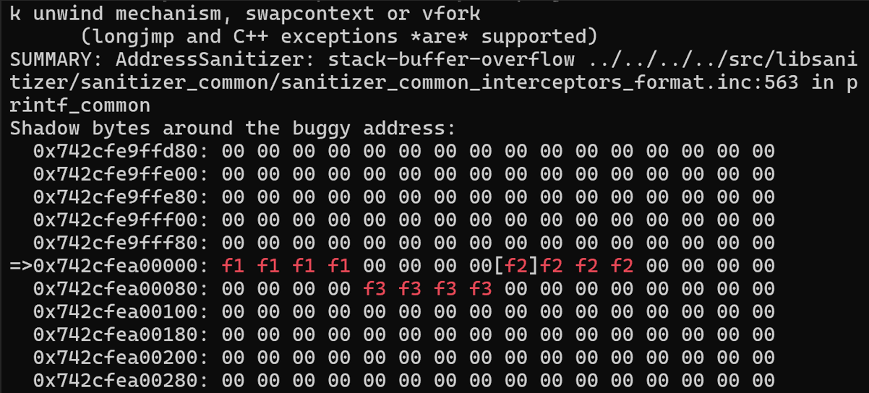

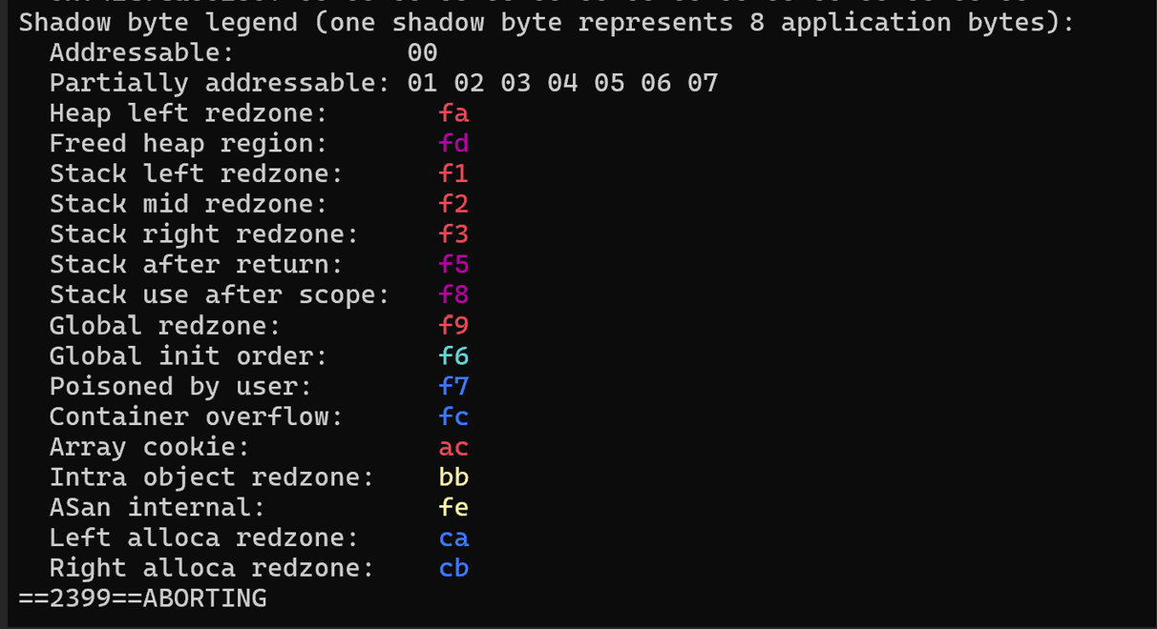

Output from Fixed code, runs successfully without causing any memory copy issue as the buffer overflow has been fixed.

