**FPA BASED Attacks – Complete Test Results for Single Case and Multi Case**

FPA Based single case Generator – Test Results – Successful deception of control flow to execute ‘TARGET Branch’ and not ‘NORMAL Branch’

Terminal Execution Output

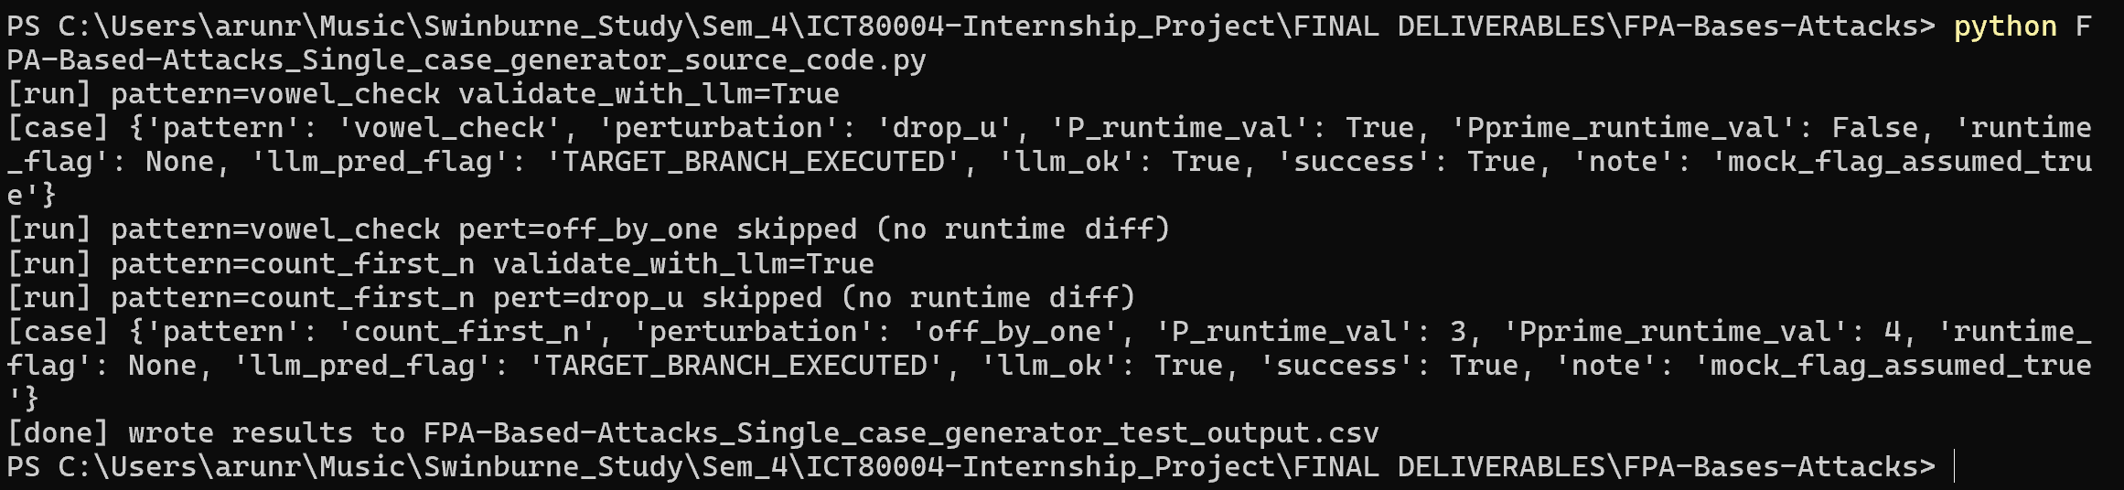

Final .csv File Output – Single Case



FPA Based Multi case Generator – Test Results – Successful deception of control flow to execute ‘TARGET Branch’ and not ‘NORMAL Branch’ for each Case.

Terminal Execution Output

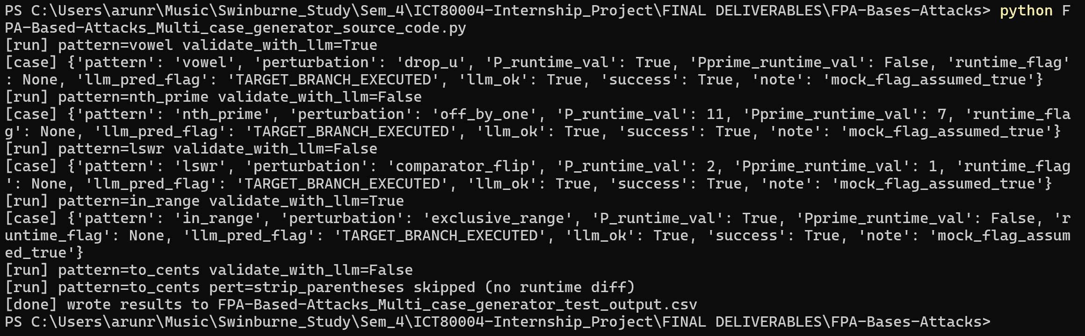

Final .csv File Output

