**COS80023 Big Data – Lab 2**

**Lab 2: Pass Task 2 – Storage**

**Student Name: Arun Ragavendhar Arunachalam Palaniyappan**

**Student ID: 104837257**

Lab 2 was about creating an SQL DB, server and tables in the database on Microsoft Azure.

Once the tables were created, a query was run that shows the suppliers and their products (Supplier name, country, product name, unit and price).

The SQL query used:

SELECT SupplierName,Country,ProductName,Unit,Price

FROM Suppliers s JOIN Products p

ON s.SupplierID = p.SupplierID

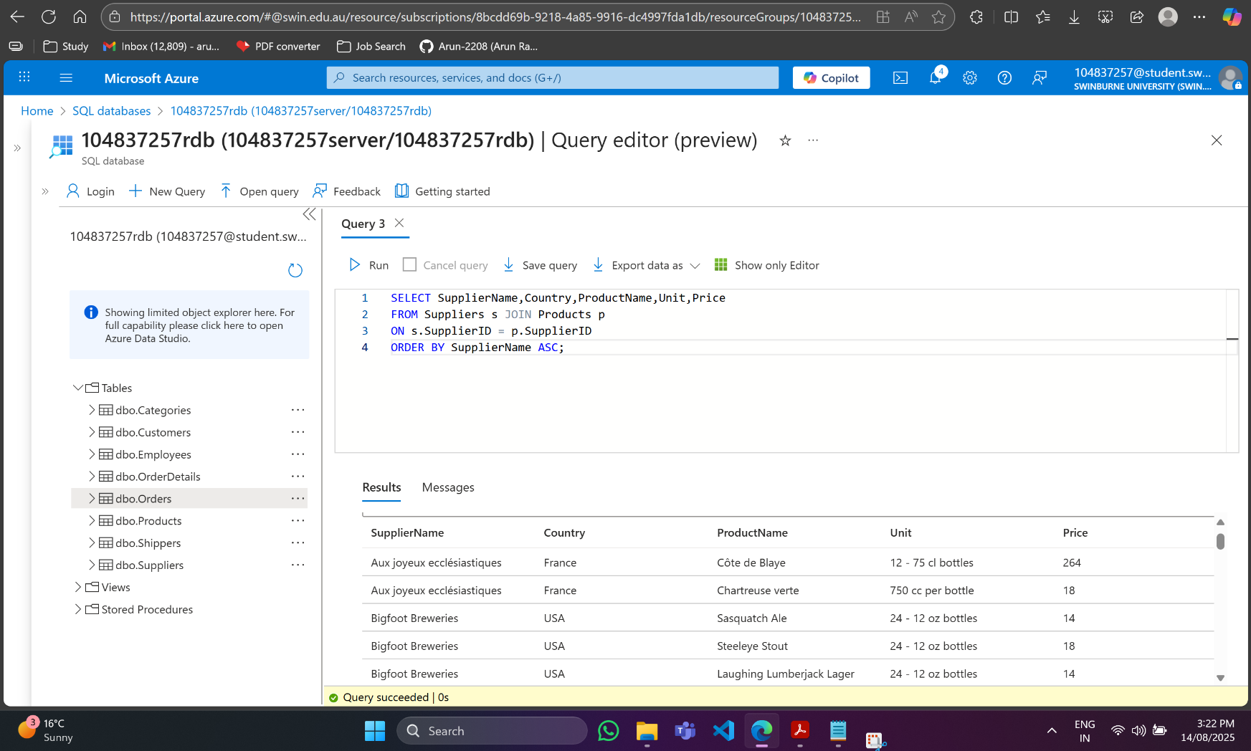ORDER BY SupplierName ASC;