COS80023 Big Data – Lab 6 – Credit Task
Lab 6: Credit Task 6 – Messaging with Kafka
Student Name: Arun Ragavendhar Arunachalam Palaniyappan
Student ID: 104837257
Zookeeper Instance Started
Kafka Broker Started
Creating topics streams-plaintext-input and streams-wordcount-output.
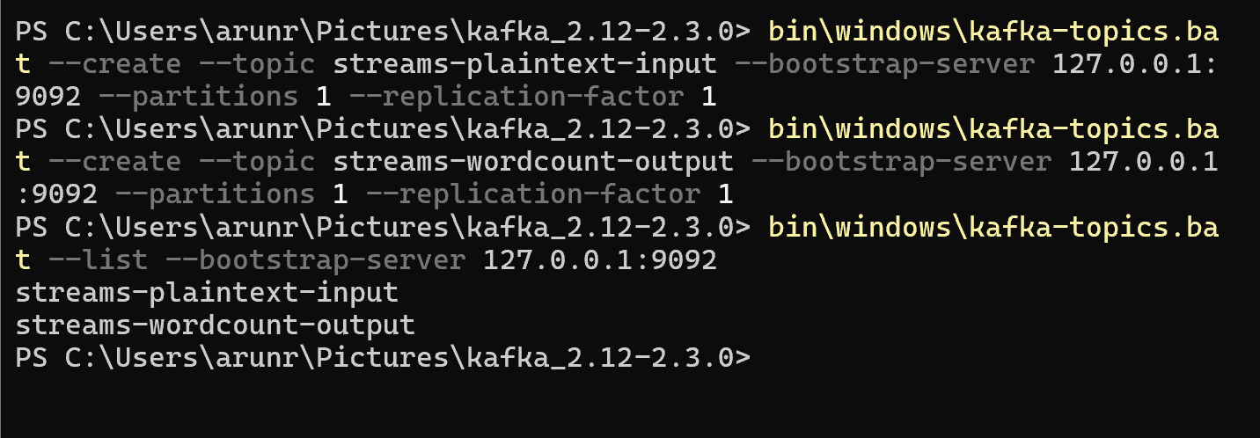
Starting the Wordcount java module.
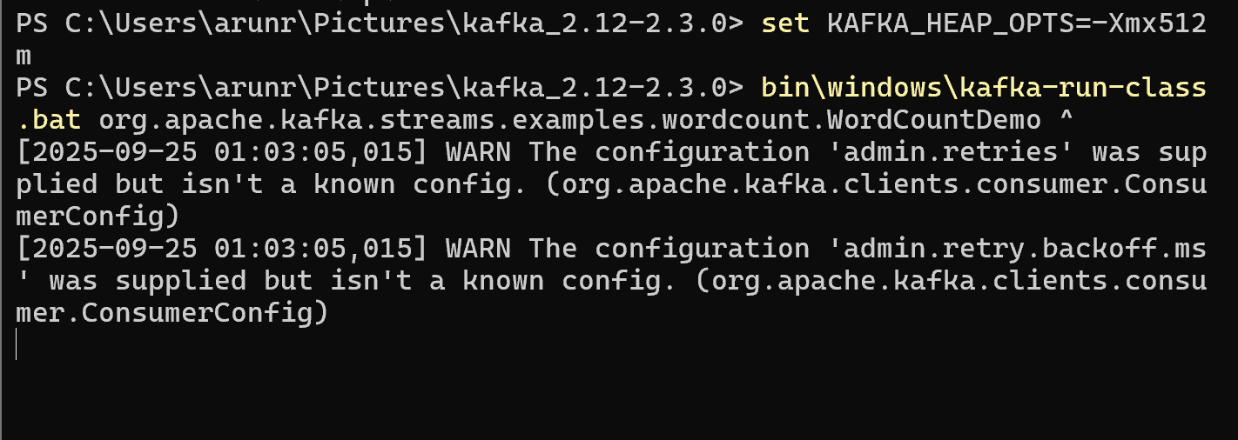
Main Results:
Producer that connects to streams-plaintext-input and input typed.
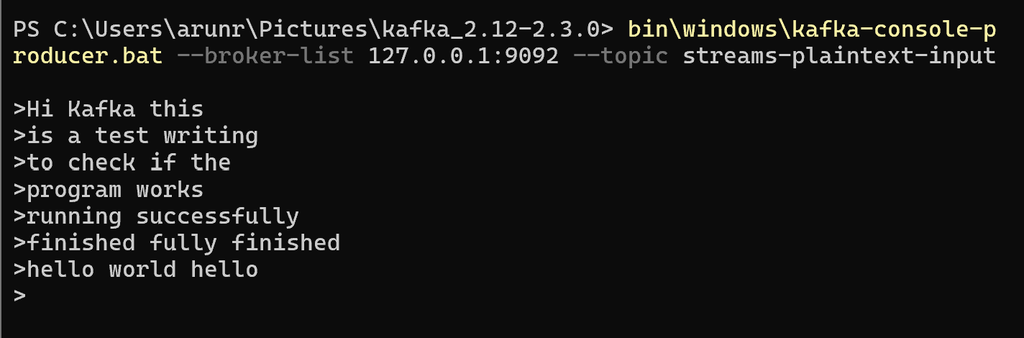

Consumer that connects to streams-wordcount-output and output observed.
