COS80023 - Big Data

Learning Summary Report

Student Name: Arun Ragavendhar Arunachalam Palaniyappan
Student ID: 104837257
Tutor: Dr. Afzaal Hassan
Class: Thursday 14:30-16:30

Self-Assessment Details
The following checklists provide an overview of my self-assessment for this unit.

 | Pass  (P) | Credit  (C) | Distinction  (D) | High Distinction  (HD)
Self-Assessment (please tick)
Self-assessment Statement

Included (please tick)
Learning Summary Report
Pass tasks are marked as correct on Canvas
Credit tasks are marked as correct on Canvas (optional)
Distinction/High Distinction plan has been approved on Canvas (optional)
Distinction/High Distinction report has been submitted on Canvas (optional)
Distinction/High Distinction interview has been booked (optional)
Submission Checklist

Declaration
I declare that this portfolio is my individual work. I have not copied from any other student’s work or from any other source except where due acknowledgment is made explicitly in the text, nor has any part of this submission been written for me by another person.

Signature:
Introduction
I am writing this report to summarise what I learned in COS80023 Big Data. It includes my self-assessment against the unit learning outcomes, a short note on why I chose each piece of evidence, a clear account of how my work meets each outcome, and a reflection on my learning. My evidence spans all lectures, ten weekly labs (Weeks 1–10), and a Distinction/High-Distinction exploratory data analysis project in R on Victorian crash data. Together, these show end-to-end skills: setting questions, preparing and joining multi-table data, querying different storage models, building and checking visuals and statistics, and turning findings into practical actions.
Coverage of the Unit Learning Outcomes
This section explains how the included work shows my depth of understanding for each intended learning outcome of the unit.
ULO 1: Challenges and Opportunities of Big Data
Explain Big Data’s hurdles and advantages, covering computing needs, privacy, and security, and relate these to what organisations can achieve with it.
What I learned: I can explain both sides. Opportunities: better decisions, faster services, new value from combining sources. Challenges: storage and extract, multi-format integration, data quality, privacy, etc. I paired each challenge with a practical response (cloud/distributed storage, simple ETL, validation rules, clear retention, measured cost controls).
My evidence:
- Lab 1: Pass Task 1, Q1 (Opportunities).
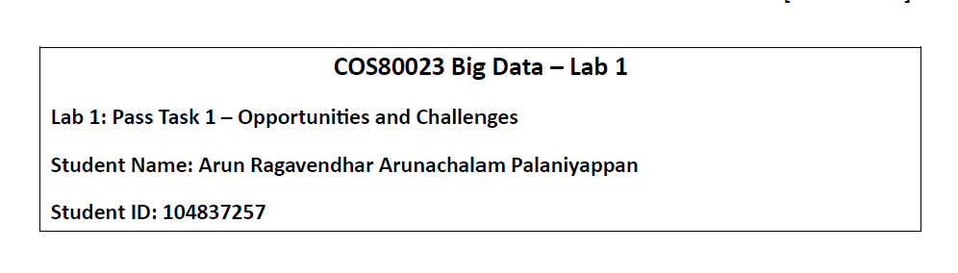
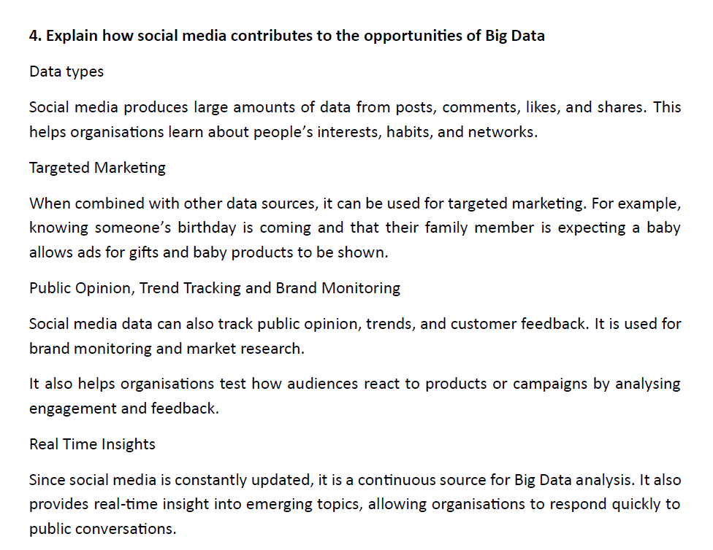
- Lab 1: Pass Task 1, Q2 (Challenges + how I would handle them).
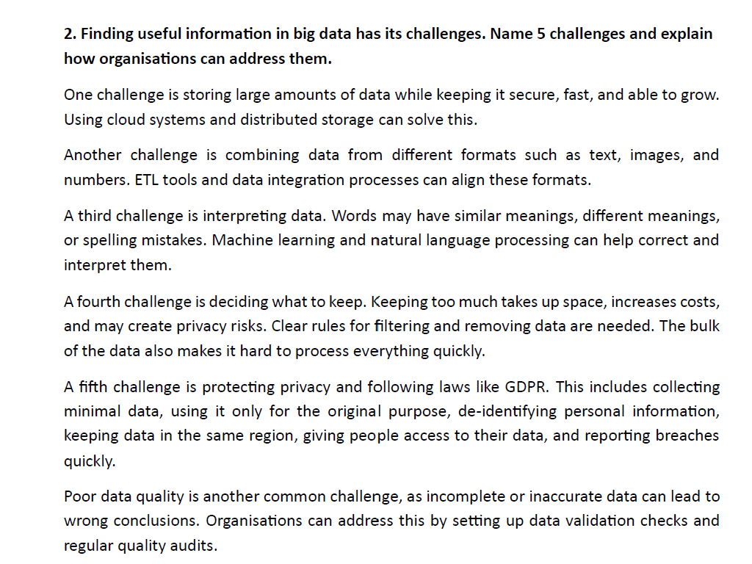
- Lecture 1: slide titled “Why are people interested in it?”
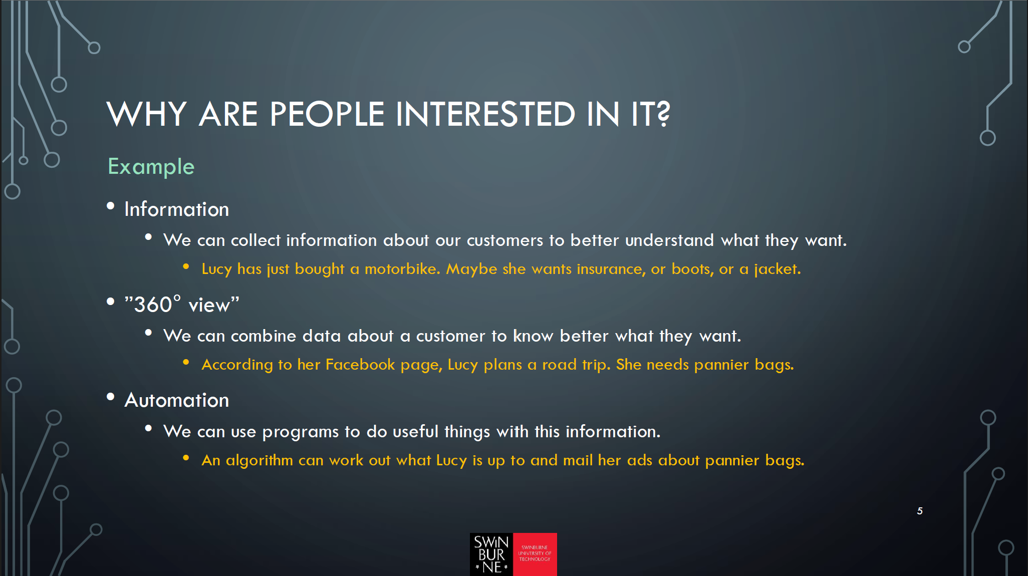
- Final Project: Figure: “Exposure (share %) vs severity (per 1,000) by speed.”
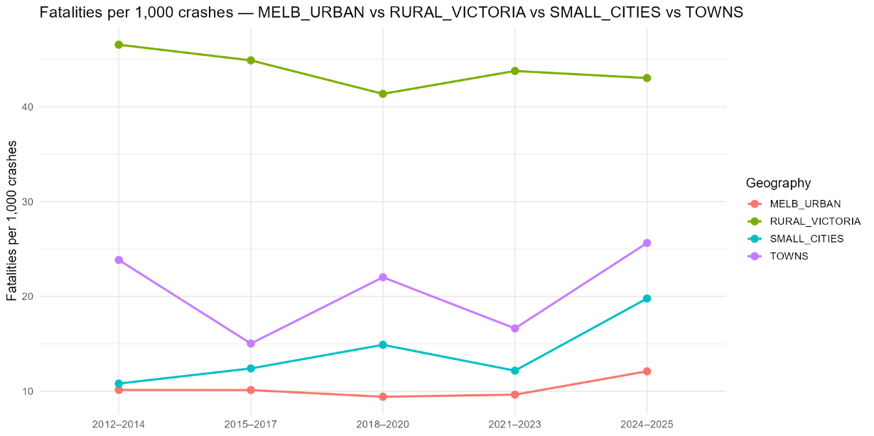

How I applied it: In the D/HD project, I took nine tables which had road accidents related data, kept the ‘crashes’ as the unit of measurement, joined the tables on ACCIDENT_NO key, grouped by five different time blocks and four geographical regions, and reported fatalities per 1,000 crashes with exposure share. This produced an actionable finding: speed in rural roads with ≥90 km/h and mid-blocks and T-intersections carry the highest fatal risk.
Why this meets ULO 1: I show the organisational potential (turn raw data into decisions) and the practical hurdles (scale, heterogeneity, quality, privacy), with evidence from labs, lectures, and a full project where I applied those trade-offs end-to-end.

ULO 2: Storing and Managing Data
Suggest practical, efficient ways to store and manage very large datasets.
What I learned: I learned to choose the right store for the job (cloud SQL, HDFS/Blob), design stable keys and tables so that joins work, and manage the data on the HD clusters.

My evidence:
- Lab 2: Azure SQL Query Editor: portal view with my database/tables and the join output listing SupplierName, Country, ProductName, Unit, Price.
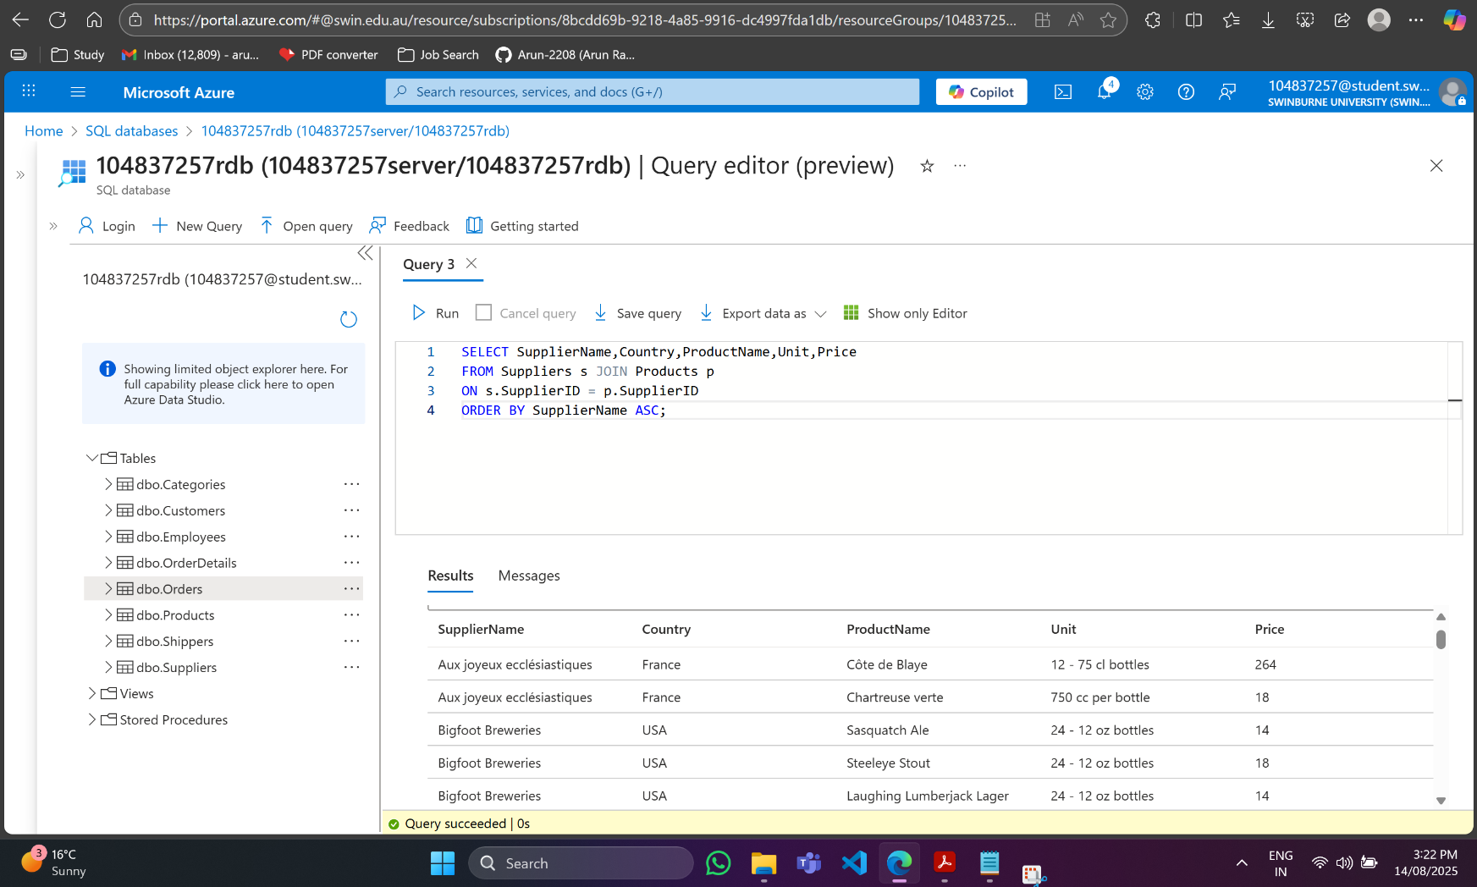

- Lab 4: HDInsight + WASB/ADLS.
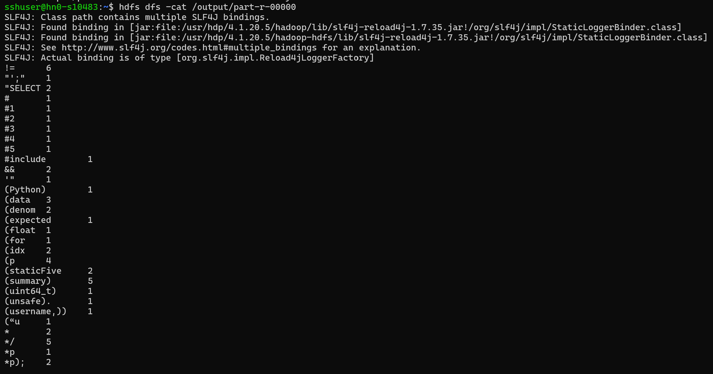
How I applied it: For relational data, I used Azure SQL to create tables and verify joins in the portal. For distributed files, I showed how HDInsight reads/writes via WASB/ADLS, mapping input and output paths clearly.
Why this meets ULO 2: I proposed and used practical storage options (cloud SQL, Blob/HDFS) and demonstrated data storage and management patterns with verifiable screenshots that show set-up, data stored, and results.
ULO 3: Information Retrieval
Use the right tools to query different kinds of data stores, including NoSQL systems.
What I learned: I learned to pull data from different stores and formats, streams (Kafka), and multi-table files (CSV in a project folder) in the final project work on the accidents data and use the right tools to turn them into usable results (CLI consumers for streams; R/dplyr for linked tables).
My evidence:
- Lab 6: Kafka/Zookeepers: terminal screenshots showing producer terminal (typed messages), and consumer terminal (received messages).
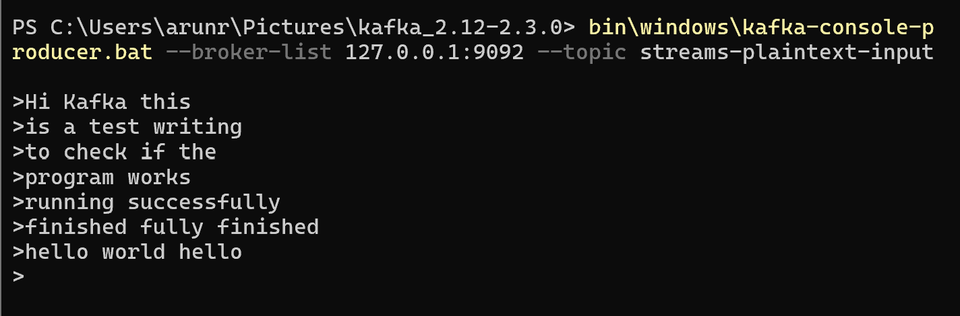
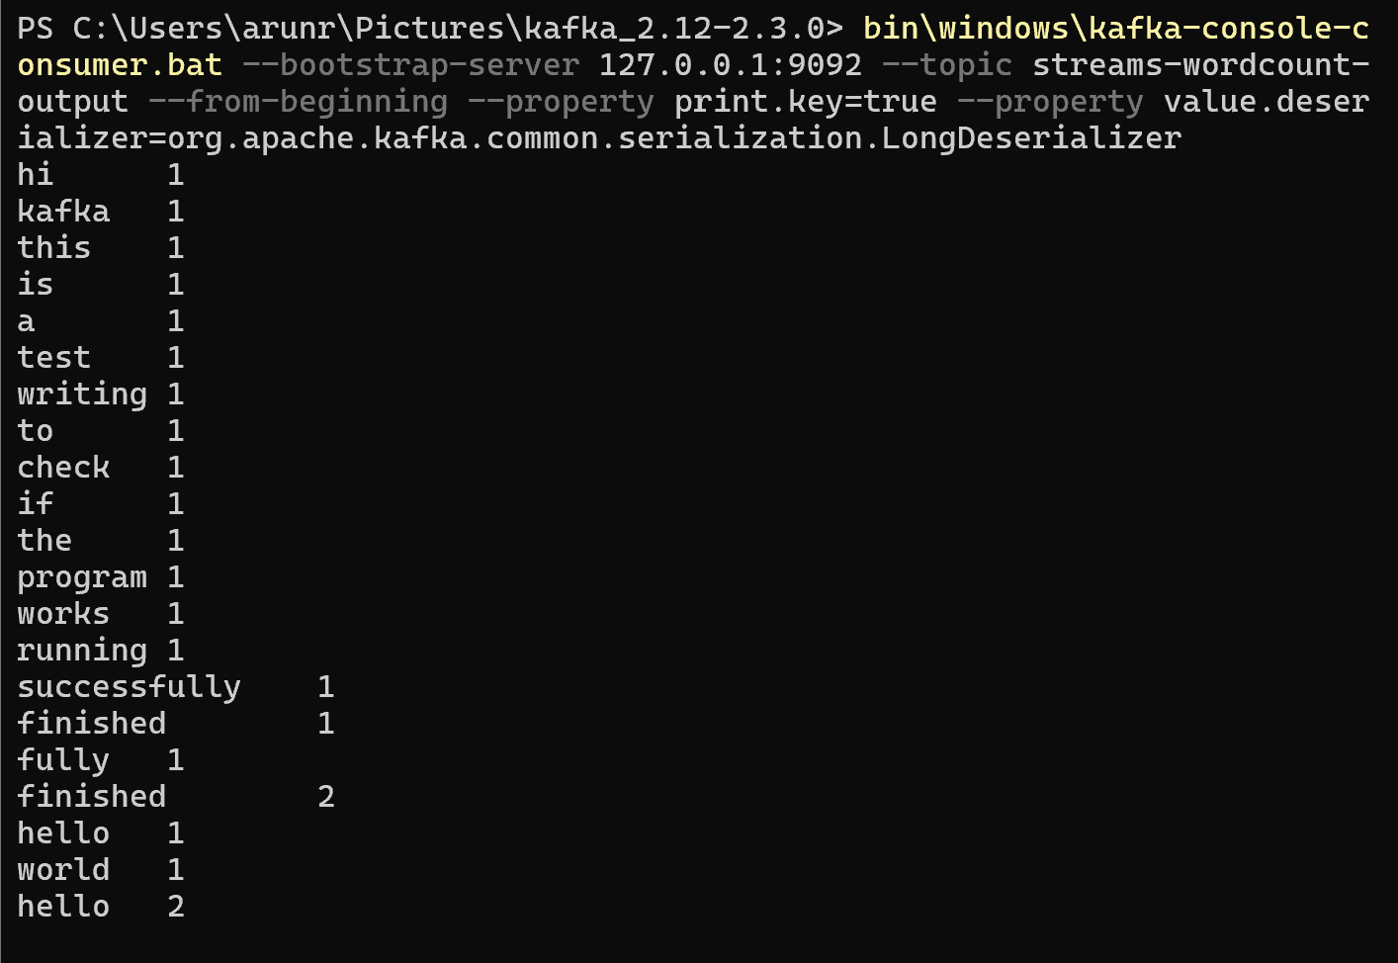

- Exposure (share %) vs severity (per 1000) by road geometry, part of the works done regarding information retrieval, filtering, aggregation and analysis in the final project.

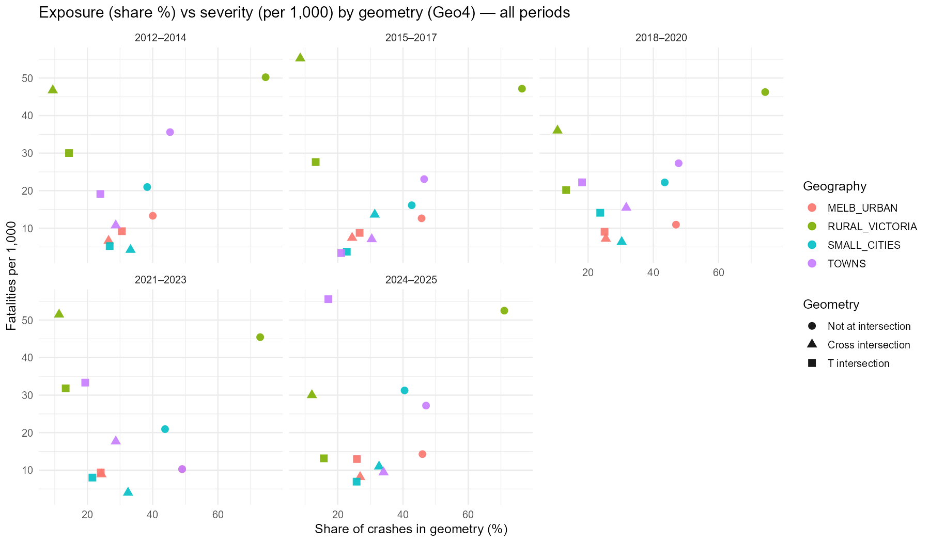
How I applied it: From the stream side, I retrieved live data by creating Kafka topics, sending messages with the producer, and reading them with the consumer CLI to confirm end-to-end flow. In the exploratory data analysis for the final project, I retrieved and joined six CSV tables on ACCIDENT_NO in R, filtered to five different time blocks and four regions, and queried the combined data with dplyr to produce simple, comparable tables (counts, fatalities, fatalities per 1,000, exposure share) that feed the figures.
Why this meets ULO 3: I used efficient tools for each store: Kafka CLI to retrieve records from a stream, and R/dplyr to query linked file tables at scale. The project shows I can turn raw, multi-source input into precise answers (e.g., where and when risk is highest), and Lab 6 shows I can retrieve information from a non-relational streaming system.
ULO 4: ETL
Choose and apply suitable technologies and methods to extract data and combine it from sources with different levels of structure.
What I learned: I learned how to take data from different places (CSV files and a small stream) and turn it into clean tables I can reuse. I kept the raw data, fixed types and missing values, removed duplicates, and saved tidy outputs.
My evidence:
- Lab 5 (Pig, CSV to tidy output): I loaded a CSV, filtered out headers/blank rows, picked the columns I needed, grouped by a key (like country or payment type), added simple totals, sorted the results, and saved them to an output folder.
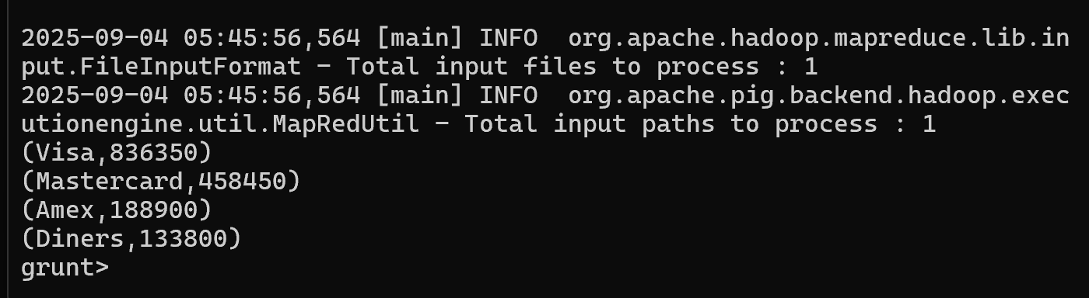
- Final project (crash data, end-to-end): I brought in the nine CSV tables, joined them by ACCIDENT_NO, fixed labels (lighting/surface/weather), removed duplicate records by keeping the newest, and saved a final table by year and region so charts load fast.

How I applied it: I first saved the raw files as it is, then made a cleaned copy with proper types and labels and finally wrote an analysis-ready table. I checked counts after each step and made sure joins on ACCIDENT_NO didn’t lose rows.
Why this meets ULO 4: I compared simple tools (Pig vs my project steps) and applied them to extract and combine data with different shapes into one clean, reliable table that supports the analysis.

ULO 5: Machine Learning
Judge whether the extracted information is reliable and useful by applying appropriate statistical checks.
What I learned: I learned to judge if results are trustworthy and useful by using simple checks: split the data into train/test, look at a confusion matrix, and read accuracy, sensitivity, and specificity together (not just one number). I also learned to watch for overfitting and use cross-validation to confirm the model holds up on new data.
My evidence:
- Lab 7 (basics of ML): I practised simple stats first, mean, spread, plots, and then the key ML ideas: the difference between supervised and unsupervised work, how overfitting shows up (good on train, worse on test), and how cross-validation gives a fairer score than a single split.
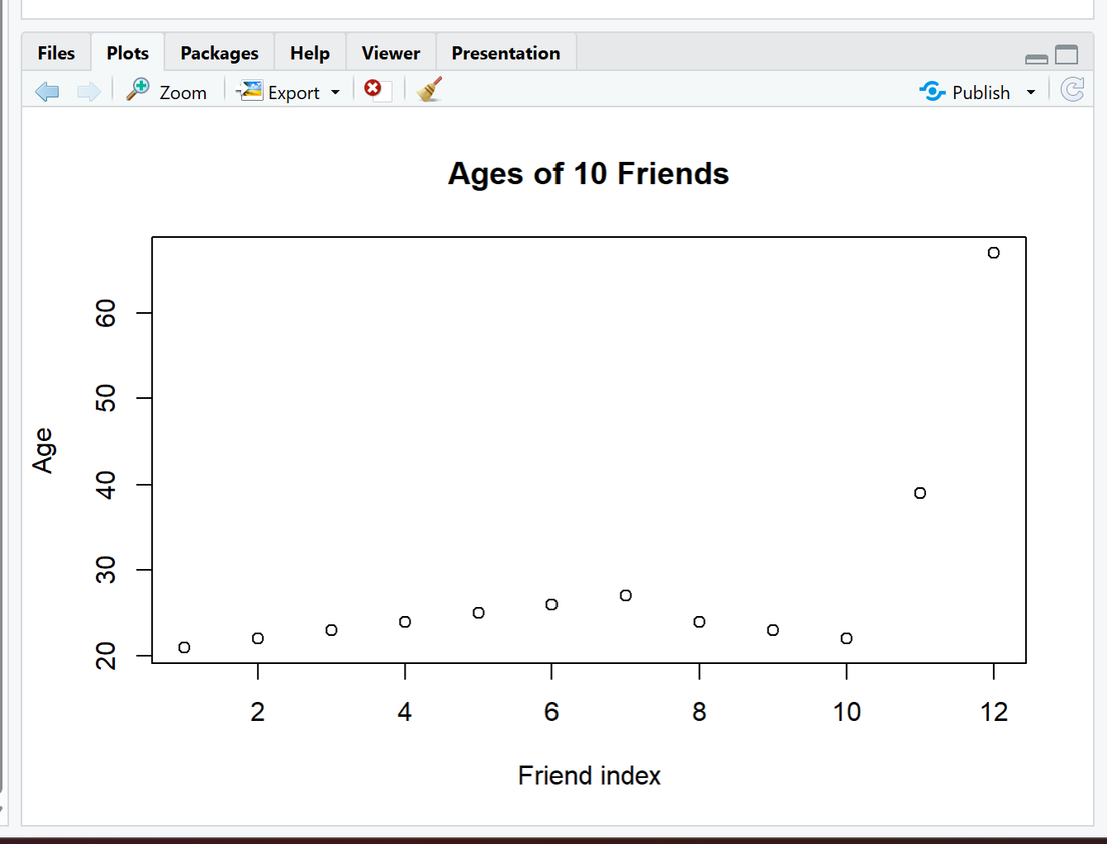
- Lab 8 (classifiers): I trained two small models (SVM and Random Forest) on iris and compared them using the same train/test split. I checked the confusion matrix per class and picked the better model based on test results, not just train results.
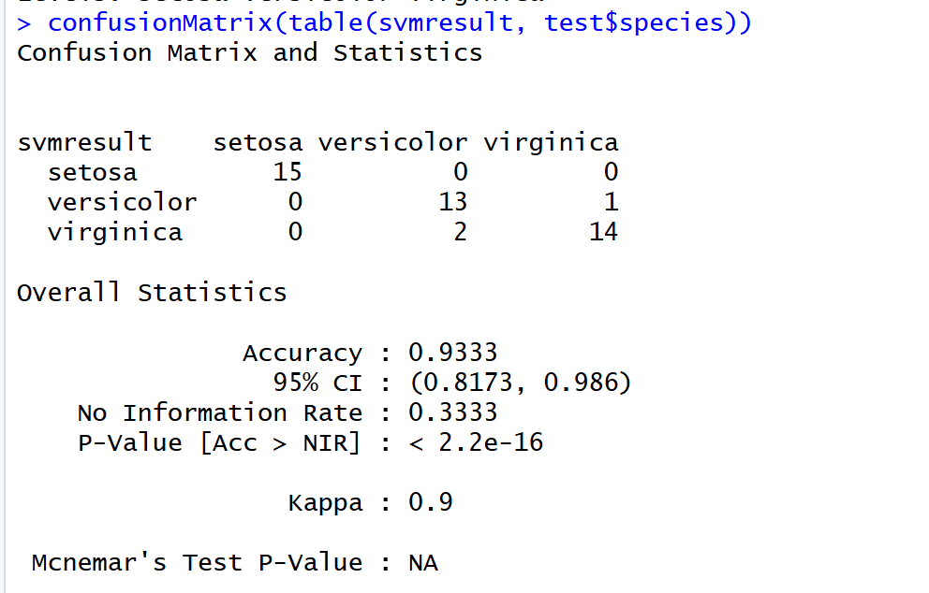

- Lab 9 (NLP spam filter): I cleaned text, built simple word features, and trained a model to tell ham from spam. Because the classes were uneven, I checked sensitivity and specificity, not just accuracy, and noted where the model missed spam so I could improve it (features or threshold).

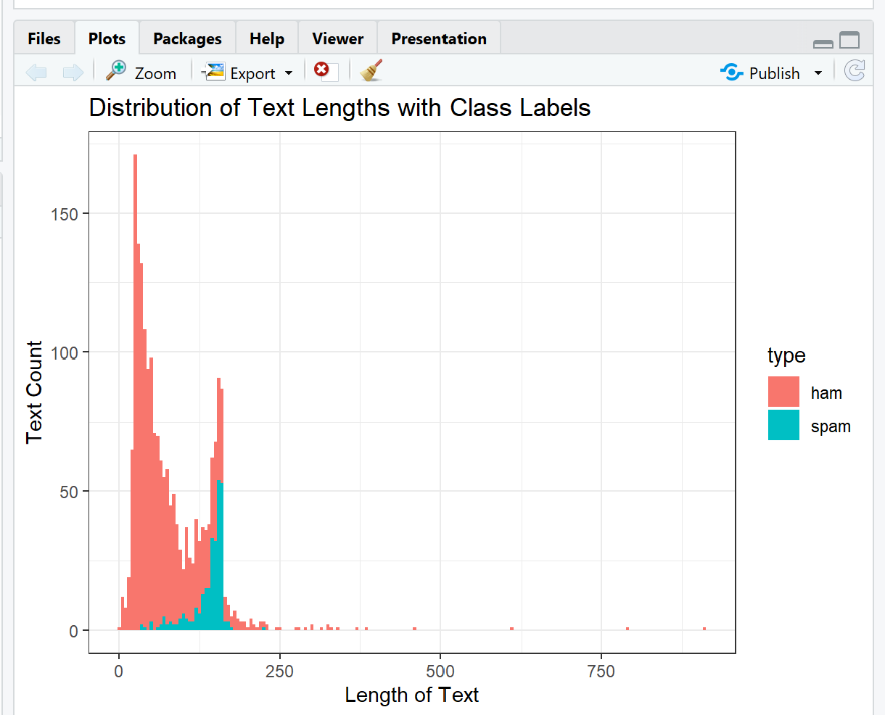
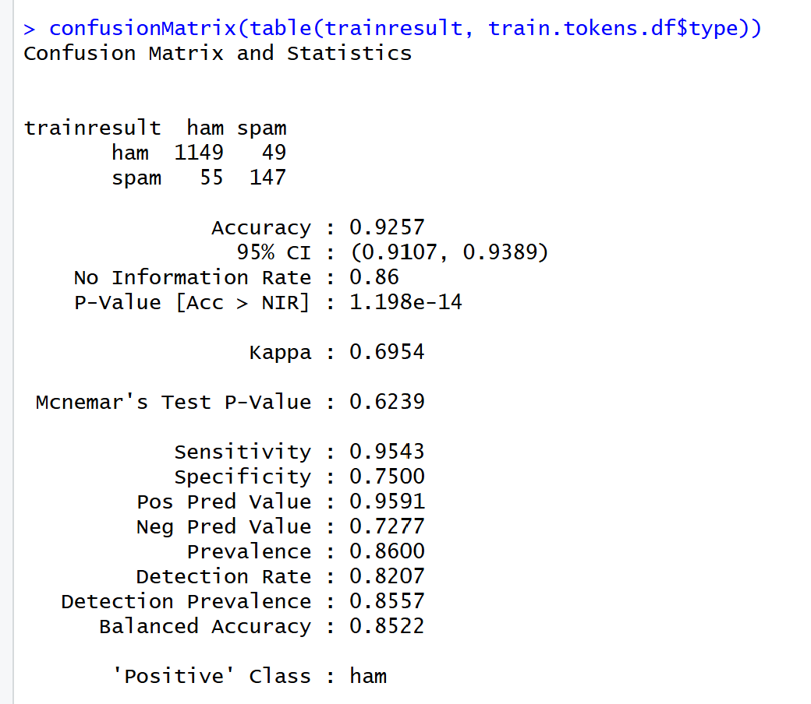

How I applied it: For each lab I kept the same routine: make a clean train/test split, train more than one model, and compare them with the same metrics; check class-by-class results; and confirm with cross-validation when possible. If train and test were close, I trusted the model; if not, I simplified or tried a different one.
Why this meets ULO 5: I used simple, clear statistics to judge the quality of the results and chose models that were fit for purpose, fair on new data, balanced across classes, and explained with numbers anyone can read.
Reflection
The most important things I learned: I learned to start with a clear question, keep the raw data safe, and build small steps I can trust. In the project, I joined the crash tables by ACCIDENT_NO, checked counts at each step, and only then made charts. This simple routine, of going from questioning to joining to checking to showing (the excel tables), kept me honest and helped me find where rural roads and higher speeds made crashes deadlier, in my final project.
What helped me most: Short, hands-on runs helped the most. In Lab 6 (Kafka) I sent a few lines like ACCIDENT_NO=V12345, speed_zone=100 and watched the consumer receive the same lines immediately, streams finally “clicked.” In Lab 5 (Pig) I loaded a messy CSV, dropped header/blank rows, grouped by country and payment type, and saved tidy totals; cleaning first made every later step easier. Training two small models’ side by side (SVM vs Random Forest) and reading the confusion matrix made model choice feel real, not theoretical.
What I found challenging: Messy labels and near-duplicates were the hardest. In the crash data in the project, the same event could appear more than once or with slight changes. I fixed this by keeping the newest record (based on update time) and using simple label maps for lighting, surface, and weather. In ML, it was tempting to trust a high accuracy, but class imbalance (like spam vs ham) forced me to check misses and weigh the cost of false alarms vs misses.
What I found most interesting: I liked putting share of crashes and deaths per 1,000 crashes side by side. It showed where volume is high, but risk is normal, and where volume is low, but risk is extreme. That contrast led to practical ideas: focus on rural mid-blocks and T-intersections at higher speeds, especially where surface quality is poor.
What I learned well: I built a repeatable way of working: save raw files, make a clean copy with fixed types and labels, join with one key, and check counts after each step. For ML, I now follow a small routine: split train/test, try more than one model, read the confusion matrix per class, and use cross-validation when possible.
What I still need to work on: I need to explain uncertainty better. Instead of “the model is good,” I should say “it got these classes right and struggled here,” with a short note on likely reasons (e.g., very short spam lines). I also want to automate basic checks (row counts, missing joins) so I can run them with one command.
My progress in this unit: I started by following lab steps and ended by setting my own steps for the project. Early on I copied examples; later I adapted them to fit the crash data and saved a final year×region table so charts load fast. The biggest jump was moving from “does this code run?” to “does this result make sense, and can I prove it?”
How this will help me in the future: At work I can pull data from different places, clean it, and show a clear, fair result that others can repeat. I can compare simple models on the same test set, explain trade-offs in plain English, and link findings to action (like where to focus road-safety work).
If I did this unit again: I would set up folders and checks on day one, write shorter notes after each lab, and lock a simple naming scheme for tables and charts. I would also decide earlier which two models to compare and stick with them to save time.
Other reflections: Small, clear wins build trust. A working Kafka send/receive, a Pig group-by that matches hand totals, a confusion matrix anyone can read, and a final table that reproduces the chart, these steps turned a big topic into work I can deliver and explain.

Supporting evidence and screenshots for completing all task in this unit (both mandatory and optional):
Pass tasks are marked as correct on Canvas and Credit tasks are marked as correct on Canvas.
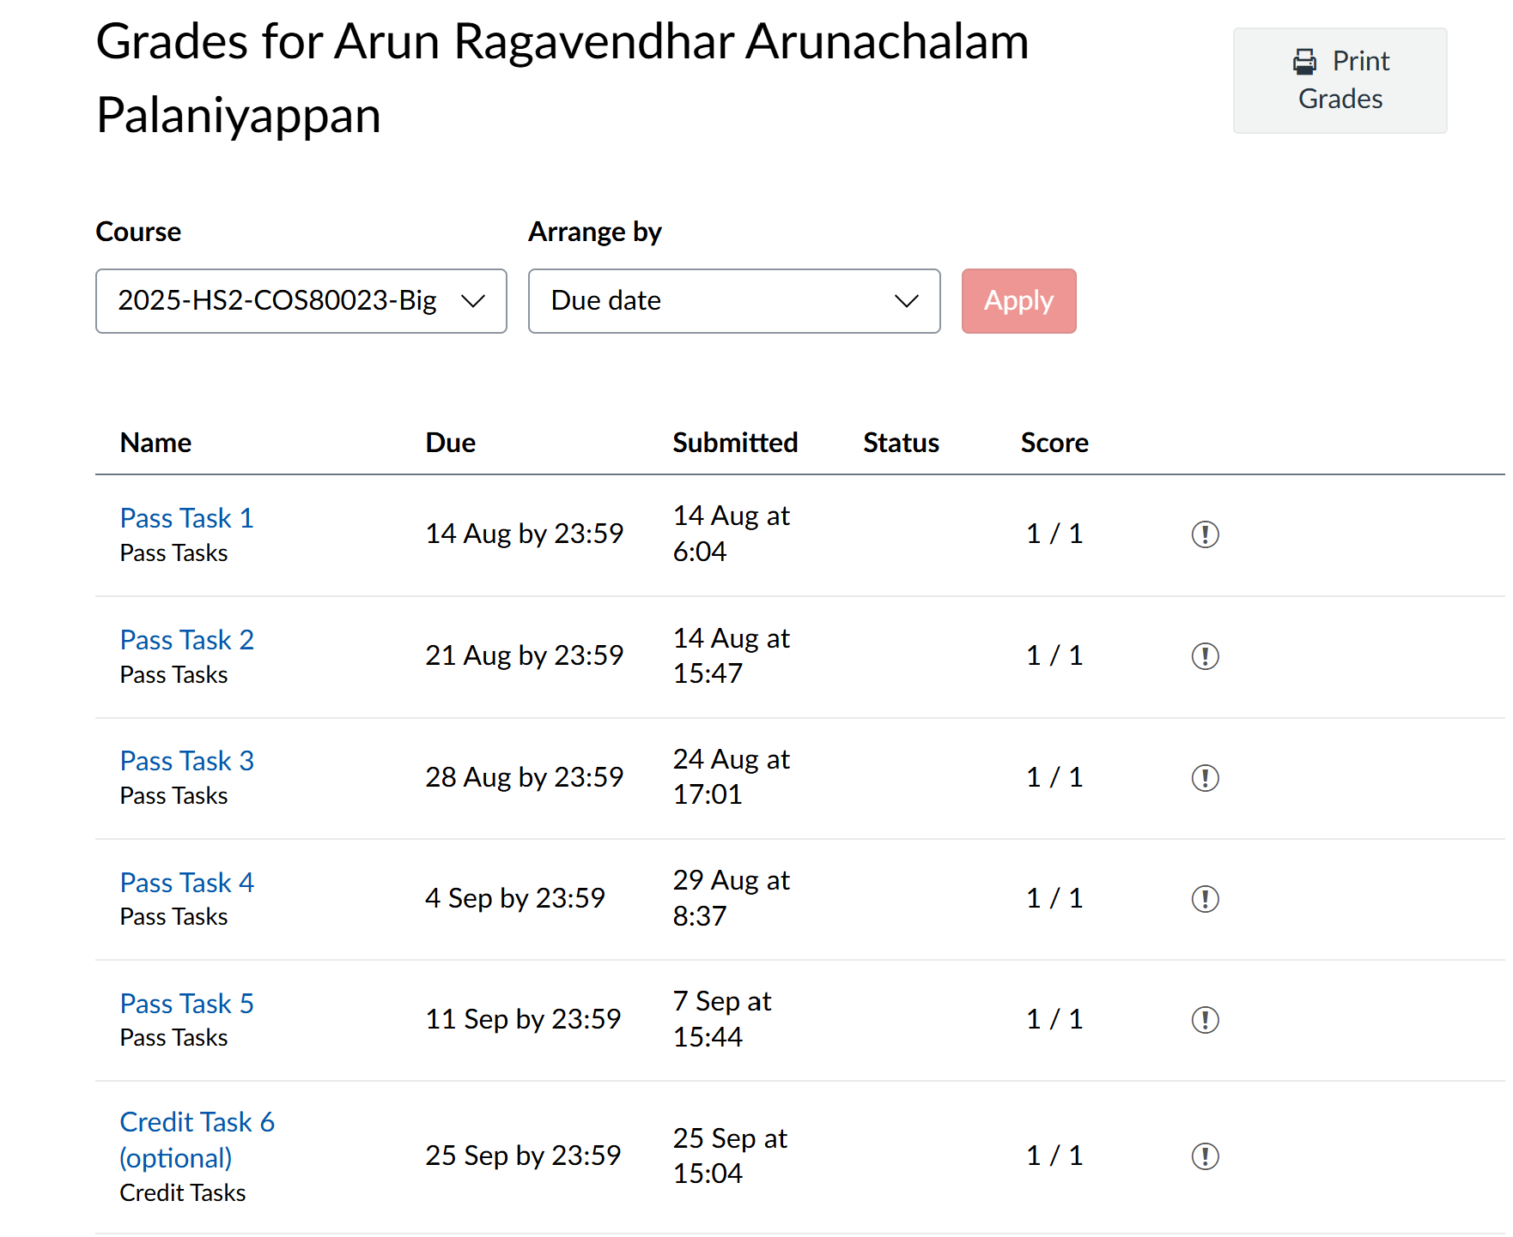
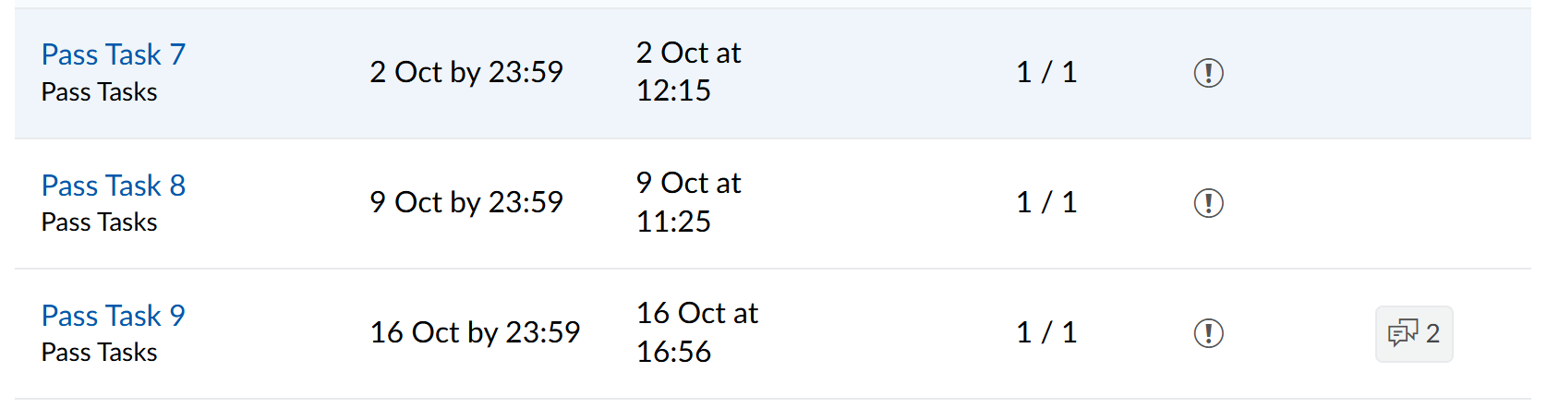
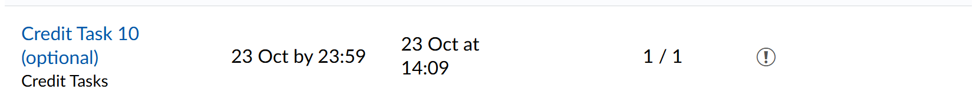

Distinction/High Distinction plan has been approved on Canvas
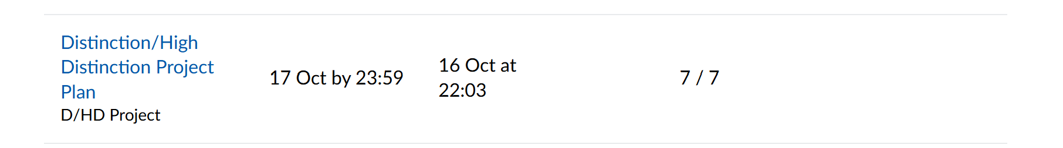

Distinction/High Distinction report has been submitted on Canvas and interview has been booked (optional)

