COS80023 Big Data – Lab 10
Lab10: Pass Task 10 - Credit Task 10 Clustering vs. Classifiers
Student Name: Arun Ragavendhar Arunachalam Palaniyappan
Student ID: 104837257
Classification output from RS classifier:
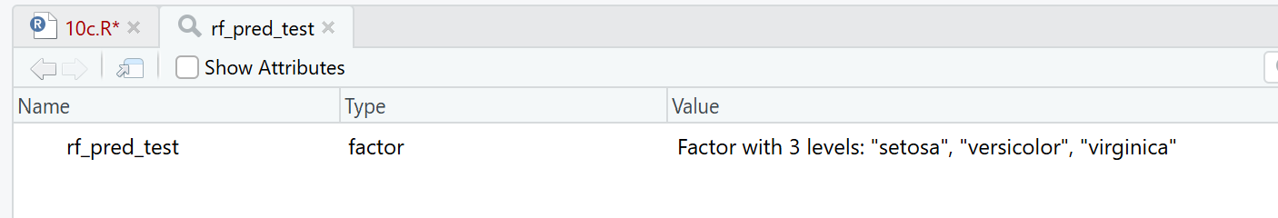
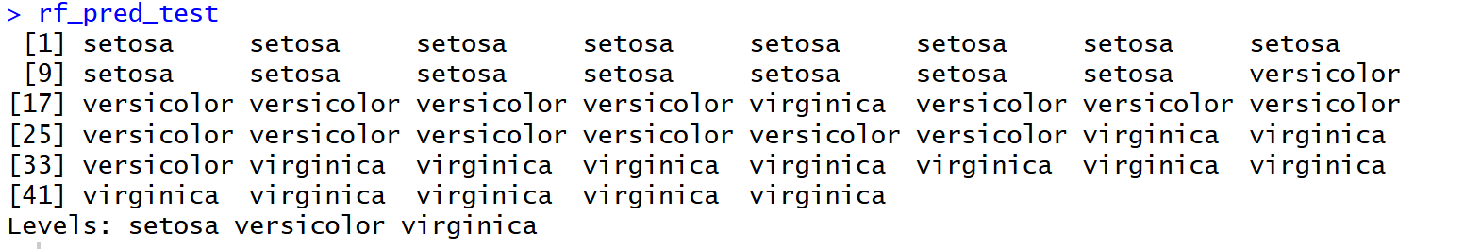
Q1. What variable should be entered for each parameter, and why?
For k-means, the data input used only the four numeric measurements: sepal_length, sepal_width, petal_length, petal_width. The label species was left out because clustering was unsupervised and did not use labels. The number of clusters k was set to 3, matching the three known groups in the iris data (Setosa, Versicolor, Virginica) and allowing a direct comparison between clusters and species.
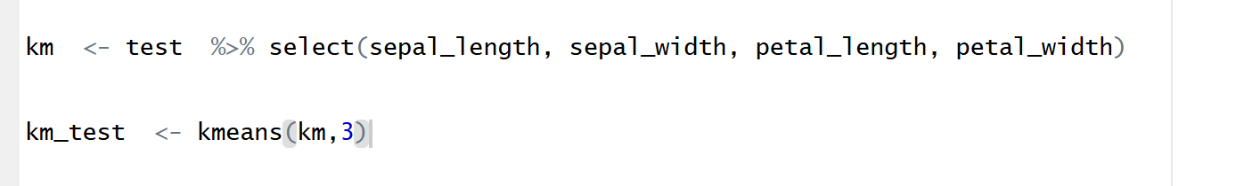
Q2. Should clustering use the train set, test set, or the complete dataset? Why?
Generally, clustering does not require labels, so can be used on any split.
In this assignment, k-means was run on the test rows so that each row aligned with both its true species and the Random Forest (RF) prediction. This made a simple, row-by-row comparison possible between cluster assignment, model prediction, and the true label.
Q3. Did the k-means cluster assignments agree with the Random Forest predictions, and could clusters be identified as species?
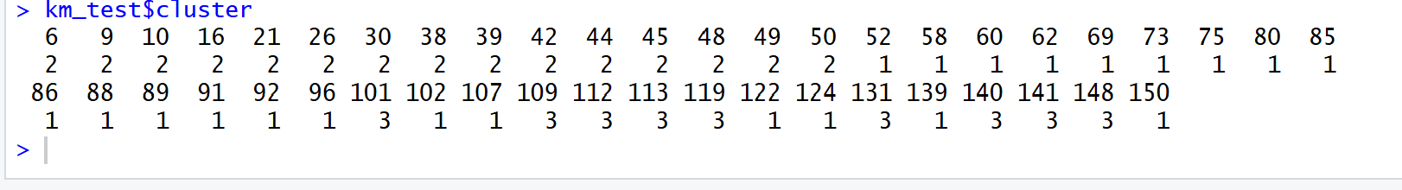
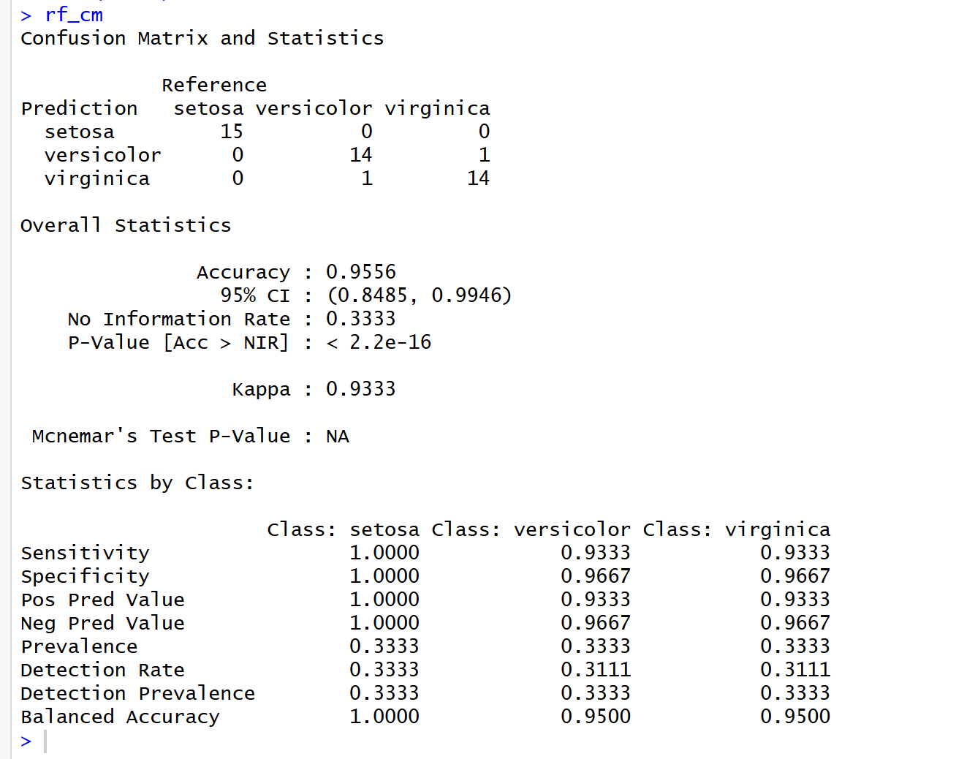
Agreement was partial, and clusters were identified by majority vote. The Random Forest (supervised) reached 95.56% accuracy on the test set with Kappa = 0.933. Class results were Sensitivity/Specificity of 1.00/1.00 (Setosa), 0.933/0.967 (Versicolor), and 0.933/0.967 (Virginica).
The k-means result (unsupervised), after mapping each cluster to the species most common within it, achieved 86.67% accuracy on the same test rows. The observed mapping was cluster 3 → Setosa, cluster 2 → Versicolor, and cluster 1 → Virginica. Setosa was perfectly recovered (15/15). Most mistakes occurred between Versicolor and Virginica (e.g., 6 Virginica points assigned to the Versicolor cluster). In summary, the supervised RF performed better overall, while k-means still recovered the main grouping structure, especially the clearly separated Setosa class.
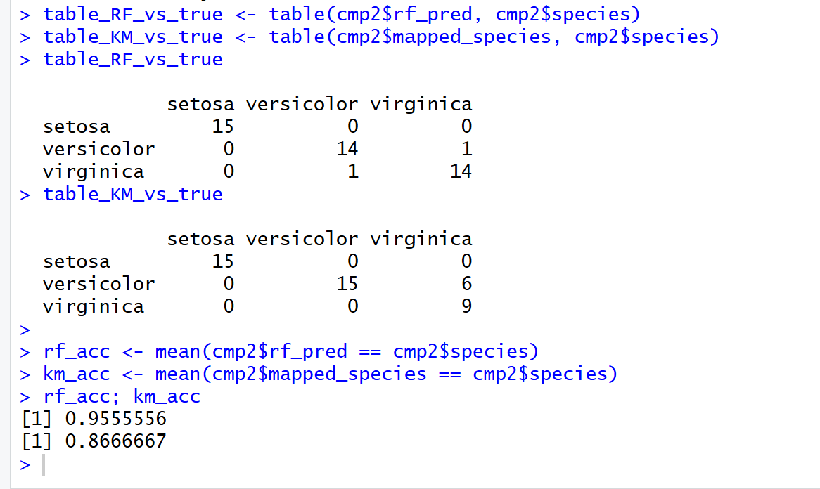
Q4. Why did kmeans() assign the clusters as observed?
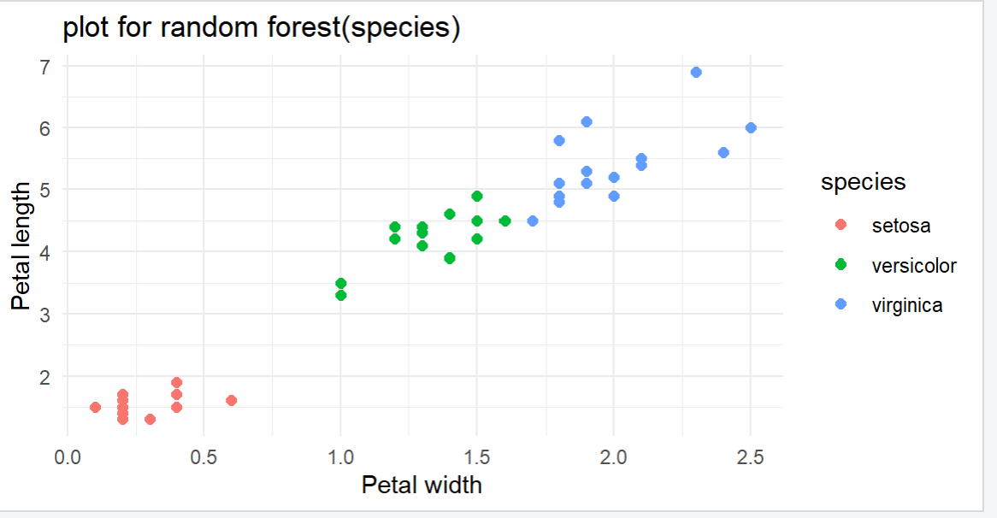
RF classier scatter plot
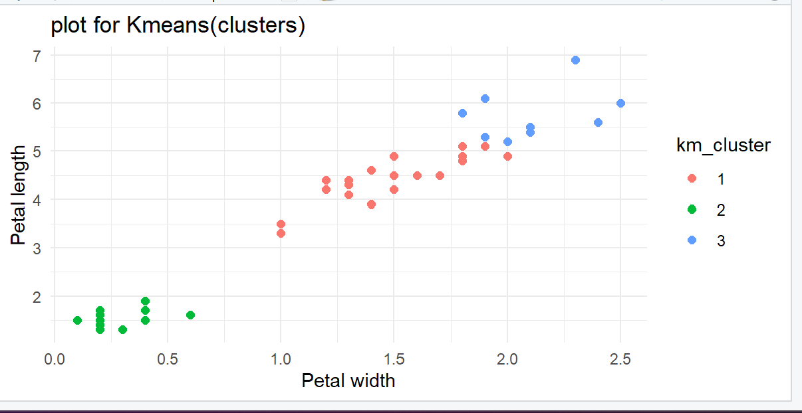
kmeans clustering scatter plot with cluster id

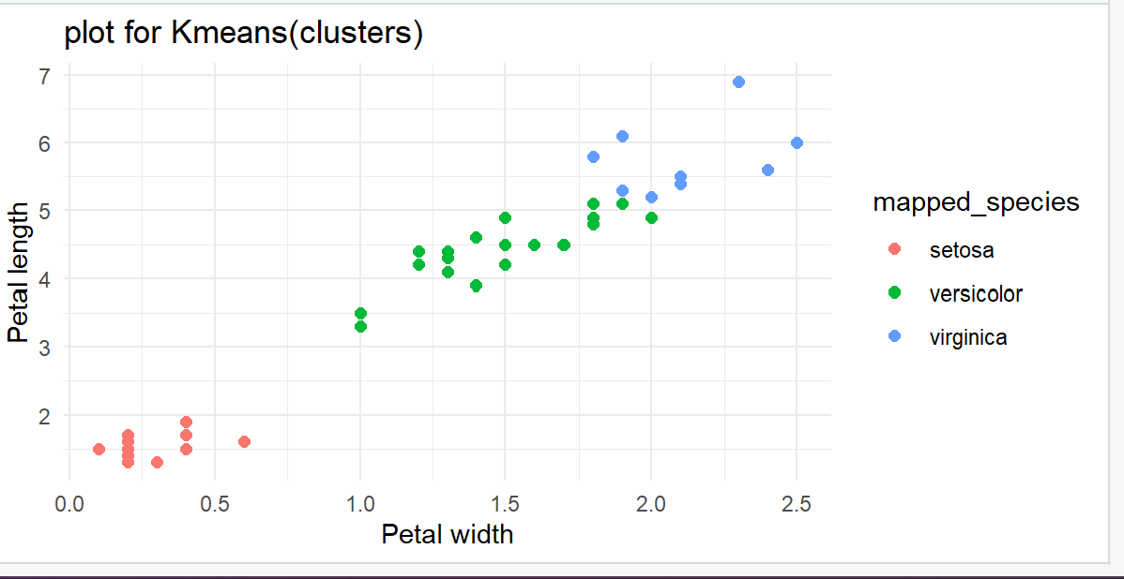
kmeans clustering scatter plot with mapped species
The result followed directly from the shapes and positions of the points in feature space.
- One group had very small petal length and petal width, which matched Setosa and was clearly separated; k-means placed these points together with no confusion.
- The other two species, Versicolor and Virginica, had larger petals and overlapped each other; their points sat in the same general region with only subtle differences.
Because k-means placed centers (centroids) and assigned each point to its nearest center, it effectively drew round-ish regions around those centers based on the original feature scales. Without scaling, features with larger numeric variation (the petal measurements) had a stronger influence on distance, which further emphasized the clear Setosa group but did not fully separate Versicolor from Virginica. As a result, k-means split that shared region into two clusters that were close—but not identical—to the species boundary, producing the observed mix-ups (for example, six Virginica points placed with Versicolor). This also explained the accuracy gap: the supervised Random Forest (trained with labels) reached 95.56%, while the label-free k-means reached 86.67%.

