COS80023 Big Data – Lab 5
Lab 4: Pass Task 4 – Information Retrieval with Pig
Student Name: Arun Ragavendhar Arunachalam Palaniyappan
Student ID: 104837257

Question 1: What does each part of this line do?
rawsales = LOAD '/pigdata/SalesJan2009.csv' USING PigStorage(',')
AS (Transaction_date:chararray, Product:chararray, Price:int,
Payment_type:chararray, Name:chararray, City:chararray,
State:chararray, Country:chararray);
- rawsales = LOAD '/pigdata/SalesJan2009.csv' → Loads the CSV file from the directory /pigdata into Pig.
- USING PigStorage(',') → Tells Pig to use a comma as the field separator.
- AS (...) → Defines the schema (column names and data types).
  - Transaction_date:chararray → stores the date as a string.
  - Product:chararray → stores the product name.
  - Price:int → stores the price as an integer.
  - Payment_type:chararray → type of payment (e.g., Visa, MasterCard).
  - Name, City, State, Country → customer details stored as strings.
This command loads the raw CSV file and maps it into a structured dataset that Pig can process.
DUMP rawsales;
- It prints the contents of the relation rawsales to the screen.
salesdata = FILTER rawsales BY Price IS NOT NULL;
- Removes the header row and any invalid rows where the Price field is missing.
- Ensures only meaningful sales data is kept.

Question 2: What does each line do (explain every detail)?
salesandcountry = FOREACH salesdata GENERATE (chararray) Country AS country, (int) Price AS price;
- Creates a new relation with only two columns: country and price.
- Explicitly casts Country as a string and Price as an integer.
countrygroups = GROUP salesandcountry BY country;
- Groups all sales transactions by country.
- Prepares the dataset for aggregation (summing).
salespercountry = FOREACH countrygroups GENERATE group as country, SUM(salesandcountry.price) AS totalsales;
- For each country, calculates the total sales amount by summing all prices in that group.
- Outputs a dataset with country and totalsales.
Question 3: What do these two lines do?
sortedsales = ORDER salespercountry BY totalsales desc;
- Sorts the countries in descending order of total sales.
- Ensures the highest sales appear first.
STORE sortedsales INTO '/pigdata/SalesByCountry' USING PigStorage(' ');
- Saves the sorted results into a new directory called SalesByCountry inside /pigdata.
- Uses space (' ') as the field separator in the output file.
Question 4: Document your code for sales per credit card.
To calculate sales per credit card type, I modified the Pig script as follows:
salesandpayment = FOREACH salesdata GENERATE (chararray) Payment_type AS payment, (int) Price AS price;

paymentgroups = GROUP salesandpayment BY payment;

salesperpayment = FOREACH paymentgroups GENERATE group as payment_type, SUM(salesandpayment.price) AS totalsales;

sortedsalespayment = ORDER salesperpayment BY totalsales desc;

STORE sortedsalespayment INTO '/pigdata/SalesByPaymentType' USING PigStorage(' ');
- Extracts only Payment_type and Price.
- Groups by Payment_type (e.g., Visa, MasterCard, Amex).
- Sums the sales per payment type.
- Orders the results by total sales in descending order.
- Stores the results in /pigdata/SalesByPaymentType.
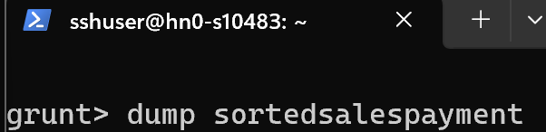
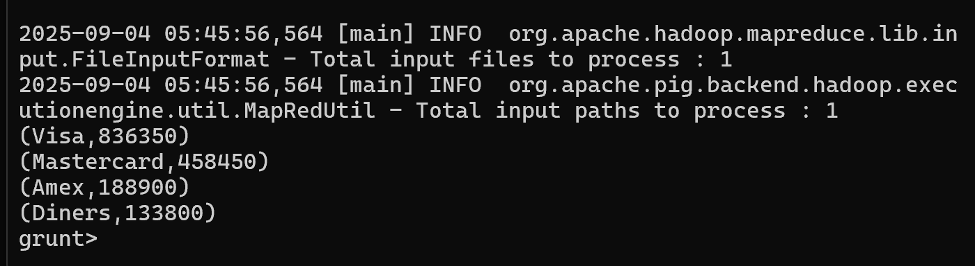DUMP of sorted credit card payments

Question 5: Repeat the wordcount example in Pig.
Steps followed:
- Uploaded a text file to /pigdata/wordinput.
- Ran the following Pig Latin commands:
lines = LOAD '/pigdata/wordinput' USING PigStorage('\n') AS (line:chararray);

words = FOREACH lines GENERATE FLATTEN(TOKENIZE(line)) AS word;

wordgroups = GROUP words BY word;

wordcount = FOREACH wordgroups GENERATE group AS word, COUNT(words) AS count;
STORE wordcount INTO '/pigdata/WordCountOutput' USING PigStorage(' ');
- LOAD → loads the text file line by line.
- TOKENIZE → splits each line into words.
- FLATTEN → converts tokenized words into individual rows.
- GROUP → groups the words by their value.
- COUNT → counts how many times each word appears.
- STORE → writes the results to /pigdata/WordCountOutput.

DUMP wordcount;
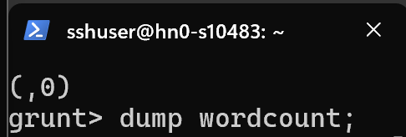
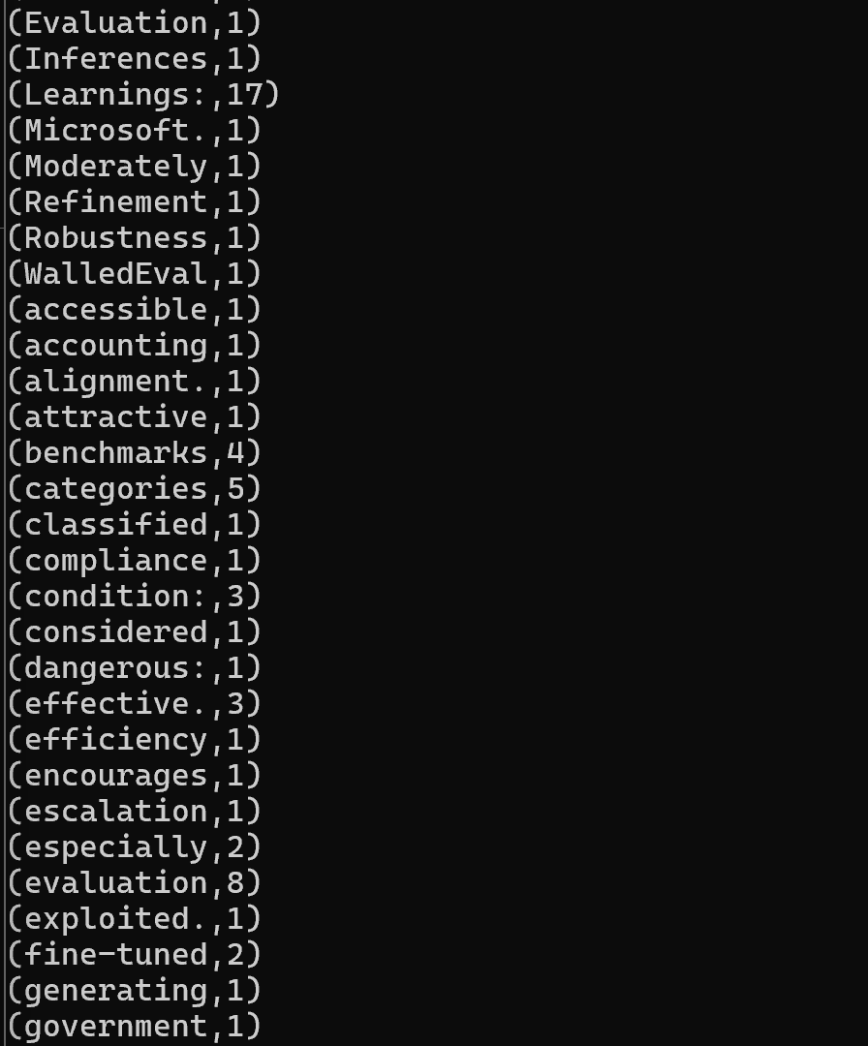
DUMP of Wordcount from the text file
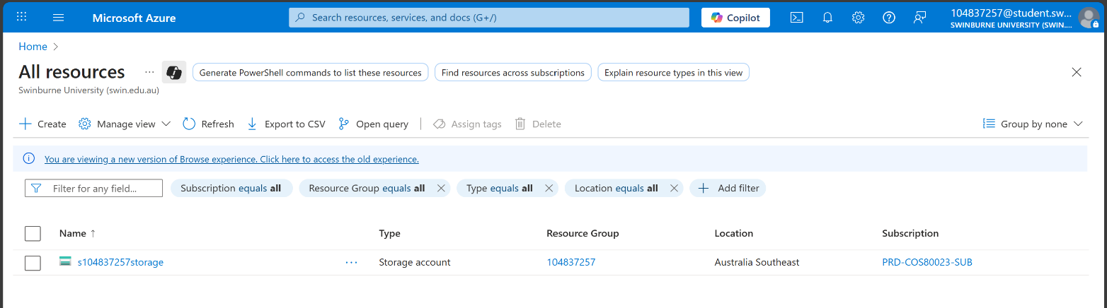
1630500
1617500

