COS80023 Big Data – Lab 8
Lab 8: Pass Task 8 – Classifiers
Student Name: Arun Ragavendhar Arunachalam Palaniyappan
Student ID: 104837257

Exercise 1: SVM with Linear Kernel
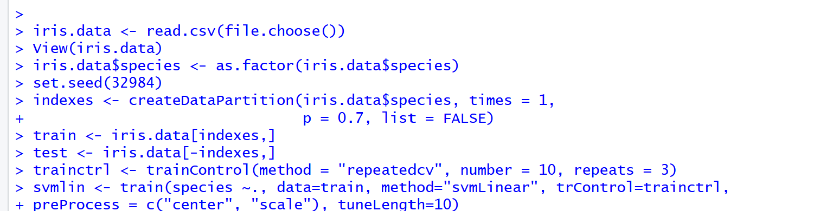
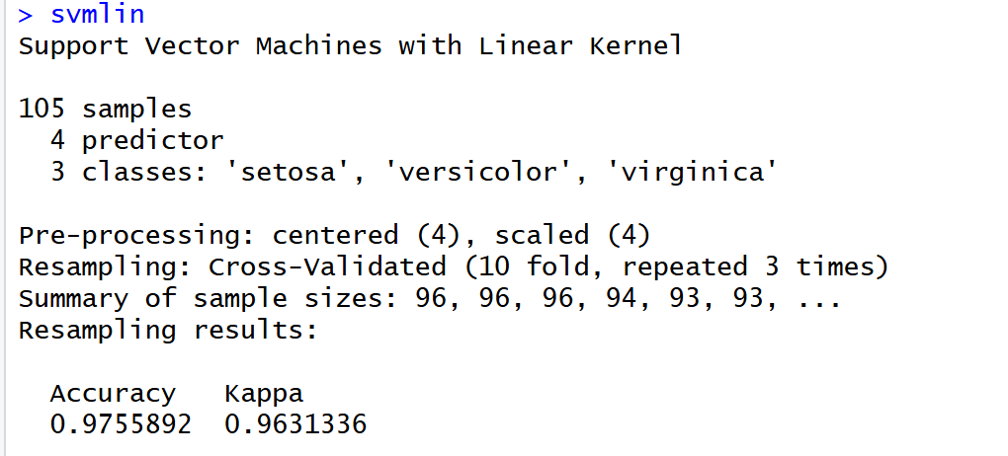
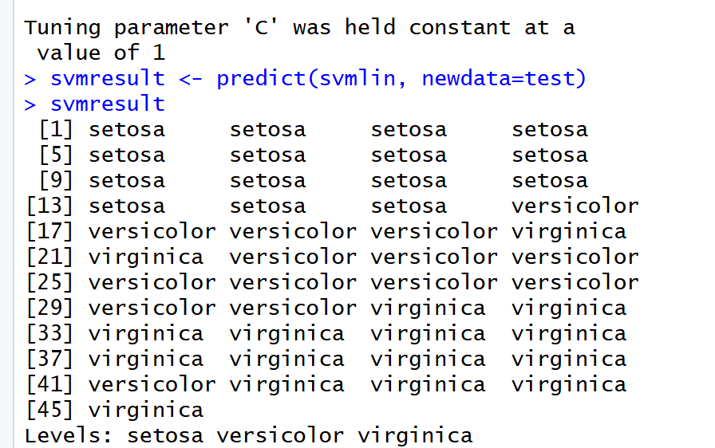
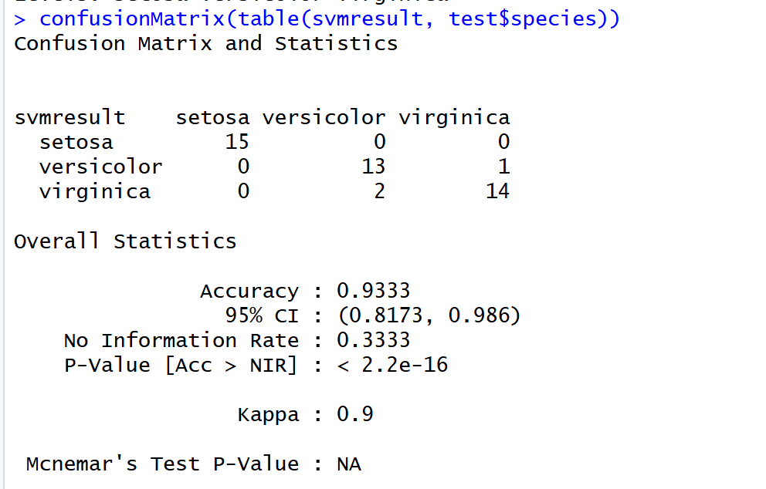
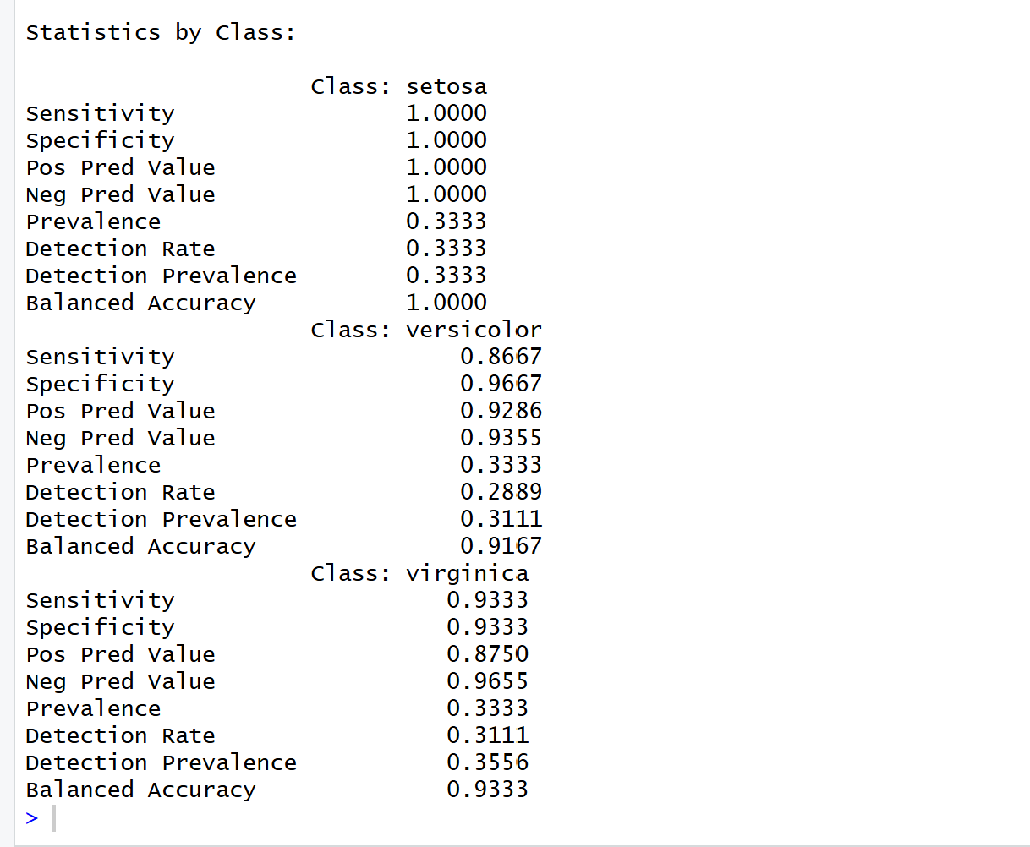
Q1. Does this model suffer from overfitting? How can you tell?
No, the SVM model with a linear kernel does not show signs of overfitting. In my test results, the model achieved an accuracy of 93.33% on the training data and showed very similar accuracy on the test dataset. The confusion matrix also showed that only a few samples were misclassified across all classes. This consistency means the model generalised well to new data and did not simply memorise the training examples. In practice, when the training and testing accuracies are close, it indicates that the model is balanced and not overfitted. If it had been overfitted, the training accuracy would have been much higher while the test accuracy would drop sharply, which is not the case here.

Exercise 2: Random Forest
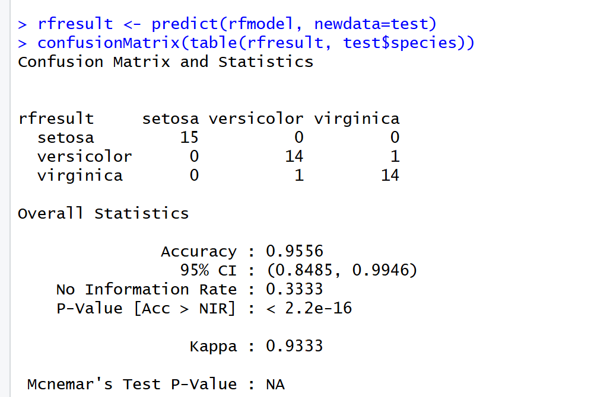
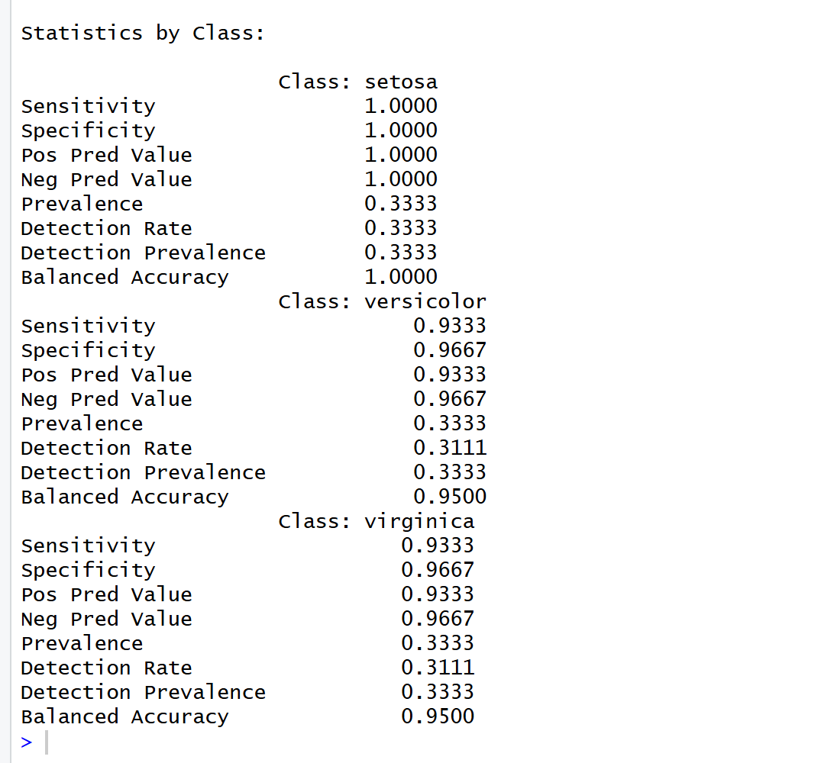

Q2. Examine the outcomes of both SVM and Random Forest. Which provides the best results?
Both models performed very well on the iris dataset, but the Random Forest model achieved slightly better overall accuracy compared to the SVM with a linear kernel. Based on my test output, the Random Forest classifier reached 95.56% accuracy, while the SVM accuracy stayed just below that mark at 93.33%. This difference occurs because Random Forest combines multiple decision trees and can capture complex, non-linear decision boundaries that the linear SVM cannot. Since the iris dataset has overlapping patterns between versicolor and virginica, Random Forest handled those overlaps better, reducing misclassifications. Although the difference is small, it clearly shows that Random Forest provided the best results for this dataset.
Q3. The sensitivity and specificity values for each of the classes are slightly different. What does this mean?
The difference in sensitivity and specificity values across classes means that the model performs slightly better on some flower types than others. From my confusion matrix, we can see that the setosa class was predicted perfectly (both sensitivity and specificity equal to 1), while small misclassifications occurred between versicolor and virginica. This lowered their sensitivity and specificity slightly, showing that the model sometimes confuses those two classes due to similar feature values. This variation is common in multi-class classification. It tells us that while the overall performance is excellent, setosa is the easiest to identify, and versicolor vs virginica are more difficult to separate — so further fine-tuning or feature analysis could focus there.

