Rural areas have shown consistently higher fatal crash severity (fatalities per 1,000 crashes, per-year normalised) than urban areas across 2012–2025, a gap aligned with greater rural exposure to higher posted speed limits, open-road (non-intersection) segments, and low-light conditions.

Screenshots:
Step 1:
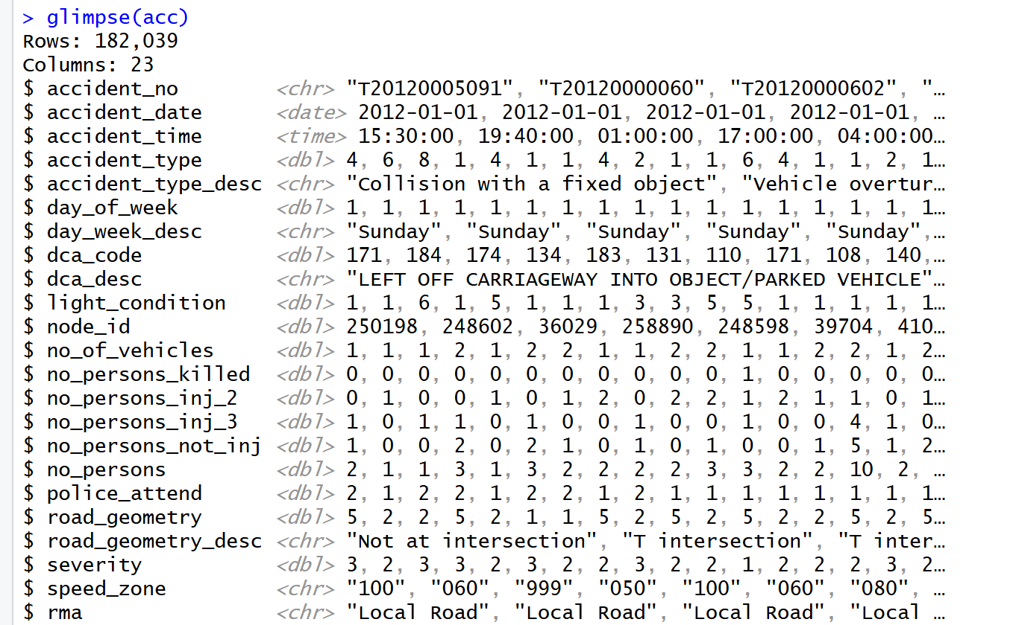
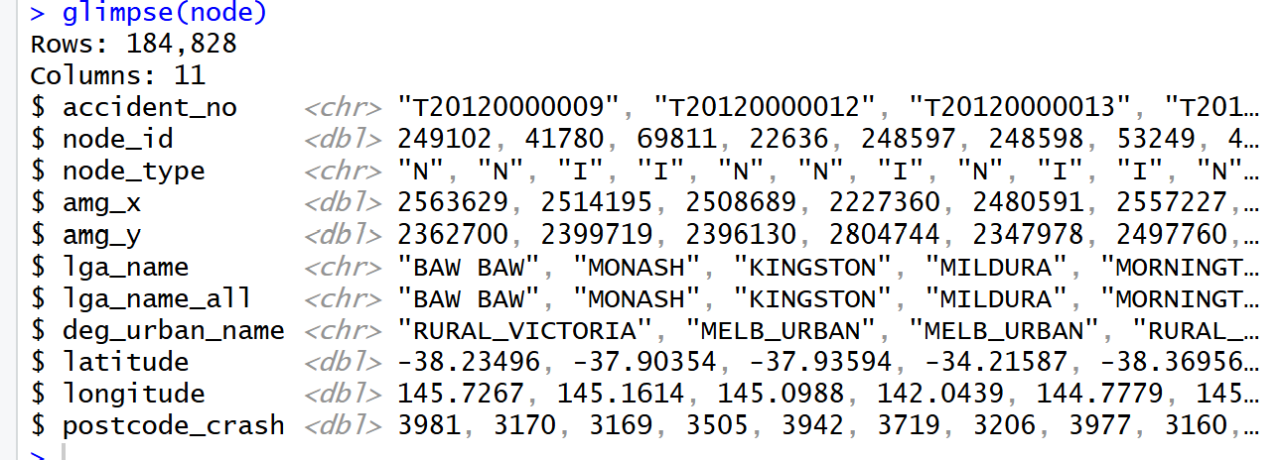

Step 2

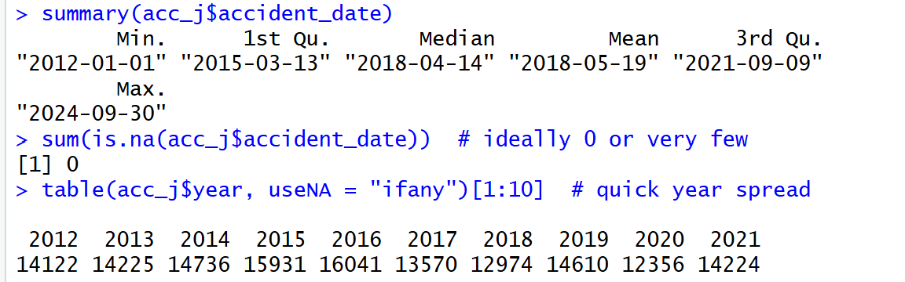

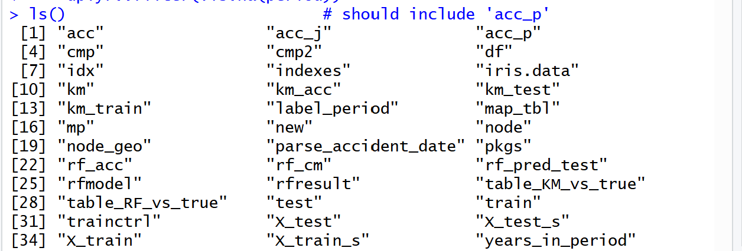

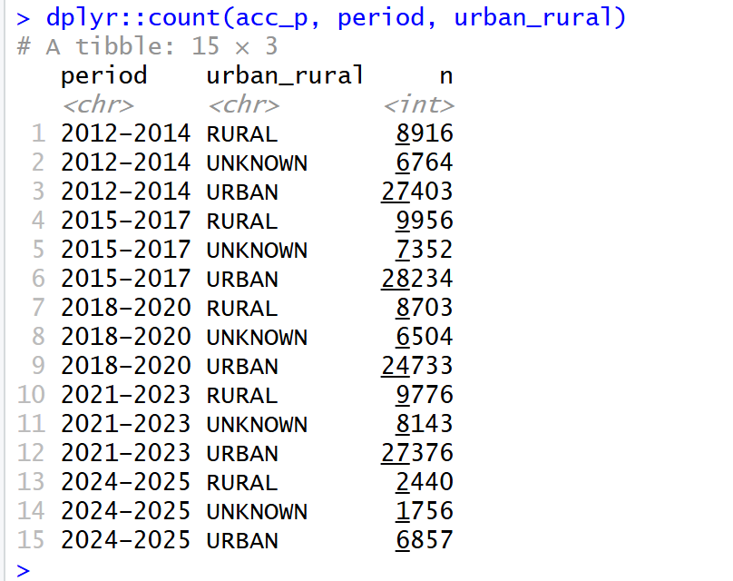

Step 3
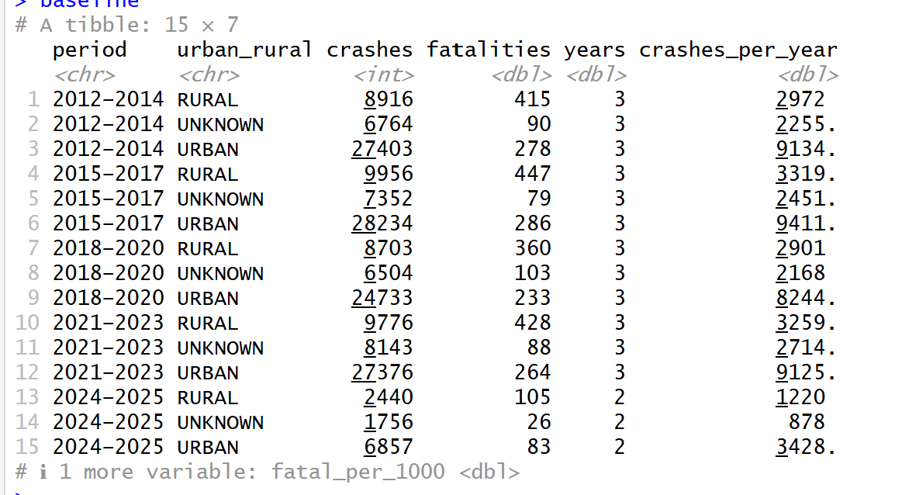

Step 4

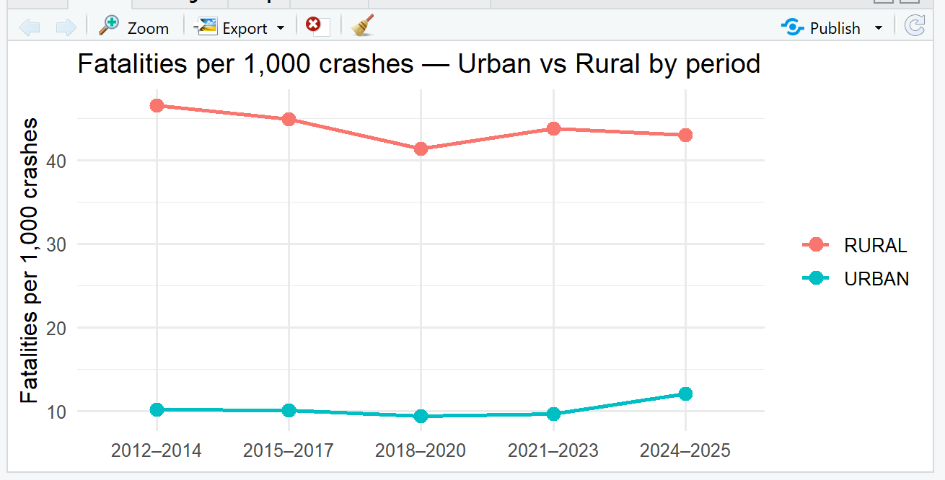

Step 5
Cleaning and reparsing to ensure all 5 time periods
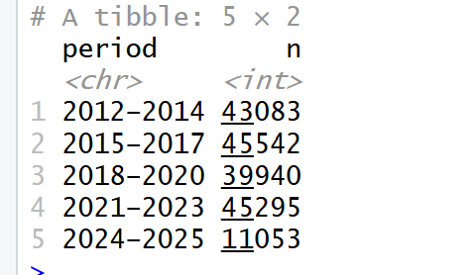

Cleaning posted speed limits
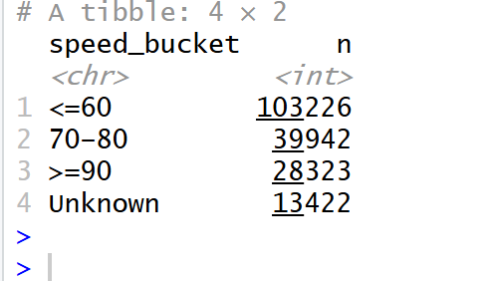

Fatalities rate by speed limits in all periods in urban vs rural
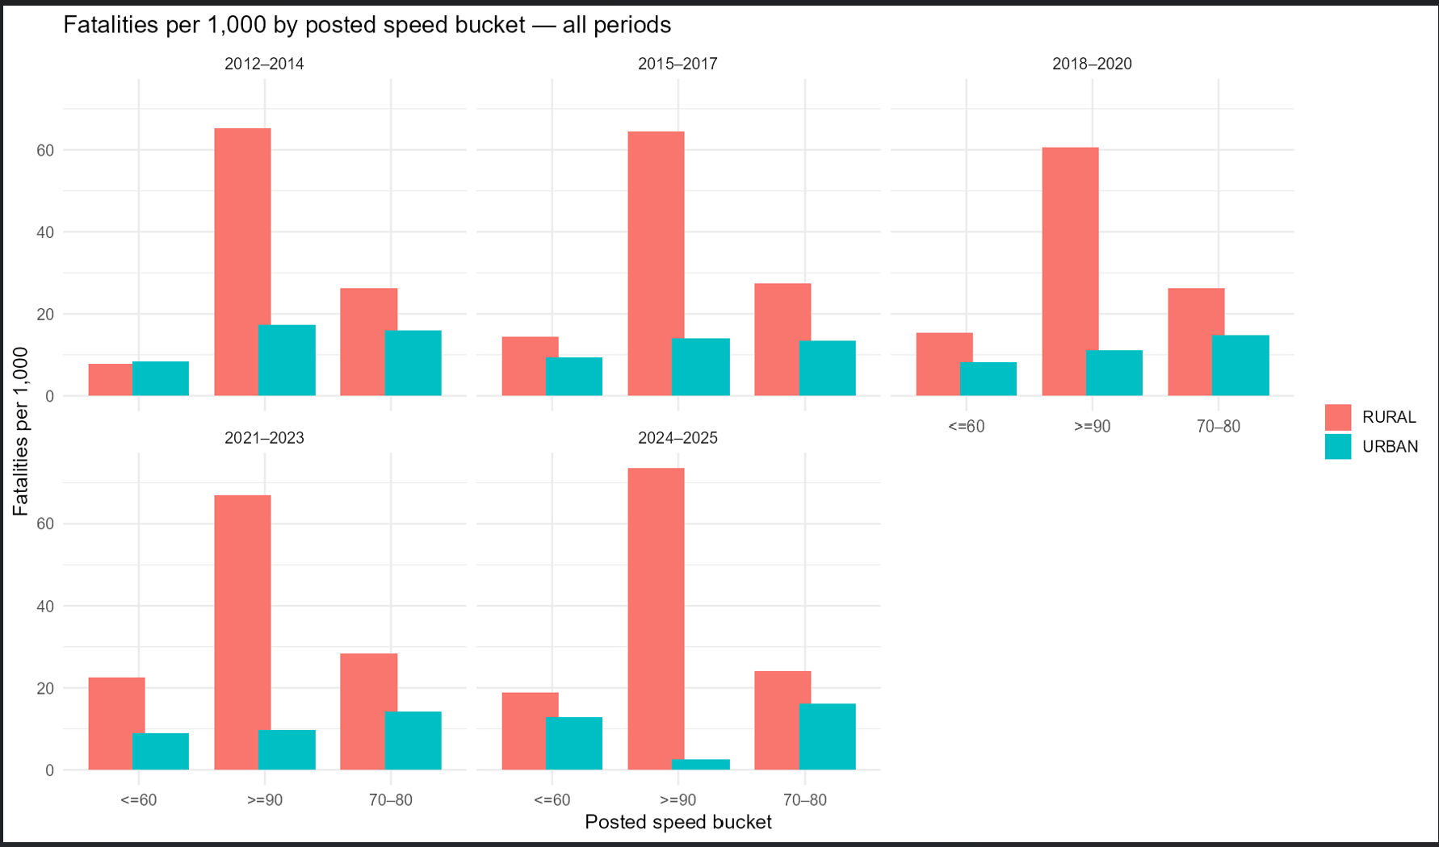

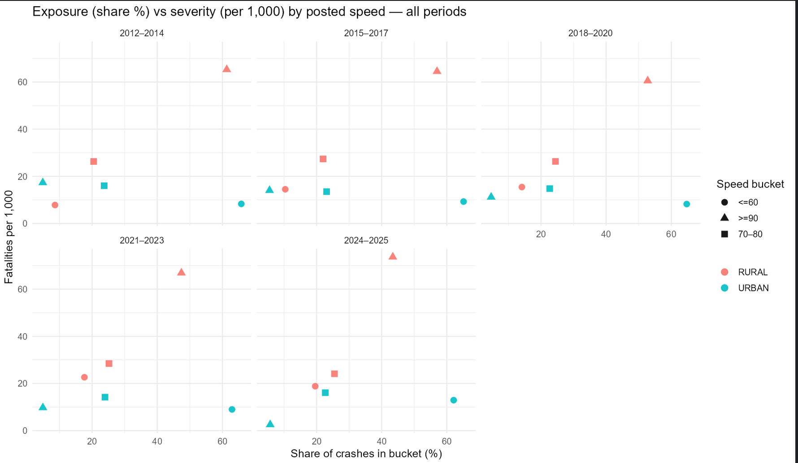

Step 6 Road Geometry

severity + exposure into one tidy table (no category drop)

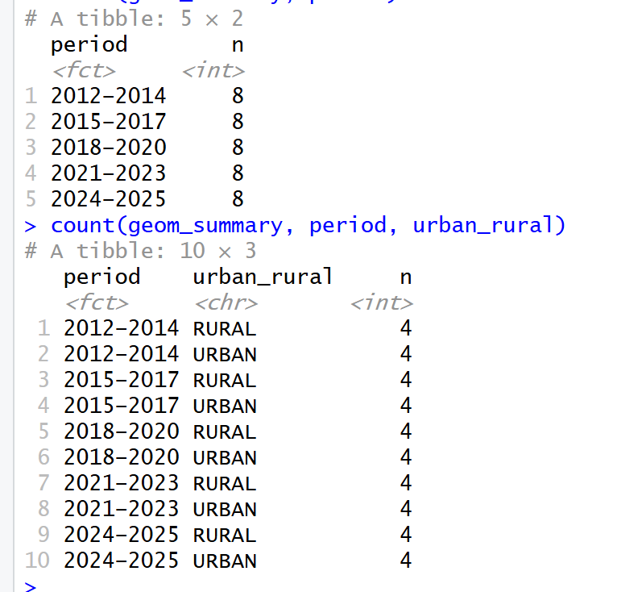

A) Faceted bar chart — severity per 1,000 by geometry (all periods)
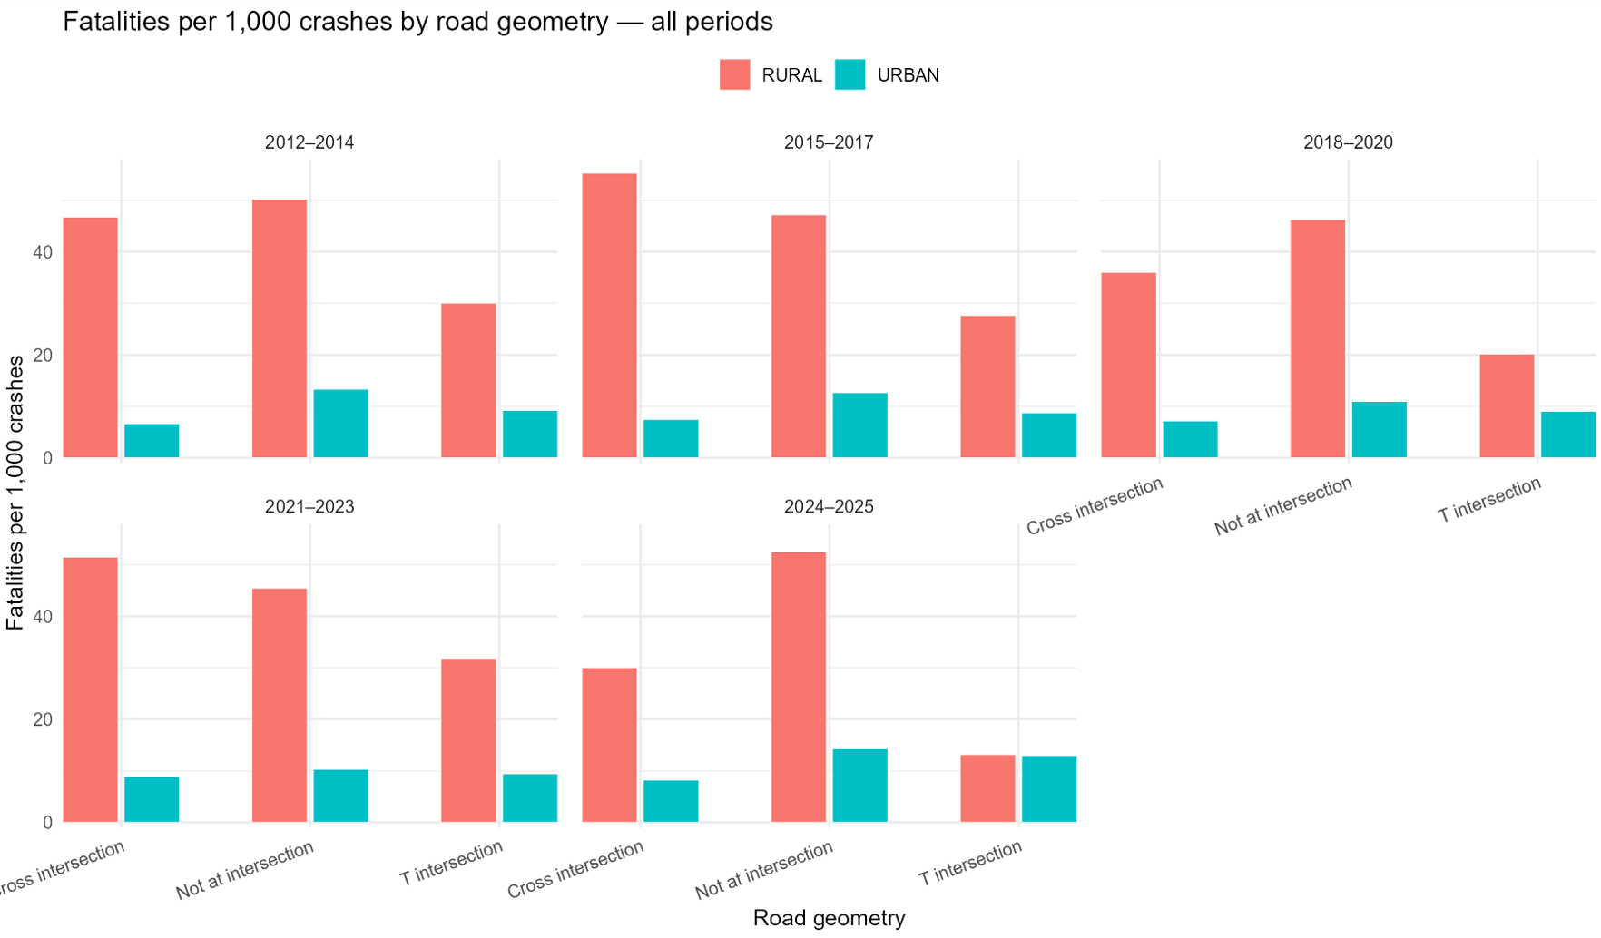

B) Faceted scatter — exposure vs severity by geometry (all periods)
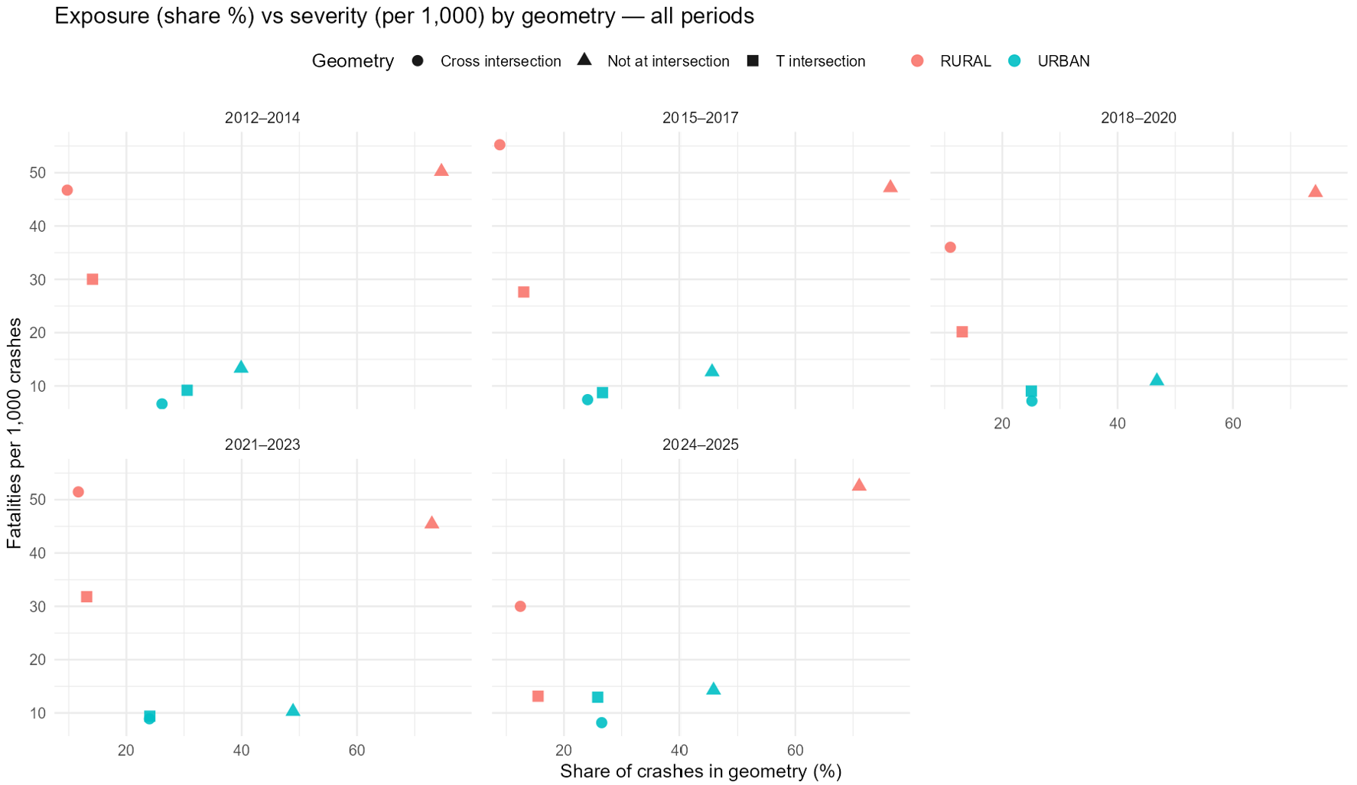

Step 7- lighting conditions
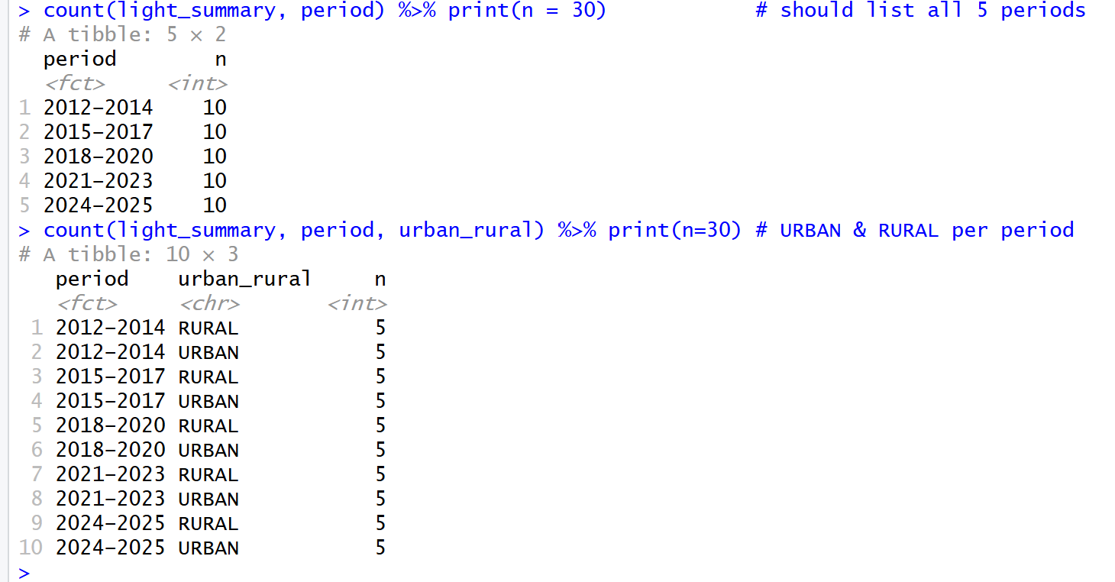

Contrary to popular belief , accident have happened in rural areas in broad daylight.
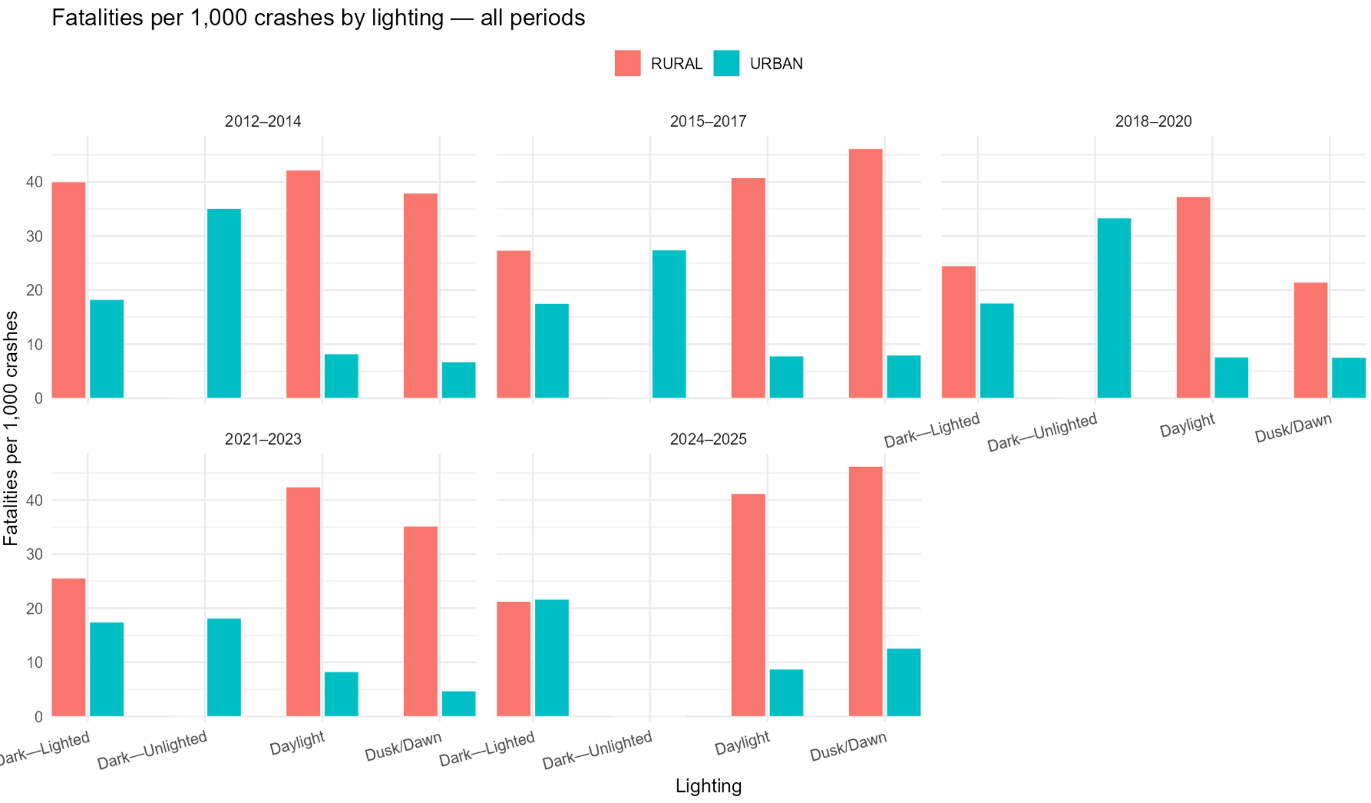

And a major share of it as well

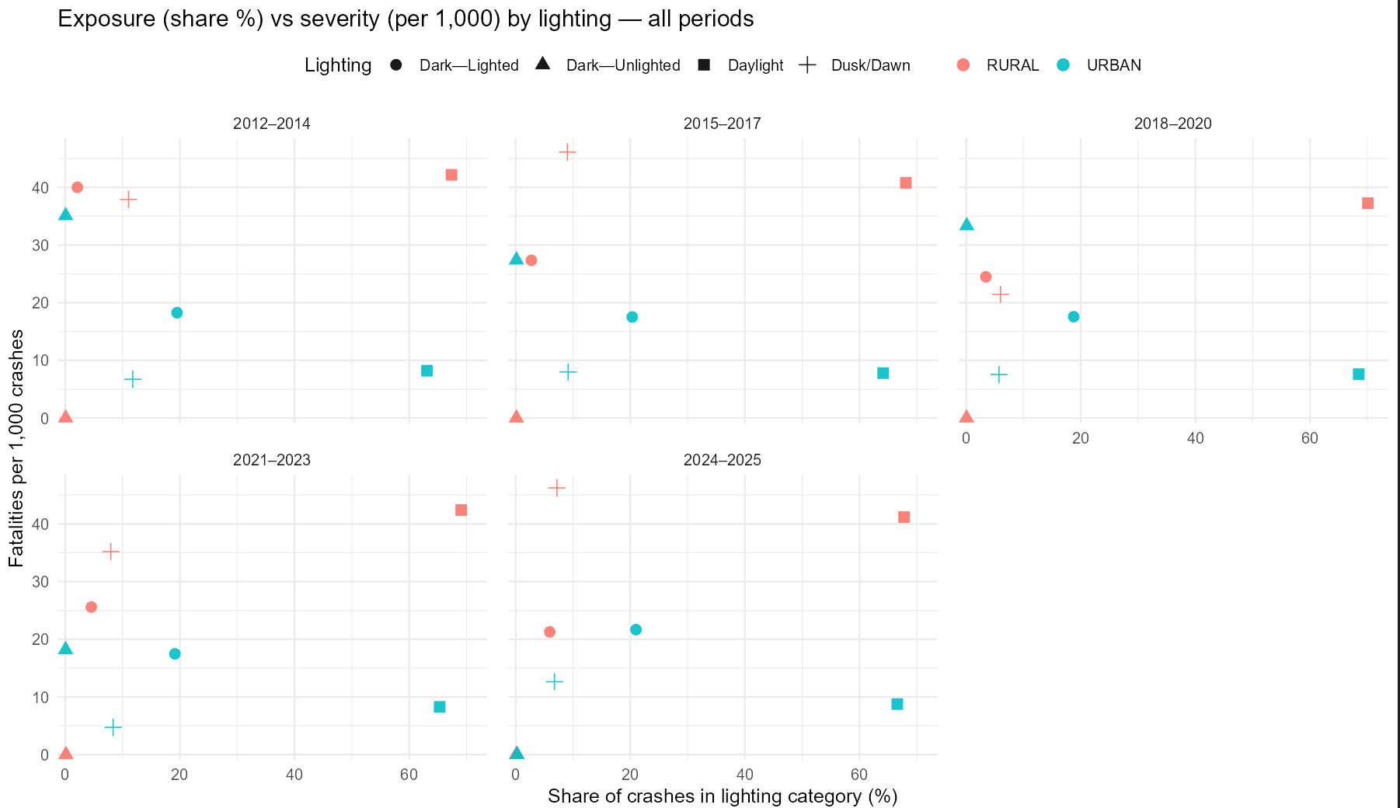

8 ) Based on road conditions
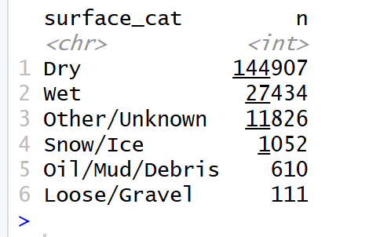

Exposure x
