Stack Buffer Over flow testing and fixing vulnerable code snippets –
BAD example for array out of bound issue.
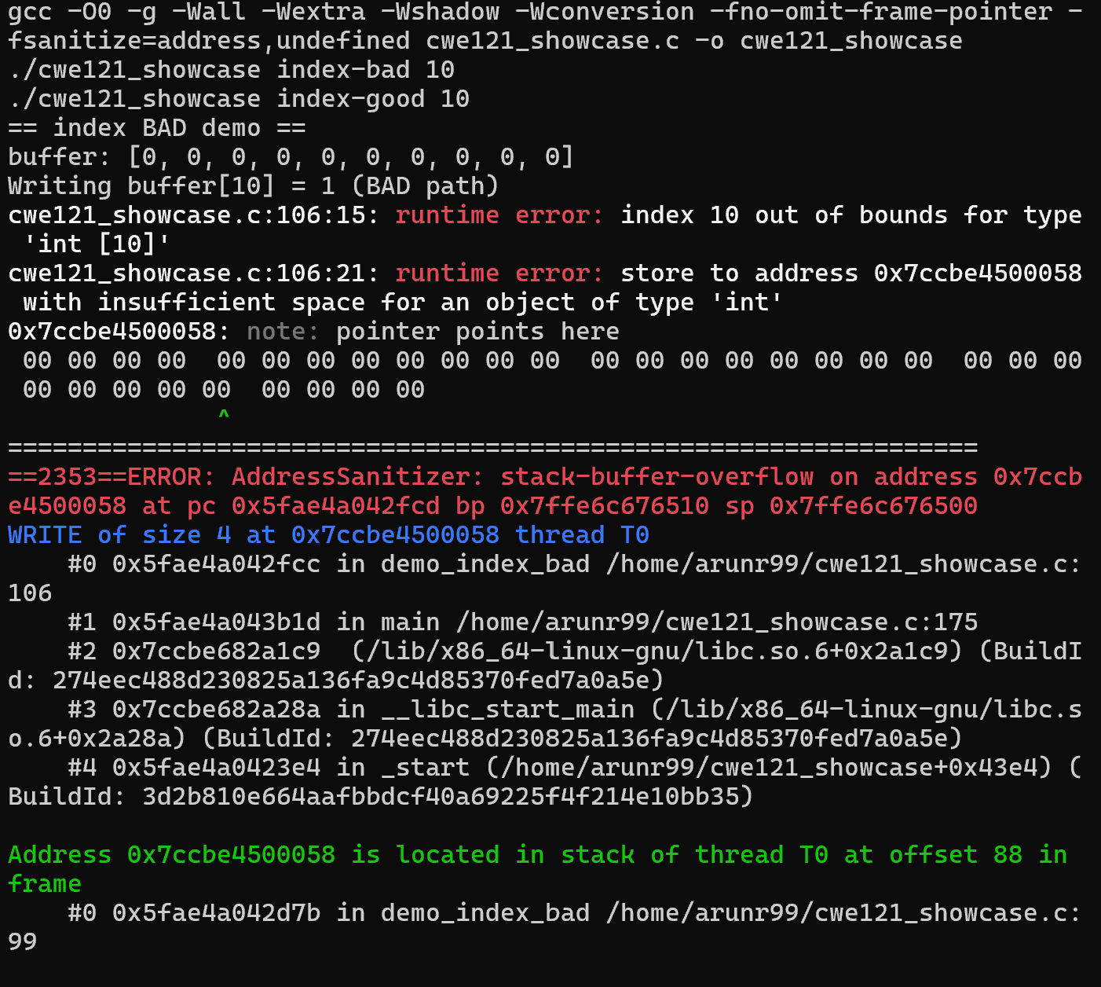
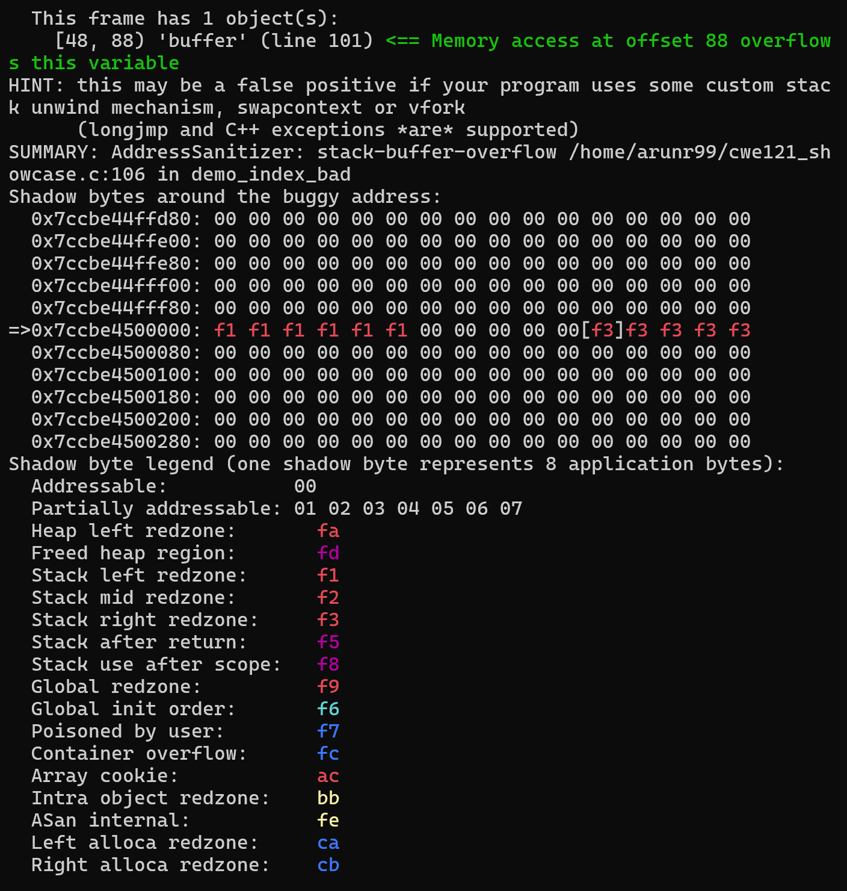

Output of good demo after it was fixed.
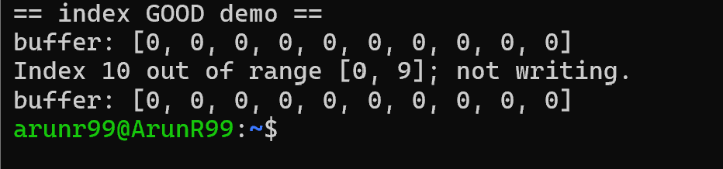

Memory copy issue – bad example
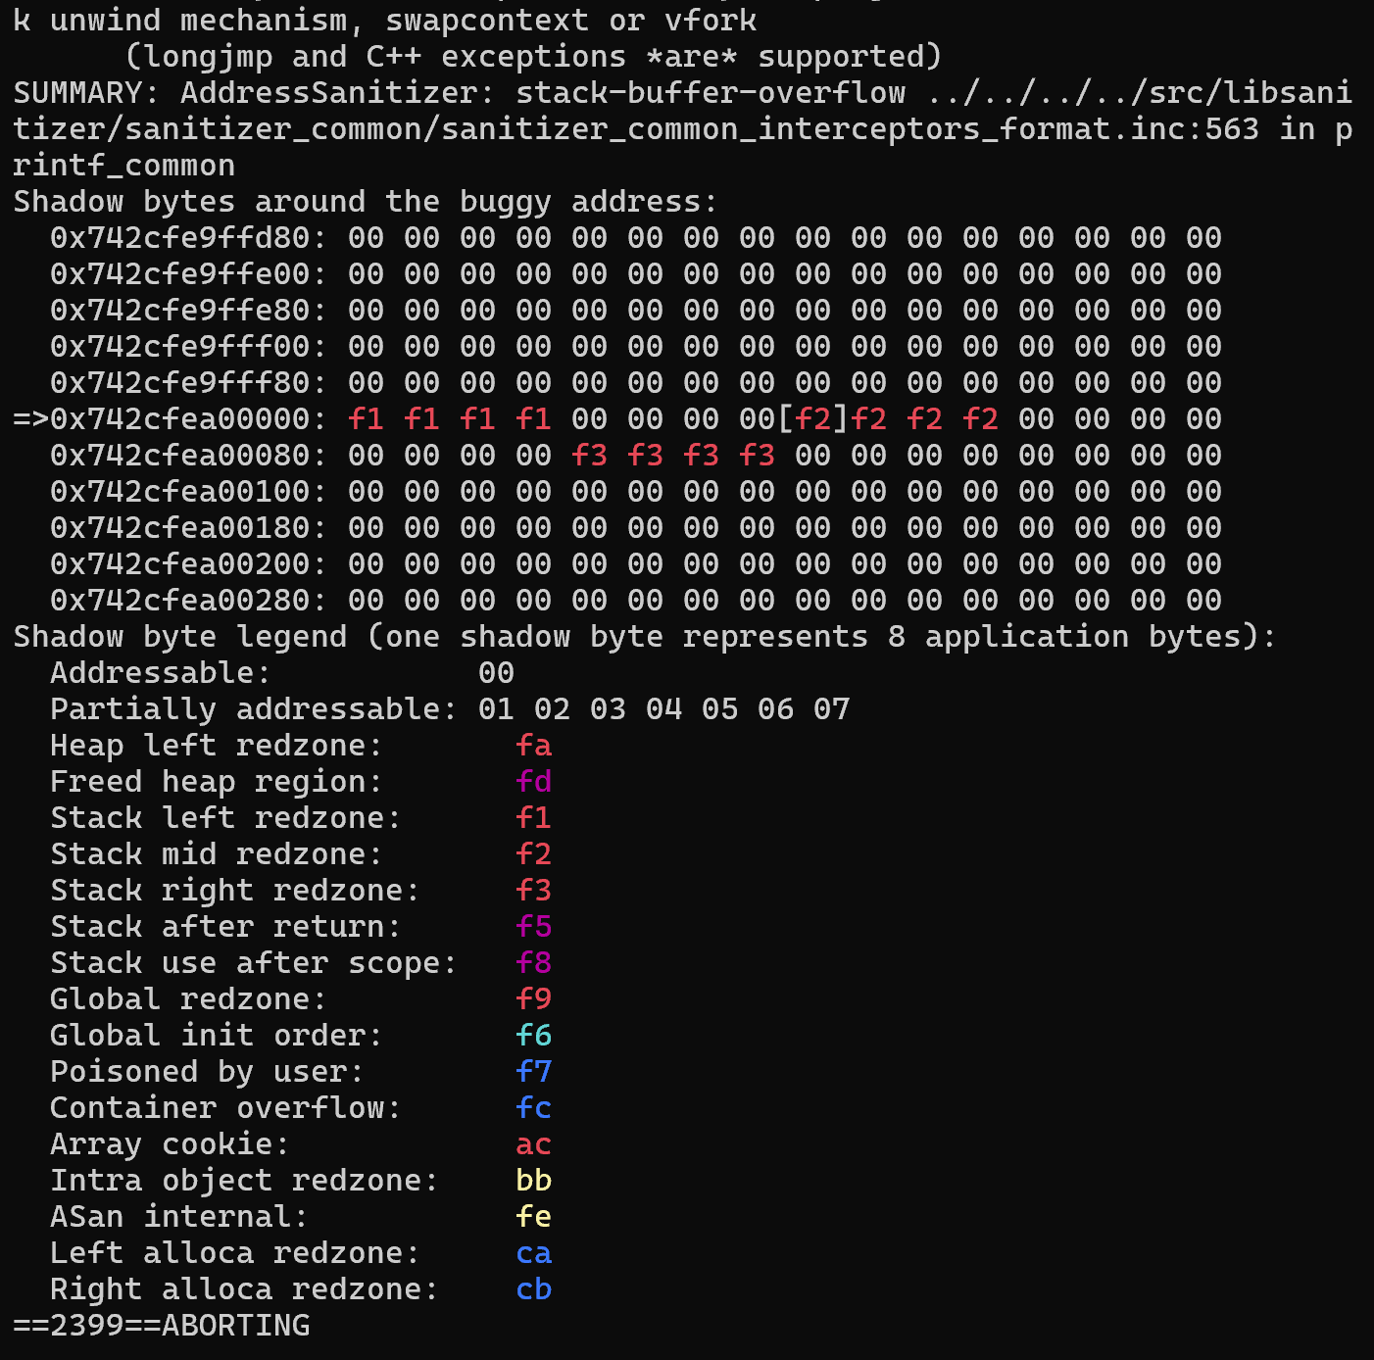

Good example after code fix
