

**Software Requirements**

**Specifications**

**My FoodPrint**

**Personalized Nutrition On-the-Go**

**Submitted By:**

**THUMMALAPALLI CHANDINI 21N31A66H9**

**TRIPURARI VENKATA SRIKAR 21N31A66J2**

**V. ARUN KUMAR REDDY 22N35A6620**

**Under the guidance of**

**Mrs. G. Deepthi**

**Department of Computational Intelligence**

**MRCET**

## TABLE OF CONTENTS ...............................................................2

**INTRODUCTION ...........................................................................................3**

1. **LITERATURE SURVEY..............................................................................3-9** 
   1. Existing System……………………………………………………...…...………3
   2. Drawbacks of Existing System...............................................................................4
   3. Proposed System.....................................................................................................4-5
   4. System Architecture............................................................................................... 5
   5. use case…………………………………………………………………………...6
   6. class diagram………………………………………………………………...……7
   7. sequence diagram………………………………………………...……………….8
2. **OVERALL DESCRIPTION..........................................................................9** 
   1. Feasibility Study.......................................................................................................9
      1. Operational Feasibility................................................................................9
      2. Economic Feasibility……………………………………..………………9
      3. Technical Feasibility...................................................................................9
      4. Legal and Ethical Feasibility…………………………………..…………9
3. **SYSTEM ANALYSIS.....................................................................................10** 
   1. Software Requirement Specifications......................................................................10
      1. Hardware and Software Requirements………………………………….. 10
      2. Hardware Requirements………………………………………………… 10
      3. Software Requirements…………………………………………………..10
4. **FUNCTIONAL REQUIREMENTS…………………………………….….11**
5. **NON-FUNCTIONAL REQUIREMENTS………………………………………...12-13**
6. **REFERENCE……………………………………………………………………….14**

**INTRODUCTION**

"My FoodPrint" aims to empower individuals to make informed dietary choices and cultivate healthier eating habits for long-term well-being. By leveraging personalized data, the application provides tailored nutritional recommendations, fosters mindful eating habits, and promotes accountability through tracking and monitoring features. Integrating seamlessly with other health platforms, "My FoodPrint" supports holistic wellness management and encourages sustainable lifestyle changes. Through education, personalization, and behavioural support, the application strives to revolutionize dietary management and help users lead healthier, happier lives.

**1. LITERATURE SURVEY**

#### 1.1 Existing System:

* Many existing apps may not provide highly personalized insights based on individual characteristics like age, gender, and specific food intake frequencies.
* some apps may not go beyond basic calorie counting and macronutrient tracking to provide a comprehensive analysis of long-term dietary habits.
* Existing systems may not offer in-depth assessments of potential health risks associated with specific dietary patterns.

1. **MyFitnessPal:**

- MyFitnessPal is a popular app for tracking nutrition and exercise. It allows users to log their food intake, set fitness goals, and provides nutritional information.

2. **Neutrino:**

- Neutrino is designed to provide personalized nutrition recommendations based on individual health goals, preferences, and dietary restrictions.

3. **Lifesum:**

- Lifesum combines nutritional tracking with personalized recommendations, taking into account health goals and lifestyle.

#### 1.2 Drawbacks of Existing System:

**1. Lack of Personalization:** Many existing apps may not provide highly personalized insights based on individual characteristics like age, gender, and specific food intake frequencies.

**2. Focus on Nutritional Information:** While nutritional information is crucial, some apps may not go beyond basic calorie counting and macronutrient tracking to provide a comprehensive analysis of long-term dietary habits.

**3. Limited Health Risk Assessment:** Existing systems may not offer in-depth assessments of potential health risks associated with specific dietary patterns, potentially limiting their ability to motivate users toward healthier choices.

#### 1.3 Proposed System:

* Users gain a better understanding of their dietary habits and their potential impact on health.
* Improved preventative healthcare.
* Tailored recommendations and support.
* "My FoodPrint" focuses specifically on user-reported food intake and potential health risks, it aligns with this broader trend of leveraging technology for personalized health initiatives.
* Personalized Recommendations.
* Comprehensive Nutritional Analysis.
* Privacy and Security.
* Behavioural Support.
* Improved User Experience.

#### 1.4 System Architecture:

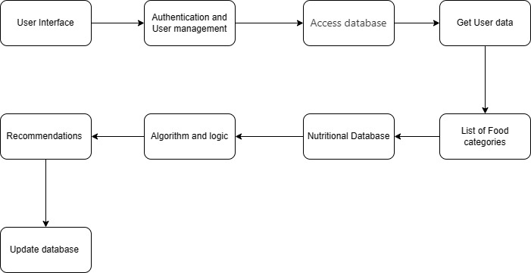

#### 1.5 Use-case Diagram:

A [UML](https://en.wikipedia.org/wiki/Unified_Modeling_Language) use case diagram is the primary form of system/software requirements for a new software program underdeveloped. Use cases specify the expected behaviour (what), and not the exact method of making it happen (how). Use cases once specified can be denoted both textual and visual representation (i.e. use case diagram). A key concept of use case modelling is that it helps us design a system from the end user's perspective. It is an effective technique for communicating system behaviour in the user's terms by specifying all externally visible system behaviour.

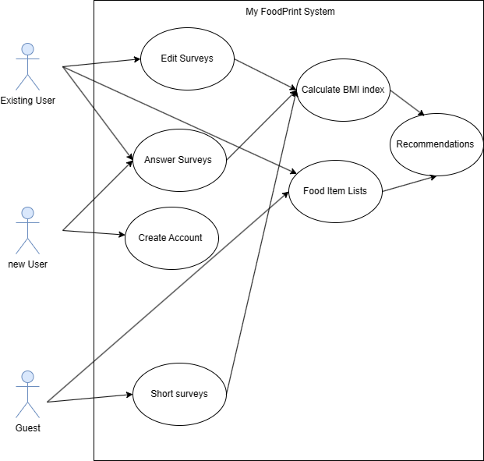

#### 1.6 Class Diagram:

Class diagrams are a type of [UML (](https://www.geeksforgeeks.org/unified-modeling-language-uml-introduction/)Unified Modelling Language) diagram used in software engineering to visually represent the structure and relationships of classes in a system. UML is a standardized modelling language that helps in designing and documenting software systems. They are an integral part of the software development process, helping in both the design and documentation phases.

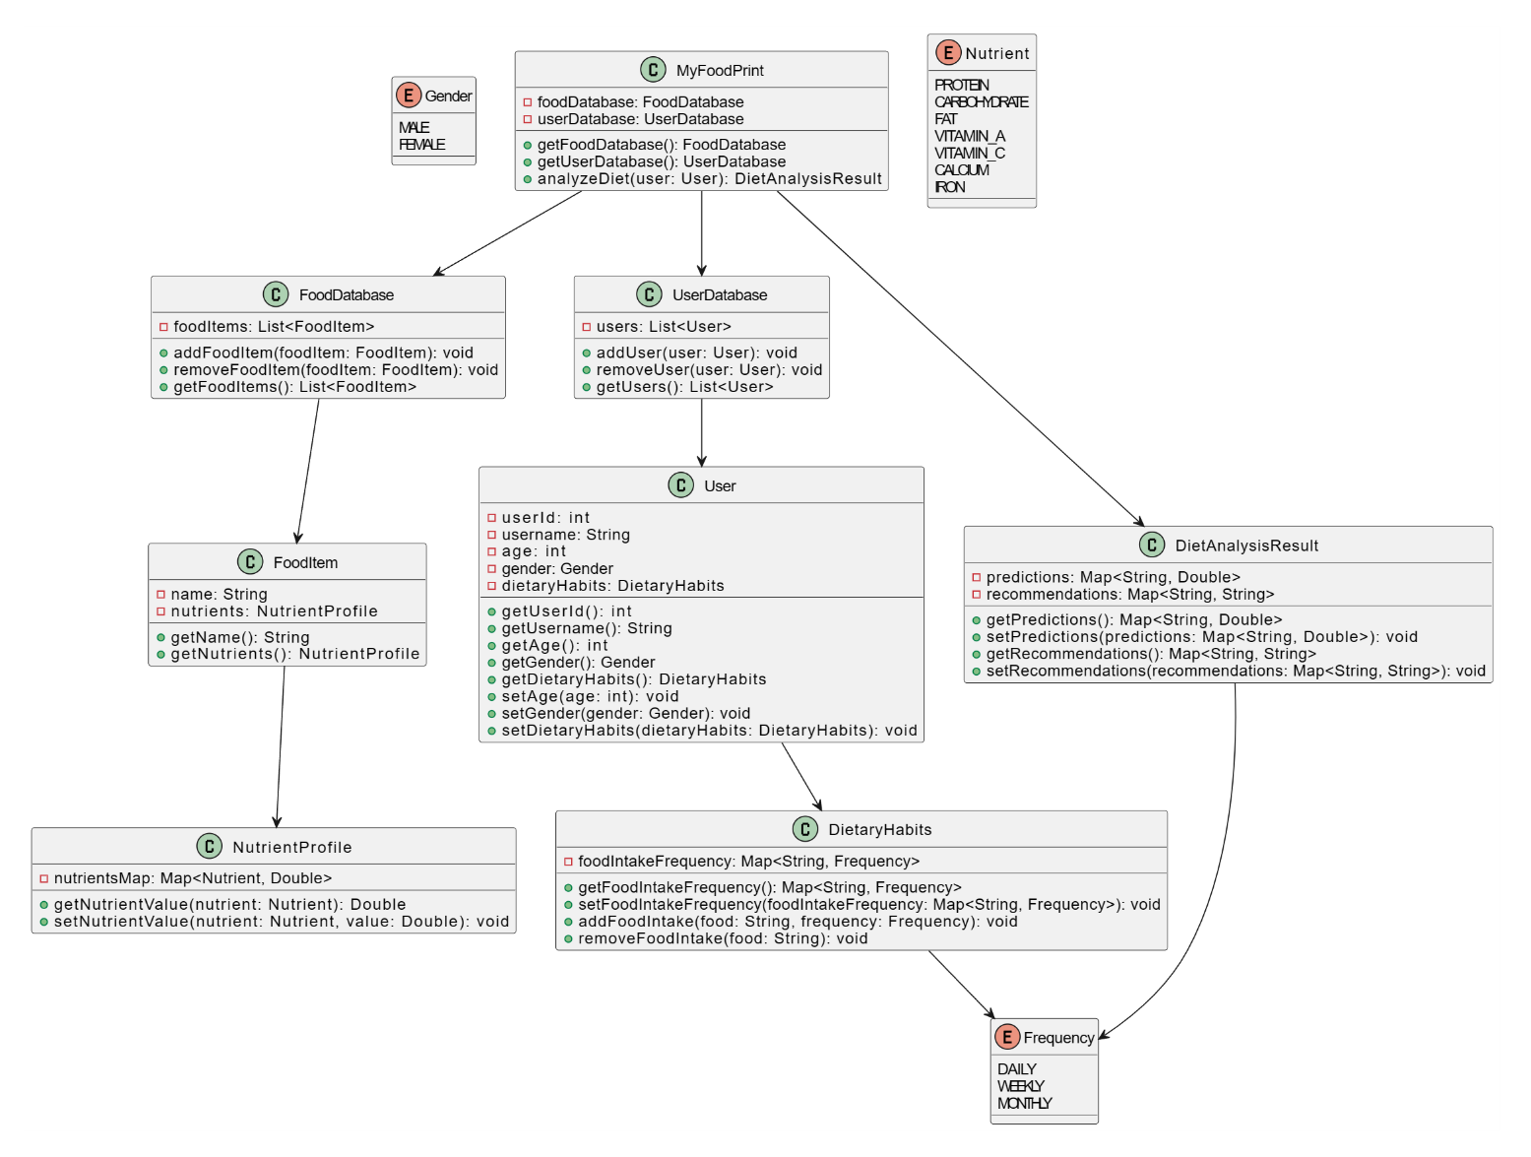

#### 1.7 Sequence Diagram:

A sequence diagram shows process interactions arranged in time sequence. This diagram depicts the processes and objects involved and the sequence of messages exchanged as needed to carry out the functionality. Sequence diagrams are typically associated with use case realizations in the [4+1 architectural view model](https://en.wikipedia.org/wiki/4+1_architectural_view_model) of the system under development. Sequence diagrams are sometimes called event diagrams or event scenarios.

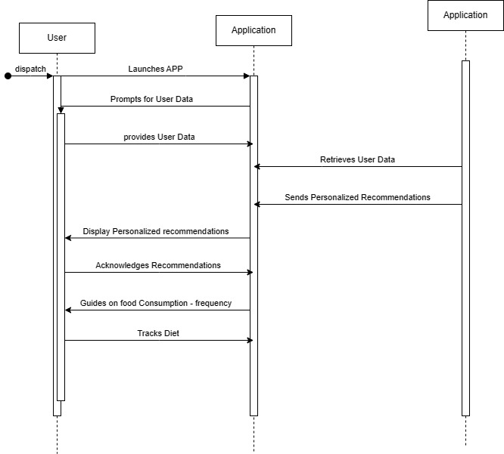

### 

### 2. OVERALL DESCRIPTION

#### 2.1 Feasibility Study:

**1. Technical Feasibility:** Evaluate whether the proposed technology and infrastructure required for developing and maintaining "My FoodPrint" are feasible. This includes assessing the availability of suitable development tools, databases, APIs, and integration capabilities.

**2. Market Feasibility:** Analyse the market demand for a dietary management application like "My FoodPrint." Conduct market research to identify potential users, their needs, preferences, and willingness to adopt such a solution. Evaluate the competitive landscape and identify opportunities for differentiation.

**3. Financial Feasibility:** Determine the financial viability of developing and operating "My FoodPrint." Estimate the initial development costs, including software development, database setup, and infrastructure expenses. Assess the potential revenue streams, such as subscription fees, in-app purchases, or partnerships.

**4. Legal and Regulatory Feasibility:** Identify and evaluate any legal or regulatory requirements that may impact the development and operation of "My FoodPrint." This includes compliance with data protection laws (e.g., GDPR), health information privacy regulations, and any other relevant laws or standards.

**5. Operational Feasibility:** Assess the practicality and ease of implementing and operating "My FoodPrint" within the intended user base. Consider factors such as user adoption, user interface design, data input methods, customer support requirements, and scalability.

**6. Environmental Feasibility:** Evaluate the environmental impact of developing and operating "My FoodPrint." Consider factors such as energy consumption, carbon footprint, and any potential environmental benefits or drawbacks associated with the application.

**7. Social Feasibility:** Assess the social impact and acceptance of "My FoodPrint" within the target user community. Consider factors such as cultural norms, social trends, and potential barriers to adoption (e.g., stigma around tracking dietary habits).

**8. Risk Analysis:** Identify and evaluate potential risks and uncertainties that may affect the success of "My FoodPrint." This includes technical risks, market risks, financial risks, legal risks, and operational risks. Develop strategies to mitigate or manage these risks effectively.

## 3. SYSTEM ANALYSIS

#### 3.1 Software Requirement Specifications:

A software requirements specification (SRS) is a comprehensive description of the intended purpose and environment for software under development. The SRS fully describes what the software will do and how it will be expected to perform. An SRS minimizes the time and effort required by developers to achieve desired goals and minimizes the development cost. A good SRS defines how an application will interact with system hardware, other programs, and human users in a wide variety of real-world situations. Hence, we start the srs with the feasibility study.

##### 3.1.1 Hardware and Software Requirements:

Software and Hardware Requirements. All computer software needs certain hardware components or other software resources to be present on a computer. These prerequisites are known as (computer) system requirements and are often used as a guideline as opposed to an absolute rule.

##### 3.1.2 Hardware Requirements:

1.RAM: 4GB(Minimum), 8GB(Recommended)

2.ROM: 5GB(Minimum), 20GB(Recommended)

3.Storage space for storing databases.

##### 3.1.3 Software Requirements:

1.IDE: VS Code or Android studio.

2.Emulator: API level 34 or newer version.

3.Flutter development Kit.

## 4. FUNCTIONAL REQUIREMENTS

## 1. User Registration and Authentication:

## - Users should be able to register for an account using their email address or social media accounts.

## - The system should authenticate users securely before granting access to the application's features.

## 2. Food Database Management:

## - The application should maintain a comprehensive database of food items, including their nutritional information.

## - Users should be able to search, browse, and select food items from the database.

## 3. User Profile Management:

## - Users should be able to create and manage their profiles, including personal information such as age, gender, and dietary preferences.

## - Users should have the option to update their profiles and preferences as needed.

## 4. Dietary Tracking and Analysis:

## - Users should be able to log their food intake, specifying the quantity and frequency of consumption for each item.

## - The system should analyse users' dietary habits and provide insights into their nutritional intake, highlighting areas of improvement and potential health risks.

## 5. Personalized Recommendations:

## - Based on users' dietary habits and nutritional needs, the system should generate personalized recommendations for healthier food choices and portion sizes.

## - Recommendations should consider individual factors such as age, gender, activity level, and health conditions.

## 6. Goal Setting and Progress Tracking:

## - Users should be able to set dietary goals, such as calorie intake targets or nutrient balance objectives.

## - The system should track users' progress towards their goals and provide feedback and encouragement to help them stay on track.

## 7. Integration with Health Platforms:

## - The application should integrate seamlessly with other health and fitness platforms, allowing users to synchronize their dietary data with other health metrics such as exercise and sleep.

# 5. NON-FUNCTIONAL REQUIREMENTS

1. **Performance:**

## - The application should respond quickly to user interactions, with minimal latency and loading times.

## - It should be capable of handling a large number of concurrent users without experiencing slowdowns or downtime.

**2.Scalability:**

## - The system should be designed to scale seamlessly as the user base grows, with the ability to accommodate increased data storage and processing requirements.

**3. Usability:**

- The user interface should be intuitive and easy to navigate, with clear instructions and prompts.

## - The application should support multiple languages and accessibility features to accommodate diverse user needs.

## 4. Security:

## - User data should be encrypted and stored securely to protect against unauthorized access or data breaches.

## - The application should implement secure authentication mechanisms, such as two-factor authentication, to prevent unauthorized access to user accounts.

## 5. Reliability:

## - The application should be highly reliable, with minimal downtime and robust error handling mechanisms to prevent data loss or corruption.

## 6. Privacy:

## - The system should adhere to strict privacy regulations and guidelines, such as GDPR, to ensure the protection of user privacy and data confidentiality.

## - Users should have control over their data and the ability to delete or export it as needed.

## 7. Compatibility:

## - The application should be compatible with a wide range of devices and operating systems, including mobile phones, tablets, and desktop computers.

## - It should support both iOS and Android platforms, ensuring broad accessibility for users.

**6. REFERENCES:**

## A blog on AI in Personalized Nutrition and Diet:

<https://blog.emb.global/role-of-ai-in-personalized-nutrition-and-diet/>

1. A News article on FoodPrint app: **Motivating Sustainable**

**Consumption-**From Hackathon Idea to Reality

<https://medium.com/@omkarp/foodprint-a-sustainable-living-application-from-hackathon-idea-to-reality-63f022fd779d>

1. **My FoodData-**Mobile Application

<https://www.myfooddata.com/>

1. Best Food Tracking Apps for Android 2022

<https://www.androidcentral.com/best-food-apps>