Blinkit Analysis
- See all the cleaned data imported:
SELECT * FROM blinkit_final
- DATA CLEANING:
Cleaning the Item_Fat_Content field ensures data consistency and accuracy in analysis. The presence of multiple variations of the same category (e.g., LF, low fat vs. Low Fat) can cause issues in reporting, aggregations, and filtering. By standardizing these values, we improve data quality, making it easier to generate insights and maintain uniformity in our datasets.
UPDATE blinkit_final
SET item_fat_content =
CASE
WHEN item_fat_content = 'LF' THEN 'Low Fat'
WHEN item_fat_content = 'reg' THEN 'Regular'
ELSE item_fat_content
END;
After executing this query check the data has been cleaned or not using below query
SELECT DISTINCT Item_Fat_Content FROM blinkit_final;
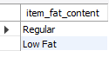

A. KPI’s:
1. Total Sales:
SELECT CONCAT(CAST(SUM(total_sales)/1000000 AS DECIMAL(10,2)),' ','Millon')
AS Total_Sales_Millons
FROM blinkit_final;
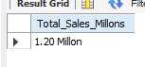

2. Average Sales:
SELECT ROUND(AVG(total_sales), 0) AS Avg_Sales
FROM blinkit_final;
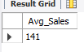

3. No.Of Items:
SELECT COUNT(*) AS No_Of_Items
FROM blinkit_final;
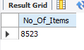

4. Avg Rating:
SELECT CAST(AVG(rating) AS DECIMAL(10,2)) AS Avg_Rating
FROM blinkit_final;
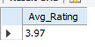

5. Total Sales by Fat Content:
SELECT item_fat_content, CAST(SUM(total_sales) AS DECIMAL(10,2)) AS Total_Sales
FROM blinkit_final
GROUP BY item_fat_content;
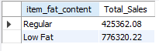
6. Total Sales by Item Type:
SELECT item_type, CAST(SUM(total_sales) AS DECIMAL(10,2)) AS Total_Sales
FROM blinkit_final
GROUP BY item_type;
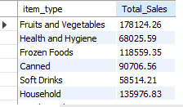
7. Fat Content by Outlet for Total Sales:
SELECT outlet_location_type,
ROUND(SUM(CASE WHEN item_fat_content = 'Low Fat'
THEN total_sales
ELSE 0
END), 2) AS Low_Fat,
ROUND(SUM(CASE WHEN item_fat_content = 'Regular'
THEN total_sales
ELSE 0
END), 2) AS Regular,
FROM blinkit_final
GROUP BY outlet_location_type
ORDER BY outlet_location_type;
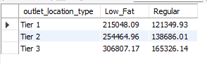

8. Total Sales by Outlet Establishment:
SELECT outlet_establishment_year,
CAST( SUM(total_sales) AS DECIMAL (10,2)) as Total_Sales
FROM blinkit_final
GROUP BY outlet_establishment_year
ORDER BY outlet_establishment_year DESC;
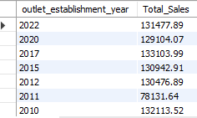

9. Percentage of Sales by Outlet Size:
WITH sales_cte AS (
SELECT
outlet_size,
SUM(total_sales) AS total_sales
FROM blinkit_final
GROUP BY outlet_size
)
SELECT outlet_size,
CAST(total_sales AS DECIMAL(10,2)) AS Total_Sales,
CAST( total_sales * 100.0 / SUM(total_sales) OVER () AS DECIMAL(10,2) ) AS Sales_Percentage
FROM sales_cte
ORDER BY Total_Sales;

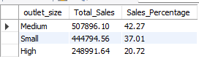

10. Sales by Outlet Location:

SELECT outlet_location_type,
CAST(SUM(total_sales) AS DECIMAL (10,2)) AS Total_Sales
FROM blinkit_final
GROUP BY outlet_location_type
ORDER BY Total_Sales DESC;
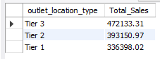

11.All Metrics by Outlet Type:
SELECT outlet_type,
CAST(SUM(total_sales) AS DECIMAL(10,2)) AS Total_Sales,
ROUND(AVG(total_sales), 0) AS Avg_Sales,
COUNT(*) AS No_Of_Items,
CAST(AVG(rating) AS DECIMAL(10,2)) AS Avg_Rating
FROM blinkit_final
GROUP BY outlet_type
ORDER BY Total_Sales DESC;
