AWS CONCEPTS

IP addresses classes
class | 1st Octet Decimal Range | 1st Octet High Order Bits
A | 1 – 126* | 0
B | 128 – 191 | 10
C | 192 – 223 | 110
D | 224 – 239 | 1110 | Reserved for Multicasting
E | 240 – 254 |  | Experimental; used for research

Private IP Addresses
These are private ip addresses used inside the companies and they communicate through internet gateway which will convert private ip address to one public ip and get the information needed to the person. The above process is called NATing
Class | Private Networks | Subnet Mask | Address Range
A | 10.0.0.0 | 255.0.0.0 | 10.0.0.0 - 10.255.255.255
B | 172.16.0.0 - 172.31.0.0 | 255.240.0.0 | 172.16.0.0 - 172.31.255.255
C | 192.168.0.0 | 255.255.0.0 | 192.168.0.0 - 192.168.255.255

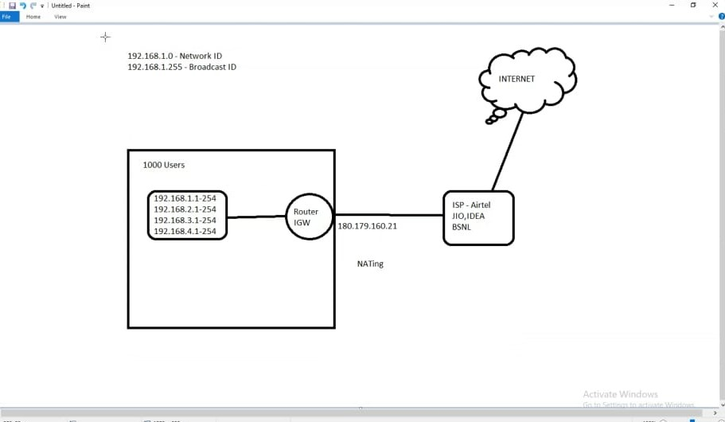

Subnet calculator:
http://www.subnet-calculator.com/

VPC: Virtual private cloud
- Security issues
- Ip addresses overlap
- Management issues
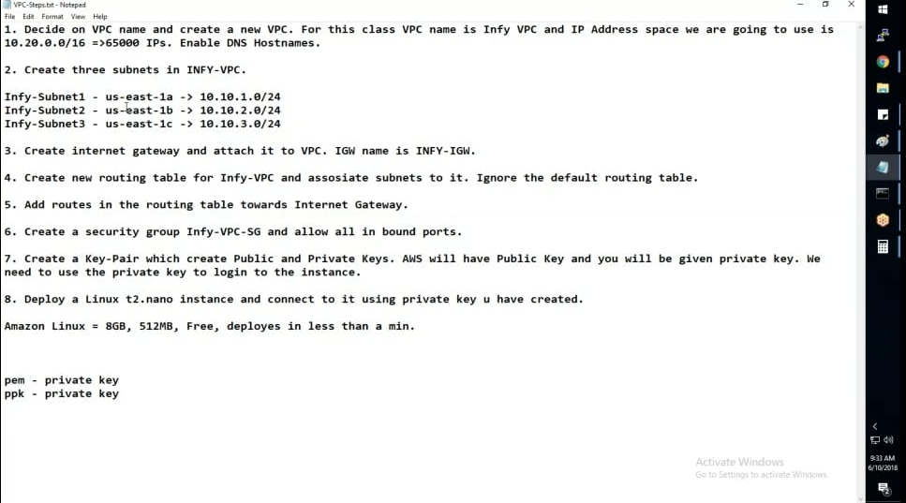

Security groups(statefull firewall)

NACL(stateless firewall)

GIT-- version control software
Repository -- github, bitbucket, gitlab, VSTs

git untracked
git add
Git commit
Git push

Git Commands:

$ git init
The git init command creates a new Git repository. It can be used to convert an existing, unversioned project to a Git repository or initialize a new, empty repository. Most other Git commands are not available outside of an initialized repository, so this is usually the first command you'll run in a new project.

$ git add “filename”
The git add command adds a change in the working directory to the staging area. It tells Git that you want to include updates to a particular file in the next commit. However, git add doesn't really affect the repository in any significant way—changes are not actually recorded until you run git commit
$ git add . --- add all the files in the directory

$ git status
The git status command displays the state of the working directory and the staging area. It lets you see which changes have been staged, which haven't, and which files aren't being tracked by Git. Status output does not show you any information regarding the committed project history.
$ git status -s
It will about the file in one lu=ine about the status

$ git commit -m “Message”
git commit. The "commit" command is used to save your changes to the local repository. Note that you have to explicitly tell Git which changes you want to include in a commit before running the "git commit" command. This means that a file won't be automatically included in the next commit just because it was changed.

$ git config --global user.name "Arun"
$ git config --global user.email "aruntm2707@gmail.com"
git config Adding Your account details to git

$ git log

git log tool allows you to view information about previous commits that have occurred in a project. The simplest version of the log command shows the commits that lead up to the state of the currently checked out branch. These commits are shown in reverse chronological order (the most recent commits first)
$ git log --oneline
Display the one line details about the committed information

$ cat ~/.gitconfig
It will the configuration users in those file

$ git chekout
The git checkout command lets you navigate between the branches created by git branch . Checking out a branch updates the files in the working directory to match the version stored in that branch, and it tells Git to record all new commits on that branch

$ git revert
If you want to revert the last commit just do git revert <unwanted commit hash> ; then you can push this new commit, which undid your previous commit. To fix the detached head do git checkout <current branch>
From this you can revert the last committed HEAD. It will revert back to previous commit

$ git rebase
In Git, the rebase command integrates changes from one branch into another. It is an alternative to the better known "merge" command. Most visibly, rebase differs from merge by rewriting the commit history in order to produce a straight, linear succession of commits.

Here you can delete the commits from the the master.

$ git clean -n/-f
Clean all the files other than added files

$ git reset
To reset the all the commits to and get back to mentioned committed value

$ git branch -- to list the branches

$ git branch branch_name -- create the new branch branch_name

$ git merge branch_name -- to merge the branch branch_name to master

$ git branch -d branch_name -- to delete the branch branch_name

$ git push -- Push the files to repository
Ex: git push origin master

$ git pull -- get the files from repository
Git pull repo-link

Jenkins

Free, open source and has lot of plugins
Jenkins is an open source automation server intended to automate repetitive technical tasks involved in the continuous integration and delivery of software. Jenkins is Java-based and can be installed from Ubuntu packages or by downloading and running its Web application ARchive (WAR) file — a collection of files that make up a complete web application which is intended to be run on a server

echo "# awstesting"
>>README.md
git initgit add README.md
git commit -m "first commit"
git remote add origin https://github.com/Arun-Mulimani/awstesting.git
git push -u origin master

