ANNA UNIVERSITY
College of Engineering, Guindy
Chennai - 600 025

IT23502 - WEB PROGRAMMING
MINI-PROJECT REPORT

NoQ
Smart Canteen Pre-Ordering and Queue Management System
"No Queue. Just Order."
Unit IV - Advanced Frameworks | Unit V - Web Services

No. | Team member | Register number
1 | Harish M | 2024115118
2 | Arun N M | 2024115098
3 | Sreeram Santhosh | 2024115126
Team No.: [TeamNo - to be filled in]
Academic Year 2026
Abstract
Queues at college canteens waste students' break time, and staff have no reliable way to see what customers want before they reach the counter. NoQ ("No Queue") is a web application that lets students browse a live menu, order in advance without creating an account, receive an order reference and a secret six-digit pickup code, and collect their food when it is ready. The canteen uses two simple staff pages: the Kitchen page, where the cooks switch dishes between Available and Not available and mark incoming orders Ready for Pickup, and the Staff page, where counter staff check the pickup code, record the counter payment and hand the food over.
The system consists of two independent Spring Boot 3.5 applications written for Java 21: the main application (port 8080), which serves server-rendered Thymeleaf pages and a JSON REST API backed by MySQL 8 through Spring Data JPA and Hibernate, and a small notification microservice (port 8081) that receives an "order ready" event over HTTP. Payment is made at the counter only: the customer hands cash or UPI to the staff member, who records it in the system. There is no online payment and no card or UPI data is ever collected.
The project demonstrates the Unit IV topics - Spring Boot and MVC, dependency injection, JPA and Hibernate with HQL, single-table inheritance mapping, SessionFactory/Session/Transaction, aspect-oriented programming and caching - and the Unit V topics: RESTful web services, service-to-service communication, and the difference between monolithic and microservice designs. Order placement is made safe under simultaneous requests by locking database rows. An automated test suite of 32 tests and a 35-request Postman collection check the behaviour. This report describes the final, simplified version of the application and states clearly which results were verified on this version and which were not.
Table of Contents
Chapter 1 - Introduction
1.1 Background and motivation
1.2 Problem statement
1.3 Objectives
1.4 Scope of the project
1.5 Existing approach and its limitations
1.6 Proposed solution
1.7 Expected benefits
Chapter 2 - Requirements Analysis
2.1 Functional requirements
2.2 Non-functional requirements
2.3 User roles and permissions
2.4 Software and hardware requirements
2.5 Assumptions and limitations
Chapter 3 - System Design
3.1 Overall architecture
3.2 Main application and notification microservice
3.3 MVC design
3.4 Module descriptions
3.5 Customer, Kitchen and Staff workflows
3.6 Order lifecycle and status transitions
Chapter 4 - Technology Stack
Chapter 5 - Database Design
5.1 Overview
5.2 Entity-relationship diagram
5.3 Table definitions
5.4 Keys and relationships
5.5 JPA annotations and ORM mapping
5.6 ID generation strategy
5.7 Payment inheritance mapping
5.8 Sample database records
Chapter 6 - Implementation
6.1 Customer menu browsing
6.2 Cart and checkout
6.3 Server-side price and stock validation
6.4 Order creation and idempotency
6.5 Stock updates and concurrency control
6.6 Order confirmation and live status
6.7 Counter payment and handover
6.8 Kitchen and Staff pages
6.9 Pickup OTP generation and verification
6.10 Menu availability
6.11 Notification microservice integration
6.12 Authentication, authorization and error handling
6.13 Simplification and readability
Chapter 7 - Unit IV: Advanced Frameworks
7.1 Spring Boot application structure
7.2 MVC architecture
7.3 Dependency injection
7.4 BeanFactory and ApplicationContext
7.5 JPA and Hibernate
7.6 CRUD operations
7.7 HQL queries
7.8 Inheritance mapping
7.9 SessionFactory, Session and Transaction
7.10 Aspect-oriented programming
7.11 Caching
7.12 Spring Cloud and its purpose
Chapter 8 - Unit V: Web Services
8.1 Web services
8.2 REST architecture
8.3 HTTP methods and status codes
8.4 REST API endpoints
8.5 Testing the API with Postman
8.6 Communication between the main application and the notification microservice
8.7 Monolithic versus microservice architecture
8.8 REST versus SOAP
8.9 Git and GitHub
8.10 Maven and the role of DevOps
8.11 Implemented functionality and concepts explained for the course
Chapter 9 - Testing and Results
9.1 Testing strategy
9.2 Automated test suite
9.3 Important test cases
9.4 API testing
9.5 Database-backed testing
9.6 Concurrency testing
9.7 Error-handling and negative tests
9.8 Reported results
9.9 Known limitations and unverified areas
Chapter 10 - Screenshots and Demonstration
10.1 Suggested demonstration sequence
Chapter 11 - Setup and Execution
11.1 Prerequisites
11.2 Environment configuration
11.3 Database creation and initialisation
11.4 Maven build and test commands
11.5 Running the applications
11.6 Postman setup
11.7 Troubleshooting
Chapter 12 - Limitations and Future Enhancements
12.1 Limitations of the current system
12.2 Future enhancements
Chapter 13 - Conclusion
References
Appendix A - API Endpoint Summary
Appendix B - Sample Requests and Responses
Appendix C - HQL and Query Examples
Appendix D - Database Schema
Appendix E - Seed Data (menu_item)
Appendix F - Test-Case Summary
Appendix G - Local Execution Commands

Chapter 1 - Introduction

1.1 Background and motivation
A college canteen serves hundreds of students in short breaks between classes. Orders are usually taken at a single counter, so students queue to order, queue again to pay and wait again to collect. Time that could be spent eating or studying is lost, and the canteen has no advance view of how much food will be needed.
Web technology can remove most of this waiting. If the menu is available on a phone, a student can place the order while walking to the canteen and arrive when the food is ready. NoQ was built to demonstrate this idea with the technologies taught in IT23502 Web Programming.

1.2 Problem statement
Design and implement a web application for a college canteen in which customers can browse a live menu, order before reaching the counter and collect the food with a secret code, while the canteen's kitchen and counter staff manage dish availability, incoming orders, payments and handover from separate, access-controlled pages.

1.3 Objectives
- Provide a responsive customer interface for browsing, searching, filtering and ordering without creating an account.
- Validate every order on the server: items, quantities, prices and stock are never trusted from the browser.
- Generate a unique order reference and a separate secret pickup code, and allow each order to be collected only once.
- Support payment at the counter, recorded by staff and kept separate from the food-preparation status.
- Give the kitchen one page for dish availability and incoming orders, and give counter staff one page for ready orders: pickup-code check, counter payment and handover.
- Keep stock correct when many customers order at the same time.
- Demonstrate the Unit IV topics (Spring Boot, MVC, dependency injection, JPA/Hibernate, HQL, inheritance mapping, AOP, caching) and the Unit V topics (REST web services and a separate microservice) in working code.

1.4 Scope of the project
In scope: one canteen; customer ordering with a live order status; a Kitchen page and a Staff page; role-based access for the KITCHEN and STAFF roles; counter payments; stock management; a pickup-code workflow; a REST API; and one small notification microservice.
Out of scope: online payment, customer accounts, an administrator role or menu-editing screens (the menu comes from the sample-data script), SMS or e-mail delivery, multiple canteens, and cloud deployment. Possible extensions are listed in Chapter 12.

1.5 Existing approach and its limitations
In a typical manual setup, orders are taken verbally or on paper at the counter. The common limitations are:
- Customers wait in a queue to place an order and again to collect it.
- Staff learn about demand only when customers reach the counter.
- Sold-out items are discovered only after waiting in the queue.
- There is no reliable record of orders, payments or which items sell best.
- Handing over food without a verification step can lead to disputes about who ordered what.

1.6 Proposed solution
NoQ moves ordering to the web. The customer adds menu items to a cart, places the order and immediately receives an order reference (for example NQ-2026-7KQ2M) and a secret six-digit pickup code on a confirmation screen. The order appears on the Kitchen page as PREPARING; when the food is cooked the kitchen presses Ready for Pickup. The customer's open confirmation screen then changes to READY FOR PICKUP by itself, and the separate notification service is told. At the counter, staff type the customer's code on the Staff page; a correct code records the counter payment, and staff confirm the handover, which marks the order COLLECTED. A pickup code can be used only once.

1.7 Expected benefits
- Customers: less waiting, visible availability and prices, and a clear status for every order.
- Staff: a Kitchen page and a Staff page that each show only what that person needs, instead of verbal orders, and a one-click way to mark a dish Not available.
- Management: a record of orders and a popularity count per menu item.
- Students of the course: a complete, explainable example of the Unit IV and Unit V concepts.

Chapter 2 - Requirements Analysis

2.1 Functional requirements
Table 2.1: Functional requirements and where they are implemented
ID | Requirement | Main implementation
FR1 | Show the menu with images, prices, descriptions and availability; filter by category, search and sort. | index.html, menu.js, MenuService
FR2 | Provide popular items from real order counts (HQL query), through the API and the "Most popular" sort. | MenuService.getPopularItems
FR3 | Cart stored in the browser; quantities can be changed or removed. | app.js, cart.js
FR4 | Place an order; the server validates items, quantities, prices and stock and calculates all totals. | OrderService.placeOrder
FR5 | Reject repeated submissions of the same checkout. | idempotencyKey
FR6 | Generate a unique order reference and a separate six-digit pickup OTP, stored only as a hash. | OrderService, PickupCodeService
FR7 | Order confirmation screen with the OTP; it re-reads and shows the current status every 5 seconds. | cart.js, GET /api/orders/{ref}
FR8 | Pay at the counter: staff record the payment after a correct OTP; payment status is kept apart from the food status. | PaymentService, staff.js
FR9 | Kitchen page, Incoming Orders: PREPARING orders with one Ready for Pickup button each. | staff.js (kitchen mode), OrderRestController
FR10 | Kitchen page, Menu Availability: one Available / Not available switch per dish, enforced at checkout. | kitchen.js, MenuService.updateAvailability
FR11 | Staff page: ready orders only; verify the pickup OTP, then confirm the handover; an order is collected only once. | staff.js, OrderService.verifyPickup, collect
FR12 | Cancel an order while it is still PREPARING (API only); the reserved stock is restored. | OrderService.cancel
FR13 | Notify a separate service when an order becomes READY_FOR_PICKUP. | NotificationClient, noq-notification-service
FR14 | Provide a REST API under /api for the above, with validation and structured errors. | restcontroller package

2.2 Non-functional requirements
Table 2.2: Non-functional requirements
Quality | Requirement
Correctness | Prices and totals are calculated on the server from the database. Money uses BigDecimal. Order status changes follow a fixed state machine.
Data consistency | Order creation, stock changes and payments run in transactions. Rows are locked so simultaneous orders cannot oversell an item or create two payments.
Security | Kitchen and Staff operations require login and the correct role. Passwords and pickup OTPs are stored as BCrypt hashes. The OTP is not logged and is returned only once.
Usability | Mobile-first, responsive pages with a clean, minimal layout; one action per order card; clear error messages; images fall back to an emoji tile if they fail to load.
Maintainability | Layered architecture (controller, service, repository, entity, DTO), constructor injection, centralised exception handling, and short, readable methods.
Testability | Automated unit and integration tests, runnable without MySQL (H2), plus a Postman collection for the API.
Portability | Runs on any machine with JDK 21 and MySQL 8; secrets come from environment variables or an ignored .env file.

2.3 User roles and permissions
NoQ has three kinds of users. Customers need no account. Kitchen and Staff users log in with credentials stored in the staff_user table, and each login has exactly one role, KITCHEN or STAFF. There is no administrator role. The rules below are enforced by SecurityConfig on the server, not by hiding buttons in the page.
Table 2.3: Roles and permissions
Operation | Who may do it | Notes
Browse the menu, search, filter and sort, place an order | Anyone (Customer) | No login. GET /api/menu and POST /api/orders are public.
Read back one's own order (status, items, total) | Customer with the pickup OTP | The OTP is sent in the X-Pickup-Otp header. Five wrong attempts lock this read for that order.
Switch a dish Available / Not available; mark an order Ready for Pickup | KITCHEN | Kitchen page. STAFF receives HTTP 403 for these two endpoints.
List incoming and ready orders | KITCHEN or STAFF | Each page lists its own orders (PREPARING for the kitchen, READY_FOR_PICKUP for staff).
Verify the pickup OTP, record the counter payment, confirm the handover | STAFF | Staff page. KITCHEN receives HTTP 403 for these endpoints.
Demo endpoints (/api/demo/**) and actuator metrics | STAFF | Only /actuator/health is public.

Two demo accounts are created by the sample-data script: kitchen (role KITCHEN) and staff (role STAFF). Their demo passwords are listed in Chapter 11 and the README and must be changed for any real use.

2.4 Software and hardware requirements
Table 2.4: Software requirements
Software | Requirement
Java | JDK 21 or newer (the project targets Java 21)
Database | MySQL 8.x (the in-memory H2 database is used by the tests and an optional demo profile)
Build tool | Maven, supplied through the included Maven Wrapper (Maven 3.9.16)
Browser | A current desktop or mobile browser
Optional tools | Git, Postman, Spring Tool Suite or IntelliJ IDEA

Table 2.5: Hardware requirements
Hardware | Requirement
Processor and memory | Any computer able to run JDK 21 and MySQL; about 4 GB of RAM is comfortable
Disk | A few hundred megabytes for dependencies and build output
Network | Internet access for the first Maven build and for the food photographs (see assumptions)

2.5 Assumptions and limitations
- Payment is made at the counter only. NoQ records that the counter received the money; no gateway, bank or card network is contacted and no card or UPI details are collected.
- Menu photographs are loaded from an external image service. If an image cannot be loaded, the page shows an emoji tile instead.
- There are no customer accounts. A customer is recognised for an order by its reference plus the pickup OTP, which the browser keeps in its own local storage.
- Menu items, prices and stock come from the sample-data script (data.sql). The application has no menu-editing screen; the kitchen can only switch dishes between Available and Not available.
- Pre-orders are accepted at any time. Opening hours are neither shown nor enforced.
- The wrong-OTP counter is held in memory, so it resets when the application restarts.
- The notification service keeps events in memory and does not retry failed deliveries.
- The application is a college mini-project and is not presented as production-ready.

Chapter 3 - System Design

3.1 Overall architecture
NoQ consists of two separate Spring Boot applications and one database. The main application serves the customer pages, the Kitchen and Staff pages and the REST API. It stores its data in MySQL. When the kitchen marks an order READY_FOR_PICKUP it sends a small HTTP request to the notification service. Figure 3.1 shows the runtime structure; the ports are taken from the configuration (server.port defaults to 8080 for the main application and 8081 for the notification service).
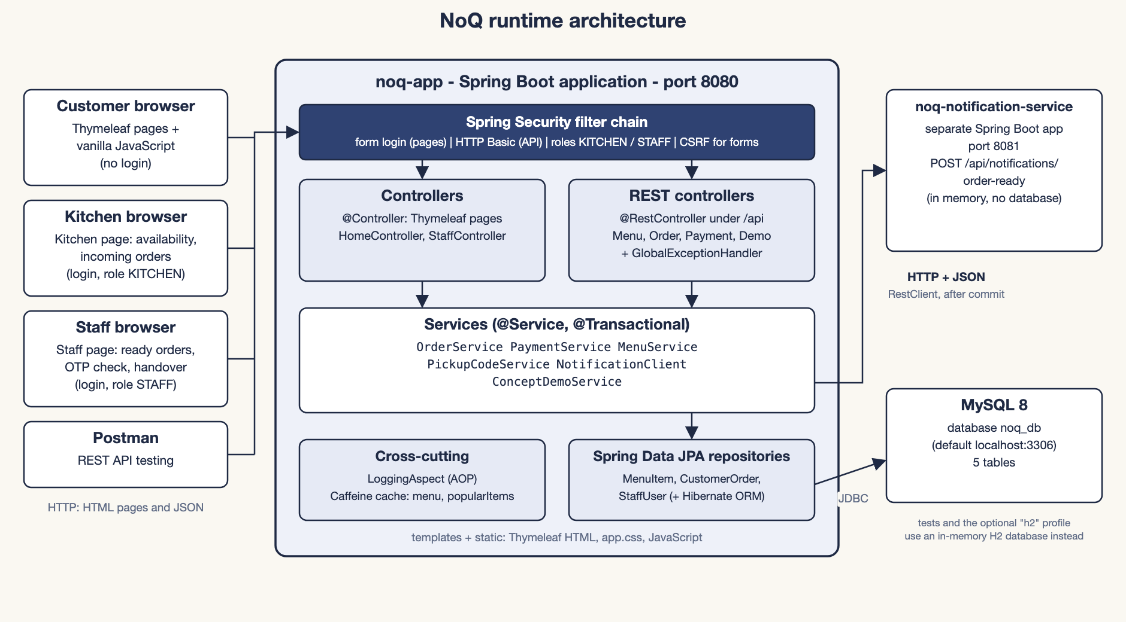
Figure 3.1: Runtime architecture of NoQ

3.2 Main application and notification microservice
The two programs live in one Git repository as a simple Maven multi-module project, but they are built and run independently. They share no code and no database; they talk only over HTTP and JSON.
Table 3.1: The two applications compared
 | noq-app | noq-notification-service
Port | 8080 | 8081
Role | Customer pages, Kitchen and Staff pages, REST API, business rules, data access | Receives "order ready" events, validates them, logs them and keeps the last 100 in memory
Data store | MySQL 8 (database noq_db by default) | None (in-memory list)
Key endpoints | /, /cart, /staff, /staff/kitchen, /api/** | POST /api/notifications/order-ready, GET /api/notifications
Build output | noq-app-1.0.0.jar | noq-notification-service-1.0.0.jar

The main application is intentionally a monolith: pages, API, business rules and data access run in one process, which keeps development, testing and deployment simple for a small team. Notification sending was separated as a microservice to demonstrate service-to-service communication and graceful failure (Chapter 8).

3.3 MVC design
The main application follows Spring MVC. The code is split into packages under com.noq, each with one responsibility:
Table 3.2: Package structure of the main application
Package | Responsibility
controller | Thymeleaf page controllers (@Controller): HomeController (menu and cart pages) and StaffController (login, Staff page, Kitchen page). They put data in the Model and return a view name.
restcontroller | JSON API controllers (@RestController): MenuRestController, OrderRestController, PaymentRestController, DemoRestController.
service | Business rules and transactions: OrderService, PaymentService, MenuService, PickupCodeService, NotificationClient, ConceptDemoService.
repository | Spring Data JPA interfaces: MenuItemRepository, CustomerOrderRepository, StaffUserRepository (with the HQL queries).
entity | JPA entities mapped to tables, including the Payment inheritance hierarchy (Payment and CashPayment).
dto | Request and response records with validation annotations. Entities are never returned directly from the API.
enums | Category, OrderStatus, PaymentMethod, PaymentStatus, StaffRole.
exception | ApiException, ApiError and GlobalExceptionHandler (every REST error becomes one JSON shape).
aspect, security | LoggingAspect (AOP); SecurityConfig and StaffUserDetailsService.

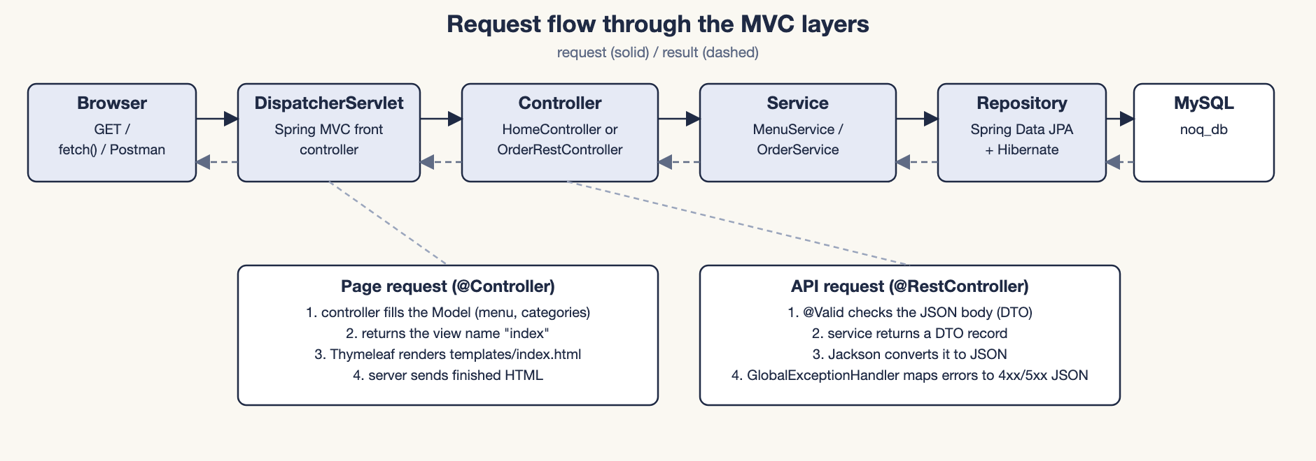
Figure 3.2: Request flow through the MVC layers
Controllers never access repositories directly; they call services. Services return DTOs, so entities and their relationships stay inside the transaction boundary. All dependencies are supplied through constructors.

3.4 Module descriptions
Table 3.3: Modules of NoQ
Module | Description
Menu module | Lists active menu items (cached), popular items and category filtering. The Kitchen page switches a dish between Available and Not available. Items, prices and stock come from the sample-data script.
Order module | Checkout with server-side validation and stock deduction, order reference and OTP generation, status transitions, cancellation (API only), pickup verification and handover.
Payment module | Counter payments, recorded as CashPayment rows when staff verify a correct OTP, kept separate from the order status.
Kitchen and Staff module | Form login, the KITCHEN and STAFF roles, the Kitchen page (Incoming Orders and Menu Availability) and the Staff page (ready orders, OTP check, handover).
Notification module | NotificationClient in the main application and the separate notification service.
Front end | Thymeleaf templates, one stylesheet and one small JavaScript file per page (menu, cart and confirmation, Staff and Kitchen lists).

3.5 Customer, Kitchen and Staff workflows
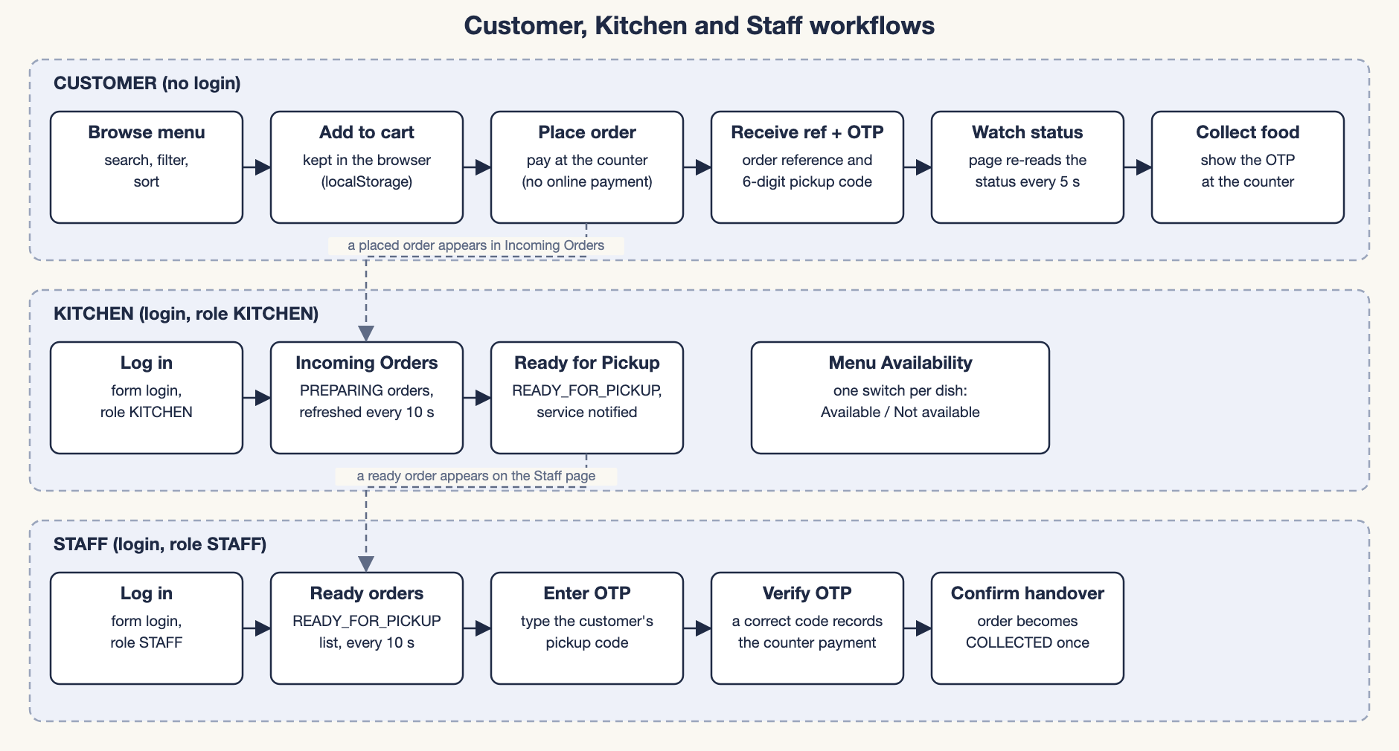
Figure 3.3: Customer, Kitchen and Staff workflows
The customer side needs no login. The cart lives in the browser's local storage; at checkout the browser sends only item ids, quantities and an idempotency key. After checkout the confirmation screen stays on the device and re-reads the order status every five seconds. The Kitchen and Staff pages require login; their order lists refresh every ten seconds and show only the next valid action for each order.

3.6 Order lifecycle and status transitions
An order has four statuses: PREPARING, READY_FOR_PICKUP, COLLECTED and CANCELLED. The allowed moves are defined in one place, OrderStatus.canMoveTo, and an automated test checks all sixteen pairs of statuses against the table below.
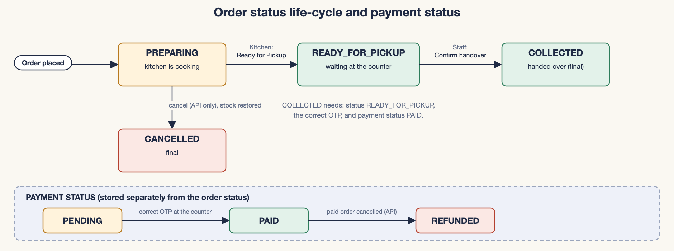
Figure 3.4: Order status life-cycle and payment status
Table 3.4: Order status transitions
From | Allowed next status | Condition
PREPARING | READY_FOR_PICKUP, CANCELLED | The kitchen sets READY_FOR_PICKUP; a notification is sent after the status is saved. CANCELLED is possible through the API only, and the stock is restored.
READY_FOR_PICKUP | COLLECTED | Only through the Staff page: a correct pickup OTP, and the payment status must be PAID. Cancelling is no longer allowed.
COLLECTED | (none) | Final.
CANCELLED | (none) | Final. The stock was restored; a PAID order becomes REFUNDED.

Payment has its own status (PENDING, PAID, REFUNDED). It is stored separately from the food status. A new order is PENDING; when staff enter a correct OTP the counter payment is recorded and the order becomes PAID. REFUNDED is set only if an order that was already paid is cancelled through the API.

Chapter 4 - Technology Stack
This chapter lists the technologies that are actually used in the project and explains what each one does there.
Table 4.1: Technologies used in NoQ
Technology | Purpose in NoQ
Java 21 | Implementation language (compiler target 21). The code uses records for DTOs and events, switch expressions in OrderStatus.canMoveTo and Math.clamp in the popular-items endpoint.
Spring Boot 3.5.16 | Auto-configuration, embedded Tomcat, dependency management through the parent POM, and executable JARs. Used by both applications.
Spring MVC | Maps URLs to controller methods and converts JSON to and from Java objects.
Thymeleaf | Renders the HTML pages on the server from templates and a Model. The Spring Security extras provide sec:authorize for role-dependent navigation (Orders for STAFF, Kitchen for KITCHEN).
Spring Data JPA and Hibernate 6.6 | Object-relational mapping and repositories. Hibernate generates the SQL, creates the tables (ddl-auto=update) and provides optimistic locking and HQL.
MySQL 8 | Main relational database. H2 (in memory) is used by the automated tests and an optional demo profile. Earlier versions of NoQ were also run on MySQL 8.4.9; the final version was verified on H2 only (Chapter 9).
Spring Security with BCrypt | Form login for pages, HTTP Basic for the API, role checks (KITCHEN and STAFF), CSRF protection for forms and BCrypt hashing for staff passwords and pickup OTPs.
Spring Validation | Bean Validation annotations (@NotNull, @NotEmpty, @Min, @Max, @Pattern ...) on request DTOs, checked with @Valid.
Spring Cache with Caffeine | In-memory cache for the menu and popular-item lists (60-second expiry), cleared after changes.
Spring AOP | LoggingAspect times every public service method and logs failures.
Spring Boot Actuator | /actuator/health (public) and cache metrics (staff only).
RestClient | Spring's HTTP client, used by NotificationClient to call the notification service.
HTML, CSS, JavaScript | Responsive pages (one stylesheet) and small vanilla-JavaScript files for the menu, the cart and order confirmation, and the Staff and Kitchen lists. No front-end framework is used.
Maven | Builds and tests both modules, resolves dependencies and packages the JARs (Maven Wrapper, Maven 3.9.16).
JUnit 5, Spring Boot Test, MockMvc | Automated unit and integration tests.
Postman | A 35-request collection for testing the REST API manually or with the collection runner.
noq-notification-service | A second, independent Spring Boot application (web, validation, actuator) that receives order-ready events.

Not used: no front-end framework, message broker, cache server, container platform, online payment provider or Spring Cloud component is part of the implementation. Spring Cloud is explained as a concept in Chapter 7.

Chapter 5 - Database Design

5.1 Overview
The database has five tables, created by Hibernate from the entity classes (spring.jpa.hibernate.ddl-auto=update) and filled with sample data by data.sql. The column types below match the entity mappings and the DDL in docs/schema-mysql.sql.
Table 5.1: Tables and entities
Table | Entity class | Purpose
menu_item | MenuItem | A dish on the menu with price, stock, availability flags and popularity count.
customer_order | CustomerOrder | One customer order: reference, hashed pickup OTP, statuses, totals and timestamps.
order_item | OrderItem | One line of an order, with a copy of the item name and price at order time.
payment | Payment, CashPayment | One payment record per counter payment; the hierarchy is mapped to this one table.
staff_user | StaffUser | Kitchen and Staff logins with BCrypt password hashes and a role (KITCHEN or STAFF).

5.2 Entity-relationship diagram
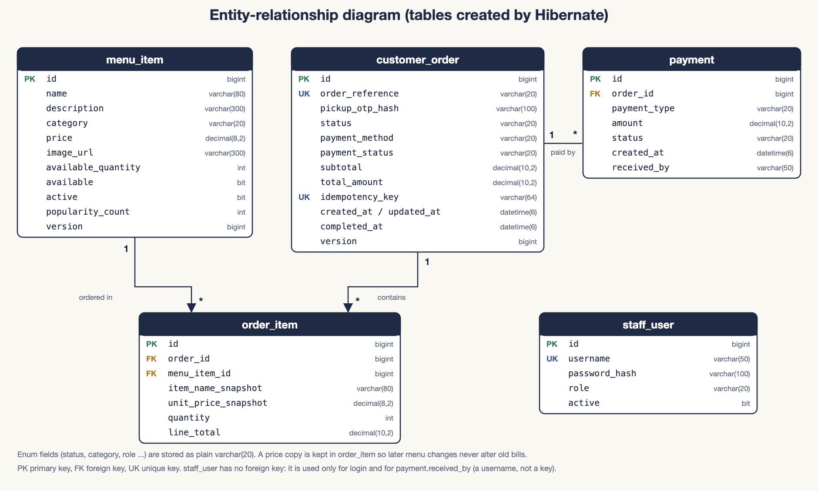
Figure 5.1: Entity-relationship diagram of the NoQ database

5.3 Table definitions
Table 5.2: Columns, types and constraints
Column | Type | Constraint / meaning
menu_item
id | bigint | Primary key, AUTO_INCREMENT
name / description | varchar(80) / varchar(300) | name is NOT NULL
category | varchar(20) | SNACKS, MEALS, FAST_FOOD, BEVERAGES or DESSERTS; indexed (idx_menu_item_category)
price | decimal(8,2) | Money, never floating point
image_url | varchar(300) | Optional
available_quantity | int | Current stock
available / active | bit | available = the kitchen's Available / Not available switch; active = on the menu at all
popularity_count | int | Units ordered (reduced again when an order is cancelled)
version | bigint | Optimistic-locking column (@Version)
customer_order
id | bigint | Primary key
order_reference | varchar(20) | UNIQUE, for example NQ-2026-7KQ2M
pickup_otp_hash | varchar(100) | BCrypt hash of the six-digit OTP; the OTP itself is never stored
status | varchar(20) | PREPARING, READY_FOR_PICKUP, COLLECTED, CANCELLED; indexed with created_at
payment_method / payment_status | varchar(20) | PAY_AT_COUNTER (the only value); PENDING, PAID or REFUNDED
subtotal / total_amount | decimal(10,2) | Calculated on the server
idempotency_key | varchar(64) | UNIQUE; stops a repeated checkout from creating a second order
created_at / updated_at / completed_at | datetime(6) | Filled by Hibernate (@CreationTimestamp, @UpdateTimestamp) and at handover
version | bigint | Optimistic-locking column
order_item
id, order_id, menu_item_id | bigint | order_id and menu_item_id are NOT NULL foreign keys
item_name_snapshot / unit_price_snapshot | varchar(80) / decimal(8,2) | Copies taken at order time
quantity / line_total | int / decimal(10,2) | line_total = unit price x quantity
payment
id, order_id | bigint | order_id is a NOT NULL foreign key to customer_order
payment_type | varchar(20) | Discriminator column: CASH
amount / status / created_at | decimal(10,2) / varchar(20) / datetime(6) | status: PAID when the counter takes the money
received_by | varchar(50) | CASH only: the staff username that recorded the payment
staff_user
id | bigint | Primary key
username | varchar(50) | UNIQUE
password_hash / role / active | varchar(100) / varchar(20) / bit | BCrypt hash; KITCHEN or STAFF; account enabled flag

5.4 Keys and relationships
Table 5.3: Relationships
Relationship | Cardinality | Implementation
customer_order - order_item | one to many | order_item.order_id references customer_order.id. In Java: CustomerOrder has @OneToMany(mappedBy = "customerOrder", cascade = ALL, orphanRemoval = true); OrderItem has @ManyToOne.
menu_item - order_item | one to many | order_item.menu_item_id references menu_item.id. An item can appear in many order lines; a line refers to exactly one item.
customer_order - payment | one to many | payment.order_id references customer_order.id. The model allows several payment rows per order; in normal use staff record one counter payment per order.
staff_user | none | No foreign key. payment.received_by stores a username as plain text.

Saving a CustomerOrder also saves its items and payments because of cascade = ALL. The helper methods addItem and addPayment keep both sides of each bidirectional relationship in sync. Both @ManyToOne associations from OrderItem are lazy; entities are used only inside transactions (spring.jpa.open-in-view=false).

5.5 JPA annotations and ORM mapping
Each entity class corresponds to one table and each field to one column. The excerpt below shows the main annotations on MenuItem:
MenuItem (abridged)
@Entity
@Table(name = "menu_item",
indexes = @Index(name = "idx_menu_item_category", columnList = "category"))
public class MenuItem {

@Id
@GeneratedValue(strategy = GenerationType.IDENTITY) // MySQL AUTO_INCREMENT
private Long id;

@Enumerated(EnumType.STRING)
@Column(nullable = false, columnDefinition = "varchar(20)")
private Category category;

@Column(nullable = false, precision = 8, scale = 2) // money: BigDecimal
private BigDecimal price;

@Version // optimistic locking
private Long version;
...
}

Enums are stored as text with @Enumerated(EnumType.STRING) and a plain varchar(20) column definition. This avoids MySQL ENUM and CHECK constraints, which Hibernate's ddl-auto=update would never change, so a new enum value in Java needs no manual ALTER TABLE. Prices use BigDecimal mapped to decimal.
OrderItem copies the item name and price when the order line is created, so later price changes or deactivation never alter old orders:
OrderItem constructor: price snapshot
public OrderItem(MenuItem menuItem, int quantity) {
this.menuItem = menuItem;
this.itemNameSnapshot = menuItem.getName();
this.unitPriceSnapshot = menuItem.getPrice();
this.quantity = quantity;
this.lineTotal = menuItem.getPrice().multiply(BigDecimal.valueOf(quantity));
}

5.6 ID generation strategy
Every entity uses @GeneratedValue(strategy = GenerationType.IDENTITY), so MySQL generates the primary key with AUTO_INCREMENT and Hibernate reads it back after each insert. The public identifier of an order is separate from the primary key: order_reference is generated with SecureRandom (the format is NQ- + year + five characters from an alphabet without 0, O, 1 and I). The generator checks for a clash and the UNIQUE constraint is the final guarantee.

5.7 Payment inheritance mapping
Payments are modelled with an abstract Payment entity and one concrete subclass, CashPayment. The strategy is InheritanceType.SINGLE_TABLE: Hibernate stores the hierarchy in the one payment table and uses the discriminator column payment_type to decide which Java class to create when a row is read. Columns that belong to only one subclass (here received_by) must be nullable, because they would be NULL for any other subclass. Only CASH exists today; a new way of paying would be one more subclass with its own discriminator value.
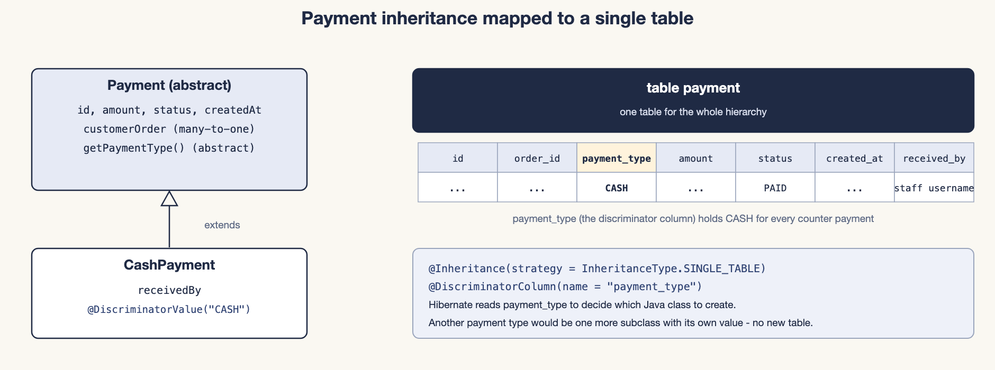
Figure 5.2: Payment inheritance mapped to a single table
Inheritance annotations (abridged)
@Entity
@Inheritance(strategy = InheritanceType.SINGLE_TABLE)
@DiscriminatorColumn(name = "payment_type", length = 20)
public abstract class Payment { ... }

@Entity
@DiscriminatorValue("CASH")
public class CashPayment extends Payment { private String receivedBy; ... }

SINGLE_TABLE was chosen because it needs no joins and keeps the schema simple; the trade-off is that subclass columns must be nullable. The hierarchy is used by the real application: PaymentService creates a CashPayment when staff record a counter payment. The isolated Hibernate demonstration (Section 7.9) groups the payments by subclass with the HQL function type(p).

5.8 Sample database records
The sample data below comes from data.sql (menu and staff users) and from a real order placed through the application while the screenshots in Chapter 10 were taken (on the H2 database). Password hashes and the pickup OTP hash are deliberately not shown.
Table 5.4: Sample rows of menu_item (23 rows are seeded)
id | name | category | price | stock | flags
1 | Masala Dosa | MEALS | 50.00 | 40 | available, active
3 | Samosa (2 pcs) | SNACKS | 20.00 | 60 | available, active
7 | Masala Chai | BEVERAGES | 15.00 | 100 | available, active
16 | Margherita Pizza | FAST_FOOD | 120.00 | 0 | out of stock
22 | Garden Salad Bowl | MEALS | 80.00 | 15 | marked Not available
23 | Chilli Paneer | SNACKS | 90.00 | 20 | inactive (off the menu)

Table 5.5: The two seeded staff_user rows (demo passwords are in the README and must be changed for any real use)
username | role | active | password_hash
kitchen | KITCHEN | yes | (BCrypt, not shown)
staff | STAFF | yes | (BCrypt, not shown)

Table 5.6: A sample customer_order row (pickup_otp_hash omitted)
order_reference | status | payment_method | payment_status | subtotal | total_amount
NQ-2026-D2NBS | COLLECTED | PAY_AT_COUNTER | PAID | 105.00 | 105.00

Table 5.7: Sample order_item rows of that order
item_name_snapshot | unit_price_snapshot | quantity | line_total | order
Masala Dosa | 50.00 | 1 | 50.00 | NQ-2026-D2NBS
Samosa (2 pcs) | 20.00 | 2 | 40.00 | NQ-2026-D2NBS
Masala Chai | 15.00 | 1 | 15.00 | NQ-2026-D2NBS

Table 5.8: The payment row of that order, showing the discriminator in use
payment_type | status | amount | received_by | order
CASH | PAID | 105.00 | staff | NQ-2026-D2NBS

Chapter 6 - Implementation
This chapter describes how each feature is implemented, using the real class and method names. The code excerpts are short and, where lines were shortened to fit the page, marked "abridged". All of the code shown reflects the final, simplified version described in Section 6.13.

6.1 Customer menu browsing
HomeController.index loads the full menu from MenuService, adds it to the Model together with the list of categories, and returns the view name index. Thymeleaf renders index.html as one compact row per dish (photo, name, short description, price, availability and an Add button), writing each item's data into data-* attributes.
Filtering by category, searching by name or description and the five sort modes run in the browser (menu.js) without extra requests. A dish that is Not available or sold out shows its state and a disabled Add button; inactive items are not listed. The "Most popular" sort uses each item's popularity count.
MenuService.getMenu and getPopularItems are annotated with @Cacheable (cache names menu and popularItems). The popular list comes from an HQL query ordered by popularityCount and is served by GET /api/menu/popular.

6.2 Cart and checkout
The cart is a plain JavaScript object kept in the browser's localStorage by app.js. On the cart page, cart.js re-reads /api/menu, replaces stored prices with the current server prices, and flags lines that are not available, sold out, removed or larger than the remaining stock; checkout stays disabled until those are fixed.
When the customer presses Place order, the browser sends only item ids, quantities and a random idempotency key. No prices, totals or payment method are sent: every order is paid at the counter. The key is kept in sessionStorage, so a double click or a retry after a network failure uses the same key.
Checkout request (no prices are sent)
POST /api/orders
{
"items": [ {"menuItemId": 1, "quantity": 2}, {"menuItemId": 7, "quantity": 1} ],
"idempotencyKey": "3f1c0d9e8a7b4c2d"
}

6.3 Server-side price and stock validation
Validation happens in two stages. First, @Valid on PlaceOrderRequest rejects an empty cart, more than 20 lines, and quantities outside 1-20 with HTTP 400 and a message per field. Second, OrderService.addLineToOrder checks every line against the database:
OrderService.addLineToOrder (abridged)
private void addLineToOrder(CustomerOrder order, Long menuItemId, int quantity) {
MenuItem item = menuItemRepository.findWithLockById(menuItemId)
.orElseThrow(() -> ApiException.badRequest(
"Menu item " + menuItemId + " does not exist"));

if (quantity > MAX_QUANTITY_PER_ITEM) { ... 400 }
if (!item.isActive()) {
throw ApiException.conflict(item.getName() + " is no longer on the menu");
}
if (!item.isAvailable()) {
throw ApiException.conflict(item.getName() + " is not available right now");
}
if (item.getAvailableQuantity() == 0) {
throw ApiException.conflict(item.getName() + " is sold out");
}
if (quantity > item.getAvailableQuantity()) {
throw ApiException.conflict("Only " + item.getAvailableQuantity()
+ " x " + item.getName() + " left");
}

item.reduceStock(quantity); // also increases popularityCount
order.addItem(new OrderItem(item, quantity)); // price snapshot
}

The price always comes from the MenuItem loaded in this transaction; checkout never uses the cache, and any price or total field sent by a client is ignored. Totals are summed with BigDecimal. Any failed check throws ApiException, the transaction rolls back, and no stock is deducted for any line of that order.

6.4 Order creation and idempotency
OrderService.placeOrder is a single @Transactional method. It reads from top to bottom as a short sequence of steps:
OrderService.placeOrder (abridged)
@Transactional
public OrderPlacedResponse placeOrder(PlaceOrderRequest request) {
String idempotencyKey = request.idempotencyKey();
if (idempotencyKey != null && idempotencyKey.isBlank()) {
idempotencyKey = null;
}
rejectIfAlreadySubmitted(idempotencyKey);

CustomerOrder order = new CustomerOrder();
Map<Long, Integer> quantities = mergeDuplicateLines(request.items());
for (Map.Entry<Long, Integer> entry : quantities.entrySet()) {
addLineToOrder(order, entry.getKey(), entry.getValue());
}

BigDecimal subtotal = BigDecimal.ZERO;
for (OrderItem line : order.getItems()) {
subtotal = subtotal.add(line.getLineTotal());
}
order.setSubtotal(subtotal);
order.setTotalAmount(subtotal); // no taxes or fees
order.setIdempotencyKey(idempotencyKey);
order.setOrderReference(newOrderReference());
String otp = pickupCodes.newOtp();
order.setPickupOtpHash(pickupCodes.hash(otp));
orderRepository.save(order); // cascades to the order items

menuService.evictMenuCaches(); // stock and popularity changed
return new OrderPlacedResponse(...); // the only response that contains the OTP
}

Idempotency. If an order with the same key already exists, rejectIfAlreadySubmitted throws HTTP 409 with the existing order reference. Because customer_order.idempotency_key is also UNIQUE, even two simultaneous requests with the same key cannot both succeed.
Repeated lines are merged first ([{1, x2}, {1, x1}] becomes {1: 3}), and the merged quantity is checked against the 20-per-item limit. On success the response is 201 Created with a Location header.

6.5 Stock updates and concurrency control
When two customers order the last unit at the same moment, both transactions could read "stock 1". The project protects against this at three levels.
- Row locks at checkout. MenuItemRepository.findWithLockById is annotated @Lock(LockModeType.PESSIMISTIC_WRITE), which makes MySQL run SELECT ... FOR UPDATE. Buyers of the same item queue up; the second one then sees the new stock and receives a clean 409 ("sold out"). Lines are processed in ascending item-id order (the TreeMap in mergeDuplicateLines), so two orders containing the same items cannot lock them in opposite order.
- Row locks on orders. Every action that changes an order (updateStatus, collect and the counter payment) first loads it with findForUpdate. Two staff recording a payment at the same moment, or a payment racing a cancellation, therefore run one after the other, and the second sees the new state and receives 409.
- Optimistic locking as a safety net. MenuItem and CustomerOrder have a @Version column. If a conflicting update ever slips through, Hibernate adds WHERE version = ? to the UPDATE, the update fails, and GlobalExceptionHandler returns 409.
The two locking repository methods
// MenuItemRepository
@Lock(LockModeType.PESSIMISTIC_WRITE)
Optional<MenuItem> findWithLockById(Long id);

// CustomerOrderRepository
@Lock(LockModeType.PESSIMISTIC_WRITE)
Optional<CustomerOrder> findWithLockByOrderReference(String orderReference);

Why the locks were needed. During development, an earlier optimistic-lock-only design passed its tests on H2, but on MySQL/InnoDB simultaneous requests deadlocked: inserting an order line takes a shared lock on the menu_item row (the foreign-key check) and the later stock UPDATE needs an exclusive lock on the same row, so two buyers each waited for the other and MySQL aborted one (HTTP 503). Locking the row first removed the deadlock. The final version keeps this locking and its concurrency tests pass on H2 (Chapter 9); the MySQL deadlock finding comes from the earlier development stage.

The stock-restoring operations use the same rules. OrderService.cancel adds each line's quantity back to its menu item and lowers the popularity count (never below zero); it runs only when canMoveTo(CANCELLED) is true, so stock can never be restored twice.

6.6 Order confirmation and live status
After checkout the cart page shows the order confirmation straight from the response of POST /api/orders: the order reference, the items, the total, the payment status, the current status and the pickup OTP. The browser also stores the confirmation, including the OTP, in localStorage (key noq.lastOrder), because the server keeps only the hash of the OTP and could not show it again. A page refresh, or opening the cart again, therefore shows the same confirmation.
While the confirmation is open, cart.js calls GET /api/orders/{ref} every five seconds with the OTP in the X-Pickup-Otp header. The server checks the OTP (at most five wrong attempts per order) and returns the saved status and payment status, so the screen moves from PREPARING to READY FOR PICKUP and finally COLLECTED without a separate tracking page. Plain HTTP polling was chosen instead of WebSockets because it is simple and adequate for food orders.
If the confirmation is lost (for example the browser data is cleared, or the checkout response never arrives), the pickup code cannot be shown again, because only its hash is stored. This is a documented limitation (Chapter 12).

6.7 Counter payment and handover
Counter payment. The customer pays cash or UPI to the staff member at the counter. On the Staff page the staff member types the customer's pickup OTP and presses Verify OTP. The page first calls POST /api/orders/{ref}/verify-pickup, which only checks the order and the OTP and changes nothing. Only if that succeeds, and the order is not yet PAID, the page calls POST /api/orders/{ref}/payments/counter-confirmation. PaymentService.confirmCounterPayment locks the order, checks that it is not already PAID or cancelled, adds a CashPayment (recording the staff username) and sets the payment status to PAID. A wrong OTP therefore never records a payment, and a second payment attempt returns 409.
Confirm handover. After the payment is recorded, the card shows "OTP verified. Food can be delivered." and a Confirm handover button. POST /api/orders/{ref}/collect checks the OTP and the order status again (the server never trusts the first step), refuses the handover unless the payment status is PAID, and then saves COLLECTED and the completion time exactly once.
OrderService.collect (abridged)
@Transactional
public OrderResponse collect(String orderReference, String otp) {
CustomerOrder order = findForUpdate(orderReference);
checkPickup(order, otp); // not collected yet, READY_FOR_PICKUP, OTP matches
if (order.getPaymentStatus() != PaymentStatus.PAID) {
throw ApiException.conflict("Payment pending: ... at the counter first");
}
order.setStatus(OrderStatus.COLLECTED);
order.setCompletedAt(LocalDateTime.now());
return OrderResponse.from(order);
}

The pages only offer the next step; the server checks every rule again on each call. For example, collecting an order whose payment is still PENDING returns 409 "Payment pending", and a wrong OTP returns 400 "Invalid pickup OTP" without changing anything.

6.8 Kitchen and Staff pages
Both pages use the same script, staff.js, in two modes chosen by the data-mode attribute of the page. It loads orders from GET /api/orders?status=... every ten seconds and draws one card per order, oldest first. In kitchen mode it asks for PREPARING orders, and each card has a single Ready for Pickup button that sends PATCH /api/orders/{ref}/status with READY_FOR_PICKUP. In staff mode it asks for READY_FOR_PICKUP orders, and each card shows the items, the total, the payment status and the OTP form described in Section 6.7. The status filter runs HQL query 2 (findByStatusNewestFirst), and a refresh never wipes an input field that the user is typing in.
OrderService.updateStatus enforces the status rules on the server:
OrderStatus.canMoveTo: the single definition of the state machine
public boolean canMoveTo(OrderStatus next) {
return switch (this) {
case PREPARING -> next == READY_FOR_PICKUP || next == CANCELLED;
case READY_FOR_PICKUP -> next == COLLECTED;
case COLLECTED, CANCELLED -> false;
};
}

updateStatus refuses COLLECTED (400: only the pickup handover may collect an order), delegates CANCELLED to cancel, and rejects illegal moves with 409. Moving to READY_FOR_PICKUP publishes an OrderReadyEvent (Section 6.11).

6.9 Pickup OTP generation and verification
- Generation: PickupCodeService.newOtp uses SecureRandom and formats the number as six digits with leading zeros. It is independent of the order reference.
- Storage: only a BCrypt hash is saved in pickup_otp_hash. The plain OTP is returned once in the 201 Created response and kept in the customer's own browser. It is not written to the logs: LoggingAspect never logs method arguments or results.
- Customer access: reading one's own order requires the matching OTP in the X-Pickup-Otp header. checkCustomerAccess counts each attempt atomically before the slow BCrypt comparison; after five wrong attempts the order's customer read answers HTTP 403.
- Pickup: staff enter the OTP. OrderService.verifyPickup only checks that the order is READY_FOR_PICKUP and the OTP matches. OrderService.collect repeats those checks, requires the payment status to be PAID, and then sets COLLECTED and completedAt. A second attempt returns 409 "already collected"; because the order row is locked first, two simultaneous requests run one after the other. The staff-side checks are not rate-limited, because only a logged-in STAFF user can call them (see Chapter 12).
PickupCodeService.matches
public boolean matches(String otp, String otpHash) {
boolean looksLikeAnOtp = otp != null && otp.matches("\\d{6}");
if (!looksLikeAnOtp) {
return false; // skip the slow BCrypt check for garbage input
}
return passwordEncoder.matches(otp, otpHash);
}

6.10 Menu availability
The Kitchen page has two tabs. Menu Availability lists every dish on the menu with its price and one switch. kitchen.js loads GET /api/menu; when the cook presses Mark not available (or Mark available) it sends PATCH /api/menu/{id}/availability with {"available": false}. MenuService.updateAvailability loads the item, sets the flag, clears the menu caches and returns the item. A dish that is Not available stays on the menu, greyed out, and checkout rejects it with HTTP 409 ("... is not available right now"). The stock count is never shown to, or changed by, the kitchen: it changes only when orders are placed or cancelled.
Menu content. NoQ has no administrator and no menu-editing screen. Dishes, prices, descriptions, images and starting stock come from the sample-data script data.sql, which uses INSERT IGNORE, so a restart never overwrites existing rows. Inactive items (active = false) are hidden from customers but stay in the database, so old orders remain valid.
MenuService.updateAvailability
@Transactional
public MenuItemResponse updateAvailability(Long id, boolean available) {
MenuItem item = find(id);
item.setAvailable(available); // managed entity: Hibernate writes the UPDATE at commit
evictMenuCaches();
return MenuItemResponse.from(item);
}

Cache eviction. After any change to the menu, stock or popularity, evictMenuCaches registers a transaction synchronisation that clears both caches in afterCommit(). Clearing earlier could let another request re-cache the old rows before the commit; a rollback clears nothing.

6.11 Notification microservice integration
When an order moves to READY_FOR_PICKUP, OrderService publishes an OrderReadyEvent carrying only the order reference. NotificationClient listens with @TransactionalEventListener(phase = AFTER_COMMIT), so the call happens only after the READY_FOR_PICKUP status has been saved. It uses Spring's RestClient with a two-second connect and read timeout to POST {"orderReference": "...", "eventType": "ORDER_READY"} to the notification service.
NotificationClient.onOrderReady (abridged)
@TransactionalEventListener(phase = TransactionPhase.AFTER_COMMIT)
public void onOrderReady(OrderReadyEvent event) {
try {
Map<?, ?> ack = restClient.post()
.uri("/api/notifications/order-ready")
.contentType(MediaType.APPLICATION_JSON)
.body(Map.of("orderReference", event.orderReference(),
"eventType", "ORDER_READY"))
.retrieve()
.body(Map.class);
log.info("Notification service acknowledged order {} ...");
} catch (RestClientException e) {
log.warn("Notification service unavailable; order {} is still READY_FOR_PICKUP. ...");
}
}

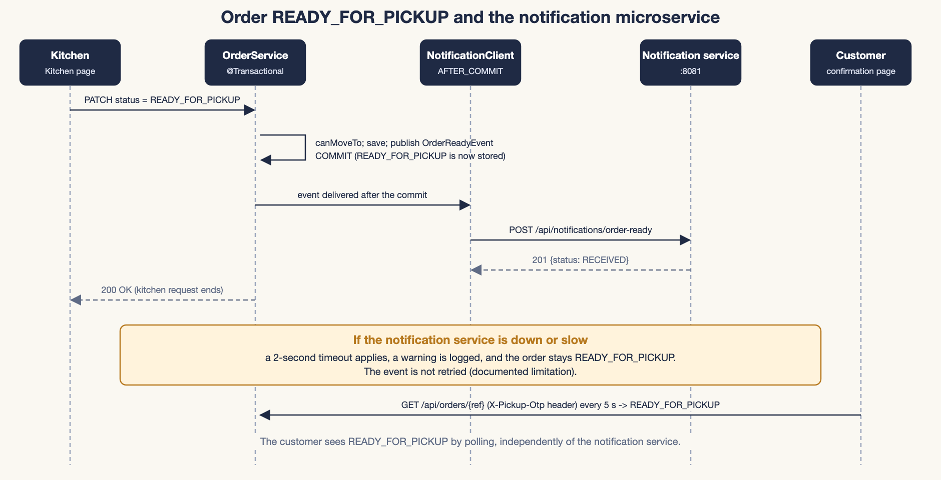
Figure 6.1: Order READY_FOR_PICKUP and the notification microservice
A failure is logged and never rethrown, so the kitchen still receives a normal response and the customer sees READY FOR PICKUP through polling. The notification service validates the payload (reference format NQ-dddd-XXXXX and event type ORDER_READY), logs the event, keeps the last 100 in memory and answers 201 Created with an acknowledgement. The limitation is that the call is synchronous, has no retry, and events are lost if the notification service is down or restarts. If the service hangs or cannot be reached, the kitchen's request waits about two seconds for the timeout.

6.12 Authentication, authorization and error handling
SecurityConfig defines the access rules on the server. The rules are evaluated top to bottom and the first match wins, which is why the specific rules come before the general /api/** rule:
SecurityConfig access rules (abridged)
.requestMatchers("/staff/kitchen").hasRole("KITCHEN")
.requestMatchers("/staff").hasAnyRole("KITCHEN", "STAFF")
.requestMatchers(HttpMethod.GET, "/api/menu/**").permitAll()
.requestMatchers(HttpMethod.PATCH, "/api/menu/*/availability").hasRole("KITCHEN")
.requestMatchers(HttpMethod.POST, "/api/orders").permitAll()
.requestMatchers(HttpMethod.GET, "/api/orders/*").permitAll() // the service checks the OTP
.requestMatchers(HttpMethod.GET, "/api/orders").hasAnyRole("KITCHEN", "STAFF")
.requestMatchers(HttpMethod.PATCH, "/api/orders/*/status").hasRole("KITCHEN")
.requestMatchers("/api/**", "/actuator/**").hasRole("STAFF")

- Browser pages use form login (/staff/login); Postman and scripts can use HTTP Basic. StaffUserDetailsService loads users from staff_user and gives each user exactly the one role stored in the table. After login, /staff sends a KITCHEN user to the Kitchen page and a STAFF user to the Staff page.
- API requests without login receive a JSON 401; a wrong role receives a JSON 403. Browsers requesting a staff page are redirected to the login page.
- CSRF protection stays on for HTML forms. It is switched off only for /api/** and /actuator/** (the API is called by the project's own JavaScript and by Postman); session cookies are SameSite=Lax.
- Customer-side order endpoints (place an order, read one's own order) are public in the URL rules; reading an order is protected inside the service by the OTP check, unless the caller is logged in as STAFF.
Error handling. GlobalExceptionHandler (a @RestControllerAdvice for the REST controllers) converts exceptions into one JSON shape: timestamp, status, error, message, path and, for validation errors, fieldErrors.
Table 6.1: Exception handling in GlobalExceptionHandler
Exception | HTTP | Meaning
ApiException (notFound, badRequest, conflict, forbidden) | 404, 400, 409, 403 | Business-rule failures thrown by the services.
MethodArgumentNotValidException | 400 | @Valid failed; one message per invalid field.
HttpMessageNotReadableException | 400 | Broken JSON or an unknown enum value.
MethodArgumentTypeMismatchException / MissingRequestHeaderException | 400 | Bad parameter value, or a missing X-Pickup-Otp header.
ObjectOptimisticLockingFailureException / PessimisticLockingFailureException | 409 | A concurrent change or a database lock conflict: "please retry".
DataIntegrityViolationException | 409 | A database constraint (for example a duplicate idempotency key).
DataAccessException | 503 | Other database errors (logged).
Spring web exceptions (no endpoint, wrong method or media type) | 404, 405, 415 | Keep their own status.
Any other exception | 500 | Logged; the client sees a generic message.

6.13 Simplification and readability
After the features were complete, the project was simplified so that it is easier to explain and maintain, without changing its core rules (server-side validation, row locking, hashed OTPs). The changes were:
Table 6.2: Simplification changes
Area | Change
Roles | The administrator role and the menu-management pages were removed. Only Customer, Kitchen and Staff remain.
Payment | The simulated online payment, the payment-gateway interface and the payment page were removed. Payment is at the counter only.
Order lifecycle | The six statuses (PLACED, CONFIRMED, PREPARING, READY, COMPLETED, CANCELLED) became four: PREPARING, READY_FOR_PICKUP, COLLECTED and CANCELLED.
Customer view | The separate tracking page was replaced by the order confirmation screen, which shows the pickup OTP and the live status.
Staff pages | The four-column staff board became two short lists: Incoming Orders on the Kitchen page and Ready for pickup on the Staff page.
Pickup flow | The OTP is verified first: a correct OTP records the counter payment, then staff confirm the handover. Collection still requires the payment status PAID.
User interface | A flat, minimal style with one stylesheet; the home page shows only the menu with search, filters and sort.
Code | Unused classes, methods, styles and configuration left over from the removed features were deleted. The automated tests were updated, not reduced.

The behaviour after the simplification was checked with the automated tests, the Postman collection and the browser screenshots described in Chapters 9 and 10. The row locking, the after-commit cache eviction and the atomic OTP attempt counter were deliberately left unchanged.

Chapter 7 - Unit IV: Advanced Frameworks
Each subsection explains a Unit IV concept and shows where it appears in NoQ. Where a concept is demonstrated only by an isolated example endpoint rather than by the business workflow, this is stated.

7.1 Spring Boot application structure
Spring Boot removes most manual configuration. The entry point is NoqApplication:
NoqApplication
@SpringBootApplication // @Configuration + @EnableAutoConfiguration + @ComponentScan
@EnableCaching // switches on @Cacheable / Caffeine
public class NoqApplication {
public static void main(String[] args) {
SpringApplication.run(NoqApplication.class, args);
}
}

Component scanning finds every @Controller, @Service, @Repository and @Component under com.noq and creates a bean for each. Auto-configuration sees the MySQL driver and Spring Data JPA on the classpath and configures the data source, the EntityManagerFactory and the transaction manager. The embedded Tomcat server means the application starts with java -jar and no separate web server. Settings live in application.properties; secrets come from environment variables or an ignored .env file.

7.2 MVC architecture
MVC separates Model (data shown by the view), View (Thymeleaf templates) and Controller (request handling). In NoQ, HomeController.index fills the Model with the menu and the category list and returns the view name index; DispatcherServlet passes the Model to Thymeleaf, which renders templates/index.html. Figure 3.2 shows the full request flow.
@Controller methods return view names (HTML pages). @RestController methods return objects that Jackson writes directly as JSON; these form the REST API. Request bodies are validated with @Valid on the DTO records, and validation errors come back as JSON with one message per field (Section 6.12).

7.3 Dependency injection
Dependency injection (an application of Inversion of Control) means an object does not create its collaborators; the container creates and supplies them. NoQ uses constructor injection everywhere; there is no field injection. For example, OrderService receives its repositories and helpers through its constructor:
Constructor injection in OrderService
public OrderService(CustomerOrderRepository orderRepository,
MenuItemRepository menuItemRepository,
MenuService menuService, PickupCodeService pickupCodes,
ApplicationEventPublisher events) { ... }

The chain controller to service to repository is wired the same way: HomeController receives MenuService, which receives MenuItemRepository, an interface for which Spring Data generates the implementation at run time. Constructor injection keeps dependencies explicit, allows fields to be final, and makes classes easy to test.

7.4 BeanFactory and ApplicationContext
BeanFactory is the basic IoC container interface: it creates beans (lazily) and supplies them with getBean(). ApplicationContext extends it with eager creation of singleton beans, event publishing, resource loading, environment and profile support and automatic registration of the post-processors that make features such as @Transactional, @Cacheable and AOP work. Spring Boot creates an ApplicationContext at start-up; NoQ uses its event publishing when OrderService publishes an OrderReadyEvent.
Demonstration (isolated example). ConceptDemoService.springContainerDemo, exposed to staff as GET /api/demo/spring-container, reports facts about the running container. On a run of the final version it returned applicationContextIsABeanFactory: true, a total of 458 beans (20 of them NoQ's own classes), orderServiceIsSingleton: true and orderServiceIsAopProxy: true (the OrderService bean is a CGLIB proxy that adds transactions and logging). The bean names of NoQ's own classes are collected with an ordinary loop:
ConceptDemoService.springContainerDemo (excerpt)
List<String> noqBeans = new ArrayList<>();
for (String beanName : applicationContext.getBeanDefinitionNames()) {
Class<?> beanType = applicationContext.getType(beanName);
if (beanType != null && beanType.getName().startsWith("com.noq")) {
noqBeans.add(beanName);
}
}
Collections.sort(noqBeans);

7.5 JPA and Hibernate
ORM (object-relational mapping) lets the program work with Java objects while the framework writes the SQL. JPA is the specification (annotations and the EntityManager API); Hibernate is the implementation used here (version 6.6 as managed by Spring Boot 3.5.16); Spring Data JPA generates repository implementations from interfaces. Chapter 5 shows the mappings. Related settings in application.properties:
- spring.jpa.hibernate.ddl-auto=update: create missing tables and columns from the entities.
- spring.jpa.open-in-view=false: database access finishes inside service methods; views never trigger lazy loading.
- hibernate.default_batch_fetch_size=50: load the items of many orders in batches instead of one query per order (the "N+1" problem).

7.6 CRUD operations
Table 7.1: CRUD operations in the project
Operation | Where in NoQ
Create | OrderService.placeOrder (order, order items, cascade); PaymentService.confirmCounterPayment (payment rows). Menu items are created by the sample-data script, not by the application.
Read | MenuService.getMenu, getPopularItems, getItem; OrderService.getOrder, getOrderForCustomer, listOrders.
Update | MenuService.updateAvailability; OrderService.updateStatus, collect, cancel. For a managed entity, changing a field is enough: Hibernate's dirty checking writes the UPDATE at commit.
Delete | The application deletes nothing. Inactive menu items stay in the database so history is preserved. Order items and payments belong to their order (cascade / orphanRemoval), and orders themselves are never deleted.

7.7 HQL queries
HQL (Hibernate Query Language) is written against entity and field names (MenuItem, popularityCount), not table and column names; Hibernate translates it to SQL for the configured database. NoQ contains these HQL queries in its repositories:
The two required HQL queries (MenuItemRepository, CustomerOrderRepository)
// 1. Most popular items that can be ordered right now
@Query("""
select m from MenuItem m
where m.active = true and m.available = true and m.availableQuantity > 0
order by m.popularityCount desc, m.id asc""")
List<MenuItem> findPopularAvailable(Limit limit);

// 2. Orders with a given status, newest first (Kitchen and Staff pages)
@Query("select o from CustomerOrder o where o.status = :status "
+ "order by o.createdAt desc")
List<CustomerOrder> findByStatusNewestFirst(@Param("status") OrderStatus status);

Two simple derived queries list the active menu items. Both required queries run in the application: the first is served by GET /api/menu/popular; the second runs whenever the Kitchen or Staff page asks for orders with a given status (GET /api/orders?status=...). Both are also exercised by automated tests. The isolated Hibernate demonstration in Section 7.9 runs three further HQL queries, including select type(p), count(p) from Payment p group by type(p), which uses the inheritance discriminator.

7.8 Inheritance mapping
Section 5.7 and Figure 5.2 describe the mapping: the abstract Payment and its subclass CashPayment, strategy SINGLE_TABLE, discriminator column payment_type with the value CASH. Unlike the isolated demonstrations, this is used by the real workflow: every counter payment creates a CashPayment row.
Table 7.2: Inheritance strategies compared
Strategy | How it stores subclasses | Remark
SINGLE_TABLE (used) | One table for all subclasses plus a discriminator column | No joins; subclass-only columns must be nullable
JOINED | A parent table plus one table per subclass, joined by key | Normalised, but queries need joins
TABLE_PER_CLASS | One full table per concrete class | Polymorphic queries need UNION

7.9 SessionFactory, Session and Transaction
- SessionFactory is built once from all mappings; it is thread-safe and expensive. In JPA terms it is the EntityManagerFactory.
- Session is a short-lived, single-threaded unit of work that holds the persistence context (loaded entities and dirty checking). In JPA terms it is the EntityManager.
- Transaction groups operations so that they all commit or all roll back.
In normal operation Spring manages these: @Transactional on a service method makes Spring open a transaction and bind a session to the thread, commit on success and roll back on a runtime exception. Demonstration (isolated example): ConceptDemoService.hibernateSessionDemo, exposed as GET /api/demo/hibernate-session, does the same steps by hand. It unwraps the SessionFactory that Spring Boot already built (no second one is created), opens a Session, begins a Transaction, runs HQL, commits and rolls back on error:
ConceptDemoService.hibernateSessionDemo (abridged)
SessionFactory sessionFactory = entityManagerFactory.unwrap(SessionFactory.class);
try (Session session = sessionFactory.openSession()) {
Transaction tx = session.beginTransaction();
try {
Long activeItems = session.createQuery(
"select count(m) from MenuItem m where m.active = true",
Long.class).getSingleResult();
...
tx.commit();
} catch (RuntimeException e) {
tx.rollback();
throw e;
}
}

7.10 Aspect-oriented programming
Some concerns, such as logging and timing, apply to many classes but are not business logic. AOP keeps them in one place. LoggingAspect wraps every public method of every class in com.noq.service:
LoggingAspect (abridged)
@Aspect
@Component
public class LoggingAspect {
@Around("execution(public * com.noq.service..*(..))")
public Object logExecution(ProceedingJoinPoint joinPoint) throws Throwable {
long start = System.nanoTime();
try {
Object result = joinPoint.proceed(); // run the real method
log.info("{} took {} ms", method, ...);
return result;
} catch (Throwable ex) {
log.warn("{} failed after {} ms: {}", method, ..., ex.getMessage());
throw ex;
}
}
}

Table 7.3: AOP terms
Term | In NoQ
Aspect | The class LoggingAspect (@Aspect).
Advice | The @Around method logExecution; it runs before and after the target method.
Pointcut | execution(public * com.noq.service..*(..)): any public method in the service package.
Join point | A matched method call, represented by ProceedingJoinPoint.
Weaving | Done at run time by Spring using proxies (the same mechanism behind @Transactional and @Cacheable).

Typical log lines are OrderService.placeOrder took 118 ms and OrderService.verifyPickup failed after 6 ms: Order already collected at .... Method arguments and results are deliberately not logged because they can contain pickup OTPs.

7.11 Caching
Spring's cache abstraction with Caffeine caches the menu lists. MenuService.getMenu is @Cacheable("menu") with the key ALL or the category name, and getPopularItems is @Cacheable("popularItems"). The first call logs "Cache MISS" and queries the database; later calls with the same key return the stored list without SQL. The cache is configured as maximumSize=100,expireAfterWrite=60s,recordStats, and hit and miss counts are visible at /actuator/metrics/cache.gets (staff only).
Menu changes and orders clear both caches after the transaction commits. Checkout never uses the cache: stock and price are always read from the database with a row lock.

7.12 Spring Cloud and its purpose
Spring Cloud is a set of projects for building distributed systems with Spring Boot. Typical capabilities are:
Table 7.4: Spring Cloud capabilities
Capability | Purpose
Service discovery (Eureka, Consul) | Services register themselves; callers find them by name instead of a fixed URL.
Centralised configuration (Config Server) | One place for the settings of many services.
API gateway (Spring Cloud Gateway) | A single entry point that routes, authenticates and rate-limits requests.
Load balancing and resilience | Choose between service instances; circuit breakers, retries and timeouts.
Distributed tracing and messaging | Follow a request across services; message-based communication.

Not implemented in NoQ. The project uses no Spring Cloud component. With only two services on fixed local ports, the main application simply calls noq.notification.base-url (default http://localhost:8081). Service discovery and an API gateway would become useful if the number of services grew.

Chapter 8 - Unit V: Web Services

8.1 Web services
A web service is software that exposes functionality over a network using standard web protocols (HTTP) and data formats (JSON or XML), so that programs written in different languages can use it. NoQ exposes two: the REST API of the main application (/api/...) and the notification service. The project's own JavaScript, Postman and the main application itself are the clients.

8.2 REST architecture
REST (Representational State Transfer) is an architectural style. Resources have URLs (for example /api/orders/NQ-2026-DEBCE) and are manipulated with standard HTTP methods; representations are exchanged, usually as JSON; each request is stateless (it carries what the server needs, such as the Basic-auth header or the X-Pickup-Otp header); and responses use standard status codes. JSON is lightweight, readable and native to JavaScript; Spring converts DTO records to and from JSON with Jackson.

8.3 HTTP methods and status codes
Table 8.1: HTTP methods used
Method | Meaning | Example in NoQ
GET | Read; safe and idempotent | GET /api/menu, GET /api/orders/{ref}
POST | Create or perform an action | POST /api/orders (201), POST /api/orders/{ref}/verify-pickup
PUT | Replace a resource's details | Not used: the simplified version has no endpoint that replaces a resource (explained as a concept only)
PATCH | Partial update | PATCH /api/orders/{ref}/status, PATCH /api/menu/{id}/availability
DELETE | Remove | Not used: the application deletes nothing (explained as a concept only)

Table 8.2: HTTP status codes used
Code | Name | Used in NoQ for
200 | OK | Successful read or update
201 | Created | New order (with a Location header) and new notification
400 | Bad Request | Validation failure, malformed JSON, unknown item, wrong pickup OTP at the counter, COLLECTED requested through the status endpoint
401 | Unauthorized | A Kitchen or Staff endpoint called without a login
403 | Forbidden | Wrong role, or a missing / wrong / locked customer OTP
404 | Not Found | Unknown order or menu item
409 | Conflict | Not available, sold out, not enough stock, illegal status change, already paid, payment pending, already collected, duplicate submission, concurrent change
503 | Service Unavailable | Other database errors

8.4 REST API endpoints
The main application exposes 13 REST endpoints (summarised in Appendix A). Two examples with real captured responses follow; more are in Appendix B.
Response of the checkout request in Section 6.2 (OTP value not shown)
POST /api/orders -> 201 Created
{
"orderReference": "NQ-2026-RQV35",
"pickupOtp": "<six digits, shown once>",
"status": "PREPARING",
"paymentStatus": "PENDING",
"totalAmount": 115.0,
"message": "Order placed! Pay Rs.115.00 at the counter. ...",
"items": [ {"name": "Masala Dosa", "unitPrice": 50.0, "quantity": 2, "lineTotal": 100.0}, ... ]
}

Customer read of the order (what the confirmation screen polls)
GET /api/orders/NQ-2026-RQV35 (header X-Pickup-Otp: <the six digits>) -> 200 OK
{
"orderReference": "NQ-2026-RQV35",
"status": "PREPARING",
"paymentStatus": "PENDING",
"subtotal": 115.0,
"totalAmount": 115.0,
"createdAt": "2026-10-26T21:54:05.50745",
"completedAt": null,
"items": [ ... ]
}

8.5 Testing the API with Postman
The collection postman/NoQ.postman_collection.json contains 35 requests in six folders. Variables (baseUrl, notificationUrl, demo logins, and the order reference and OTP captured by the "place order" requests) are collection variables, and every request has a test that checks the expected status code. The folders are meant to be run in order (or with the collection runner).
Table 8.3: Postman collection folders
# | Folder | Requests and purpose
1 | Menu (public) | 5: list, category filter, popular items, one item, unknown item (404)
2 | Kitchen: menu availability (KITCHEN) | 3: mark a dish not available, order it (409), mark it available again
3 | Counter-payment order (full flow) | 14: place order, details with and without OTP, list PREPARING, collect via status (400), Ready for Pickup, handover before payment (409), payment, duplicate payment (409), wrong OTP (400), verify, handover, second handover (409), customer read
4 | Errors and cancellation | 6: sold-out and unknown items, invalid quantity, cancel while PREPARING, list without login (401)
5 | Viva demos (STAFF) | 4: Hibernate session demo, Spring container demo, health, cache metrics
6 | Notification microservice (:8081) | 3: valid event (201), invalid event (400), list events

8.6 Communication between the main application and the notification microservice
Section 6.11 describes the call in detail. In short: after the READY_FOR_PICKUP status is committed, the main application sends POST /api/notifications/order-ready with {"orderReference", "eventType"}; the notification service validates it, logs it and returns 201 Created with {"notificationId", "orderReference", "eventType", "status": "RECEIVED", "receivedAt"}. The two applications share nothing except this HTTP contract. If the service is unavailable, the main application logs a warning and the order remains READY_FOR_PICKUP.

8.7 Monolithic versus microservice architecture
Table 8.4: Monolith compared with microservices
 | Monolith | Microservices
Deployment | One deployable unit | Many small services, deployed independently
Communication | In-process method calls | Network calls (HTTP/JSON, messaging)
Data | Usually one database | Ideally a database per service
Strengths | Simple to build, test and debug | Independent scaling and deployment; failures can be isolated
Costs | Whole application redeployed for any change | Network failures, distributed data and operations complexity

NoQ's position. The core (pages, API, orders, payments, data) is a deliberate monolith because it is simpler for a three-member team. One loosely coupled concern, notification sending, is a separate microservice to demonstrate REST communication and failure handling. NoQ is therefore a small hybrid, not a full microservice system.

8.8 REST versus SOAP
Table 8.5: REST compared with SOAP
 | REST | SOAP
Nature | Architectural style | Protocol
Message format | Usually JSON (also XML or text) | XML envelope only
Contract | Optional (for example OpenAPI) | Required (WSDL)
Transport | HTTP | HTTP, SMTP and others
Weight | Lightweight, cacheable | Heavier, more processing
Typical use | Web and mobile apps, public APIs, microservices | Enterprise integrations that need strict contracts and WS-* standards (banking, telecom)

NoQ uses REST because its clients are browser JavaScript and Postman and it needs no WS-* features. No SOAP service is implemented.

8.9 Git and GitHub
Git is a distributed version-control system; GitHub hosts Git repositories and adds pull requests, issues and automation. For a team of three, branches and pull requests let members work in parallel and review each other's changes. The project folder is a Git repository with a .gitignore that excludes build output, IDE files, database files and the local .env file.
Status at the time of writing: the repository has a commit history and a remote named origin (github.com/Arun-N-M-07/NoQ). Whether the latest commits have been pushed is for the team to confirm before submission.

8.10 Maven and the role of DevOps
Maven describes the build in pom.xml files: dependencies (resolved from Maven Central, including their own dependencies), a standard directory layout, a lifecycle (compile, test, package, verify) and plugins. In NoQ the root POM aggregates two modules, each with its own spring-boot-starter-parent so that each application is built and run independently; the Maven Wrapper (mvnw) pins Maven 3.9.16 so every team member builds the same way. ./mvnw clean verify compiles and tests both modules and packages two executable JARs.
DevOps joins development and operations through automation. Version control records every change. Continuous integration builds and tests every push automatically; continuous delivery automatically packages and deploys tested builds. Related practices are automated tests, configuration through environment variables, and monitoring. In NoQ the following exist: Git and a .gitignore, Maven builds, automated tests, secrets kept out of Git, and Actuator health checks. A CI/CD pipeline (for example GitHub Actions running ./mvnw -B verify) is not part of the project; it is explained here as a concept and described in the README as a possible next step.

8.11 Implemented functionality and concepts explained for the course
Table 8.6: Implemented versus explained
Topic | Status in this project
REST API (GET, POST, PATCH), validation, error handling | Implemented and tested
PUT and DELETE methods | Explained only; the simplified version has no endpoint that uses them
Separate notification microservice and REST integration | Implemented and tested
Postman collection | Implemented (35 requests)
Maven multi-module build and wrapper | Implemented
Monolith versus microservices | Partly implemented (monolith plus one microservice); comparison explained
REST versus SOAP | Explained only; no SOAP service exists
Spring Cloud (discovery, config server, gateway) | Explained only; not implemented
Git history and GitHub hosting | Repository has commits and a GitHub remote; pushing is for the team to confirm
CI/CD pipeline | Explained only; not implemented

Chapter 9 - Testing and Results
How to read the results. The numbers in this chapter were produced on the final, simplified version of NoQ on the development machine (JDK 26.0.2.1, H2 in-memory database) on 26 October 2026. Where a result comes from an earlier version of the project, or could not be checked, this is stated. The results are not a claim that the application is production-ready. Known limitations are listed in Section 9.9.

9.1 Testing strategy
- Unit tests for business rules that need no framework (the order-status state machine).
- Integration tests with Spring Boot Test and MockMvc that start the application context, run real requests through security, controllers, services and the database, and check responses and stored data.
- API tests with a Postman collection that checks status codes for every endpoint and the main failure cases.
- Concurrency tests that fire simultaneous requests at the same order or menu item.
- Front-end checks that run the real page scripts (app.js, cart.js, staff.js, kitchen.js) against the running application.
- Real-browser screenshots of every page and of one complete order (Chapter 10).

9.2 Automated test suite
The Maven build runs 32 automated tests (30 in the main application and 2 in the notification service). The main-application tests run on an in-memory H2 database by default, so ./mvnw test needs no MySQL.
Table 9.1: Automated test classes
Test class | Tests | What it covers
OrderStatusTest | 3 | Allowed and forbidden transitions, and the full matrix of all 16 status pairs.
MenuApiTest | 10 | Menu retrieval and filtering, sold-out items, the HQL popular query, real BCrypt logins for the kitchen and staff accounts (the old admin login is rejected), role checks, the two Kitchen tabs, the availability switch saved and enforced at checkout, cache fill and eviction (after commit, not on rollback).
OrderApiTest | 17 | Order creation and server-side totals, invalid orders, duplicate submission, the full counter lifecycle (OTP check, payment, handover, duplicate handover), cancellation and stock restore, the customer read with OTP and its lock-out, role checks for both pages, the removed tracking, payment and online-payment features, and the concurrency tests (last item, double payment, cancel versus payment, parallel OTP guesses).
NotificationControllerTest | 2 | Valid event gives 201 and is listed; invalid payload gives 400 with field errors.

9.3 Important test cases
Table 9.2: Representative test cases
Test case | Expected result
Order 2 + 1 Samosa (two lines) while the client sends a fake total of 1 | One merged line, total 60.00 from the database price; the fake total is ignored; stock -3; popularity +3.
Empty cart, quantity 0, no items, unknown item, malformed JSON | HTTP 400 with a clear message; no order and no stock change.
Order a sold-out, inactive or Not available dish, or more than the stock | HTTP 409; stock untouched.
Submit the same idempotency key twice | 201 then 409; stock deducted once.
Kitchen marks a dish Not available | Saved in the database; the menu shows "Not available"; a direct API order gets 409 and no order is saved; switching back allows orders again.
STAFF or an anonymous caller uses the availability switch | 403 (STAFF) and 401 (anonymous).
KITCHEN tries to collect or record a payment; STAFF tries Ready for Pickup | 403 in both directions.
Collect through the status endpoint; verify the OTP before the order is ready | 400; 409.
Unpaid order: wrong OTP, then correct OTP, then collect | 400; 200 with payment still PENDING (no payment recorded by a wrong OTP); 409 "Payment pending".
Record the counter payment twice; collect twice | First 200, second 409; first COLLECTED, second 409 "already collected".
Cancel while PREPARING; cancel again | Stock restored once; second cancel 409. A cancelled order cannot be paid, made ready or collected.
Customer reads an order with no OTP, a wrong OTP, the right OTP | 403, 403, 200; the response never contains the OTP or its hash. Staff need no OTP; an unknown order gives 404.
Five wrong OTPs on the customer read | The read is locked (403 "Too many ...") even for the right OTP.
20 parallel wrong OTP guesses | At most 5 are checked; then the order is locked.
Six customers buy the last unit at the same moment | One 201, five 409, stock 0 (never negative).
Two staff record the same payment at once | One 200, one 409, exactly one payment row.
Cancellation racing a counter payment (5 rounds) | Never a 500; stock restored exactly once or the order stays PAID; consistent state.
101 newer COLLECTED orders and one old PREPARING order | The old open order is still in the list.
Real logins kitchen / staff; wrong password; the old admin login | Each gets only its own role; 401 for the wrong password and for admin.
Ready for Pickup while the notification service is unreachable | HTTP 200 and READY_FOR_PICKUP; a warning is logged.

9.4 API testing
The 35-request Postman collection (Section 8.5) was replayed in order against the running final version (H2 database) by a small Node script that executes the collection's own test scripts; all 38 assertions passed. This is not the same as running the collection in the Postman application, which the team can still do (Section 11.6). A second script of 62 HTTP checks covered the same flows plus the demo endpoints; it is not part of the repository.

9.5 Database-backed testing
The automated tests and every check above ran on H2 in MySQL compatibility mode. Earlier versions of NoQ, before the simplification, were run against MySQL 8.4.9 on a fresh throw-away database: schema creation, seed data, two restarts without duplicated rows, and the concurrency tests that exposed the deadlocks described in Section 6.5. The final version has not been run on MySQL again. docs/schema-mysql.sql was updated by hand to match the final entities (the online-payment columns were removed) and has not been re-checked against a fresh MySQL run. Running the final version once on MySQL is therefore a remaining task for the team (Section 9.9).

9.6 Concurrency testing
The concurrency tests start several threads that send requests at the same moment: six buyers for the last unit, two staff recording the same payment, a payment racing a cancellation (five rounds) and 20 parallel OTP guesses. They pass on H2 in the final version. In the earlier development stage the optimistic-lock-only version passed such tests on H2, but three of them failed on MySQL with HTTP 503 caused by InnoDB deadlocks; after the locking fixes described in Section 6.5 those tests passed on MySQL for that earlier version.

9.7 Error-handling and negative tests
Negative tests cover invalid quantities, missing and unknown items, Not available, sold-out and inactive items, invalid status moves (including COLLECTED through the status endpoint), repeated payments, wrong and repeated pickup codes, handover before payment, unauthorised and forbidden requests for each role, invalid JSON, and cancelled orders. During the earlier development stage a failure was also injected into the database at three points (inserting an order line, the final stock update and inserting a payment) using temporary triggers on a disposable MySQL database; each time the transaction rolled back completely, with no order, no stock change and no partial payment. That injection test was not repeated on the final version.

9.8 Reported results
Table 9.3: Test results for the final version
Check | Result | Environment
Full Maven build (./mvnw clean package), including 2 notification-service tests | BUILD SUCCESS; 32 of 32 tests passed (30 + 2) | H2 (in memory), JDK 26.0.2.1, compiled for Java 21
Postman collection replay (35 requests) | 38 of 38 assertions passed | H2; replayed by a script, not by the Postman application
Front-end check: the real app.js, cart.js, staff.js and kitchen.js run in Node against the live server (checkout, confirmation, Kitchen list, Ready for Pickup, availability switch, Staff OTP flow, payment failure, already-paid order, handover, duplicate handover) | 35 of 35 checks passed | H2; scripts, not a browser
End-to-end HTTP script (all endpoints, roles and the main failure cases) | 62 of 62 checks passed | H2; script not in the repository
Real-browser screenshots (Chapter 10) | 14 screenshots captured from one real order flow | H2; headless Google Chrome
Earlier versions of NoQ (before the simplification) | Ran on MySQL 8.4.9; deadlocks found and fixed (Section 6.5) | MySQL 8.4.9; not repeated for the final version

9.9 Known limitations and unverified areas
- The final version was verified on H2 only; it has not been run on MySQL (earlier versions were).
- The pages were viewed in headless Google Chrome only: at 1280 px wide, and the menu and Staff pages also at 390 px. Other browsers, real mobile devices and other widths were not checked.
- The Postman collection was replayed by a script, not in the Postman application.
- The application was not tested with more than one running instance or under heavy load.
- Brute-force protection on the login form was not tested (the code has none), and the staff-side OTP check has no attempt limit.
- The 62-check HTTP script and the 35-check front-end script are not part of the repository, so those results cannot be reproduced from the repository alone.
- The wrong-OTP counter is in memory and is never time-limited (Chapter 12).

Chapter 10 - Screenshots and Demonstration
The screenshots below are real captures of the final application, taken in headless Google Chrome against the running application (H2 database, demo data) while one order was taken from the customer's cart to the handover. The pickup code shown belongs to a throw-away demo order. The same images are stored in docs/screenshots/. Two screenshots could not be produced automatically and are marked as placeholders for the team.
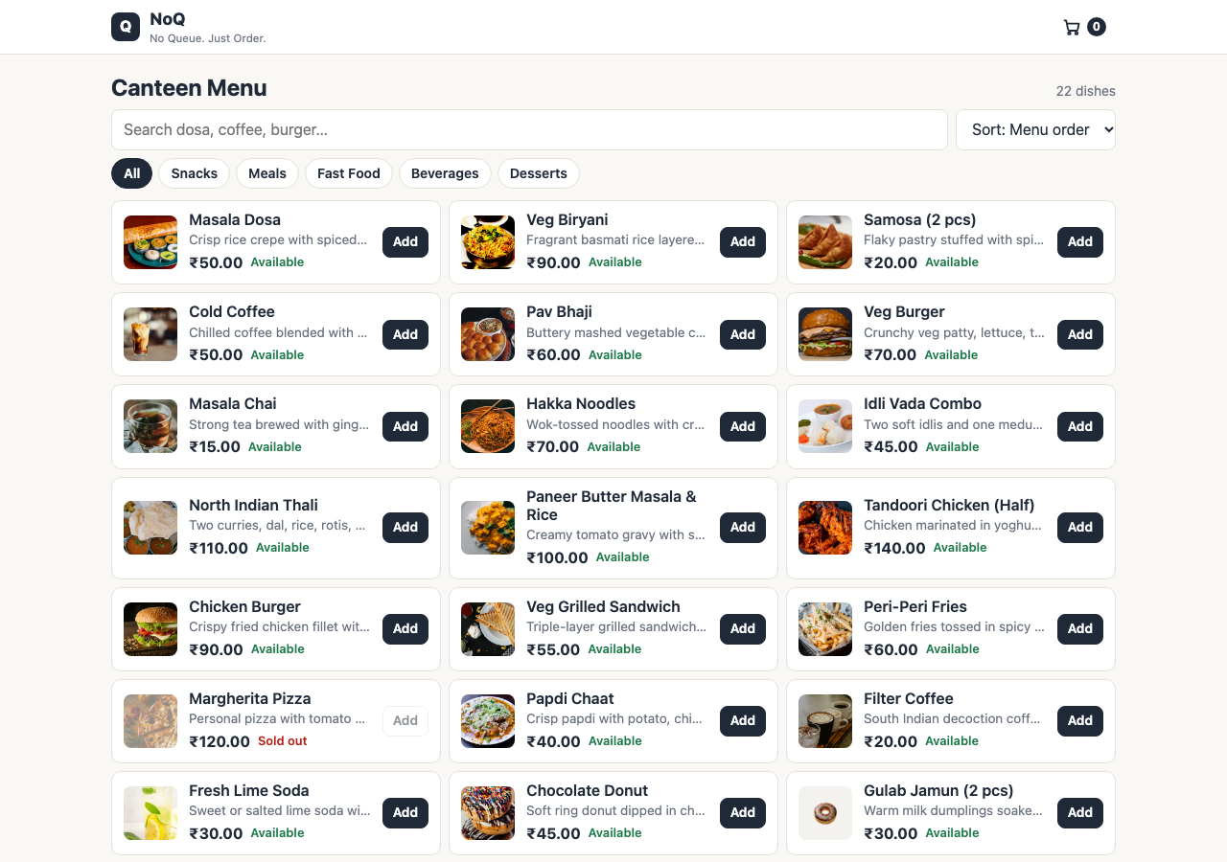
Figure 10.1: Customer menu: the simplified food menu with search, sort and category filters
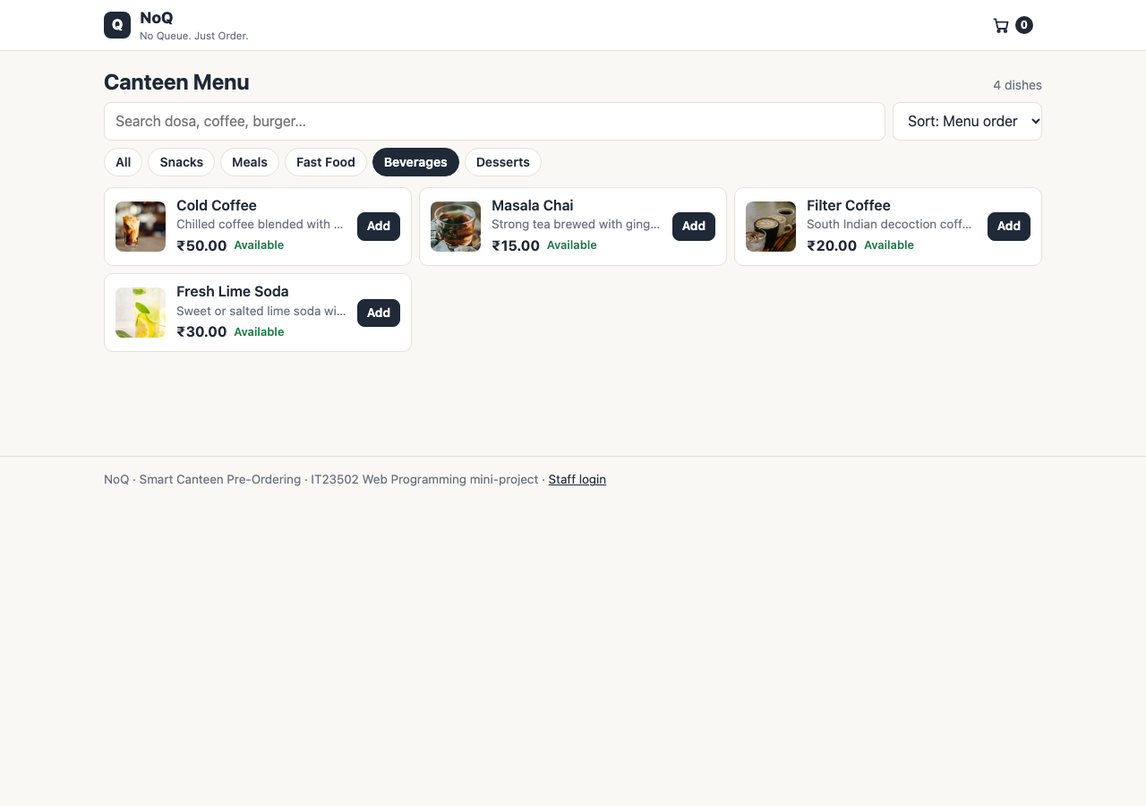
Figure 10.2: Customer menu filtered to the Beverages category
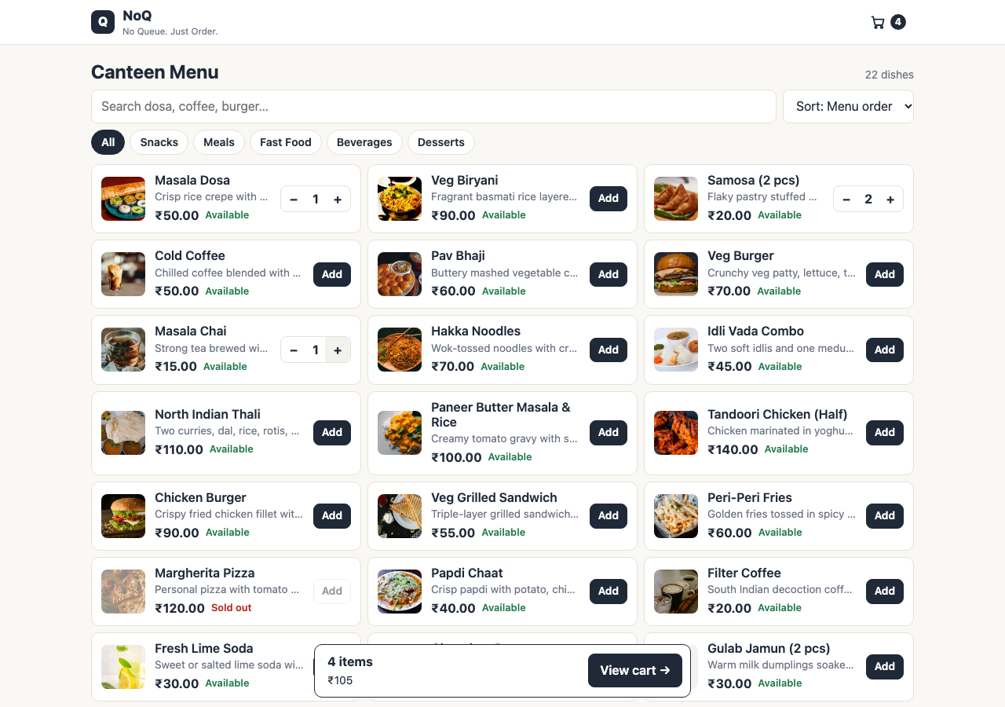
Figure 10.3: Customer menu after adding dishes: quantity buttons and the cart bar
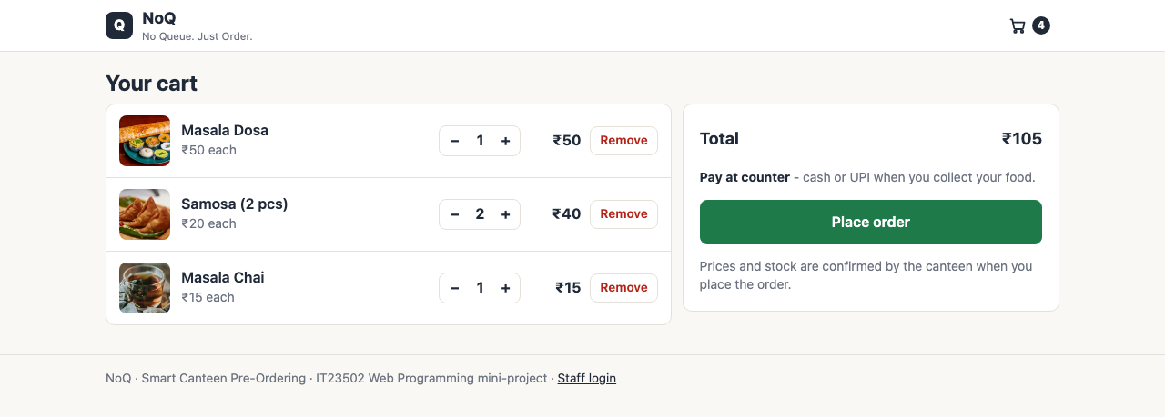
Figure 10.4: Cart and checkout: pay at counter, one Place order button
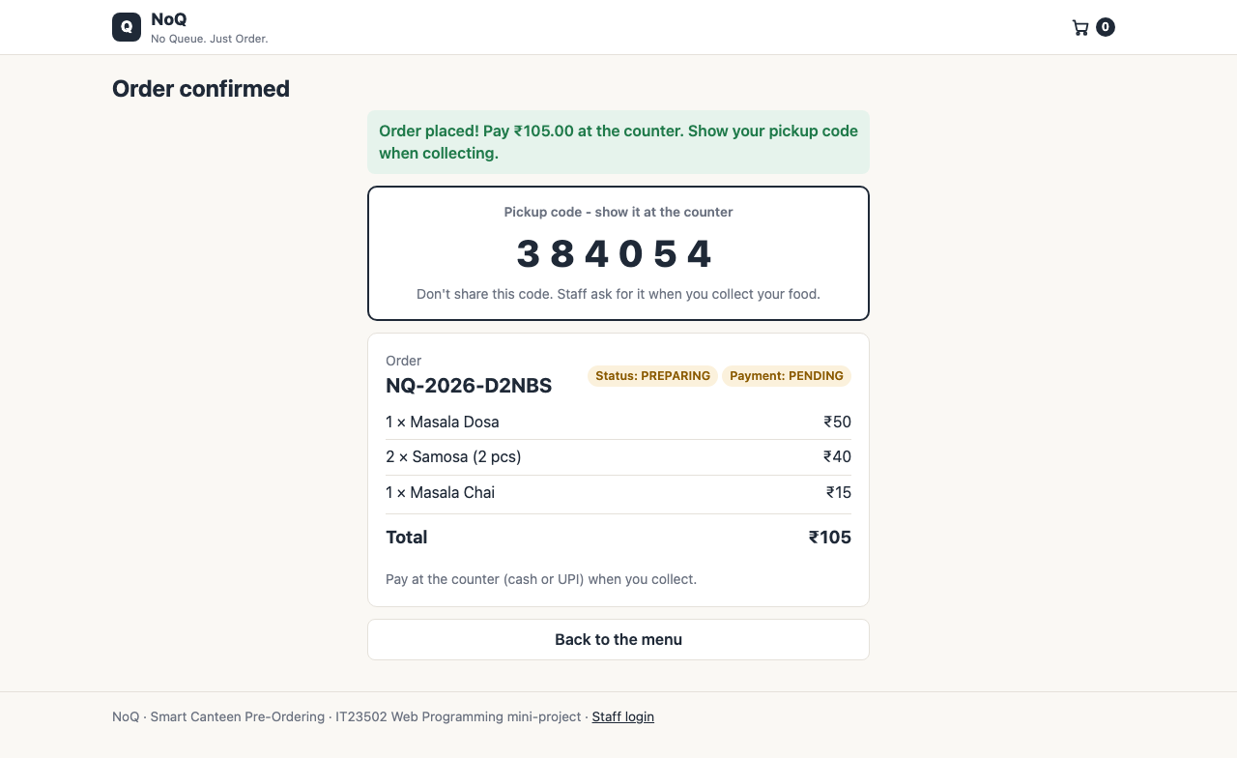
Figure 10.5: Order confirmation with the pickup OTP and the status PREPARING
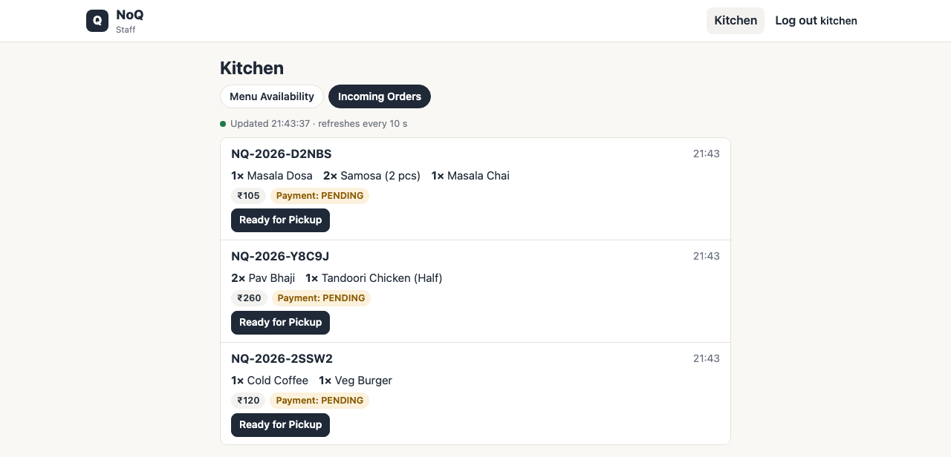
Figure 10.6: Kitchen page, Incoming Orders: one Ready for Pickup button per order
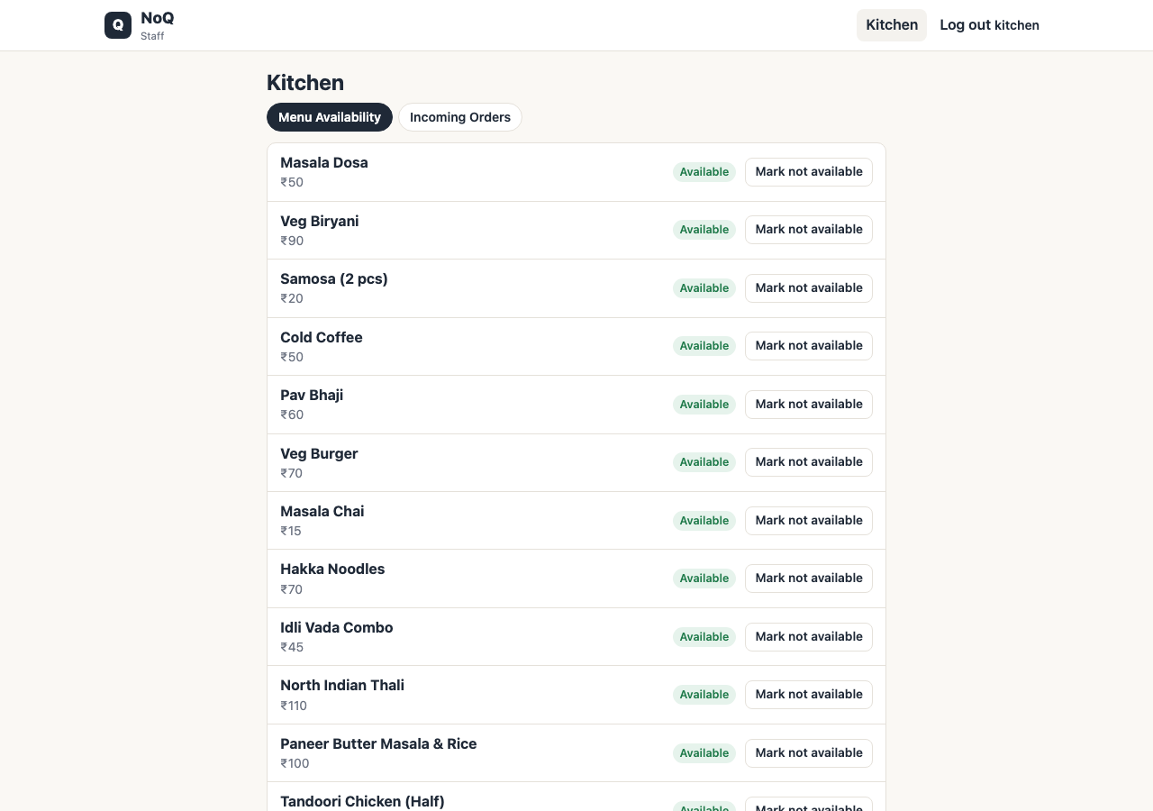
Figure 10.7: Kitchen page, Menu Availability: one Available / Not available switch per dish
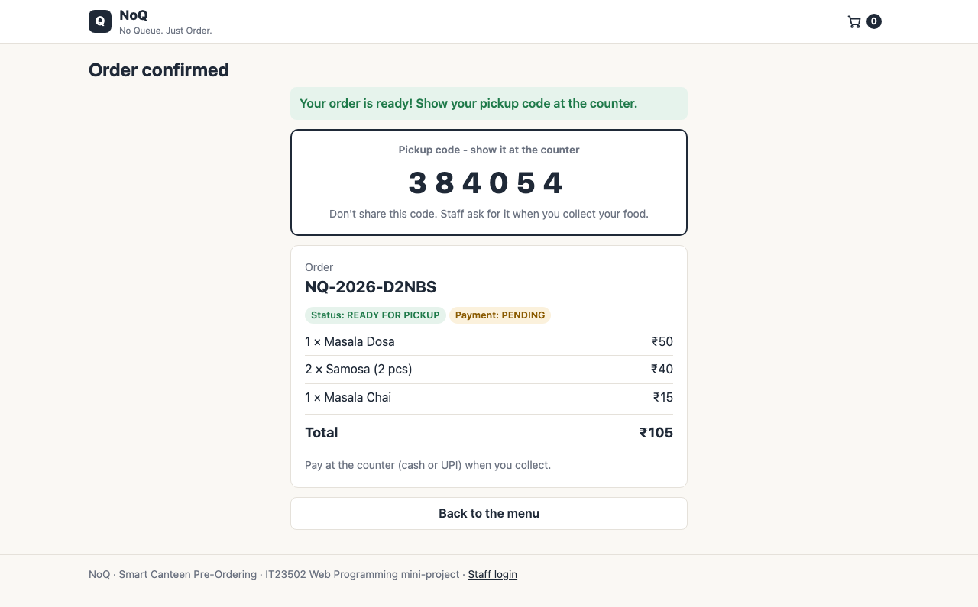
Figure 10.8: The customer's confirmation after the kitchen pressed Ready for Pickup
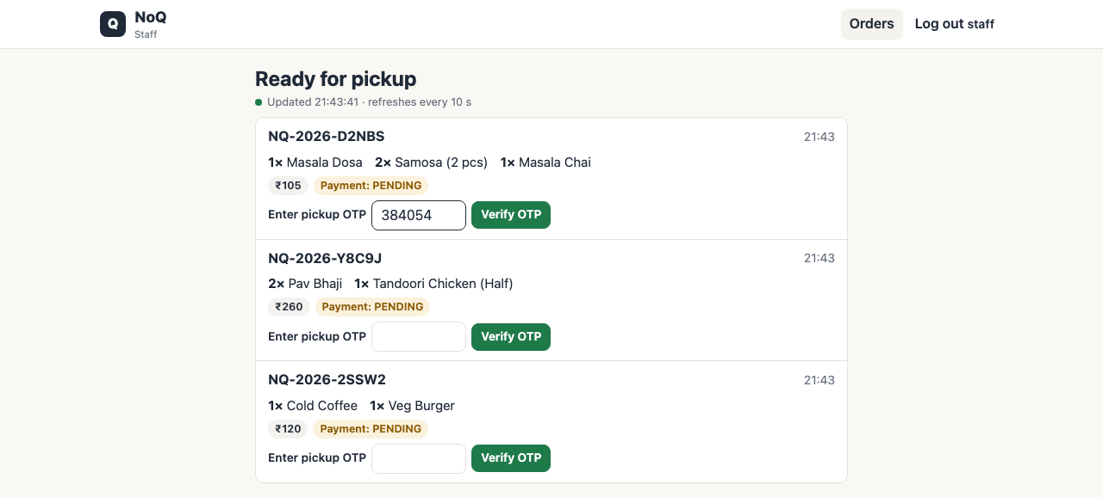
Figure 10.9: Staff page: ready orders, each with an Enter pickup OTP field (a code is being typed)
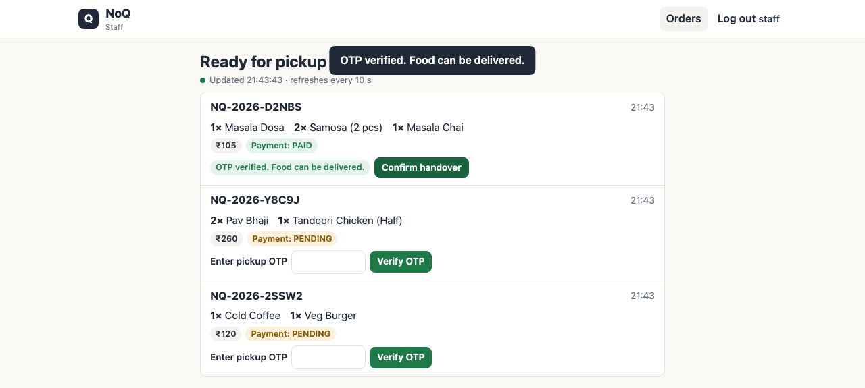
Figure 10.10: Staff page after a correct OTP: payment recorded (PAID), "OTP verified. Food can be delivered." and Confirm handover
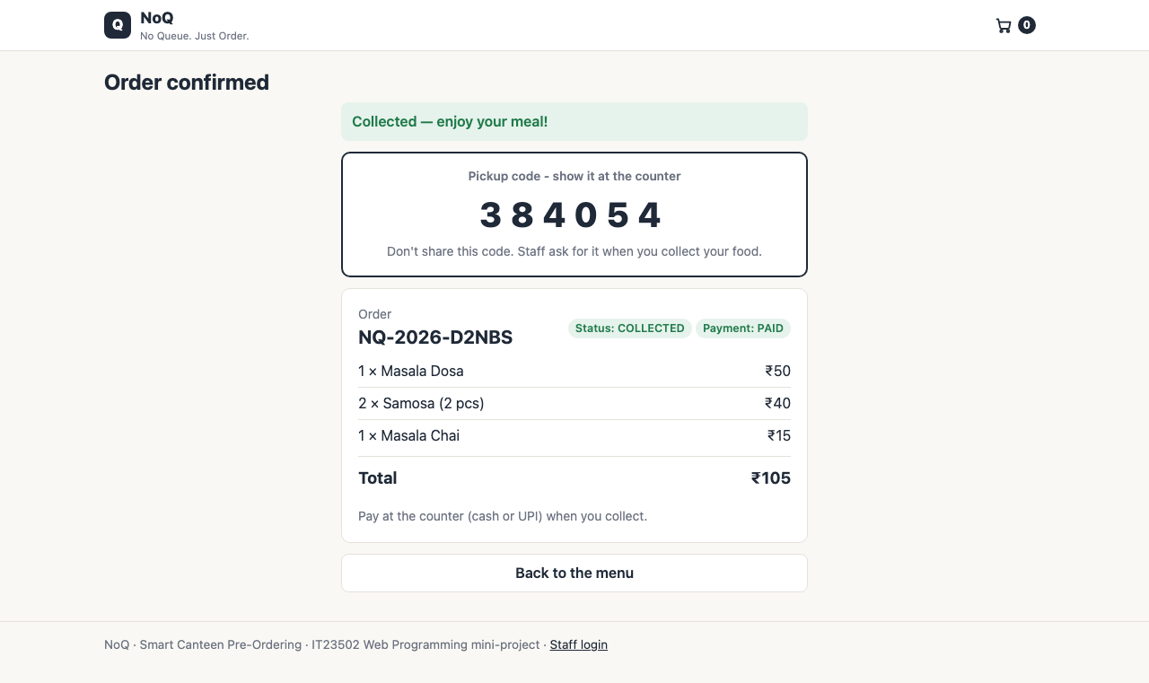
Figure 10.11: The customer's confirmation after the handover: COLLECTED

Figure 10.12: Kitchen and Staff login page
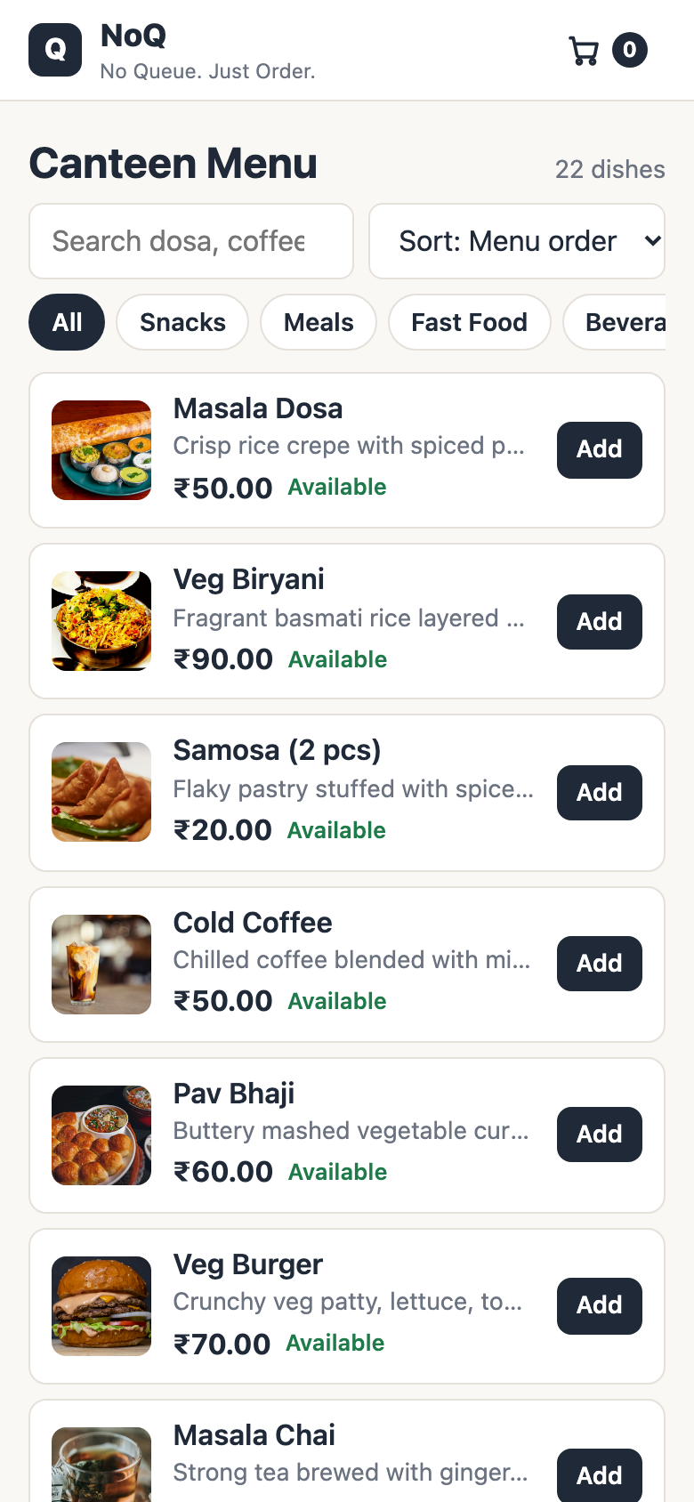
Figure 10.13: Customer menu on a 390 px wide phone screen
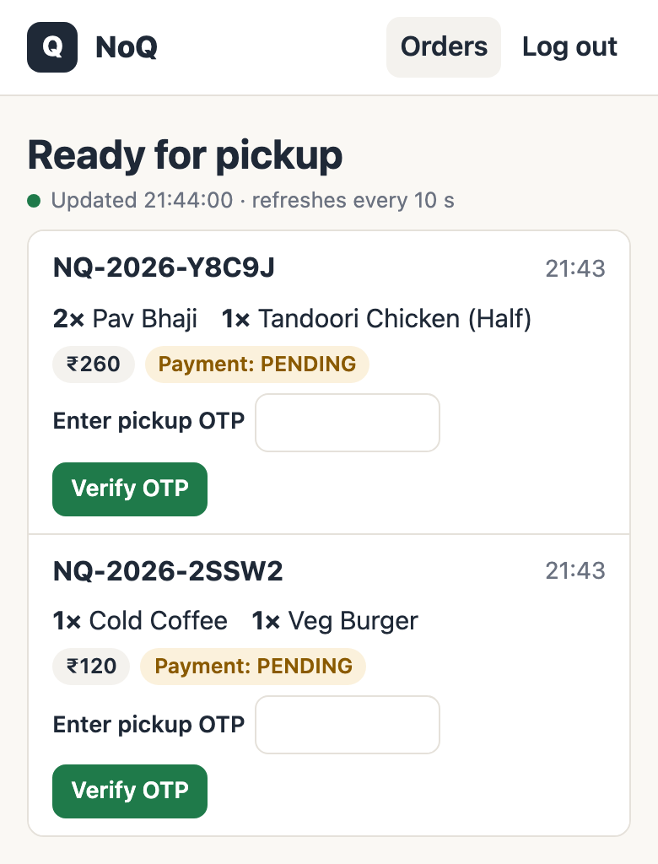
Figure 10.14: Staff page on a 390 px wide phone screen
SCREENSHOT TO BE INSERTED BY THE TEAM - Postman: REST API tests. Insert a screenshot of the Postman collection runner showing the 35 requests and their results.

Figure 10.15 (placeholder above): REST API tests in Postman.
SCREENSHOT TO BE INSERTED BY THE TEAM - Both applications running. Insert a screenshot of two terminals: noq-app on port 8080 and noq-notification-service on port 8081, showing the "NOTIFY customer" log line after an order becomes READY_FOR_PICKUP.

Figure 10.16 (placeholder above): the main application and the notification service running together.

10.1 Suggested demonstration sequence
- Open the menu, search for an item or filter by category, and add a few items to the cart.
- Place the order and note the order reference and the pickup code on the confirmation screen.
- In a second browser window, log in as kitchen and watch the order appear under Incoming Orders. Press Ready for Pickup.
- Show that the customer's confirmation changes to READY FOR PICKUP within about five seconds, and that the notification service log prints the order-ready line.
- In a third window, log in as staff. Enter a wrong pickup code (rejected, nothing is paid), then the right one: the payment is recorded and "OTP verified. Food can be delivered." appears. Press Confirm handover; the order is COLLECTED and the customer's screen shows "Collected - enjoy your meal!".
- As kitchen, mark a dish Not available and show that customers can no longer order it.
- Stop the notification service, mark another order Ready for Pickup and show that the order still becomes READY_FOR_PICKUP.

Chapter 11 - Setup and Execution
This chapter follows the project README. Run the commands from the repository root unless stated otherwise (on Windows use mvnw.cmd instead of ./mvnw).

11.1 Prerequisites
Table 11.1: Prerequisites
Tool | Notes
JDK 21 or newer | Check with java -version
MySQL Server 8.x | Running locally; you need a user that can create databases
Maven | Not required: use the included Maven Wrapper (downloads Maven 3.9.16 on first use)
Git, Postman | Optional
STS, Eclipse or IntelliJ | Optional (import as an existing Maven project)

11.2 Environment configuration
Copy the template and enter your own values. The real .env file is ignored by Git and must never be committed or shared:
Create the local configuration file
cp noq-app/.env.example noq-app/.env

Table 11.2: Environment variables (values are not shown here)
Variable | Purpose
DB_URL | JDBC URL of the MySQL database (default jdbc:mysql://localhost:3306/noq_db?createDatabaseIfNotExist=true)
DB_USERNAME | MySQL user name (default root)
DB_PASSWORD | MySQL password: enter your own; it is not stored in the repository
NOTIFICATION_URL | Address of the notification service (default http://localhost:8081)

The same variables can be set as real environment variables instead of using the file. The .env file is read from the current directory, so when starting a built JAR, start it from inside noq-app/.

11.3 Database creation and initialisation
Nothing has to be created by hand. With createDatabaseIfNotExist=true, MySQL creates noq_db on first connection; Hibernate then creates the five tables from the entities and data.sql loads the 23 sample menu items and the two demo users. The script uses INSERT IGNORE, so a restart never duplicates rows or overwrites changes made through the application. To create the schema manually instead:
Optional manual initialisation
mysql -u root -p -e "CREATE DATABASE IF NOT EXISTS noq_db"
mysql -u root -p noq_db < docs/schema-mysql.sql
mysql -u root -p noq_db < noq-app/src/main/resources/data.sql

If MySQL is not available, the application can run on an in-memory H2 database (data is lost when it stops): ./mvnw -pl noq-app spring-boot:run -Dspring-boot.run.profiles=h2.

11.4 Maven build and test commands
Table 11.3: Maven commands
Goal | Command
Compile both applications | ./mvnw compile
Run all tests (32 tests; no MySQL needed) | ./mvnw test
Test one module | ./mvnw -pl noq-app test
Build and test everything, package the JARs | ./mvnw clean package
Same, including the verify phase | ./mvnw clean verify

11.5 Running the applications
Start the notification service and the main application in two terminals (the main application also works without the notification service; it then logs a warning when an order becomes READY_FOR_PICKUP).
Running both services
# terminal 1 - notification service, port 8081
./mvnw -pl noq-notification-service spring-boot:run

# terminal 2 - main application, port 8080
./mvnw -pl noq-app spring-boot:run

To run the built JARs instead: cd noq-app && java -jar target/noq-app-1.0.0.jar and java -jar noq-notification-service/target/noq-notification-service-1.0.0.jar.
Table 11.4: Default ports and URLs
URL | Page
http://localhost:8080/ | Customer menu
http://localhost:8080/cart | Cart and order confirmation
http://localhost:8080/staff | Login; then the Staff page (STAFF) or the Kitchen page (KITCHEN)
http://localhost:8080/staff/kitchen | Kitchen page (KITCHEN only)
http://localhost:8080/actuator/health | Health check
http://localhost:8081/api/notifications | Events received by the notification service

Two demo accounts are created by data.sql: kitchen / kitchen123 (role KITCHEN) and staff / staff123 (role STAFF). These demo passwords are also listed in the README and must be changed before any real use.

11.6 Postman setup
Import postman/NoQ.postman_collection.json into Postman. The collection variables baseUrl (http://localhost:8080) and notificationUrl (http://localhost:8081) can be changed if the ports differ. Run the folders top to bottom, or use the collection runner; the "place order" request stores orderRef and otp automatically for the requests that follow. Kitchen and Staff requests use HTTP Basic authentication with the demo accounts (the kitchenUser, kitchenPass, staffUser and staffPass variables).

11.7 Troubleshooting
Table 11.5: Common startup problems
Problem | Fix
Access denied for the MySQL user | The DB_PASSWORD value is wrong; correct it in noq-app/.env.
Communications link failure | MySQL is not running, or the host and port in DB_URL are wrong.
Port 8080 or 8081 already in use | Stop the other program, or start with -Dspring-boot.run.arguments=--server.port=9090.
.env seems to be ignored when running a JAR | Start the JAR from inside noq-app/, or export the variables in the shell.
Food photographs do not appear | They load from an external image service. Without internet access an emoji tile is shown instead.
"Notification service unavailable" in the log | Start the notification service; orders still work without it.
Warnings about Mockito or ByteBuddy during tests on newer JDKs | Harmless; JDK 21 is the target.

Chapter 12 - Limitations and Future Enhancements
This chapter separates what already exists from realistic improvements that are not implemented. None of the future enhancements below is part of the delivered system.

12.1 Limitations of the current system
- Payment is at the counter only. NoQ records that the counter received the money; there is no online payment and no gateway.
- No menu editing. Dishes, prices and stock come from the sample-data script. The application cannot add, edit or remove dishes; the kitchen can only switch them Available / Not available.
- Abandoned orders. Orders never expire, and cancelling is possible only through the API while an order is PREPARING (there is no Cancel button). An order that is never collected stays on the Staff page and keeps its stock reserved.
- OTP lock-out and lost codes. After five wrong codes the customer read of an order stays locked until the application restarts; there is no timed lock. The staff-side OTP check has no attempt limit. The pickup code exists only in the customer's browser (the server stores its hash), so a lost confirmation cannot be shown again.
- Notifications can be lost. Delivery is a single synchronous call with a two-second timeout and no retry, and the notification service stores events only in memory.
- Checked layouts. The pages were viewed at 1280 px and (menu and Staff pages) 390 px only.
- Single instance. Locks protect concurrent requests to one database, but the OTP attempt counter is per application instance.

12.2 Future enhancements
Table 12.1: Possible future work
Enhancement (not implemented) | Idea
Online payment | Add a payment gateway (for example Razorpay or Stripe) as another Payment subclass, confirmed by a webhook.
Menu editing | A protected page to add, edit and deactivate dishes and set stock, if the canteen needs it.
More resilient notification delivery | Retry failed notifications later, or send them through a message queue; persist events in the notification service.
Push updates instead of polling | Server-Sent Events or WebSockets for the confirmation screen and the Kitchen and Staff lists.
Better expiry handling | Expire orders that are never collected, and let staff close or cancel a READY_FOR_PICKUP order from the page.
Timed OTP lock-out | Lock an order for a limited time instead of until restart; limit attempts on the staff side too; let staff re-issue a lost code.
Customer accounts | Optional login with order history and favourites.
Database migrations | Flyway migrations and ddl-auto=validate instead of ddl-auto=update.
Continuous integration | A GitHub Actions workflow that runs ./mvnw -B verify on every push.

Chapter 13 - Conclusion
NoQ shows how a familiar problem, the canteen queue, can be solved with a complete but compact web application. Customers can browse, order ahead, watch the status of their order and collect it with a secret code; the kitchen sees incoming orders and controls which dishes are available; counter staff verify the code, record the counter payment and hand the food over. Payment is at the counter only, as stated throughout this report, and the system is a college mini-project rather than a production service.
Objectives achieved. Orders are validated and priced on the server; stock stays correct under simultaneous requests because rows are locked and conflicts are reported as 409 responses; order and payment states follow strict rules; pickup codes are generated securely, stored only as hashes and usable once; Kitchen and Staff operations are protected by role; and a separate microservice is notified when an order is ready without being able to break the order.
Technology integration. Spring Boot, Spring MVC with Thymeleaf, Spring Data JPA with Hibernate on MySQL, Spring Security, Spring Cache with Caffeine, Spring AOP and RestClient work together in one application, while Maven builds a two-module project and Postman and JUnit verify it.
Learning outcomes. From Unit IV the team applied dependency injection, MVC, JPA and Hibernate mappings, HQL, single-table inheritance, SessionFactory/Session/Transaction concepts, AOP and caching in working code. From Unit V the team designed and tested a REST API with correct HTTP methods and status codes, connected two services over HTTP, and compared monolithic and microservice designs, REST and SOAP. A practical lesson was that behaviour proven on an in-memory database must also be tested on the real database: MySQL locking exposed deadlocks that H2 never showed, and fixing them required understanding transactions and row locks.

References
The following official documentation describes the technologies used in NoQ. It is listed as relevant reading for the concepts in this report. The team should confirm which of these sources they consulted before submission and remove any they did not.

- Spring Boot Reference Documentation. Spring. https://docs.spring.io/spring-boot/
- Spring Framework Reference (Core, Web MVC, Data Access, AOP, Cache). Spring. https://docs.spring.io/spring-framework/reference/
- Spring Data JPA Reference Documentation. Spring. https://docs.spring.io/spring-data/jpa/reference/
- Hibernate ORM User Guide. Hibernate. https://hibernate.org/orm/documentation/
- Spring Security Reference. Spring. https://docs.spring.io/spring-security/reference/
- Thymeleaf documentation: Thymeleaf + Spring. https://www.thymeleaf.org/documentation.html
- MySQL 8.4 Reference Manual, including InnoDB locking and deadlocks. Oracle. https://dev.mysql.com/doc/refman/8.4/en/
- Apache Maven documentation. Apache Software Foundation. https://maven.apache.org/guides/
- Caffeine cache. https://github.com/ben-manes/caffeine
- Spring Cloud project overview. Spring. https://spring.io/projects/spring-cloud
- R. T. Fielding, "Architectural Styles and the Design of Network-based Software Architectures", doctoral dissertation, University of California, Irvine, 2000.
- HTTP response status codes. MDN Web Docs. https://developer.mozilla.org/en-US/docs/Web/HTTP/Status

Appendix A - API Endpoint Summary
Table A.1: REST endpoints (main application: 13; notification service: 2)
Method | Path | Access | Purpose
GET | /api/menu[?category=] | Public | Active menu (cached)
GET | /api/menu/popular?limit= | Public | Popular items (HQL, cached)
GET | /api/menu/{id} | Public | One item
PATCH | /api/menu/{id}/availability | KITCHEN | {"available": true or false}
POST | /api/orders | Public | Place order (201)
GET | /api/orders/{ref} | OTP header or STAFF | Order details (never the OTP)
GET | /api/orders[?status=] | KITCHEN or STAFF | Open orders, or the orders with one status
PATCH | /api/orders/{ref}/status | KITCHEN | Ready for Pickup (or cancel while PREPARING)
POST | /api/orders/{ref}/verify-pickup | STAFF | Check the pickup OTP (changes nothing)
POST | /api/orders/{ref}/collect | STAFF | Confirm the handover (COLLECTED)
POST | /api/orders/{ref}/payments/counter-confirmation | STAFF | Record the counter payment
GET | /api/demo/hibernate-session | STAFF | Viva demo: SessionFactory, Session, Transaction
GET | /api/demo/spring-container | STAFF | Viva demo: ApplicationContext and beans
POST | :8081/api/notifications/order-ready | Public (internal) | Receive an "order ready" event (201)
GET | :8081/api/notifications | Public (internal) | List received events

Appendix B - Sample Requests and Responses
All responses below were captured from the running final version on 26 October 2026; the pickup OTP is not shown.
B.1 Validation failure
POST /api/orders
{"items": [{"menuItemId": 1, "quantity": 0}]}
-> 400 Bad Request
{
"status": 400, "error": "Bad Request", "message": "Validation failed",
"path": "/api/orders",
"fieldErrors": { "items[0].quantity": "quantity must be at least 1" }
}

B.2 Not enough stock
POST /api/orders {"items": [{"menuItemId": 12, "quantity": 20}]}
-> 409 Conflict
{ "status": 409, "error": "Conflict",
"message": "Only 14 x Tandoori Chicken (Half) left",
"path": "/api/orders" }

B.3 Collecting through the status endpoint is refused
PATCH /api/orders/NQ-2026-RQV35/status {"status": "COLLECTED"} (as KITCHEN)
-> 400 Bad Request
{ "status": 400,
"message": "Orders are collected by verifying the customer's pickup OTP (collect)", ... }

B.4 Handover before payment
POST /api/orders/NQ-2026-RQV35/collect {"otp": "<six digits>"} (as STAFF, payment still PENDING)
-> 409 Conflict
{ "status": 409, "message": "Payment pending: collect Rs.115.00 at the counter first", ... }

B.5 Counter payment
POST /api/orders/NQ-2026-RQV35/payments/counter-confirmation (as STAFF)
-> 200 OK
{
"orderReference": "NQ-2026-RQV35", "paymentType": "CASH",
"paymentStatus": "PAID", "amount": 115.0,
"message": "Counter payment received"
}

the same request again -> 409 "Payment already received for this order"

B.6 Authentication and authorization
PATCH /api/menu/1/availability (no login) -> 401 "Staff login required"
PATCH /api/menu/1/availability (logged in as staff) -> 403 "You do not have permission
for this action"

B.7 Notification service
POST http://localhost:8081/api/notifications/order-ready
{ "orderReference": "NQ-2026-PZKJP", "eventType": "ORDER_READY" }
-> 201 Created
{ "notificationId": "<uuid>", "orderReference": "NQ-2026-PZKJP",
"eventType": "ORDER_READY", "status": "RECEIVED",
"receivedAt": "2026-10-26T16:24:21.252088Z" }

{ "orderReference": "bad", "eventType": "SOMETHING" } -> 400
fieldErrors: orderReference "must look like NQ-2026-AB12C",
eventType "only ORDER_READY is supported"

Appendix C - HQL and Query Examples
Table A.2: HQL queries in the project
Where | Query
MenuItemRepository.findPopularAvailable | select m from MenuItem m where m.active = true and m.available = true and m.availableQuantity > 0 order by m.popularityCount desc, m.id asc
CustomerOrderRepository.findByStatusNewestFirst | select o from CustomerOrder o where o.status = :status order by o.createdAt desc
MenuItemRepository.findAllActive | select m from MenuItem m where m.active = true order by m.id
MenuItemRepository.findActiveByCategory | select m from MenuItem m where m.active = true and m.category = :category order by m.id
ConceptDemoService (demo) | select count(m) from MenuItem m where m.active = true
ConceptDemoService (demo) | select m.name from MenuItem m order by m.popularityCount desc, m.id asc
ConceptDemoService (demo) | select type(p), count(p) from Payment p group by type(p)

Spring Data also derives simple queries from method names, for example findByOrderReference, findByIdempotencyKey, existsByOrderReference and findByStatusInOrderByCreatedAtDesc (used for the open-orders list).

Appendix D - Database Schema
The schema below is the content of docs/schema-mysql.sql (the storage-engine and character-set clauses are omitted here). It was first produced from a MySQL 8.4.9 server for an earlier version and then updated by hand to match the final entities, as explained in Section 9.5.
D.1 menu_item and customer_order
CREATE TABLE menu_item (
id bigint NOT NULL AUTO_INCREMENT,
active bit(1) NOT NULL,
available bit(1) NOT NULL,
available_quantity int NOT NULL,
category varchar(20) NOT NULL,
description varchar(300) DEFAULT NULL,
image_url varchar(300) DEFAULT NULL,
name varchar(80) NOT NULL,
popularity_count int NOT NULL,
price decimal(8,2) NOT NULL,
version bigint DEFAULT NULL,
PRIMARY KEY (id),
KEY idx_menu_item_category (category)
);

CREATE TABLE customer_order (
id bigint NOT NULL AUTO_INCREMENT,
completed_at datetime(6) DEFAULT NULL,
created_at datetime(6) NOT NULL,
idempotency_key varchar(64) DEFAULT NULL,
order_reference varchar(20) NOT NULL,
payment_method varchar(20) NOT NULL,
payment_status varchar(20) NOT NULL,
pickup_otp_hash varchar(100) NOT NULL,
status varchar(20) NOT NULL,
subtotal decimal(10,2) NOT NULL,
total_amount decimal(10,2) NOT NULL,
updated_at datetime(6) NOT NULL,
version bigint DEFAULT NULL,
PRIMARY KEY (id),
UNIQUE KEY (order_reference),
UNIQUE KEY (idempotency_key),
KEY idx_order_status_created (status,created_at)
);

D.2 order_item, payment and staff_user
CREATE TABLE order_item (
id bigint NOT NULL AUTO_INCREMENT,
item_name_snapshot varchar(80) NOT NULL,
line_total decimal(10,2) NOT NULL,
quantity int NOT NULL,
unit_price_snapshot decimal(8,2) NOT NULL,
order_id bigint NOT NULL,
menu_item_id bigint NOT NULL,
PRIMARY KEY (id),
FOREIGN KEY (menu_item_id) REFERENCES menu_item (id),
FOREIGN KEY (order_id) REFERENCES customer_order (id)
);

CREATE TABLE payment (
payment_type varchar(20) NOT NULL,
id bigint NOT NULL AUTO_INCREMENT,
amount decimal(10,2) NOT NULL,
created_at datetime(6) NOT NULL,
status varchar(20) NOT NULL,
received_by varchar(50) DEFAULT NULL,
order_id bigint NOT NULL,
PRIMARY KEY (id),
FOREIGN KEY (order_id) REFERENCES customer_order (id)
);

CREATE TABLE staff_user (
id bigint NOT NULL AUTO_INCREMENT,
active bit(1) NOT NULL,
password_hash varchar(100) NOT NULL,
role varchar(20) NOT NULL,
username varchar(50) NOT NULL,
PRIMARY KEY (id),
UNIQUE KEY (username)
);

Appendix E - Seed Data (menu_item)
data.sql inserts these 23 menu items (descriptions and image addresses are omitted). Popularity counts start at 0 and grow from real orders.
Table A.3: Seeded menu items
id | name | category | price | stock | note
1 | Masala Dosa | MEALS | 50.00 | 40
2 | Veg Biryani | MEALS | 90.00 | 30
3 | Samosa (2 pcs) | SNACKS | 20.00 | 60
4 | Cold Coffee | BEVERAGES | 50.00 | 40
5 | Pav Bhaji | SNACKS | 60.00 | 35
6 | Veg Burger | FAST_FOOD | 70.00 | 25
7 | Masala Chai | BEVERAGES | 15.00 | 100
8 | Hakka Noodles | FAST_FOOD | 70.00 | 30
9 | Idli Vada Combo | MEALS | 45.00 | 40
10 | North Indian Thali | MEALS | 110.00 | 20
11 | Paneer Butter Masala & Rice | MEALS | 100.00 | 20
12 | Tandoori Chicken (Half) | MEALS | 140.00 | 15
13 | Chicken Burger | FAST_FOOD | 90.00 | 20
14 | Veg Grilled Sandwich | FAST_FOOD | 55.00 | 30
15 | Peri-Peri Fries | FAST_FOOD | 60.00 | 30
16 | Margherita Pizza | FAST_FOOD | 120.00 | 0 | out of stock
17 | Papdi Chaat | SNACKS | 40.00 | 30
18 | Filter Coffee | BEVERAGES | 20.00 | 80
19 | Fresh Lime Soda | BEVERAGES | 30.00 | 50
20 | Chocolate Donut | DESSERTS | 45.00 | 24
21 | Gulab Jamun (2 pcs) | DESSERTS | 30.00 | 40 | no image (emoji tile)
22 | Garden Salad Bowl | MEALS | 80.00 | 15 | marked Not available
23 | Chilli Paneer | SNACKS | 90.00 | 20 | inactive (off the menu)

Appendix F - Test-Case Summary
Table A.4: The 32 automated tests
Test method | Checks
OrderStatusTest.happyPathTransitionsAreAllowed | PREPARING to READY_FOR_PICKUP to COLLECTED is allowed
OrderStatusTest.invalidTransitionsAreRejected | Skipping steps, leaving final states, cancelling after READY_FOR_PICKUP
OrderStatusTest.completeTransitionMatrixIsExactlyTheDocumentedOne | All 16 status pairs match the state machine
MenuApiTest.publicMenuShowsActiveItemsOnly | Inactive items and internal fields are hidden
MenuApiTest.menuCanBeFilteredByCategory | Category filter; an invalid category gives 400
MenuApiTest.kitchenToggleAvailabilityIsSavedAndEnforcedByCheckout | Switch saved; STAFF 403, anonymous 401; menu shows Not available; direct order 409 with no order and no stock change; switching back allows orders
MenuApiTest.kitchenPageHasExactlyTwoTabs | Menu Availability and Incoming Orders; STAFF cannot open the page
MenuApiTest.soldOutItemIsNotOrderable | orderable is false for stock 0; an unknown item gives 404
MenuApiTest.hqlPopularQueryReturnsOnlyOrderableItemsByPopularity | HQL query 1: only orderable items, highest popularity first
MenuApiTest.realLoginsHaveExactlyTheirOwnRole | Real BCrypt logins give each user only their role; wrong password and the old admin login give 401; no menu create or delete
MenuApiTest.staffLoginLandsOnTheirOwnPage | /staff sends KITCHEN to the Kitchen page and shows STAFF the Staff page; /staff/menu is gone
MenuApiTest.cacheIsFilledOnReadAndEvictedOnKitchenUpdate | The menu cache is filled on read and evicted by a kitchen update
MenuApiTest.cacheIsEvictedOnlyAfterCommitAndNotOnRollback | Eviction happens after the commit, never on rollback
OrderApiTest.placingAnOrderDeductsStockAndReturnsReferenceAndOtp | Server total, merged lines, stock and popularity, reference and OTP, status PREPARING
OrderApiTest.invalidOrdersAreRejected | Nine invalid cases (400 or 409)
OrderApiTest.duplicateSubmissionIsRejected | Same idempotency key: 201 then 409; stock deducted once
OrderApiTest.counterOrderFullLifecycleWithPaymentAndPickup | Whole counter flow from Ready for Pickup to COLLECTED, with every refusal on the way
OrderApiTest.cancellingRestoresStock | Cancel restores stock once; a cancelled order cannot be paid, made ready or collected; HQL query 2
OrderApiTest.twoStaffMarkingTheSameCounterOrderPaidCreateOnePayment | Two parallel payments: one 200, one 409, one row
OrderApiTest.cancelRacingCounterPaymentNeverLeavesAnInconsistentOrder | Cancel versus payment race: never a 500, consistent state
OrderApiTest.parallelOtpGuessesCannotBypassTheAttemptLimit | 20 parallel guesses: at most 5 are checked
OrderApiTest.tooManyWrongOtpsLockTheCustomerRead | Five wrong OTPs lock the customer read
OrderApiTest.customerReadsOwnOrderOnlyWithOtpAndNeverSeesIt | OTP needed; the response never contains the OTP or its hash; staff need no OTP
OrderApiTest.staffOrdersPageIsOneList | The Staff page is one list titled Ready for pickup
OrderApiTest.trackingAndPaymentPagesAreGone | No tracking or payment pages; old customer endpoints are closed
OrderApiTest.onlyCounterPaymentExists | The online-payment endpoint is closed; payment_method is always PAY_AT_COUNTER
OrderApiTest.staffEndpointsRequireLogin | 401 without login; 403 for the wrong role on each endpoint
OrderApiTest.concurrentCustomersCannotOversellTheLastItem | Six buyers of the last unit: one 201, five 409
OrderApiTest.staffBoardKeepsAnOldOpenOrderWhenMoreThan100NewerOrdersExist | An old open order is not hidden by 101 newer orders
OrderApiTest.hibernateSessionDemoRuns | The Hibernate and Spring container demo endpoints answer correctly
NotificationControllerTest.acceptsValidOrderReadyEvent | Valid event: 201 and listed
NotificationControllerTest.rejectsInvalidPayload | Invalid payload: 400 with field errors

Appendix G - Local Execution Commands
Commands to build and run NoQ
# 1. configuration (enter your own MySQL password in the new file)
cp noq-app/.env.example noq-app/.env

# 2. build and test everything
./mvnw clean verify

# 3. run the notification service (terminal 1, port 8081)
./mvnw -pl noq-notification-service spring-boot:run

# 4. run the main application (terminal 2, port 8080)
./mvnw -pl noq-app spring-boot:run

# optional: in-memory database instead of MySQL
./mvnw -pl noq-app spring-boot:run -Dspring-boot.run.profiles=h2

# optional: run the built JARs
cd noq-app && java -jar target/noq-app-1.0.0.jar
java -jar noq-notification-service/target/noq-notification-service-1.0.0.jar

