COMPUTER VISION – AD23402

IMAGE TRANSFORMATIONS- SHEARING

WORD DOC

ARUN SANKAR M

**2023510033**

AI AND DS

SEMESTER:4

**Shearing in Image Transformation**

**1. Introduction to Image Transformation**

**Image Transformation** refers to modifying the spatial or geometric structure of an image. It's widely used in image processing and computer vision tasks to manipulate the appearance of an image, such as shifting, scaling, rotating, or distorting it. These transformations help in enhancing images, aligning them, or preparing them for feature extraction or recognition.

**2. Spatial Domain vs Frequency Domain**

* **Spatial Domain:**
  + Operations are applied **directly to image pixels**.
  + Common examples: filtering, rotation, shearing, scaling.
  + Example: Applying a blur filter by averaging neighboring pixel values.
* **Frequency Domain:**
  + The image is transformed using mathematical methods like **Fourier Transform**.
  + Operations are applied to the **frequency components** instead of pixel values.
  + Example: Removing noise using a low-pass filter in frequency space.

**Difference:**

* Spatial domain modifies the actual pixel intensities.
* Frequency domain modifies the image's frequency representation (like waves).

**3. What is Shearing?**

**Shearing** is a type of affine transformation that **slants an image** along the horizontal or vertical axis. It causes a shift in one direction that is proportional to the other axis. The result is a distorted, skewed image that appears "tilted."

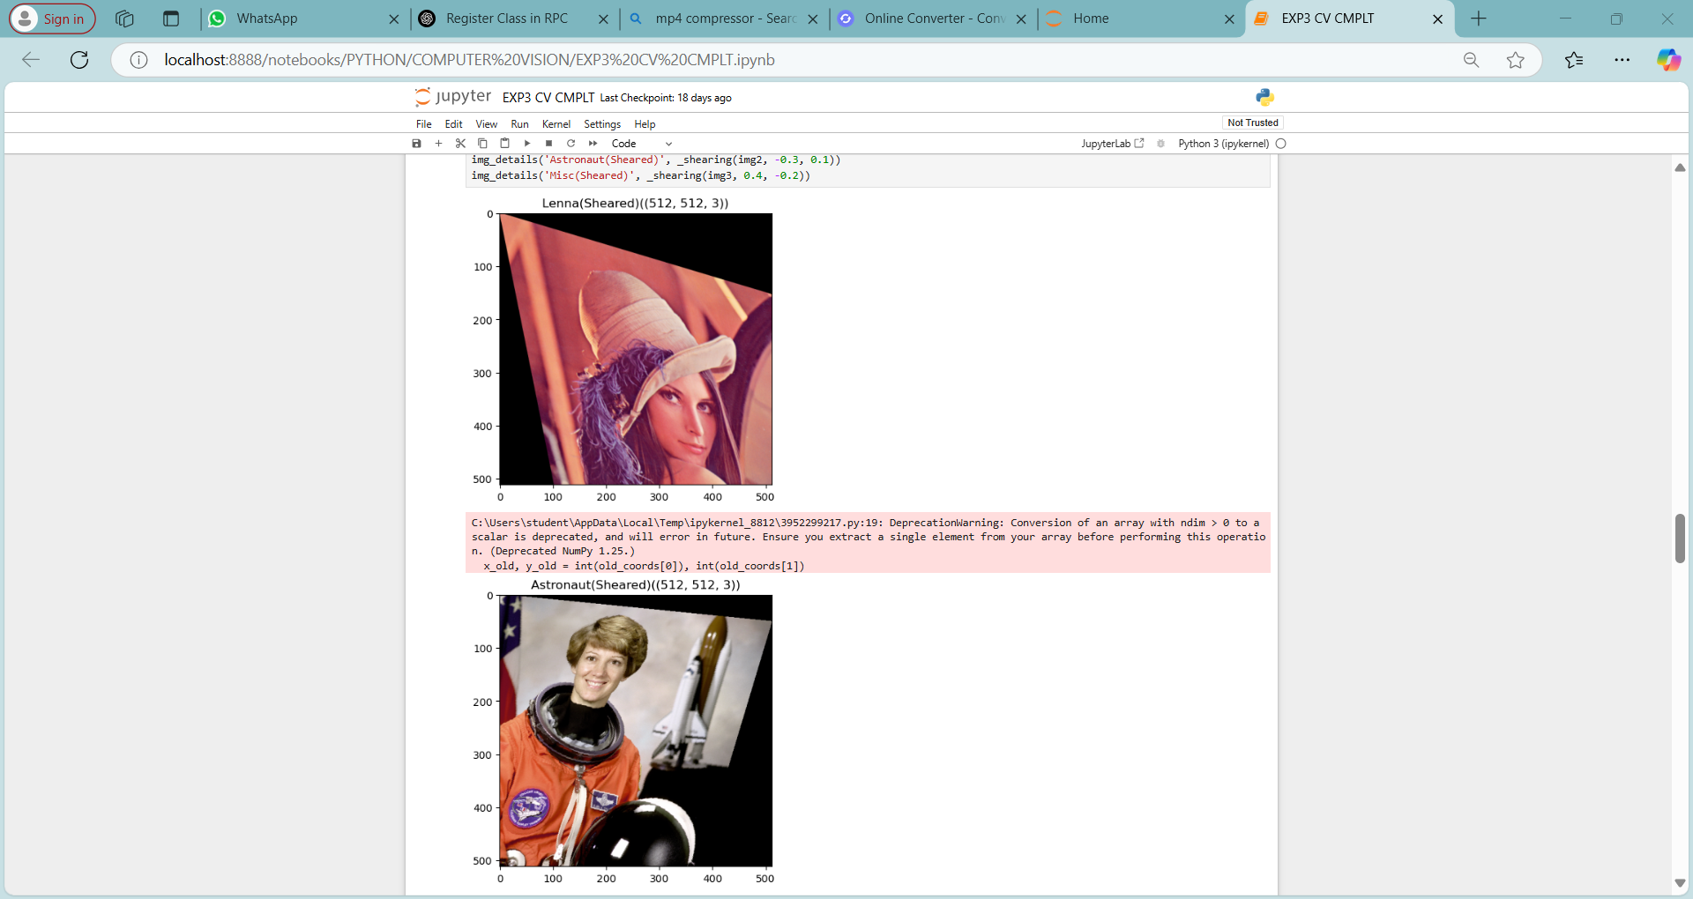



**4. Mathematical Representation**

There are two main types of shear transformations:

* **Horizontal Shear** (slanting sideways):

| 1 sh_x |

| 0 1 |

* **Vertical Shear** (slanting upward/downward):

| 1 0 |

| sh_y 1 |

* **Combined Shear Matrix**:

| 1 sh_x |

| sh_y 1 |

Where:

* sh_x is the horizontal shear factor.
* sh_y is the vertical shear factor.

**Transformation of a point (x, y):**

* Horizontal shear:  
  x′ = x + sh_x × y  
  y′ = y
* Vertical shear:  
  x′ = x  
  y′ = y + sh_y × x

### **Shearing a Sample 2×2 Image**

Let’s consider a simple 2×2 grayscale image represented as a matrix of pixel values:

#### **Original Image Matrix**

|  | **x = 0** | **x = 1** |
| --- | --- | --- |
| y = 0 | 100 | 150 |
| y = 1 | 200 | 250 |

Each value represents pixel intensity (0–255), and coordinates are given as (x, y).

### **Horizontal Shearing Transformation**

We use the shearing matrix:

[1shx01]\begin{bmatrix} 1 & sh_x \\ 0 & 1 \end{bmatrix}[10​shx​1​]

Let’s choose a shear factor: **shₓ = 1**

Transformation becomes:

x′=x+y,y′=yx' = x + y,\quad y' = yx′=x+y,y′=y

### **Transforming Pixel Coordinates**

| **Original (x, y)** | **Pixel Value** | **Transformed (x′, y′)** |
| --- | --- | --- |
| (0, 0) | 100 | (0 + 0, 0) = (0, 0) |
| (1, 0) | 150 | (1 + 0, 0) = (1, 0) |
| (0, 1) | 200 | (0 + 1, 1) = (1, 1) |
| (1, 1) | 250 | (1 + 1, 1) = (2, 1) |

### **Resulting Sheared Image Matrix (3×2 Canvas)**

We expand the canvas to fit the new coordinates (up to x = 2):

|  | **x = 0** | **x = 1** | **x = 2** |
| --- | --- | --- | --- |
| y = 0 | 100 | 150 | — |
| y = 1 | — | 200 | 250 |

(“—” represents empty/unmapped pixels; you can fill them with 0 if needed.)

**5. Applications of Shearing**

* **Data Augmentation**: Shearing is used to artificially expand datasets by creating variations of training images, helping machine learning models generalize better.
* **Perspective Simulation**: It helps simulate slight changes in camera angle or perspective, useful in computer vision tasks like object detection and recognition.
* **Artistic and Stylized Effects**: Graphic designers and image editing tools use shearing to apply creative distortions or slanting effects for visual appeal.
* **OCR and Document Alignment**: In Optical Character Recognition (OCR), shearing is used to correct or align skewed scanned documents for better text extraction.
* **Motion Simulation in Videos**: Shearing can simulate motion blur or directional movement, commonly used in animation or video editing for dynamic effects.



**6. Shearing in Python Using OpenCV**

import cv2

import numpy as np

image = cv2.imread('input.jpg')

rows, cols = image.shape[:2]

sh_x = 0.5 # Horizontal shear

sh_y = 0.0 # Vertical shear

M = np.float32([

[1, sh_x, 0],

[sh_y, 1, 0]

])

sheared_image = cv2.warpAffine(image, M, (cols + int(sh_x * rows), rows))

cv2.imshow("Sheared Image", sheared_image)

cv2.imwrite("sheared_output.jpg", sheared_image)

cv2.waitKey(0)

cv2.destroyAllWindows()

**7. Summary**

Shearing is a simple yet effective image transformation that tilts an image in a chosen direction. It is useful for visual effects, perspective correction, and especially in machine learning for diversifying datasets. Understanding its mathematics and implementation helps in mastering image manipulation techniques.