AWS Cloud Infrastructure
Complete Technical Documentation
─────────────────────────────────────────
Covering: VPC • EC2 • ECS • ECR • RDS/Aurora • S3 • IAM • ALB • Auto Scaling
CloudWatch • CloudFormation • CloudTrail • API Gateway • Route 53 • CloudFront
SES • Serverless • Security & Encryption • High Availability & Scalability
─────────────────────────────────────────
Includes: Project Architecture Documentation (VPC + ALB + EC2 + MySQL RDS)

1. AWS Fundamentals & Global Infrastructure

1.1 What is AWS?
Amazon Web Services (AWS) is the world's most comprehensive and broadly adopted cloud platform, offering over 200 fully featured services from data centers globally. AWS provides on-demand cloud computing platforms and APIs to individuals, companies, and governments, on a metered pay-as-you-go basis.

Why Use AWS?
- No upfront investment — pay only for what you use
- Global reach — deploy applications in minutes worldwide
- Reliability — built-in redundancy and high availability
- Security — industry-leading compliance certifications
- Scalability — scale up or down automatically based on demand
- Managed services — AWS handles undifferentiated heavy lifting

1.2 AWS Global Infrastructure
AWS infrastructure is built around Regions, Availability Zones (AZs), and Edge Locations.

Regions
A Region is a physical location in the world where AWS clusters data centers. Each Region is a separate geographic area (e.g., ap-south-1 = Mumbai, us-east-1 = N. Virginia). AWS has 33+ Regions globally.
📌 Note: ap-south-1 (Mumbai) is the region used in the project documented in this guide.

Availability Zones (AZs)
Each Region has multiple, isolated Availability Zones — distinct locations engineered to be isolated from failures in other AZs. They are connected through low-latency links. The Mumbai region (ap-south-1) has three AZs: ap-south-1a, ap-south-1b, and ap-south-1c.
AZ Name | Location | Purpose in Project
ap-south-1a | Mumbai AZ-A | Public Subnet 1, Private Subnet 1 (App), DB Subnet 1 (Primary RDS)
ap-south-1b | Mumbai AZ-B | Public Subnet 2, Private Subnet 2 (App), DB Subnet 2 (Standby RDS)

Edge Locations
Edge Locations are endpoints for AWS used for caching content via CloudFront CDN. There are more Edge Locations than Regions (400+). They reduce latency by serving content from a location closer to the user.

1.3 AWS Shared Responsibility Model
Security on AWS is a shared responsibility between AWS and the customer:
AWS Responsibility (Security OF the Cloud) | Customer Responsibility (Security IN the Cloud)
Physical hardware, data centers, network infrastructure | OS patching, application code, data encryption
Hypervisor, managed services infrastructure | IAM configuration, security groups, NACLs
Compliance certifications for infrastructure | Encryption of data at rest and in transit

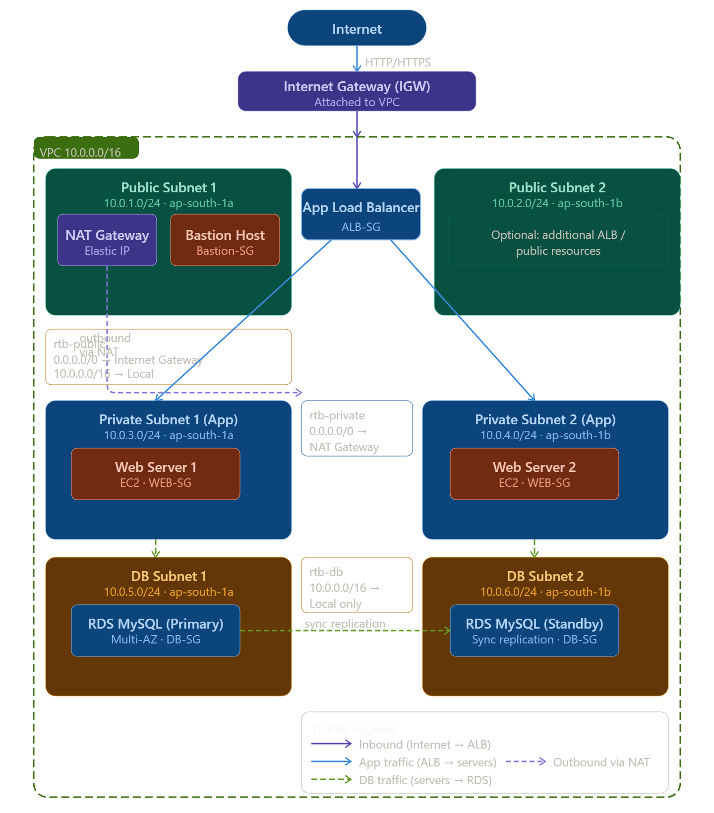

2. Networking — VPC, Subnets, Route Tables & Security

2.1 Virtual Private Cloud (VPC)
A VPC is your own logically isolated section of the AWS Cloud where you can launch AWS resources in a virtual network that you define. It gives you complete control over your virtual networking environment, including IP address ranges, subnets, route tables, and network gateways.

Why do we need a VPC?
- Isolation — your resources are completely isolated from other AWS customers
- Control — define IP ranges, create subnets, configure routing
- Security — control inbound/outbound traffic at the subnet and instance level
- Connectivity — connect to the internet, your data center, or other AWS services

CIDR Blocks — How Instances Get IP Addresses
CIDR (Classless Inter-Domain Routing) notation defines an IP address range. The format is: IP_Address/Prefix_Length
Example: 10.0.0.0/16
The /16 means the first 16 bits are fixed (the network part). The remaining 16 bits are for hosts. This gives 2^16 = 65,536 possible IP addresses (10.0.0.0 to 10.0.255.255).
CIDR | Subnet Mask | Available IPs | Common Use
10.0.0.0/16 | 255.255.0.0 | 65,536 | Entire VPC
10.0.1.0/24 | 255.255.255.0 | 256 (251 usable) | Single subnet
10.0.1.0/28 | 255.255.255.240 | 16 (11 usable) | Small subnet
0.0.0.0/0 | 0.0.0.0 | All IPs | Default route (internet)

📌 Note: AWS reserves 5 IP addresses in each subnet: network address, VPC router, DNS, future use, broadcast. So /24 gives 256 - 5 = 251 usable IPs.

Public vs Private IP Addresses
Every EC2 instance in a VPC gets a Private IP address from the subnet's CIDR block automatically. This is assigned by the VPC's DHCP service and is used for communication within the VPC.
A Public IP address is optionally assigned to instances in a public subnet. It allows communication with the internet. Public IPs are ephemeral — they change when the instance is stopped and started.
An Elastic IP (EIP) is a static public IP address that you allocate to your AWS account. It does not change even if the instance is stopped. The NAT Gateway in the project uses an EIP.

⚙ TASK: Create a VPC
1 | AWS Console → VPC → Your VPCs → Create VPC
2 | Name tag: my-project-vpc
3 | IPv4 CIDR block: 10.0.0.0/16 (provides 65,536 IPs)
4 | IPv6 CIDR block: No IPv6 CIDR block (unless needed)
5 | Tenancy: Default (shared hardware; Dedicated is expensive)
6 | Click Create VPC
7 | Note: VPC is created in a specific Region (e.g., ap-south-1)
8 | Result: VPC ID is assigned (e.g., vpc-0abc123def456789a)

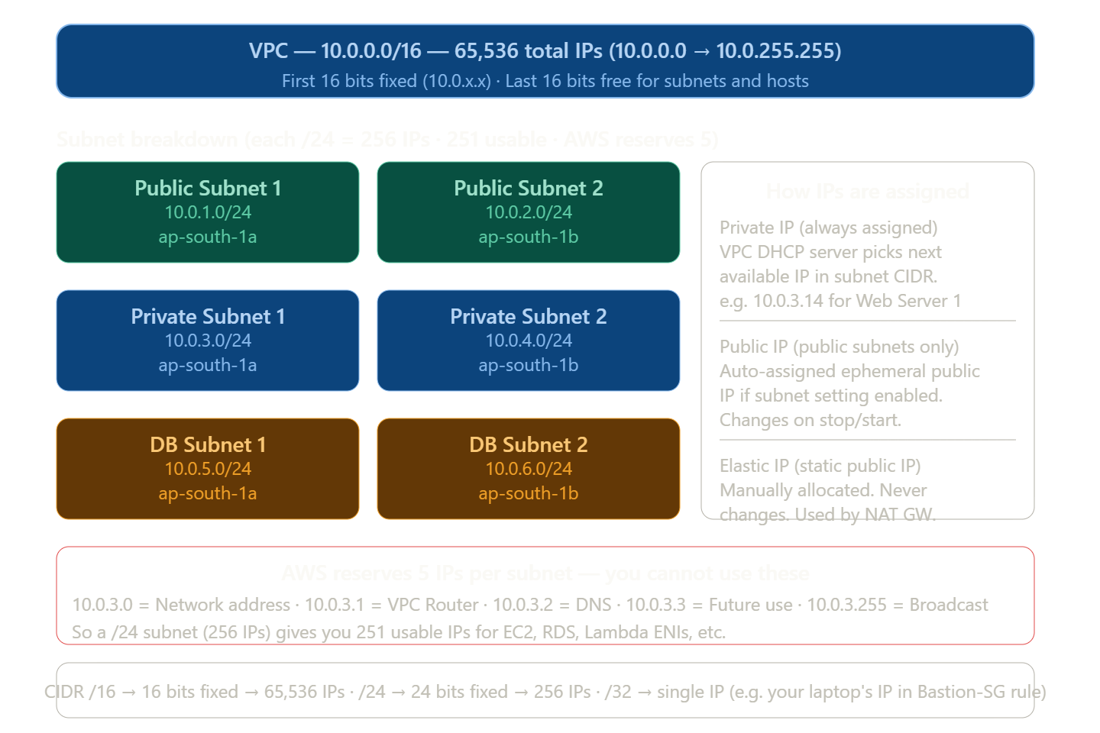

2.2 Subnets
A subnet is a range of IP addresses within your VPC. Subnets must reside within a single Availability Zone. You divide your VPC CIDR block into smaller CIDR blocks for each subnet.

Public Subnets
A subnet is public when its route table contains a route to an Internet Gateway (IGW). Resources in public subnets can communicate directly with the internet if they have a public IP.

Private Subnets
A subnet is private when it does NOT have a route to the Internet Gateway. Resources in private subnets cannot be reached from the internet directly. They use a NAT Gateway to initiate outbound connections to the internet.
Subnet | Type | CIDR | AZ | Purpose
Public Subnet 1 | Public | 10.0.1.0/24 | ap-south-1a | NAT Gateway, Bastion Host, ALB
Public Subnet 2 | Public | 10.0.2.0/24 | ap-south-1b | ALB (second AZ for HA)
Private Subnet 1 | Private | 10.0.3.0/24 | ap-south-1a | Web Server 1 (App Tier)
Private Subnet 2 | Private | 10.0.4.0/24 | ap-south-1b | Web Server 2 (App Tier)
DB Subnet 1 | Private | 10.0.5.0/24 | ap-south-1a | RDS Primary (MySQL)
DB Subnet 2 | Private | 10.0.6.0/24 | ap-south-1b | RDS Standby / Replica

⚙ TASK: Create a Subnet
1 | VPC → Subnets → Create subnet
2 | VPC ID: Select your VPC (my-project-vpc)
3 | Subnet name: public-subnet-1
4 | Availability Zone: ap-south-1a
5 | IPv4 CIDR block: 10.0.1.0/24
6 | Click Add new subnet to add more subnets in the same step
7 | Repeat for all 6 subnets (public-subnet-2, private-subnet-1, private-subnet-2, db-subnet-1, db-subnet-2)
8 | For public subnets: Enable auto-assign public IPv4 → Subnet settings → Enable auto-assign public IPv4 address

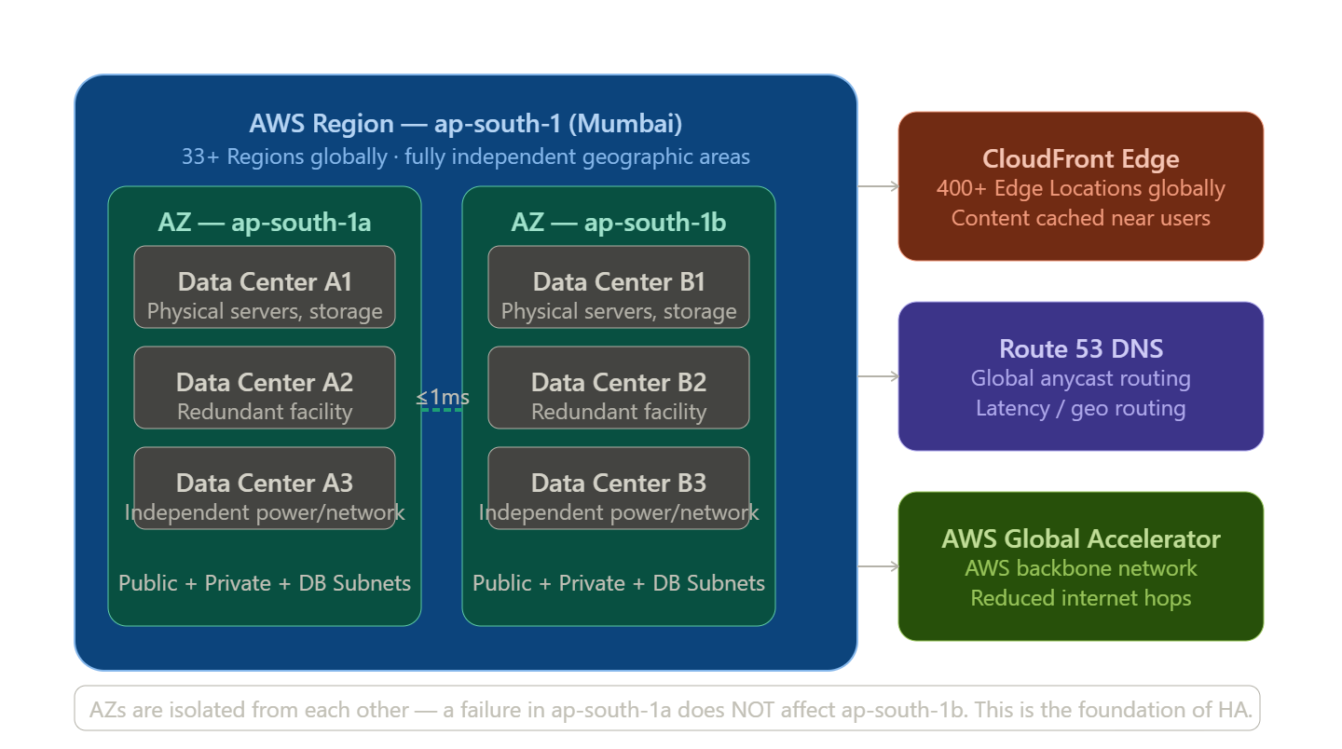

2.3 Internet Gateway (IGW)
An Internet Gateway is a horizontally scaled, redundant, and highly available VPC component that allows communication between your VPC and the internet. It performs NAT (Network Address Translation) for instances with public IP addresses.

How it works
- Attach one IGW per VPC
- Add a route in the public subnet's route table pointing 0.0.0.0/0 to the IGW
- Instances in the public subnet with public IPs can now reach and be reached from the internet
⚙ TASK: Create and Attach Internet Gateway
1 | VPC → Internet Gateways → Create internet gateway
2 | Name tag: my-project-igw
3 | Click Create internet gateway
4 | Select the IGW → Actions → Attach to VPC
5 | Select your VPC → Click Attach internet gateway
6 | Note: Only ONE IGW can be attached to a VPC at a time

2.4 NAT Gateway
A NAT (Network Address Translation) Gateway enables instances in a private subnet to connect to the internet or other AWS services, but prevents the internet from initiating connections with those instances.
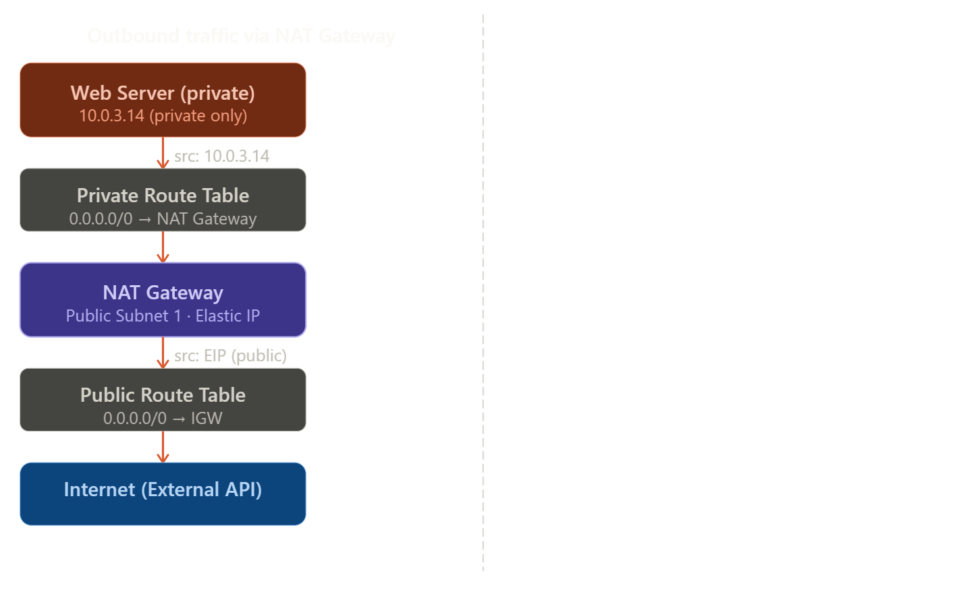

Why NAT Gateway?
- Web servers in private subnets need to download updates, packages, call external APIs
- Direct internet access would expose them — NAT solves this
- NAT translates the private IP to its public EIP for outbound connections
- Return traffic is routed back to the originating private instance
📌 Note: NAT Gateway is placed in a PUBLIC subnet with an Elastic IP. Instances in PRIVATE subnets route their outbound traffic to the NAT Gateway.

⚙ TASK: Create NAT Gateway
1 | VPC → NAT Gateways → Create NAT gateway
2 | Name: my-project-nat
3 | Subnet: Select public-subnet-1 (MUST be in a public subnet)
4 | Connectivity type: Public
5 | Elastic IP allocation ID: Click Allocate Elastic IP → this assigns a static public IP
6 | Click Create NAT gateway
7 | Wait for Status to become Available (2-3 minutes)
8 | Update the private route table to route 0.0.0.0/0 to this NAT Gateway

2.5 Route Tables
A route table contains a set of rules, called routes, that determine where network traffic from your subnet or gateway is directed. Every subnet must be associated with a route table.

Why are Route Tables Required?
Without route tables, AWS would not know where to send network packets. Route tables are the GPS of your VPC — they tell every packet where to go next.
When a packet arrives at a subnet, the router checks the route table entries in order from most specific to least specific (longest prefix match). The first matching route wins.
Route Table | Associated Subnets | Routes | Purpose
rtb-public | Public Subnet 1, Public Subnet 2 | 10.0.0.0/16 → Local 0.0.0.0/0 → IGW | Internet-facing traffic
rtb-private | Private Subnet 1, Private Subnet 2 | 10.0.0.0/16 → Local 0.0.0.0/0 → NAT GW | Outbound via NAT
rtb-db | DB Subnet 1, DB Subnet 2 | 10.0.0.0/16 → Local (No internet route) | DB isolated, VPC-only

How a Request Passes Through Subnets
Understanding the flow of a request is critical. Here is the complete journey:
- User types https://myapp.com in browser
- DNS resolves the domain to the ALB's public IP (Route 53 → ALB DNS name)
- Request travels via Internet → IGW → ALB (in Public Subnet)
- ALB evaluates listener rules and forwards to target group (Web Servers in Private Subnets)
- ALB routes to Web Server 1 (Private Subnet 1, 10.0.3.x) or Web Server 2 (Private Subnet 2, 10.0.4.x)
- Web Server processes request, queries MySQL RDS at 10.0.5.x (DB Subnet 1) via private route
- RDS returns data → Web Server builds response → ALB → IGW → Internet → User
- For outbound calls FROM web server (e.g., calling an external API): Private Subnet Route Table → NAT GW → EIP → Internet

⚙ TASK: Create Route Tables and Associate Subnets
1 | VPC → Route Tables → Create route table
2 | Name: rtb-public, VPC: my-project-vpc → Create
3 | Select rtb-public → Routes tab → Edit routes → Add route: 0.0.0.0/0 target: igw-xxxx → Save
4 | Subnet Associations tab → Edit subnet associations → Select public-subnet-1 and public-subnet-2 → Save
5 | Create rtb-private → Add route 0.0.0.0/0 target: nat-xxxx → Associate private-subnet-1 and private-subnet-2
6 | Create rtb-db → No internet route (only local 10.0.0.0/16 → Local exists by default) → Associate db-subnet-1 and db-subnet-2
7 | Verify: Each subnet should show its associated route table in the Subnet Details page

2.6 Security Groups
A Security Group acts as a virtual firewall for your EC2 instance to control inbound and outbound traffic. Security Groups operate at the instance level (not subnet level).

Key Characteristics
- Stateful — if you allow inbound traffic, the response is automatically allowed outbound
- Allow rules only — you cannot create deny rules in security groups
- Rules can reference other security groups (e.g., allow traffic from ALB-SG)
- Multiple SGs can be assigned to a single instance

Security Groups in the Project
Security Group | Inbound Rules | Outbound Rules | Attached To
ALB-SG | HTTP 80 from 0.0.0.0/0 HTTPS 443 from 0.0.0.0/0 | All traffic → Web-SG | Application Load Balancer
Bastion-SG | SSH 22 from Your IP /32 | All traffic → 0.0.0.0/0 | Bastion Host EC2
WEB-SG | HTTP 80 from ALB-SG SSH 22 from Bastion-SG | All traffic → 0.0.0.0/0 | Web Server EC2 instances
DB-SG | MySQL 3306 from WEB-SG | All traffic → 0.0.0.0/0 | RDS MySQL instances

⚙ TASK: Create Security Group: ALB-SG
1 | EC2 → Security Groups → Create security group
2 | Security group name: ALB-SG
3 | Description: Security group for Application Load Balancer
4 | VPC: my-project-vpc
5 | Inbound rules → Add rule: Type=HTTP, Protocol=TCP, Port=80, Source=0.0.0.0/0
6 | Add rule: Type=HTTPS, Protocol=TCP, Port=443, Source=0.0.0.0/0
7 | Outbound rules: Leave default (All traffic → 0.0.0.0/0) — we will tighten later
8 | Click Create security group

⚙ TASK: Create Security Group: WEB-SG
1 | Create security group: WEB-SG
2 | Inbound: Add rule → Type=HTTP, Port=80, Source=Custom → select ALB-SG (this means only ALB can reach web servers)
3 | Inbound: Add rule → Type=SSH, Port=22, Source=Custom → select Bastion-SG (only bastion can SSH into web servers)
4 | Outbound: All traffic → 0.0.0.0/0
5 | This security group will be attached to Web Server EC2 instances

⚙ TASK: Create Security Group: DB-SG
1 | Create security group: DB-SG
2 | Description: Security group for RDS MySQL
3 | Inbound: Add rule → Type=MySQL/Aurora, Protocol=TCP, Port=3306, Source=WEB-SG
4 | This ensures ONLY web servers can connect to the database — not the internet
5 | Outbound: All traffic → 0.0.0.0/0

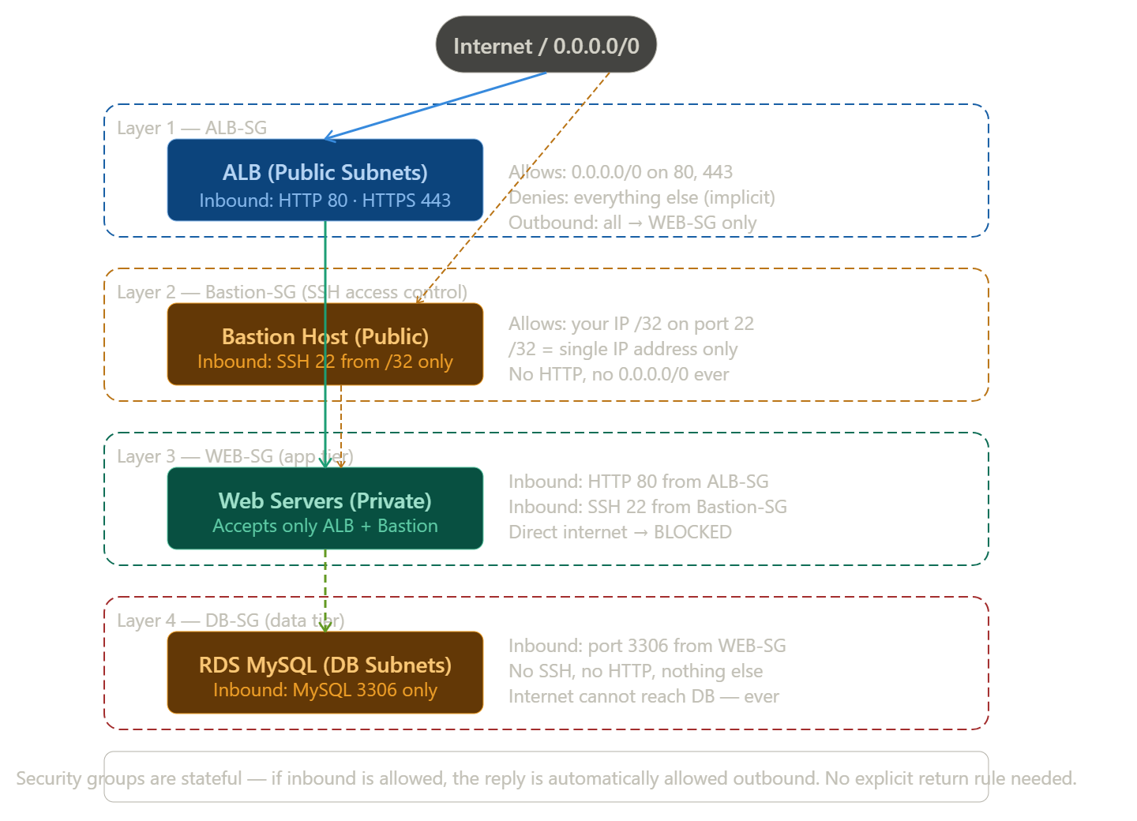

2.7 Elastic Network Interface (ENI)
An ENI is a logical networking component in a VPC that represents a virtual network card. Every EC2 instance has a primary ENI (eth0) attached to it automatically. ENIs are subnet-specific and can be moved between instances.

ENI Properties
- Primary private IPv4 address from the subnet CIDR
- One or more secondary private IPv4 addresses
- One Elastic IP per private IPv4 (optional)
- One public IPv4 address (optional, for instances in public subnets)
- One or more IPv6 addresses
- Security groups
- MAC address
📌 Note: When you terminate an EC2 instance, the primary ENI is deleted. Secondary ENIs persist. Useful for failover: detach ENI from a failed instance and re-attach to a replacement.

3. Amazon EC2 — Elastic Compute Cloud

3.1 What is EC2?
Amazon EC2 provides resizable compute capacity in the cloud. You can launch virtual machines (called instances) with the operating system, CPU, memory, and storage of your choice. EC2 is the backbone of most AWS architectures.

Why EC2?
- Full control over the operating system and installed software
- Wide variety of instance types optimized for different use cases
- Pay per second (Linux) or per hour (Windows)
- Can be stopped, started, rebooted, or terminated on demand

3.2 EC2 Instance Types
Family | Purpose | Examples | Use Case
General Purpose | Balanced CPU/memory/network | t3.micro, t3.medium, m5.large | Web servers, dev environments
Compute Optimized | High CPU | c5.large, c5.xlarge | Batch processing, ML inference
Memory Optimized | Large RAM | r5.large, r5.2xlarge | In-memory DBs, caching
Storage Optimized | High disk I/O | i3.large, d2.xlarge | Data warehousing, Hadoop
Accelerated | GPU/FPGA | p3.2xlarge, g4dn.xlarge | ML training, video rendering

3.3 EC2 Pricing Models
Model | Description | Savings | Best For
On-Demand | Pay per hour/second, no commitment | 0% | Development, unpredictable workloads
Reserved (1yr) | Reserve capacity for 1 year | ~30-40% | Steady-state production workloads
Reserved (3yr) | Reserve capacity for 3 years | ~50-60% | Long-term committed workloads
Spot Instances | Bid on unused capacity | ~70-90% | Batch jobs, fault-tolerant workloads
Savings Plans | Flexible commitment ($/hr) | ~20-66% | Mixed instance family usage
Dedicated Hosts | Physical server dedicated to you | Varies | Compliance/licensing requirements

3.4 EC2 Storage

Instance Store (Ephemeral Storage)
Instance store provides temporary block-level storage for your instance. The storage is physically attached to the host computer. Data is LOST when the instance is stopped or terminated.
- Very high I/O performance (directly attached NVMe SSD)
- No additional cost (included in instance price)
- Use case: temporary data, buffers, caches, scratch data
⚠️ Warning: Instance store data is NOT persistent. Never store important data only on instance store.

Amazon EBS (Elastic Block Store)
EBS provides persistent block storage volumes for EC2 instances. EBS volumes persist independently from the instance — data survives instance stop/start and termination (if configured).
EBS Type | IOPS | Throughput | Use Case
gp3 (General Purpose SSD) | 3,000-16,000 | 125-1,000 MiB/s | Default for most workloads
gp2 (General Purpose SSD) | 100-16,000 (3 IOPS/GB) | 128-250 MiB/s | Legacy general purpose
io2 Block Express | Up to 256,000 | 4,000 MiB/s | Critical databases
st1 (Throughput HDD) | 500 | 500 MiB/s | Log processing, big data
sc1 (Cold HDD) | 250 | 250 MiB/s | Infrequently accessed data

3.5 AMI — Amazon Machine Image
An AMI is a template that contains the software configuration (OS, application server, and applications) required to launch an instance. Think of it as a snapshot of a fully configured server.
- AWS-provided AMIs: Amazon Linux 2, Ubuntu, Windows Server, etc.
- AWS Marketplace AMIs: third-party software pre-configured
- Custom AMIs: create your own from an existing instance (golden image)

3.6 Key Pairs
Key pairs are used to securely SSH into Linux EC2 instances. AWS stores the public key on the instance; you keep the private key (.pem file) locally.
⚠️ Warning: Download the .pem file immediately when created — AWS does NOT store the private key. If lost, you cannot recover it.
⚙ TASK: Launch EC2 Instance (Web Server)
1 | EC2 → Instances → Launch instances
2 | Name: web-server-1
3 | AMI: Amazon Linux 2023 AMI (free tier eligible)
4 | Instance type: t3.micro (or t2.micro for free tier)
5 | Key pair: Click Create new key pair → Name: my-project-key → RSA → .pem → Download and save securely
6 | Network settings: VPC = my-project-vpc, Subnet = private-subnet-1
7 | Auto-assign public IP: Disable (private subnet — no public IP needed)
8 | Security group: Select existing → WEB-SG
9 | Storage: 20 GiB gp3 (Root volume)
10 | Advanced details → User data: paste startup scripts (install Apache/Nginx, etc.)
11 | Click Launch instance
12 | Repeat for web-server-2 in private-subnet-2

⚙ TASK: Create a Bastion Host
1 | A Bastion Host is a special-purpose instance in a PUBLIC subnet used to SSH into instances in PRIVATE subnets.
2 | EC2 → Launch instance → Name: bastion-host
3 | AMI: Amazon Linux 2023 AMI
4 | Instance type: t3.micro (Bastion only forwards SSH — tiny size is sufficient)
5 | Network: VPC = my-project-vpc, Subnet = public-subnet-1
6 | Auto-assign public IP: Enable
7 | Security group: Bastion-SG (allows SSH 22 from YOUR IP only — /32)
8 | Key pair: my-project-key
9 | Launch instance
10 | To SSH into a private web server: first SSH to bastion (ssh -i key.pem ec2-user@<bastion-public-ip>), then from bastion SSH to web server private IP
11 | Best practice: Use SSH agent forwarding (ssh -A) or AWS Systems Manager Session Manager instead of bastion host for production

3.7 EC2 User Data
User Data is a script that runs once when an EC2 instance first starts. It is used to automate the configuration of instances at launch.
#!/bin/bash
yum update -y
yum install -y httpd
systemctl start httpd
systemctl enable httpd
echo "<h1>Web Server 1 - $(hostname -f)</h1>" > /var/www/html/index.html

3.8 EC2 Metadata
Instance metadata is data about your running instance that you can access from within the instance itself at the special URL:
curl http://169.254.169.254/latest/meta-data/
curl http://169.254.169.254/latest/meta-data/instance-id
curl http://169.254.169.254/latest/meta-data/local-ipv4
curl http://169.254.169.254/latest/meta-data/public-ipv4
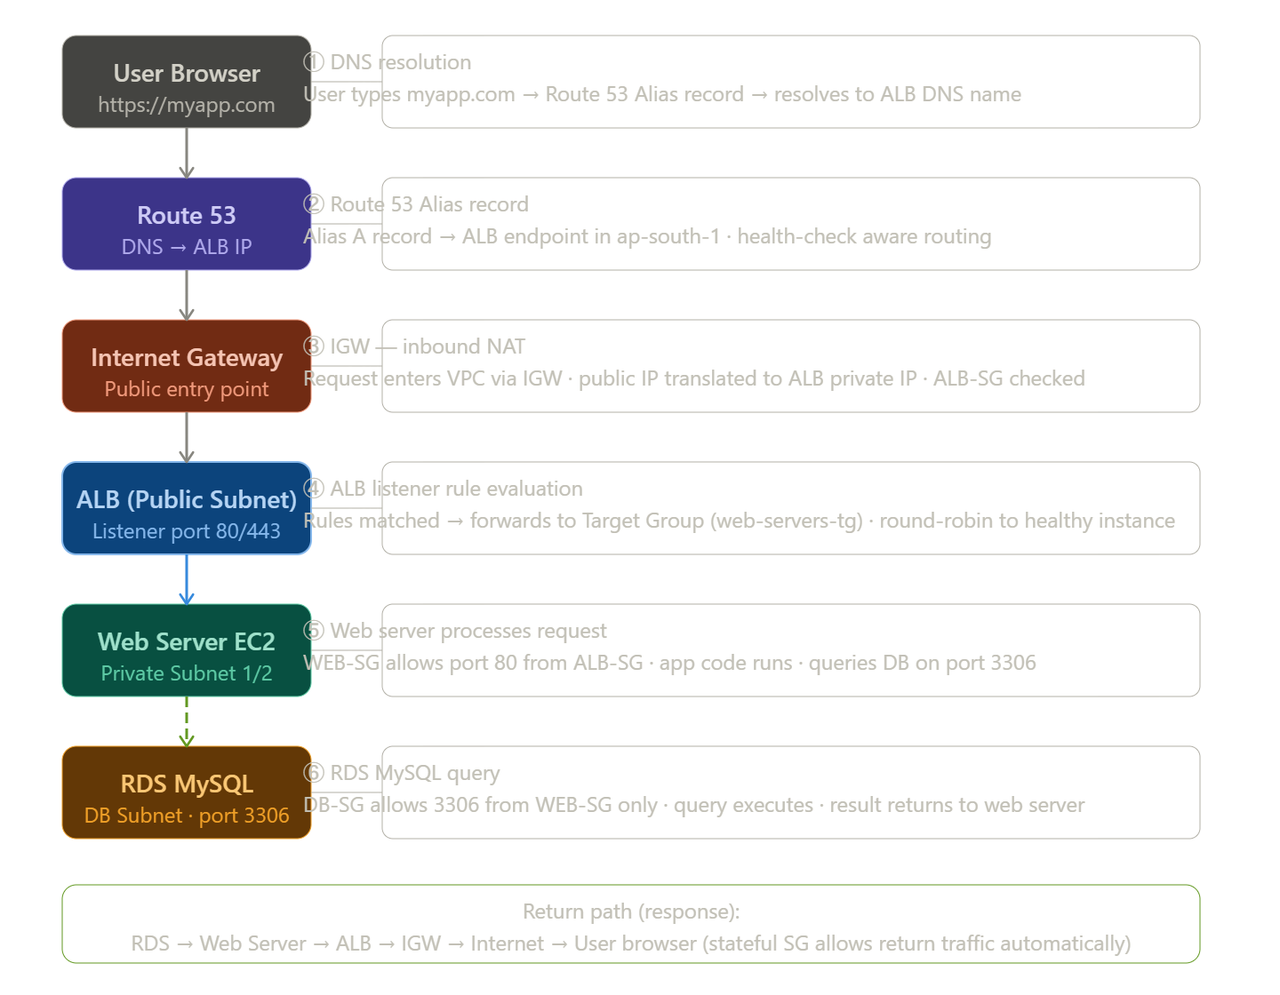

4. IAM — Identity and Access Management

4.1 What is IAM?
AWS Identity and Access Management (IAM) enables you to manage access to AWS services and resources securely. Using IAM, you can create and manage AWS users and groups, and use permissions to allow and deny their access to AWS resources.

Why IAM?
- Security — never use root account for daily operations
- Least Privilege — give only the minimum permissions required
- Audit — CloudTrail logs all IAM actions
- Compliance — meet regulatory requirements for access control

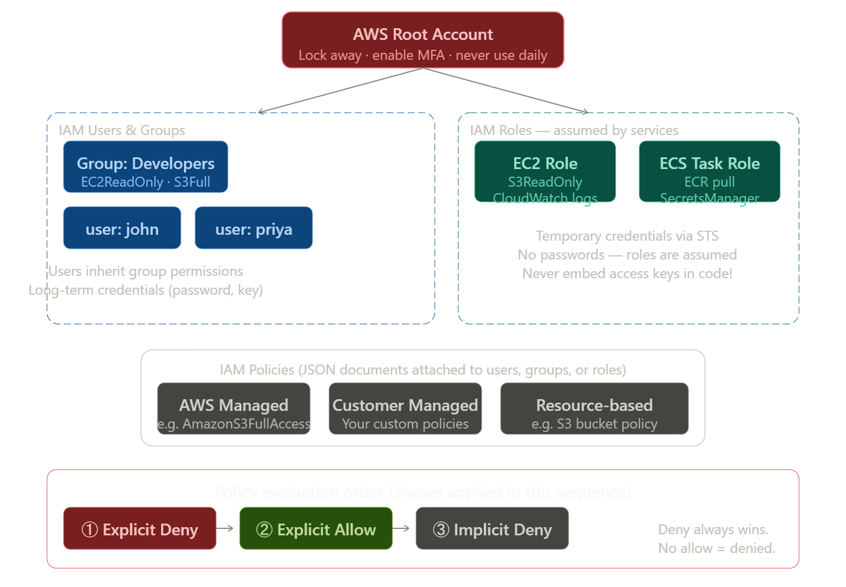

4.2 IAM Components

IAM Users
An IAM user is an entity that represents a person or application that interacts with AWS. Users have permanent long-term credentials (password for console, access keys for CLI/API).

IAM Groups
A group is a collection of IAM users. You attach permissions to groups, and all users in the group inherit those permissions. Groups cannot be nested.

IAM Roles
A role is an identity with permission policies that determine what the identity can and cannot do in AWS. Roles are assumed temporarily and do not have permanent credentials. Used by EC2 instances, Lambda functions, ECS tasks, etc.

IAM Policies
Policies are JSON documents that define permissions. They specify which actions are allowed or denied on which resources.
{"Version": "2012-10-17",
"Statement": [{
"Effect": "Allow",
"Action": ["s3:GetObject","s3:PutObject"],
"Resource": "arn:aws:s3:::my-bucket/*"
}]}
Policy Type | Description | Use Case
AWS Managed | Created and maintained by AWS | Common use cases like S3FullAccess
Customer Managed | Created by you, reusable across users | Custom access requirements
Inline | Embedded directly in a user/group/role | One-off specific permissions
Resource-based | Attached to a resource (e.g., S3 bucket policy) | Cross-account access

4.3 IAM Best Practices
- Never use the root account for day-to-day tasks — lock it away with MFA
- Enable MFA for all users, especially privileged ones
- Use IAM Roles for EC2, ECS, Lambda — never embed access keys in code
- Apply least privilege — start with no access, add as needed
- Rotate access keys regularly
- Use IAM Access Analyzer to find over-permissive policies
- Use Service Control Policies (SCPs) in AWS Organizations for guardrails
⚙ TASK: Create IAM User for Developer
1 | IAM → Users → Create user
2 | User name: developer-john
3 | Enable: Provide user access to the AWS Management Console
4 | Password: Custom password or auto-generated
5 | Permissions: Add user to group → Create group "Developers" with AmazonEC2ReadOnlyAccess and AmazonS3FullAccess
6 | Tags: Key=Department, Value=Engineering
7 | Review and create
8 | Download credentials CSV — give to the user
9 | User must change password on first login

⚙ TASK: Create IAM Role for EC2 Instance (e.g., to access S3)
1 | IAM → Roles → Create role
2 | Trusted entity type: AWS service
3 | Use case: EC2 (EC2 can assume this role)
4 | Permissions: Search and attach AmazonS3ReadOnlyAccess
5 | Role name: ec2-s3-readonly-role
6 | Create role
7 | Attach to EC2: EC2 Console → Instance → Actions → Security → Modify IAM role → select ec2-s3-readonly-role
8 | The instance can now call S3 APIs without any hardcoded credentials

4.4 IAM Policy Evaluation Logic
When a request is made, IAM evaluates all applicable policies and determines if the request is allowed or denied:
- Explicit Deny — if any policy has an explicit Deny, the request is DENIED immediately
- Explicit Allow — if a policy has an Allow and there is no Deny, the request is ALLOWED
- Default Deny — if there is no explicit Allow, the request is DENIED (implicit deny)
📌 Note: Explicit Deny always wins. Even if ten policies allow an action, one Deny overrides them all.

5. Amazon S3 — Simple Storage Service

5.1 What is S3?
Amazon S3 is an object storage service that offers industry-leading scalability, data availability, security, and performance. S3 stores data as objects within containers called buckets. An object is a file and any metadata that describes that file.

Why S3?
- Virtually unlimited storage capacity
- 99.999999999% (11 nines) durability — 11 9s
- 99.99% availability
- Objects from 0 bytes to 5 TB
- Versioning, lifecycle policies, cross-region replication

5.2 S3 Storage Classes
Storage Class | Durability | Retrieval | Cost | Use Case
S3 Standard | 11 nines | Milliseconds | Highest | Frequently accessed data
S3 Standard-IA | 11 nines | Milliseconds | Lower (retrieval fee) | Infrequent access, backups
S3 One Zone-IA | 11 nines (1 AZ) | Milliseconds | Lowest IA | Re-creatable infrequent data
S3 Glacier Instant | 11 nines | Milliseconds | Low | Archives with instant access
S3 Glacier Flexible | 11 nines | Minutes-hours | Very low | Long-term archives
S3 Glacier Deep Archive | 11 nines | 12-48 hours | Lowest | Compliance archives (7+ yrs)
S3 Intelligent-Tiering | 11 nines | Milliseconds | Monitoring fee | Unknown access patterns

5.3 S3 Security

Bucket Policies
Resource-based policies attached to the bucket. Define who can access the bucket and what actions they can perform.

ACLs (Access Control Lists)
Legacy access control mechanism. AWS recommends using bucket policies instead.

Block Public Access
4 settings to block all public access. Should be enabled for most buckets unless serving static websites.
⚙ TASK: Create S3 Bucket for Application Assets
1 | S3 → Create bucket
2 | Bucket name: my-project-assets-2024 (must be globally unique)
3 | AWS Region: ap-south-1
4 | Object Ownership: ACLs disabled (recommended)
5 | Block Public Access: Keep all 4 settings checked (enabled) for private bucket
6 | Versioning: Enable (protects against accidental deletion)
7 | Default encryption: SSE-S3 (Server-Side Encryption with S3 Managed Keys)
8 | Create bucket
9 | To make a specific folder publicly accessible, use a bucket policy (not recommended for production — use CloudFront instead)

5.4 S3 Use Cases in the Project
- Storing application static assets (images, CSS, JS files)
- Storing EC2 application logs shipped via CloudWatch
- Terraform state files (if using Terraform for IaC)
- CloudTrail log storage
- Database backups
- ALB access logs

6. RDS & Aurora — Managed Relational Databases

6.1 Amazon RDS
Amazon Relational Database Service (RDS) is a managed service that sets up, operates, and scales a relational database in the cloud. It automates time-consuming administration tasks such as hardware provisioning, database setup, patching, and backups.

Why RDS?
- Managed — AWS handles patching, backups, replication
- High availability — Multi-AZ deployments with automatic failover
- Performance — Read replicas for scaling reads
- Security — encryption at rest and in transit, VPC integration
- Engines: MySQL, PostgreSQL, MariaDB, Oracle, SQL Server, Aurora

6.2 RDS MySQL — Project Database
In this project, the database tier uses Amazon RDS with MySQL engine deployed in Multi-AZ configuration for high availability. The primary instance is in DB Subnet 1 (ap-south-1a) and the standby/replica is in DB Subnet 2 (ap-south-1b).
Component | Value
Engine | MySQL 8.0
Primary AZ | ap-south-1a (DB Subnet 1: 10.0.5.0/24)
Standby AZ | ap-south-1b (DB Subnet 2: 10.0.6.0/24)
Security Group | DB-SG (allows TCP 3306 from WEB-SG only)
Subnet Group | db-subnet-group (includes both DB subnets)
Multi-AZ | Enabled (automatic failover ~1-2 min)
Storage | 100 GB gp3 SSD with auto-scaling
Backup | Automated daily backups, 7-day retention
Encryption | At-rest encryption enabled (AWS KMS)

⚙ TASK: Create RDS Subnet Group
1 | RDS → Subnet groups → Create DB Subnet Group
2 | Name: db-subnet-group
3 | Description: Subnet group for RDS MySQL
4 | VPC: my-project-vpc
5 | Availability Zones: ap-south-1a AND ap-south-1b
6 | Subnets: Select db-subnet-1 (10.0.5.0/24) and db-subnet-2 (10.0.6.0/24)
7 | Click Create
8 | A subnet group is required before creating an RDS instance — it defines which subnets RDS can use

⚙ TASK: Create RDS MySQL Instance (Multi-AZ)
1 | RDS → Databases → Create database
2 | Creation method: Standard create
3 | Engine type: MySQL, Version: 8.0.x
4 | Templates: Production
5 | DB instance identifier: my-project-db
6 | Master username: admin
7 | Master password: (strong password, store in AWS Secrets Manager)
8 | DB instance class: db.t3.medium (or appropriate size)
9 | Storage: 100 GiB gp3, Enable storage autoscaling, Max 200 GiB
10 | Multi-AZ deployment: Create a standby instance (ENABLED for HA)
11 | VPC: my-project-vpc
12 | Subnet group: db-subnet-group
13 | Public access: No (private subnet — no public access)
14 | VPC security group: Select DB-SG
15 | Database port: 3306
16 | Database name: myappdb (creates initial database)
17 | Backup: Automated backups enabled, 7 days retention
18 | Encryption: Enable encryption, AWS managed key
19 | Create database (takes 5-10 minutes)
20 | Note the Endpoint URL — use this in your application to connect: my-project-db.xxxxxxxx.ap-south-1.rds.amazonaws.com

6.3 RDS Multi-AZ vs Read Replicas
Feature | Multi-AZ | Read Replica
Purpose | High Availability / Failover | Performance / Read Scaling
Replication | Synchronous (no data loss) | Asynchronous (slight lag)
Standby accessible? | No — standby is not accessible (failover only) | Yes — read traffic can be sent to replica
Auto failover? | Yes — automatic (~60-120 seconds) | No — manual promotion required
Cross-region? | Same region only | Yes — cross-region replicas possible
Use case | Production HA requirement | Scale read-heavy workloads

6.4 Amazon Aurora
Amazon Aurora is a MySQL and PostgreSQL-compatible relational database built for the cloud, combining the performance and availability of commercial databases with the simplicity and cost-effectiveness of open-source databases.

Aurora vs Standard RDS
- 5x performance improvement over standard MySQL
- Storage auto-scales in 10 GB increments from 10 GB to 128 TB
- 6 copies of data across 3 AZs — extremely high durability
- 15 Aurora Replicas (vs 5 for RDS Read Replicas)
- Aurora Serverless — auto-scales capacity based on demand

Aurora Serverless v2
Aurora Serverless v2 automatically scales Aurora database capacity up or down based on application demand. You pay per Aurora Capacity Unit (ACU) consumed. Ideal for variable or unpredictable workloads.
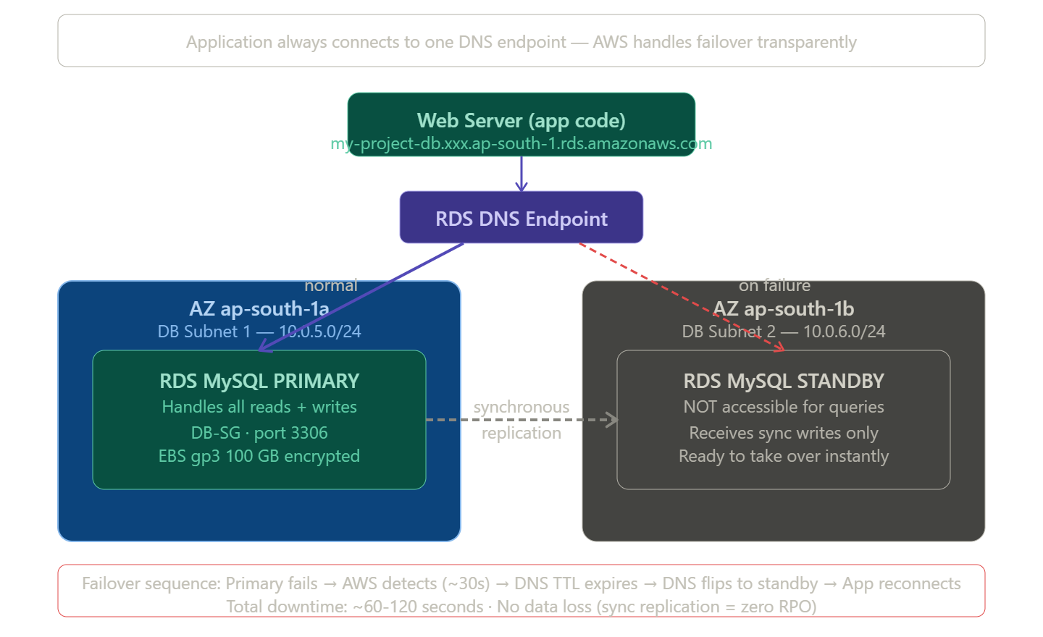

7. Elastic Load Balancing & Auto Scaling

7.1 Elastic Load Balancing (ELB)
Elastic Load Balancing automatically distributes incoming application traffic across multiple targets — EC2 instances, containers, IP addresses, Lambda functions. It monitors the health of registered targets and routes traffic only to healthy targets.

Types of Load Balancers
Type | Layer | Protocol | Use Case
Application Load Balancer (ALB) | Layer 7 (HTTP/HTTPS) | HTTP, HTTPS, WebSocket | Web applications, microservices, URL routing
Network Load Balancer (NLB) | Layer 4 (Transport) | TCP, UDP, TLS | Extreme performance, static IPs, gaming
Gateway Load Balancer (GWLB) | Layer 3+4 | IP (GENEVE) | Virtual appliances, firewalls, IDS/IPS
Classic Load Balancer (CLB) | Layer 4/7 | HTTP, HTTPS, TCP | Legacy (not recommended for new projects)

7.2 Application Load Balancer (ALB) — Project Component
The project uses an ALB placed in both public subnets (Public Subnet 1 and Public Subnet 2) to distribute HTTP/HTTPS traffic to Web Server 1 and Web Server 2 in the private subnets.

ALB Key Concepts
- Listener — checks for connection requests using the protocol and port you configure (e.g., HTTP:80, HTTPS:443)
- Target Group — a group of targets (EC2 instances) that receive requests; ALB routes to this group
- Health Check — ALB periodically checks targets in the target group; unhealthy targets receive no traffic
- Rules — conditions that determine how requests are routed (host-based, path-based, header-based routing)

How ALB Routes Traffic
- Client sends request to ALB DNS name (or IP via Route 53)
- ALB Listener (port 80/443) receives the request
- ALB evaluates Listener Rules in priority order
- Matching rule forwards to the specified Target Group
- ALB selects a healthy target from the Target Group (round-robin by default)
- ALB forwards request to the target (web server) on the configured port (e.g., 80)
- Target processes request, returns response to ALB
- ALB forwards response to the client
⚙ TASK: Create Target Group for Web Servers
1 | EC2 → Target Groups → Create target group
2 | Target type: Instances
3 | Target group name: web-servers-tg
4 | Protocol: HTTP, Port: 80
5 | VPC: my-project-vpc
6 | Protocol version: HTTP1
7 | Health checks: Protocol=HTTP, Path=/index.html (or /health for health endpoint)
8 | Healthy threshold: 2, Unhealthy threshold: 3, Timeout: 5s, Interval: 30s
9 | Click Next → Register targets → Select web-server-1 and web-server-2 → Include as pending
10 | Create target group

⚙ TASK: Create Application Load Balancer
1 | EC2 → Load Balancers → Create load balancer → Application Load Balancer
2 | Load balancer name: my-project-alb
3 | Scheme: Internet-facing
4 | IP address type: IPv4
5 | Network mapping: VPC = my-project-vpc
6 | Mappings: Select ap-south-1a + public-subnet-1 AND ap-south-1b + public-subnet-2
7 | Security groups: ALB-SG (remove default SG)
8 | Listeners: HTTP:80 → Forward to web-servers-tg
9 | Create load balancer
10 | Copy the DNS name (e.g., my-project-alb-123456.ap-south-1.elb.amazonaws.com)
11 | This DNS name is what Route 53 will point to (CNAME or Alias record)
12 | For HTTPS: add a Listener on port 443, attach ACM certificate, configure redirect from HTTP to HTTPS

7.3 Auto Scaling
Auto Scaling ensures you have the right number of EC2 instances available to handle application load. You define minimum, desired, and maximum capacity, and Auto Scaling adjusts the number of instances within those limits.
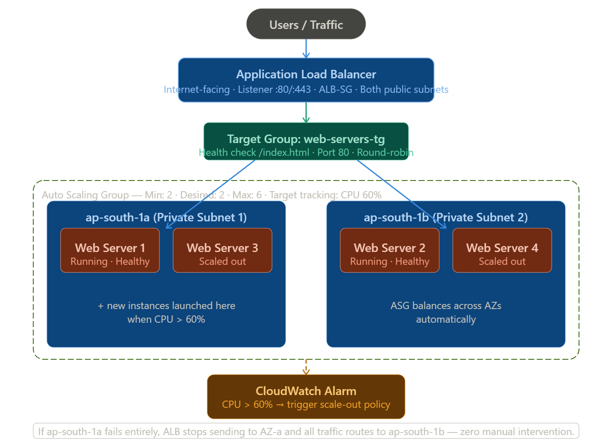

Auto Scaling Components
- Launch Template — defines the EC2 configuration (AMI, instance type, key pair, SG, user data) for new instances
- Auto Scaling Group (ASG) — defines where (subnets/AZs) and how many instances to maintain
- Scaling Policies — rules that trigger scaling actions based on conditions

Scaling Policy Types
Policy Type | Trigger | Use Case
Target Tracking | Maintain a metric at a target (e.g., CPU = 60%) | Most common, auto-managed
Step Scaling | Scale in steps based on alarm threshold | Fine-grained control
Simple Scaling | Add/remove a fixed number when alarm triggers | Basic scaling
Scheduled Scaling | Scale at a specific time/date | Known traffic patterns (e.g., business hours)
Predictive Scaling | ML-based forecast + proactive scaling | Recurring patterns

⚙ TASK: Create Launch Template
1 | EC2 → Launch Templates → Create launch template
2 | Launch template name: web-server-lt
3 | AMI: Your custom AMI (created from a configured web server) or Amazon Linux 2023
4 | Instance type: t3.micro
5 | Key pair: my-project-key
6 | Security groups: WEB-SG
7 | Storage: 20 GiB gp3
8 | Advanced → IAM instance profile: ec2-app-role (if needed)
9 | User data: Bootstrap script to install/configure web server
10 | Create launch template

⚙ TASK: Create Auto Scaling Group
1 | EC2 → Auto Scaling Groups → Create Auto Scaling group
2 | Name: web-servers-asg
3 | Launch template: web-server-lt (latest version)
4 | VPC: my-project-vpc
5 | Availability Zones and subnets: private-subnet-1 (ap-south-1a) + private-subnet-2 (ap-south-1b)
6 | Load balancing: Attach to existing load balancer → web-servers-tg
7 | Health check: ELB (checks via ALB health check)
8 | Health check grace period: 300 seconds
9 | Desired capacity: 2, Minimum: 2, Maximum: 6
10 | Scaling policies: Target tracking → Metric: Average CPU utilization, Target: 60%
11 | Notifications: Optional SNS topic for scale in/out events
12 | Create Auto Scaling group

7.4 High Availability & Scalability Architecture

High Availability
High Availability (HA) means the system is designed to operate continuously without failing for a long time. In the project, HA is achieved by:
- ALB spanning 2 AZs — if one AZ fails, traffic automatically routes to the other
- Auto Scaling Group across 2 AZs — instances are distributed across ap-south-1a and ap-south-1b
- RDS Multi-AZ — if the primary DB fails, automatic failover to standby in < 2 minutes
- NAT Gateway — highly available within an AZ (for critical workloads, create NAT GW in each AZ)

Scalability
Scalability means the ability to handle increased load. Two types:
- Vertical Scaling (Scale Up) — increase instance size (e.g., t3.micro → t3.xlarge). Has limits and requires downtime for some changes.
- Horizontal Scaling (Scale Out) — add more instances. Auto Scaling handles this automatically. No downtime.

11. Route 53

11.1 Amazon Route 53
Amazon Route 53 is a highly available and scalable cloud DNS (Domain Name System) web service. It routes end users to internet applications by translating domain names to IP addresses. Named after the DNS port number 53.

Route 53 Routing Policies
Routing Policy | Description | Use Case
Simple | Single resource, no health checks | One web server, one IP
Weighted | Route % traffic to different resources | A/B testing, blue-green deployments
Failover | Active-passive failover with health checks | DR setup: primary + standby
Latency-based | Route to region with lowest latency | Global users, multi-region deployment
Geolocation | Route based on user's geographic location | Serve regional content/regulations
Geoproximity | Route based on resource location + bias | Fine-tune traffic flow with Traffic Flow
Multi-Value Answer | Return multiple IPs (basic load balancing) | Simple HA without ALB
IP-based | Route based on client IP CIDR | Route corporate IP to different backend

Route 53 Record Types
- A Record — maps domain to IPv4 address (e.g., example.com → 1.2.3.4)
- AAAA Record — maps domain to IPv6 address
- CNAME — maps domain to another domain name (cannot be used for root domain)
- Alias — AWS-specific, maps domain to AWS resource (ALB, CloudFront, S3 website). Can be used for root domain. FREE for AWS resources.
- MX — mail exchange records for email
- TXT — text records (domain verification, SPF records)
⚙ TASK: Configure Route 53 for Project Domain
1 | Route 53 → Hosted zones → Create hosted zone
2 | Domain name: myapp.com
3 | Type: Public hosted zone
4 | Create hosted zone
5 | Note the 4 Name Server (NS) records → update at your domain registrar
6 | Create record: Name=myapp.com, Type=A (Alias), Route traffic to=Application/Classic Load Balancer
7 | Region=ap-south-1, Select my-project-alb
8 | Routing policy=Simple, Evaluate target health=Yes
9 | Create record
10 | For www.myapp.com: Create another A Alias record for www → same ALB
11 | DNS propagation takes up to 48 hours (usually much faster)

12. AWS Security & Encryption

13. Project Architecture — Complete Documentation

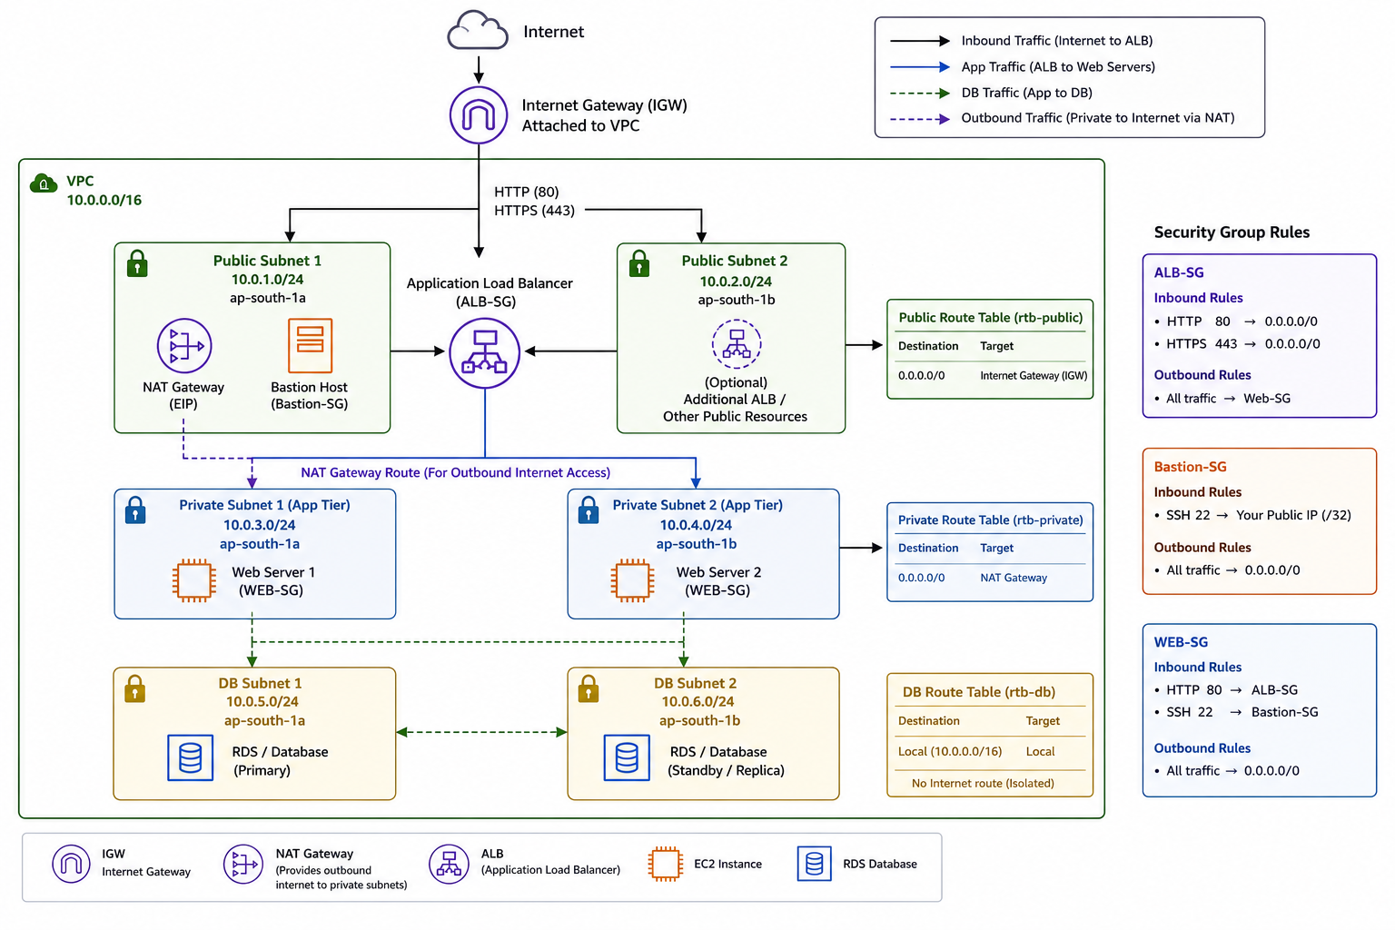

13.1 Architecture Overview
The project implements a highly available, multi-tier web application deployed in the AWS Mumbai region (ap-south-1). The architecture follows a classic three-tier model: Presentation Tier (ALB), Application Tier (Web Servers), and Data Tier (MySQL RDS). Resources are distributed across two Availability Zones (ap-south-1a and ap-south-1b) to eliminate single points of failure.

13.2 Complete Infrastructure Inventory
Component | Type | Details | Purpose
VPC | AWS VPC | 10.0.0.0/16, ap-south-1 | Isolated network boundary
Internet Gateway | IGW | Attached to VPC | Internet access for public subnets
NAT Gateway | NAT GW + EIP | In Public Subnet 1 | Outbound internet for private subnets
Public Subnet 1 | Subnet | 10.0.1.0/24, ap-south-1a | NAT GW, Bastion Host
Public Subnet 2 | Subnet | 10.0.2.0/24, ap-south-1b | ALB second AZ
Private Subnet 1 | Subnet | 10.0.3.0/24, ap-south-1a | Web Server 1
Private Subnet 2 | Subnet | 10.0.4.0/24, ap-south-1b | Web Server 2
DB Subnet 1 | Subnet | 10.0.5.0/24, ap-south-1a | RDS Primary MySQL
DB Subnet 2 | Subnet | 10.0.6.0/24, ap-south-1b | RDS Standby MySQL
Application Load Balancer | ALB | Across both Public Subnets | Distributes HTTP/HTTPS traffic
Bastion Host | EC2 | In Public Subnet 1 | SSH jump server
Web Server 1 | EC2 | In Private Subnet 1 | Application server (AZ-a)
Web Server 2 | EC2 | In Private Subnet 2 | Application server (AZ-b)
RDS Primary | RDS MySQL 8.0 | DB Subnet 1, Multi-AZ | Primary database
RDS Standby | RDS MySQL 8.0 | DB Subnet 2, Multi-AZ | Automatic failover standby
ALB-SG | Security Group | HTTP/HTTPS from 0.0.0.0/0 | Protects ALB
Bastion-SG | Security Group | SSH from your IP /32 | Protects Bastion
WEB-SG | Security Group | HTTP from ALB-SG, SSH from Bastion-SG | Protects Web Servers
DB-SG | Security Group | MySQL 3306 from WEB-SG | Protects RDS
rtb-public | Route Table | 0.0.0.0/0 → IGW | Routes public subnet traffic
rtb-private | Route Table | 0.0.0.0/0 → NAT GW | Routes private subnet outbound
rtb-db | Route Table | Local only, no internet | Isolates DB tier

13.3 Complete Request Flow (End-to-End)

Inbound Request: User → Application
- User enters https://myapp.com in browser
- DNS query → Route 53 resolves myapp.com → ALB DNS name (or CloudFront if CDN is used)
- Browser connects to ALB over HTTPS (port 443) → passes through IGW → reaches ALB in Public Subnets
- ALB-SG allows HTTPS 443 from 0.0.0.0/0 → request enters ALB
- ALB Listener (HTTPS:443) evaluates rules → matches default rule → forward to web-servers-tg
- ALB performs health check — only sends to healthy targets
- ALB selects Web Server 1 (10.0.3.x) or Web Server 2 (10.0.4.x) using round-robin
- WEB-SG allows HTTP port 80 from ALB-SG → request reaches web server
- Web Server processes the request, needs database data
- Web Server connects to RDS primary endpoint (10.0.5.x:3306) via Private route table
- DB-SG allows MySQL 3306 from WEB-SG → database query executes
- RDS returns query results → Web Server builds HTML response
- Response travels back: Web Server → ALB → IGW → Internet → User

Outbound Request: Web Server → Internet (e.g., External API call)
- Web Server (10.0.3.x) needs to call external API or download package
- Private Route Table: 0.0.0.0/0 → NAT Gateway (in Public Subnet 1)
- NAT Gateway translates private IP to its Elastic IP
- Request exits via Public Route Table: 0.0.0.0/0 → IGW → Internet
- Internet → IGW → NAT GW → Web Server receives response (NAT maintains connection table)

SSH Access: Admin → Web Server (via Bastion)
- Admin SSHs to Bastion Host: ssh -i key.pem ec2-user@<bastion-public-ip>
- Bastion-SG allows SSH 22 from admin IP /32 → connection accepted
- From Bastion: ssh -i key.pem ec2-user@10.0.3.x (Web Server 1 private IP)
- WEB-SG allows SSH 22 from Bastion-SG → connection accepted to Web Server

Database Failover (RDS Multi-AZ)
- Primary RDS in ap-south-1a becomes unavailable (hardware failure, AZ issue)
- AWS automatically detects failure via monitoring
- RDS DNS endpoint automatically updates to point to Standby in ap-south-1b
- Application reconnects to same endpoint — no code change required
- Failover completes in 60-120 seconds

13.4 Security Layers
The project implements defense-in-depth with multiple security layers:
Layer | Control | Description
Network | VPC | Logical isolation from other AWS accounts
Network | Public/Private Subnets | DB and App servers not directly internet-reachable
Network | Security Groups | Stateful firewall at instance level (least privilege)
Network | NACLs | Stateless subnet-level firewall
Network | Route Tables | DB subnet has no internet route — fully isolated
Compute | Bastion Host | Single SSH entry point with IP restriction (/32)
Data | RDS Encryption | Data encrypted at rest using KMS
Data | Secrets Manager | No hardcoded DB passwords in code
Application | ALB | Terminates TLS, WAF integration possible
Monitoring | CloudTrail | All API calls logged
Monitoring | CloudWatch | Metrics, alarms, log aggregation

14. Complete Step-by-Step Project Build Guide
Follow these tasks in order to build the complete project infrastructure from scratch.

Phase 1: Foundation — VPC and Networking
⚙ TASK: Task 1.1 — Create VPC
1 | VPC → Your VPCs → Create VPC
2 | Name: my-project-vpc
3 | IPv4 CIDR: 10.0.0.0/16
4 | Tenancy: Default
5 | Create VPC

⚙ TASK: Task 1.2 — Create All 6 Subnets
1 | Create public-subnet-1: 10.0.1.0/24, ap-south-1a, enable auto-assign public IP
2 | Create public-subnet-2: 10.0.2.0/24, ap-south-1b, enable auto-assign public IP
3 | Create private-subnet-1: 10.0.3.0/24, ap-south-1a
4 | Create private-subnet-2: 10.0.4.0/24, ap-south-1b
5 | Create db-subnet-1: 10.0.5.0/24, ap-south-1a
6 | Create db-subnet-2: 10.0.6.0/24, ap-south-1b

⚙ TASK: Task 1.3 — Internet Gateway
1 | VPC → Internet Gateways → Create IGW → Name: my-project-igw → Create
2 | Attach to VPC: Actions → Attach to VPC → my-project-vpc

⚙ TASK: Task 1.4 — NAT Gateway
1 | VPC → NAT Gateways → Create NAT gateway
2 | Subnet: public-subnet-1 | Connectivity: Public | Allocate Elastic IP
3 | Create NAT gateway — wait for it to become Available

⚙ TASK: Task 1.5 — Route Tables
1 | Create rtb-public: Add route 0.0.0.0/0 → IGW | Associate public-subnet-1, public-subnet-2
2 | Create rtb-private: Add route 0.0.0.0/0 → NAT GW | Associate private-subnet-1, private-subnet-2
3 | Create rtb-db: No internet route | Associate db-subnet-1, db-subnet-2

⚙ TASK: Task 1.6 — Security Groups
1 | Create ALB-SG: Inbound HTTP/80 + HTTPS/443 from 0.0.0.0/0
2 | Create Bastion-SG: Inbound SSH/22 from <your-ip>/32
3 | Create WEB-SG: Inbound HTTP/80 from ALB-SG + SSH/22 from Bastion-SG
4 | Create DB-SG: Inbound MySQL/3306 from WEB-SG

Phase 2: Compute
⚙ TASK: Task 2.1 — Create Key Pair
1 | EC2 → Key Pairs → Create key pair
2 | Name: my-project-key | Type: RSA | Format: .pem (Linux) or .ppk (Windows PuTTY)
3 | Download and save the .pem file to ~/.ssh/ on your local machine
4 | chmod 400 ~/.ssh/my-project-key.pem (Linux/Mac)

⚙ TASK: Task 2.2 — Launch Bastion Host
1 | AMI: Amazon Linux 2023 | Type: t3.micro
2 | Network: my-project-vpc | Subnet: public-subnet-1 | Auto-assign public IP: Enable
3 | Security group: Bastion-SG | Key pair: my-project-key
4 | Tag: Name=bastion-host

⚙ TASK: Task 2.3 — Launch Web Servers
1 | Web Server 1: AMI=Amazon Linux 2023, t3.micro, private-subnet-1, WEB-SG, User data: install Apache
2 | Web Server 2: AMI=Amazon Linux 2023, t3.micro, private-subnet-2, WEB-SG, User data: install Apache
3 | Tag: Name=web-server-1 and web-server-2 respectively
4 | Test: SSH to bastion → SSH to web server private IP → curl localhost

Phase 3: Load Balancer
⚙ TASK: Task 3.1 — Create ALB Target Group
1 | EC2 → Target Groups → Create target group
2 | Target type: Instances | Protocol: HTTP | Port: 80 | VPC: my-project-vpc
3 | Health check path: / | Healthy threshold: 2 | Interval: 30s
4 | Register web-server-1 and web-server-2 as targets

⚙ TASK: Task 3.2 — Create Application Load Balancer
1 | Scheme: Internet-facing | Subnets: public-subnet-1 (ap-south-1a) + public-subnet-2 (ap-south-1b)
2 | Security group: ALB-SG
3 | Listener: HTTP:80 → Forward to web-servers-tg
4 | Test: Copy ALB DNS name → paste in browser → should see your web app

Phase 4: Database
⚙ TASK: Task 4.1 — Create RDS Subnet Group
1 | RDS → Subnet groups → Create → Name: db-subnet-group
2 | VPC: my-project-vpc | AZs: ap-south-1a + ap-south-1b
3 | Subnets: db-subnet-1 + db-subnet-2

⚙ TASK: Task 4.2 — Create RDS MySQL Instance
1 | Engine: MySQL 8.0 | Template: Production | Multi-AZ: Yes
2 | Instance class: db.t3.medium | Storage: 100 GB gp3 with autoscaling
3 | VPC: my-project-vpc | Subnet: db-subnet-group | Public access: No | SG: DB-SG
4 | Store credentials in Secrets Manager
5 | Copy endpoint URL — configure in web server application settings

Phase 5: DNS
⚙ TASK: Task 5.1 — Configure Route 53
1 | Create hosted zone for your domain
2 | Create Alias A record pointing myapp.com → ALB
3 | Update domain registrar name servers to Route 53 NS records

Phase 6: Monitoring
⚙ TASK: Task 6.1 — Set Up CloudWatch
1 | Enable detailed monitoring on EC2 instances
2 | Create alarms: CPU > 80%, NetworkIn spike, unhealthy ALB targets
3 | Install CloudWatch agent on web servers for application logs
4 | Create dashboard: ALB RequestCount, TargetResponseTime, EC2 CPU, RDS Connections

⚙ TASK: Task 6.2 — Enable CloudTrail
1 | Create trail with S3 bucket for storage
2 | Enable CloudWatch Logs integration
3 | Configure alerts for root login, IAM changes, security group modifications

15. Quick Reference — Remaining Services

15.1 AWS Elastic Beanstalk
PaaS service for deploying and scaling web applications. Upload code (ZIP, Docker, WAR) and Beanstalk handles provisioning EC2, ALB, Auto Scaling, RDS. Good for developers who don't want to manage infrastructure.

15.2 Amazon DynamoDB
Fully managed NoSQL database. Single-digit millisecond performance at any scale. Used for serverless architectures alongside Lambda. Key-value and document data model. Pay-per-request or provisioned capacity.

15.3 Amazon ElastiCache
Managed in-memory caching service. Supports Redis and Memcached. Use to cache frequently read database queries, session data, and real-time leaderboards to reduce RDS load and improve response time.

15.4 Amazon SNS — Simple Notification Service
Managed pub/sub messaging service. Publishers send messages to Topics; Subscribers receive them. Supports Email, SMS, HTTP/S, SQS, Lambda as subscribers. Used for CloudWatch alarm notifications in the project.

15.5 Amazon SQS — Simple Queue Service
Fully managed message queuing service. Decouples application components. Standard queues (at-least-once, high throughput) and FIFO queues (exactly-once, ordered). Dead-letter queues for failed message handling.

15.6 AWS Step Functions
Serverless orchestration service for coordinating multiple AWS services into serverless workflows. Define workflows as state machines in JSON. Used for complex business processes, data pipelines, and microservice coordination.

15.7 Amazon Kinesis
Real-time data streaming service. Kinesis Data Streams: collect and process large data streams. Kinesis Firehose: load streaming data into S3, Redshift, OpenSearch, Splunk. Use case: clickstream analysis, log aggregation, IoT telemetry.

15.8 AWS Glue
Fully managed ETL (Extract, Transform, Load) service. Automatically discovers data schema (Glue Crawler), stores metadata in Glue Catalog, runs Spark-based ETL jobs. Used with Athena, Redshift, and data lakes.

15.9 Amazon Athena
Interactive query service to analyze data in S3 using standard SQL. Serverless — no infrastructure. Pay per query (per TB scanned). Use with CloudTrail logs, ALB access logs, application logs stored in S3.

15.10 AWS Systems Manager (SSM)
Operations hub for managing AWS infrastructure. Key features: Session Manager (SSH to EC2 without a bastion host or opening port 22), Parameter Store (store configuration and secrets), Patch Manager (automate OS patching), Run Command (run scripts on instances remotely).
📌 Note: Consider replacing Bastion Host with SSM Session Manager in production — more secure, no port 22 exposure, full audit log in CloudTrail.

16. Glossary of Key Terms
Term | Definition
AZ | Availability Zone — isolated data center location within a region
CIDR | Classless Inter-Domain Routing — notation to define IP address ranges (e.g., 10.0.0.0/16)
EIP | Elastic IP — static public IPv4 address you allocate to your account
IGW | Internet Gateway — allows VPC resources to communicate with the internet
NAT | Network Address Translation — translates private IPs to public IP for outbound traffic
ALB | Application Load Balancer — Layer 7 load balancer for HTTP/HTTPS traffic
ASG | Auto Scaling Group — automatically adjusts number of EC2 instances based on demand
AMI | Amazon Machine Image — template for launching EC2 instances
IAM | Identity and Access Management — controls who can do what in AWS
S3 | Simple Storage Service — object storage with 11 nines of durability
RDS | Relational Database Service — managed SQL databases
ECS | Elastic Container Service — managed container orchestration
ECR | Elastic Container Registry — private Docker image registry
VPC | Virtual Private Cloud — isolated virtual network in AWS
SG | Security Group — virtual firewall at the instance level
NACL | Network Access Control List — stateless firewall at the subnet level
ENI | Elastic Network Interface — virtual network card
CDN | Content Delivery Network — caches content at edge locations (CloudFront)
DNS | Domain Name System — translates domain names to IP addresses (Route 53)
TLS | Transport Layer Security — encrypts data in transit (HTTPS)
KMS | Key Management Service — manages cryptographic keys
SES | Simple Email Service — managed email sending service
IaC | Infrastructure as Code — define infrastructure in code (CloudFormation, Terraform)
HA | High Availability — system designed to operate continuously without failure
Multi-AZ | Deploying resources in multiple AZs to eliminate single points of failure
TTL | Time to Live — how long a DNS record or cached item is valid

— End of Documentation —
AWS Cloud Infrastructure | Complete Technical Documentation

