Guidance:

**Guidance for home page on intranet sites:**

* “If the homepage doesn’t work well, then staff frustration will quickly be heard.”
* There are seven key roles for the homepage:
* news
* navigation
* key tools
* key information
* community and culture
* internal marketing
* collaboration

**Possible recommendations**

Leave space for changing feature(s)

Explore the use of task-based navigation, such as a ‘how do I?’ section.

Include Search and the staff directory, which are the most frequently used intranet tools.

Twitter or other social media feeds

Distinctive logo

Interesting background image - Choose something that means something DOT

Determine what is ‘useful’ for users

**Avoid**

Limit the use of ‘quick links’, as these can easily grow over time, and have little inherent structure or order.

**Websites viewed for research:**

<https://www.interact-intranet.com/blog/9-engaging-intranet-design-examples-beyond-the-homepage/>  - DONE viewing

<https://www.steptwo.com.au/papers/kmc_homepagesthathelp/>

<https://www.steptwo.com.au/papers/kmc_homepage/>

<https://www.hyperoffice.com/blog/2018/06/20/intranet-examples/>

**Guidance for footers on intranet sites:**

* The purpose of a website footer is to help visitors by adding information and navigation options at the bottom of web pages.
* A footer provides visitors with a sense of consistency, as the same information will appear at the bottom of every single page.
* Secondary site navigation is an attractive footer item (even if it duplicates the header menu). (People often scroll to the bottom of page while a page is loading).  It gives employees one more chance to locate what they need.  It can be arranged:
* By repeating the global navigation
* Suggesting related content
* Presenting popular links

**Possible recommendations – but not all of these**

A-Z index (doesn’t sound like it’s going to happen) - unless it’s in the header

Branding (another form of the logo we choose(?))

Content owner and or author

1. DOT mission – keeping it short

Jobs at DOT

1. Link to a recent DOT-related news item?

Phone and or fax and/or email

Privacy policy

1. Repeated navigation

Sign up for bulletin or other newsletters

Sign-in for MyDOT authors

Site map

Skype

Upcoming events   
**Avoid**

Social media icons – they will be higher on page, if at all

Search button (will be higher on page)

Image – not necessary - takes up too much real estate

**Websites viewed for research:**

<https://www.orbitmedia.com/blog/website-footer-design-best-practices/>

<https://jetpack.com/2018/08/22/website-footer-tips/>

<https://icons8.com/articles/website-footer-design/>

<https://www.nngroup.com/articles/top-intranet-trends/>

Close button fix:

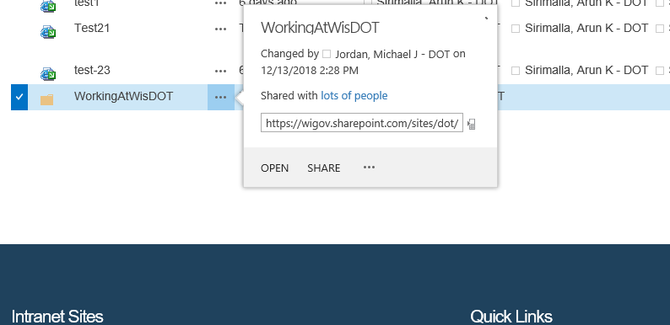

Fix error with the page layout:

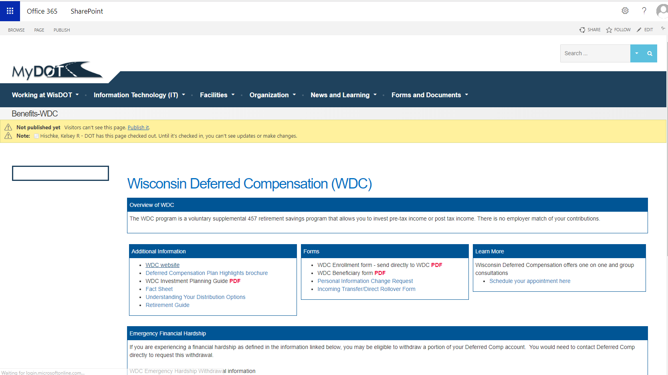

2.Fix the color issues for Hyperlinks and left side rectangle issue.

3.Summary link issue with the icon.

4.bottom icons are not showing up even global navigation is missing for some users.( for some authors).

5.search is still breaking.( tried with old template it works fine.).

6.Nintex workflow issues ( two workflows).

7.Explorer view is not opening many of the times.

8.

Questions:

1. How to delete a file with showing the following error or how to disable specific file.
2. 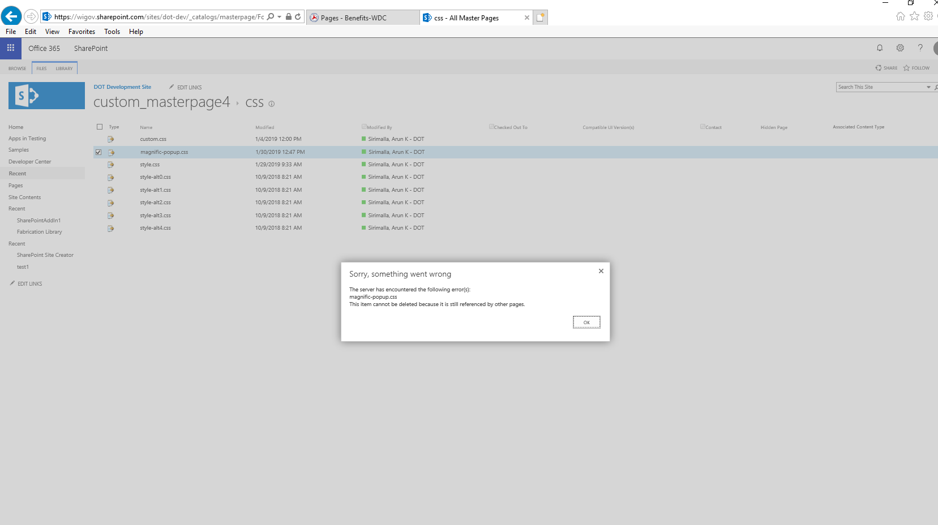
3. Try to use

Work-arounds:

1.Try to use old search templates to make it work or check some other templates.

2.Brush up PowerShell scripts for office online.

Existing Issues:

Page Title is not showing up for the Users with Design permission.

Can we align text in the middle of the box in SharePoint?

User is not able to see the Page Title.

Confirm with the supervisor.

Making up lost time.

Heading issues:

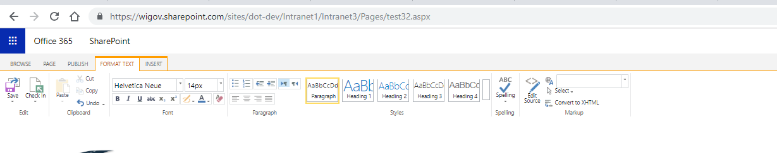

Drop down is holding on the footer and also close icon is not showing up:

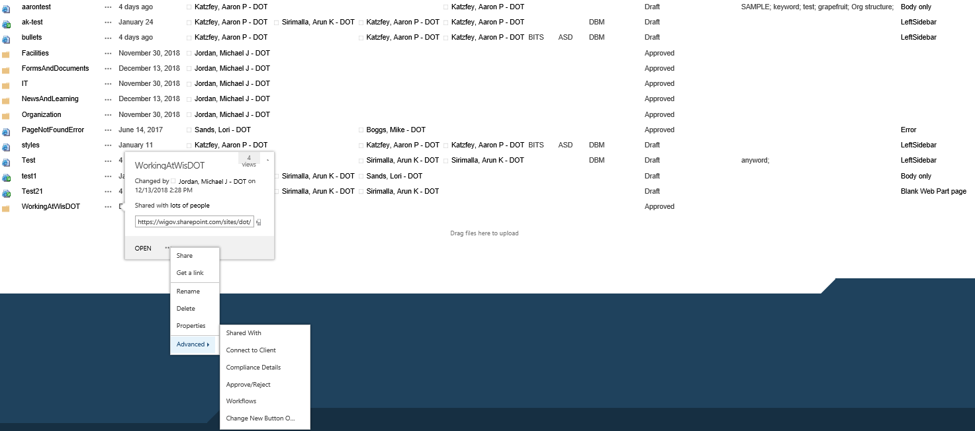

Check out:

1.PowerApps for SharePoint.

Tasks to do:

1. For page owner, that should grab from the “Owner” metadata field as that person is ultimately responsible for the content and end users may ask questions of that person when looking at a page.

2.Workflow issue.

3.

Hide Page content2 from the the view.

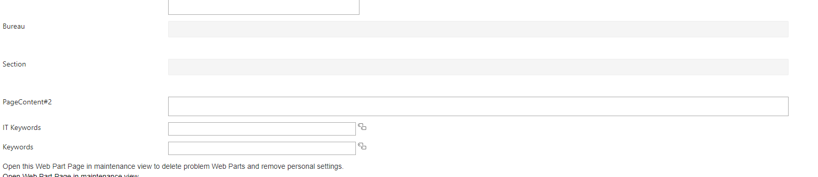

Issues 02/05/2019:

R&D:

How to achieve drift messenger in SharePoint. With chat box.

Study hall issues

1.Page Owner display:

2.Need to display save conflict to the second user or not save.

Machine generated alternative text:
BROWSE 
Save Check In 
Edit 
cut 
Copy 
Paste 
unda - 
Clipboard 
FORMAT TEXT 
Helvetica Neue 
INSERT 
Font 
14 PX 
ower w 
AaBbCcD 
Peregreph 
AaB 
Heeding 1 
AaBbC 
Heading 2 
Stvles 
AaBbCc 
Heading 3 
Heading 4 
ABC 
Spelling 
Spelling 
Edit 
Source 
Employees with knowl 
information to the Secr 
employee from any ret 
Telephone use 
State phone lines, cell 
permitted. The number 
may ultimately revoke t 
The State Telephone S 
access to the system, 
made using a personal 
Postal use 
Paragraph 
Save Conflict 
Sirimalla, Arun K - DOT is editing this page and has made changes which conflict with yours. It is 
recommended that you stop modifying this page until the other user is finished. What would you 
like to do? 
o 
o 
o 
Continue Editing: You will have to manually merge your changes later. 
Merge Changes: Open another window and copy your changes into that window. 
Discard Your Changes: Stop editing this page and delete all your changes. 
Overwrite the Page: Delete the other user's changes and replace them with your own. 
OK 
Select 
Convert to XHTML 
Merkuo 
ule or regulation in g 
uires confidentiality 
rsonal use of state 
it or if this privilege 
all long distance bl 
ance calls. Essentk 
Since the department handles a large volume of mail daily, personal letters should be posted at a public mail box and are not to be included with deF 
metered postage or WisDOT-purchased stamps for personal mail is prohibited. 

3.Remove misspelled term from the keyword metadata column.(done).

Machine generated alternative text:
sites/dot/Pages/ 
Office 365 
https://wgov.sharepon 
SharePoint 
EDIT 
Cut 
Delete 
Paste 
Item 
Clipboard 
Actions 
t. co 
orms/EdltForm.aspx?ID 
x 
BROWSE 
Save Cancel 
Commit 
Select : Kemords 
New items are added under the currently selected item. Add New Item 
Make a request or send feedback to the Term Set manager. Send Feedback 
mployee Handbook 
mpoayee Assistance Program 
Equal Employment Opportunities 
Hide physical URLs from search 
IT Keywords 
Keywords 
Open this Web Part Page in maintenance view to 
Open Web Part Page in maintenance view 
Version: 0.9 
Created at 1/24/2019 2:19 PM by 
Sobotik, Shwuli - 
Last modified at 2/5/2019 1:49 PM by 
Sirimalla, Arun 
ergonomics 
Flexible Spending 
€2 FMLA 
Health 
Health Savings 
Holiday 
Org structure 
€2 SAMP E 
Select > > 
Employee Handbook' conduct' Empooyee Assistance Program 
OK 
Cancel 

1. Extra space in the top from the pagecontent #2 and also see extra space b/w each field.

​Code of Ethics, Personal Conduct and Additional Employee Responsibilities

|  |
| --- |
| ​**Overview of Code of Ethics** |
| ​ |

|  |
| --- |
| **​Conflicts of Interest** |
| ​ |

Machine generated alternative text:
BROWSE 
Office 365 
PAGE 
PUBLISH 
SharePoint 
FORMAT TEXT 
INSERT 
TABLE LAYOUT 
36px 
DESIGN 
SHARE 
Helvetica Neue 
Copy 
undo 
Clipboard 
BbCcD 
Paragraph 
AaB 
Heading 1 
AaBbC 
Heading 2 
Styles 
AaBbCc 
Heading 3 
Save Check In 
Edit 
Heading 4 
ABC 
Spelling 
Spelling 
Edit 
Source 
Font 
Convert to XHTML 
Markup 
Paragraph 
Facilities • 
Working at WisDOT • 
Information Technology (IT) • 
Handbook-EAP 
Checked out to you Only you can see your recent changes. Check it in. 
Organization • 
News and Learning • 
Forms and Documents 
Page Content 
Introduction 
Letter from the Secretary 
Organization Structure 
Work Rules 
Code of Ethics, Personal 
conduct, and additional 
employee Responsibilities 
Work Schedules and Hours 
of Work 
Payroll & Benefits 
Medical Information & FMLA 
PageContent#2 
Employee Assistance Program 
Overview of EAP 
The Wisconsin Department of Transportation recognizes that employees live and work in a complex, fast-paced environment. To help m 
adversely affect employees, the department provides Employee Assistance Program (EAP) services to employees and their family mem 
Search . 
Sope for Business 
sands, Lori - DOT 
37:30 
FOLLOW 
hat can 
WisDOT utilizes the State of Wisconsin's contract with FEI to provide employee assistance. FEI is an external EAP vendor which provides 24/7 coverage so all employees have reasonable 
access to services. FEI contact information 1-866-274-4723 www.feieap.com username: SOWI 

1. Aligned text overlapping with masterpage css.

Machine generated alternative text:
https://wigov.sharepoint.com/sites/dot/Pages/Worki ngAtWi sDOT/Ha nd boo k- H u ma n.aspx 
BROWSE 
Office 365 
PAGE 
PUBLISH 
SharePoint 
FORMAT TEXT 
INSERT 
Helvetica Neue 
14px 
Copy 
undo 
Clipboard 
BbCcD 
Paragraph 
AaB 
Heading 1 
AaBbC 
Heading 2 
Styles 
AaBbCc 
Heading 3 
Save Check In 
Edit 
Heading 4 
ABC 
Spelling 
Spelling 
Edit 
Source 
Font 
Paragraph 
Convert to ) 
Markup 
probationary period gives a supervisor an opportunity to review an employee's work and gives the employee to become familiar with the r 
valuations of an employee's work and discuss the performance with the employee one or more times during the probationary period and a 
uring probation determines whether or not he/she will be granted permanent status. If the employee's performance is not satisfactory durir 
xtended or the employee may be dismissed without right of appeal. 
For positions included in the Career Executive program, the probationary period is referred to as a two-year career executive trial period. 
Personnell File 
personnel file (P-File) is maintained by Human Resources for the duration of an employee's employment in state service. Exal 
appointment letters, reclassifications, position descriptions, changes in classifications and pa rates, erformance evaluations, d 
official P-File is maintained b Human Resrouces and is housed electronicall in Peo lesoft. 
ccess to P-files is restricted according to state law and administrative code. If an employee wishes to look through their own P-file, they st 
Resources team. 
Employee Development and Training 
he department offers a variety of job-related and career development training. The department encourages all employees to supplement a 
evelopment skills, knowledge and abilities. The department's WisDOT LearnCenter is available to all employees and serves as the trainiru 
isDOT LearnCenter is used by employees to register for training or participate in online computer-based training courses. In addition, the 
anscripts. 
For more information about the department's policies on training, including career development plans and tuition reimbursement, please sel 
Moving Expenses 
he department may provide moving expenses under Section 20.917 of the Wisconsin State Statutes and the Compensation Plan. Moving 
ere the appointing authority requires the employee to change residence location because the employee: 

1. Need add hyperlink to the text from the TAM(from internal link to the text) need to add the images from the sharepoint library.( told to check with Mike)

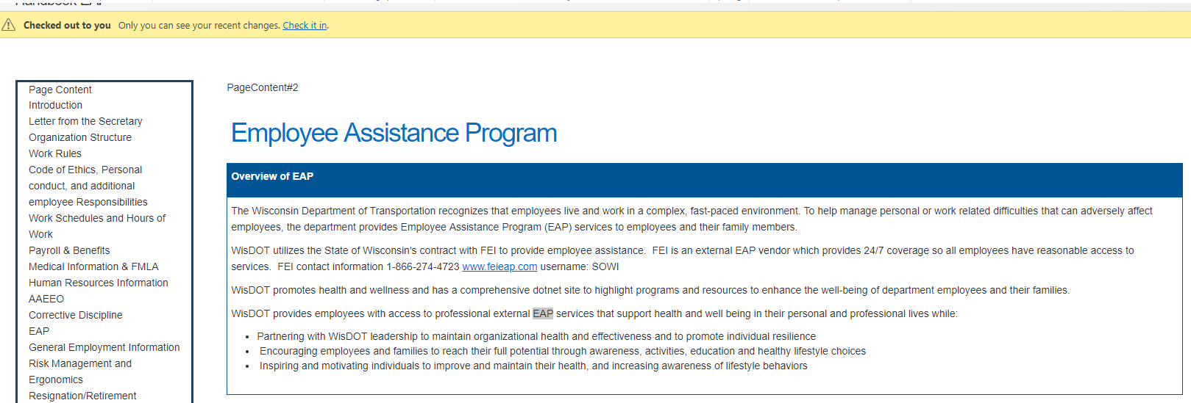

7.

----------------------------------------\

1.There is # in the URL.

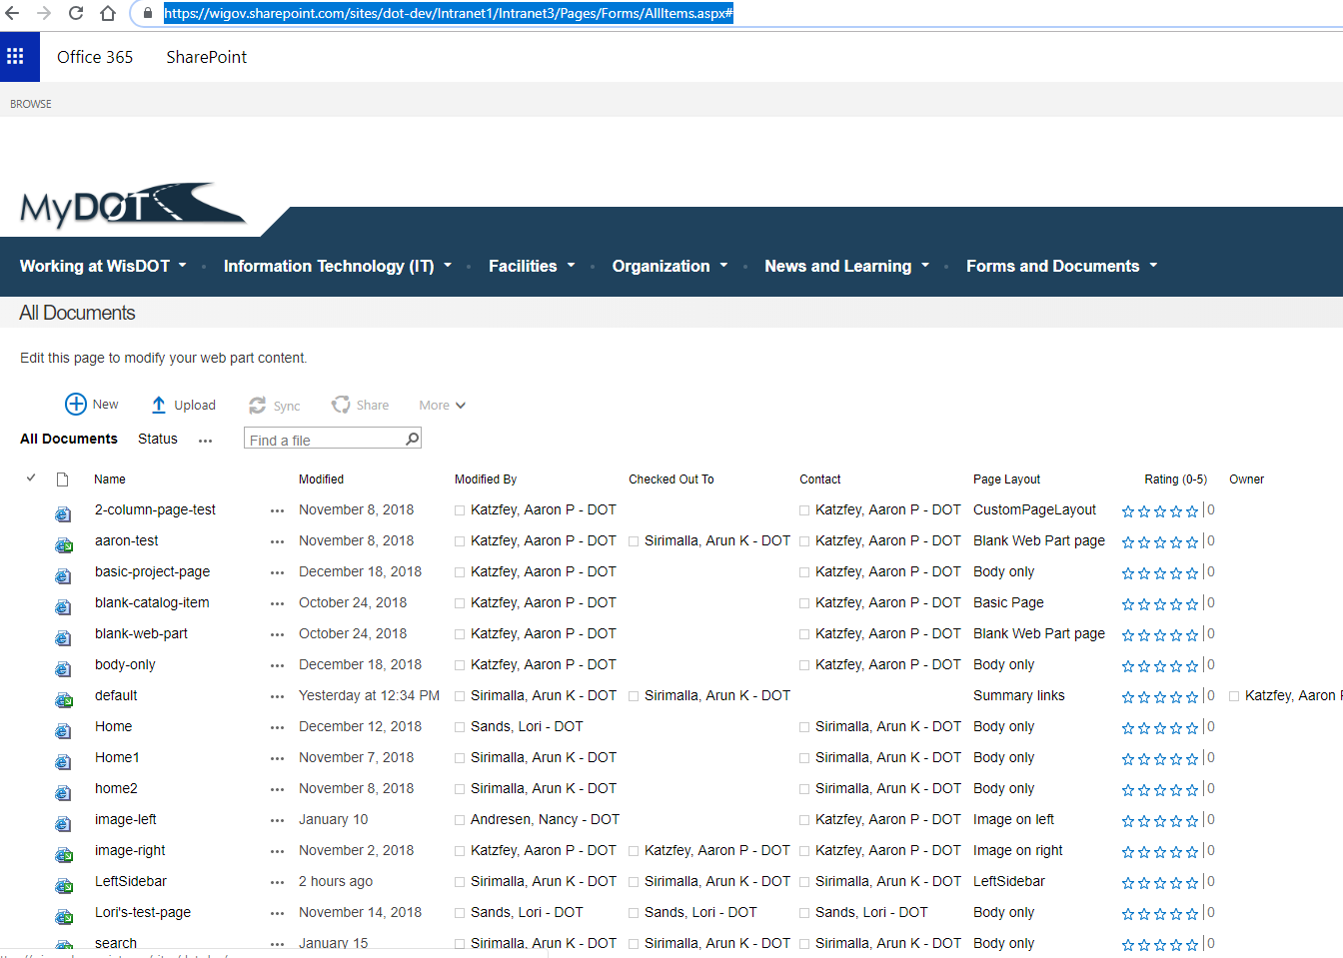

[https://wigov.sharepoint.com/sites/dot-dev/Intranet1/Intranet3/Pages/Forms/AllItems.aspx#](https://wigov.sharepoint.com/sites/dot-dev/Intranet1/Intranet3/Pages/Forms/AllItems.aspx)

2.Close button is not showing up for the list.

3.size of search box in IE should increase. 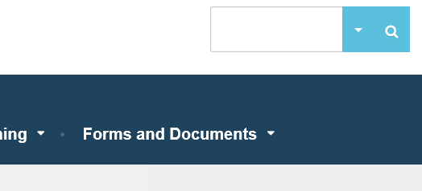

4.

Issue with the content editor webparts on both sides.

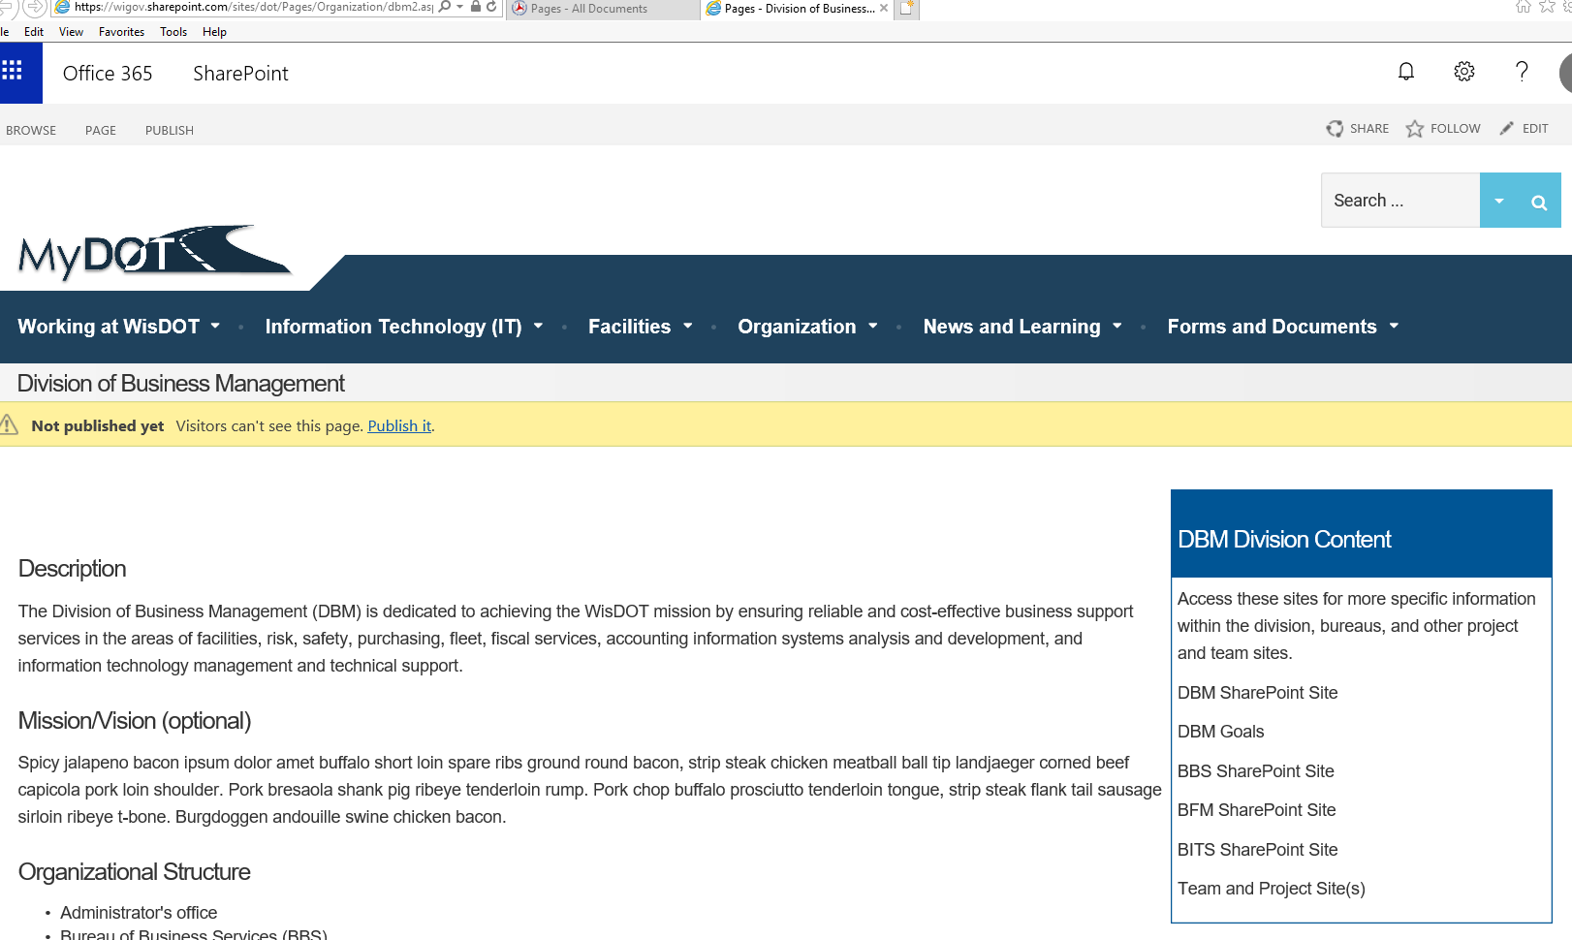

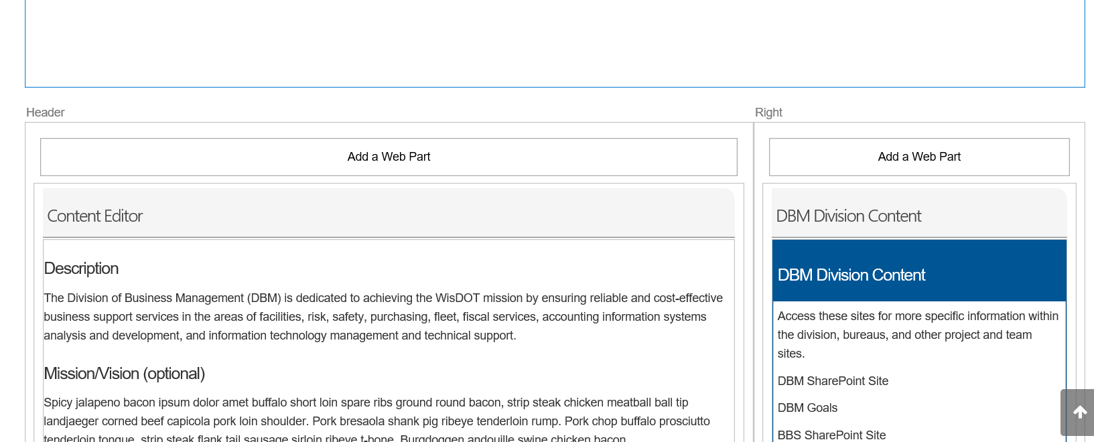

Description

The Division of Business Management (DBM) is dedicated to achieving the WisDOT mission by ensuring reliable and cost-effective business support services in the areas of facilities, risk, safety, purchasing, fleet, fiscal services, accounting information systems analysis and development, and information technology management and technical support.

Mission/Vision (optional)

Spicy jalapeno bacon ipsum dolor amet buffalo short loin spare ribs ground round bacon, strip steak chicken meatball ball tip landjaeger corned beef capicola pork loin shoulder. Pork bresaola shank pig ribeye tenderloin rump. Pork chop buffalo prosciutto tenderloin tongue, strip steak flank tail sausage sirloin ribeye t-bone. Burgdoggen andouille swine chicken bacon.

Organizational Structure

* Administrator's office
* Bureau of Business Services (BBS)
* Bureau of Financial Management (BFM)
* Bureau of Information Technology Services (BITS)

​Contacts

* Interim administrator: Mitchel Warren
* Deputy administrator: Greg Gasper
* Executive assistant: Gayle Straw

Location

Message from the Administrator (optional)

Pork chop buffalo prosciutto tenderloin tongue, strip steak flank tail sausage sirloin ribeye t-bone. Burgdoggen andouille swine chicken bacon.

​

|  |
| --- |
| ​DBM Division Content |
| ​Access these sites for more specific information within the division, bureaus, and other project and team sites.  DBM SharePoint Site  DBM Goals  BBS SharePoint Site  BFM SharePoint Site  BITS SharePoint Site  Team and Project Site(s) |

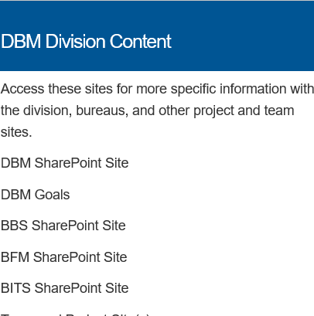

<https://wigov.sharepoint.com/sites/dot-dev/Intranet1/Intranet3/Intranet%20Sites/Forms/AllItems.aspx>

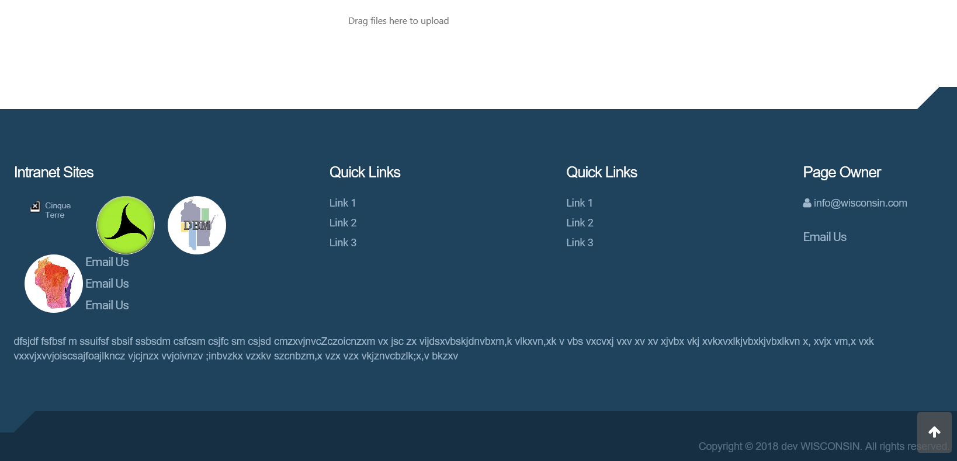

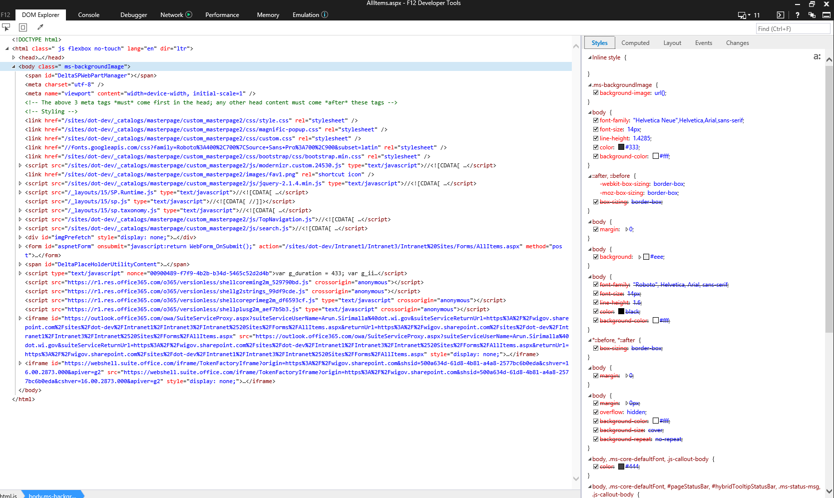

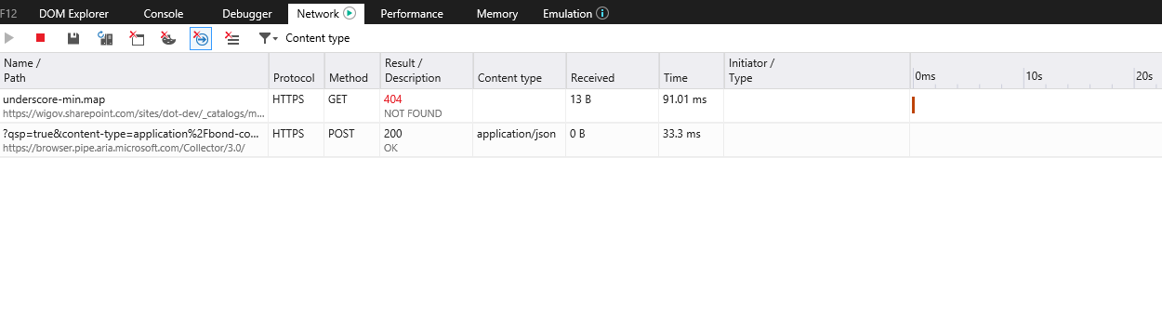

<https://wigov.sharepoint.com/sites/dot-dev/Intranet1/Intranet3/Lists/Quick%20Links/AllItems.aspx>

<https://wigov.sharepoint.com/sites/dot-dev/Intranet1/Intranet3/Lists/Quick%20Links/AllItems.aspx#InplviewHash52bccb82-09cf-45c1-968f-778e773798ca=SortField%3DLinkTitle-SortDir%3DAsc>

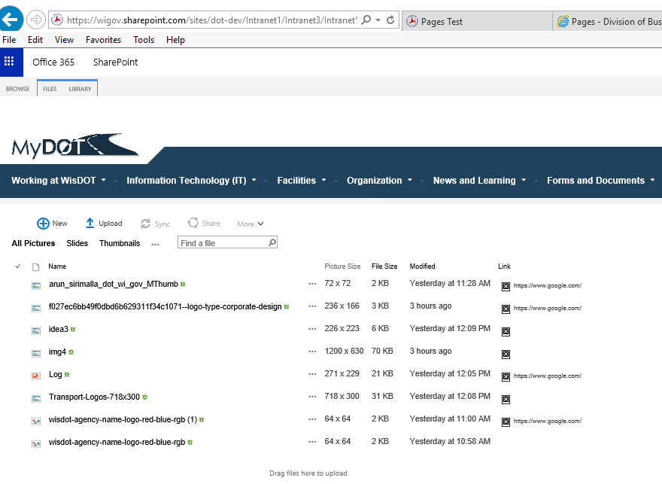

<https://wigov.sharepoint.com/sites/dot-dev/Intranet1/Intranet3/Lists/Quick%20Links/AllItems.aspx#InplviewHash52bccb82-09cf-45c1-968f-778e773798ca=SortField%3DLinkTitle-SortDir%3DAsc>

<https://wigov.sharepoint.com/sites/dot-dev/Intranet1/Intranet3/Intranet%20Sites/Forms/AllItems.aspx#InplviewHash2589b9f6-afa4-4235-b089-8c6881454f4b=SortField%3DLink-SortDir%3DAsc>

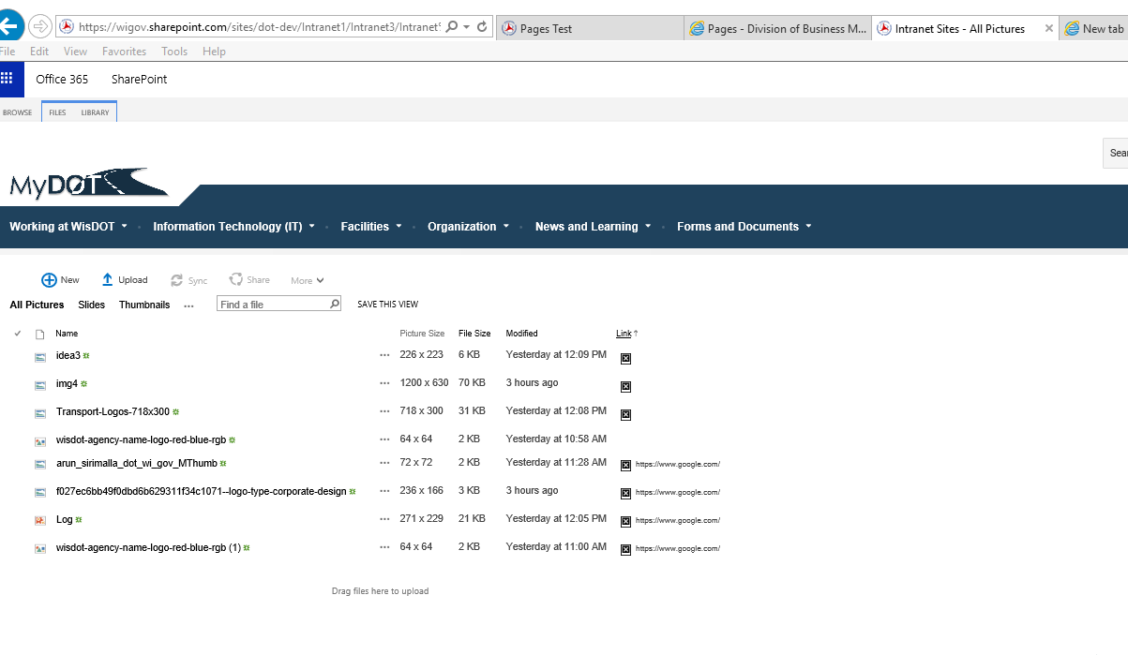

02/11/2019

1.Issue with loading the script.

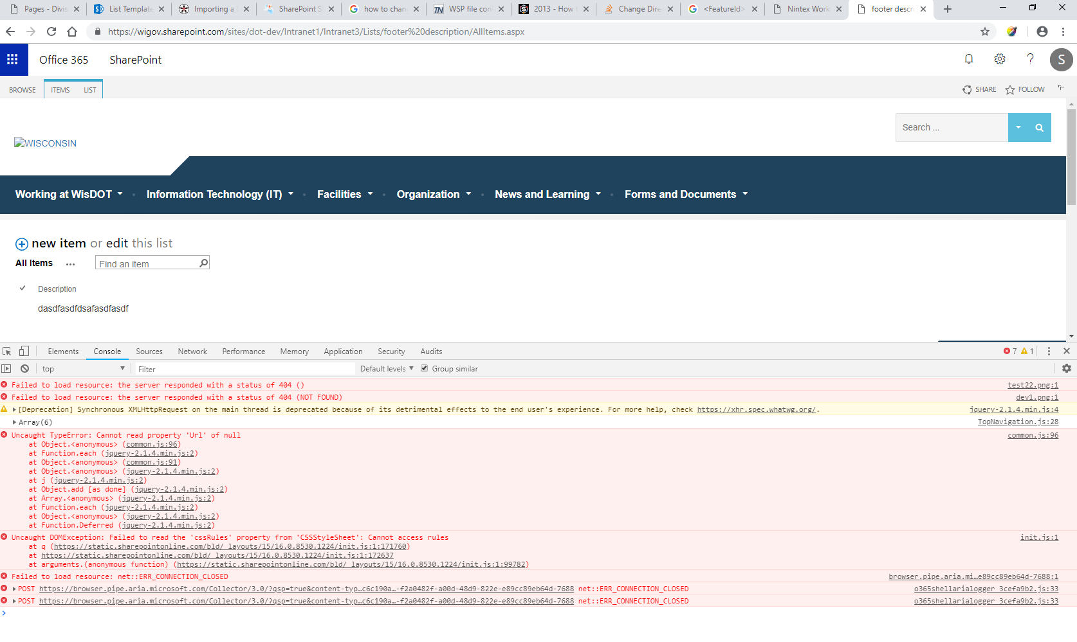

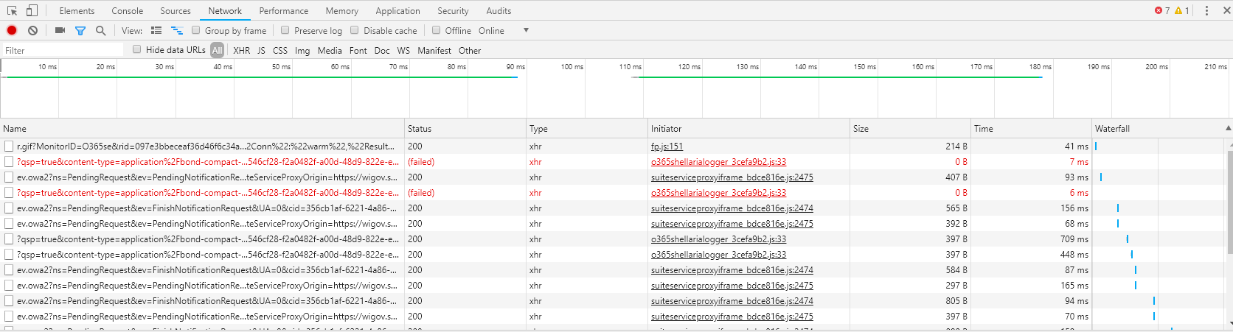

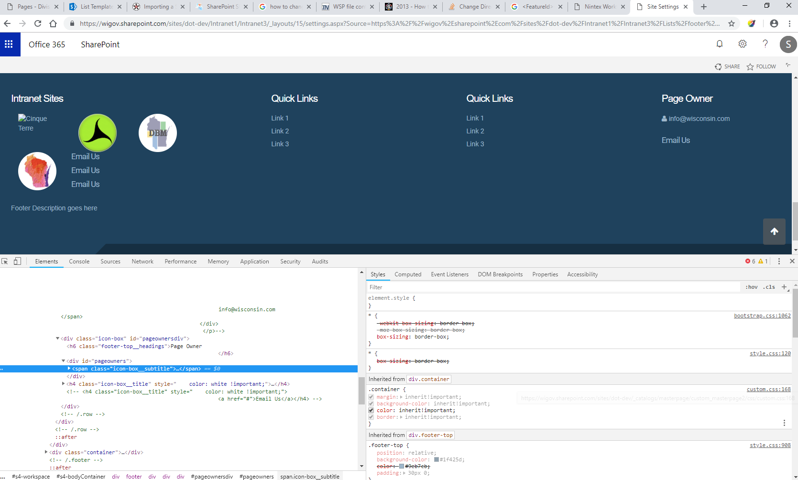

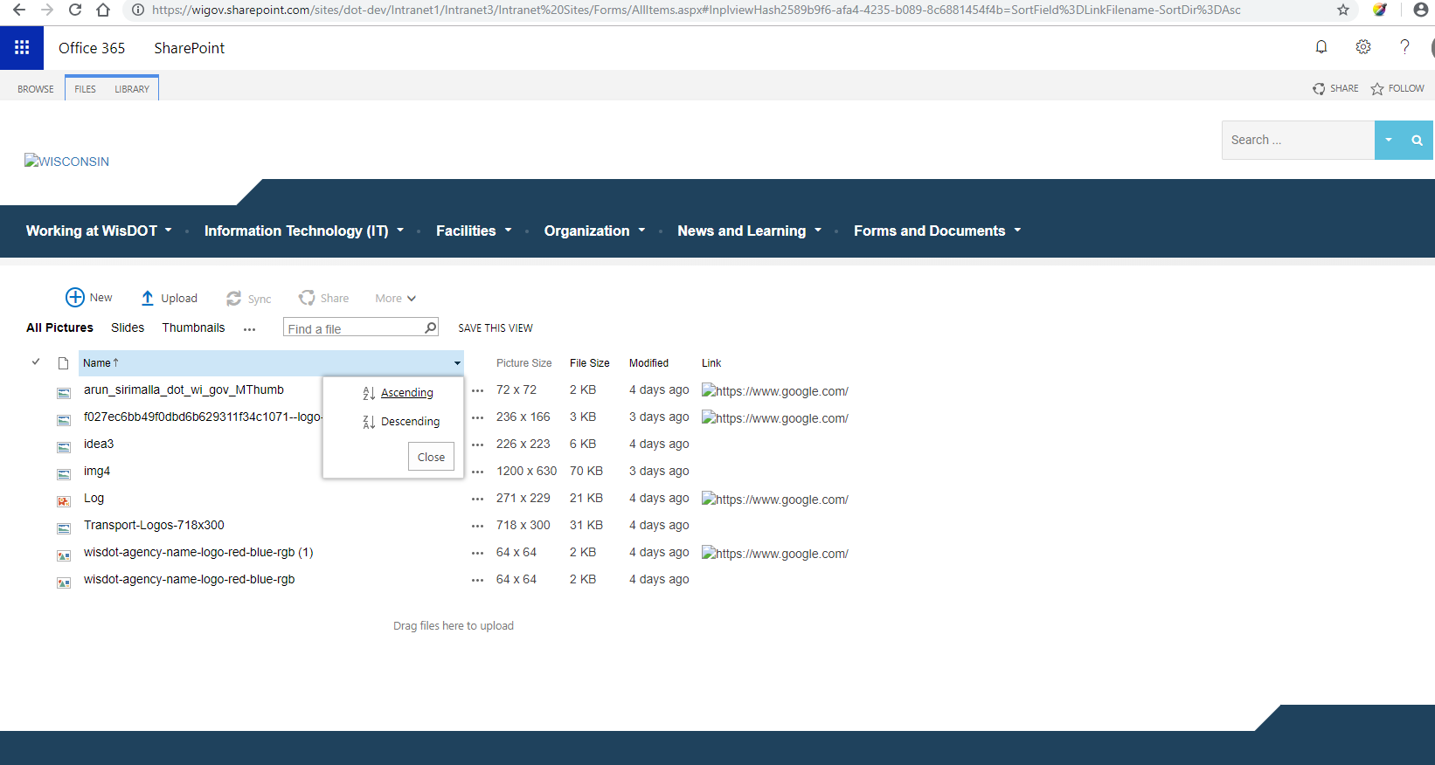

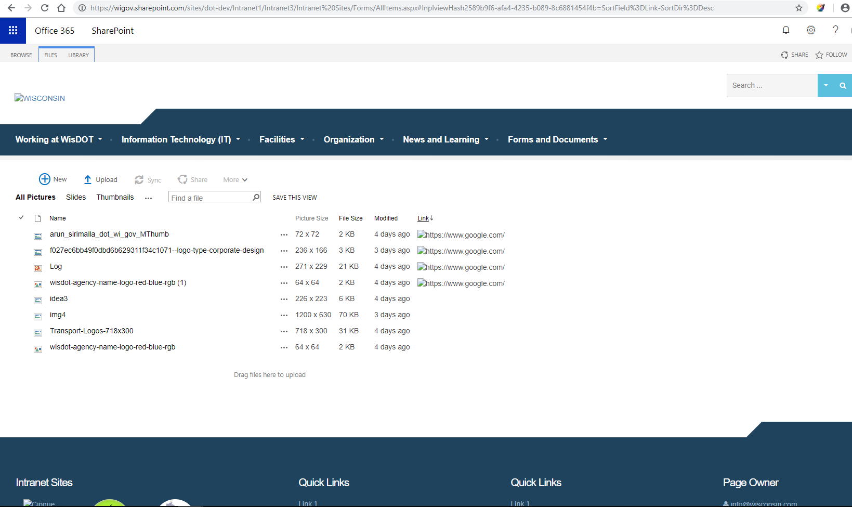

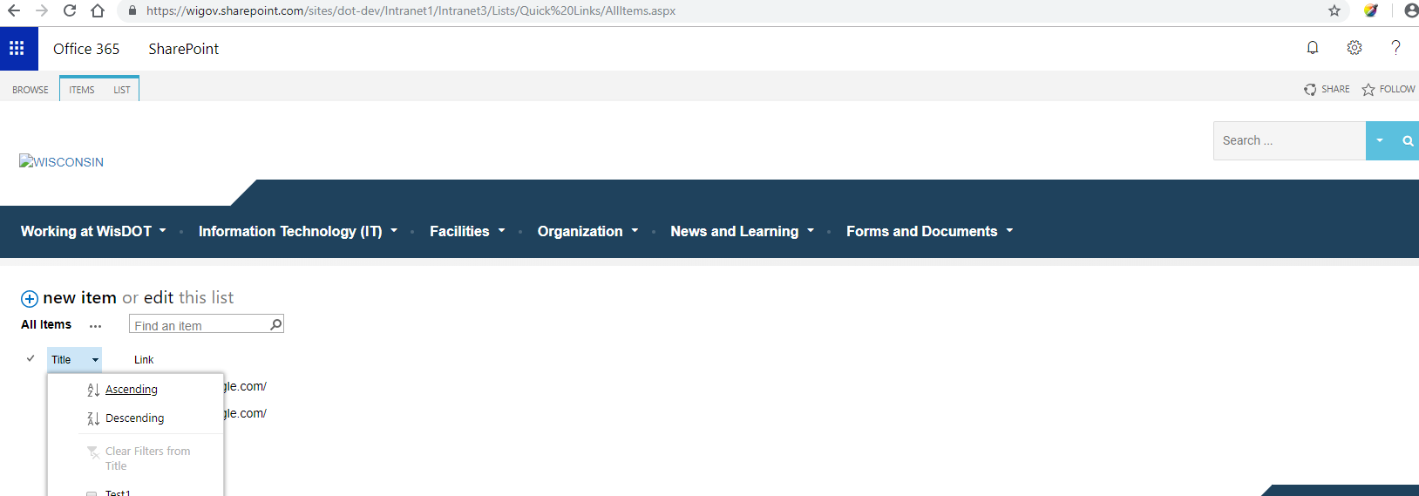

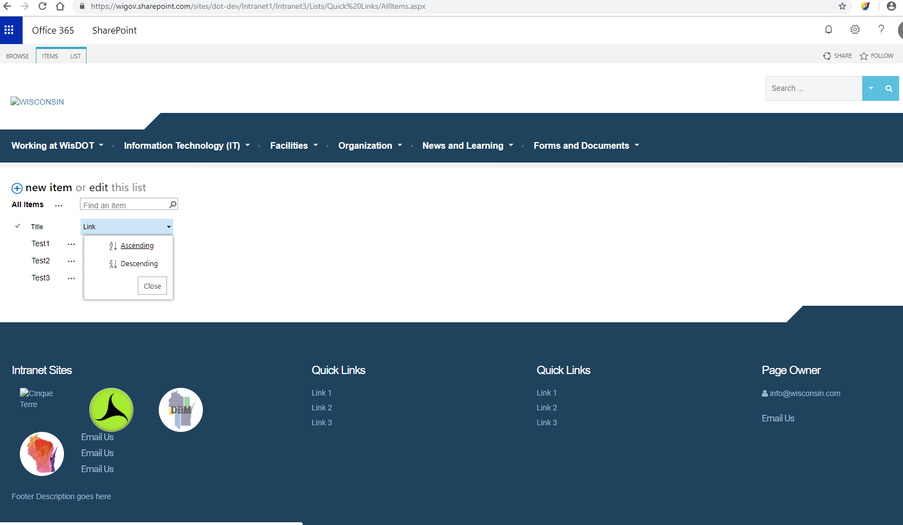

Workflow:

Update list item.



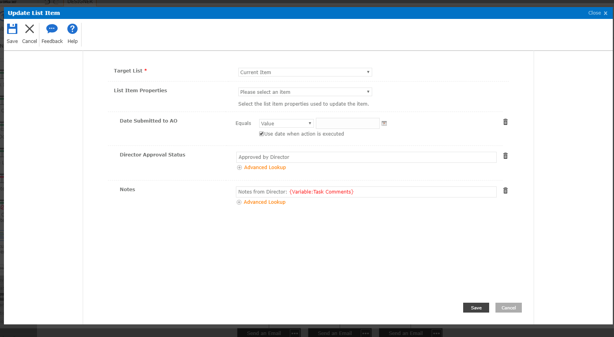

Var is like

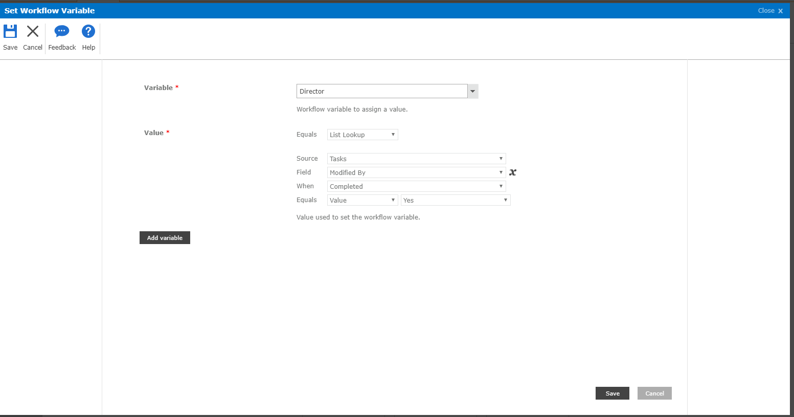

Check out put in SS.

CSS:

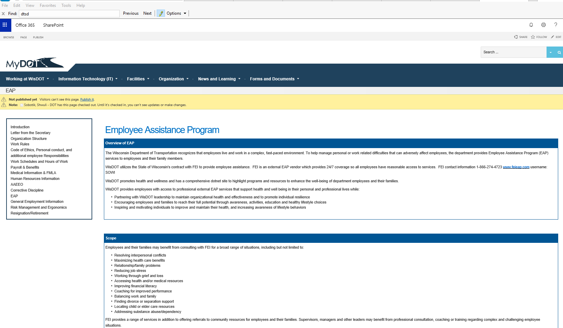

Still shows extra spaces b.w

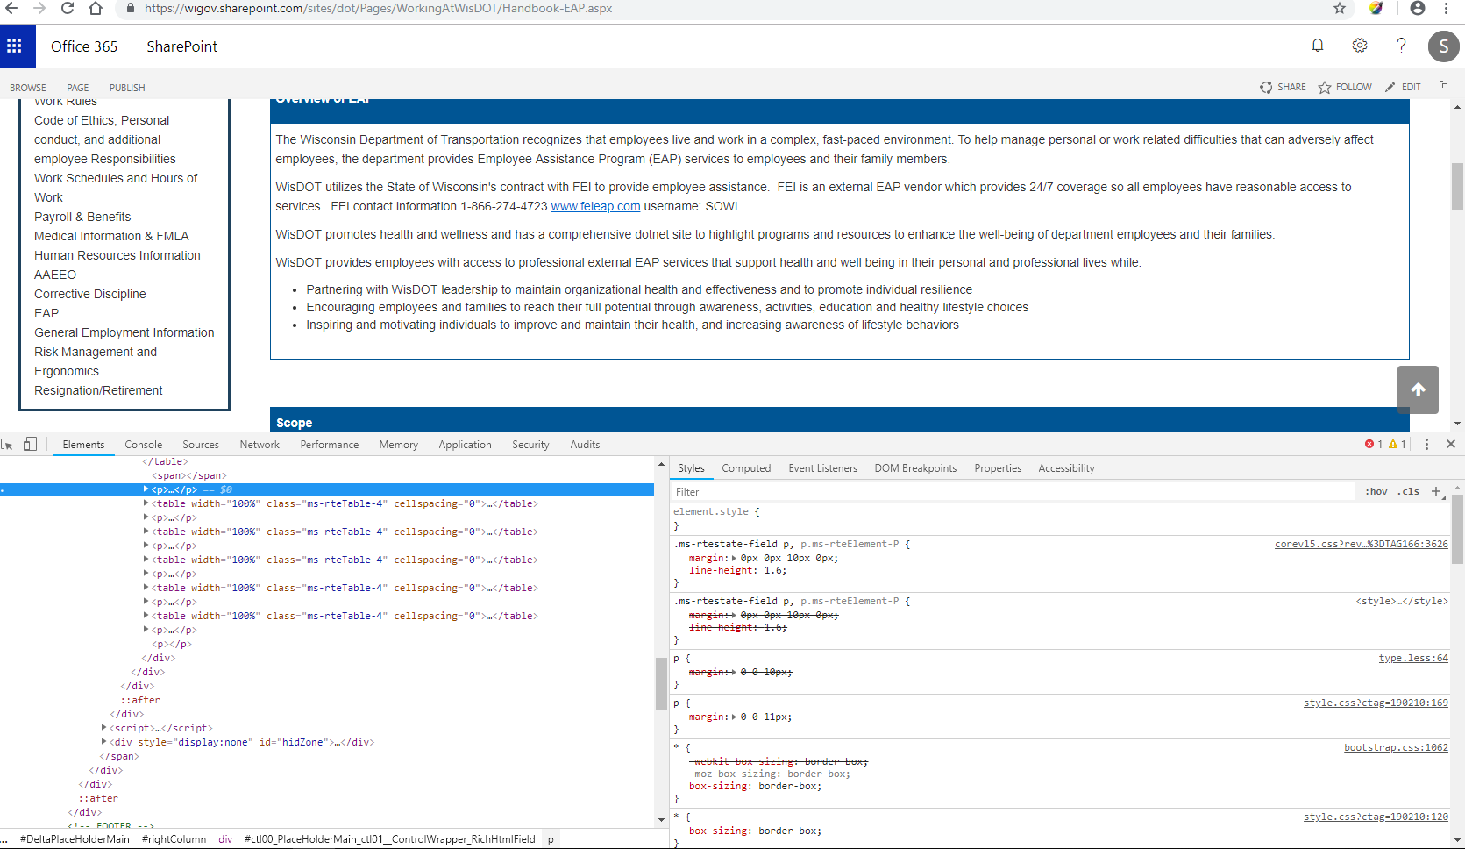

-000000000000000000000000000

I have notice there's some updates on "Assign task to Dir" so, Director variable has set to value of the person who

Modified the task when status completed. Is anything else to work on this task?

Please do let me know if I miss anything.

Machine generated alternative text:
Approved 
Set Workflow 
Variable 
Assign a task to Dir 
o 
Rejected 
Set Workflow 
Variable 
Send bac... 
Set Workflow 
Variable 

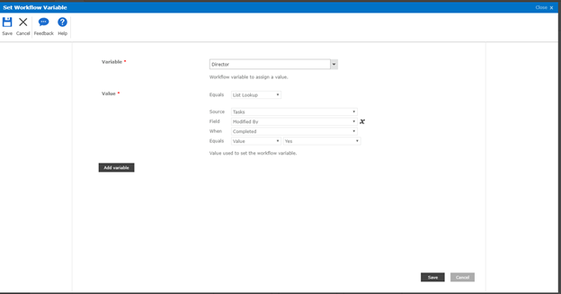

Machine generated alternative text:
ate Approved by Sec Office 
Notes 
View 
Entries 
View 
Entries 
View 
Entries 
View 
Entries 
Submitter 
Jordan, Michael J 
- DOT 
Section Chief Approval Status 
Rejected by Katzfey, 
Aaron P - DOT 
Approved by Kessenich, 
Michael J - DOT 
Approved by Jordan, 
Michael J - DOT 
Approved by Sirimalla, 
Arun K - DOT 
Director Approval Status 
Approved by Director 
Approved by Director 
CurrentStatus 
Returned 
Kessenich, Michael J - DOT 
AO Approval Status 
Approved by AO 
Katzfey, Aaron P 
Jordan, Michael J 
- DOT 
- DOT 
RTF Process 
Rejected 
by Katzfey, 
Aaron P 
DOT 
Approved 
by AO 
Approved 
by 
Director 
Approved 
by 
Sirimalla, 
Arun K 
DOT 

.ms-rtestate-field p{

margin:0px!important;

}

