|  |
| --- |
| #Load SharePoint CSOM Assemblies  Add-Type -Path "C:\Program Files\Common Files\Microsoft Shared\Web Server Extensions\16\ISAPI\Microsoft.SharePoint.Client.dll"  Add-Type -Path "C:\Program Files\Common Files\Microsoft Shared\Web Server Extensions\16\ISAPI\Microsoft.SharePoint.Client.Runtime.dll"  Add-Type -Path "C:\Program Files\Common Files\Microsoft Shared\Web Server Extensions\16\ISAPI\Microsoft.SharePoint.Client.Taxonomy.dll"    #Variables for Processing  $AdminURL = "https://crescent-admin.sharepoint.com/"  $TermGroupName = "Regions"  $TermSetName = "East Africa"  $CSVFile="C:\Temp\TermSetData.csv"    Try {      #Get Credentials to connect      $Cred = Get-Credential      $Credentials = New-Object Microsoft.SharePoint.Client.SharePointOnlineCredentials($Cred.Username, $Cred.Password)        #Setup the context      $Ctx = New-Object Microsoft.SharePoint.Client.ClientContext($AdminURL)      $Ctx.Credentials = $Credentials        #Get the term store      $TaxonomySession=[Microsoft.SharePoint.Client.Taxonomy.TaxonomySession]::GetTaxonomySession($Ctx)      $TermStore =$TaxonomySession.GetDefaultSiteCollectionTermStore()      $Ctx.Load($TaxonomySession)      $Ctx.Load($TermStore)      $Ctx.ExecuteQuery()        #Get the Term Group      $TermGroup=$TermStore.Groups.GetByName($TermGroupName)        #Get the term set      $TermSet = $TermGroup.TermSets.GetByName($TermSetName)        #Get all tersm from the term set      $Terms = $TermSet.Terms      $Ctx.Load($Terms)      $Ctx.ExecuteQuery()        Write-Output $TermsetName > $CSVFile      #Export Terms to CSV      Foreach($Term in $Terms)      {          Write-Output $Term.Name >> $CSVFile      }      Write-host "Term Set Data Exported Successfully!" -ForegroundColor Green  }  Catch {      write-host -f Red "Error Exporting Term Set!" $_.Exception.Message  } |

This script extract each term in the given term set into a CSV file. But wait! each term can go up to 7 levels deep! While the above script exports terms at one-single level, Here is my another PowerShell script to export terms and child terms of all levels of a given term set.

[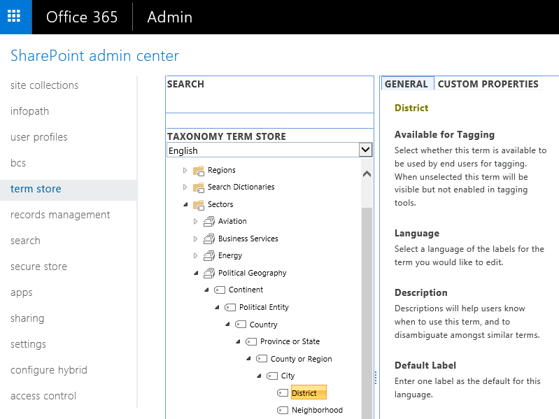](https://2.bp.blogspot.com/-WDWmBK19ZQU/WjAl3dbgWGI/AAAAAAAANhs/HFLS0a8XL2Ue-_hKDkmJqRsFT1BMtjyOwCLcBGAs/s1600/SharePoint%2BOnline%2BExport%2BTerm%2BSet.png)

**Export Term Set in SharePoint Online using PowerShell:**

|  |  |
| --- | --- |
| 1  2  3  4  5  6  7  8  9  10  11  12  13  14  15  16  17  18  19  20  21  22  23  24  25  26  27  28  29  30  31  32  33  34  35  36  37  38  39  40  41  42  43  44  45  46  47  48  49  50  51  52  53  54  55  56  57  58  59  60  61  62  63  64  65  66  67  68  69  70  71  72  73  74  75  76  77  78  79  80  81  82  83  84  85  86  87  88  89  90  91  92 | #Load SharePoint CSOM Assemblies  Add-Type -Path "C:\Program Files\Common Files\Microsoft Shared\Web Server Extensions\16\ISAPI\Microsoft.SharePoint.Client.dll"  Add-Type -Path "C:\Program Files\Common Files\Microsoft Shared\Web Server Extensions\16\ISAPI\Microsoft.SharePoint.Client.Runtime.dll"  Add-Type -Path "C:\Program Files\Common Files\Microsoft Shared\Web Server Extensions\16\ISAPI\Microsoft.SharePoint.Client.Taxonomy.dll"    #Variables for Processing  $AdminURL = "https://crescent-admin.sharepoint.com/"  $TermGroupName = "Sectors"  $TermSetName = "Political Geography"  $CSVFile="C:\Temp\TermSet.csv"    #Custom Function get child terms of a given term  Function Get-Terms([Microsoft.SharePoint.Client.Taxonomy.Term] $Term,[String]$ParentTerm,[int] $Level)  {    $ChildTerms = $Term.Terms    $Ctx.Load($ChildTerms)    $Ctx.ExecuteQuery()    if($ParentTerm)    {      $ParentTerm = $ParentTerm + "," + $Term.Name    }    else    {      $ParentTerm = $Term.Name    }      Foreach ($SubTerm in $ChildTerms)    {       $Level = $Level + 1       #Terms may have upto 7 levels       $NumofCommas =  7 - $Level       $commas =""         #Append Commas       For ($j=0; $j -lt $NumofCommas; $j++)       {          $Commas = $Commas + ","       }        #Append the Output to CSV File      "," + "," + "," + $Term.IsAvailableForTagging + ",""$($Term.Description)""," + $ParentTerm + "," + $SubTerm.Name + $Commas >> $CSVFile        #Call the function recursively      Get-Terms -Term $SubTerm -ParentTerm $ParentTerm -Level $Level    }  }  Try {      #Get Credentials to connect      $Cred = Get-Credential      $Credentials = New-Object Microsoft.SharePoint.Client.SharePointOnlineCredentials($Cred.Username, $Cred.Password)        #Setup the context      $Ctx = New-Object Microsoft.SharePoint.Client.ClientContext($AdminURL)      $Ctx.Credentials = $Credentials        #Get the term store      $TaxonomySession=[Microsoft.SharePoint.Client.Taxonomy.TaxonomySession]::GetTaxonomySession($Ctx)      $TermStore =$TaxonomySession.GetDefaultSiteCollectionTermStore()      $Ctx.Load($TaxonomySession)      $Ctx.Load($TermStore)      $Ctx.ExecuteQuery()        #Write Termset CSV Header (As in the standard format)      "Term Set Name,Term Set Description,LCID,Available for Tagging,Term Description,Level 1 Term,Level 2 Term,Level 3 Term,Level 4 Term,Level 5 Term,Level 6 Term,Level 7 Term" > $CSVFile        #Get the Term Group      $TermGroup=$TermStore.Groups.GetByName($TermGroupName)        #Get the term set      $TermSet = $TermGroup.TermSets.GetByName($TermSetName)      $Ctx.Load($Termset)      $Ctx.ExecuteQuery()        #Get all tersm from the term set      $Terms = $TermSet.Terms      $Ctx.Load($Terms)      $Ctx.ExecuteQuery()        #Write 2nd line as Termset properties(As per standard format)      $TermSet.Name + ",""$($TermSet.Description)""," + $TermStore.DefaultLanguage + "," + $TermSet.IsAvailableForTagging + ",""$($Terms[0].Description)""," + $Terms[0].Name + "," + "," + "," + "," + "," + "," >> $CSVFile        #Process each Term in the termset      Foreach($Term in $Terms)      {          write-host $Term.Name          Get-Terms $Term -Level 1 -ParentTerm ""      }      Write-host "Term Set Data Exported Successfully!" -ForegroundColor Green  }  Catch {      write-host -f Red "Error Exporting Term Set!" $_.Exception.Message  } |

#Read more: <http://www.sharepointdiary.com/2016/12/sharepoint-online-powershell-to-export-term-set-to-csv.html#ixzz5hPPjmfCd>