Hesse,Debra R issue.

I open my SharePoint spreadsheet and click on the open in Excel - Open in Excel 2016 - and Excel opens.  I edit the document and get errors that it is locked for editing by another user.  Debra Hesse which is me and I cannot save my work.  Attached are the screen shots.  This is two days in a row that it has done this to me.



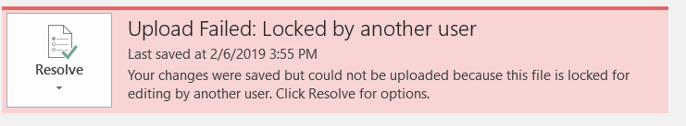

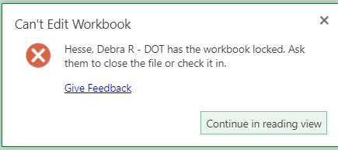



Trouble shooting done:

1. Cleared office cache.

<https://social.technet.microsoft.com/Forums/en-US/032265e1-8cb3-47e7-806d-655082e4b589/upload-failed-this-file-is-locked-for-editing?forum=sharepointgeneral>

<https://answers.microsoft.com/en-us/msoffice/forum/all/upload-failed-locked-by-another-user-for-document/d0af9be9-d4d2-4888-be35-5949e519c9c7>

<https://sharepoint.stackexchange.com/questions/42999/clearing-short-term-file-lock>

<http://kennekro.net/2017/12/file-is-locked-for-shared-use-by-user/>

<https://veenstra.me.uk/2018/06/19/sharepoint-online-the-file-document-docx-is-locked-for-shared-use-by-usernametenant-onmicrosof/>

<http://robertgreiner.com/2014/12/fixing-pending-upload-issues-with-microsoft-office-upload-center/>

Lets see this after you go home

Need to be done by DET:

Resolution:

Let’s focus on other tasks now

Ok

Connect-SPOService

Get-SPOSite

Add-PSSnapin microsoft.sharepoint.powershell

$web = get-spweb "https://i81.sharepoint.com/sites/ilab"

$list = $web.Lists["Documents"]

$item = $list.Items.GetItemById("Document")

$item.File.ReleaseLock($item.File.LockId)

$web.Dispose()

Connect-SPOService

Get-SPOSite

Add-PSSnapin microsoft.sharepoint.powershell

$web = Get-SPOSite "https://i81.sharepoint.com/sites/ilab"

$list = $web.Lists["Shared%20Documents"]

$item = $list.Items.GetItemById("Document")

$item.File.ReleaseLock($item.File.LockId)

$web.Dispose()