1. Unable to open Word doc (in Word)

<https://wigov.sharepoint.com/sites/dot-dbm/bits/is/sdam/Shared%20Documents/Weekly%20DMV%20Review/Issue-Brief-Genesys-CCA-CARES.docx?d=w35f47ff214d045a3876589b76c66da6a>

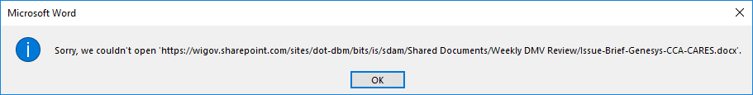

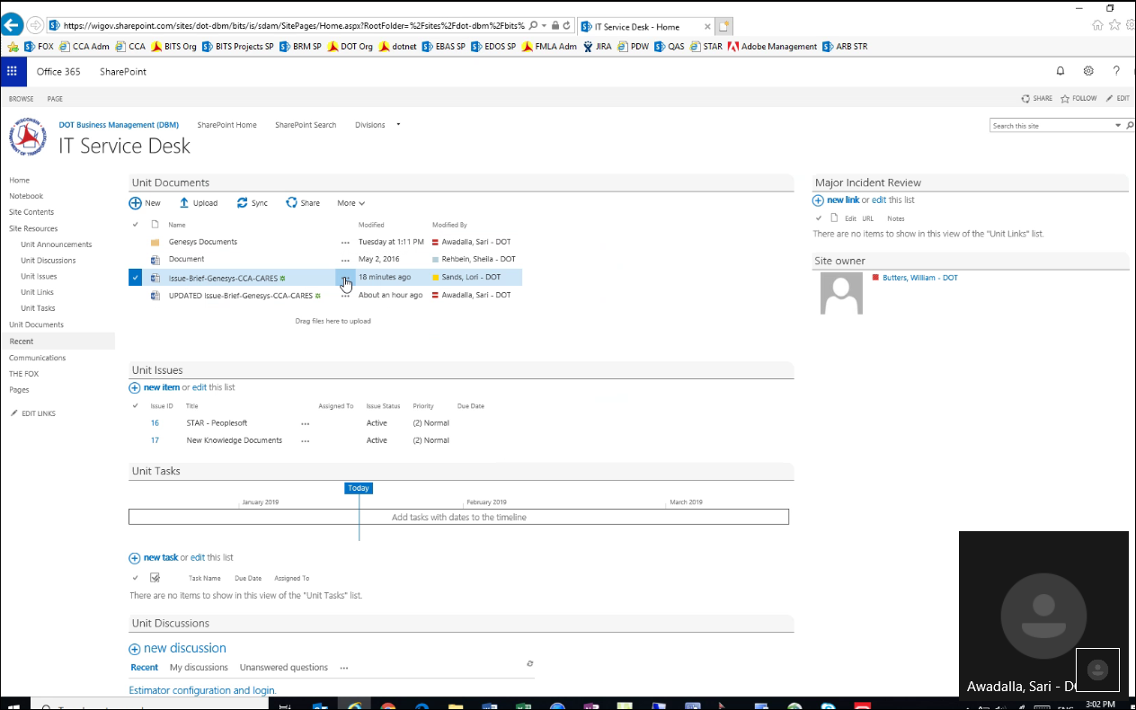

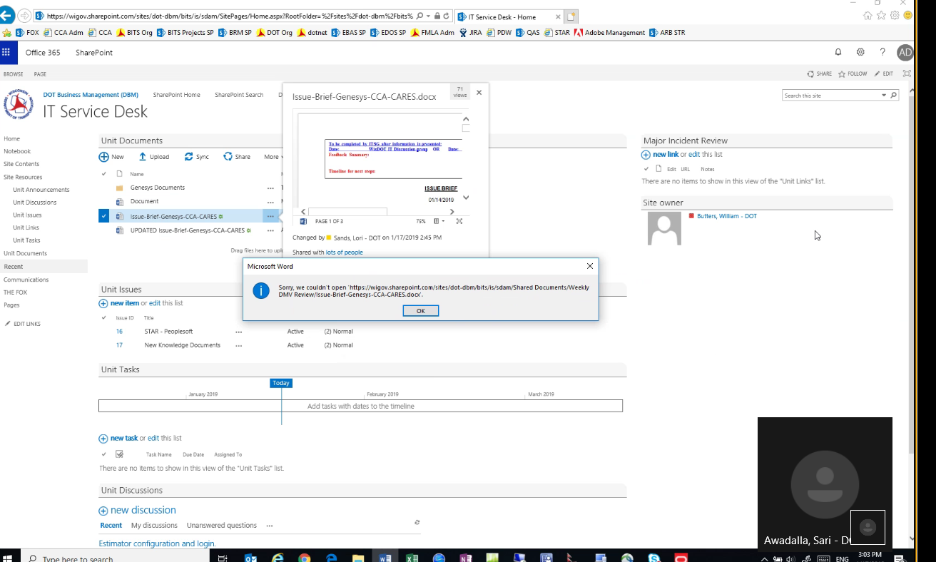

|  |  |
| --- | --- |
| Incident 2007427  SharePoint Issue - Report Incident  was assigned to team DOT SharePoint Services | |
| Open [Incident 2007427](CherwellClient://commands/goto?rectype=Incident&PublicID=2007427)  in Rich Client.    Open [Incident 2007427](https://cherwell.enterprise.wistate.us/CherwellClient/Access/Command/Queries.GoToRecord?BusObID=Incident&PublicID=2007427)  in Browser Client. | |
| Ticket ID : | Incident 2007427 |
| Status : | New |
| Priority : | 3 (Single User / Average) |
| Title : | SharePoint Issue - Report Incident |
| Description : | Unable to open Word doc (in Word)    <https://wigov.sharepoint.com/sites/dot-dbm/bits/is/sdam/Shared%20Documents/Weekly%20DMV%20Review/Issue-Brief-Genesys-CCA-CARES.docx?d=w35f47ff214d045a3876589b76c66da6a>    cid:image002.png@01D4AE74.C3782FA0 |
| Primary Contact : | Awadalla, Sari - DOT  [Sari2.Awadalla@dot.wi.gov](mailto:Sari2.Awadalla@dot.wi.gov)  608 264-7707 |
| Service Recipient : | Awadalla, Sari - DOT |
| Location : |  |
| Owned By : | DOT  DOT SharePoint Services  < Ticket Not Assigned > |
| Classification : | Web Content, SharePoint Issue, Report Incident |
| Primary CI : |  |
| External Ref ID : |  |
| SLA : | DOT Default      Respond By: 2019-01-18T11:38:00      Resolve By: 2019-01-25T13:37:11 |

Specifics - DOT Default Incident

|  |  |
| --- | --- |
| todo - format specifics info. |  |
|  |  |
|  |  |
|  |  |
|  |  |
|  |  |
|  |  |
|  |  |
|  |  |
|  |  |

Troubleshooting steps:

1.unchecked protected view as below

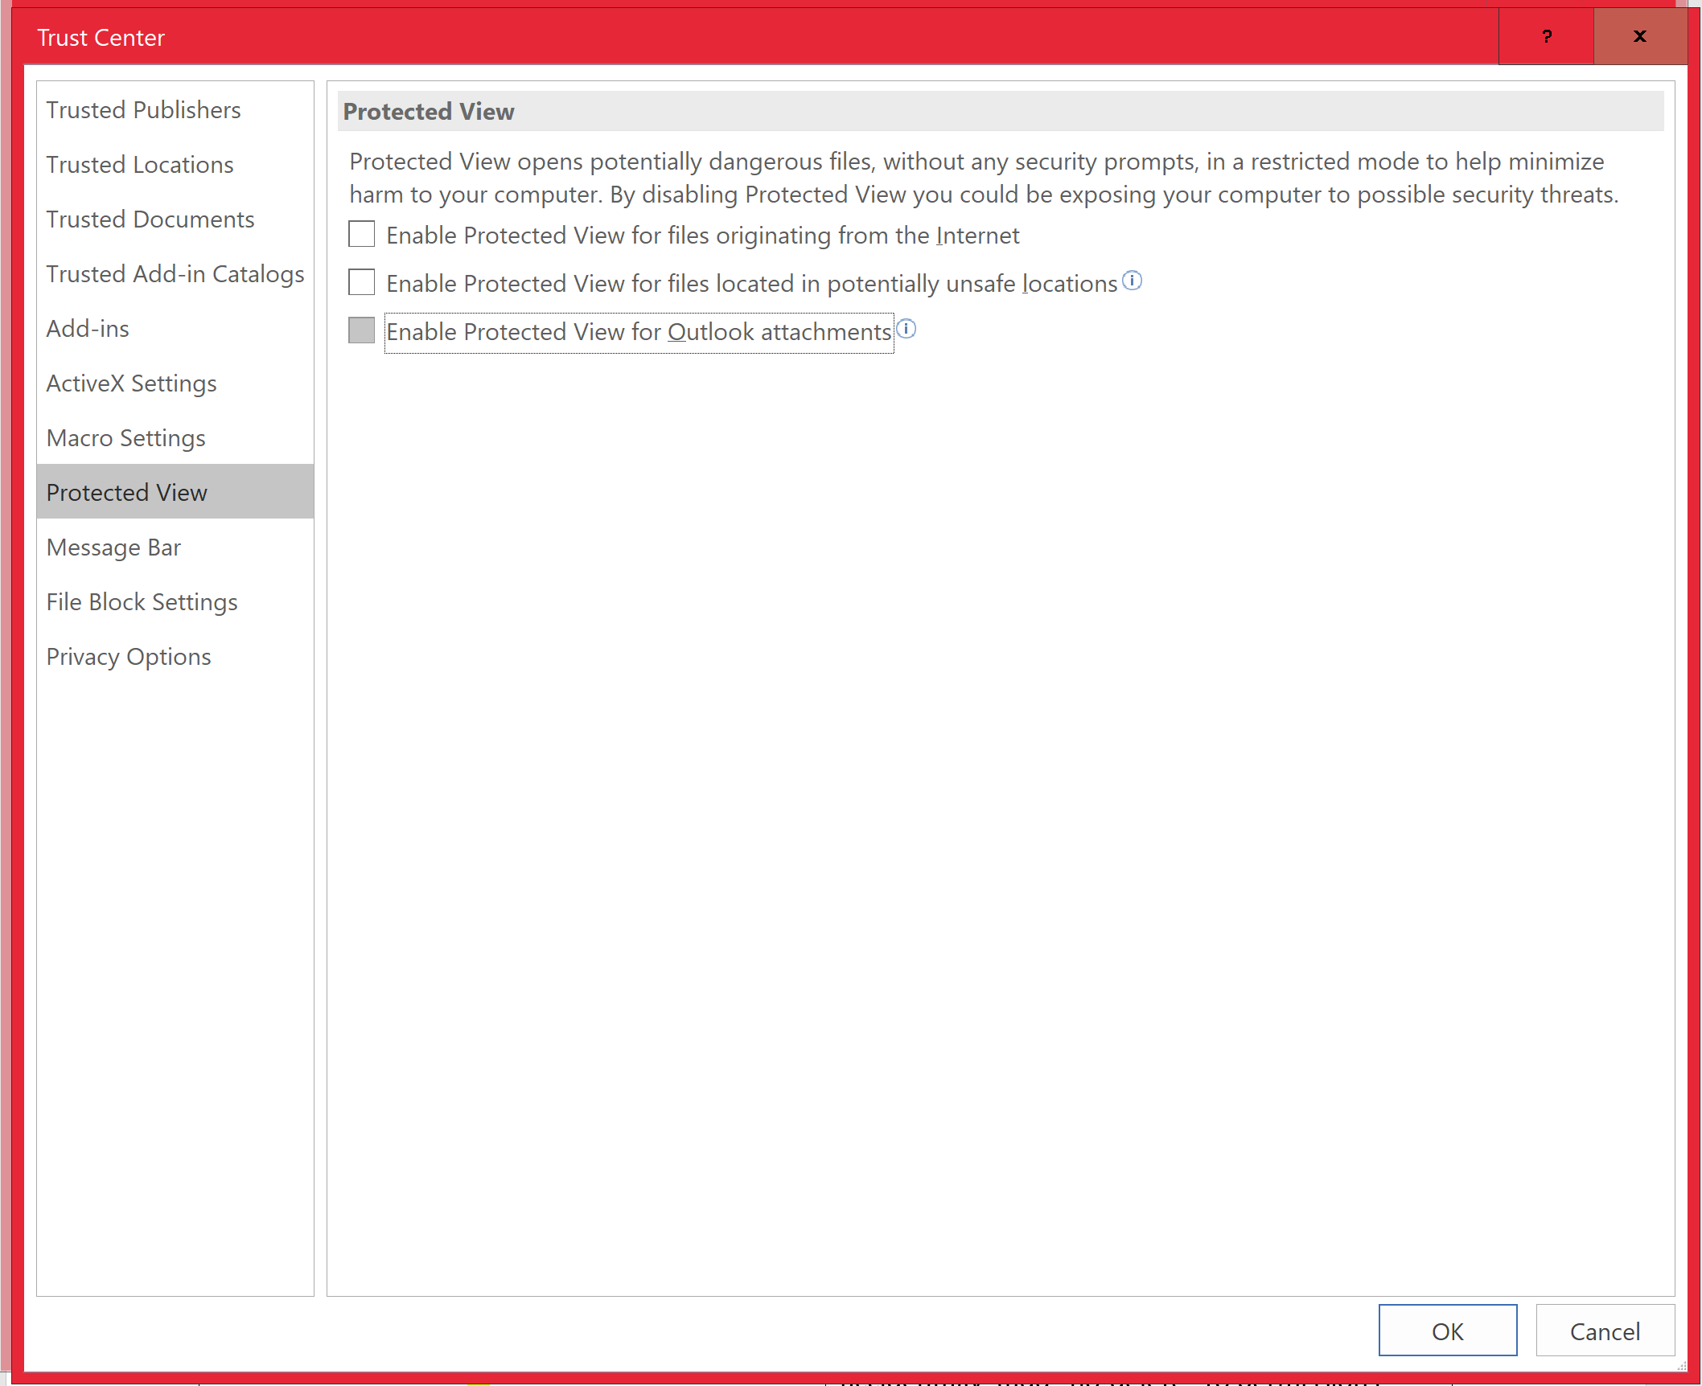

2.Repaired the document from options section.

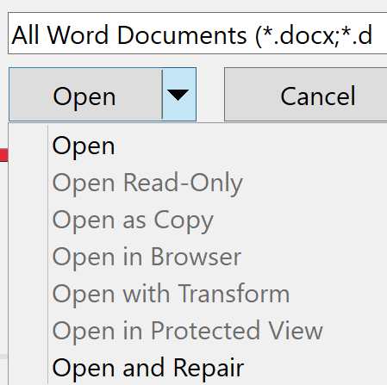

3.Opened with word pad and copied the same data into new doc file with same document name and reuploaded in the document library and made sure that we are able to see the version history. Still No Luck.

4.Made sure attributes are unchecked to read only and hidden.

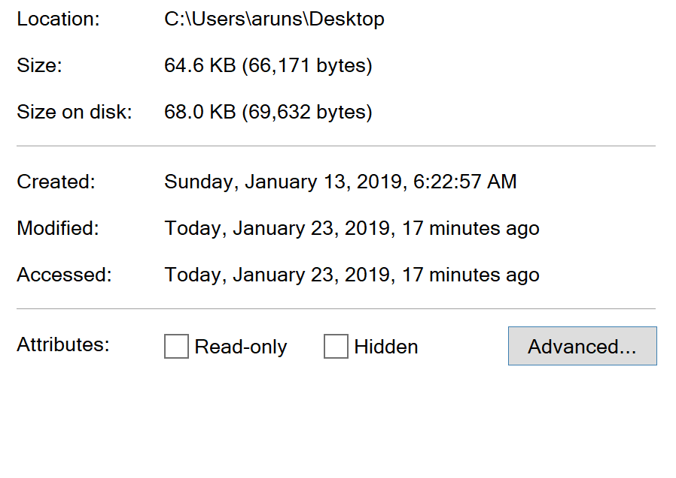

5. Deleted the cache and browsing history as below.

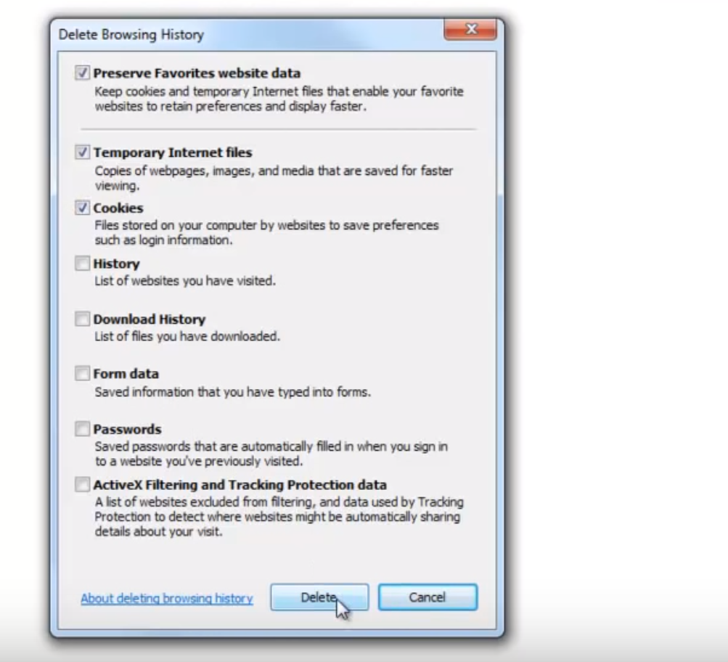

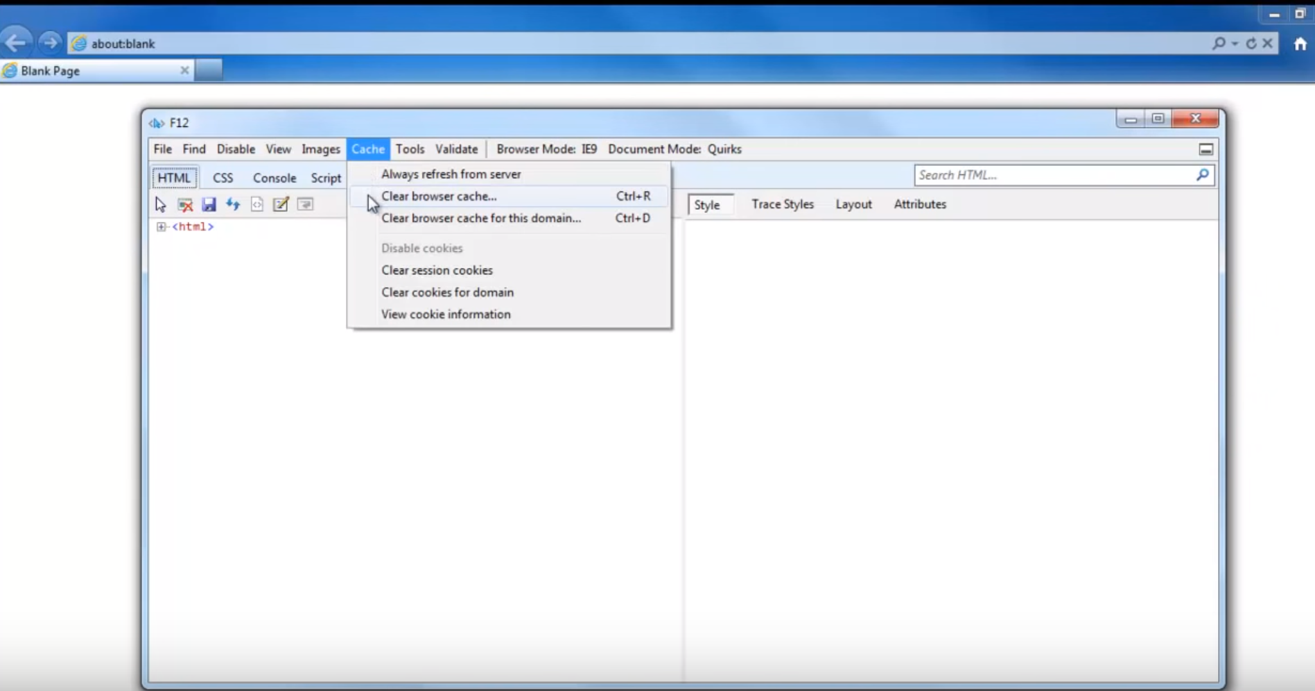

6. Elevated the permissions for the user to full control. But still no luck.

7.Tried in chrome.

8.Tried this below troubleshoot from TechNet. (using Switching accounts option from the word and tried relogging in to the office 365 account).

<https://answers.microsoft.com/en-us/msoffice/forum/msoffice_sharepoint-mso_win10-msoversion_other/sharepoint-error-sorry-we-couldnt-open/7d8c5bfb-b454-405b-be5e-b099ec333c80>

9.Tested with the other user with same permission level.(other user is able to see it, no issue with other user).

10. Tried testing using same document in my environment.( I am unable to re-create the issue).