E-COMMERCE TRANSFORMATION
Premium Website & Automation Proposal
Prepared exclusively for Wood Art Interio, Manarcadu, Kottayam

Prepared for:  Wood Art Interio  Manarcadu, Kottayam, Kerala  +91 9400233733 | Prepared by:  Aarpo Global Solutions  aarpo.in  April 2025

This proposal is valid for 30 days from the date above

1. Executive Summary
Wood Art Interio is one of Kottayam's most trusted furniture showrooms, with a rich catalogue spanning Bedroom, Living Room, Dining, and Occasional furniture. However, your current website limits your digital reach and fails to convert online visitors into paying customers.

Aarpo Global Solutions proposes to build a world-class e-commerce website with full backend automation — transforming Wood Art Interio into a 24/7 digital showroom that reaches customers across Kerala, captures leads automatically, and sends instant WhatsApp alerts to your team.

2. Current Website vs New Solution

What Your Current Website Lacks
- No product pricing shown — customers leave without enquiring
- No shopping cart or online checkout capability
- No WhatsApp integration for instant lead alerts
- No mobile-optimised or premium visual experience
- No admin panel to add or update products easily
- No automation — all enquiries are handled manually

What the New Website Will Deliver
- Full e-commerce with Razorpay checkout — UPI, Cards, EMI
- Beautiful product gallery with filters by room, material, price
- Admin panel — add products, manage orders, track all leads
- WhatsApp alerts to your phone for every new enquiry
- Customer login, order tracking, and wishlist features
- Google SEO-optimised for "furniture shops in Kottayam" searches

3. Visual Preview — Homepage Design
The homepage will create a powerful first impression with warm wood tones, a clear navigation for all product categories, a featured product grid, and the Offer Zone prominently placed. Visitors can immediately browse by room type or view current deals.

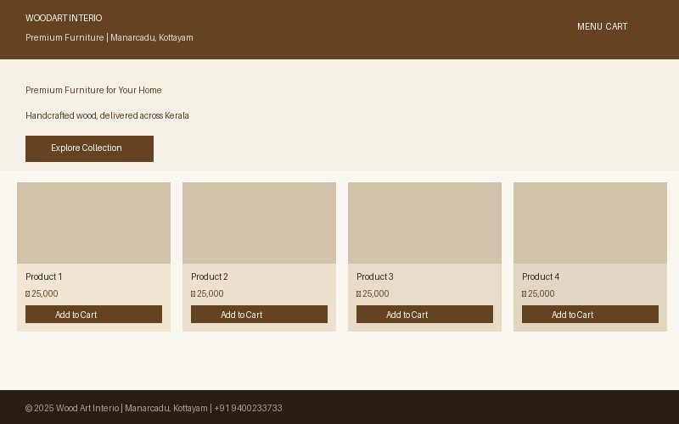
Homepage Preview — Hero section, category navigation, product grid, and footer with contact details

Key homepage elements include: a sticky header with search and cart, category banners for Bedroom / Living Room / Dining / Occasional, an offer zone with countdown timers, and a WhatsApp floating button visible on all pages.

4. Visual Preview — Product Detail Page
Each product listing will feature a multi-image gallery, material and dimension specifications, colour variant selector, pricing with any ongoing offer, EMI information, and clear buttons for both Add to Cart and Get a Custom Quote.

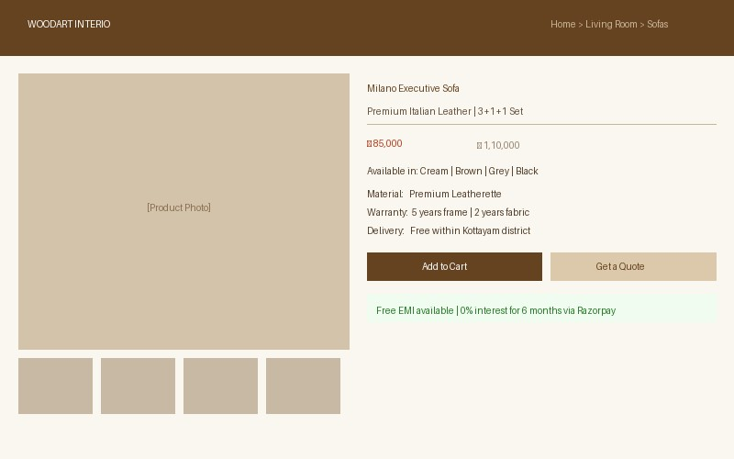
Product Page Preview — Image gallery, specifications, price, EMI badge, Add to Cart and Get a Quote buttons

This is where browsers become buyers. The layout is designed to answer every customer question — material, size, warranty, delivery — without them needing to call your showroom.

5. Admin Panel — Manage Your Business from One Screen
Your team will have exclusive access to a private admin panel. From here you can add new products with photos and pricing, view and update order statuses, track all lead enquiries, and download sales reports — no technical knowledge required.

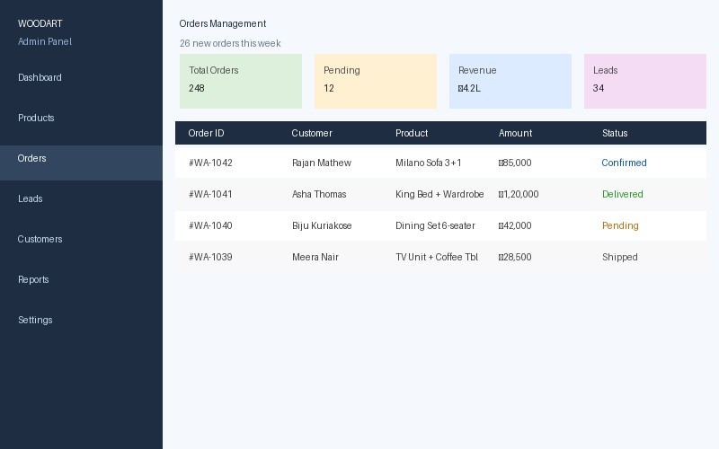
Admin Panel Preview — Order management, lead tracking, revenue overview, and product inventory control

Admin Module | What you can do
Product Manager | Add, edit, or remove products with photos, price, specs, and category tags
Order Manager | View all online orders and update status: Confirmed / Shipped / Delivered
Lead Tracker | See all enquiry form submissions with customer name, phone, and product interest
Offer Zone Manager | Create limited-time deals, enter discount prices, set countdown timers
Reports Dashboard | Weekly and monthly charts showing revenue, top products, and conversions

6. Operations Automation — Working While You Sleep
The website will run 6 automated workflows using n8n — connecting your website, WhatsApp, email, and Supabase database. Every lead, order, and delivery automatically triggers the right action, saving hours of manual follow-up every day.

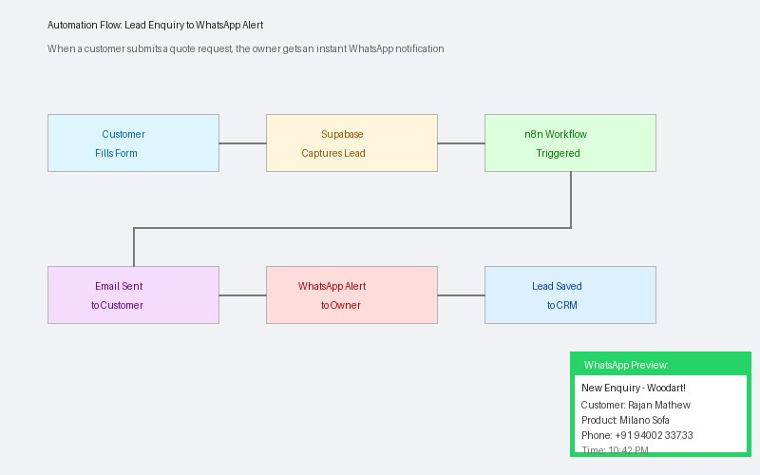
Automation Flow — Customer enquiry triggers instant WhatsApp alert, branded email, and CRM entry simultaneously

# | Automation | What happens automatically
1 | WhatsApp Lead Alert | Every enquiry form sends your phone an instant WhatsApp with customer name, product, and phone
2 | Order Confirmation Email | Customer gets a branded email with order summary, estimated delivery, and your showroom contact
3 | Inventory Alert | When stock reaches zero, admin is alerted and product is auto-marked Out of Stock on the website
4 | Weekly Sales Report | Every Monday, a report of orders, revenue, and new leads is emailed to you automatically
5 | Google Review Request | 3 days after delivery, customer receives a WhatsApp message asking for a Google Review
6 | AI Chat Bot (Zia) | Intelligent chat widget answers product queries, collects leads after hours, routes to WhatsApp

7. Technology Stack
We use only proven, modern technologies — the same stack trusted by leading Indian e-commerce platforms. Every tool is chosen for reliability, speed, India-specific features, and long-term maintainability.

Layer | Technology | Why it is right for Wood Art Interio
Frontend | Next.js 14 | Lightning-fast pages with great Google SEO — ranks higher in Kottayam furniture searches
Database | Supabase | Securely stores all products, orders, and leads with real-time admin panel updates
Styling | Tailwind CSS | Premium, responsive design — looks perfect on mobile phones and desktop screens
Payments | Razorpay | Supports UPI, debit/credit cards, net banking, and 0% EMI — built for Indian buyers
Hosting | Vercel | Free hosting with 99.9% uptime, automatically scales during sale seasons
Email | Resend | Branded order confirmation and enquiry emails delivered reliably every time
Automation | n8n | Connects WhatsApp, email, and Supabase — runs all 6 automated workflows 24/7
AI Chat | Zoho SalesIQ + Zia | Smart chat widget that answers product questions and captures leads after business hours

8. Investment Plans
Three flexible packages are available based on your goals and timeline. All packages include mobile-optimised design, Supabase backend, and hosting on Vercel.

Feature | Starter | Growth (Recommended) | Enterprise
Investment | ₹ 35,000 | ₹ 75,000 | ₹ 1,50,000
Timeline | 3 weeks | 6 weeks | 10 weeks
Product catalogue — all rooms | Yes | Yes | Yes
Premium mobile-optimised design | Yes | Yes | Yes
WhatsApp enquiry alerts | Yes | Yes | Yes
Offer Zone with discount pricing | Yes | Yes | Yes
Razorpay checkout & payments | — | Yes | Yes
Admin panel (products, orders) | — | Yes | Yes
n8n automation (6 workflows) | — | Yes | Yes
AI chat widget (Zia) | — | Yes | Yes
Custom CRM module | — | — | Yes
Blog & SEO content setup | — | — | Yes
Delivery tracking integration | — | — | Yes
Post-launch support | 1 month | 3 months | 6 months AMC

Recommendation: The Growth Plan at Rs. 75,000 gives Wood Art Interio everything needed to generate online revenue — checkout, automation, admin panel — within 6 weeks.

9. Project Timeline — Growth Plan (6 Weeks)
Phase | Duration | Key Tasks | Deliverables
Phase 1: Discovery | Week 1 | Product data, branding, content, and content gathering | Sitemap and design wireframes
Phase 2: Design | Week 2 | Homepage, product, category, and admin pages designed in Figma | Design approved by client
Phase 3: Development | Weeks 3-4 | Next.js build, Supabase, admin panel, Razorpay integration | Staging website live for review
Phase 4: Automation | Week 5 | n8n workflows, WhatsApp alerts, emails, Zia chat widget | All 6 automations tested
Phase 5: Launch | Week 6 | Product data entry, final QA, domain setup, go live | Website live on your domain

10. About Aarpo Global Solutions
Aarpo Global Solutions  We are a Kerala-based digital agency specialising in custom websites, e-commerce, AI automation, and CRM solutions for SMBs.  Unlike large IT firms, we offer enterprise-quality work at SMB-friendly pricing — because every Kerala business deserves a world-class digital presence. | Our Services  - Custom E-Commerce Websites  - AI Chat & Lead Automation  - WhatsApp Business Integration  - Admin Panels & CRM Systems  - SEO & Google Ranking  - Post-Launch Support & AMC

11. Payment Terms & Next Steps

Payment Milestones
Milestone | Payment
On Signing Agreement | 30% of total project investment
After Design Approval | 40% of total project investment
On Final Launch | Remaining 30% of project investment

To Get Started
- Review and select your preferred package: Starter, Growth, or Enterprise
- Confirm scope and timeline with our team via call or WhatsApp
- Sign the project agreement and pay the first milestone to begin
- Share your product photos and any existing content to start the build

Ready to build Kerala's finest furniture e-commerce website? Let's talk.
Aarpo Global Solutions | aarpo.in | This proposal is valid for 30 days

