Project Title A

CRM Application to Manage the Services offered by an Institution

**Team leader NM ID:**

6890214E29D5914BE2D4A24513E3D48A

**Team Members NM ID:**

0286B812A8183A5A1BD469A59F83F27F

E34D2F388B2C569B3944A6D73A75EC33

C3A18016794BACDB5A148AA81619E83E

3A1C1EEB8E5CCF3A9814D4A000F3E36B

**CRM Application to Manage the Services offered by an Institution**

## Project Overview

The CRM application aims to leverage Salesforce's ecosystem to streamline the management of institutional services, enhance customer relationships, and optimize service delivery processes. This solution will help institutions centralize customer data, automate workflows, and deliver personalized experiences to customers. It also provides insights through robust analytics, allowing institutions to make data-driven decisions

## Objectives:

• **Centralized Data Management:** Consolidate all customer and service data into a single, accessible platform.

• **Streamlined Service Operations:** Automate workflows like service requests, approvals, and notifications to reduce manual workload.

• **Improved Customer Experience:** Provide self-service portals for customers to book, track, and provide feedback on services.

• **Enhanced Decision-Making:** Use real-time analytics and reports to monitor service trends and customer satisfaction.

• **Scalability:** Create a solution that adapts to the institution's growing needs.

# Salesforce Key Features and Concepts Utilized

1. **Core Objects:**

* **Accounts and Contacts: To manage customer information.**
* **Service Requests (Custom Object): To track and manage individual service requests.**

1. **Salesforce Service Cloud:**

* **Case management to handle and resolve customer issues efficiently.**
* **Integration with Knowledge Base for customer self-help.**

1. **Salesforce Experience Cloud:**

* **Customizable portals for customers to access services, track requests, and provide feedback.**

1. **Salesforce Flow Builder and Process Builder:**

* **Automate workflows like case creation, approvals, and notifications.**

1. **Reports and Dashboards:**

* **Real-time data visualization for performance tracking and decision-making.**

1. **AppExchange Integrations:**

* **Third-party apps for payment gateways and communication tools like WhatsApp or email marketing.**

1. **Einstein Analytics (Optional):**

* **AI-driven insights to predict customer needs and improve service delivery.**

## Detailed Steps to Solution Design

It requires addressing multiple aspects such as functionality, user experience, technology stack, and security.

**Salesforce CRM (Customer Relationship Management)**

* **Customer 360**: Provides a holistic view of customers, including their travel preferences, past bookings, and interactions, enabling personalized

experiences and communication.

* **Accounts and Contacts**: Manage information about travel businesses (accounts) and their individual customers (contacts), including personal details, preferences, and history.
* **Opportunities**: Track sales opportunities such as bookings, upsells, or partnerships with travel vendors.

Search app:

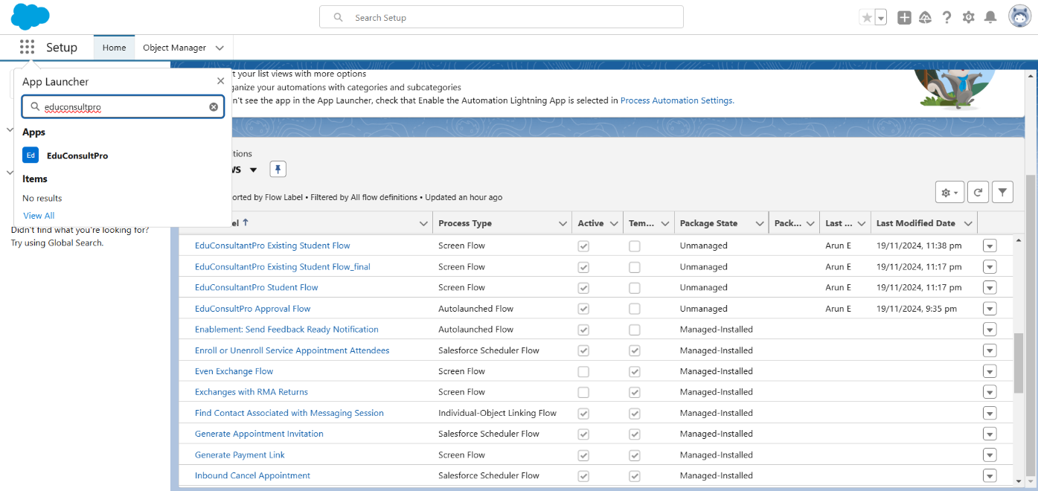

App homepage:

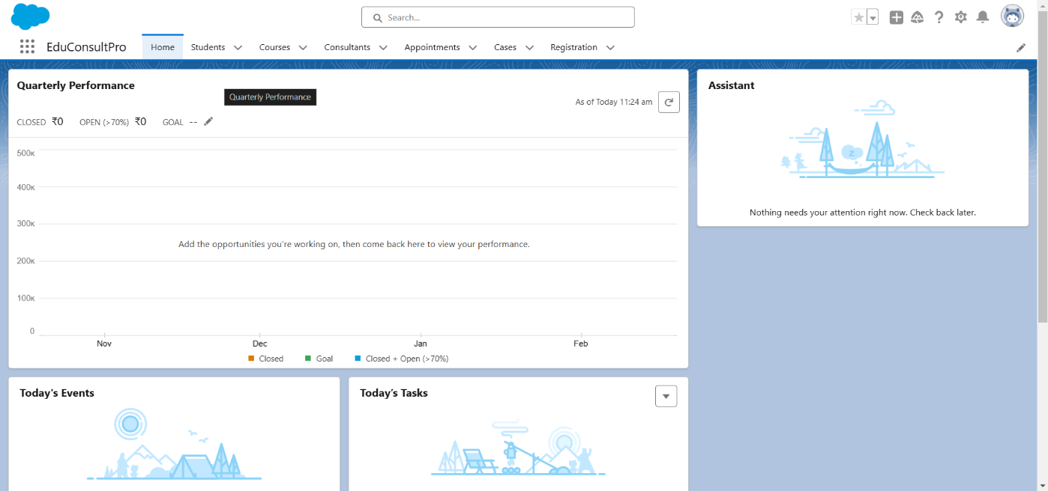

**Step 1: Requirements Gathering**

* **Understand the institution’s services, workflows, and customer needs.**
* **Identify key pain points and areas for automation.**

**Step 2: Data Modeling**

* **Define objects:**
  + **Accounts: Represent customers or institutions.**
  + **Contacts: Store details of individual customers.**
  + **Service Requests: Custom object to manage service interactions.**
* **Establish relationships between objects.**

**Step 3: Workflow Design**

* **Use Flow Builder to automate:**
  + **Service request approvals.**
  + **Notifications for service progress.**
  + **Case escalations.**
* **Configure Service Level Agreements (SLAs) in Service Cloud.**

**Step 4: Portal Development**

* **Create a customer-facing portal using Experience Cloud.**
* **Features:**
  + **Login and registration.**
  + **Service booking and tracking.**
  + **FAQ and feedback submission.**

**Step 5: Reporting and Analytics**

* **Design dashboards for:**
  + **Service trends.**
  + **Staff performance metrics.**
  + **Customer satisfaction scores.**

**Step 6: Integrations**

* **Connect payment gateways for service transactions.**
* **Integrate with external scheduling tools like Google Calendar.**

**Design:**

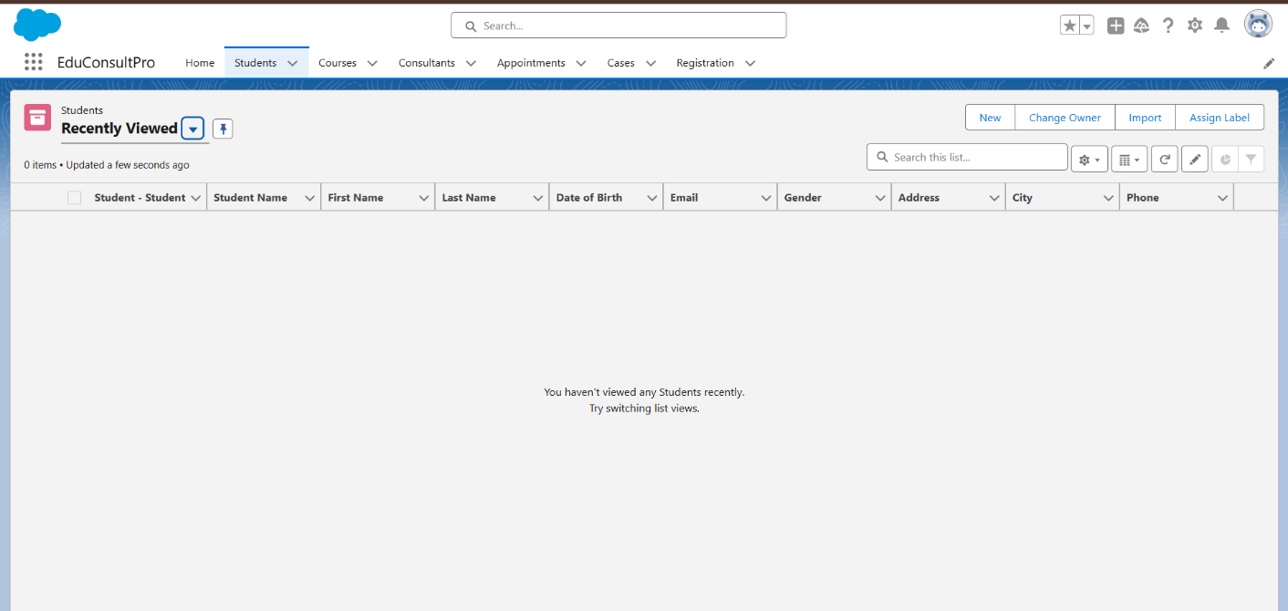

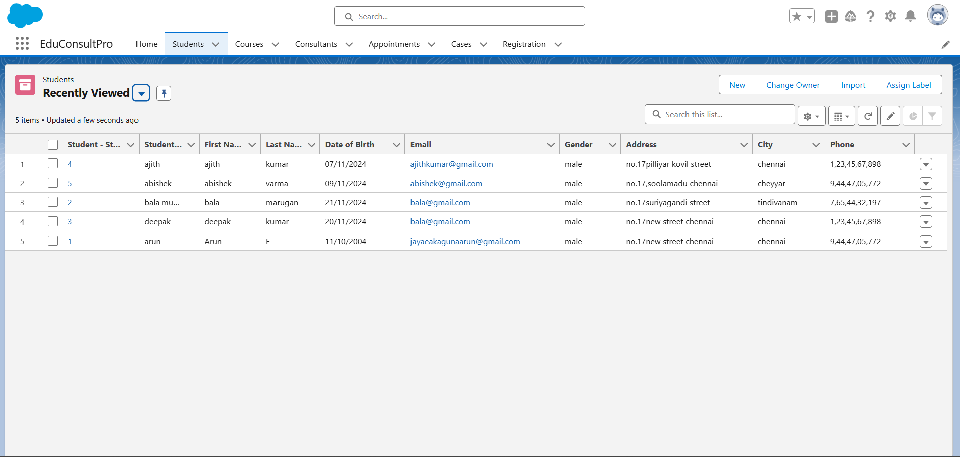**DashBoard:**

**Student object:**

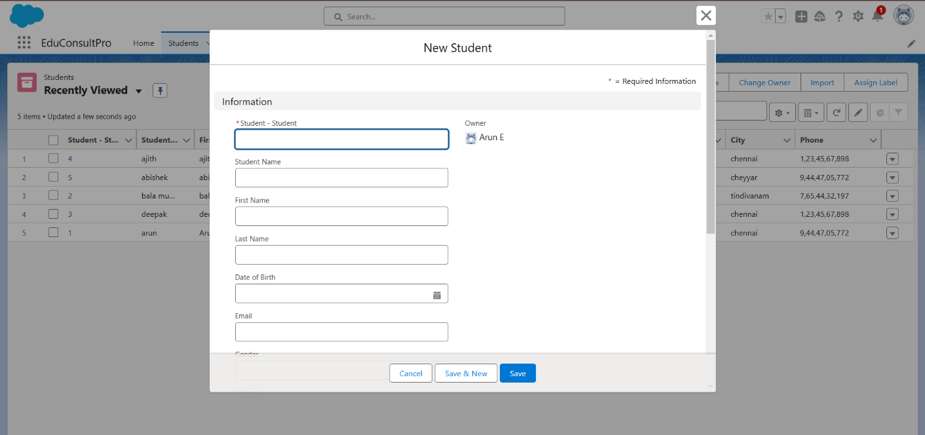

**Registration object:**

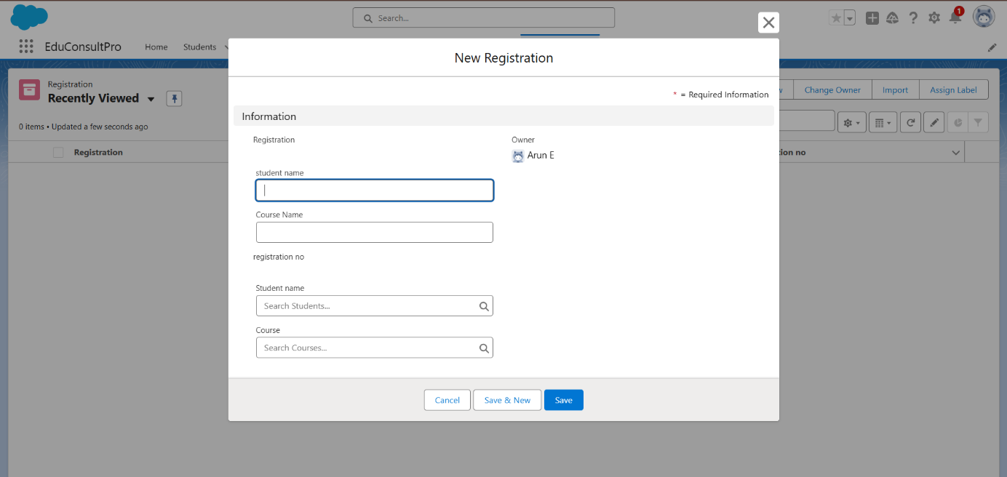

**Course object:**

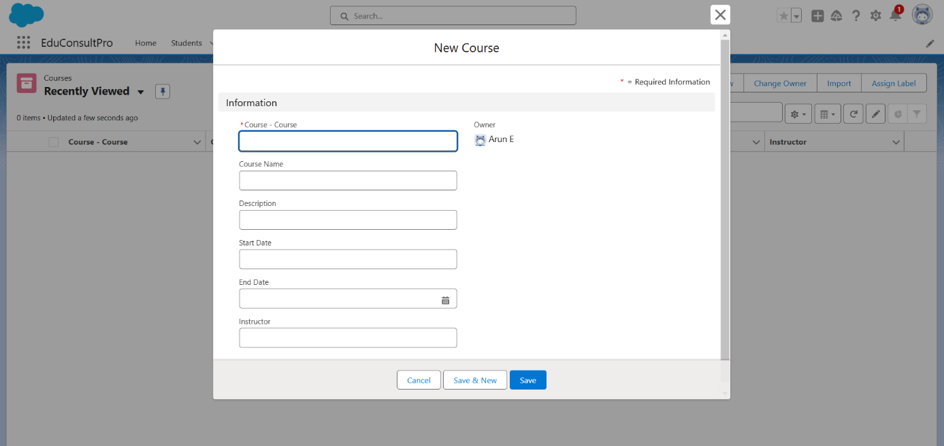

**Case object :**

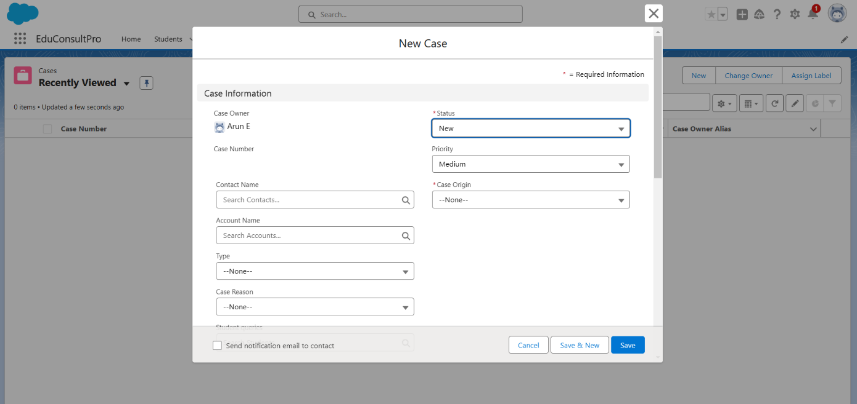

**Report:**

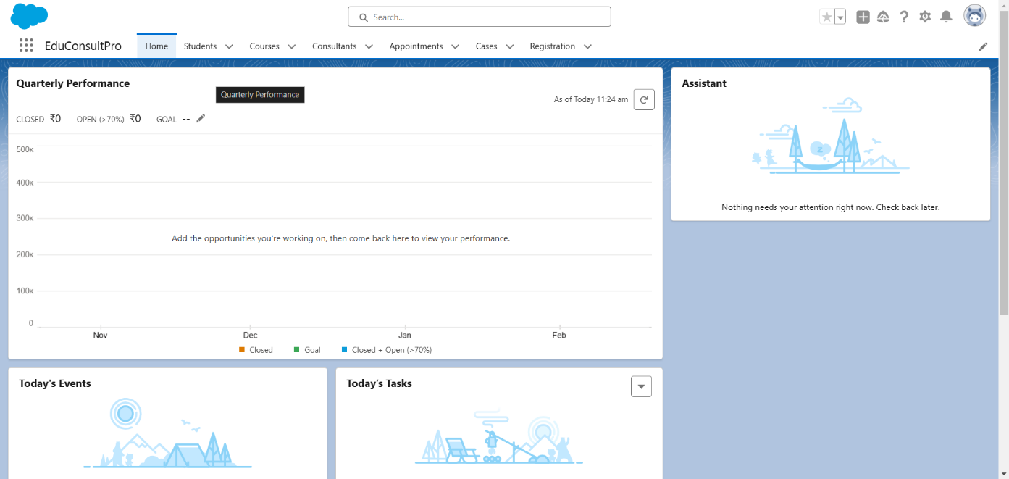

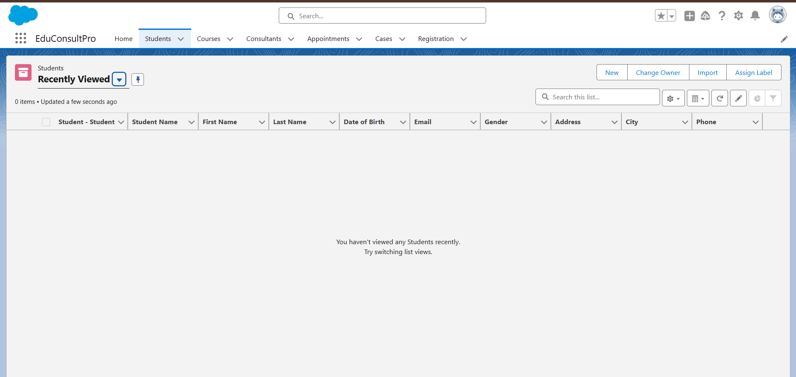

## Testing and Validation

**Testing Plan:**

1. **Unit Testing: Validate each component (e.g., custom objects, workflows, and portal features).**
2. **Integration Testing: Ensure seamless communication between Salesforce and integrated systems.**
3. **User Acceptance Testing (UAT): Involve institution staff and customers to verify usability and requirements compliance.**

**Validation Steps:**

1. **Test automated workflows for accuracy.**
2. **Validate customer portal functionality.**
3. **Check report accuracy and alignment with business goals.**

## Key Scenarios Addressed by Salesforce in the Implementation Project

* **Service Request Management:**
* Automating the process from request submission to completion.
* Ensuring customers receive timely updates.
* **Customer Communication:**
* Centralizing all customer interactions for better tracking.
* Sending automated notifications and reminders.
* **Staff Productivity Monitoring:**
* Dashboards to track workload and performance.
* Automated task assignments.
* **Customer Self-Service:**
  + Empowering customers to book services and resolve queries without staff intervention.
* **Feedback Management:**
  + Collecting and analyzing customer feedback to improve services.

## Conclusion

The Salesforce-based CRM application empowers institutions to manage their services efficiently, improving customer satisfaction while reducing operational overhead. By leveraging Salesforce's capabilities like Service Cloud, Experience Cloud, and automation tools, the institution can streamline workflows, provide a superior customer experience, and gain valuable insights for continuous improvement.

The system’s flexibility and scalability ensure it meets the institution's current needs while adapting to future growth. Salesforce's robust ecosystem makes it a reliable foundation for long-term success in service management.

Output:

